Financial Fraud Detection & Risk Analytics System
Name: ABUZER
Department: Artificial Intelligence
Institute: UMT Lahore

Abstract
This project presents a Financial Fraud Detection and Risk Analytics System using Machine Learning, SQL Data Warehousing, and Power BI. A fraud transaction dataset was analyzed using Python and a Random Forest model to identify fraudulent transactions. The processed data was stored in a MySQL Data Warehouse using a Star Schema design, and analytical insights were visualized through Power BI dashboards.

Objectives
- Detect fraudulent financial transactions using Machine Learning
- Design a Data Warehouse using Fact and Dimension tables
- Build relationships using Star Schema architecture
- Create interactive dashboards in Power BI

Technologies Used
Technology | Purpose
Python | Machine Learning & Preprocessing
Scikit-learn | Random Forest Model
MySQL Workbench | Data Warehouse Design
SQL | Schema & Relationships
Power BI | Dashboard Visualization

System Workflow
Dataset → Data Cleaning → Machine Learning → Fraud Prediction → Data Warehouse → Power BI Dashboard

ER Diagram
Star Schema Data Warehouse Design:
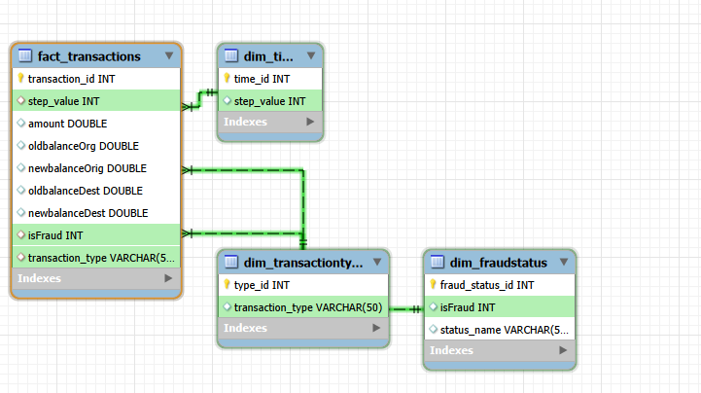

Power BI Dashboard
Fraud Analytics Dashboard:
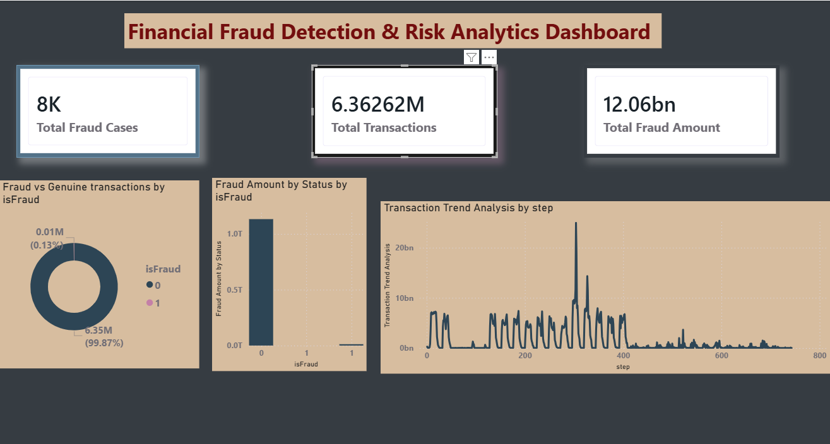

Conclusion
The project successfully detected fraudulent transactions and generated analytical insights through Power BI dashboards. The integration of Artificial Intelligence, SQL Data Warehousing, and Business Intelligence technologies demonstrates an effective solution for financial fraud analysis.

