First name___Abylay________ Second name__Dalabay___Student ID__22B030030___

Number of true answers from 1 to 4

Maximum points 3 for the test, this test is the trial version of the test, which you have on the final exam.

Test 1

1. Which of the following graphs could be used to visualize 40% chance of success?

a)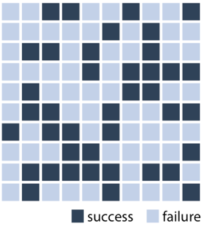 b)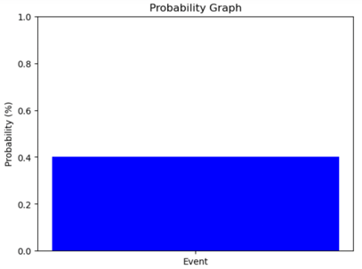 c)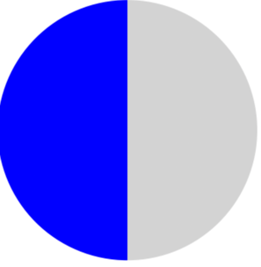d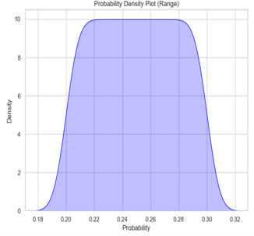

2. Which of the following definition could be used as probability distribution

a) measures the spread or dispersion of a random variable's distribution

b) the range of possible outcomes with their associated likelihoods

c) a variable whose possible values are outcomes of a random phenomenon

d) the likelihood of possible outcomes in a sample space

3. 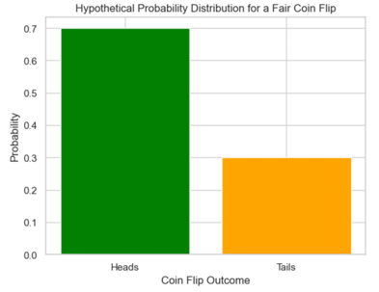

a) The probability of getting Heads is higher than the probability of getting Tails.

b) All outcomes have an equal probability of occurring.

c) The probability of getting Heads is the same as the probability of getting Tails.

d) The probability of getting Tails is the lowest among all possible outcomes.

4. Which of the following graphs could NOT be used to represent the probability, in case if

a) 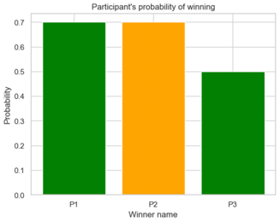b) 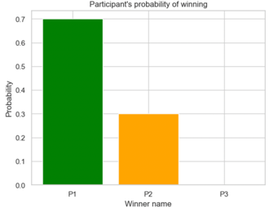c) 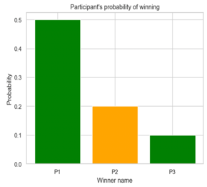d)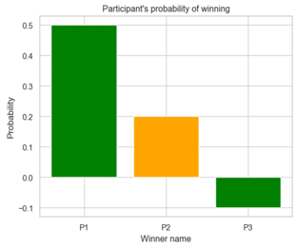

5) The given data is data = [1,2,3,4,5,1,2,3,4,5] Which boxplot could be used to visualize it

a)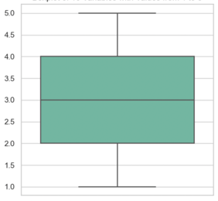 b) 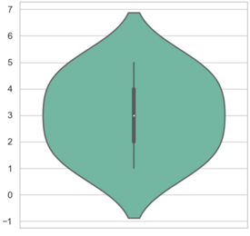c) 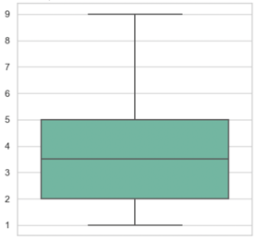d) 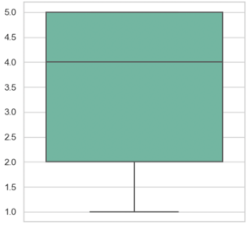

6) How the mean value of the data below will be changed if two additional numbers will be added: 3, 3

a) will be bigger than old one

b) will be the same

c) will be smaller

d) could not be calculated

7) How the median value of the data below will be changed if two additional numbers will be added: 3, 3

a) will be bigger than old one b) will be the same c) will be smaller d) could not be calculated

8) What is the difference between population and sample

a) population is smaller than sample b) sample is smaller than population

c) the population is the entire group of interest, while the sample is a subset of that population

d) the sample is the entire group of interest, while the population is a subset of that sample

9) 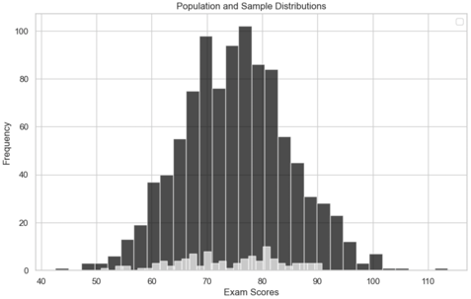

a) The population and sample have the same mean.

b) The sample provides an accurate representation of the entire population.

c) The population and sample have different variances.

d) The sample has a larger frequency of high exam scores compared to the population.

10)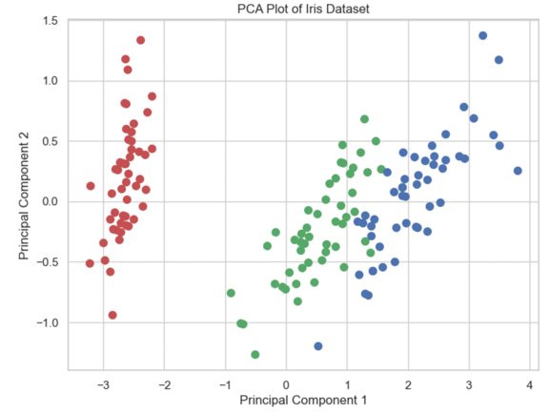

A) The three iris species are perfectly separable based on the first two principal components.

B) The first principal component alone is sufficient to distinguish between all three iris species.

C) The second principal component alone is sufficient to distinguish between all three iris species.

D) The iris species overlap significantly in the reduced-dimensional space.

11) You have information about the product which has maximum consumption in winter, which of the following graphs can be used to show it

a) bar char b) pie char c) line graph d) map

12) 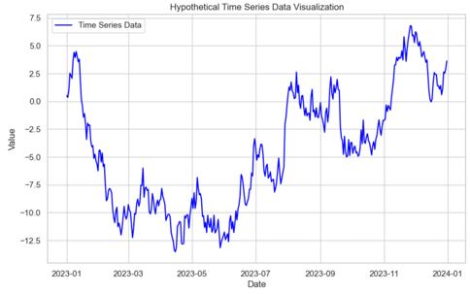

A) There is a clear upward trend in the financial metric over the year.

B) The financial metric exhibits a strong seasonality pattern.

C) The financial metric shows periods of both increase and decrease.

D) The financial metric remains constant throughout the year.

13) Describe an issues with questions which you have

9 11

12

9) if sample representative enough it should have same mean and variance as all dataset________________________________________________________________________________________11) time is continuous so lets use line graph and bar char___________________________________________________________________________________________ 12)___________________________________________________________________________________________________________________________________________________________________________________________________________________________________________________________________________________________