Sports Goods Store Management System
Final Project Report
Course: Advanced Databases (NoSQL)
Students:
Abylay Dosymbek (SE-2435)
Sakenov Rassul (SE-2435)

1. Introduction
This report describes the design and implementation of a web-based Sports Goods Store Management System developed as the final project for the Advanced Databases (NoSQL) course. The project focuses on applying NoSQL database concepts using MongoDB, including advanced data modeling, aggregation pipelines, indexing strategies, and backend logic.

2. Project Overview
The goal of the project is to build a functional web application that demonstrates practical usage of MongoDB as the main database. The application allows managing sports products, categories, suppliers, and orders, as well as performing analytical queries based on real business scenarios.

3. System Architecture
The system follows a client-server architecture. The frontend is implemented using HTML, CSS, and Vanilla JavaScript. The backend is implemented using Node.js and Express.js. MongoDB is used as the primary database.
Frontend and backend are deployed as separate services and communicate through RESTful API endpoints using HTTP requests.
System architecture of the Sports Goods Store application.
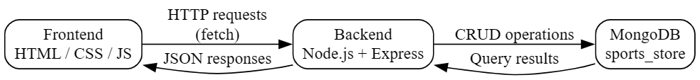

4. Database Schema Design
The database consists of multiple collections designed according to NoSQL principles. Both embedded and referenced data models are used depending on access patterns.
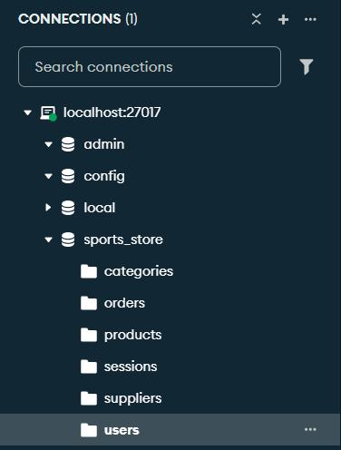

4.1 Users Collection
The users collection stores authentication data and user roles. Fields include username, password, and role. A unique index is created on the username field.
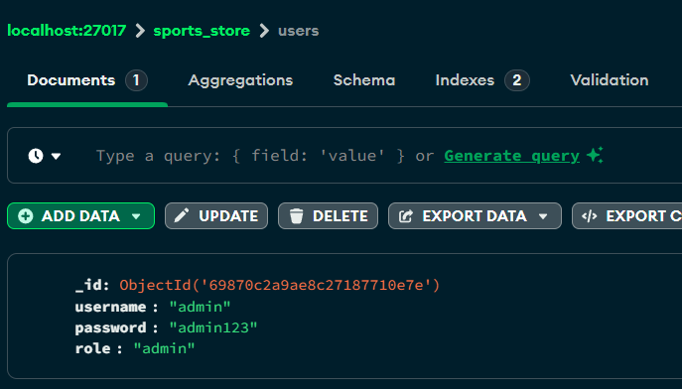

4.2 Categories Collection
The categories collection stores product categories. Each category document contains a name field and is referenced by products.
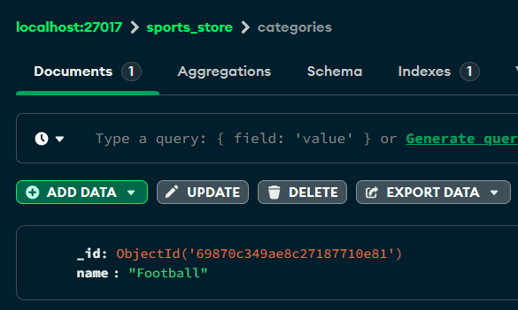

4.3 Suppliers Collection
The suppliers collection stores information about product suppliers, including name and country.
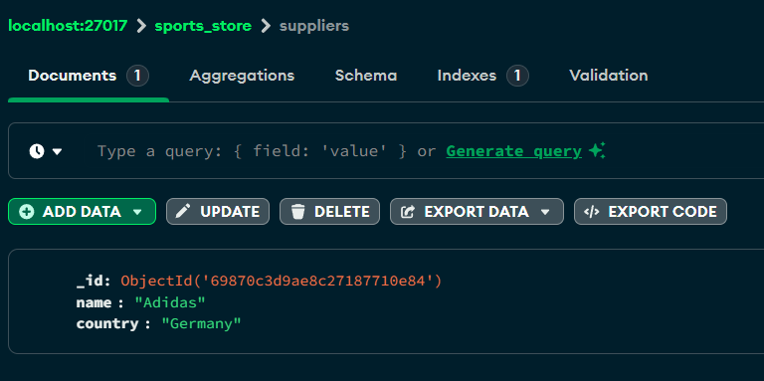

4.4 Products Collection
The products collection stores information about sports goods. Each product references a category and a supplier using ObjectId references. Reviews are stored as embedded documents inside the product document.
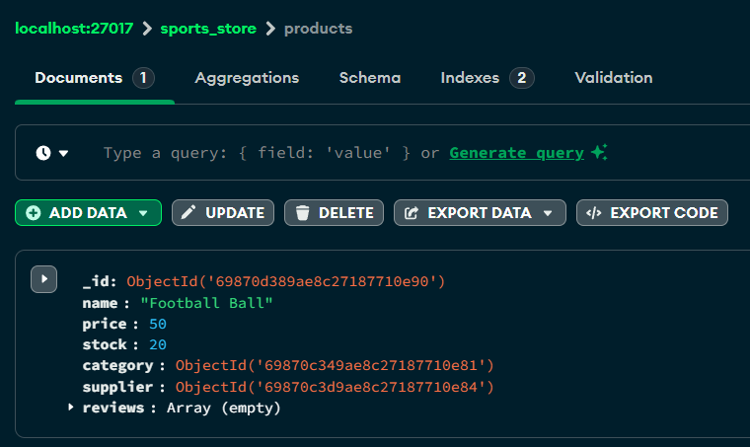

4.5 Orders Collection
The orders collection stores customer orders. Each order contains an array of ordered items, total price, and creation date. Orders reference products indirectly through stored identifiers.
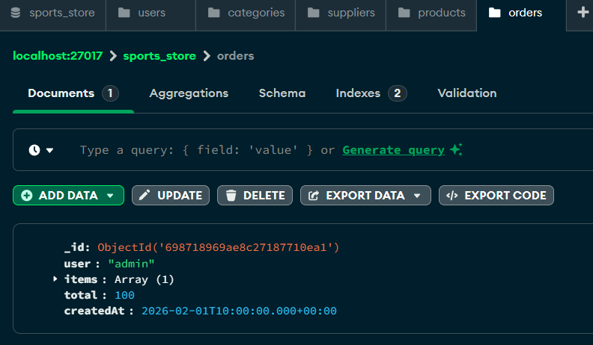
Database schema showing embedded and referenced document relationships.

5. MongoDB Operations
The project implements full CRUD operations across multiple collections. Advanced update and delete operators such as $set, $inc, $push, and $pull are actively used.
CRUD operations performed on products collection.
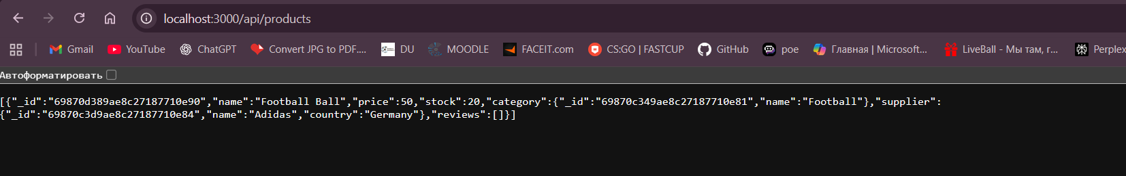
Usage of advanced MongoDB update operators in product controller.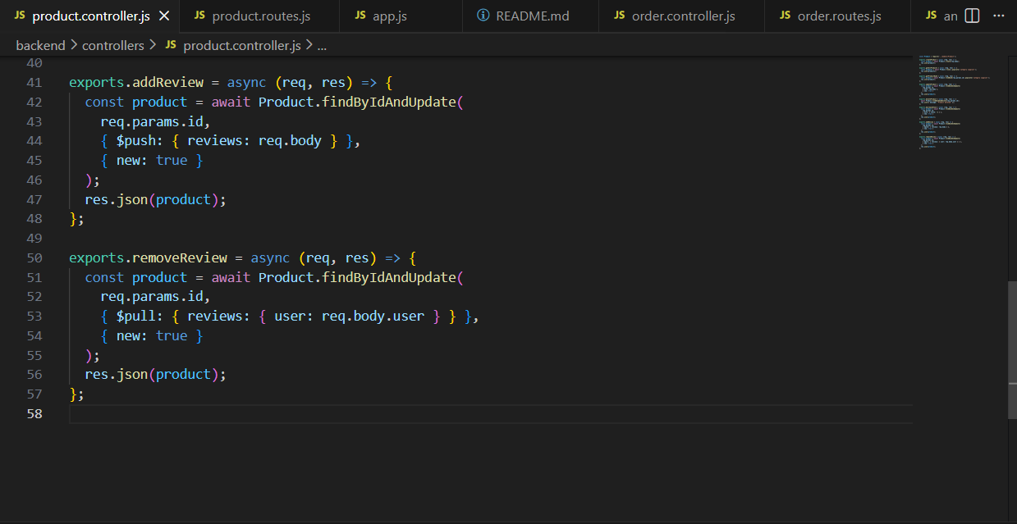

6. Aggregation Framework
MongoDB aggregation pipelines are used to perform analytical queries with real business meaning.
Implemented aggregations include total sales by category, top selling products, and monthly revenue calculations. Each aggregation pipeline uses multiple stages such as $lookup, $unwind, $group, and $sort.
Aggregation pipeline result showing total sales by category.
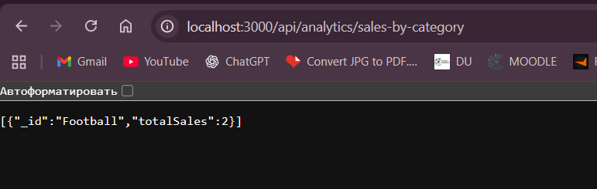
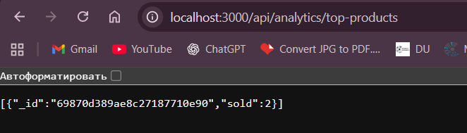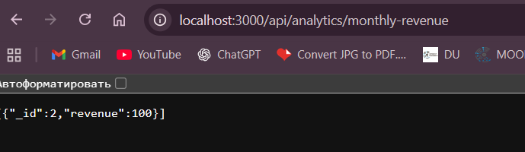
Aggregation pipeline flow for analytics queries.
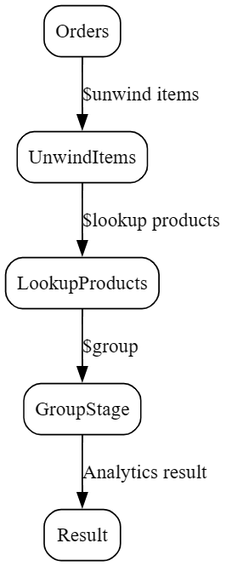

7. Indexing and Optimization Strategy
Indexes are created to optimize frequent queries and aggregation performance. A compound index on category and price fields is created in the products collection. Indexes on createdAt in orders and username in users are also implemented.
Compound index on category and price fields.
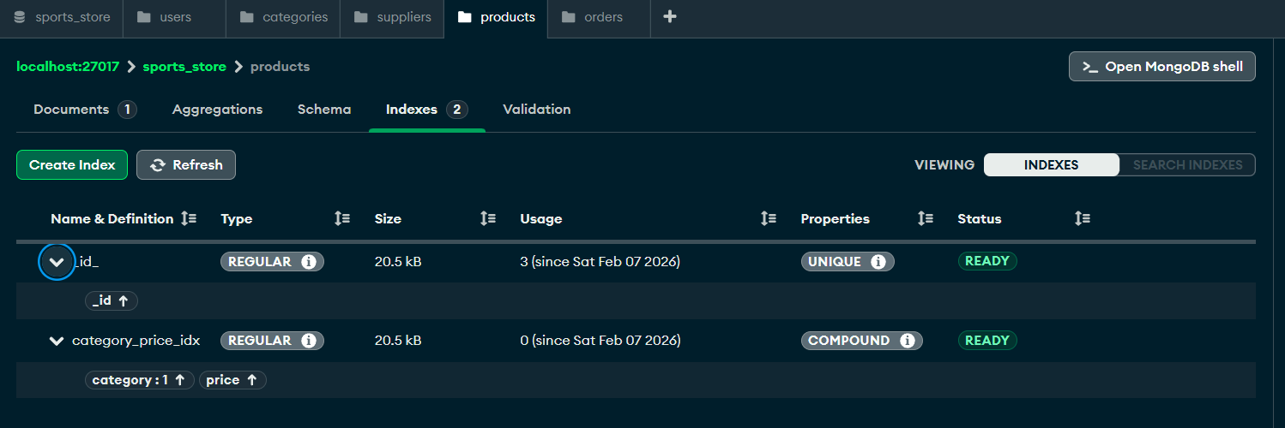

Unique index on username for authentication.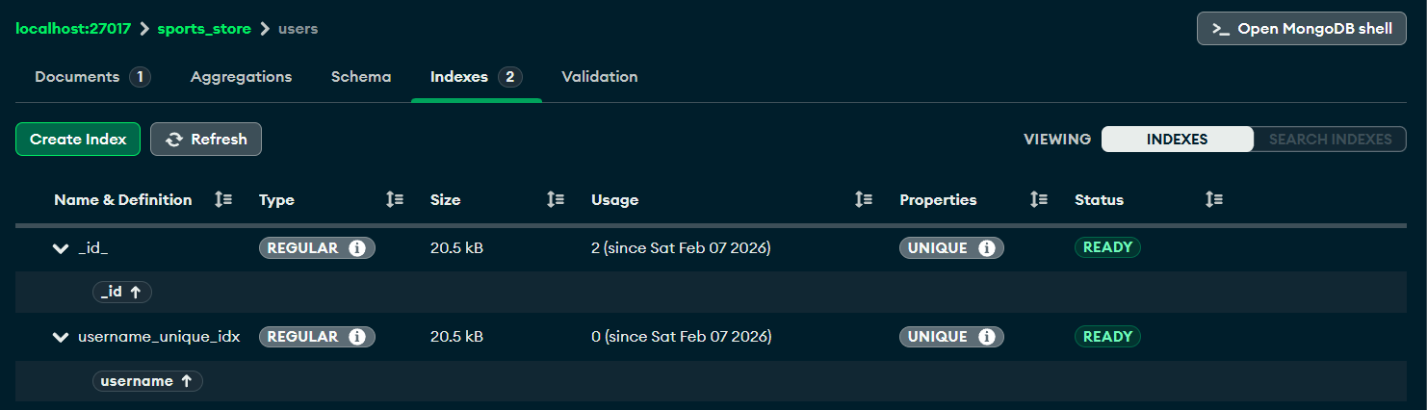

8. REST API Design
The backend exposes more than twelve REST API endpoints, satisfying the requirements for a two-student project. Endpoints include authentication, products management, orders management, and analytics.
REST API routes implemented in the backend.
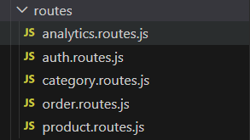

9. Authentication and Authorization
Session-based authentication is implemented using express-session with MongoDB session storage. User roles are used to restrict access to administrative operations.
Session-based authentication is implemented using the express-session middleware with MongoDB as a session store.
User sessions are created dynamically upon successful authentication and stored in the database.
During local testing, the sessions collection may remain empty until active user sessions are generated.

10. Frontend Implementation
The frontend provides basic interaction with the backend. Users can view products, view orders, and access analytics. The Fetch API is used for HTTP communication.
Products page displaying data fetched from backend API.
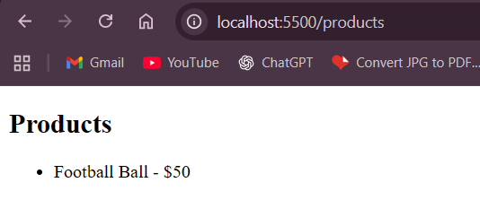
Admin page showing analytics data from aggregation endpoints.
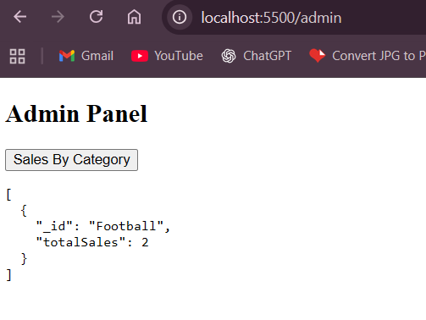

11. Contribution of Each Student
Abylay Dosymbek was responsible for database design, MongoDB queries, aggregation pipelines, and backend logic. Sakenov Rassul was responsible for frontend development, API integration, and testing.

12. Conclusion
In this project, a web-based Sports Goods Store Management System was successfully designed and implemented using MongoDB as the primary NoSQL database. The project demonstrates practical application of advanced database concepts studied in the Advanced Databases (NoSQL) course.
During the development process, special attention was given to NoSQL data modeling principles. Both embedded and referenced document models were applied to represent real-world relationships between entities such as products, categories, suppliers, and orders. This approach allowed flexible data storage while maintaining clear logical connections between collections.
The backend of the system exposes a RESTful API that supports full CRUD operations across multiple collections. Advanced MongoDB update operators and multi-stage aggregation pipelines were implemented to perform meaningful business analytics, such as sales statistics and revenue calculations. Indexing strategies were also applied to optimize query performance and ensure efficient data access.
The frontend provides basic but functional interaction with the backend through real HTTP requests. It allows users to view products, orders, and analytical data, demonstrating end-to-end communication between client and server components.
Overall, the project fulfills all functional and technical requirements of the course. It demonstrates a clear understanding of MongoDB features, NoSQL database design, and backend integration. The developed system can serve as a solid foundation for further extension and improvement in future projects.

