Software Engnieering Lab 3

苏建锐 10195101553 East China University

**Course Assignment 1**

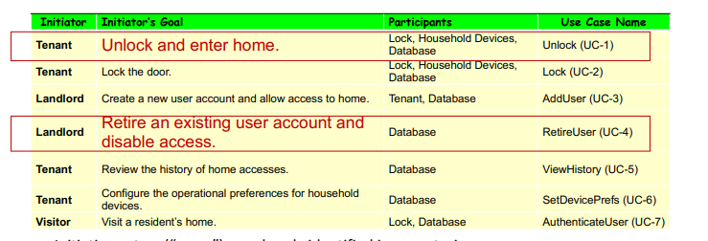

• Derive UC-1 (Unlock) and UC-4 (RetireUser)

The orange characters are the supplement of participants.

The crossed out charactors are deleted

|  |  |  |  |
| --- | --- | --- | --- |
| **Initiator** | **Initiator’Goal** | **Participants** | **Use Case Name** |
| Tenant | Unlock and enter home. | Lock, ~~Household Devices~~, Database, Landlord | Unlock(UC-1) |
| Landlord | Retire an existing user account and disable access. | Database, Lock | RetireUser(UC-4) |

• Give the use case schemas of UC-1 and UC-4

**Schema for Use Case 1:**

|  |  |  |  |
| --- | --- | --- | --- |
| **Use Case UC-1:** | | | Unlock |
| **Related Requirements:** | | | Tenant, Lock, Database, Landlord |
| **Initiating Actor:** | | | Tenant |
| **Actor’s Goal:** | | | Unlock and enter home. |
| **Participating Actors:** | | | Lock, Database, Landlord |
| **Preconditions:** | | | Door locked |
| **Postconditions:** | | | Door unlock |
| **Flow of Events for Main Success Scenario:** | | | |
| → | 1. | Tenant sends unlock request to lock. | |
| ← | 2. | Lock sends request to database to access. | |
| ← | 3. | Access was confirmed, door unlocked. | |
| **Flow of Events for Extensions (Alternate Scenarios): What could go wrong? List the exceptions to the routine and describe how they are handled** | | | |
| → | 1a. | Tenant enter the wrong password. (Request rejected) | |
| ← | 2a. | Lock failed to access to database. (check the network/enter password again) | |

**Schema for Use Case 4:**

|  |  |  |  |
| --- | --- | --- | --- |
| **Use Case UC-4:** | | | Retire account & Disable access |
| **Related Requirements:** | | | Landlord, Database, Lock |
| **Initiating Actor:** | | | Landlord |
| **Actor’s Goal:** | | | Retire an existing user account and disable access. |
| **Participating Actors:** | | | Database, Lock |
| **Preconditions:** | | | Account exist & Can be accessed |
| **Postconditions:** | | | Account being retired & Access disabled |
| **Flow of Events for Main Success Scenario:** | | | |
| → | 1. | Landlord send request to retire the existed account. | |
| ← | 2. | Database received the request and delete the account. | |
| → | 3. | Database send command to lock that the account has been deleted. | |
| ← | 4. | When using the account that was deleted, can’t access to database. | |
| **Flow of Events for Extensions (Alternate Scenarios): What could go wrong? List the exceptions to the routine and describe how they are handled** | | | |
| → | 1a. | Database didn’t received the request(send request again). | |
| → | 2a. | Database failed to delete the account(try again). | |
| ← | 3a. | Lock didn’t received the command from database. | |

• Give the acceptance tests for UC-1 and UC-4

Acceptance tests for UC-1:

|  |  |
| --- | --- |
| **Test-case Identifier:**  **Use Case Tested:**  **Pass/fail Criteria:**  **Input Data:** | TC-1  UC-1  Pass Criteria: Door unlock  Fail Criteria: Door still locked  Numeric keycode, door identifier |
| **Test Procedure:** | **Expected Result:** |
| **Step 1:** Type in the correct keycode and door identifier | System beeps to indicate failure; System flashes a green light to indicate success; records successful access in the database; disarms the lock device |

Acceptance tests for UC-4:

|  |  |
| --- | --- |
| **Test-case Identifier:**  **Use Case Tested:**  **Pass/fail Criteria:**  **Input Data:** | TC-4  UC-4  Pass Criteria: Account being retired & Access disabled  Fail Criteria: Account still exist/Access success  Management of account device, Account Numeric keycode, door identifier |
| **Test Procedure:** | **Expected Result:** |
| **Step 1:** Using the device to send request to retire the existed account.  **Step 2:** Unlock the door with the deleted account | If the device shows [account has been deleted], it is successful, if the account still in the account list, the test is failed.  If the door is unlocked, the test failed; if the door is not unlocked, the test success. |