Software Engnieering Lab 5

苏建锐 10195101553 East China Normal University

*Assignment 1：Design sequence diagram*

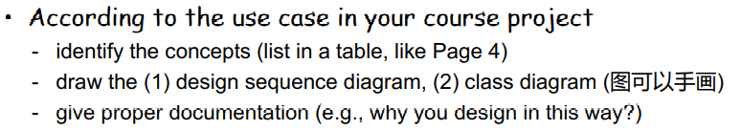

**(1) Concepts**

|  |  |  |
| --- | --- | --- |
| **Responsibility Description** | **type** | **Concept name** |
| The medium in which users use the comment function. | K | account |
| Check the availability of the account used by the user. | D | account checker |
| Coordinate actions of all concepts associated with a use case, a logical grouping of use cases, or the entire system and delegate the work to other concepts. | D | controller |
| Container for the comment that users and admin sended. | K | comment storage |
| Container for all accounts (avilable/unavilable). | K | account storange |
| Log all interactions with the system in persistent storage. | D | logger |

**(2) Sequence diagram**

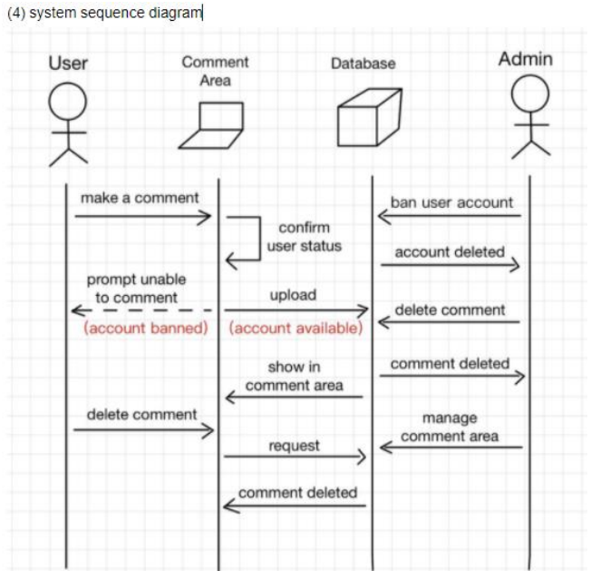

**(3) Class disgram**

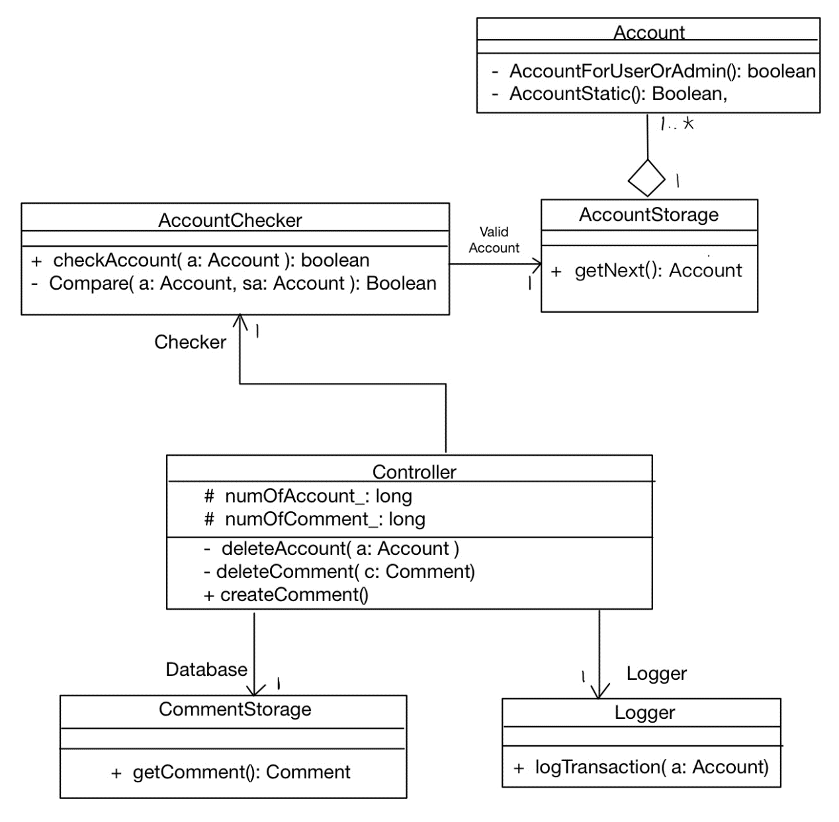

Mainly based on sequence diagram.

About Account, I devided it into three parts, Account, AccountStorage and AccountChecker.

Controller carries most of the functions, like Account management and Comment management.

Besides, there should have a Logger to logging the operations.