Software Engnieering Lab 6

苏建锐 10195101553 East China Normal University

*Assignment 1：JUnit Tests*

测试用例：

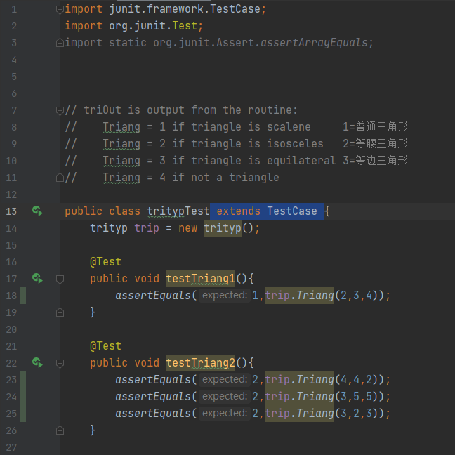

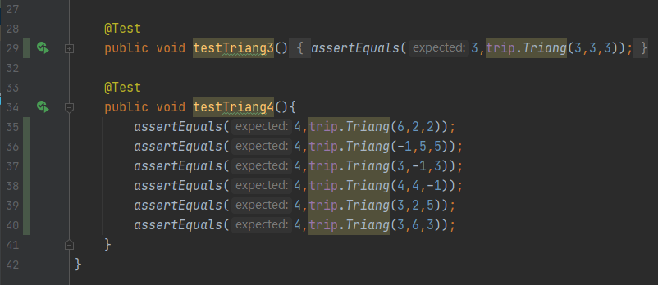

结果：



59% of line coverage

100% of branch coverage