**Concepts**

|  |  |  |
| --- | --- | --- |
| Responsibility Description | Type | Concept Name |
| Coordinate actions of all concepts associated with a use case, a logical grouping of use cases, or the entire system and delegate the work to other concepts | D | Controller |
| Container for user’s authentication data, such as password | K | Password |
| Verify whether or not the password used by the user is correct. | D | Password Checker |
| Container for the collection of valid password associated with users | K | Password Storage |
| Display the information on the Illustrated books | K | Illustrated books |
| web page jumps to the web page of the illustrated book | D | Web turn |
| Log all interactions with the system in persistent storage. | D | Logger |

**Sequence diagram**

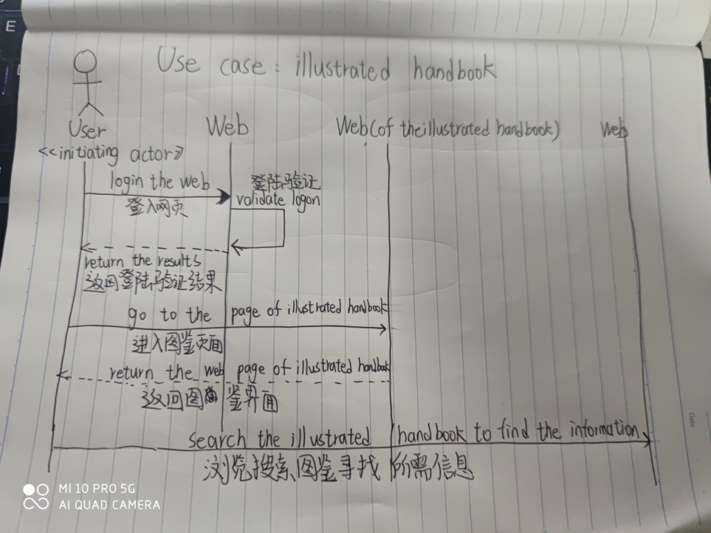

**Class diagram**

