Journal of Geophysical Research: Solid Earth
Supporting Information for
Ranking Thermobarometers: An Artificial Intelligence-Based Framework for Selecting Clinopyroxene-Based Models
Xiaoyu Liu¹, Weiran Li¹
¹ Department of Earth and Planetary Sciences, The University of Hong Kong, Hong Kong SAR, China

Contents of this file

Text S1
Figures S1 to S17
Additional Supporting Information (Files uploaded separately)

Table S1. Cleaned independent dataset used to develop and test the AIMS4PT_cpx framework

Table S2. Clinopyroxene compositions from Merapi volcano used for temperature-pressure calculation

Table S3. Liquid compositions from Merapi volcano used for temperature-pressure calculation

Introduction
This supporting information contains additional methodological details, supplementary figures, and table captions for the main manuscript. Text S1 provides additional details of the AIMS4PT_cpx framework. Figures S1–S17 provide supplementary compositional comparisons of model calibration datasets, SHAP-based feature-importance analyses, evaluations of the out-of-distribution filters and deviation predictors, tests of analytical uncertainty, model-selection for Merapi data, sensitivity tests for repeated train–test splits, and sensitivity tests for Kd(Fe–Mg)-based equilibrium-liquid pairing.

Text S1. Additional methodological details for the AIMS4PT_cpx framework.
The workflow for establishing AIMS4PT_cpx is described in Section 3. Here, we provide additional methodological details not included in the main text.
All the OOD filters and deviation prediction models were trained separately for each thermometer or barometer. To maintain consistency with the original thermobarometer model, we adopt the same input variables (i.e., the clinopyroxene and liquid components) for feature-space OOD filtering and deviation prediction as the original model. For the most clinopyroxene-only models, input clinopyroxene components include SiO₂, TiO₂, Al₂O₃, FeOₜ, MnO, MgO, CaO, Na₂O, and K₂O, and clinopyroxene-liquid models usually use these clinopyroxene components together with major-element liquid oxides including SiO₂, TiO₂, Al₂O₃, FeOₜ, MnO, MgO, CaO, Na₂O, and K₂O. A few models additionally require variables such as liquid H₂O and P₂O₅, or clinopyroxene Cr₂O₃ and NiO (Chicchi et al., 2023). The reported total iron (FeO_{t}) was all treated as Fe²⁺, consistent with the assumptions of the previous thermobarometer model. In addition, the liquid compositions were renormalized to 100 wt.% anhydrous, where required by the original thermobarometer, liquid, while the content of H₂O was retained as an independent input variable.
Feature-space OOD filters were implemented using one-class SVMs in scikit-learn (Schölkopf et al., 2001; Pedregosa et al., 2011), and for the thermobarometers, their calibration datasets were reported. The input variables were standardized and then weighed using the SHAP-derived feature importance described in Section 2.3. We fit a one-class SVM for each thermobarometer using its training dataset. Positive and negative decision-function scores given by the SVM model are interpreted as feature-in-distribution and feature-space OOD, respectively. Feature-space OOD filters were fitted for all thermobarometer models except the Putirka (2008) models, as their calibration datasets are unavailable. Therefore, we apply only the predicted P–T OOD filter (the TAS-field melt-composition OOD filter is also unavailable) to Putirka (2008). For feature-space OOD filtering, we apply a conservative rule: if all other thermobarometers with feature-space OOD filters classified a sample as OOD, the Putirka (2008) models were also filtered for that sample.
Deviation predictors were trained separately for each thermobarometer using the training subset of the independent dataset. The target (i.e., the predicted value) was the absolute difference between the thermobarometer prediction and the pressure or temperature measured in experiments (considered as the “true” value in the thermobarometers). Several regression algorithms were tested for the deviation predictors, including k-nearest neighbors, random forest, ExtraTrees, XGBoost (using the XGBoost package; Chen & Guestrin, 2016), support vector regression, and kernel regression. ExtraTrees regression (Geurts et al., 2006), implemented in scikit-learn (Pedregosa et al., 2011), was used in the final workflow because it gave the best overall performance. For the ExtraTrees deviation predictors, hyperparameters were optimized using randomized search (Bergstra & Bengio, 2012) with five-fold shuffled cross-validation (Arlot & Celisse, 2010). The final model was selected based on cross-validated R².

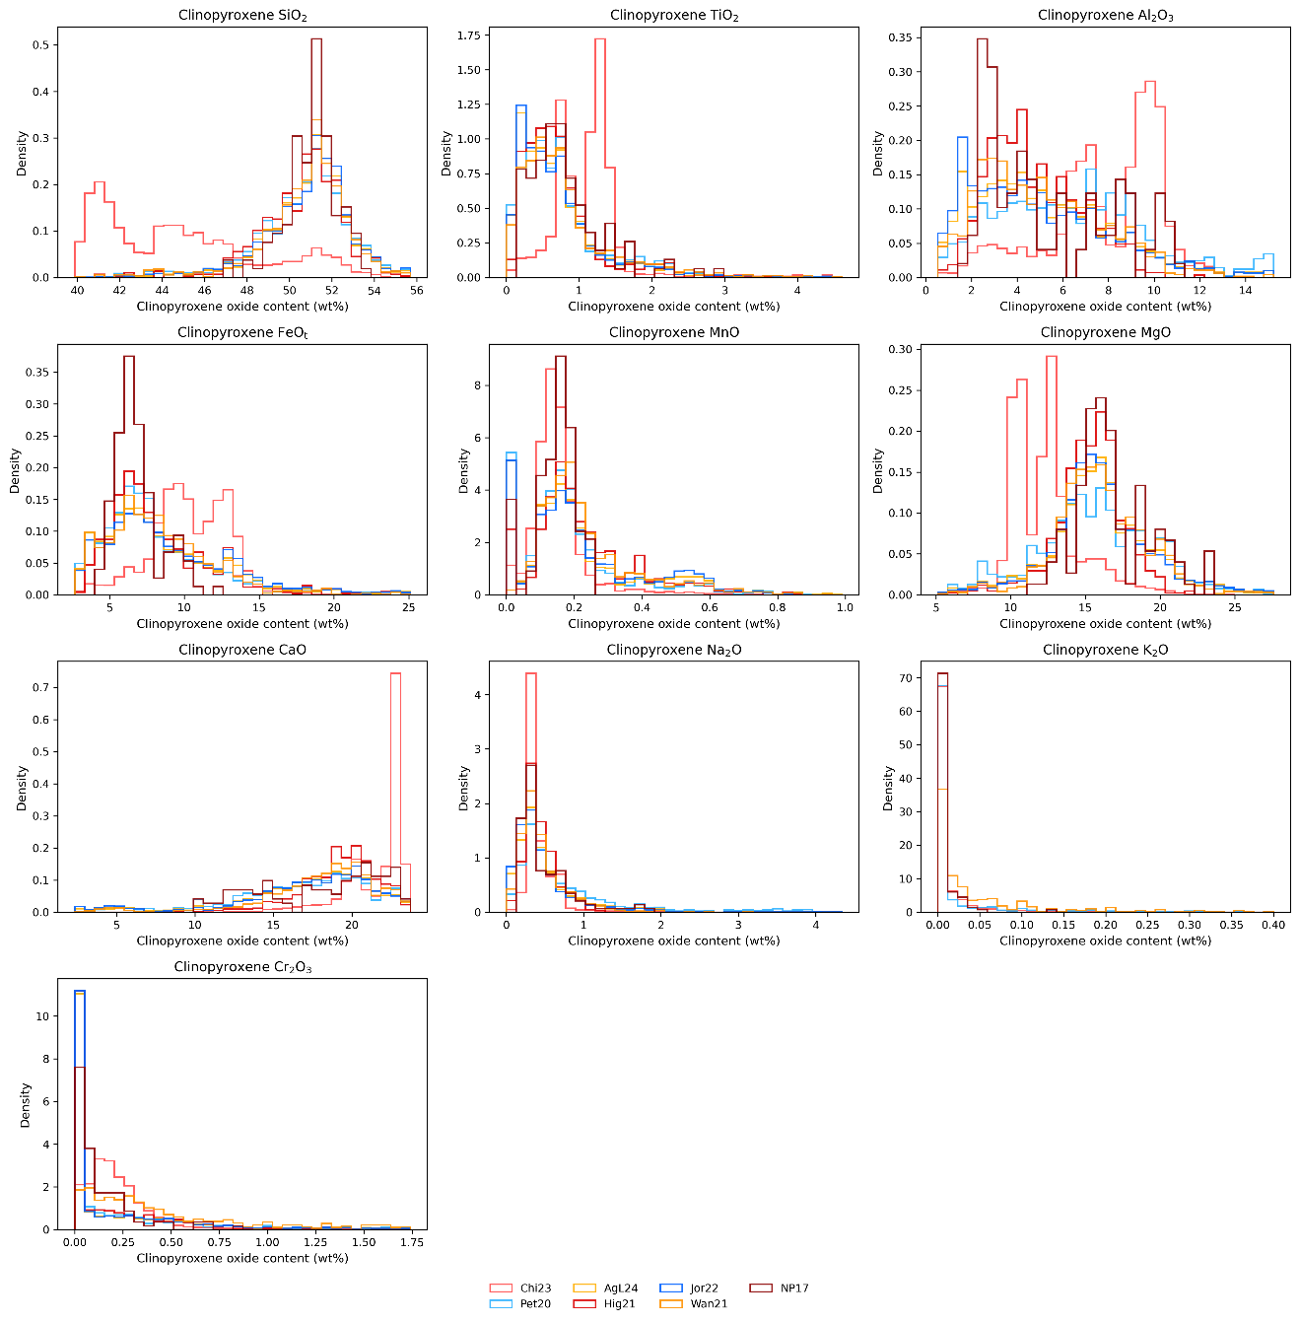

Figure S1. Distributions of clinopyroxene components in the calibration datasets of the clinopyroxene thermobarometer models considered in this study. Model abbreviations are defined in Table 1.
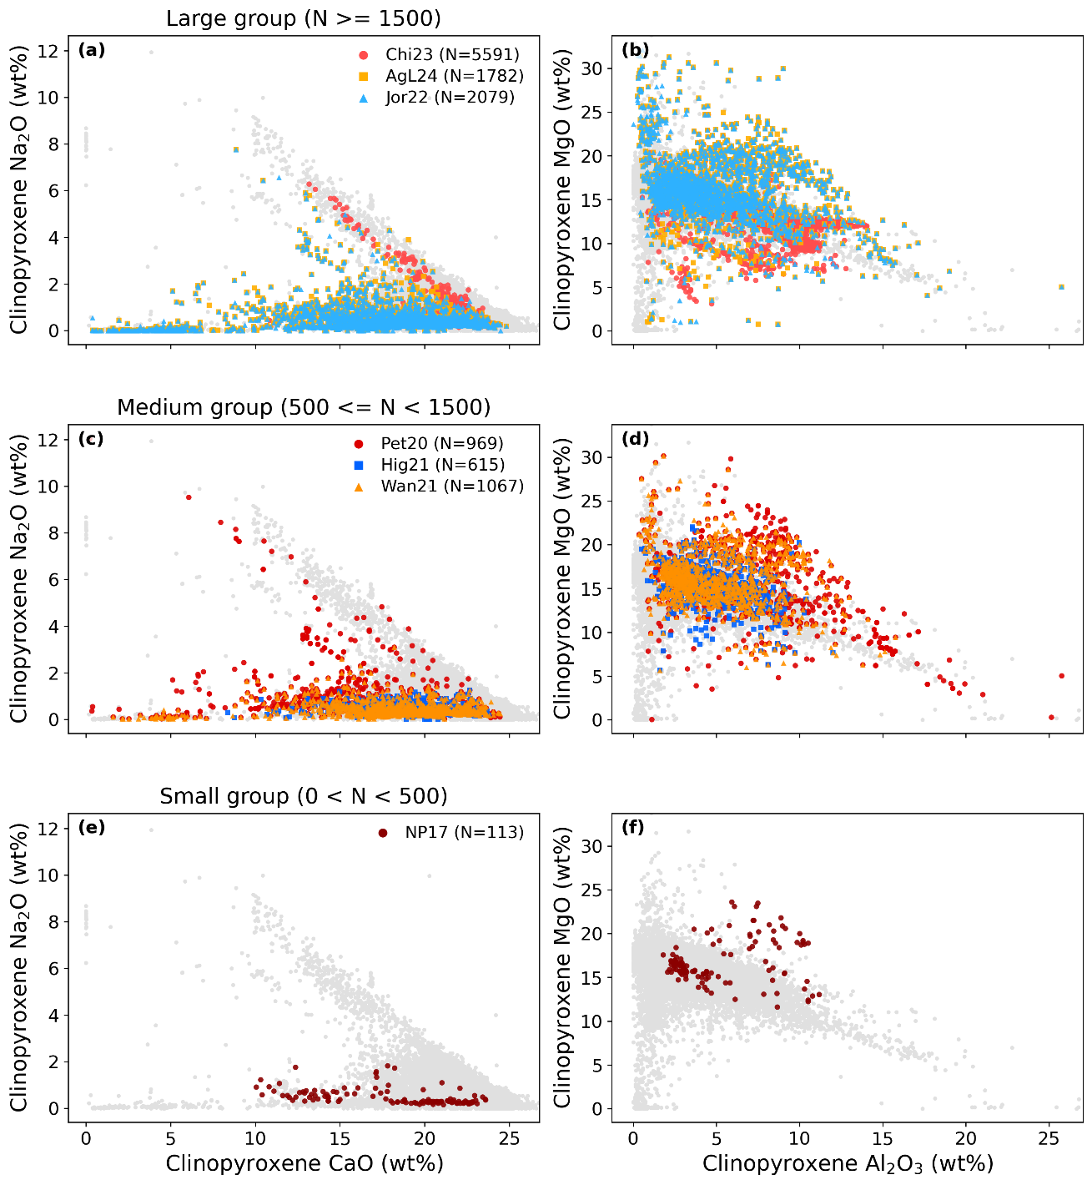

Figure S2. Clinopyroxene Na₂O versus CaO (a, c, e) and MgO versus Al₂O₃ (b, d, f) for the calibration datasets used by different thermobarometer models. Models are grouped by calibration-dataset size into large-, medium-, and small-dataset categories (see panel titles) and are distinguished by colors and symbols. Gray points show global clinopyroxene compositions from GEOROC, filtered using 97 < analysis total < 103 wt%. Model abbreviations are defined in Table 1.
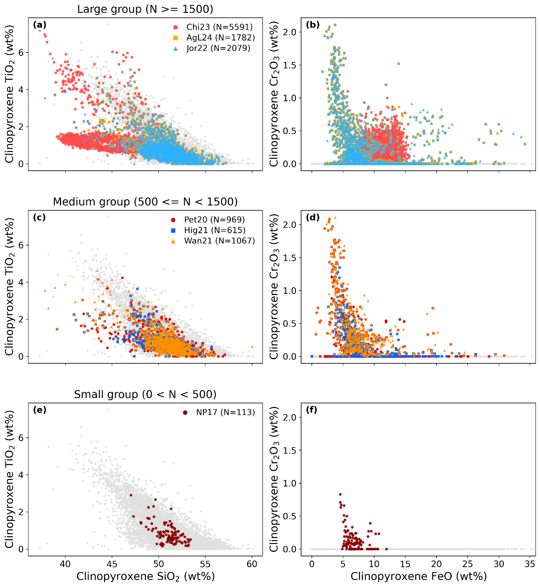

Figure S3. Clinopyroxene TiO₂ versus SiO₂ (a, c, e) and Cr₂O₃ versus FeO (b, d, f) for the calibration datasets used by different thermobarometer models. Models are grouped by calibration-dataset size into large-, medium-, and small-dataset categories (see panel titles) and are distinguished by colors and symbols. Gray points show global clinopyroxene compositions from GEOROC, filtered using 97 < analysis total < 103 wt%. Model abbreviations are defined in Table 1.
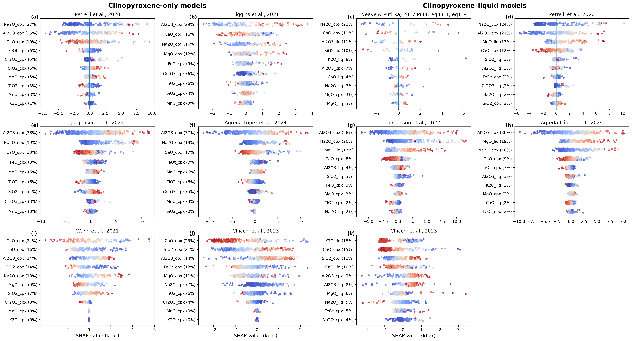

Figure S4. The ten most important clinopyroxene or liquid components for different barometers visualized by SHAP summary plots: (a–b, e–f, i–j) clinopyroxene-only models; (c–d, g–h, k) clinopyroxene–liquid models. In each row, each point represents an experimental data point. Point colors indicate relative feature values, with red indicating higher component values and blue indicating lower component values. The sign and magnitude of the SHAP values reflect the direction and magnitude of each feature's contribution to the predicted pressure. Percentages shown in the feature labels indicate each feature's overall relative importance.
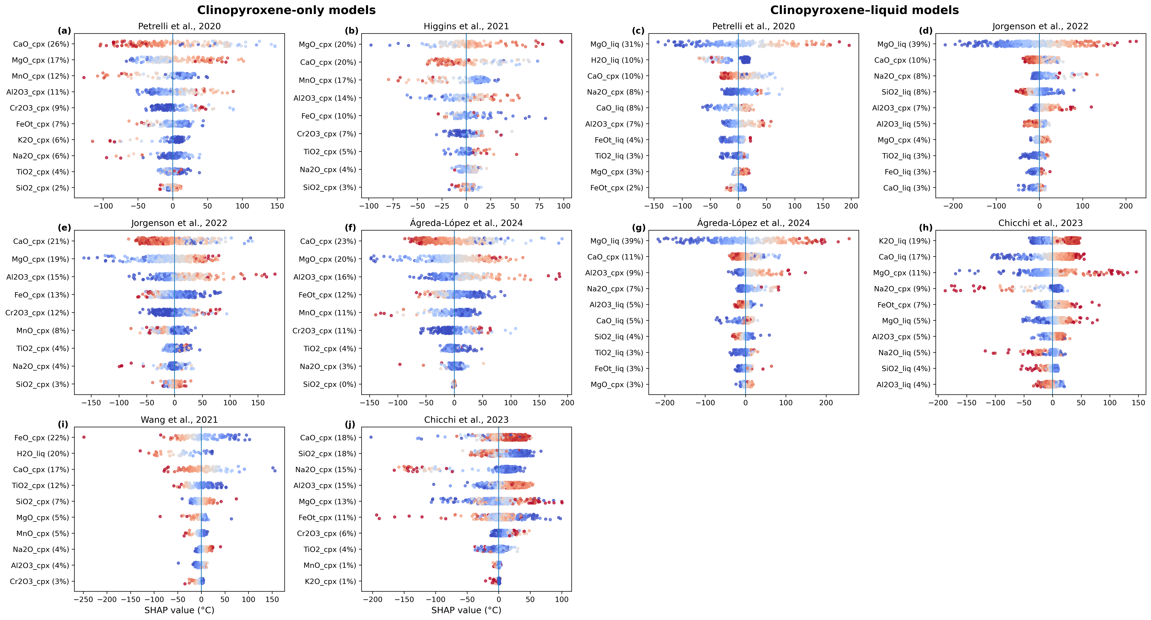

Figure S5. The ten most important clinopyroxene or liquid components for different thermometers visualized by SHAP summary plots: (a–b, e–f, i–j) clinopyroxene-only models; (c–d, g–h, k) clinopyroxene–liquid models. In each row, each point represents an experimental data point. Point colors indicate relative feature values, with red indicating higher component values and blue indicating lower component values. The sign and magnitude of the SHAP values reflect the direction and magnitude of each feature's contribution to the predicted temperature. Percentages shown in the feature labels indicate each feature's overall relative importance.
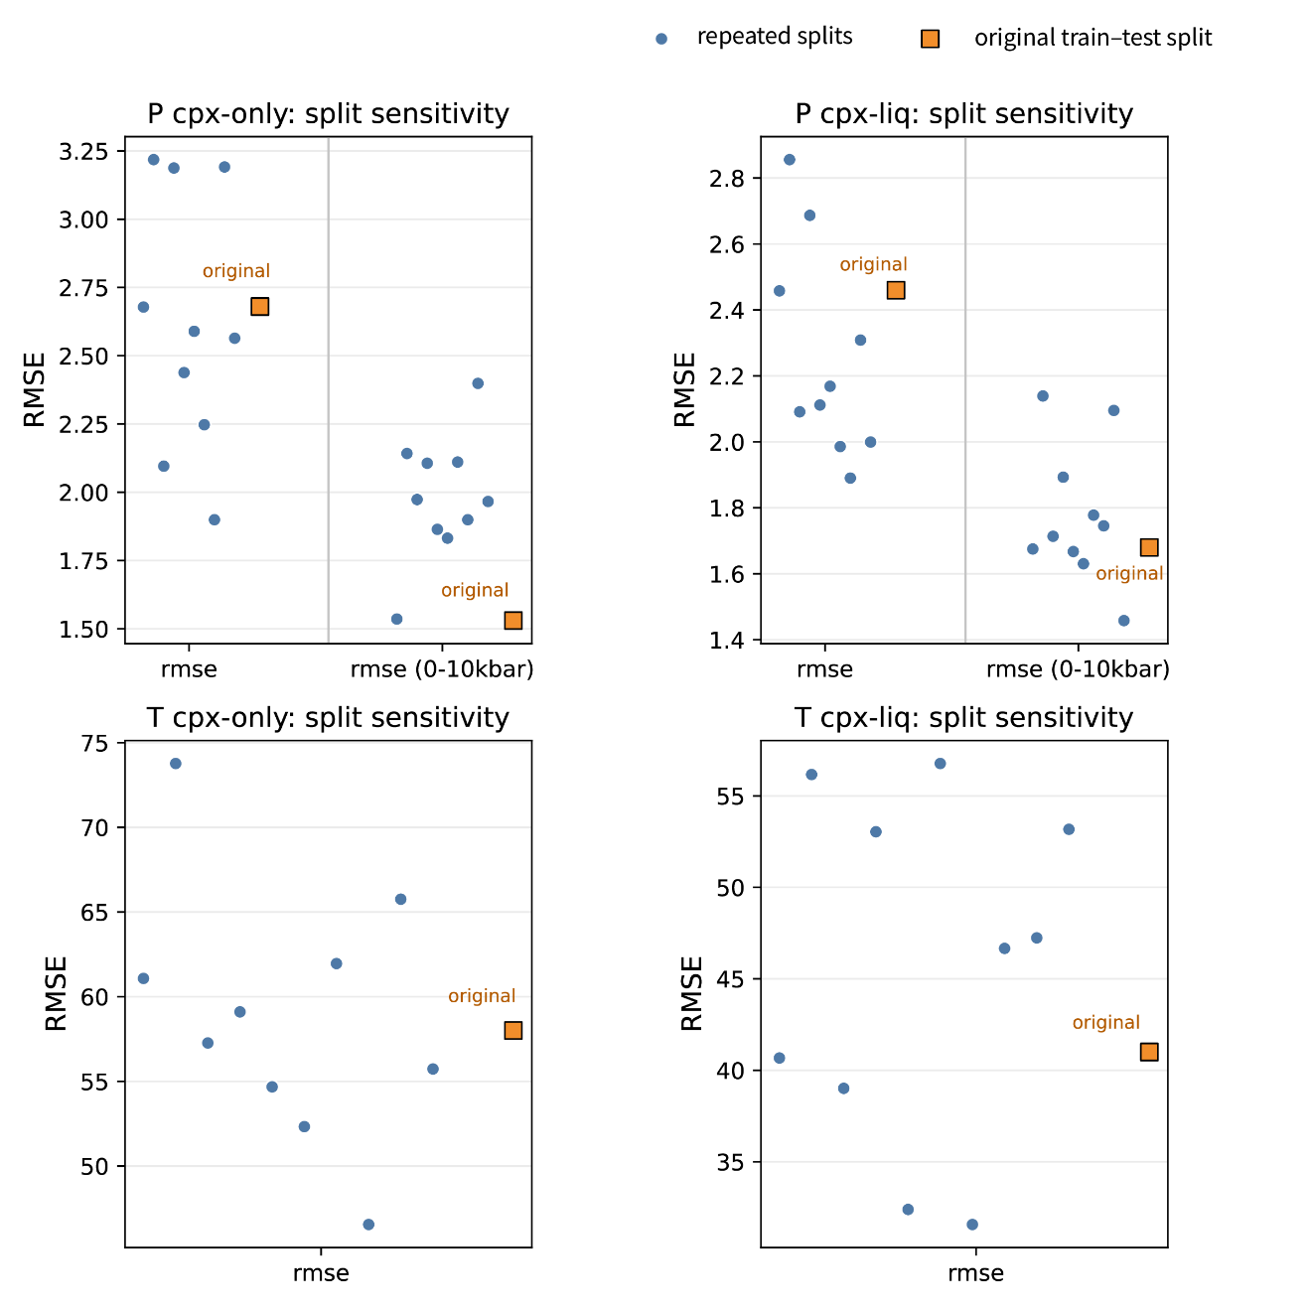

Figure S6. Sensitivity of AIMS4PT_cpx performance to repeated train–test splits. Blue circles show RMSE values from ten repeated pressure-stratified 80/20 train–test splits, and orange squares show the RMSE values from the original train–test split used in this study. Panels compare pressure and temperature estimates for clinopyroxene-only and clinopyroxene-liquid models. For pressure estimates, RMSE values are shown for both the full pressure range (0–30 kbar) of the test subset and the low-pressure subset (0–10 kbar). Pressure RMSE values are reported in kbar, and temperature RMSE values are reported in °C. The RMSE values reported in the main-test are broadly comparable to those obtained from alternative splits, indicating that the main performance results are not controlled by a single train–test partition.
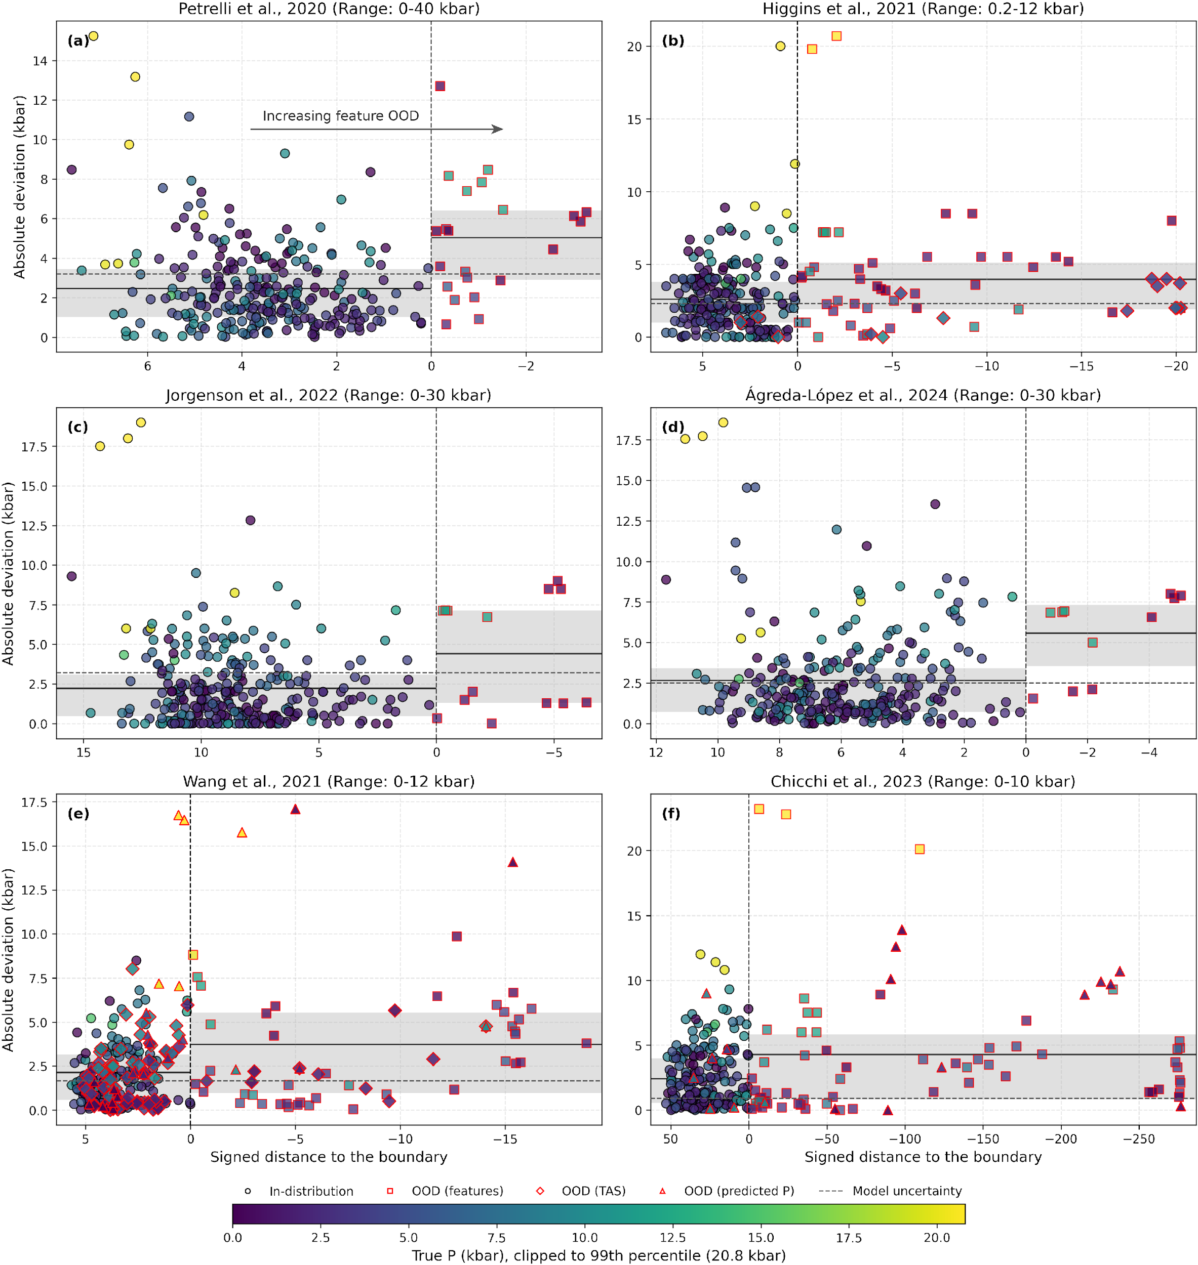

Figure S7. Weighted signed distance from the calibration-dataset boundary plotted against absolute deviation for different clinopyroxene-only barometers. Negative distances indicate out-of-distribution (OOD) samples according to the feature-space OOD criterion, whereas positive distances indicate feature-in-distribution samples. Each point represents a sample from the independent dataset compiled in this study, and its color indicates experimental pressure. OOD samples are outlined in red, with different symbols denoting different OOD criteria (see legend). The mean absolute deviations and interquartile ranges for feature-in-distribution and feature-OOD samples are shown by horizontal solid lines and shaded bands, respectively.
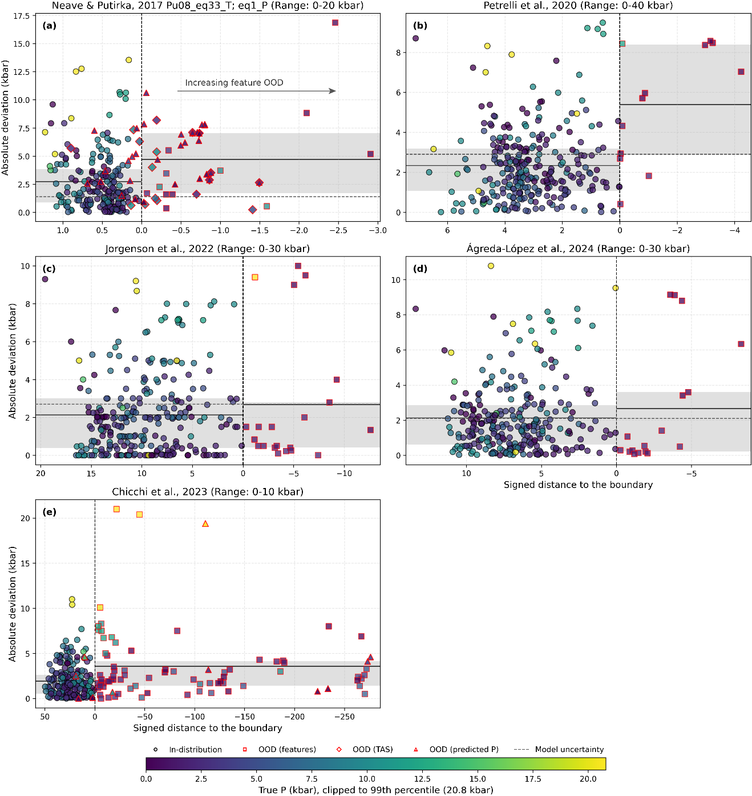

Figure S8. Weighted signed distance from the calibration-dataset boundary plotted against absolute deviation for different clinopyroxene–liquid barometers. Negative distances indicate out-of-distribution (OOD) samples according to the feature-space OOD criterion, whereas positive distances indicate feature-in-distribution samples. Each point represents a sample from the independent dataset compiled in this study, and its color indicates experimental pressure. OOD samples are outlined in red, with different symbols denoting different OOD criteria (see legend). The mean absolute deviations and interquartile ranges for feature-in-distribution and feature-OOD samples are shown by horizontal solid lines and shaded bands, respectively.
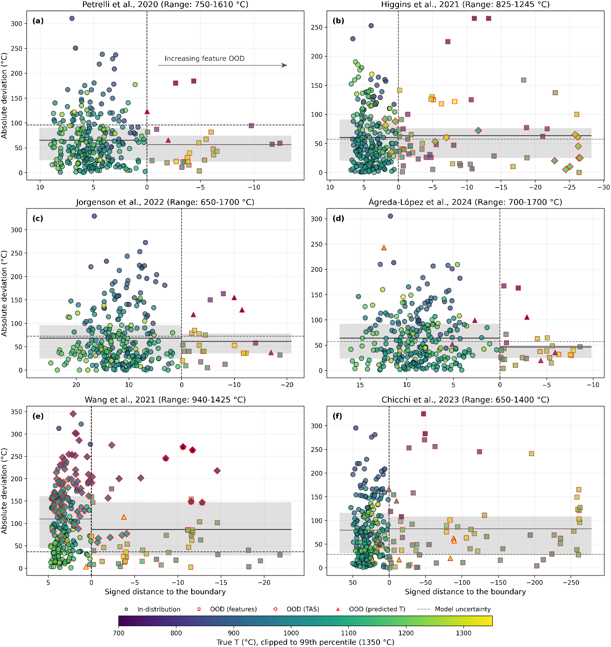

Figure S9. Weighted signed distance from the calibration-dataset boundary plotted against absolute deviation for different clinopyroxene-only thermometers. Negative distances indicate out-of-distribution (OOD) samples according to the feature-space OOD criterion, whereas positive distances indicate feature-in-distribution samples. Each point represents a sample from the independent dataset compiled in this study, and its color indicates experimental temperature. OOD samples are outlined in red, with different symbols denoting different OOD criteria (see legend). The mean absolute deviations and interquartile ranges for feature-in-distribution and feature-OOD samples are shown by horizontal solid lines and shaded bands, respectively.
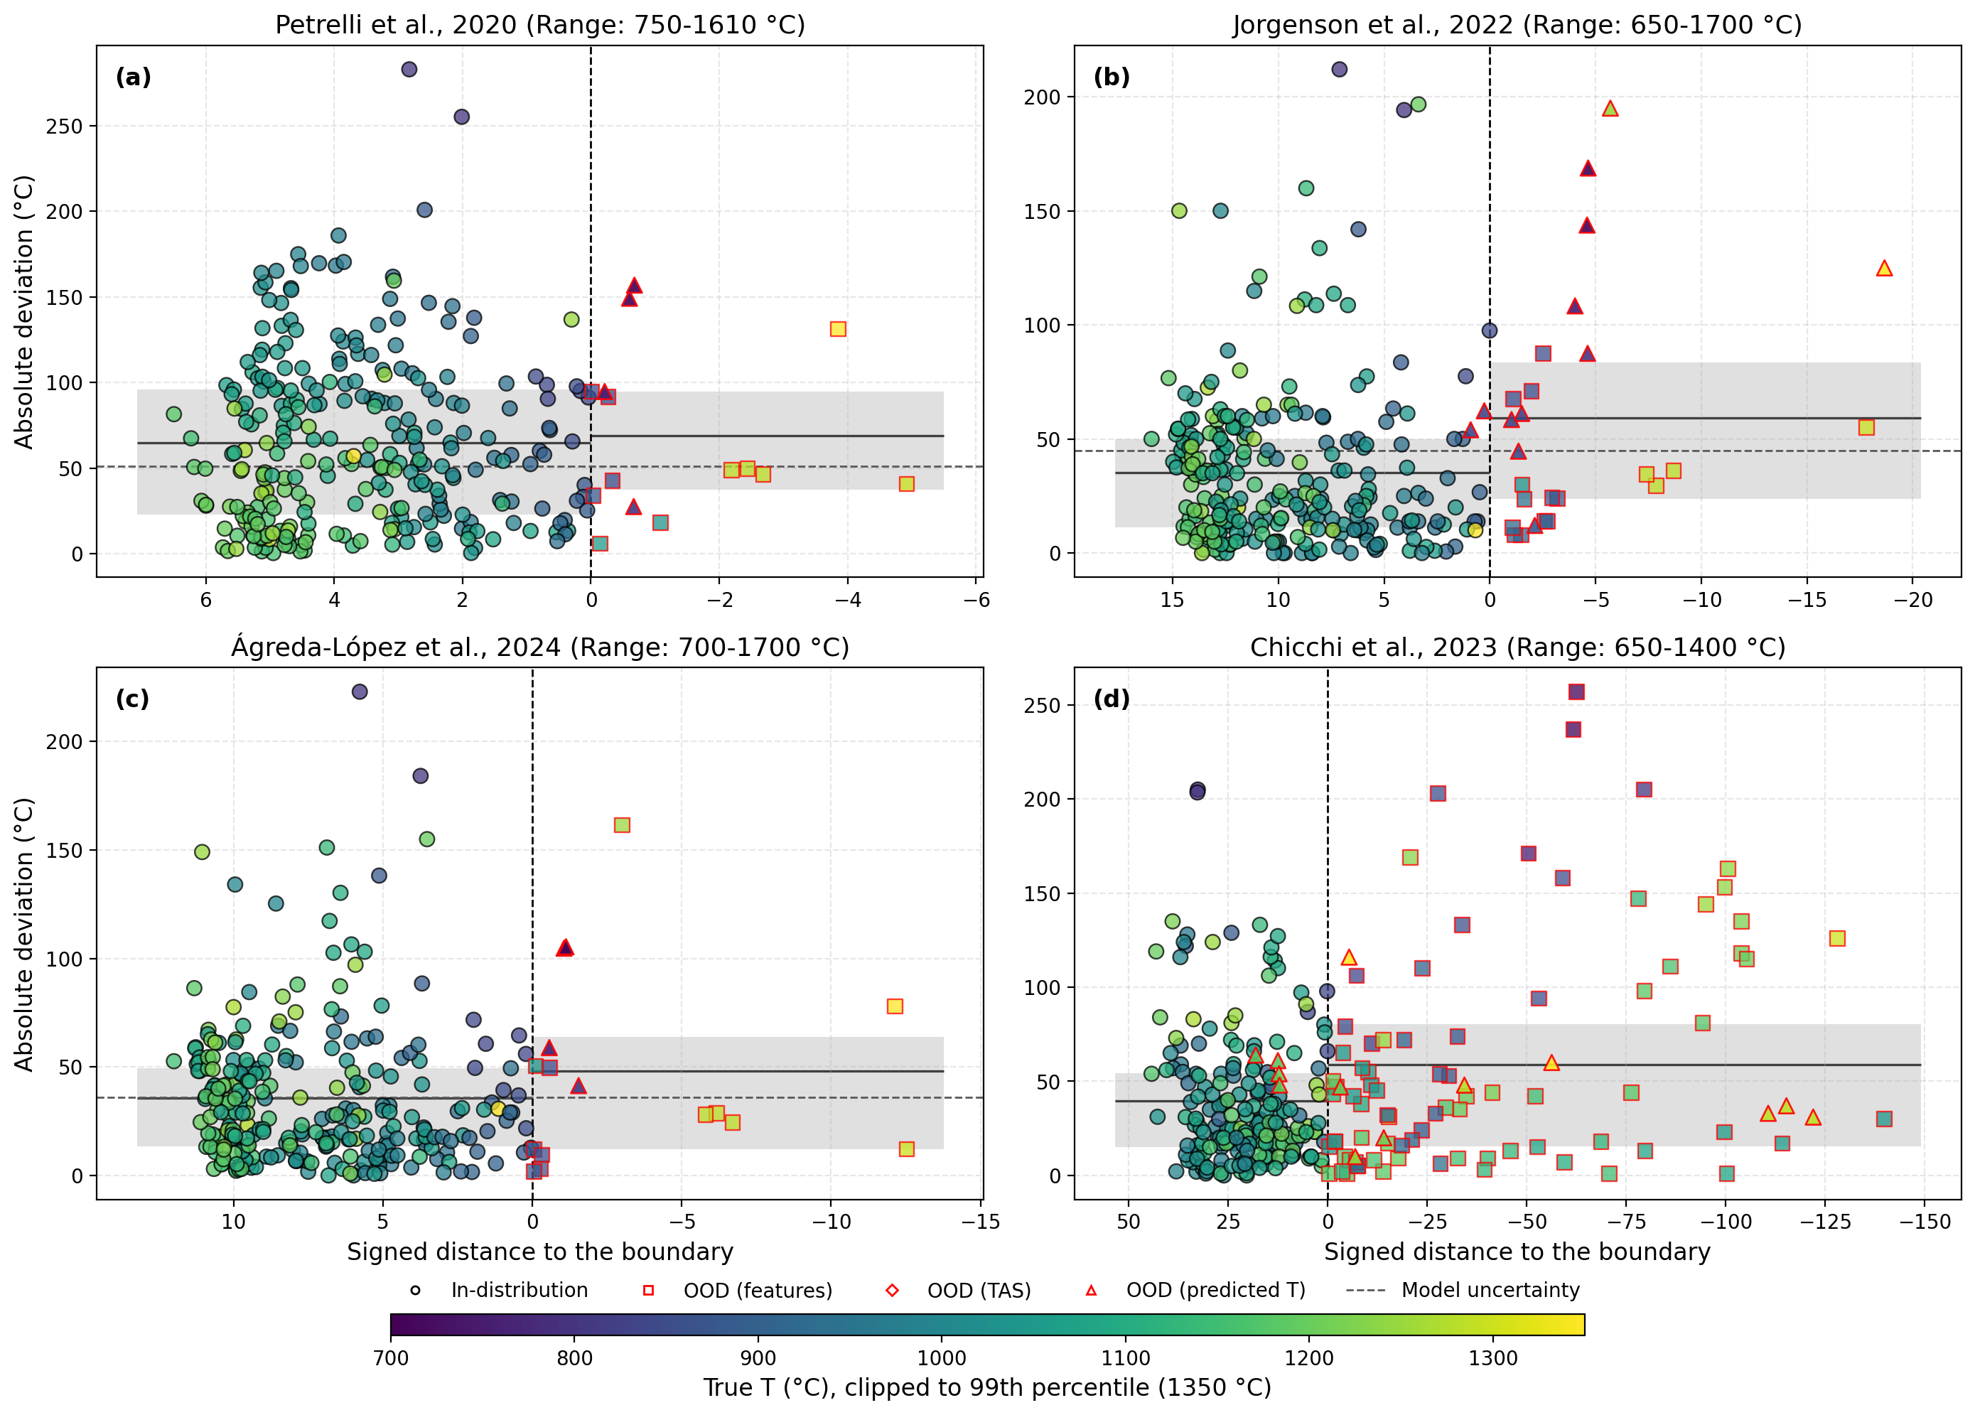

Figure S10. Weighted signed distance from the calibration-dataset boundary plotted against absolute deviation for different clinopyroxene–liquid thermometers. Negative distances indicate out-of-distribution (OOD) samples according to the feature-space OOD criterion, whereas positive distances indicate feature-in-distribution samples. Each point represents a sample from the independent dataset compiled in this study, and its color indicates experimental temperature. OOD samples are outlined in red, with different symbols denoting different OOD criteria (see legend). The mean absolute deviations and interquartile ranges for feature-in-distribution and feature-OOD samples are shown by horizontal solid lines and shaded bands, respectively.
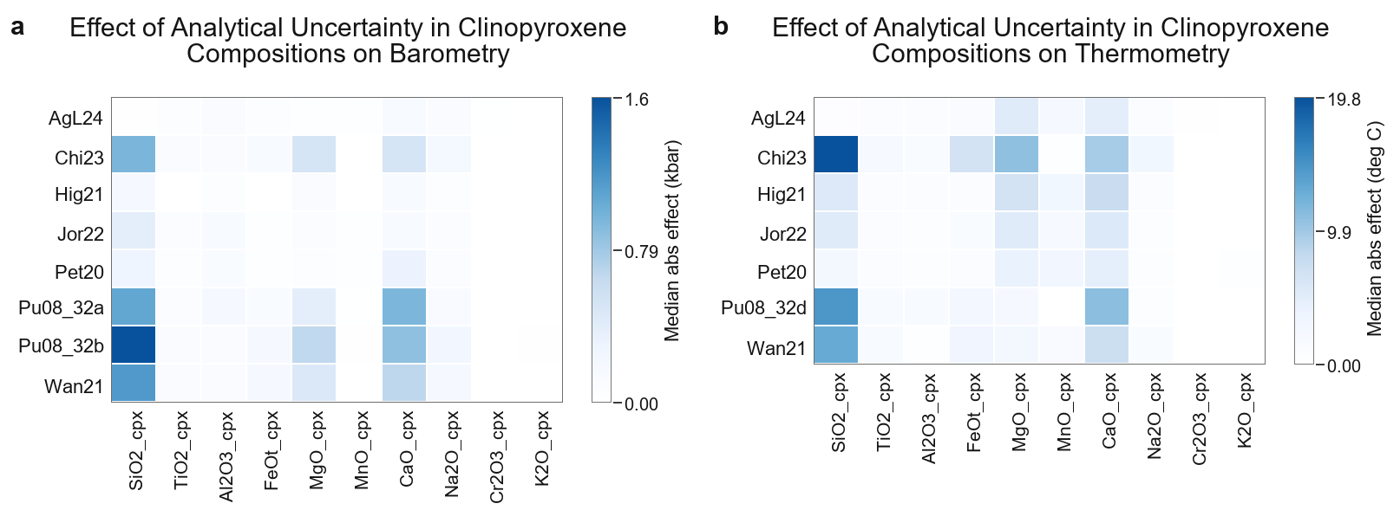

Figure S11. Effect of oxide-specific analytical uncertainty on clinopyroxene-liquid thermobarometric models. Panels show median absolute changes in predicted (a, b) pressure and (c, d) temperature caused by central plus-minus perturbations of clinopyroxene compositions (a, c) and liquid compositions (b, d). Rows represent individual cpx-liquid models, columns represent perturbed oxides, and color intensity indicates the median absolute effect across valid test-subset samples. Pressure effects are reported in kbar and temperature effects in °C. Model abbreviations follow Table 1.
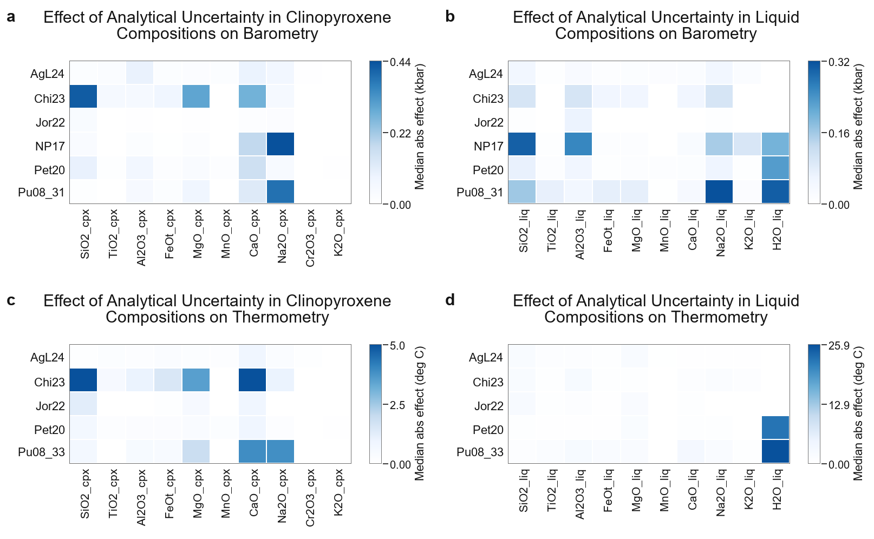

Figure S12. Effect of oxide-specific analytical uncertainty in clinopyroxene compositions on clinopyroxene-only thermobarometric models. Panels show median absolute changes in predicted (a) pressure and (b) temperature from central plus-minus perturbations of individual clinopyroxene oxides. Rows represent individual cpx-only models, columns represent perturbed oxides, and color intensity indicates the median absolute effect across valid test-subset samples. Pressure effects are reported in kbar and temperature effects in °C. Model abbreviations follow Table 1.
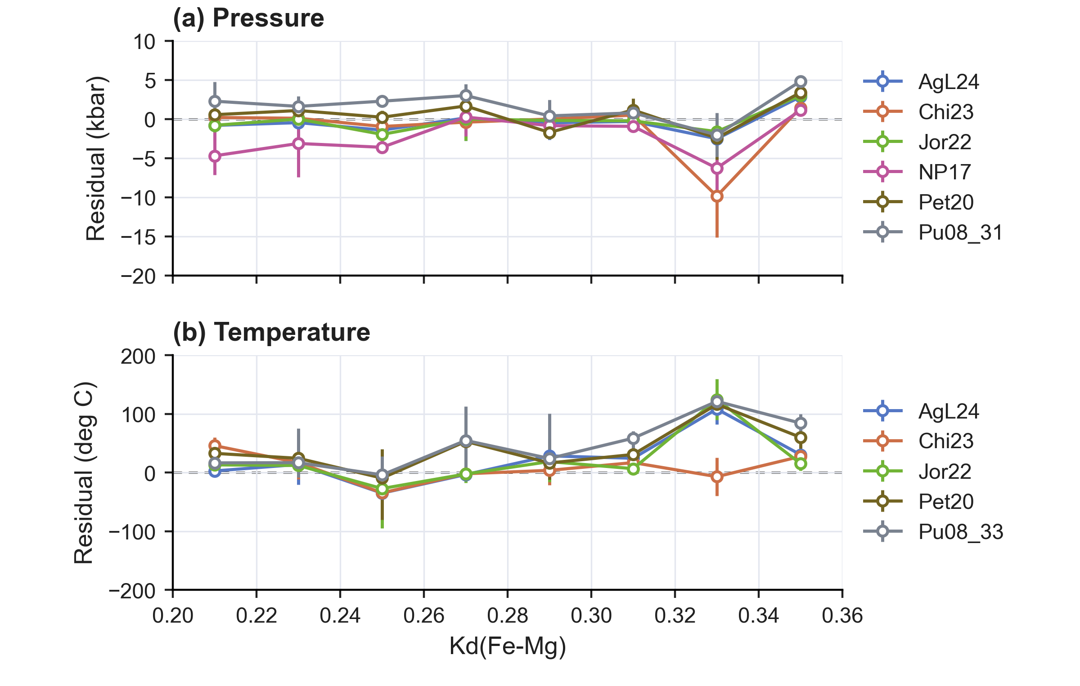

Figure SXX. Kd-bin residual distributions for clinopyroxene-liquid thermobarometers evaluated on the independent test subset. Bins span Kd(Fe-Mg) = 0.20-0.36 at 0.02 intervals. Points show median residuals, defined as predicted minus experimental pressure or temperature, and vertical bars show interquartile ranges (Q1-Q3). The dashed horizontal line marks zero residual. Panel (a) shows pressure residuals for clinopyroxene-liquid barometers; panel (b) shows temperature residuals for clinopyroxene-liquid thermometers. Model abbreviations follow Table 1.

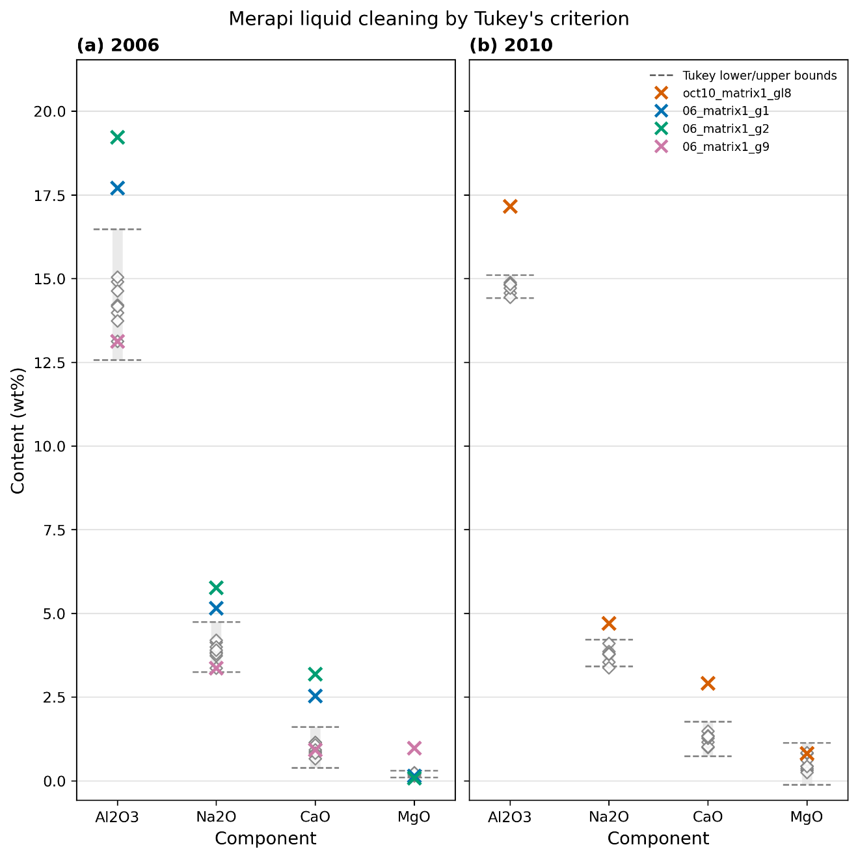

Figure S13. Merapi glass composition screening using Tukey fences for Al₂O₃, Na₂O, CaO, and MgO, which are important liquid components for P–T estimation and were therefore used to screen candidate glass compositions. Panels show glass analyses from the (a) 2006 and (b) 2010 eruptions. The gray dashed horizontal bars show the lower and upper Tukey bounds, defined as Q1 − 1.5 × IQR (IQR: interquartile range) and Q3 + 1.5 × IQR, respectively. The colored crosses mark samples treated as outliers because they fall outside the bounds for one or more components (see legend).
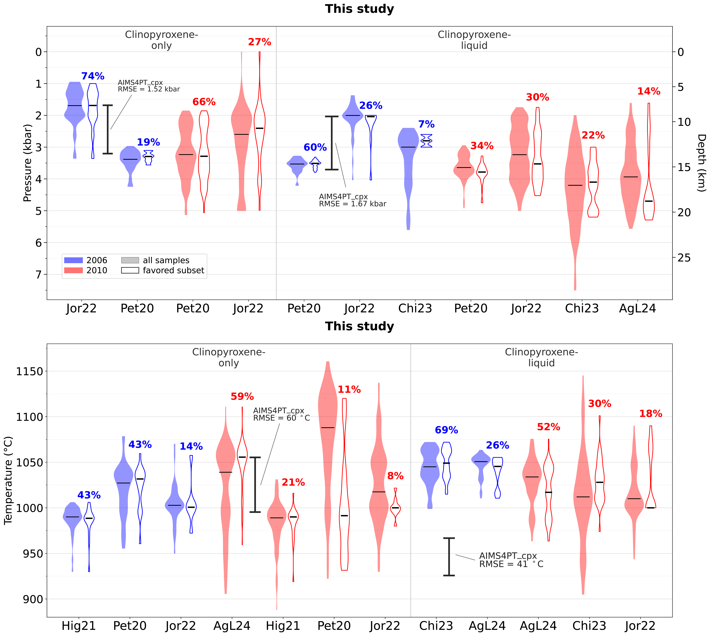

Figure S14. Clinopyroxene–liquid pressure (a) and temperature (b) estimates using equilibrium (Kd(Fe–Mg) = 0.28) clinopyroxene–liquid pairs for the (blue; N=42) and 2010 (red; N=106) Merapi eruptions. These figures show the models selected using AIMS4PT_cpx and favored by > 5% of samples. For each model, the filled violin represents estimates obtained by applying that model to all filtered samples for the corresponding eruption, whereas the open violin represents estimates for only the subset of samples by which that model was favored. Tukey-fence outliers are excluded. Black horizontal lines mark medians, and percentages indicate the proportion of filtered samples in the favored subset. The bracket shows the RMSE of AIMS4PT_cpx. Model abbreviations follow Table 1.

Figure S15. Sensitivity of clinopyroxene–liquid pressure and temperature estimates to the Kd(Fe–Mg) value used for equilibrium-liquid pairing. Pressure (a) and temperature (b) estimates are shown for the (blue; N=42) and 2010 (red; N=106) Merapi eruptions using paired clinopyroxene–liquid inputs generated with Kd(Fe–Mg) values of 0.28, 0.26, and 0.20. The same filtered clinopyroxene dataset was used for all three tests. For each model, the filled violin represents estimates obtained by applying that model to all filtered samples for the corresponding eruption, whereas the open violin represents estimates for only the subset of samples for only the subset of samples by which that model was favored. Tukey-fence outliers are excluded. Black horizontal lines mark medians, and percentages indicate the proportion of filtered samples in the favored subset. Model abbreviations follow Table 1.

