Name: Ibe Nixon Chiziterem
Track No: 21/132019
Course: Special Topics In Computer Science

INTRODUCTION
This report presents an exploratory data analysis of campaign finance expenditures in Austin, Texas, focusing on payments made by political actors to companies and other entities during major election periods. Corporate and organizational political spending plays an important role in shaping electoral outcomes, and understanding how such funds are distributed provides insight into patterns of political influence and compliance behavior. The objective of this analysis is to examine spending distribution, concentration, and reporting patterns using descriptive statistics and data visualizations.

DATA EXPLORATION
The dataset used in this analysis contains 3,152 records and 18 variables. Each observation represents a single reported political expenditure and includes information such as the payee, payer, payment amount, payment date, expenditure type, reporting date, and a unique transaction identifier. Initial data exploration involved examining the structure of the dataset, identifying key variables relevant to political spending, and reviewing data types and summary statistics. This step revealed that payment amounts were stored as text values with currency symbols and that date fields required conversion into a standardized datetime format. The exploration phase also confirmed that the dataset was sufficiently rich to support analysis of spending patterns, recipient concentration, and reporting behavior.

DATA CLEANING
Prior to analysis, several data cleaning steps were performed to ensure accuracy and consistency. Payment amounts were converted from string format to numeric values by removing currency symbols and commas, allowing for aggregation and statistical analysis. Date variables, including payment and reporting dates, were converted into datetime format to enable temporal analysis. Missing values were assessed across all variables, and while some fields contained null values, the key analytical variables such as payment amount and transaction identifiers were largely complete. The transaction identifier field was examined to confirm uniqueness, ensuring that each record represented a distinct expenditure. These steps improved the reliability of the dataset and ensured that subsequent analyses were based on valid and standardized data.

DATA VISUALIZATION
Data visualization was used to identify and communicate key patterns within the dataset. The first visualization examined the top ten payees by total political spending. This chart revealed that political expenditures were not evenly distributed across recipients. Instead, a small number of companies and entities received a disproportionately large share of total spending, suggesting a concentration of political financial activity among select recipients. This pattern indicates that political actors may rely heavily on a limited group of organizations for services such as consulting, advertising, or campaign operations.
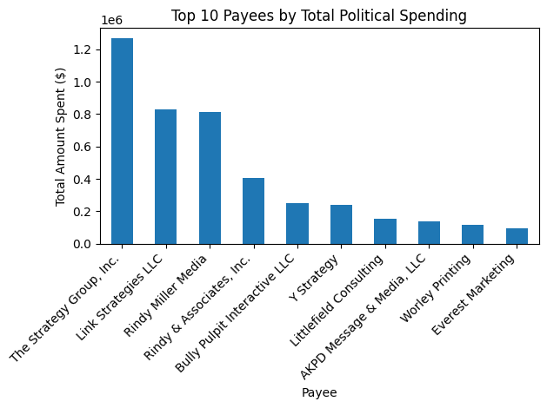

The second visualization focused on the concentration of political spending by comparing the total amount received by the top ten payees against all remaining payees combined. This comparison further reinforced the presence of spending concentration, showing that a small subset of recipients accounted for a substantial proportion of overall expenditures. Such concentration highlights the unequal distribution of political funds and raises important questions about the role of repeat or high-value vendors in local political campaigns.
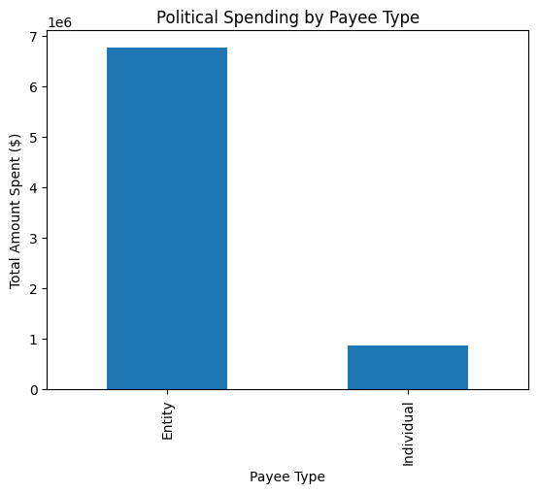

The third visualization analyzed reporting behavior by examining the number of expenditures reported by day of the month. This reported day chart revealed clear clustering of transaction reports around specific days, rather than an even distribution across the month. This pattern suggests that political expenditures are often reported in batches, likely corresponding to regulatory reporting deadlines or administrative filing practices. The visualization provides insight into compliance behavior and demonstrates that reporting activity is influenced by institutional timelines rather than occurring continuously.
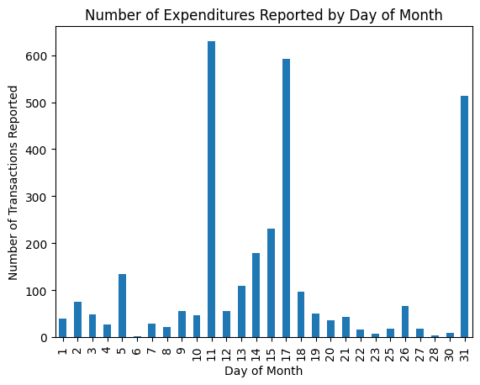
FINDINGS AND DISCUSSION
Overall, the analysis reveals three key findings. First, political spending in Austin is highly concentrated among a small number of recipients. Second, this concentration suggests the presence of dominant service providers or vendors within the political ecosystem. Third, reporting behavior shows temporal clustering, indicating that compliance and disclosure practices are shaped by reporting requirements. While the dataset offers valuable insight into political expenditure patterns, it is limited by the absence of detailed information on candidate ideology, election outcomes, and broader political context. Additionally, the analysis is descriptive in nature and does not establish causal relationships.

CONCLUSION
In conclusion, this exploratory analysis provides a clearer understanding of how political funds are distributed and reported in Austin, Texas. By combining data exploration, cleaning, and visualization, the report highlights important patterns in spending concentration and reporting behavior. These findings contribute to a broader understanding of local political finance and demonstrate the value of data-driven approaches in analyzing political transparency and accountability.

