Pediatric Chest X-Ray Classifier: Normal, Pneumonia & Tuberculosis
Introduction
Respiratory diseases like pneumonia & tuberculosis are diagnosed using chest X-rays. Early detection is important because delayed diagnosis can lead to serious health complications for patients.

Problem Description
Manual interpretation is challenging since some diseases have similar radiographic patterns. Normal & Tuberculosis cases may appear visually alike, increasing the risk of misclassification. Therefore, this project aims to develop an AI system that classifies chest X-rays into Normal, Pneumonia & Tuberculosis.

Literature Review
DenseNet121 has shown strong performance in medical image classification due to its dense connectivity, which improves information flow between layers. It has been successfully applied to chest X-ray tasks such as detecting pneumonia & tuberculosis. When combined with transfer learning, DenseNet121 often performs well on smaller datasets with limited training samples. For these reasons, DenseNet121 was selected as the backbone model for this project.

Machine Learning Models, Methods

Model Architecture:
For Model 1, we used DenseNet121 in PyTorch with transfer learning from ImageNet pretrained weights. The original classifier was replaced with a custom fully connected layer for three-class prediction.

Preprocessing:
All images were resized to 224 × 224 and augmented using random flips & rotations to improve generalization.

Class Imbalance Handling:
We applied WeightedRandomSampler and class-weighted CrossEntropyLoss.

Training Strategy:
Training used the AdamW optimizer, Cosine Annealing scheduler, early stopping & gradient clipping.

Experiment Results
The final model achieved 78% test accuracy, with validation accuracy between 77% and 78% during training. Pneumonia was the best-performing class, with recall close to 1.00, meaning most cases were correctly detected. Tuberculosis had very high precision 0.99 but lower recall 0.62, so some cases were missed. The confusion matrix showed that most errors occurred between Normal & Tuberculosis images. The loss & accuracy curves showed steady learning in early epochs, followed by stable performance without severe overfitting.
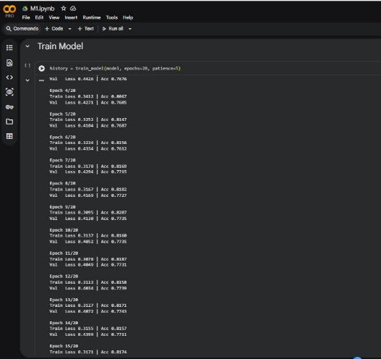 | 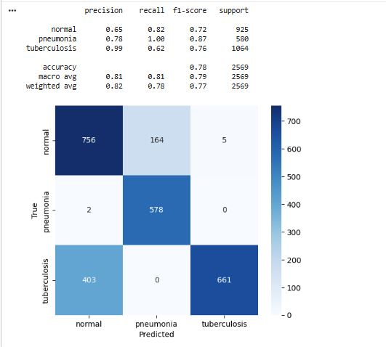
Figure 1: training the model | Figure 2: Confusion Matrix of Model 1 Predictions
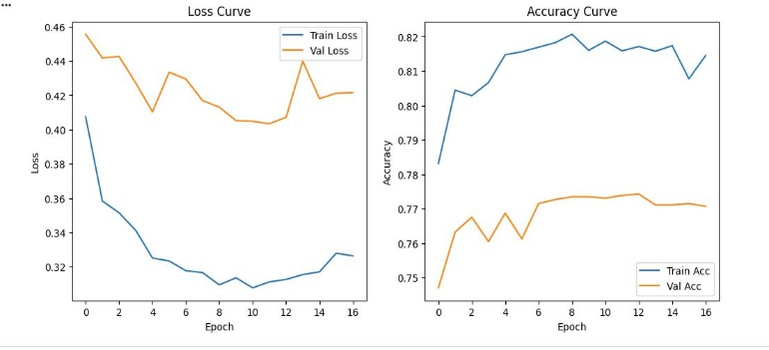

Figure 3: Training Loss and Accuracy Curves
Model 1 Conclusion
This Model demonstrated that transfer learning with DenseNet121 is an effective approach for automated chest X-ray classification. The model achieved solid multi-class performance & showed strong potential for supporting faster medical screening. Although confusion between Normal & Tuberculosis remains challenging, the results confirm that deep learning can provide valuable assistance in pediatric respiratory disease diagnosis.
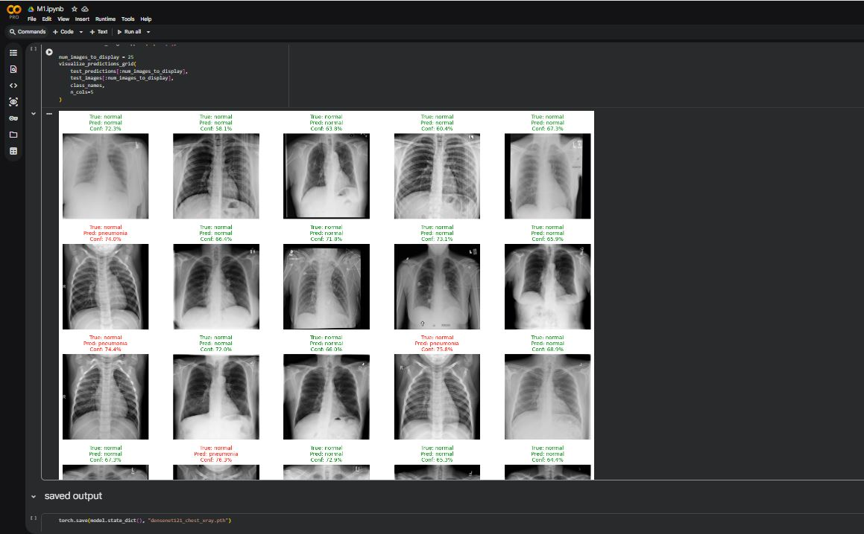 | Figure 4: Sample Predictions from Model 1 on Chest X-Ray Images
Model 2 – Pneumonia Subtype Classifier
Model 2 is a second DenseNet121 network trained to distinguish between three pneumonia related classes : bacterial, Normal, and Viral. It uses the same ImageNet pretrained backbone as model 1, but with a different classifier head: Linear(1024→256) → ReLu → Dropout(0,4) → Linear(256 → 3). DenseBlock 1-3 were fully frozen during training, and DenseBlock 4 was partially frozen, limiting the number of trinable parameters to reduce overfitting on the relatively small training set.
Class Imbalance & Loss Weighting
The training data contrained significantly more bacterial samples than Viral, and Normal cases were underrepresented relatie to both. To handle this, class weights were applied to the CrossEntropyLoss function. Seven training attempts were ran with varying weight configurations. Early iterations using weights close to 1:3:1 (Bacterial:Normal:Viral) achieved around 70% vadiation accuracy, but exhibited consistent overfitting. Increasing the Normal weight progressively reduced overfitting and improved overall accuracy. The final configuration used weights of 0.7 : 7.0 : 0.4, which produced the best generalization
Training History
Attempt | Weights (B:N:V) | Best Accuracy | Overfitting
1 | 1.0 : 3.0 : 1.0 | 70% | Yes
2 | 1.0 : 2.5 : 1.2 | 70% | Yes
3 | 1.0 : 4.0 : 0.5 | 68% | Severe
4 | 1.0 : 3.0 : 0.7 | 75% | Mild
5 | 1.0 : 3.0 : 0.7 | 76.05% | No
6 | 0.8 : 6.0 : 0.6 | 82.85% | No
7 | 0.7 : 7.0 : 0.4 | 85.60% | No

Early stopping with a patience of 5 epochs was added starting at Attempt 6, which prevents the model form training past its performance peak. The final model (7) achieved 85.6% validation accuracy. The per class confusion results were Bacterial with 224/240 correct (16 misclassified as Normal), Normal with 205/231 correct (9 → Bacterial, 17 → Viral), and Viral with 100/147 correct (37→ Bacterial, 10 → Normal). Viral pneumonia remained the most difficult class to distinguished, likely due to its visual similar to bacterial pneumonia on X-Ray
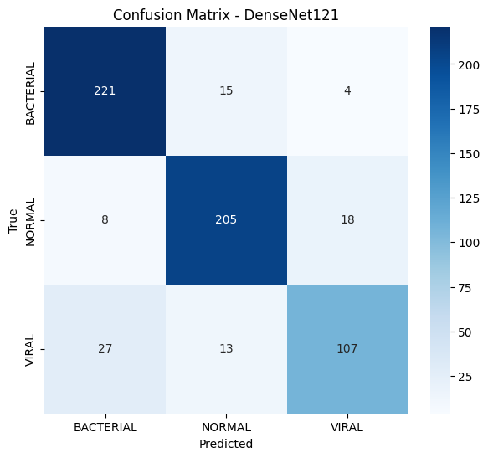
Figure 5: Confusion matrix for model 2 training result
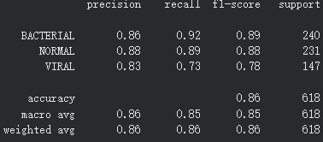
Figure 6: Model 2 training scores
Model 2 Conclusion
Model 2 demostrated that iterative tuning of class weights is a practical and effective strategy for addressing servere class imbalance in medical image classification. By progressively adjusting the loss weight across seven training attempts, the model improved from 70% to 85.6% validation accuracy while eliminating overfitting. Although Viral Pneumonia remained the most challending class due to its visual similarity to Bacterial cases on X-Ray, the model achieved strong overall performance. These results confirm that a frozen backbone transfer learning approach with targeted loss weighting can produce reliable pneumonia subtype classification, particularly when paired with early stopping to preserve peak generalization.
Web App (Combining Both)
To make the two model pipeline accessible, the project was deployed on an interactive web application using Streamlit. The app runs locally and allows a user to upload a chest X-ray image and receive a classification result afterwards. The interface is designed to be straightforward, and allowing PNG/JPG.
Application Flow
For the first stage, it was the triage with model 1. The uploaded image is preprocessed and passed through model 1, which classifies it as normal, Pneumonia, or Tuberculosis. If the result is Normal or Tuberculosis, the interface stops and result is displayed immediately.
For stage 2, this is the subtype classification with model 2. If model 1 predicts Pneumonia, the same preprocessed image is passed through model 2 which outputs possibilities for Bacterial, Normal, and Viral.
The outputs from both models are combined using a confidence based rule. If model 1’s Pneumonia confidence exceeds 80%, Model 2’s “Normal” output is overridden, and the high of the Bacterial or Viral is selected as the final diagnosis. If model 1’s Pneumonia confidence is 80% or below, Model 2’s prediction is accepted as is, including the possibility of a Normal result. This threshold was chosen to prevent Model 2 from dismissing high confidence Pneumonia cases due to noise in its own prediction.
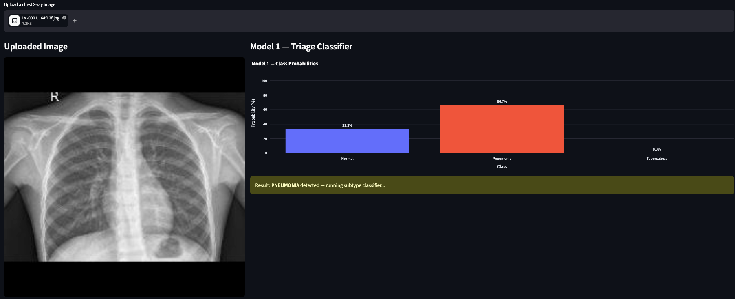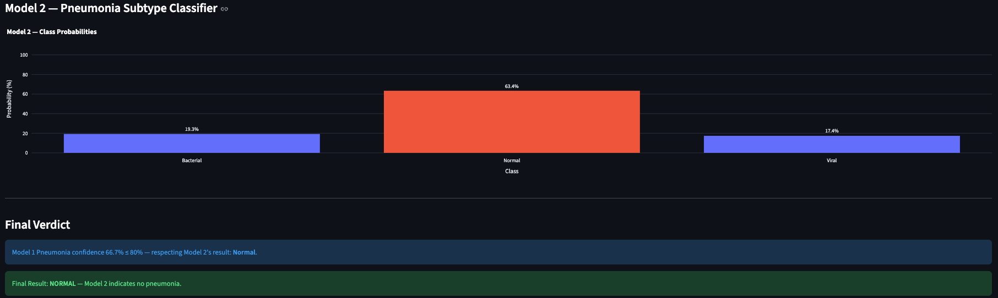
Figure 7 & 8: Results of the models from web application
Final Conclusion
This project developed a two stage deep learning pipeline for automated chest X-ray classification. Model 1 served as a triage classifier, screening X-rays for Normal, Pneumonia, or Tuberculosis using DenseNet121 fine-tuned on a labeled dataset, achieving approximately 78% test accuracy. When pneumonia is detected, model 2 performs subtype classification between Bacterial and Viral pneumonia, reaching 75.6% validation accuracy after interactive tuning of class weights and training strategy. Both model share the same DenseNet121 backbone and preprocessing pipeline, which simplified integrations.
Group Member Name
1. Chongyi Wang
2. Jason Quach
3. Yonatan Tesfagiorgis

References
Mohanty, S. (2025). Chest X-ray dataset for pneumonia classification [Data set]. Kaggle. https://doi.org/10.34740/KAGGLE/DSV/14326249
Rehan, M. (n.d.). Chest X-ray dataset [Data set]. Kaggle. https://www.kaggle.com/datasets/muhammadrehan00/chest-xray-dataset
PyTorch. (n.d.). DenseNet-121 [Data set]. Kaggle. https://www.kaggle.com/datasets/pytorch/densenet121
https://github.com/Abyss999/Pneumonia-X-Ray-Classifier

