Exercise Posture Suggestion System using Deep Learning Techniques

Paulo Mendoza  
Computer Engineering Student  
Technological Institute of the Philippines – Quezon CityBulacan, Philippines  
qpdcmendoza@tip.edu.ph

Benedick Labbao   
Computer Engineering Student  
Technological Institute of the Philippines – Quezon CityRizal, Philippines  
qbdlabbao@tip.edu.ph

Maintaining proper posture during exercise is crucial for reducing the risk of injuries and maximizing the effectiveness of workouts. This paper presents an Exercise Posture Suggestion System utilizing deep learning techniques to analyze and recommend correct exercise posture in real-time. The system incorporates pose estimation models, human activity recognition algorithms, and error detection mechanisms to provide personalized feedback to users. Pose estimation models including ResNet-50, YOLOv8, and YOLO-NAS are evaluated based on their performance metrics and execution times. Human activity recognition models such as Conv(2+1)D with ResNet, 3D CNN with LSTM, and 3D CNN with Bidirectional LSTM are trained and tested using the UCF-101 dataset. An error detection algorithm, focusing on key body angles for specific exercises, enhances the accuracy of posture suggestions. The software interface is developed using Unity, providing an intuitive platform for users to receive feedback and visualize correct posture examples. The system demonstrates promising results in optimizing workout routines and reducing injury risks, with further refinement and validation necessary for widespread adoption in fitness settings. Integration of advanced deep learning techniques and human-computer interaction will continue to enhance the system's capabilities, contributing to improved health outcomes and enhanced quality of life.

Keywords—Posture Suggestion, Deep Learning, Pose Estimation, Human Activity Recognition, Injury Prevention, Unity

# Introduction

Exercise is a cornerstone of a healthy lifestyle, contributing to physical fitness, mental well-being, and quality of life. From cardiovascular workouts to strength training and flexibility exercises, the benefits of regular physical activity are well-documented and far-reaching. Engaging in exercise not only helps maintain a healthy weight and improve cardiovascular health but also boosts mood, reduces stress, and enhances cognitive function.

In today's sedentary society, where technological advancements often lead to prolonged periods of sitting and decreased physical activity, prioritizing regular exercise is more important than ever. Whether it's a brisk walk, a yoga session, or a gym workout, finding enjoyable and sustainable ways to stay active is key to promoting longevity and vitality.

Although exercise is important, It is also important during exercise to have proper breathing and good posture, this helps the body to function and will cut muscle strain and injury [1]. But many individuals struggle to maintain correct posture, leading to suboptimal results and increased risk of injury. Proper body posture has been associated with a reduction in incidence of injuries [2]. This correlation shows the importance of correct posture in mitigating the risk of exercise-related injuries.

In response to the problem that we encountered, we propose an exercise posture suggestion system that aims to analyze and suggest correct exercise posture to help cut the risk of injury during exercise.

1. Posture Correction System Overview

In Fig. 1, this shows the process of the system, the system is composed of a device with a camera and a software. The software contains deep learning models and an algorithm used for suggestions in the posture.

# Methodology

The methods used to create the system are grouped into deep learning models, error detection algorithm and software design.

## Pose Estimation Model

The pose estimation models that we tried were ResNet-50 (Residual Network), YOLOv8, and YOLO-NAS models.

The ResNet-50 model was train using dataset acquired in the MPII Human Pose Dataset containing images annotated with 16 key body joint locations.

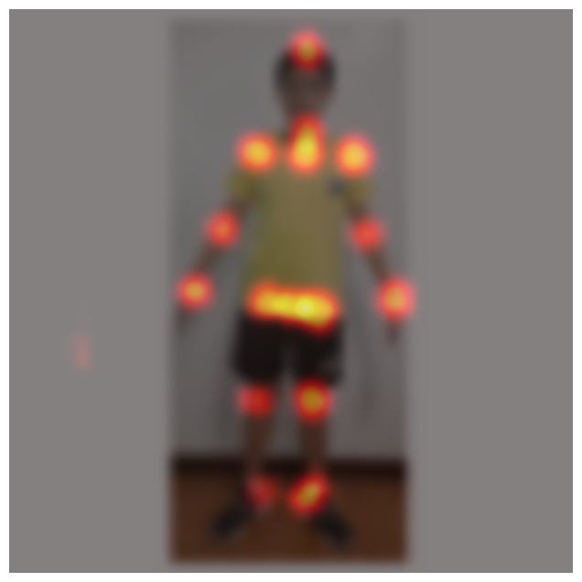

1. Output of the ResNet-50 Model

In the fig. 2 we can see the example of output of the pose estimation model, from this we selected the joints as the pixels with red color.

The YOLOv8 model, by ultralytics was trained on COCO 2017 Dataset which has 17 key points. The model’s input shape is a 640x640 image with 3 channels and the output is consisting of 17 key points.

Next we have the YOLO-NAS model, which uses Neural Architecture Search and it was also trained using COCO 2017. This results in models that potentially have better performance compared to manually designed YOLO models.

These models was then evaluated by obtaining their Mean Average-Precision Scores (mAP), execution time and model size, which are all crucial in using the model in production.

## Human Activity Recognition Model

In the Human Activity Recognition, we used the UCF-101 dataset, and we only used the data with the label Push Ups, Lunges, and Squats.

We used three different model architectures, which are Conv(2+1)D with ResNet, 3D CNN with LSTM and 3D CNN with Bidirectional LSTM.

First we have the Conv(2+1)D with ResNet model, this model contains 2 Conv3D layers which analyzes the temporal and spatial features of the data, along with Residual Neural Network.

The 3D CNN with LSTM and the 3D CNN with Bidirectional LSTM model both contains 4 ConvBlock, 2 Fully Connected Layers and the LSTM layers. each ConvBlock contains Conv3D which analyzes the spatiotemporal features of the data along with MaxPooling3D.

The model undergoes training on the training dataset, while monitoring via metrics such as loss, accuracy validation loss and validation accuracy on the training and validation set.

Upon completion of training, the model's efficacy is evaluated on the test set, employing metrics such as accuracy, and ROC curve.

## Error Detection Algorithm

In the Error Detection algorithm, we used a combination of key points for each poses, we determined that at every pose there are only certain parts of the body that needed to be corrected.

1. Important Angles

| Exercise Classes | Angles |
| --- | --- |
| Squat | Torso, Legs |
| Lunges | Left Leg, Right Leg |
| Planks | Legs, Arms |

1. Important angles for each exercise classes.

In the fig. 3 we can see the key angles that we need to monitor in each exercises. For the squat, we monitor the angles in the torso and the legs of the user. For lunges, both the legs are monitored and for planks, we monitor the angle of the arms and legs.

1. Code used in calculating angle.

In the fig. 4 we can see how the angle of the three points is calculated. We first calculated the two vectors of the angle based on point 1 and point 2, then point 2 and point 3. Next we performed dot product in both vectors, and calculated both magnitude of the vectors. Using the dot product and magnitude of the vectors, we can get the cosine of the angle, and finally we can use inverse cosine function to get the angle theta.

## Software Design

Our software was created using Unity, the UI shows example images of the exercise. Our models were created using Keras and were converted using into Open Neural Network Exchange (ONNX) model to be imported into Unity.

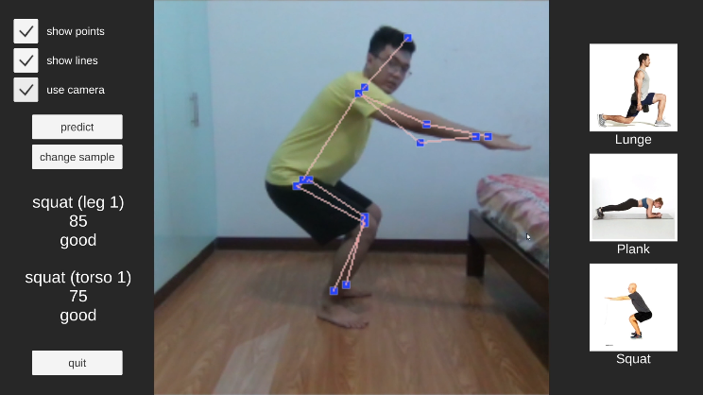

1. Important angles for each exercise classes.

In Fig. 5 we can see the UI of the software, on the left side of the UI, we have the predict and change sample buttons used for testing. We also have checkboxes for configurations and to enable the camera. On the right side we have the different classes with corresponding images.

# Testing and Results

## Pose Estimation Model

The testing was conducted by using sample images and using camera, we split the data into testing and training data for the validation of the model.

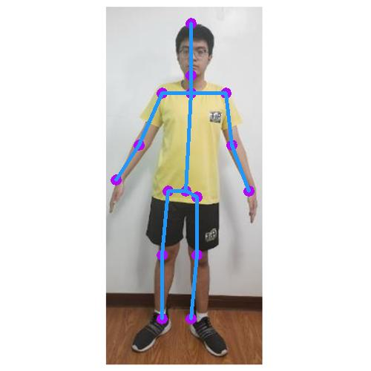

1. Sample Output of ResNet-50 Model

1. Sample Output of YOLOv8 Model

1. Sample Output of YOLO-NAS Model

The Fig. 6 to Fig. 8 shows the example output of the pose estimation model.

1. Pose Estimation Model Comparison

| Model | mAP Scores | Execution Time | Model Size |
| --- | --- | --- | --- |
| ResNet-50 | 96.351 | 265.8ms | 132.7 MB |
| YOLOv8 | 95.329 | 600.5ms | 45.7 MB |
| YOLO-NAS | 88.989 | 722.8ms | 60.2 MB |

1. Metrics for Pose Estimation Model

According to the Fig 9, we can see that ResNet-50 performed better than YOLOv8 and YOLO-NAS in terms of the performance and speed, but this is because of the gap between the model size, we can see that both YOLOv8 and YOLO-NAS have significantly lower size compared to ResNet, this is because YOLO models boasts in have smaller size while maintaining good performance.

## Human Recognition Model

For our Human Activity Recognition model, we used our training and validation accuracy for the evaluation of the model.

1. Training vs Validation Accuracy of Conv(2+1)D ResNet Model

1. Training vs Validation Loss of Conv(2+1)D ResNet Model

As seen in Fig. 10 and Fig. 11, Our Conv(2+1)D with ResNet model for HAR has achieved 93.23% accuracy during the training and 73.33% accuracy in the validation set.

1. Training vs Validation Accuracy of 3D CNN with LSTM Model

1. Training vs Validation Accuracy of 3D CNN with LSTM Model

In the Fig. 12 and Fig.13, we can see training and validation 3D CNN with LSTM. This graph shows that the model overfitting because of the lack of Dropout layers.

1. Training vs Validation Accuracy of 3D CNN with LSTM Model

1. Training vs Validation Accuracy of 3D CNN with LSTM Model

In the fig. 14 and fig. 15, we can see the training and validation 3D CNN with Bidirectional LSTM model. It is the same with the 3D CNN and LSTM model.

# Discussion

Three models were evaluated: ResNet-50, YOLOv8, and YOLO-NAS. While ResNet-50 showed superior performance, YOLO models offered smaller sizes with acceptable accuracy, making them viable alternatives.

Three model architectures were tested using the UCF-101 dataset. The Conv(2+1)D with ResNet model achieved high accuracy, but overfitting was observed in other models, emphasizing the need for regularization techniques.

An algorithm based on key points and specific body angles was used for error detection. This targeted approach enhances posture suggestions tailored to individual exercises, reducing injury risks.

Unity was chosen for its user-friendly interface. The software integrates deep learning models for real-time posture analysis and feedback, enhancing user engagement and understanding.

# Conclusion

The exercise posture suggestion system offers a promising solution for individuals seeking to optimize their workout routines while minimizing the risk of injury. Continued refinement and validation through user feedback will be essential for ensuring the system's effectiveness and widespread adoption in fitness settings. As technology continues to evolve, integrating advancements in deep learning and human-computer interaction will further enhance the system's capabilities, ultimately contributing to improved health outcomes and enhanced quality of life.

##### Acknowledgment

We would like to express our gratitude to the online communities and resources that have contributed to the success of this project. Our work would not have been possible without the availability of online data and the wealth of knowledge shared by individuals and organizations online. We acknowledge and appreciate the valuable contributions of these sources in shaping our understanding and implementation of advanced techniques in our research.

##### References

1. D. Rellinger, “Regular breathing and proper posture when exercising is important,” *MSU Extension*, Dec. 22, 2016. https://www.canr.msu.edu/news/regular_breathing_and_proper_posture_when_exercising_is_important
2. Dawid Koźlenia and Katarzyna Kochan-Jacheć, “The Impact of Interaction between Body Posture and Movement Pattern Quality on Injuries in Amateur Athletes,” *Journal of clinical medicine*, vol. 13, no. 5, pp. 1456–1456, Mar. 2024, doi: https://doi.org/10.3390/jcm13051456.
3. Audrey, “Why Having Proper Form & Exercise Techniques is Important,” *Jack City Fitness*, Jan. 21, 2021. https://jackcityfitness.com/why-having-proper-fitness-form-technique-is-important/
4. B. Xiao, H. Wu, and Y. Wei, “Simple Baselines for Human Pose Estimation and Tracking,” *arXiv:1804.06208 [cs]*, Aug. 2018, Available: https://arxiv.org/abs/1804.06208