PROJECT DOCUMENTATION

JSON Refiner
Enhanced Edition

Intelligent JSON Processing & Transformation Platform
Version | 1.0 — Production Grade
Project | SmartBridge Use-Case 3
Platform | Python 3.12+ / Gradio 6
Features | 11 Core Capabilities
Theme | Teal / Amber Dark UI
Authors | Abzana V (C3S48851),  Moksha G N (C3S48859),  Swati R B (C3S48863),  Darnal S (C3S48866)

Table of Contents

1. Project Overview 3
2. Objectives & Scope 4
3. System Architecture 5
4. Feature Specifications 6–7
5. Type Inference Engine 8
6. Case Style Reference 9
7. Project Workflow & Milestones 10–11
8. Technology Stack 12
9. Use Case Scenarios 13
10. Troubleshooting & FAQs 14
11. Future Roadmap 15

1. Project Overview

1.1 Introduction
JSON Refiner Enhanced Edition is a web-based, production-grade JSON processing platform built with Python and Gradio. It transforms unstructured key-value text into clean, typed, validated, and normalised JSON — empowering data analysts, backend developers, and DevOps engineers with eleven integrated capabilities through a single, elegant interface.

1.2 Problem Statement
Modern data pipelines regularly encounter JSON data inconsistencies — mixed naming conventions, ambiguous value types, missing required fields, deeply nested structures, and schema non-compliance. Manual correction is error-prone, slow, and non-reproducible. JSON Refiner addresses all of these challenges through intelligent automation.

1.3 Solution Summary
- Automatic type inference converts raw strings to correct JSON types without manual annotation
- Four key case styles (snake_case, camelCase, kebab-case, PascalCase) applied consistently
- JSON Schema (Draft 7) validation enforces structural correctness
- Deep merge, flatten/unflatten, diff, and CSV export cover the full transformation lifecycle
- Session history log enables audit trails and reproducibility

1.4 Project Identity
Attribute | Detail
Project Name | JSON Refiner — Enhanced Edition
Origin | SmartBridge Use-Case 3
Interface | Gradio 6 Web Application (local + public share URL)
Language | Python 3.8+ (3.12+ recommended)
Deployment | Google Colab / Local Machine / Any Python environment
License | Educational & Non-commercial

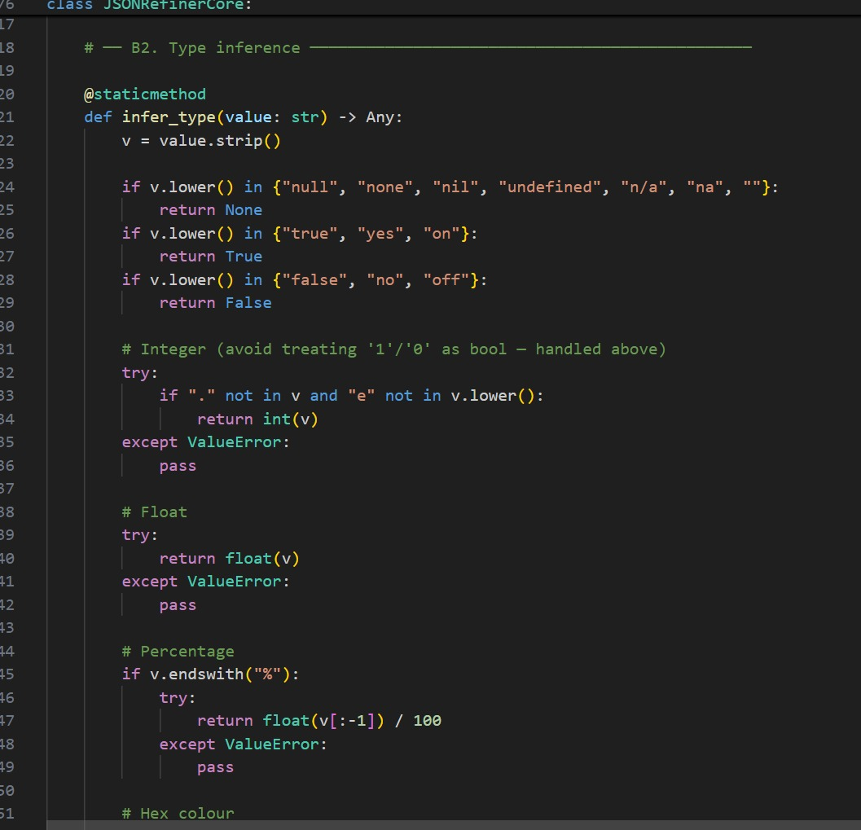

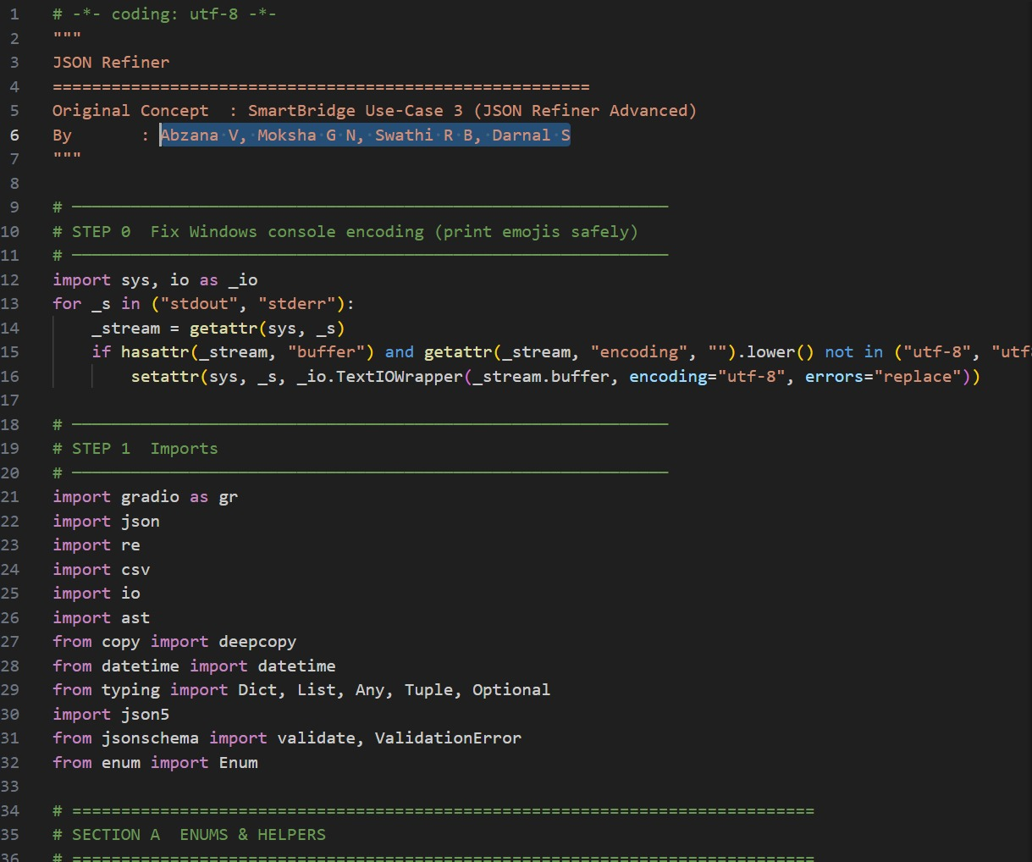

2. Objectives & Scope

2.1 Primary Objectives
- Provide an intuitive no-code interface for comprehensive JSON processing
- Eliminate manual type annotation through intelligent inference
- Standardise key naming conventions across heterogeneous data sources
- Validate JSON against schemas and required-field constraints
- Enable structural transformations: merge, flatten, diff, export
- Maintain a traceable session history for audit and reproducibility

2.2 Target Users
User Role | Primary Use
Data Analyst | CSV-to-JSON migration, type normalisation, analytics export
Backend Developer | API response normalisation, schema validation, key renaming
DevOps Engineer | Config file management, required-field validation, merge
QA Engineer | Schema-based quality assurance, JSON diff auditing
Student / Learner | JSON fundamentals exploration via Quick Templates

2.3 Scope

In Scope
- Key-value to JSON conversion with automatic type inference
- Four case-style conversions applied recursively
- JSON Schema (Draft 7) and required-field validation
- Deep-merge of up to three JSON objects
- Flatten to dot-notation and reverse unflatten
- Side-by-side JSON diff with change categorisation
- CSV export for arrays-of-objects and flat dicts
- JSON minification with savings metrics
- Session history logging and export
- Quick Templates for instant demonstration

Out of Scope
- Batch file processing of multiple uploaded files
- Persistent server-side data storage
- Authentication or multi-user isolation
- Cloud storage integration (S3, GCS)

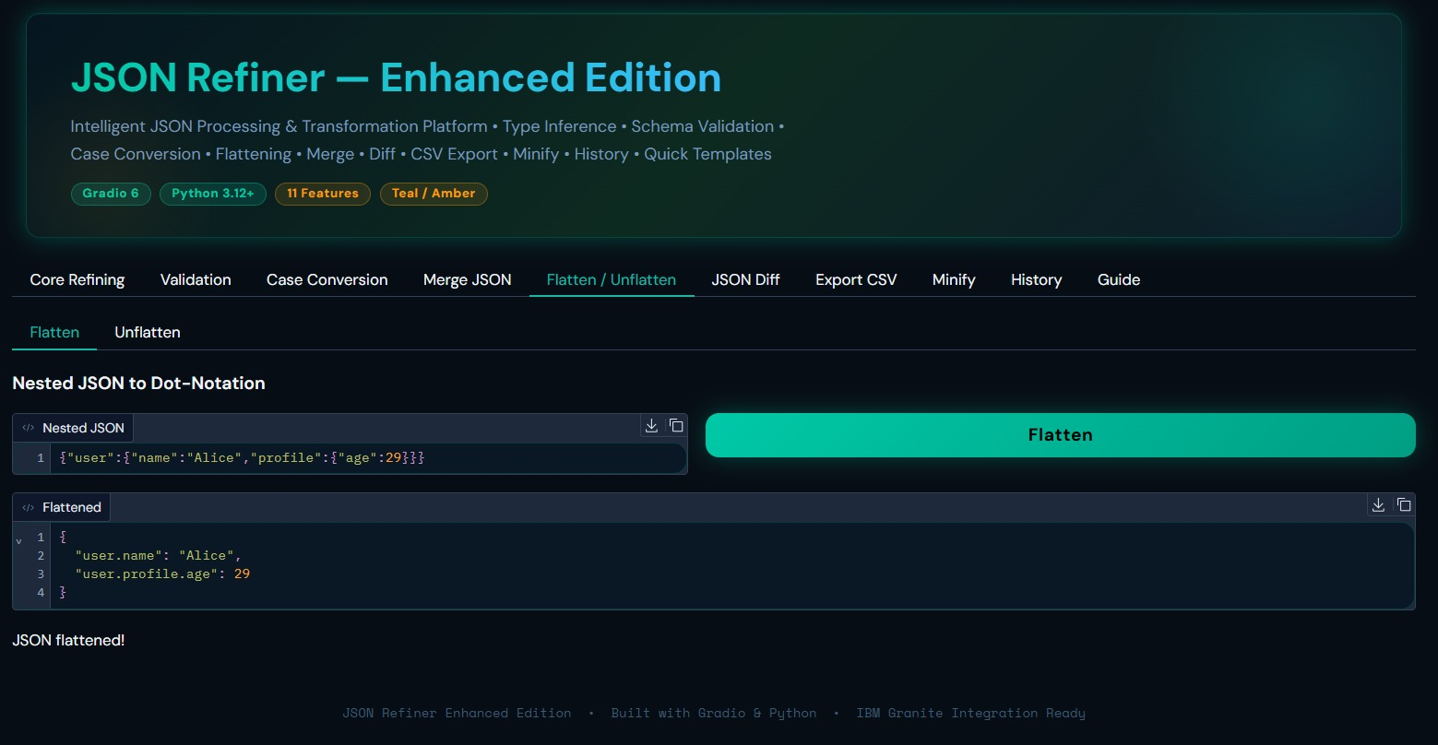

3. System Architecture

3.1 High-Level Overview
JSON Refiner follows a layered architecture separating concerns across five distinct sections. The Gradio UI layer captures user inputs and renders outputs; handler functions orchestrate business logic; the core engine executes all transformations; session state preserves history; and enums/helpers provide shared utilities.

3.2 Module Structure
Section | Module | Responsibility
A | Enums & Helpers | CaseStyle enum, parse_case_style() safe lookup
B1 | Case Converters | snake_case, camelCase, kebab-case, PascalCase normalisation
B2 | Type Inference | Automatic value type detection and conversion
B3 | KV Parser | Line-by-line key-value text parsing with error reporting
B4 | Validation | JSON Schema (Draft 7) and required-field checking
B5 | Transformations | Flatten, unflatten, merge, remove nulls, sort keys
B6 | Statistics | Key counts, type breakdown, URL/email/date detection
B7 | JSON Diff | Recursive added/removed/changed comparison
B8 | CSV Export | Array-of-objects and flat-dict to CSV conversion
B9 | Minify | Whitespace stripping with savings calculation
C | Session State | Transformation history list, templates dictionary
D | Handlers | Gradio-wired Python functions for each feature tab
E | Gradio UI | 10-tab interface, custom CSS, header HTML, theme

3.3 Data Flow
User Input → Handler Function → JSONRefinerCore Engine → Session State → Gradio Output

Each user action in the Gradio interface invokes a handler function. The handler delegates processing to the appropriate JSONRefinerCore static method, records the result in the session transformation history, and returns structured output (JSON string, status message, statistics) back to the interface components.

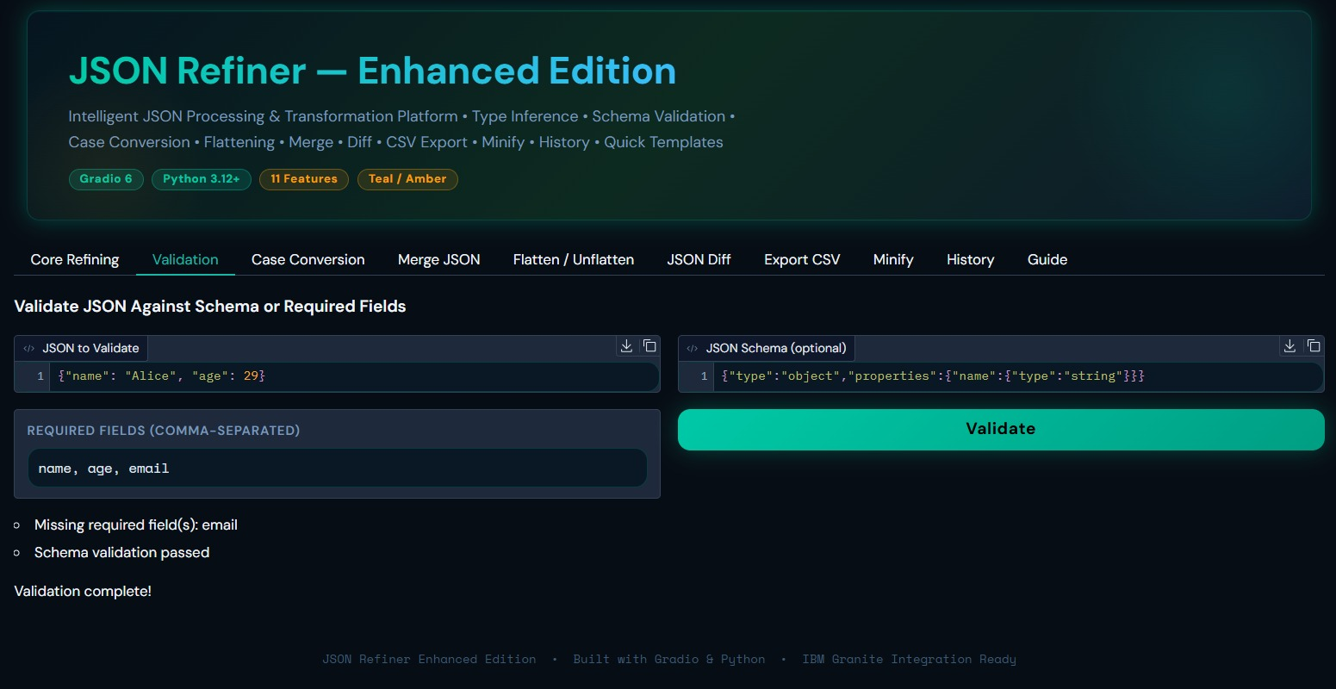

4. Feature Specifications

4.1 Feature Matrix
# | Feature | Description | Input / Output
1 | Core Refining | Convert key-value text to typed JSON with automatic type inference and configurable options | Text → JSON
2 | Validation | Check required fields and validate against JSON Schema Draft 7 | JSON + Schema → Report
3 | Case Conversion | Re-key any JSON object to snake_case, camelCase, kebab-case, or PascalCase recursively | JSON → JSON
4 | Merge JSON | Deep-merge up to 3 JSON objects with last-value-wins conflict resolution | 3× JSON → JSON
5 | Flatten | Convert nested JSON to single-level dot-notation keys | Nested → Flat
6 | Unflatten | Reverse dot-notation flat structure back to nested JSON | Flat → Nested
7 | JSON Diff | Compare two JSON objects and report added, removed, and changed keys | 2× JSON → Report
8 | Export CSV | Convert JSON arrays-of-objects or flat dicts to CSV format | JSON → CSV
9 | Minify | Strip all whitespace; shows characters and bytes saved | JSON → Minified
10 | History | Log all Core Refining transformations; export or clear the session log | Session → Report
11 | Quick Templates | Four pre-built examples: User Profile, API Config, Product Record, DB Connection | Click → Prefill

4.2 Core Refining Options
Option | Default | Behaviour
Key Case Style | snake_case | Normalises all output keys to the selected convention
Remove Nulls | Off | Strips keys whose value resolves to null/None recursively
Flatten | Off | Collapses nested structure to dot-notation after parsing
Pretty Print | On | Indents output with 2 spaces; off produces minified JSON
Sort Keys | Off | Alphabetically sorts all keys recursively for deterministic output
Allow Multivalue | Off | Collects duplicate keys into an array instead of skipping

4.3 Quick Templates
Template | Included Fields
User Profile | name, age, email, is_active, role, score, tags (array), address (object)
API Config | base_url, timeout, retry_count, ssl_verify, api_version, rate_limit
Product Record | product_id, name, price, in_stock, quantity, discount_percent, tags, rating
DB Connection | host, port, database, username, ssl_enabled, pool_size, timeout

5. Type Inference Engine

5.1 Overview
The type inference engine (JSONRefinerCore.infer_type) automatically converts raw string values from key-value input into correct JSON types. The engine applies a deterministic rule chain: null detection → boolean → integer → float → percentage → hex colour → ISO date → JSON literal → string fallback.

5.2 Inference Rule Table
Input Pattern | Inferred Type | JSON Output | Example
null, none, nil, n/a, "" | null | null | score: null → null
true, yes, on | boolean | true | active: yes → true
false, no, off | boolean | false | active: no → false
Pure integer string | integer | 29 | age: 29 → 29
Decimal string | float | 3.14 | rate: 3.14 → 3.14
Ends with % | float ÷ 100 | 0.18 | tax: 18% → 0.18
#[0-9a-fA-F]{3,8} | string | "#00c9a7" | color: #00c9a7
ISO 8601 date | string | "2024-01-15" | joined: 2024-01-15
[...] valid JSON | array | ["a","b"] | tags: ["a","b"]
{...} valid JSON | object | {"k":1} | meta: {"k":1}
Anything else | string | "Chennai" | city: Chennai

5.3 Statistics Detection
In addition to type inference, the statistics module auto-detects semantic field types:

Detected Category | Detection Pattern
Hex Colours | Values matching #[0-9a-fA-F]{3,8}
ISO Dates | Values matching YYYY-MM-DD (with optional time component)
URLs | Values starting with http:// or https://
Email Addresses | Values matching [^@]+@[^@]+\.[^@]+ pattern

6. Case Style Reference

6.1 Supported Conventions
Style | Rule | Example Keys | Common Use
snake_case | All lowercase, words separated by underscore | user_name, is_active | Python, databases
camelCase | First word lowercase, subsequent words capitalised | userName, isActive | JavaScript, APIs
kebab-case | All lowercase, words separated by hyphen | user-name, is-active | HTML, CSS, URLs
PascalCase | Every word capitalised, no separator | UserName, IsActive | C#, classes, types

6.2 Input Normalisation
The normaliser handles any input convention. Regardless of how a key arrives — firstName, first_name, First Name, FIRST-NAME, or FIRST_NAME — all are correctly converted to the target style. The underlying algorithm: strip non-alphanumeric characters, split on word boundaries, apply transformation rules, reconstruct.

6.3 Conversion Example
Original Input | snake_case | camelCase | PascalCase
firstName | first_name | firstName | FirstName
isActive | is_active | isActive | IsActive
user-profile | user_profile | userProfile | UserProfile
LAST_NAME | last_name | lastName | LastName
API Version | api_version | apiVersion | ApiVersion

6.4 Safe Lookup Implementation
Earlier implementations suffered a KeyError when camelCase or PascalCase was selected. The fix introduced parse_case_style(), a safe lookup function backed by a _STYLE_MAP dictionary that maps all known string variants to the correct CaseStyle enum value, with snake_case as the final fallback to prevent uncaught exceptions.

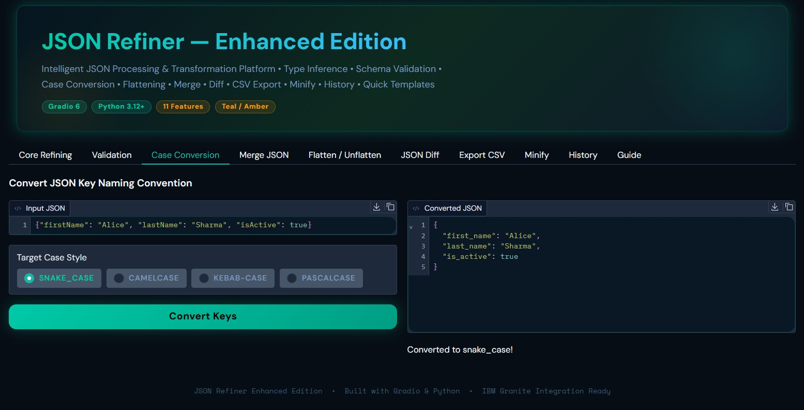

7. Project Workflow & Milestones

7.1 Development Phases
Phase | Name | Key Activities
1 | Environment Setup & Architecture | Install dependencies, define CaseStyle enum, initialise JSONRefinerCore class
2 | Core Processing Engine | Implement type inference, case converters, key-value parser
3 | Validation & Transformations | JSON Schema validation, required-field checks, flatten/unflatten, merge, sort
4 | Gradio Interface | Design 10-tab UI, wire handlers, apply Teal/Amber CSS theme, add header HTML
5 | Testing & Deployment | Google Colab deployment, functional testing, bug fixes, documentation

7.2 Milestone Detail

Milestone 1 — Environment Setup & Core Architecture
- Create requirements.txt specifying all dependencies and minimum versions
- Configure Google Colab environment with UTF-8 encoding workaround
- Define CaseStyle enum with four named constants
- Initialise JSONRefinerCore class with conversion_log, validation_errors, transformation_history

Milestone 2 — Type Inference & Case Conversion System
- Implement infer_type() with full rule chain: null → boolean → int → float → % → hex → date → JSON → string
- Build to_snake_case() using regex boundary detection
- Build to_camelCase() composing from snake_case parts
- Build to_kebab_case() and to_pascal_case() as derivative converters
- Create normalize_key() dispatcher routing to the correct converter

Milestone 3 — Validation & Transformation Features
- Implement check_required_fields() with missing-field reporting
- Implement validate_json_schema() wrapping jsonschema Draft 7 validate()
- Build flatten_json() recursive dot-notation converter
- Build unflatten_json() reconstructing nested structure from dot-notation
- Implement merge_json_objects() with recursive deep-merge semantics
- Add remove_null_values() and sort_keys_recursive() transformations
- Implement diff_json() producing added/removed/changed report lines
- Implement json_to_csv() handling both array-of-objects and dict inputs
- Implement minify() with character and byte savings calculation

Milestone 4 — Gradio Interface Development
- Design Core Refining tab with input, radio selector, five checkboxes, and three outputs
- Wire Quick Templates dropdown with load_template handler
- Build Validation, Case Conversion, Merge JSON, Flatten/Unflatten, Diff, CSV, Minify, History, and Guide tabs
- Author CUSTOM_CSS with Teal/Amber dark design tokens, DM Sans + Space Mono fonts
- Create animated gradient banner header in HEADER_HTML
- Apply gr.themes.Base with primary_hue=teal, neutral_hue=slate

Milestone 5 — Testing & Deployment
- Deploy to Google Colab with PYTHONIOENCODING=utf-8 workaround
- Test all eleven features with edge cases (empty input, duplicate keys, deeply nested structures)
- Verify camelCase/PascalCase safe lookup fix eliminates KeyError
- Confirm Gradio 6 compatibility by migrating css to launch() parameter
- Validate requirements.txt versions against installed packages

8. Technology Stack

8.1 Software Dependencies
Package | Min. Version | Purpose
gradio | 6.0.0 | Interactive web UI framework — renders all 10 tabs
json5 | 0.9.6 | Flexible JSON parsing tolerating trailing commas and comments
jsonschema | 4.17.0 | JSON Schema Draft 7 validation
pydantic | 2.0.0 | Data validation and settings management
python-dotenv | 0.19.0 | Environment variable management
deepdiff | 6.0.0 | Deep comparison utilities (optional enhancement)
transformers | 4.0.0 | IBM Granite LLM integration (future AI features)
openpyxl | 3.1.2 | Excel export capability (optional extension)
pandas | 2.2.0 | Advanced data manipulation (optional extension)

8.2 Hardware Requirements
Component | Minimum | Recommended
Processor | Any modern CPU | Intel i5 8th gen / Apple M1 or newer
RAM | 2 GB | 8 GB for LLM integration
Storage | 500 MB | 2 GB if including model weights
Display | 1024 × 768 | 1920 × 1080 for full tab visibility
Internet | Required | For Google Fonts and Gradio share link generation

8.3 Development Environment
- Python 3.8+ (3.12+ recommended for performance and security patches)
- Google Colab for cloud-based development and zero-setup deployment
- PowerShell (Windows) or Terminal (macOS/Linux) for local execution
- Any modern browser (Chrome, Firefox, Safari, Edge) for the Gradio interface



9. Use Case Scenarios

Scenario 1 — Data Migration from CSV to JSON
A data analyst converts flat CSV rows with mixed types into structured JSON. The engine auto-detects types, applies consistent naming, and validates against a schema before database migration. The CSV key-value pairs are pasted directly into the Core Refining tab; the analyst selects snake_case, enables Remove Nulls, and clicks Generate JSON to receive a schema-validated payload.

Scenario 2 — API Response Normalisation
A backend developer standardises keys from multiple third-party APIs — each using different naming conventions — into a single consistent format. The Merge JSON feature combines up to three API payloads; Case Conversion ensures a uniform key style; Remove Nulls eliminates empty fields; and Validation confirms the merged object against a master schema before delivery to the frontend.

Scenario 3 — Configuration File Management
A DevOps engineer maintains human-readable config files in Key: Value format and converts them to JSON for infrastructure-as-code tools. Required-field validation catches missing database_host or ssl_enabled entries early. Sort Keys produces deterministic output suitable for version control diffing.

Scenario 4 — Data Flattening for Analytics
An analytics team receives deeply nested JSON from their application. The Flatten feature collapses user: {profile: {age: 29}} to user.profile.age: 29 for spreadsheet analysis and CSV export. When the transformed data must re-enter the application, Unflatten reverses the operation with complete fidelity.

Scenario 5 — Schema-Based Quality Assurance
A QA team validates incoming JSON payloads against company JSON Schemas and uses the Diff engine to audit configuration changes between environment deployments. The structured diff report — listing ADDED, REMOVED, and CHANGED keys — provides a clear change log suitable for inclusion in deployment tickets.

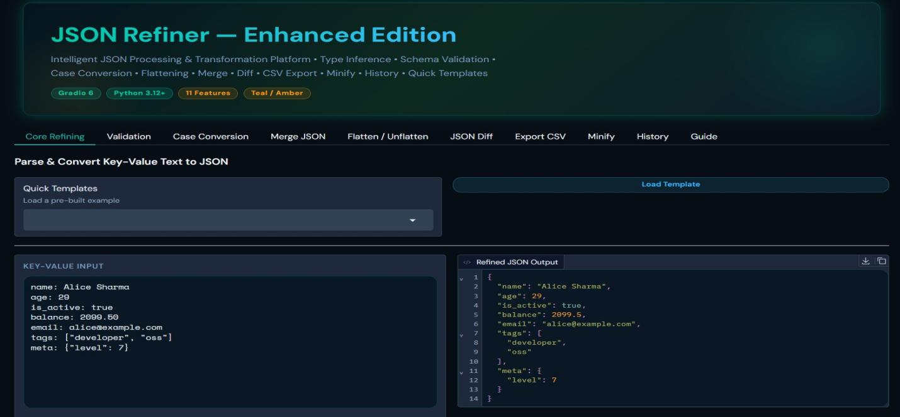
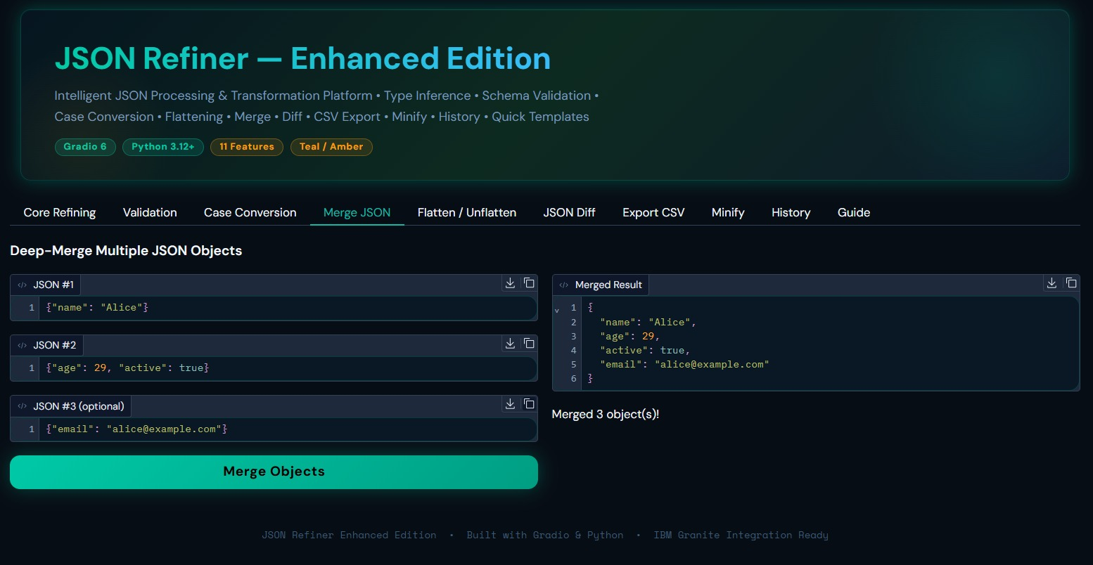

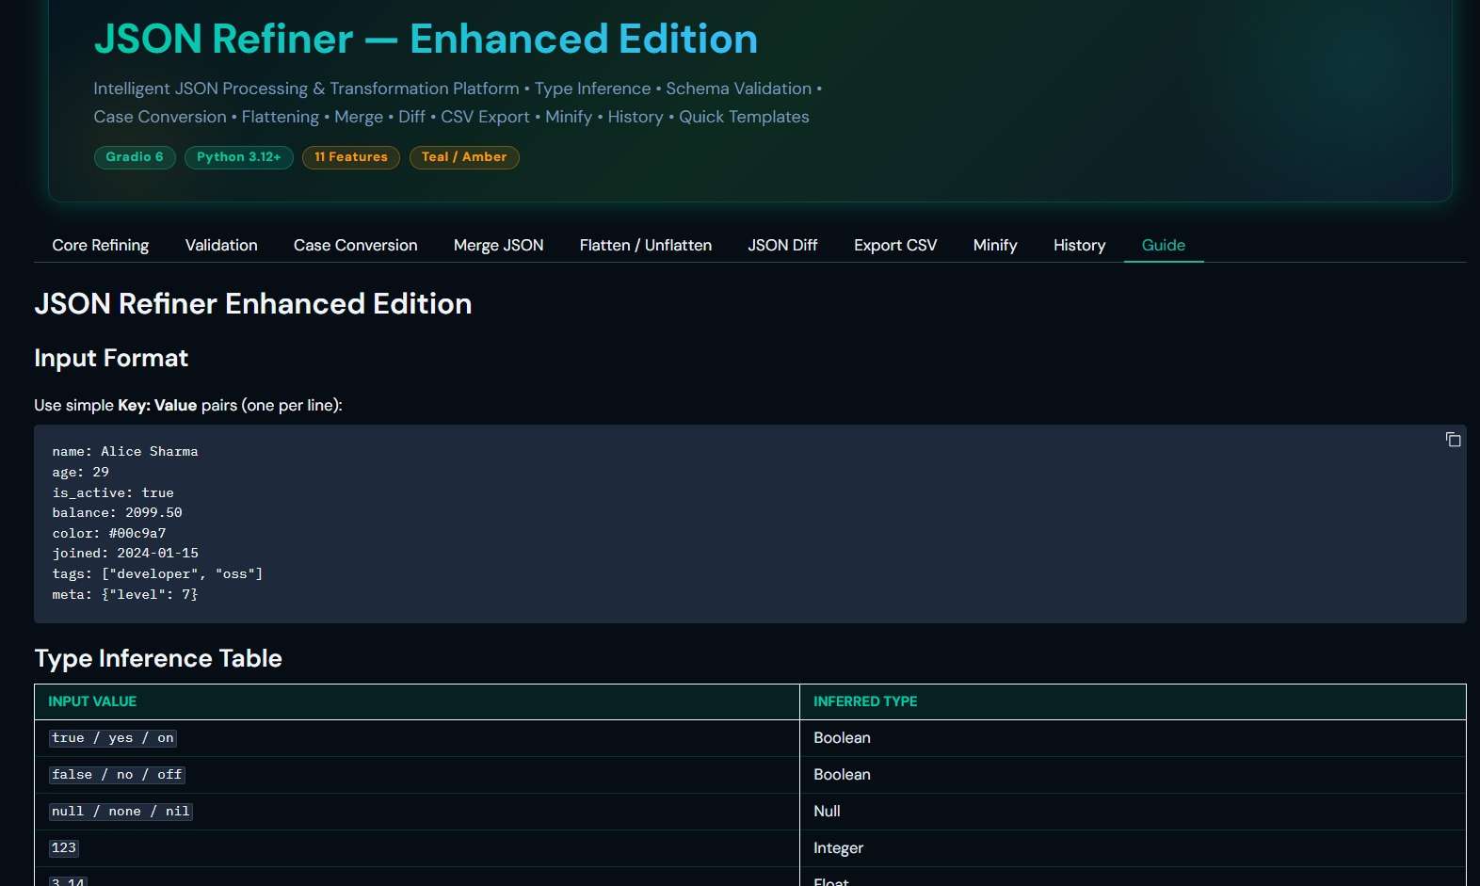

10. Troubleshooting & FAQs

Issue / Error | Resolution
ModuleNotFoundError: No module named 'gradio' | Run: pip install gradio json5 jsonschema python-dotenv pydantic
UnicodeEncodeError (emojis in terminal on Windows) | Set $env:PYTHONIOENCODING="utf-8" before launching the script
TypeError: Blocks.launch() unexpected keyword argument 'show_api' | Upgrade Gradio: pip install --upgrade gradio (requires version 6+)
camelCase or PascalCase produces a KeyError | Fixed in current version. parse_case_style() provides safe lookup with fallback
Port 7860 already in use | Windows: Get-Process -Name python* | Stop-Process -Force, then relaunch
CSS not applying (dark theme missing) | Ensure css= parameter is in demo.launch(), not Blocks() constructor (Gradio 6 change)
JSON output missing nested object | Wrap nested JSON in quotes and use valid JSON syntax: meta: {"k":1}
Duplicate key silently dropped | Enable Allow Multivalue checkbox to collect duplicates into an array instead
Validation schema parse error | Ensure schema input is valid JSON; check for trailing commas or missing quotes
Public URL expires or shows offline | Gradio share links expire after 1 week. Relaunch to generate a new public URL

10.1 Quick Start Checklist
- Verify Python 3.8+ is installed: python --version
- Install all dependencies via requirements.txt
- Set UTF-8 encoding (Windows) and run the script
- Open http://127.0.0.1:7860 in a browser
- Load a Quick Template and click Generate JSON to verify the setup

11. Future Roadmap

11.1 Planned Enhancements
Priority | Feature | Description
High | IBM Granite LLM Integration | AI-powered JSON generation from natural language descriptions
High | Batch File Processing | Upload and transform multiple JSON files in a single operation
High | JSONPath Query Engine | Execute JSONPath expressions (e.g. user.scores[0]) over loaded JSON
Medium | Custom Transformation Rules | User-defined regex pipelines applied during key-value parsing
Medium | Data Anonymisation / PII Masking | Detect and mask email, phone, and name fields automatically
Medium | Cloud Storage Integration | Upload and download transformed JSON directly to/from S3 or GCS
Medium | REST API Endpoint Generation | Auto-generate FastAPI or Flask endpoints from a JSON schema
Low | YAML / TOML Import | Accept YAML and TOML as alternative input formats alongside KV text
Low | Custom Case Style Definitions | Allow users to define their own key naming convention via regex
Low | ML-Based Type Inference | Train a lightweight model to resolve ambiguous value types

11.2 Architecture Extensibility
The modular architecture of JSON Refiner — with a pure static-method engine class, clean handler layer, and decoupled UI — ensures that new features can be added with minimal coupling. Adding a new transformation requires: (1) a static method in JSONRefinerCore, (2) a handler function in Section D, and (3) a new tab entry in Section E. No changes to existing modules are required.

JSON Refiner Enhanced Edition — SmartBridge Use-Case 3 — Abzana V, Moksha G N, Swati R B, Darnal S

