|  |  |  |  |  |  |  |  |  |
| --- | --- | --- | --- | --- | --- | --- | --- | --- |
| 期货  (缩写) | 铁矿石  I | 焦炭  J | 焦煤  JM | 沥青  BU | 锰硅  SM | 硅铁  SF | 螺纹钢  RB | 热卷  HC |
| 总收益long  Short  Both | 632  -373  -256 | 31  -369  -1178 | 721  417  415 | 608  560  -146 | -104  1058  480 | 1708  -2668  -1376 | 651  -983  -342 | 1559  -722  -849 |
| 夏普LonG  Short  Both | **0.03**  -0.0113  -0.0070 | 0.0007  -0.0058  -0.0164 | **0.024**  0.012  0.010 | 0.0068  0.0054  -0.0012 | -0.001  0.0082  0.0031 | **0.018**  -0.02  -0.0093 | 0.0094  -0.012  -0.0035 | **0.022**  -0.0088  -0.0087 |

铁矿石 I (Long, Short, Both)

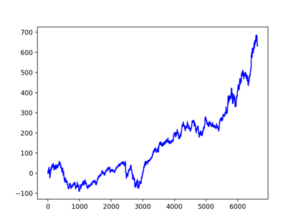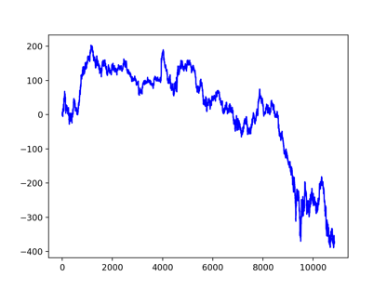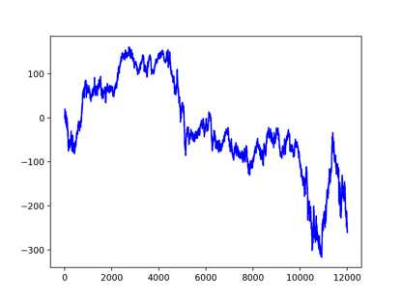

焦炭 J (Long, Short, Both)

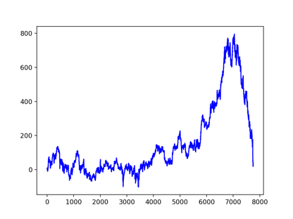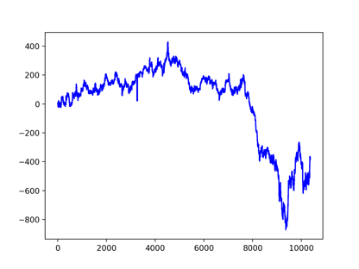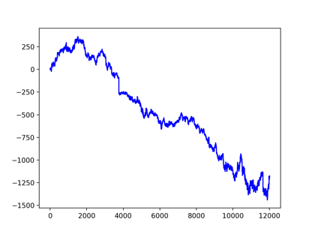

焦煤 JM (Long, Short, Both)

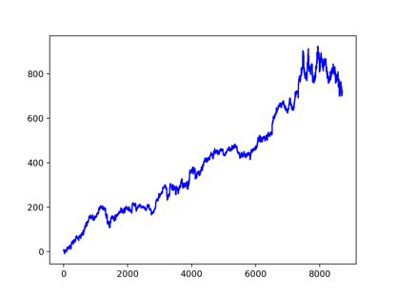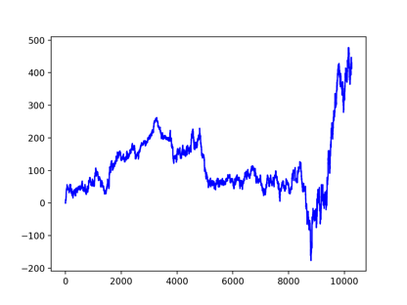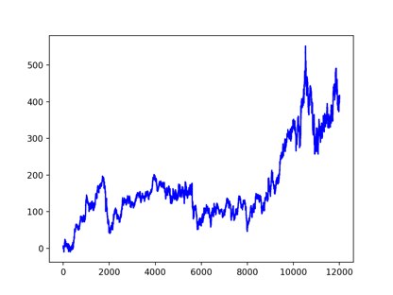

沥青 BU (Long, Short, Both)

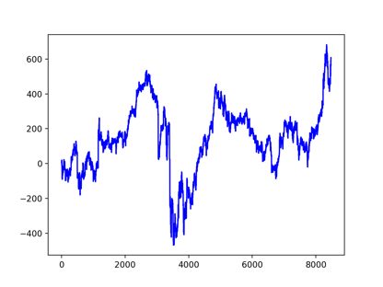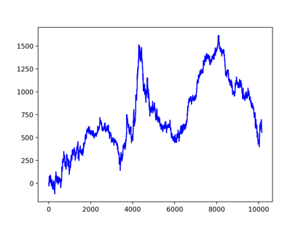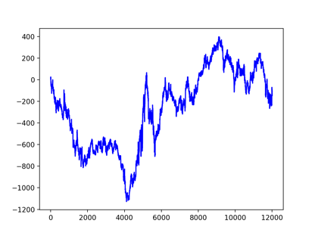

锰硅 SM (Long, Short, Both)

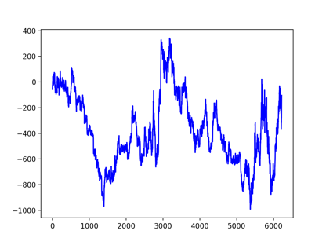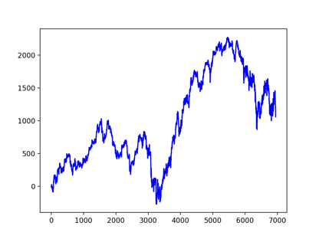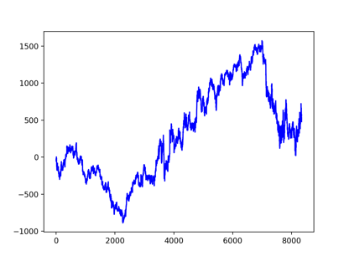

硅铁 SF (Long, Short, Both)

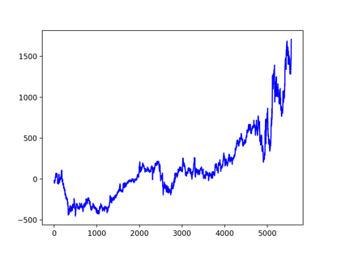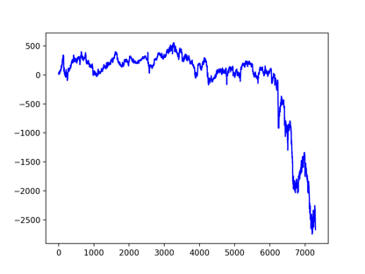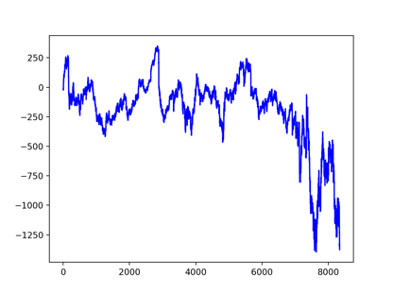

螺纹钢 RB (Long, Short, Both)

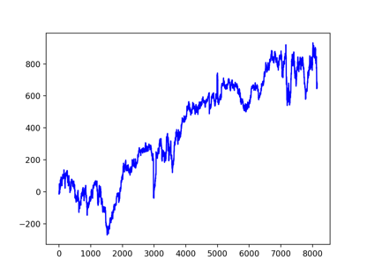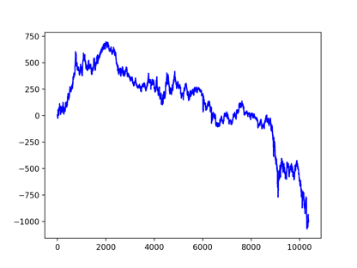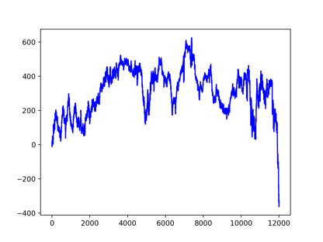

热卷 HC (Long, Short, Both)

