Institution: Vocational Training Development Institute

School of Applied Technology

Information and Communication Technology

Course Code: CS334

Course: Applied Web Programming

Lecturer: Doron Williams

Module 1, 2, and 3

SKILLS TUTOR SCHEDULING SYSTEM



Group Members:

Abigail Thomas - 1817002313

Monique Rose - 1700235552

Onaje Young - 1700254718

Tyshorna Henry - 1817004001

Venessa Barrows - 1700238280

**Due Date: April 30, 2021**

Contents

Process Modeling 4

Database Model 4

Data Flow Diagram 4

Screenshots 6

Home 6

About Us 6

Courses 7

Contact 7

Help/Support 8

Footer (Located on All Pages) 8

Header (Located on each page once user is logged into system) 8

Registration 9

Login 9

Dashboard (Admin) 10

Dashboard (Tutors) 10

Students (Admin) 11

Logs 11

Reports 12

Student Profile 12

Set Appointment 13

Student (Dashboard) 13

Course Portfolio 14

Form Layout and UI Layouts 15

Forms 15

15

Wireframes 16

Project Task Checklist 24

# Process Modeling

## Database Model

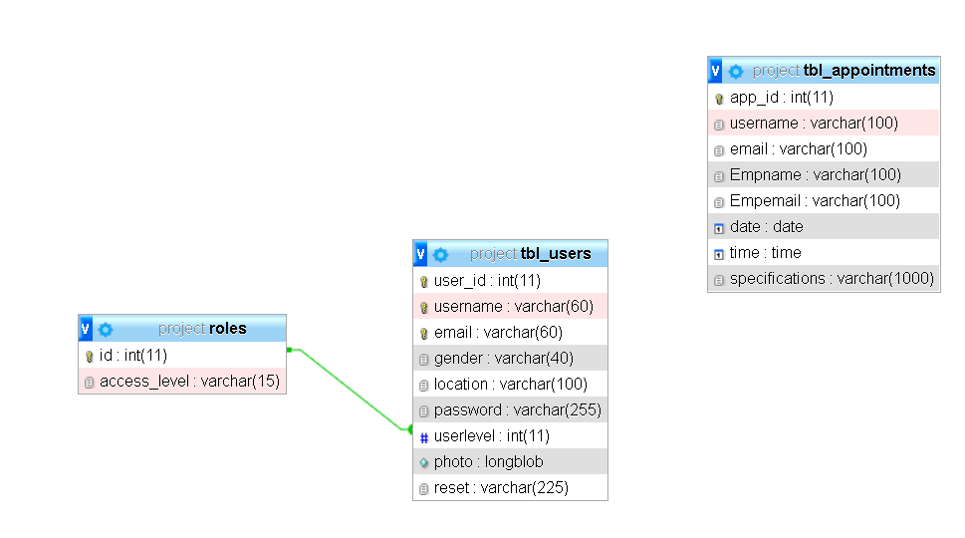

## Data Flow Diagram

Level Zero (0) Data Flow Diagram (DFD)

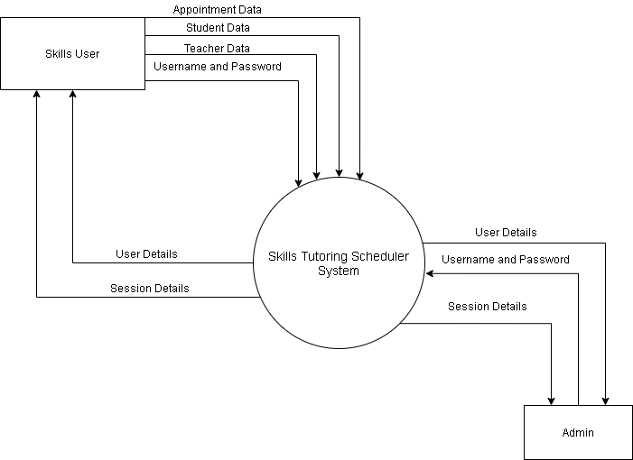

Level One (1) Data Flow Diagram (DFD)

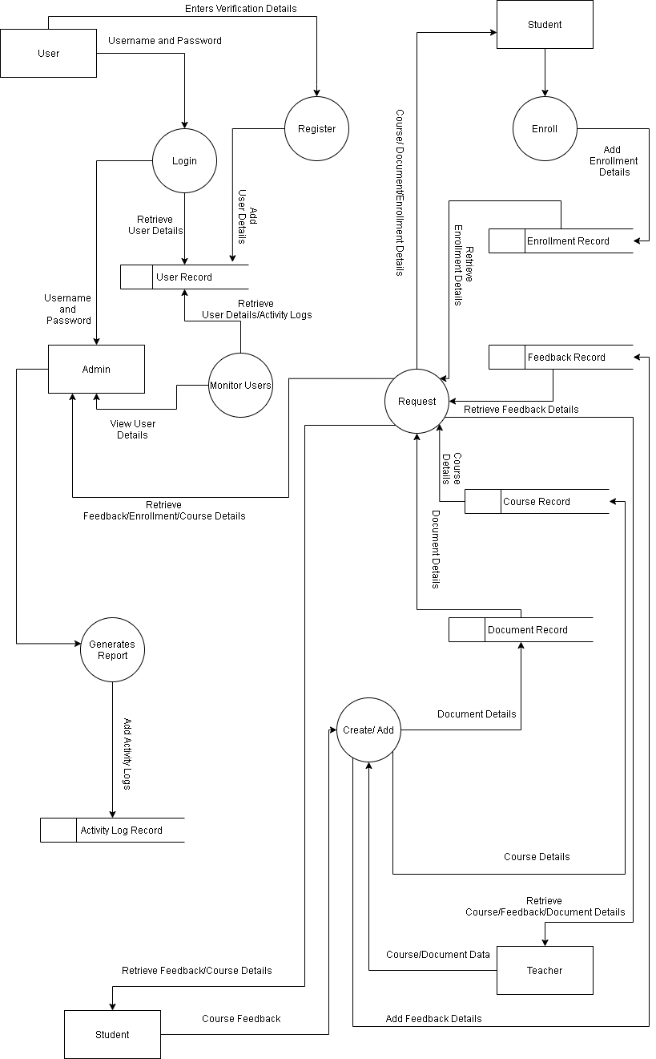

Course/Document /Session Details

Appointment Record

Retrieve Enrollment Details

Add Session Details

Set Session

# Screenshots

## Home



## About Us



## Courses



## Contact

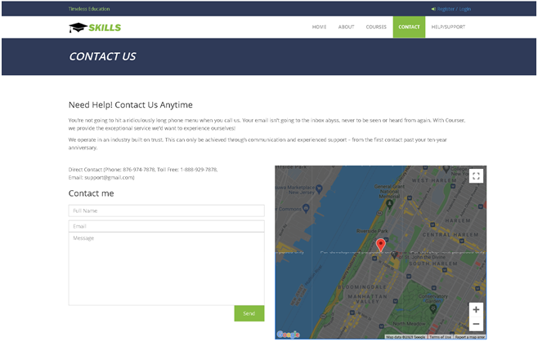

## Help/Support

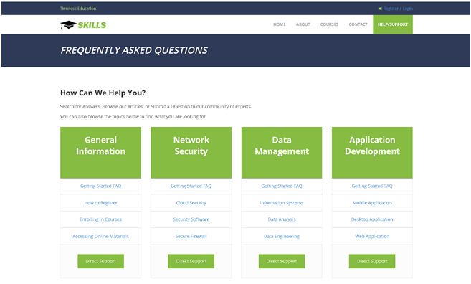

## Footer (Located on All Pages)



## Header (Located on each page once user is logged into system)

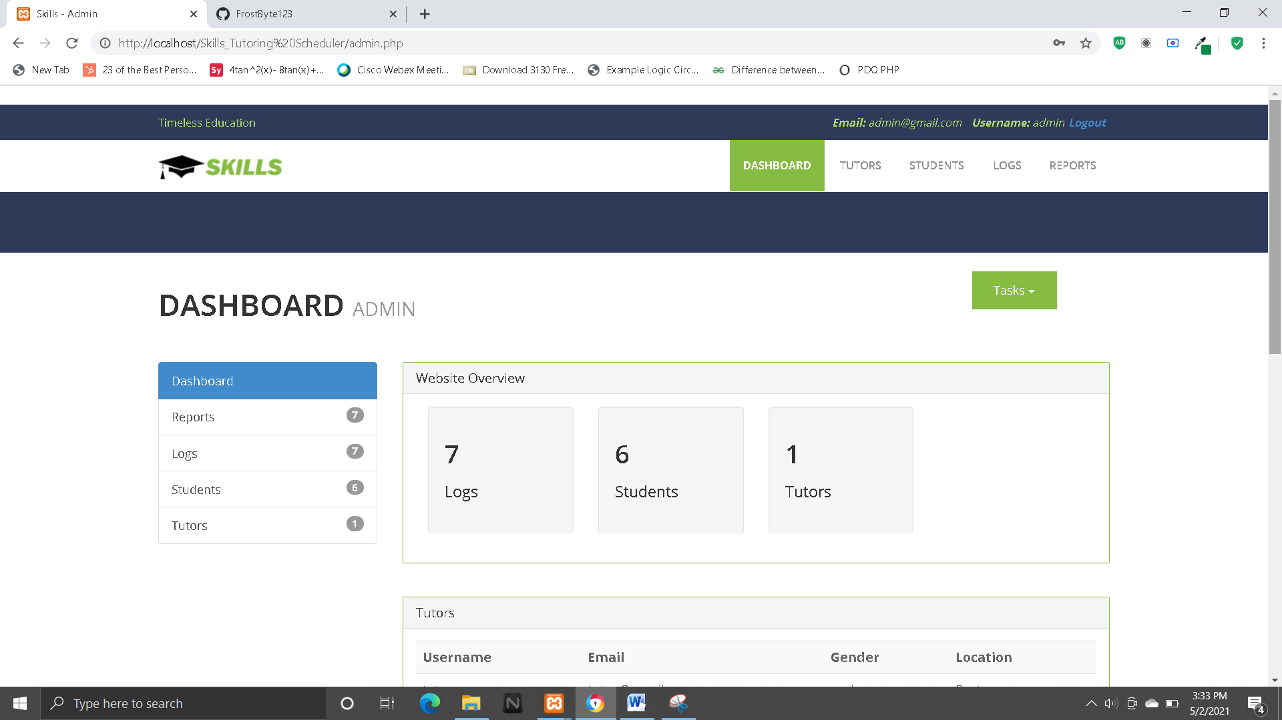

## Registration

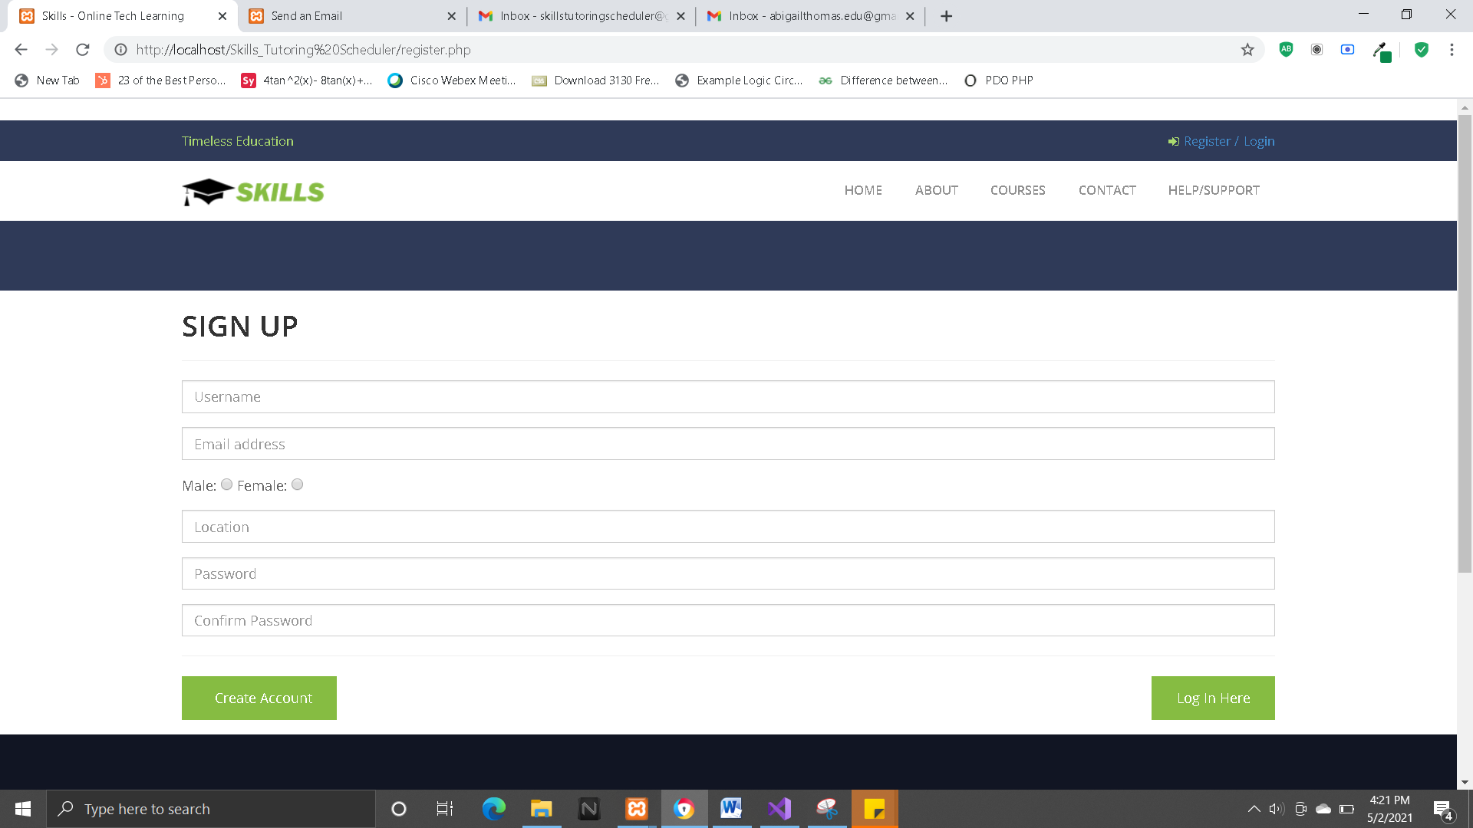

## Login

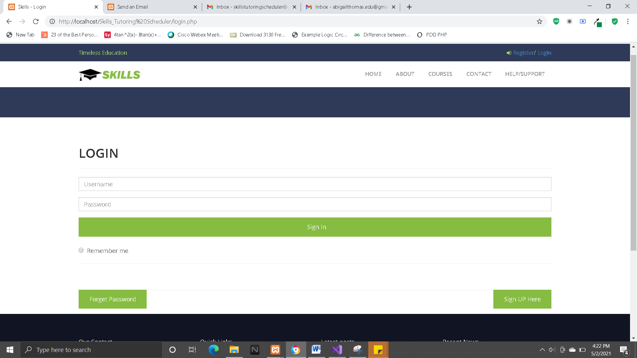

## Dashboard (Admin)

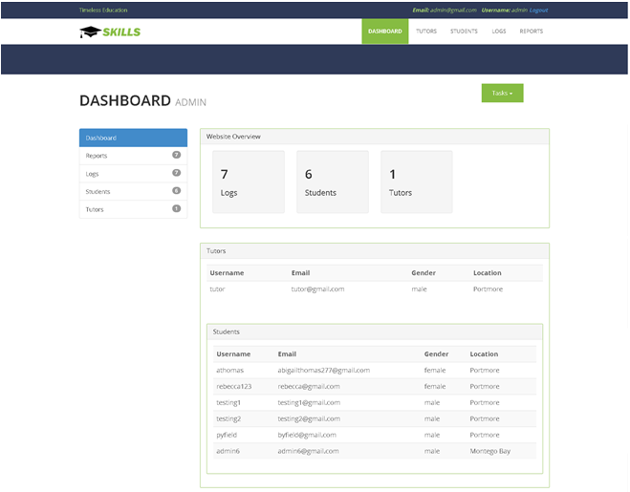

## Dashboard (Tutors)

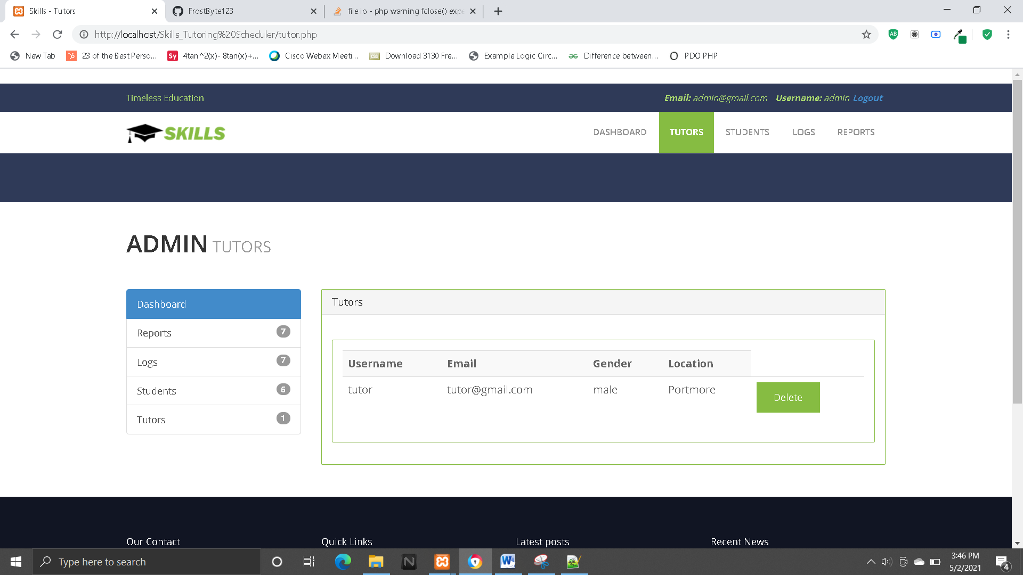

## Students (Admin)

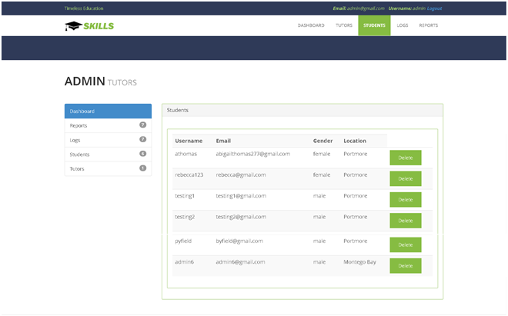

## Logs

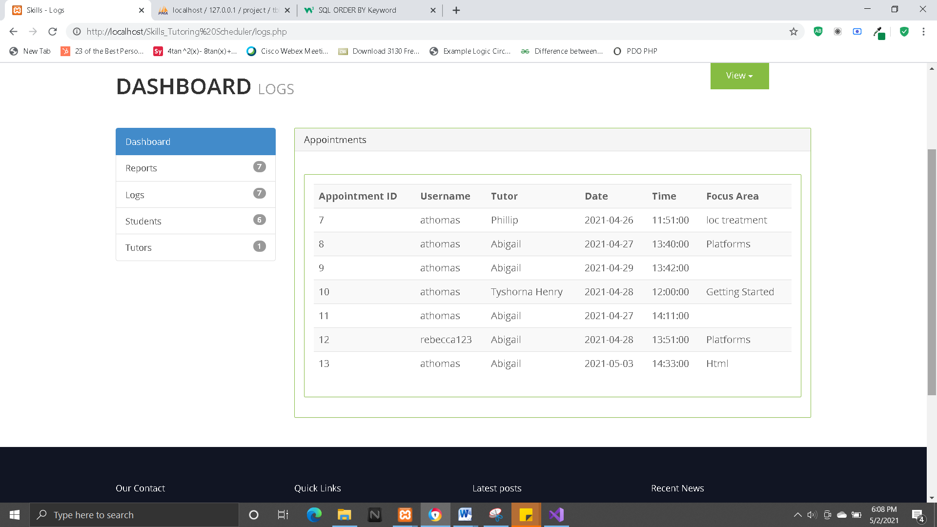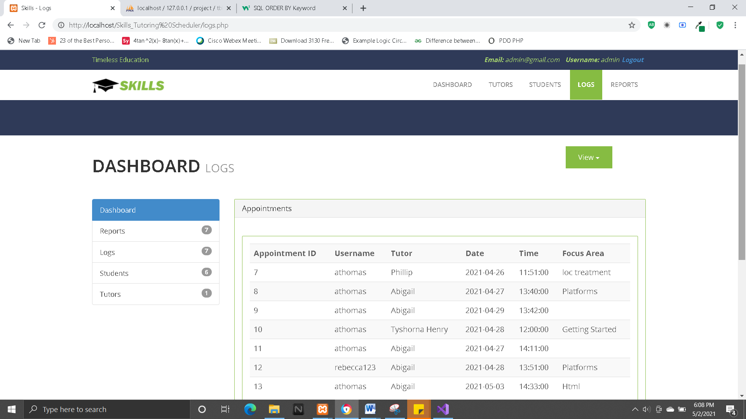

## Reports

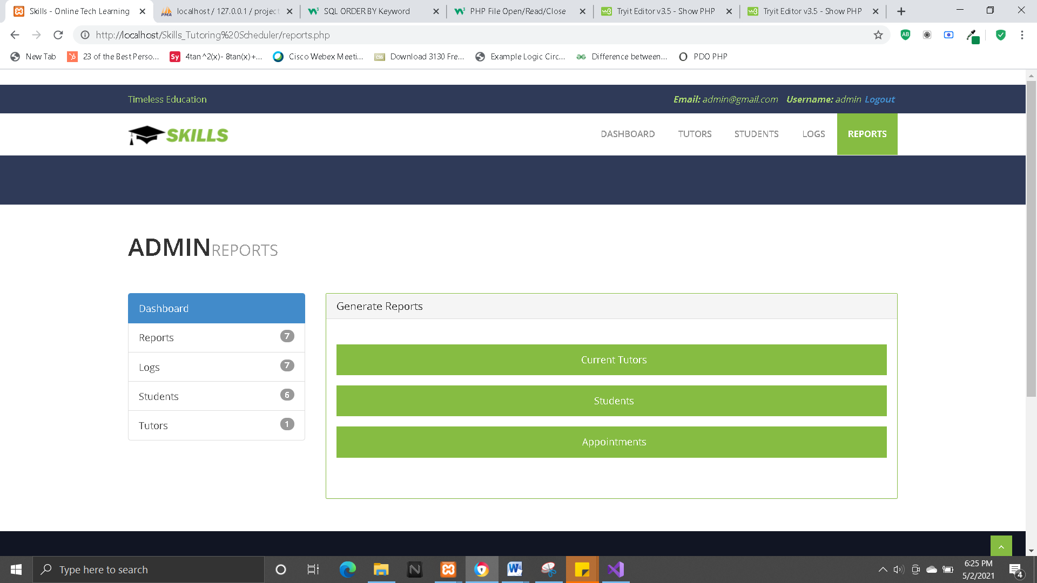

## Student Profile

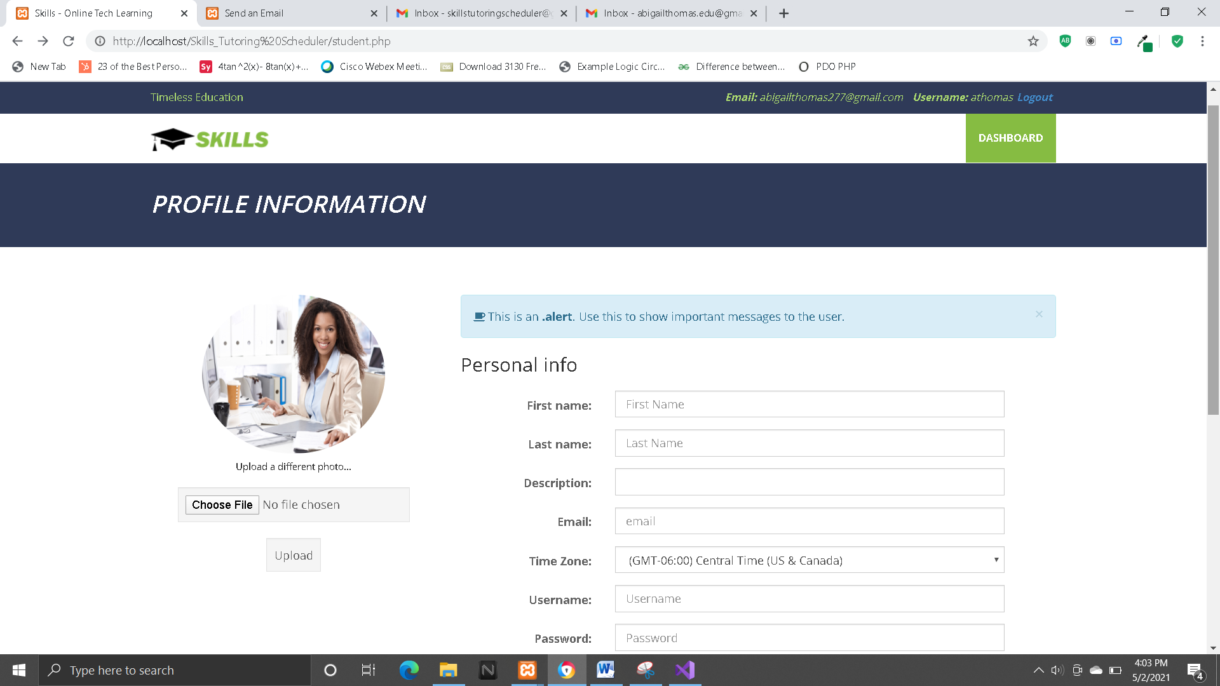

## Set Appointment

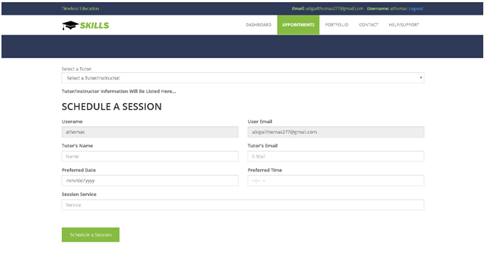

## Student (Dashboard)

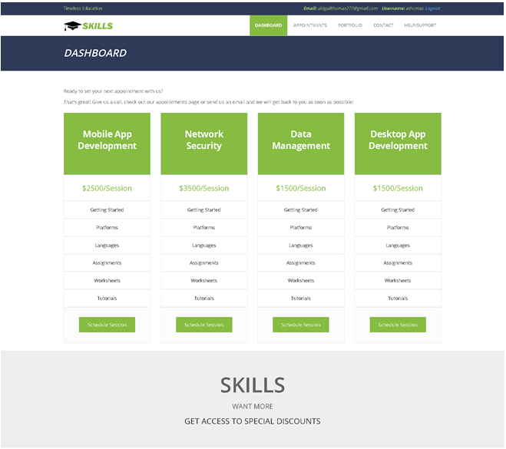

## Course Portfolio



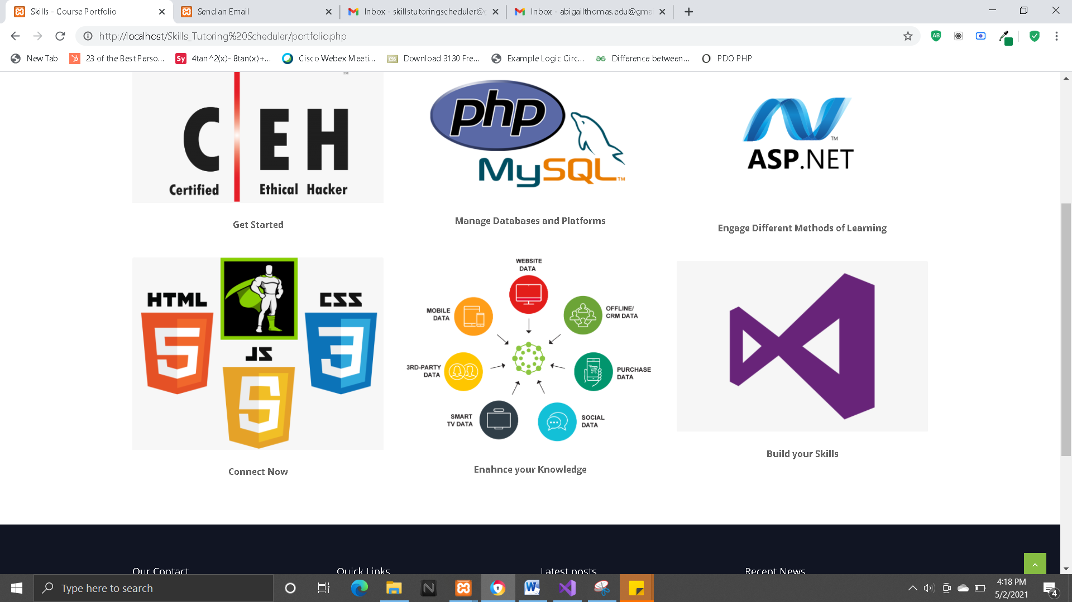

# Form Layout and UI Layouts

## Forms

## C:\Users\abiga\Downloads\index-Page-13.png

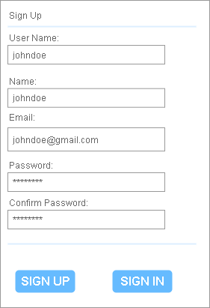

## Wireframes

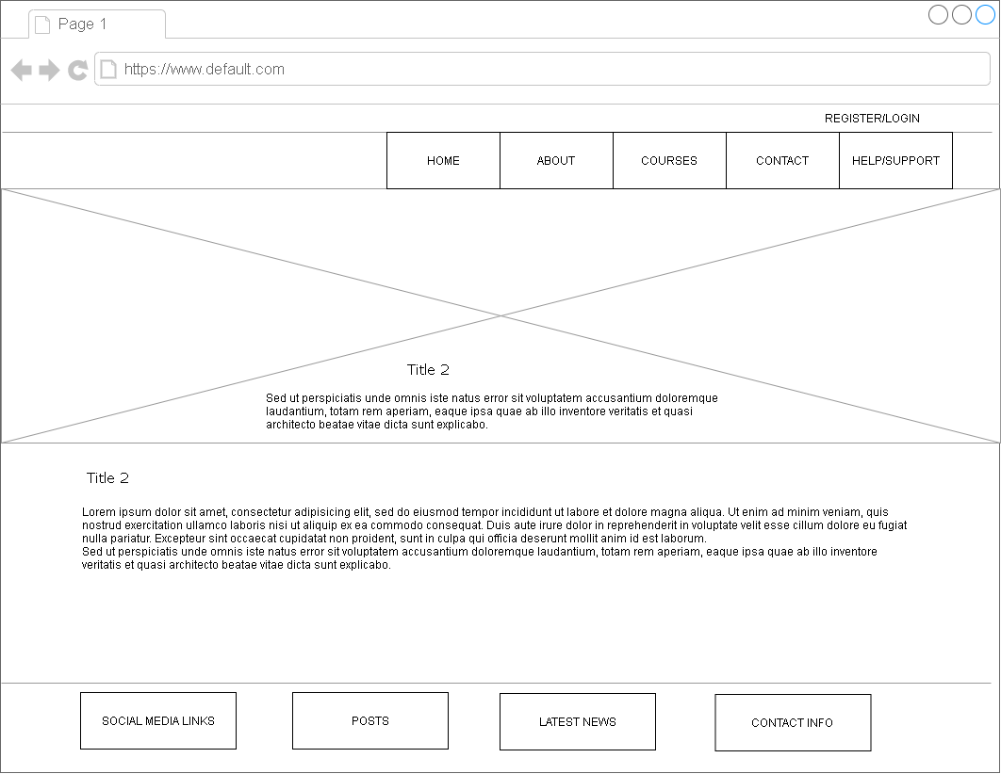

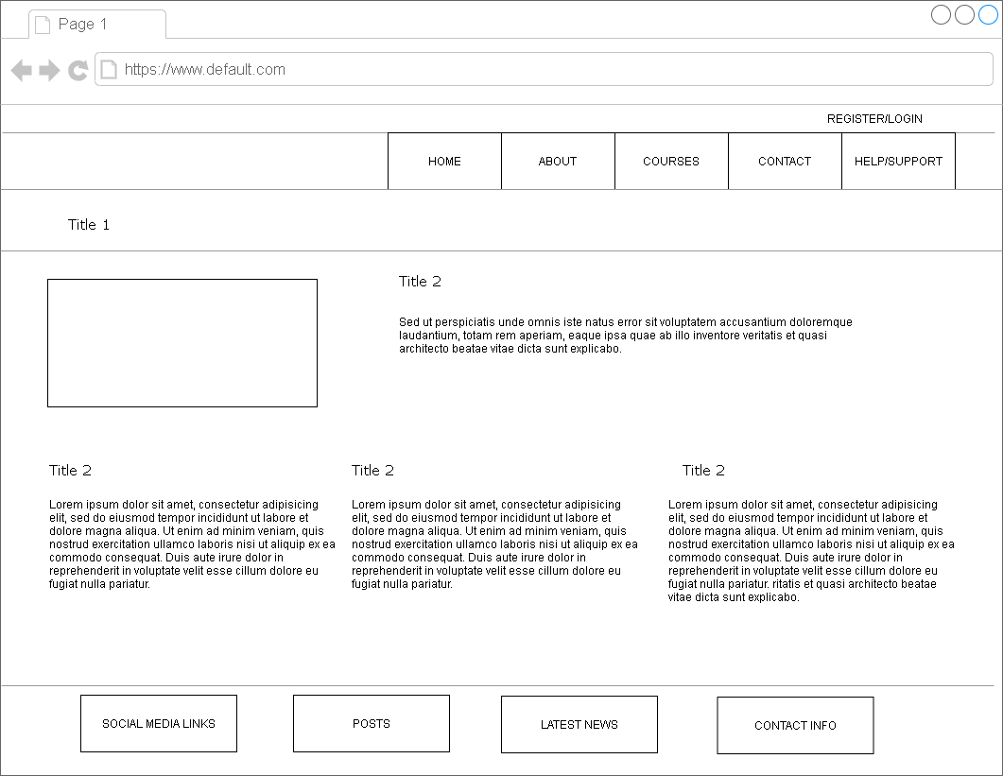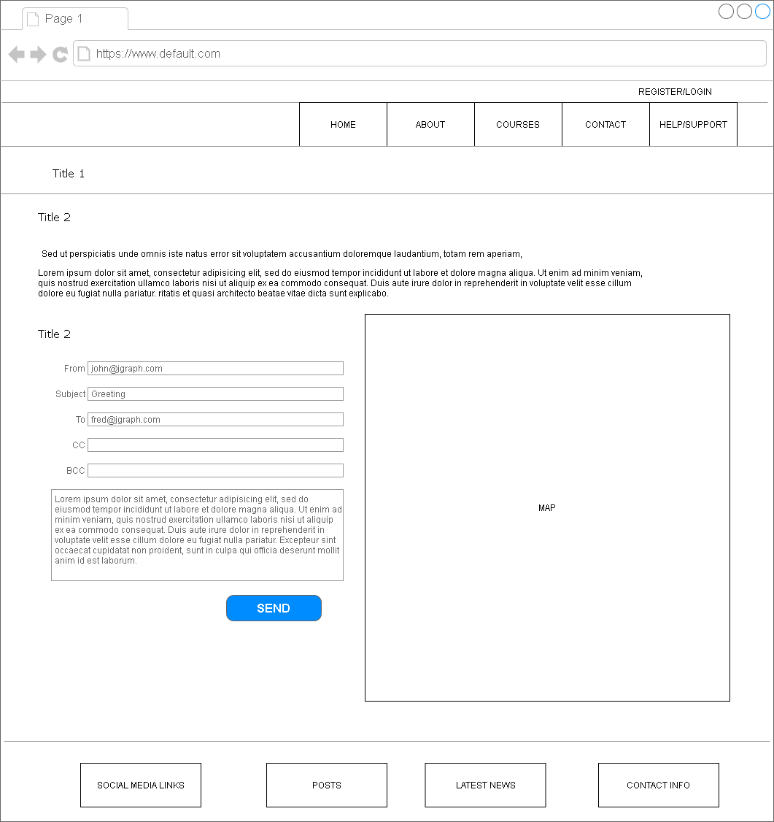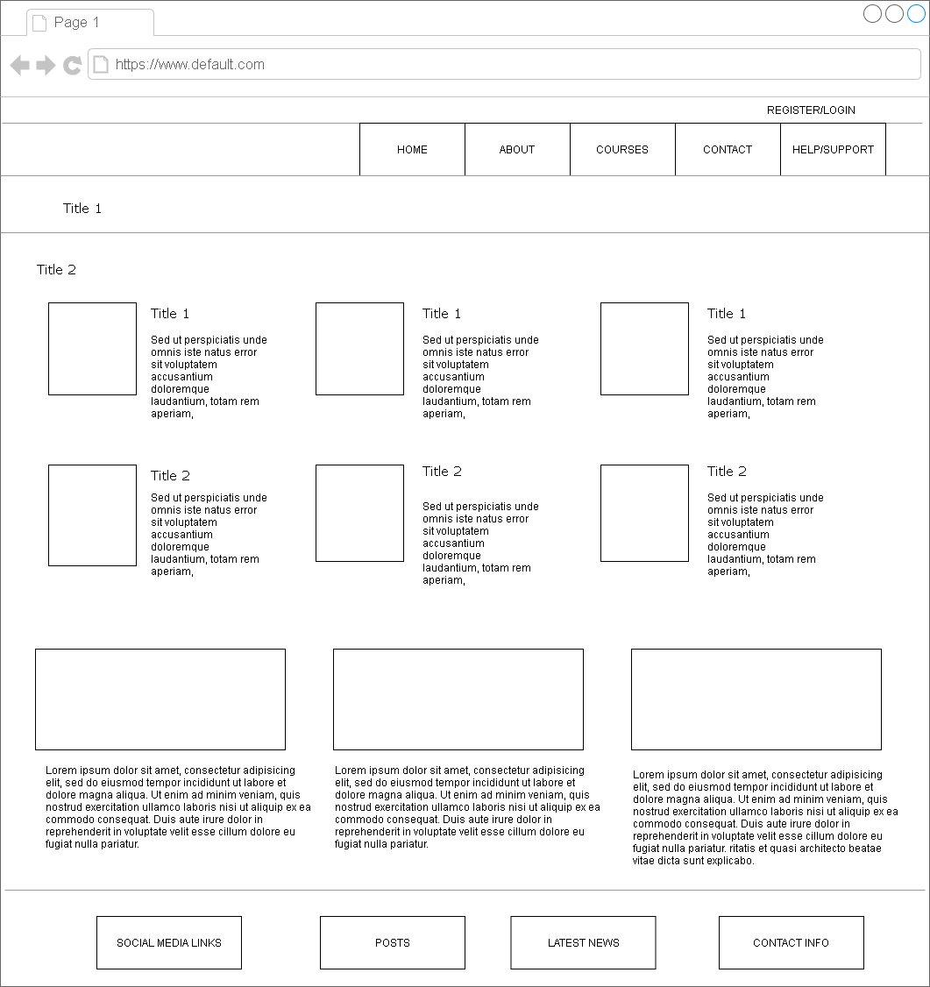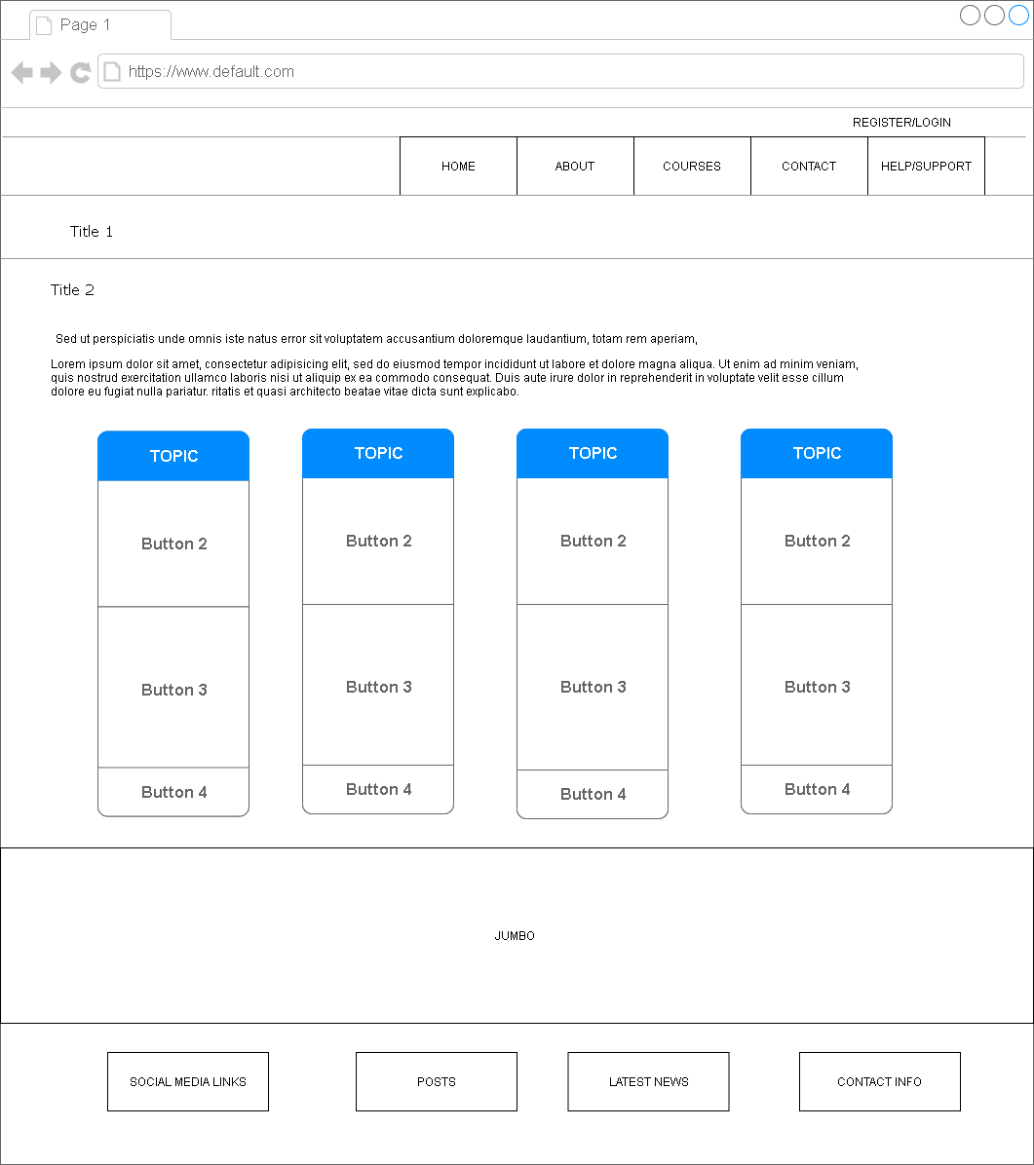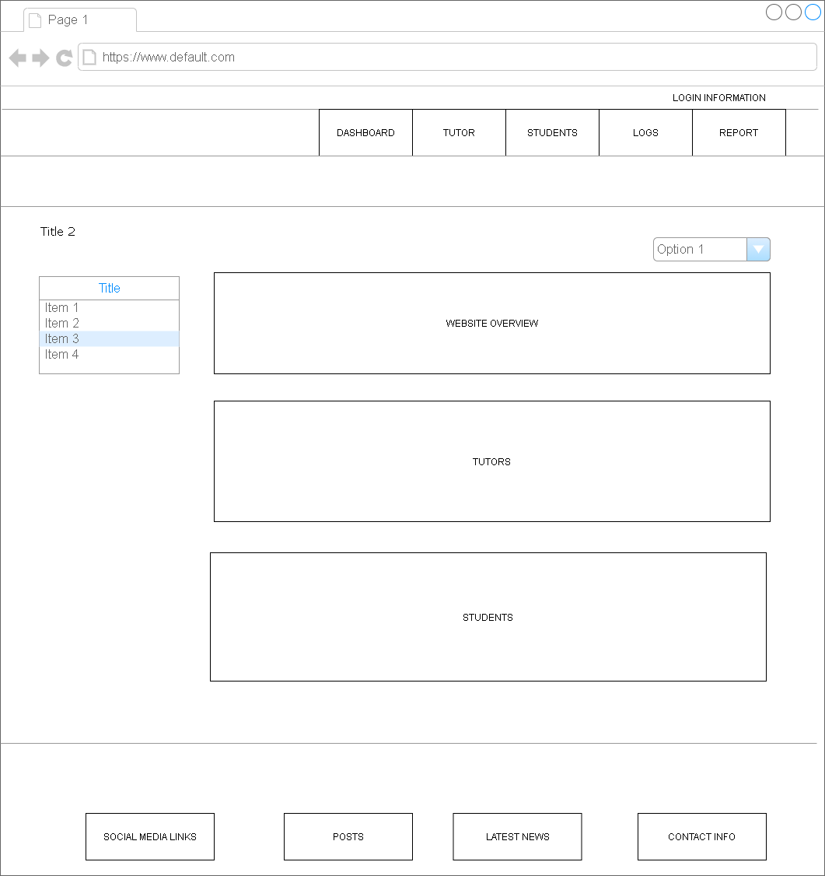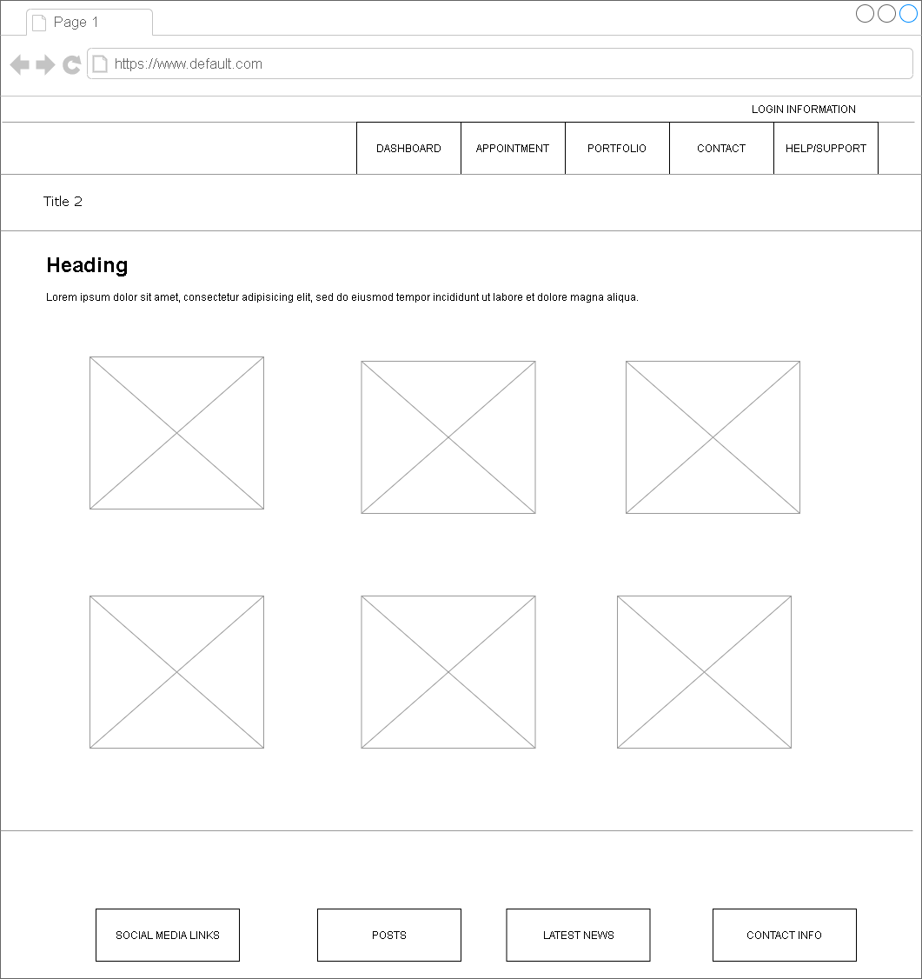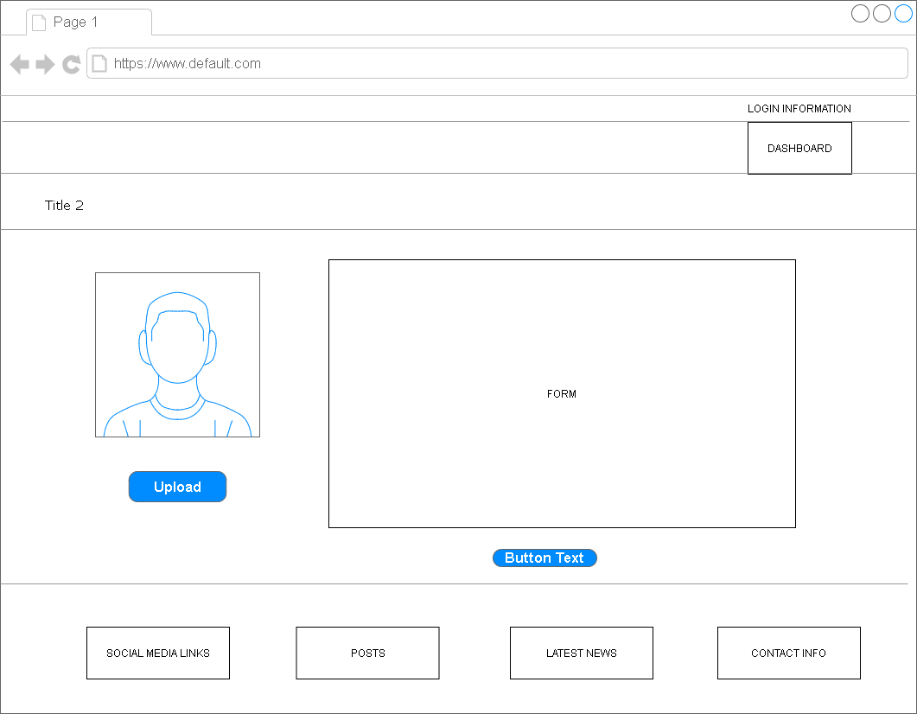

# Project Task Checklist

**Name: Skills Tutor Scheduling System**

|  |  |
| --- | --- |
| **Deliverable** | **Completed By:** |
| **Client Side** |  |
| **User Interface** |  |
| Aesthetically appealing User Interface | Monique Rose |
| Embed PHP in HTML | Monique Rose |
| Incorporate AJAX | Monique Rose |
| **Server Side** |  |
| Validation |  |
| User inputs should be validated to prevent unclean values being written to the database | Onaje Young |
| Users should get adequate feedback when incorrect values are entered | Onaje Young |
| Database |  |
| Use MySQL Workbench to graphically model database | Onaje Young |
| Generate Database from graphical model | Onaje Young |
| Security |  |
| Only registered users can use the system. | Tyshorna Henry |
| There should be different access levels for users | Tyshorna Henry |
| Use secure sessions to add additional layer of security | Tyshorna Henry |
| Encrypt passwords before storing into database | Tyshorna Henry |
| All actions performed should be logged, where only administrators can view the logs | Tyshorna Henry |
| General Requirements |  |
| Use of Control Structures (Selection and Iteration) | Abigail Thomas |
| Use of user defined Functions | Abigail Thomas |
| Use of built in Functions | Abigail Thomas |
| Use of include() and require() functions | Abigail Thomas |
| Use PHP Mail functions | Abigail Thomas |
| Use Custom PHP Classes | Abigail Thomas |
| Connect to MySQL Database | Abigail Thomas |
| Manipulate data in database | Abigail Thomas |
| Use PHP Sessions and Cookies | Abigail Thomas |
| Incorporate Object Oriented PHP paradigm | Abigail Thomas |
| Implement the PHP QR Code is open source (LGPL) library | Abigail Thomas |
| Upload images | Venessa Barrows |
| Generate and display Thumbnails | Venessa Barrows |
| Generate PDF Reports | Venessa Barrows |
| Use of Files | Venessa Barrows |
| Read information from **.xls** or **.csv** files | Venessa Barrows |