Submitted by

**IDENTIFICATION OF OPTIMUM DRUG COMBINATION FOR CANCER USING BOOLEAN NETWORKS**

ABHISEK KARMAKAR (13000114006)

ARGHA NANDAN (13000114015)

BISHAL SAHA (13000114023)

Under the guidance of Prof. Tapan Chowdhury

Submitted for the partial fulfillment for the degree of Bachelor of Technology in Computer Science and Engineering



Techno India

EM 4/1, Salt Lake, Sector – V, Kolkata – 700 091.

## **CERTIFICATE**

This is to certify that the project entitled “Identification of Optimum Drug combination for Cancer using Boolean Networks”, prepared by Abhisek Karmakar (13000114006), Argha Nandan (13000114015) and Bishal Saha (13000114023) of B.Tech (Computer Science & Engineering), Final Year, has been done according to the regulations of the Degree of Bachelor of Technology in Computer Science & Engineering. The candidates have fulfilled the requirements for the submission of the project report.

It is to be understood that, the undersigned does not necessarily endorse any statement made, opinion expressed or conclusion drawn thereof, but approves the report only for the purpose for which it has been submitted.

----------------------------------------------- -----------------------------------------------

(Signature of the Internal Guide) (Signature of the HOD)

----------------------------------------------- -----------------------------------------------

(Signature of the External Guide with Designation and Institute / Organization, as applicable)

(Signature of the External Examiner with Designation and Institute)

--------------------------------------------------------------------------------------------

DEPARTMENT OF COMPUTER SCIENCE AND ENGINEERING

--------------------------------------------------------------------------------------------

**ACKNOWLEDGEMENT**

We would like to express our sincere gratitude to Prof. Tapan Chowdhury of the department of Computer Science and Engineering, whose role as project guide was invaluable for the project. We are extremely thankful for the keen interest he took in advising us, for the books and reference materials provided for the moral support extended to us.

Last but not the least we convey our gratitude to all the teachers for providing us the technical skill that will always remain as our asset and to all non-teaching staffs for the gracious hospitality they offered us.

Place: Techno India, SaltLake

Date:

………………………………

………………………………

………………………………

**TABLE OF CONTENTS**

|  |  |  |
| --- | --- | --- |
| **SL. No.** | **TOPIC** | **PAGE NO.** |
| **1** | **Introduction** | 1 |
| **1.1** | Briefing | 1 |
| **1.2** | Problem Domain | 1 |
| **1.3** | Glossary | 1 |
| **2** | **Problem Definition** | 2 |
| **2.1** | Scope | 2 |
| **2.2** | Exclusions | 2 |
| **2.3** | Assumptions | 2 |
| **3** | **Related Study** | 2 |
| **3.1** | GRN | 3 |
| **3.2** | Boolean Networks | 3 |
| **3.3** | Faults in BN | 3 |
| **4** | **Project Planning** | 4 |
| **4.1** | Software Life Cycle Model | 4 |
| **4.2** | Scheduling | 5 |
| **4.2.1** | Project Schedule | 6 |
| **4.2.2** | Gantt Chart | 7 |
| **4.3** | Cost Analysis | 7 |
| **5** | **Requirement Analysis** | 8 |
| **5.1** | Requirement Matrix | 8 |
| **5.2** | Requirement Elaboration | 8 |
| **5.2.1** | Boolean Network Modelling | 8 |
| **5.2.2** | Unique Input Vector Identification | 8 |
| **5.2.3** | Fault Introduction into Boolean Network | 8 |
| **5.2.4** | Drug Combination Application | 9 |
| **6** | **Design** | 9 |
| **6.1** | Technical Environment | 9 |
| **6.2** | Hierarchy of Modules | 9 |
| **6.3** | Detailed Design | 10 |
| **6.3.1** | Boolean Network Modelling | 11 |
| **6.3.2** | Unique Input Vector Identification | 12 |
| **6.3.3** | Fault Introduction into Boolean Network | 12 |
| **6.3.4** | Drug Combination Application | 13 |
| **6.4** | Test Plan | 15 |
| **7** | **Conclusion** | 16 |
| **7.1** | Project Benefits | 16 |
| **7.2** | Future Scope for Improvements | 16 |
| **8** | **References** | 16 |
|  |  |  |
|  |  |  |

|  |  |  |
| --- | --- | --- |
| **SL. No.** | **List of Tables** | **Page Number** |
| **1.1** | Hardware Specifications | 1 |
|  |  |  |
|  |  |  |
|  | **List of Figures** |  |
| **4.1** | Iterative Waterfall Model | 4 |
| **4.2** | Project Schedule | 5 |
| **4.3.1** | Gantt Chart (November 2017) | 6 |
| **4.3.2** | Gantt Chart (November 2017 – Phase I completion) | 7 |
| **5.1** | Requirement Matrix | 8 |
| **6.2.1** | Hierarchy of Modules | 9 |
| **6.3.1** | Detailed Design | 10 |
| **6.4** | Different types of pathway scenarios | 11 |
|  |  |  |

1. **INTRODUCTION**
   1. **Briefing**

Cancer results in loss of thousands of lives, but the underlying cause for it is very simple and basic. Cancers are caused due to uncontrolled growth of cells in our body [1]. This growth happens due to the presence of faults and malfunctions in the genetic and signaling networks. This uncontrolled cell proliferation is usually accompanied by gene mutations and alterations in the cell.

Given a GRN, a Boolean Network is modelled and the faulty nodes are identified. The input vector, which uniquely generates an output vector is obtained.

Lastly, the optimum combination of drugs which can nullify most of the fault in the network is identified. The result would be the simulation of the network traversal and the combination of the drugs [1].

This will help us understand the workings of proteins in a simple manner. Fault location will convey that every gate in the Boolean Network is a potential fault in the system. Assumption of more than one fault at a given time will produce a more realistic solution to cancerous conditions, while figuring out the drug combination for the faulty network.

* 1. **Problem Domain**
     1. Software Specifications
* Python 3.6 Interpreter
* Spyder 3.2 for Python Programming
  + 1. Hardware Specifications

|  |  |
| --- | --- |
| Operating System | Ubuntu 16.04 LTS |
| Memory | 4 GB |
| HDD | 500 GB |
| Processor | Intel Core i3 |

Table 1.1: Hardware Specifications

* 1. **Related Studies**
     1. **GRN**

A network that has been inferred from gene expression data a “gene regulatory network,” briefly denoted as GRN. The Gene regulatory networks provide information about regulatory interactions between regulators and their potential targets; gene-gene interactions, and potential protein-protein interactions.

* + 1. **Boolean Networks**

A BN [1] (Glass and Kauffman, 1973; Kauffman, 1969, 1993),*B*=(*V,F*), on *n*genes/proteins is defined by a set of nodes (genes/proteins) *V* ={*x*1*,...,xn*}, *xi*∈{0*,*1}, *i*=1*,...,n*, and a list *F* =(*f*1*,...,fn*), of Boolean functions, *fi*:{0*,*1}*n*+*m* →{0*,*1}, *i*=1*,...,n*,*m*≥0 is the number of external inputs e.g. GFs, stresses, metabolites,etc. Each node *xi* represents the state/expression of the gene *i*, where  
*xi*=0 means that gene/protein *i* is OFF (unexpressed or inactiveaccording to their biological significance) and *xi*=1 means thatgene/protein *i* is ON (expressed or active). The function *fi*is calledthe *predictor function* for gene/protein *i*. Updating the states ofall genes/proteins in *B* is done synchronously at every time stepaccording to their predictor functions. If the predictor functions areknown, the dynamics of the BN will solely depend on the set ofinput variables. The dynamic behavior of the BN is quite differentin the presence of different external inputs. For *m* different externalinputs, we can model the dynamical system as 2*m* different closedBNs, each one of which we may define as a ‘context’. The switchingbetween contexts here occurs in response to changes in the activity  
status of external input variables and is, therefore, deterministic.

* + 1. **Faults in Boolean Networks**

A ‘fault’ [1] is defined by any structural error ofthe physical system, such that the dynamics become aberrant. For example, the accumulation of point mutations in the genomic DNAmay cause the signaling pathways to behave erratically leading toproliferation. On the other hand, sometimes the fault may not bein the genetic code of a particular protein, but rather it is in theprotein synthesis factory ribosome, or in some control mechanismof alternative splicing.

In a BN, faults are broadly classified into two types:

* Stuck-At Fault: A stuck-at fault means that a point in the  
  network circuitry is stuck to a particular value. As a result,  
  the incoming information is no longer communicated beyond  
  the faulty point; instead, only the stuck-at value is passed on  
  to the outgoing port.
* Bridging Fault: A bridging fault refersto the disruption of old interconnections and incorporation ofnew interconnections in the network. Bridging faults also makebiological sense. The molecular signal transduction relies onthe sequences and 3D conformations of the molecules involved. So, any variation in the sequence and 3D conformation of a molecule (mainly protein) will alter its functionality.As a result,many pathways involving that molecule will become inactive  
  while the altered molecule may open up new ones. Without  
  any loss of generality, this kind of aberrant behavior could be  
  modeled as a bridging fault in the BN.
  + 1. **CUDA**

CUDA[8] (Compute Unified Device Architecture) is a parallel computing platform developed by NVIDIA and programming model that makes using GPU (Graphics Processing Unit) for general purpose computing simple and elegant.

NVIDIA provides a system software that allows our programs to communicate with the CUDA-enabled hardware.

Using this driver we transfer our data to be processed to the GPU and process data in parallel and transfer the output back to the CPU for further usage.

Using this architecture we can efficiently process all the parallel jobs in very less time instead of depending upon CPU for batch processing of similar data.

The kernel code (Executable in GPU) is written using C Language.

* + 1. **PyCUDA**

PyCUDA [9]is a Python Programming environment for CUDA. It lets us access Nvidia’s CUDA Parallel computation API from Python.

It maps all CUDA into Python and enables run-time code generation for flexible, fast, automatically tuned codes. It is robust and convenient since there is a minimum need to handle all the hardware resources.

* 1. **Glossary**

GRN [3]: A network that has been inferred fromgene expression data a “gene regulatory network,” is briefly denotedas GRN.

Boolean Network(BN) [1]: A Boolean Network B (v, f), on n genes / proteins is defined by a set of nodes V=(x1……xn), xi∈ {0, 1} where I = 1… n and a list F = (f1…..fn) of boolean functions, fi: {0, 1} n+m 🡪 {0, 1}, i= 1….n, m>=0 is the number of external inputs e.g. GFs, stresses, metabolic, etc. Each node xi represents the state / expression of the gene I, where xi = 0 means the gene / protein i is OFF (inactive) and if xi = 1, that means gene / protein is ON (active).

Faults: A ‘fault’ is defined by any structural error of the physical system, such that the dynamics become aberrant. For example, the accumulation of point mutations in the genomic DNA may cause the signaling pathways to behave erratically leading to proliferation. These faults could cause structural changes in the regulatory network, thereby changes its dynamic and steady-state behavior.

Data Frame: Data Frame is a 2-D data structure which has columns of different types. It is the most used structure in the pandas package.

1. **PROBLEM DEFINITION**
   1. **Scope**

The Boolean Network derived from the GRN would not only enable us to simplify the network to understand the logic but also to introduce faults and analyze how the drug will act at particular points of the BN. This will help us understand the behavior of the network when a drug will be introduced to it. The mutations caused by cancer are irreversible but a perfect drug combination can help us nullify the faults in the network which will contribute to save lives in the near future.

* 1. **Exclusions**

The part where analysis which particular gene are affecting the growth factors to send the messages to the cells to proliferate is excluded.

* 1. **Assumptions**

The Boolean nature of proteins, although their actual levels are not quantized, but continuous.

Only Stuck-At faults [1] are considered assuming there are no bridging faults.

The drug which produces the output vector closest to the fault-less network, is optimum for the therapy.

The binary numbers used in this document are written as b1b2b3b4 instead of [b1,b2,b3,b4] for ease of understanding. They are lists, not numbers.

1. **PROJECT PLANNING**
   1. **Software Life Cycle Model**

In our Project we have followed the Iterative Waterfall Model [7]:

The problems with the waterfall model created a demand for a new method of developing systems which could provide faster results, require less up-front information and offer greater flexibility. Iterative model not only divides the project into small parts but also allows the development team to demonstrate results earlier on the process and obtain valuable feedback from system users. Each iteration is actually a mini-waterfall process with the feedback from one phase providing vital information for the design of the next phase.

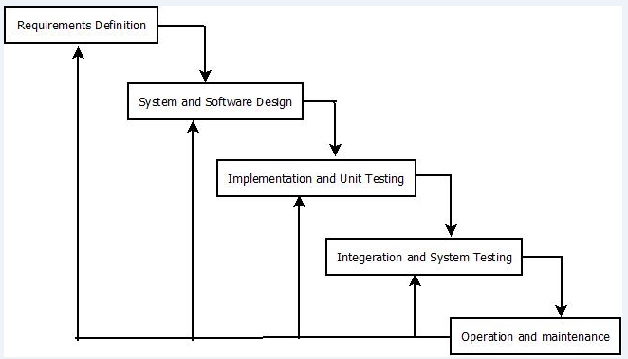

Figure: 4.1 Iterative Waterfall Model

* 1. **Scheduling**
     1. **Project Schedule**

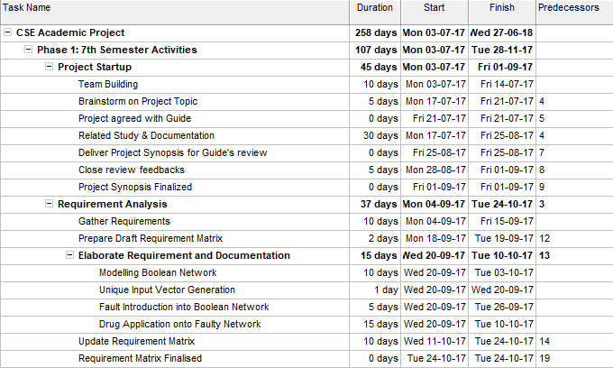

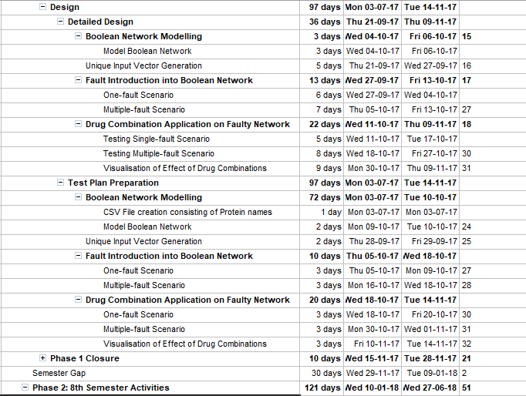

Figure 4.2: Project Schedule

* + 1. **Gantt Chart**

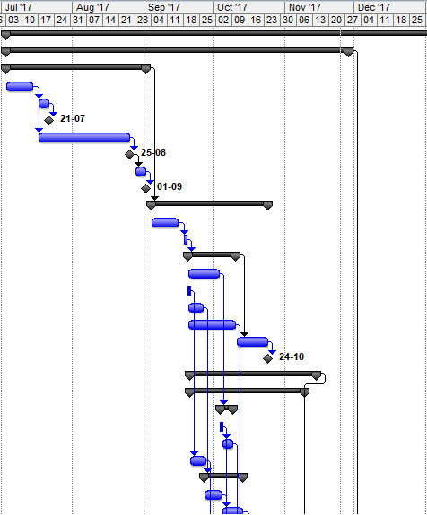

Figure 4.3.1: Gantt chart (November 2017)

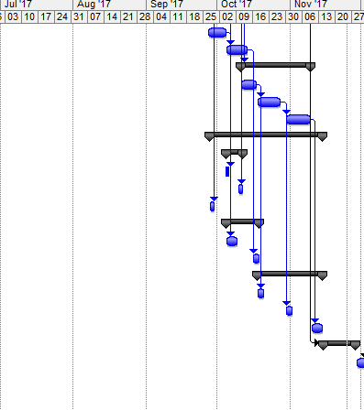

Figure 4.3.2: Gantt chart (November 2017 – Phase I closure)

* 1. **Cost Analysis**

Lines of Code= 7201.76 = 7.202 KLOC

Effort= 2.4*7.2021.05= 19.07752

Duration= 2.5*Effort0.38 = 7.67 months

Cost= ₹183971.1

Men Required= Effort / Duration = 2.488 ~ 3

1. **REQUIREMENT ANALYSIS**
   1. **Requirement Matrix**

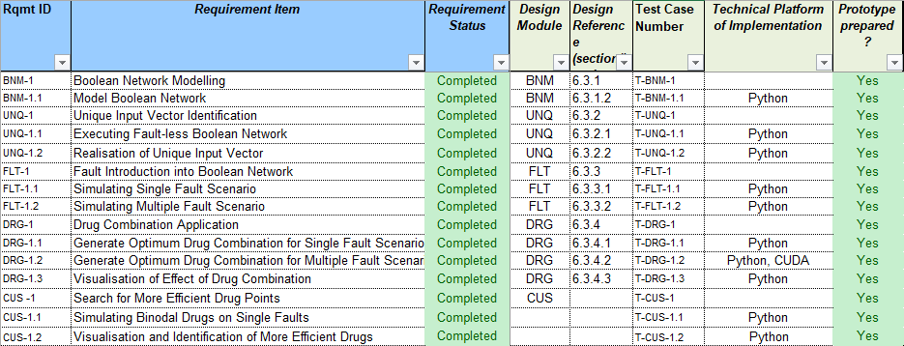

Figure 5.1: Requirement Matrix

* 1. **Requirement Elaboration**
     1. **Boolean Network Modelling**

From a given GRN, a Boolean Network needs to be modelled. We generate a CSV file containing all the proteins belonging to a Growth Factor Signaling pathway and using that data we establish their connections in the form of the Boolean Network. Some of the proteins are inputs known as growth factors; some are the nodes inside the pathway, while the rest are outputs as transcription factors and residual proteins which trigger proliferation if activated.

* + 1. **Unique Input Vector Identification**

A unique vector containing a combination of 0’s and 1’s is to be obtained from the modelled Boolean network. That input vector would further help to analyze the network after the introduction of the fault.

* + 1. **Fault Introduction into Boolean Network**

Since we’re only considering stuck-at faults, we’ll program the faults in the network such that instead of computing the values of nodes from data taken from adjacent nodes, some particular nodes will bear only one value, 0 or 1, no matter what it gets as input. Those nodes will transfer those same stuck-at faults to the next adjacent nodes as input.

We’ll consider two scenarios: a) only one fault in the network at any given time, and b) more than one faults in the network at any given time.

* + 1. **Drug Combination Application**

Having found the unique input, and classified the number of faults in the network, we’ll apply a combination of drugs which attempts to nullify the effect of faults on the output vector.

We’ll apply each of the combinations, and identify the one, which generates an output vector closest to the output generated in a fault-less Boolean Network, as the optimum therapy for that cancerous condition.

* + 1. **Search for more efficient drug Points**

Having worked with known drugs in the previous module, we will look for new drug inhibition points, which may produce better results than what achieved with known drugs. Upon generation, the nodes where the new drugs are attacking may serve as a guideline to manufacture drugs which inhibit those points.

1. **DESIGN**
   1. **Technical Environment**

We are using Ubuntu 16.04 as the base Operating System, Intel Core i3 processor, 4 GB RAM, 500 GB HDD, NVIDIA 820 M GPU.

We need Python v3.6 for interpreting our programs and for the programming we’re using Spyder 3.6 IDE, which is a part of the Anaconda software package. Spyder comes pre-built with all the necessary packages and libraries, like pandaS, numpy, matplotlib, etc., which we need to construct our DataFrames and visualize our results in the end.

We need CUDA enabled GPU for parallel computation and CUDA drivers provided by NVIDIA.

We need PyCUDA which will help to implement the CUDA kernel code from Python.

* 1. **Hierarchy of Modules**

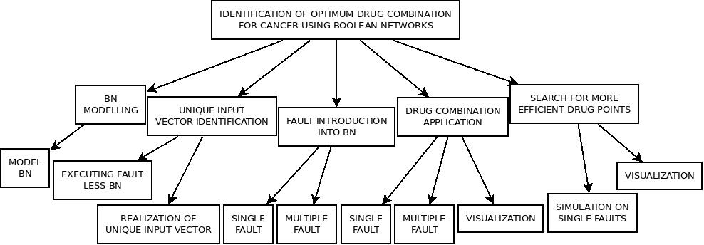

Figure 6.2.1: Hierarchy of Modules

* 1. **Detailed Design**

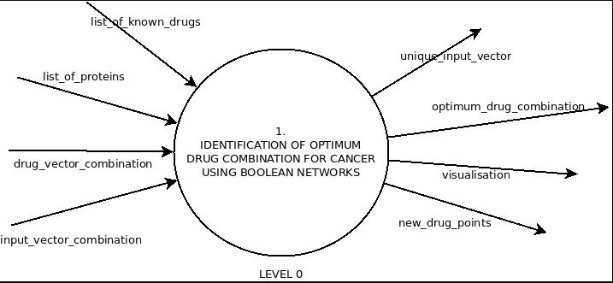

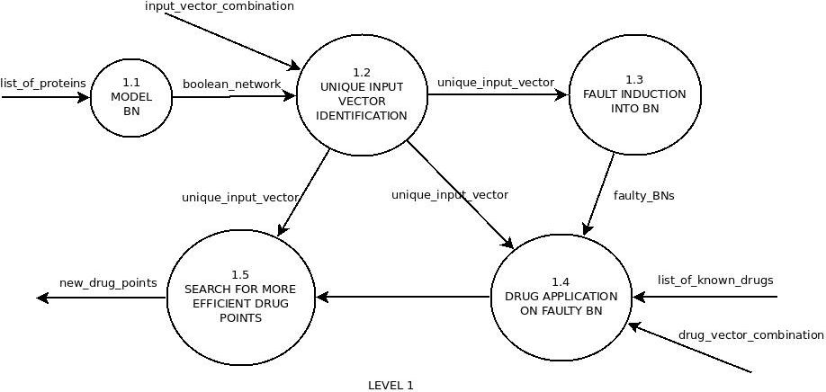

Figure 6.3.1: Data Flow Diagram

* + 1. **Boolean Network Modelling**
       1. **Model Boolean Network**

From the given signaling pathway [1], we’ll construct the pathway logic, by replacing the proteins with nodes which only bear Boolean values. There are four types of pathway logic [2], which use logic gates to interpret the given scenario. The scenarios are as follows:

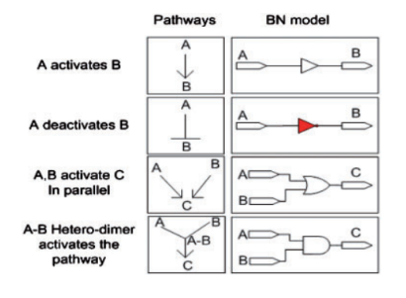

Figure 6.4: Different types of pathway scenarios

In scenario 1, the value of one node is transferred to the next as it is. This corresponds to a situation where a protein is activated only if another is also active.

In scenario 2, the value of one node is transferred to the next through a NOT gate. This corresponds to a situation where an active protein deactivates the next.

In scenario 3, the values of two different nodes are passed to the next through an OR gate. This corresponds to a situation where a protein is activated if at least one of the previous proteins is active.

In scenario 4, the values of two different nodes are passed on through an AND gate. This corresponds to a situation when a protein is activated only if the previous two proteins are activated.

We use this strategy to program the entire pathway logic into a Boolean Network, with 5 input proteins, 23 proteins in the pathway and 7 output proteins.

All three modeling would be programmed; one with faults, one with faults and known drugs, and one with faults and custom drugs.

* + 1. **Unique Input Vector Identification**
       1. **Executing fault-less Boolean Network**

As of now, the Boolean Network doesn’t have any induced faults. Keeping the 5 protein input vector in mind, we know that a Boolean number consisting of 5 bits, generates 32 combination.

So, we execute the Boolean Network using each combination as the input vector, and observe the output vectors.

* + - 1. **Identifying Unique Input Vector**

We get 32 output vectors corresponding to the 32 input vectors. If the Boolean Network we’ve designed is correct, i.e. in accordance with the signaling pathway which it is modeled from, we expect to get at least one input vector, which corresponds to an output where all the bits are 0’s.

This goes along with the biology of signaling pathway, as there should be at least one combination which stops the cells from dividing, i.e. the output vector which triggers apotosis is 0000000.

If we find the input vector, we use that vector in our future programs. If we don’t, it is certain that the modeled Boolean Network is not modeled properly.

* + 1. **Fault Introduction into Boolean Network**
       1. **Testing Single Fault Scenario**

Having found the unique input vector, we’ll use this vector for all the operations coming next. In this section, out of all the 24 potentially faulty gates in the network, we will consider only one fault at a time. We will run the Boolean Network (now faulty) with the same input vector, but each time we would change the fault location.

Now, there are two types of gates in the network, one where a NOT (inverter) is involved, which is shown in red, and some do not involve a NOT gate, i.e. AND, OR. The guide to inducing stuck-at faults biologically is given in reference [1].

We will observe all the output vector generated, a total of 24 for each fault, and classify them according to their resemblance to other faulty outputs.

A special type of fault is the **undetectable fault**, where the output vector is the same as that of the fault-free Boolean Network. In this situation, the fault cannot be detected because it generates the output vector=0000000.

* + - 1. **Testing Multiple Fault Scenario**

We have created a double fault scenario in which we are applying two faults at a time.

There are 24 nodes and considering 2 faults, the total number of combinations are 24C2 = 276. Thus the dimensions of the output DataFrame would be 7×276, i.e. 7 output proteins as rows and 276 faulty conditions as columns.

Now, we have created a triple fault scenario in which we are applying three faults at a time.

Considering that, the total number of combinations would be 24C3 = 2024 which is relatively large and will take much more computation time.

* + 1. **Drug Combination Application**
       1. **Single Fault Scenario**

Say, we have four drugs, and we know where in the Boolean Network they usually interfere. Here is how a drugs works in accordance with pathway logic:

For example, let’s consider a stuck-at-1 fault [1] in the network, meaning the gate is conveying the value 1 to the following nodes no matter what the function and input values are for that particular node. If we apply a drug, i.e. the logical value of drug is 1, and pass it through an inverter to an AND gate, whose other input is the faulty path itself, the inverted value of the drug, i.e. 0, will generate the value 0 from the AND gate, thus changing the value of that particular signal. In simple words, the drug inhibits the effect of the faulty protein.

Now, in our case, there are 24 potential faults, and 6 drugs. So, for each faulty node, there is going to be 26=64 drug combination that we can use to generate the output vectors and observe how they change in contrast to the faulty output, and how close they are to the non-proliferative output (0000000) and how far they are from the proliferative output (1111111).

* + - 1. **Multiple Fault Scenario**

In the previous section, we considered only one fault at a given time. Here, we will consider at least two faults. So, the number of rows, i.e. drug combinations will be 64 (assuming six drugs in the vector), and the number of columns is going to be, as we found out in the previous module, 276.

Again, we can increase the number of faults if we have the computing time.

* + - 1. **Visualization of Effect of Drug Combination**

Since, we have 7 output bits in the output vector, and say, for example, that a particular output is 1111111, this does not mean that the output is 127. The output vector doesn’t convey a value, but the states of the output proteins in that particular input and faulty condition.

Out of the seven outputs, 4 are transcription factors, which finally trigger the proliferation if required, and the rest are residual proteins. So, we have to separate the output vector into two parts and develop an expression that converts each of them into a meaningful number.

Let, output = [a,b,c,d,e,f ,g]

F =a+b+c+d

S = e+f +g

P=F×S

S=F+S

*f*(Output)=*z*P+(1−*z*)S,

Choosing the value of *z* is important as it will result in the difference between the outputs of the application itself.

Now, for visualizing the results, the closest the value of ***f*** is to zero, the greener it will be displayed in the table. The far it gets from zero, the redder it will appear. In the end, the row, i.e. the combination of drugs, with the most number of values closer to zero (the most greenish number of entries), will be the optimum therapy if the fault location is unknown.

In the location in known, we would isolate that particular column from the DataFrame, and look for the greenest entry, and the corresponding drug combination will be the optimum therapy.

* + 1. **Search for more efficient drug points**
       1. **Simulation of binodal drugs on single faults**

After getting some new drug points which are consideredto be more efficient than the previously available points, we simulate that condition to generate the output matrix in a single fault scenario.

* + - 1. **Visualization**

We visualize the matrix as an image . The drug combination with the output more greenish than what achieved by the optimum drug combination in the previous module, is going to be our desired result.

* 1. **Test Plan**

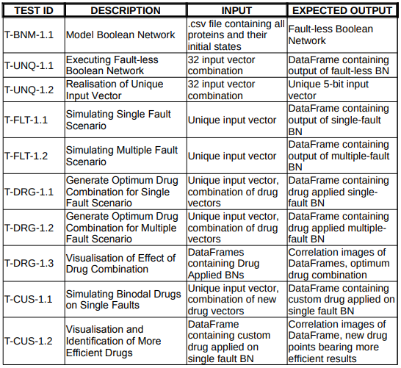

1. **Implementation**
   1. **Implementation Details**
      1. **Boolean Network Modelling**

pathway_normal.py contains our network flow, which takes faults, input, pathway, outputs as lists. Since, in this module, the network doesn’t have any fault, we would pass [0] as the fault list, so that it doesn’t flow throught any faulty statement.

pathway_drugged.py contains the network with faults along with the inhibition points of the known drugs.

pathway_custom.py contains the network with faults and the custom inhibition points of new drug combinations generated in the last module.

* + 1. **Unique Input Vector Identification**
       1. **Executing Faultless Boolean Network**

The Fault Less network, i.e. pathway_normal.py with fault list=[0], is traversed and all possible input vectors consisting of 0’s and 1’s are passed as input vector, and output vectors are generated..

* + - 1. **Realization of Unique Input Vector**

From all the output vectors obtained by traversing the network, we take a unique input value, corresponding to a unique output vector, which will act as the input vector for all the subsequent phases.

In our case the Input Vector obtained is 00001, which is the only input combination that produces the output vector 0000000.

* + 1. **Fault Introduction into Boolean Network**
       1. **Simulating Single Fault Scenario**

We introduce one fault at a node and traverse throughout the network. With every iteration, we introduce one fault to every node of the network.

The function pathway_normal.py takes in parameters as follows:def pathway(faultv,inpv,pathv,outv)

Here, only one fault location is sent in the faultv list, and inpv contains the unique input vector generated in the previous module.

* + - 1. **Simulating Multiple Fault Scenario**

Two Fault Scenario: Unlike the single fault scenario, in the two fault scenario, we are considering two nodes which are faulty for each iteration throughout the network.

Three Fault Scenario: In this case we are considering three faulty nodes at a time during a single iteration of the network.

Here, faultv takes in two and three faultv locations for a given iteration, for double and triple fault simulations respectively.

* + 1. **Drug Combination Application**
       1. **Generate optimum drug for single Fault Scenario**

The python function pathway_drugged.py models the Boolean network along with the inhibition points of six known drugs. Here, along with the fault location list, a drugv list would be passed in the parameter list, containing the drug combination for that particular network flow. faultv contains only one fault location per network iteration.

pathway_drugged.py takes parameters as:

def pathway(faultv,drugv,inpv,pathv,outv)

* + - 1. **Generate optimum drug for multiple Fault Scenario**

The same drugv contents are sent from the previous sub-module. But the faultv list would contain the list of all locations which will be faulty for that iteration.

Since, the three-fault scenario is going to generate is large DataFrame, which will take more than 6 minutes of computing time, if run on the CPU, we will use the machine’s GPU to compute the results in parallel threads. This approach will reduce the computing time down from 6 minutes to about 30 seconds.

* + - 1. **Visualization of Effect of Drug Combination**

The DataFrames generated from the previous two sub-modules are taken as input to a matplotlib function called imshow(). The x-axis maps the fault locations, and the y-axis maps the different drug combinations.

On a relatively large input, like what contains in the three-fault output, the image generated will be hard to understand, since each of the results will take less space than a pixel, a program condenser.py would return a single condensed value for each drug combination. This will increase the readability of the image, to an extent where a simple scatter plot, a function of the matplotlib package, can be used to map the values returned from each drug combination.

The drug vectors corresponding to the lowest points in the scatter plot is the optimum drug combination generated.

* + 1. **Search for More efficient drug points**
       1. **Simulating binodal drugs on single faults**

A combination of different drugs would be generated, each of which affects two nodes in the network at a time, just like what we did in the two-fault simulation. Those set of combinations will be applied to a network containing single faults. The results would be stored in the DataFrame.

* + - 1. **Visualization and Identification of more efficient drugs**

matplotlib’s imshow() and scatter() would be used to visualize the results produced in the previous sub-module. Conclusions would be drawn as done in module 6.1.4.3. If results are better than what produced using known drugs, we’d conclude that we’ve generated the desired results.

1. **CONCLUSION**
   1. **Project Benefits**

* Laying out a Boolean Network from a Gene Regulatory Network will help us understand the workings of proteins in a simple manner, stemming from the fact that every protein has an ON-OFF feature.
* Identification of unique input vector will produce output vectors which signify both proliferative and non-proliferative situations.
* Fault location will convey that every gate in the Boolean Network is a potential fault in the system.
* Assumption of more than one fault at a given time will produce a more realistic solution to cancerous conditions, while figuring out the drug combination for the faulty network.
  1. **Future Scope for Improvements**
* Introduction of more than two faults if we can get increased computation power.
* Introduction of bridge faults.

1. **REFERENCES**

* [1] Ritwik Layek, Aniruddha Datta, Michael Bittner and Edward R. Dougherty, “Cancer therapy design based on pathway logic”, Bioinformatics, Vol. 27, Advance Access 30 December 2010
* [2] Osama A. Arshad, Priyadarshini S Venkatasubramani, Aniruddha Datta, Jijayanagaram Venkatraj, “Using Boolean Logic Modeling of Gene Regulatory Networks to Exploit the Links Between Cancer and Metabolism for Therapeutic Purposes”, IEEE Journal of Biomedical and Health Informatics, Vol. 20, No. 1, January 2016
* [3] Frank Emmert-Streib, Matthias Dehmer, Benjamin Haibe-Kains, “Gene regulatory networks and their applications: understanding biological and medical problems in terms of networks”, Frontiers in Cell and Developmental Biology, Mini Review Article, 19 August 2014
* [4] Handbook of Computational Molecular Biology, “Chapter 27: Identifying Gene Regulatory Networks from Gene Expression Data”
* [5] Anwoy Kumar Mohanty, Student Member, Aniruddha Datta, Vijayanagaram Venkatraj, “A Model for Cancer Tissue Heterogeneity”, IEEE Transactions on Biomedical Engineering, Vol. 61, No. 3, March 2014
* [6] <https://www.cancer.gov/about-cancer/understanding/statistics>
* [7] Fundamentals of Software Engineering (Rajib Mall)
* [8] Cuda By Example, NVIDIA
* [9] <https://developer.nvidia.com/pycuda>