QUESTION 2.1

0.1

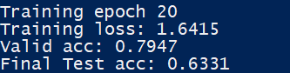

0.01

0.001

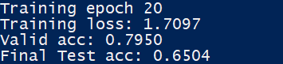

QUESTION 2.2

DROPOUT = 0.3, LR = 0.001, SGD, RELU, 1 LAYER, 1 BATCH SIZE

