Continuous Delivery

Lab 2

Tennis Smith

2019-07-12

# Prerequisites

Students will need a computer with:

* An Amazon Workspaces login (see your instructor for details)

# Lab 2

Lab2 will extract the tag of the latest docker image (1 below) in the registry and then stage it to an s3 bucket (2 below). On each instance, there is a cron job that will read the s3 bucket once per minute (3 below). If the tag in the bucket is newer than the currently-running website, then the instance will pull an image from the registry (4 below). Then, the training instance will restart the website with the new docker image (5 below). The idea is to provide a way for Jenkins to control when a training instance updates to a new version of the website.

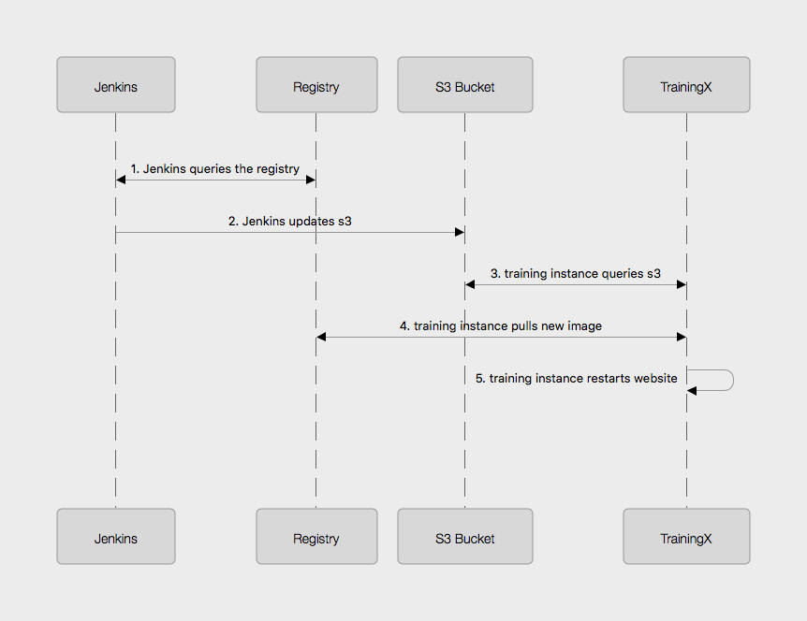

## Step 1: Login to GitHub

* In your workspaces session, open a web browser and login to github: <http://github.com>

**Tip**

If you don’t have a GitHub account, go to <http://github.com> and create a free account

## Step 2: Fork the lab2 repo

* Go to this url: <https://github.com/RoundTower-io/cd_workshop_lab2>
* Fork the repo by clicking on the "Fork" button in the upper right of the screen.
* This will create a copy of the lab2 repo under your own GitHub id

## Step 3: Clone a copy of the lab2 repo

* In your workspace session, open a new terminal window by clicking on the Powershell icon. 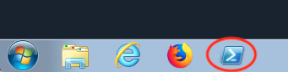
* Make a local copy of the repo by cloning it with the following command

git clone https://github.com/<your user name>/cd_workshop_lab2.git lab2

## Step 4: Update the Jenkinsfile

* Go to the home directory of your new repo
* cd lab2
* Now edit the file Jenkinsfile
* atom Jenkinsfile
* Change every occurrence of training99 to your training ID (assigned by the instructor).
* Save and exit the file

## Step 5: Commit Changes and Push to Central Repository

* First, change the working directory.

cd ~/lab2

* Next, add all altered files to the change set.

git add .

* Next, commit the changes.

git commit -m "Updated Jenkinsfile"

* Last, push the change to GitHub.

git push

## Step 6: Setup a Jenkins pipeline

* Login to Jenkins at <http://jenkins.roundtower.io>
* Login using your assigned training id (get it from your instructor).
* Click on the "New Item" option on the main menu

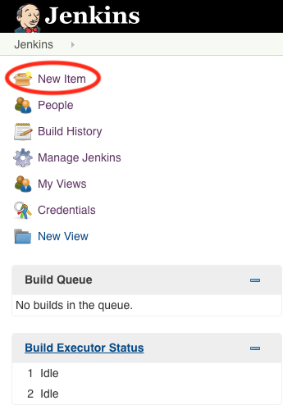

* Name your new pipeline <your training id>_lab2 and select pipeline as the type. Then click ok to save it.

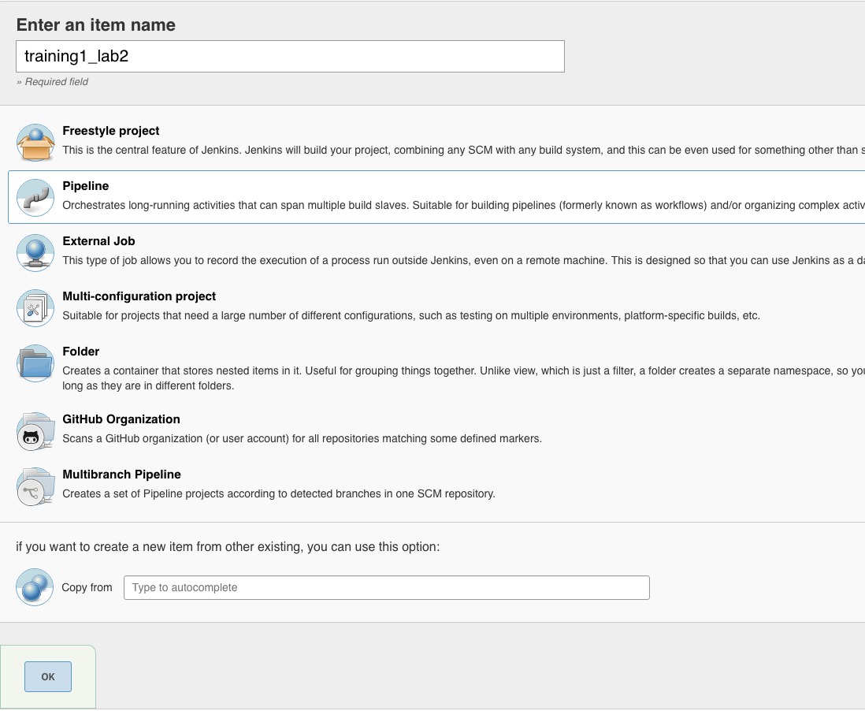

* At the bottom of the page, set the Definition field to Pipeline script from SCM, then set the SCM field to Git. Put your lab2 url in the Repository URL field. Finally, click on Save to save all your work.

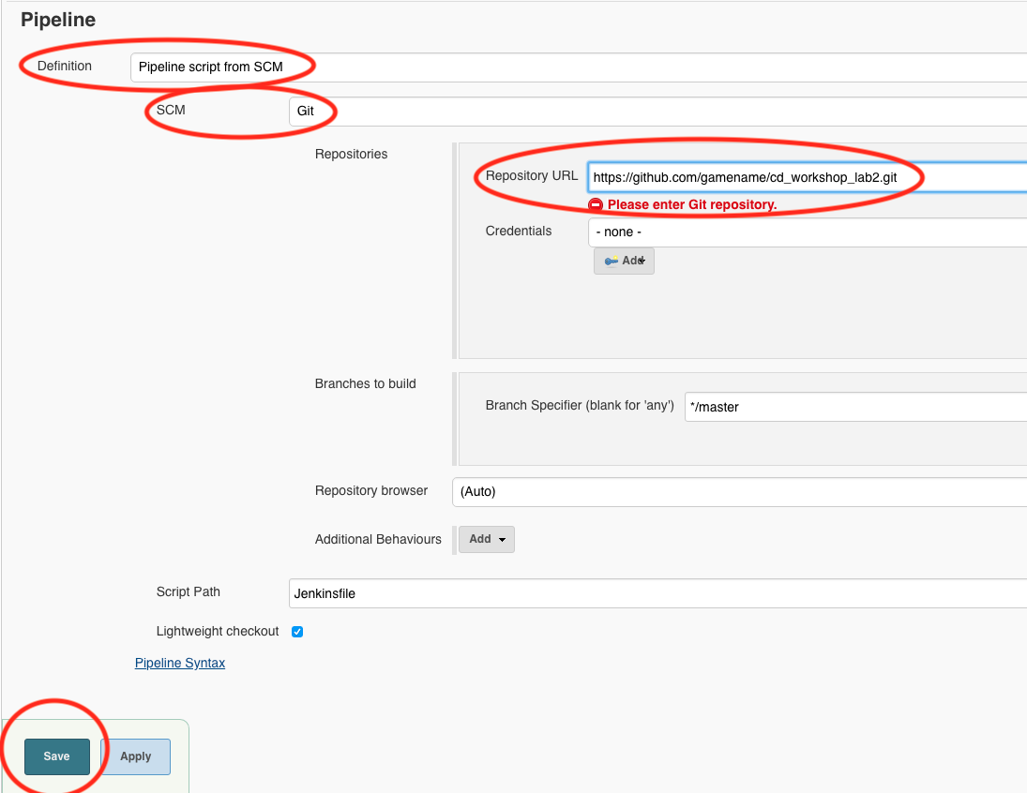

* Click Build Now on the upper left of the screen.
* After the build, click on your trainingX_lab2 link on the dashboard. You should see output something like this:

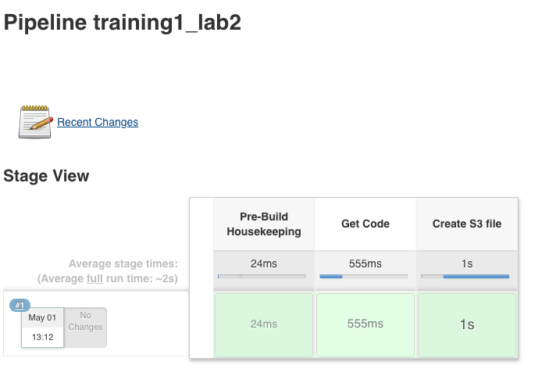

## Step 7: Access website

* Go to the following URL based on your training ID number, <http://trainingX.roundtower.io>. For example, if you are assigned training1, then the url would be <http://training1.roundtower.io>
* You should see something like this

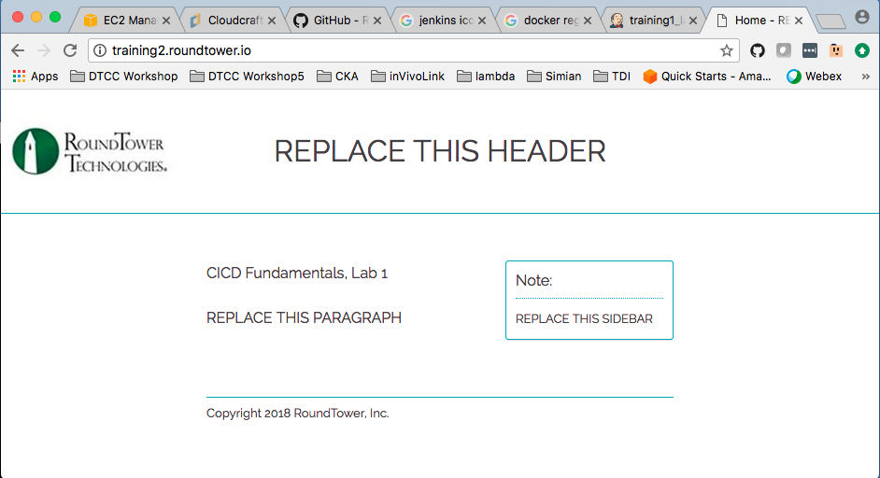

## Step 8: Setup trigger of lab2 build on completion of lab1 build

* Click on trainingX_lab2 on the main dashboard.
* Now click on Configure on the left side of the screen. This will take you back to the configuration options for lab2’s pipeline
* Scroll down to Build Triggers and click on Build after other projects are built (it is the first option in the list).
* In the Projects to watch field, put in the name of your lab1 pipeline. For example, if your training ID is training2, then the lab1 pipelne will be named training2_lab1. Make sure that Trigger only if build is stable is selected too.

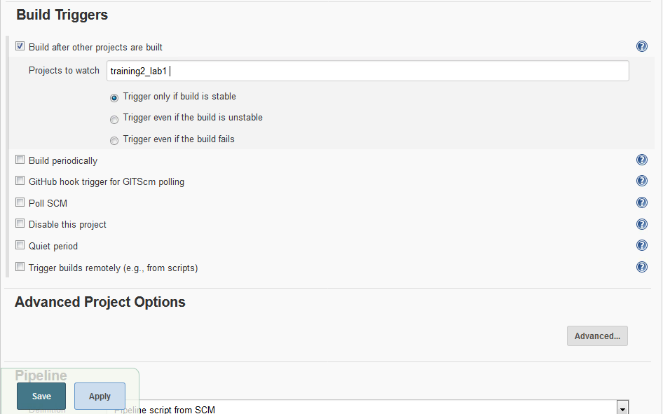

* Click on Save and exit the configuration.
* From now on, lab2 will build **only if** your lab1 pipeline builds successfully.

## Step 9: Update website unit test and source

Now we are going to update the website itself and the unit tests that verify those changes.

* Go back to your **lab 1** directory

cd ~/lab1

* Edit src/site/views/layout.jade

atom src\site\views\layout.jade

* Replace REPLACE THIS TITLE with your training ID. Then save and exit the file.

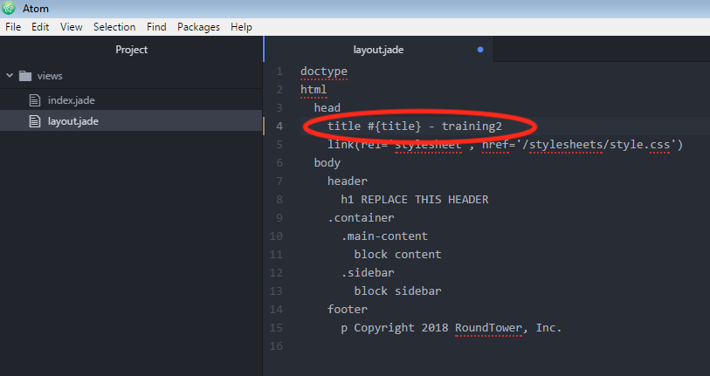

* Now edit tests/layout-test.txt to update the test for the new layout.
* atom tests/layout-test.txt
* Edit the top line and make it **exactly** like the line from layout.jade you edited in previous steps. Save and exit the file.

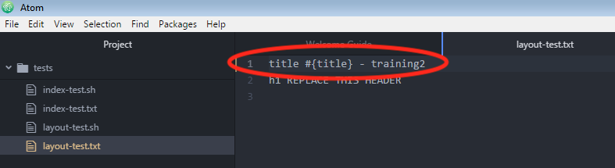

* Now, add your latest changes to the changelist
* git add .
* Commit your changes to the local repository
* git commit -m "updated header and unit test"
* Finally, push your changes back to GitHub’s repository
* git push

## Step 10: Checking website for updates

* The push in step 9 should have kicked off a new build for your trainingX_lab1 pipeline.
* When that lab1 build completed, it should have kicked off a new lab 2 pipeline build.
* Go to your website at training<your number>.roundtower.io.
* The Home tab should now have your training ID next to it. Example 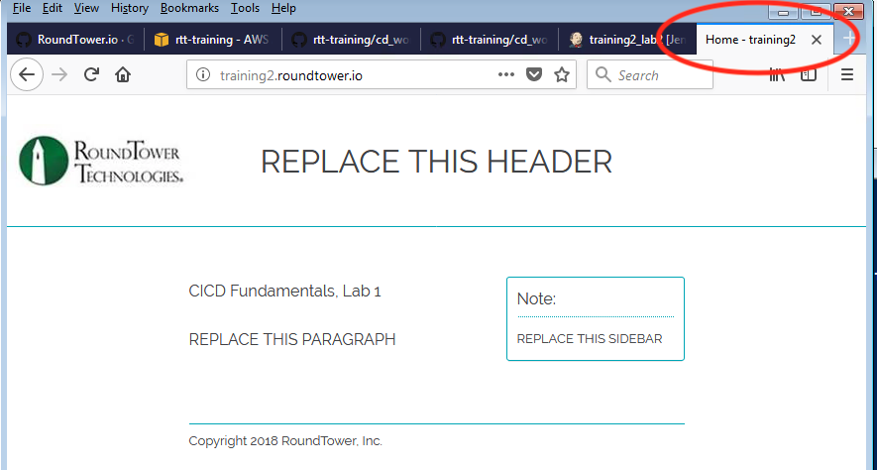
* Congratulations! You’ve completed the Labs!

## Step 11: Extra credit

* Rerun steps 9/10 and change other fields in the web page.