

JAVA FUNDAMENTAL
Java Fundamental

Contents

- Introduction to Java Programming Language

- Introduction to Variables, Operators & Data types

- Introduction to Decisions making, Iteration & Array

- Object-Orientation & class design

- Inheritance, Encapsulation & Polymorphism

- File input/output & Exception handling

- Collection

- Threading
Java Fundamental

Topic 1 Introduction to Java Programming Language

Topic Goals

- To understand the programming language

- Getting start with Java

- To compile and run your first Java program
- To recognize syntax and logic errors

The purpose of this Topic is to familiarize you with the concept of programming language. Here, you will see how to compile and run your first Java program, and how to diagnose errors that may occur when a program is compiled or executed.

What is a Programming Language..?

The term programming language usually refers to high-level languages like C++, Java, C# which contains vocabulary and set of grammatical rules for instructing a computer to perform specific tasks. Therefore programs are sequences of instructions and decisions that the computer carries out to achieve a task.

A computer must be programmed to perform tasks. Different tasks require different programs

The key to learning how to program is to start with the right language. The programming language you choose often depends on the tasks you want to accomplish. Each language has strengths and weaknesses
Java Fundamental

The Java Programming Language

Java was invented a group led by developer James Gosling as a better way to create computer programs. While working at Sun Microsystems, Gosling was
unhappy with the way the C++ programming language was performing

on a project, so he created a new language that did the job better. The language was designed to be simple and architecture neutral, so that it could be executed on a variety of hardware. Currently more than three billion devices across the world are running Java.

Java was originally designed for programming consumer devices, but it was first successfully used to write Internet applets.

Java is an enormously popular programming language as it has grown at a phenomenal rate. Java has a rich library that makes it possible to write portable programs that can on variety of OS. The Java language has an assortment of security features that guarantees that no evil applets can run on your computer. As an added benefit, these features also help you to learn the language faster.

The other benefit of Java is portability. The same Java program will run, without change, on Windows, UNIX, Linux, or the Macintosh.


Java program


Window Linux Unix

Java Fundamental

It simply returns you the portable code that was generated by the Java compiler. The virtual machine on your computer executes that portable code.

Java applications are typically compiled to byte code (.class file) that runs on any Java virtual machine (JVM) across the all operating system. Java is a general-purpose, object-oriented language which was designed to let the developers "write once, run anywhere" (WORA).

Java Virtual Machine(JVM)

JVM is the component of Java framework that executes the compiled Java code. Once we compile a Java file successfully, it interprets that compiled Java binary code (called bytecode). A Java byte code is an intermediate language produced by a Java compiler and only executed on a JVM.
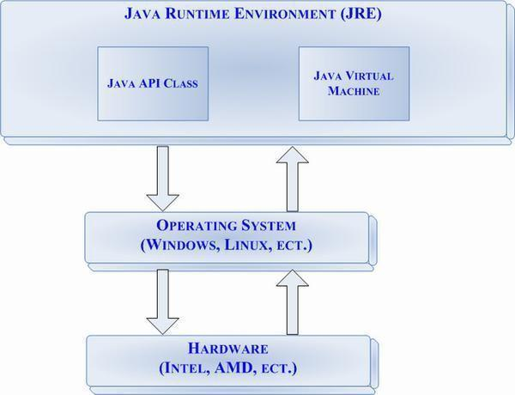
Java Fundamental

JDK and JRE

To start programming in Java, a developer needs: Java development kit (JDK) and Java Runtime environment (JRE).

JDK provides Java API as well as a Java compiler in addition to other tools which allow a programmer to write Java and compile it to a .class file to be executed by a JVM. Javac is the program that compiles Java code into bytecode.
JRE is the execution environment for Java programs which contains JVM.

In order to run your java program you install JRE on your machine but to start writing programs in Java you need to setup JDK too.
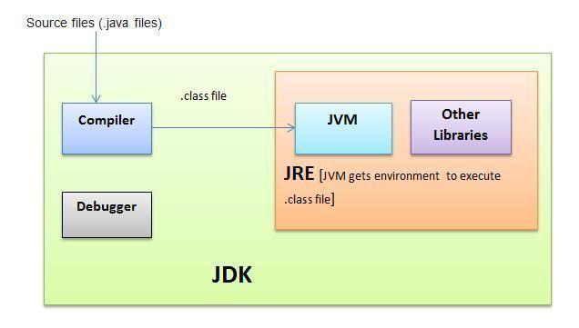

Java has a very large library. Focus on learning those parts of the library that you need for your programming projects.
Java Fundamental

Setting up your machine for Java programming

First you need to install the Java development kit(JDK) on your machine.

Link:- http://www.oracle.com/technetwork/java/javase/downloads/index.html

Make sure to download the correct version compatible to your machine (32bit or 64bit installer). After downloading the installer and setting up your machine, you’ll get the following message:
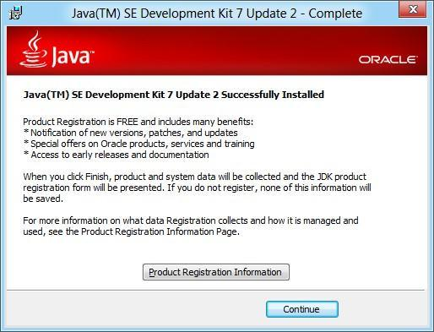

To verify you have successfully installed JDK on your machine, do the following:

- In the windows that opens, type java –version.

- You should information similar to the following:
Java Fundamental
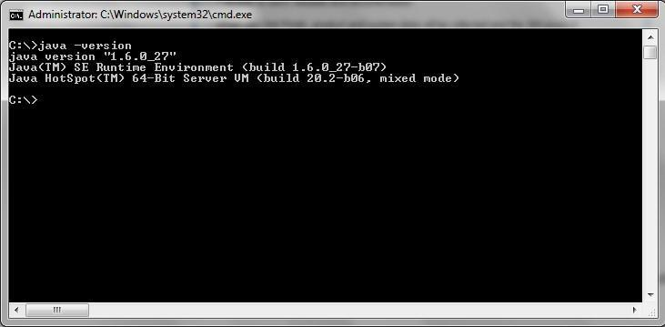

Hello World program in Java

You are now ready to write and run your first Java program. The traditional choice for the very first program in a new programming language is a program that displays a simple greeting: ―Hello, World!‖.

To write a hello-world program in Java either you can use a plain text editor (like Notepad) or an integrated development environment (like Eclipse).

Using a text Editor

➢ Open a simple text editor (like Notepad), and type the following Java code:

public class Car
{
public static void main(String[] args)
{
System.out.println("Hello
World!");
}
}

- Save it with the name Car.java

- Compile and run it.
Java Fundamental
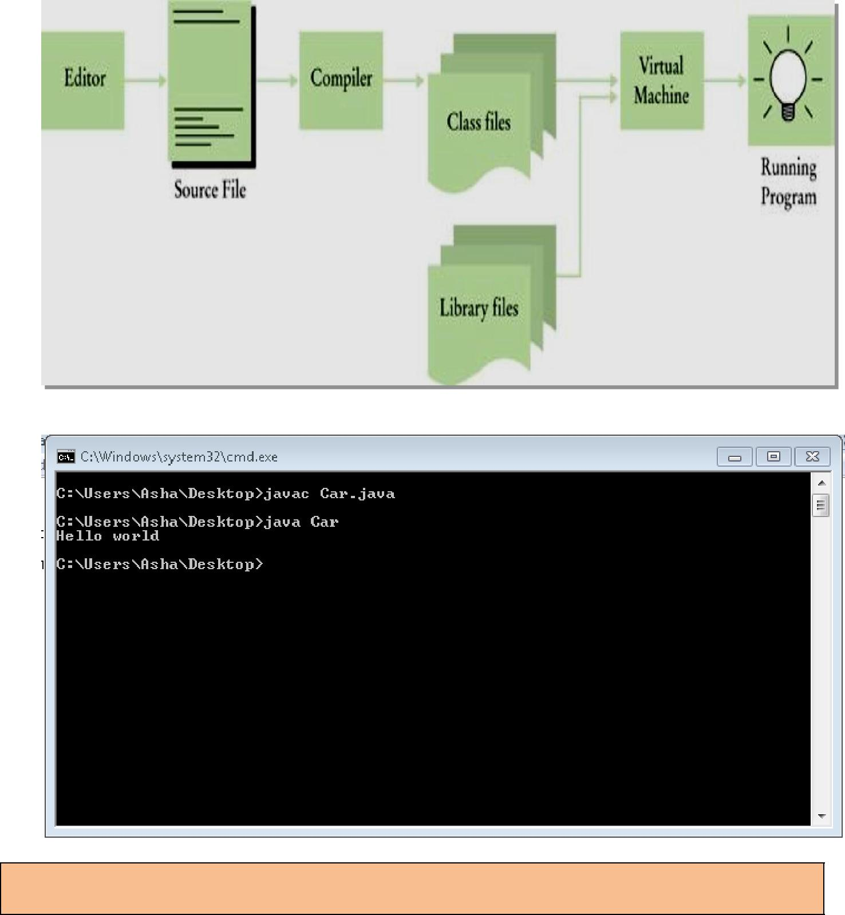

Note: Once you compile a Java file successfully, another file of extension .class is created. This is the byte code file that is executed by JVM.
Java Fundamental

Using an IDE(integrated development environment)

We can use Eclipse IDE to create, compile and run Hello-World Java program. Follow the below steps:-

An IDE is an application that provides a set of tools to help a developer accomplish many tasks more efficiently.

➢

Enter project name then click Finish.
  - On the left pane, under Package Explorer, expand the project then right click on src.

  - Move cursor to New, then click on Class

  - In Name field, enter the class name: Car.java then click finish

  - In the file editor, the file Car.java will open. Type in the same code as the previous section.

- Click on the Run button.

- The “Hello World!” should display in the Console view.

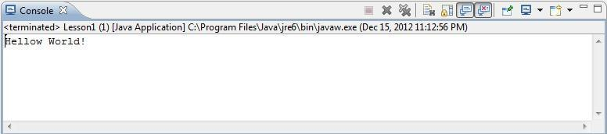

Every Java application contains a class with a main method. When the application starts, the execution of that application start from the main method.

Java Fundamental

More on main method


 |  | Return | Name
 | The keyword | Return | of method
 | The keyword | type of | of method
 | static | type of
main | static | main | The
main | indicates that the | main | The
method | indicates that the | method | parameter
method | main method | method | parameter
must be | main method | must be | contains
must be | does not operate | must be | contains
marked with | does not operate | void. | command
marked with | on an object. | void. | command
public | on an object. |  | line
keyword |  |  | arguments

public static void main (String[] args)
{
//….

}

The above first line inside the main method is a comment.

The statements inside the curly braces ({}) in the body of the main method are executed one by one and each statement ends with a semicolon (;)…….
e.g:-
public static void main(String [] args)
{

System.out.println("Hello, World!");
}

Each class contains definitions of methods. Each method contains a sequence of instructio

Java Fundamental

Comment Syntax

Comments are used to provide a summary of the code in plain english for better understanding of the code.

Compiler ignores anything that you type after/in-between either single line comment (//) or multi-line comment (/*……..*/).
e.g:-
//This is ―Hello world‖ program
/*
This is ―Hello World‖ program

*/

Common Error

Semicolons (;)

Every statement in Java must be ended with a semicolon. Forgetting to type a semicolon leads you to compile time error.
e.g:-

System.out.println("Hello World!") //error System.out.println("Hello World!"); //compile successfully

Syntax

A syntax error is a violation of the rules of the programming language. You must fix the error and compile again.
e.g;-


System.ouut.println("Hello World!") //error
Java Fundamental

Run-Time Error or Logical

The program is syntactically correct but it doesn't do what it is supposed to do. The compiler will not find these types of errors-In fact this would be the responsibility of programmer to fix them.

System.out.println("Hello, World!‖); //compiles successfully

//output Hello, World!
System.out.println("Hello, Word!"); //compiles successfully

//output Hello, World!
Java Fundamental

Topic 2 Introduction to Variables, Operators & Data types

Topic Goals

- To understand Variable and their naming conventions

- Get familiar with Java operators
- Know about fundamental of Data types & Type casting
- Java reserved keywords

This topic teaches you about declaration of variables with their value types, uses of different operators, primitive and non-primitive data type etc.

Types and Variables

Every value has a type in Java which tells you what operation you can perform with the values.
e.g:-
“HelloWorld” has a value type String.

You often want to store values for their future use, so you required some storage location for them or a variable.
A variable is a storage location in the memory that has a type, a name and contents.

Syntax :-

typeName variableName_=_value; or

typeName variableName;

e.g:-

int x=90;
String msg=‖HelloWorld‖;
Java Fundamental

Variable naming convention

1. Variable names are case-sensitive. A variable's name can be any legal identifier — an unlimited-length sequence of Unicode letters and digits, beginning with a letter, the dollar sign "$", or the underscore character "_".

int x; int _x; int $x;

- If the name you choose consists of only one word, start that word in all lowercase letters. If it consists of more than one word, capitalize the first letter of each subsequent word.

e.g:-
int marks;
int rollNumber;

3. The name you choose must not be a keyword or reserved word.

Java Operators

After declaration and initialization of variables, you probably want to know how to play with them. Then let’s talk about operators.

Operators are special symbols that perform specific operations on one, two, or three operands, and then return a result.
Java provides a rich set of operators to manipulate variables like:-

- Arithmetic Operators

- Relational Operators

- Logical Operators

- Assignment Operators

etc.
Java Fundamental

The Arithmetic Operators:

Arithmetic operators are used in mathematical expressions.

Oper | Description | Example(a=10,b=5)
ator | Description
+ | Addition operator (also used for | a+b=15
+ | String concatenation)
- | Subtraction operator | a-b=5
* | Multiplication operator | a*b=50
/ | Division operator | a/b=2
% | Remainder operator | a%b=0

The Relational Operators:

Oper | Description | Example(a=5,b=10)
ator | Description
== | Checks if the values of two | (A == B) is not true
== | operands are equal or not.
!= | Checks if the values of two | (A != B) is true
!= | operands are equal or not.
 | Checks if the value of left operand | (A > B) is not true
> | is greater than the value of right
 | operand.
< | Checks if the value of left operand | (A < B) is true
< | is less than the value of right operand
 | Checks if the value of left operand | (A >= B) is not true
>= | is greater than or equal to the value of
 | right operand.
 | Checks if the value of left operand | (A <= B) is true
<= | is less than or equal to the value of
 | right operand

Java Fundamental

The Logical Operators:

Operat | Description | Example(a is true, b is false)
or | Description
 | Logical AND operator. If both the | (A && B) is false

- operands are true, then the condition becomes true

 | Logical OR Operator. If any one of | (A || B) is true
|| | the two operands is true, then the
 | condition becomes true
 | Logical NOT Operator. If a condition | !(A && B) is true
! | is true then Logical NOT operator will
 | make false.

The Assignment Operators:

Oper | Description | Example
ator | Description
 |  | C = A +
= | Assigns values from right side operands to left side operand | B will assign
= | Assigns values from right side operands to left side operand | value of A +
 |  | B into C
 | It adds right operand to the left operand and assign the result to left | C += A is
+= |  | equivalent to
 | operand | C = C + A
 | It subtracts right operand from the left operand and assign the | C -= A is
-= |  | equivalent to
-= | result to left operand | equivalent to
 | result to left operand | C = C - A
 | It multiplies right operand with the left operand and assign the | C *= A is
*= |  | equivalent to
*= | result to left operand | equivalent to
 | result to left operand | C = C * A
 | It divides left operand with the right operand and assign the result | C /= A is
/= |  | equivalent to
/= | to left operand | equivalent to
 | to left operand | C = C / A
 | It takes modulus using two operands and assign the result to left | C %= A
%= |  | is equivalent
%= | operand | is equivalent
 | operand | to C = C % A
Etc.

Java Fundamental

Data types in Java

In Java language, every value is either a reference to an object, or it belongs to a primitive types.

Based on the data type of a variable, the operating system allocates memory and decides what can be stored in the reserved memory.

Primitive Data types

Java primitive data types are initialized to some default values when they are declared as class members.
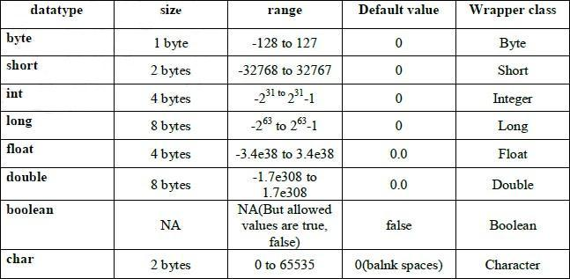

When a variable is declared local to a function it must be initialized or assigned before its first use otherwise compiler reports an error "variable <variable name> might not have been initialized". But when a variable is declared as a class member or field, it is not always essential to assign a value to the member. In the case of class member a variable is initialized to some default values by the compiler.
Java Fundamental

Reference/Object Data Types:

- Reference variables are created using defined constructors of the classes. They are used to access objects.

- Class objects and various types of array variables come under reference data type.

- Default value of any reference variable is null.

e.g:-

Car obj=new Car();


obj is a reference variable

which hold car object

Type casting in java

Assigning a value of one type of variable to another type known as type casting. Kind of casting
➢ Widening or implicit casting:-
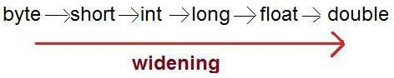
Java Fundamental

e.g:-

byte b=2;

int i=b;//does not require explicit casting

➢ Narrowing or explicit casting
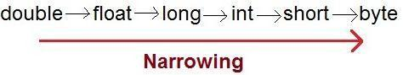

e.g:-

int i=20;

byte b=(byte)i;// requires explicit casting
Java Fundamental

String Handling: -

String probably the most common used class in Java library which encapsulated in java.lang package. Every string which you create is actually a String class object. Once you create string object, it cannot be altered (they are immutable).

e.g: -

String str=‖Hello”;
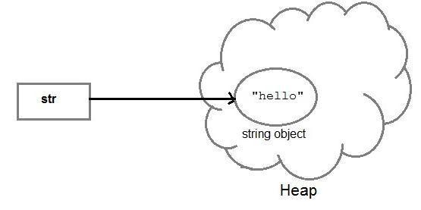
Java Fundamental

If we create another object of String: -

String str2=str;
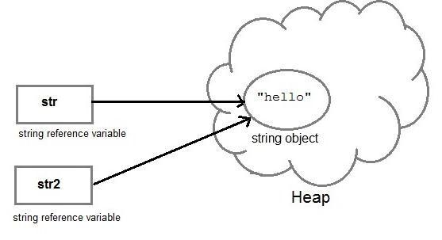
Java Fundamental

But if we change string/content

str2=str2.concat(―Wolrd”);

or

str2=str2+‖World”

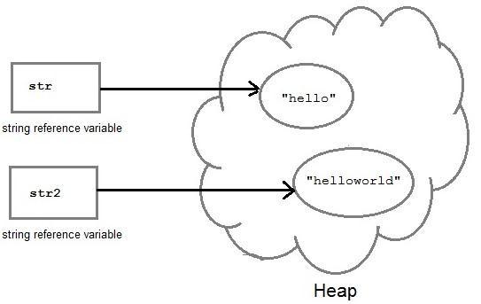

To concatenate a string either you can use concat() method or ―+‖ operator.

Java Fundamental

Some common methods of String class: -

No. | Method | Description
1 | char charAt(int index) | returns char value for the particular index
2 | int length() | returns string length
3 | String substring(int beginIndex) | returns substring for given begin index
4 | String substring(int beginIndex, int | returns substring for given begin index and
 | endIndex) | end index
5 | boolean contains(CharSequence s) | returns true or false after matching the
 |  | sequence of char value
6 | boolean equals(Object another) | checks the equality of string with object
7 | boolean isEmpty() | checks if string is empty
8 | String concat(String str) | concatinates specified string
9 | String replace(char old, char new) | replaces all occurrences of specified char
 |  | value
10 | String replace(CharSequence old, | replaces all occurrences of specified
 | CharSequence new) | CharSequence
11 | String trim() | returns trimmed string omitting leading and
 |  | trailing spaces
12 | String split(String regex) | returns splitted string matching regex
13 | String split(String regex, int limit) | returns splitted string matching regex and
 |  | limit
14 | int indexOf(int ch) | returns specified char value index
15 | int indexOf(int ch, int fromIndex) | returns specified char value index starting
 |  | with given index
16 | int indexOf(String substring) | returns specified substring index
17 | int indexOf(String substring, int | returns specified substring index starting with
 | fromIndex) | given index

Java Fundamental

String Buffer: -

As String objects are immutable, so if we do lot of changes with this object then it leads to lot of memory leakage.

So,StringBuffer calss can be use when you want to do lot of modification in String’s object because objects of StringBuffer class are mutable.

e.g: -

class StringBufferDemo
{
public static void main(String [ ]args)
{

String str1=”hello”; str1.concat(“world”);

System.out.println(str1); //output- hello

StringBuffer str2=new StringBuffer(“hello”); str2.append(“world”);
System.out.println(str1); //output- helloworld
}
}

StringBuffer is a thread safe class

StringBuilder: -

It provides similar functionality as StringBuffer but this is not thread safe because methods of this class are not synchronized.

e.g: -
Java Fundamental

class StringBufferDemo
{
public static void main(String [ ]args)
{

String str1=”hello”; str1.concat(“world”);

System.out.println(str1); //output- hello

StringBuilder str2=new StringBuilder(“hello”); str2.append(“world”);
System.out.println(str1); //output- helloworld
}
}

Java Language Keywords & special escape sequences

abstract | assert | boolean | break | byte | case
catch | char | class | const* | continu | default
 |  |  |  | e
double | do | else | enum | extends | false
final | finally | float | for | goto* | if
implements | import | instanceof | int | interfac | long
 |  |  |  | e
native | new | null | packag | private | protected
 |  |  | e
public | return | short | static | strictfp | super
switch | synchronized | this | throw | throws | transient
true | try | void | volatile | while

Java Fundamental

Java supports few special escape sequences for String and char literals
.

Notation | Character represented
\n | Newline (0x0a)
\r | Carriage return (0x0d)
\f | Formfeed (0x0c)
\b | Backspace (0x08)
\s | Space (0x20)
\t | tab
\" | Double quote
\' | Single quote
\\ | backslash

Garbage Collection

Java Memory Management is done by its built-in garbage collection. It is more about "memory recycling". When an object is no longer referenced by the program, the heap space it occupies can be recycled so that the space is made available for new object. All objects are allocated on the heap area managed by the JVM. As long as an object is being referenced, the JVM considers it alive. Once an object is no longer referenced, the garbage collector removes it and reclaims the unused memory.
Java Fundamental
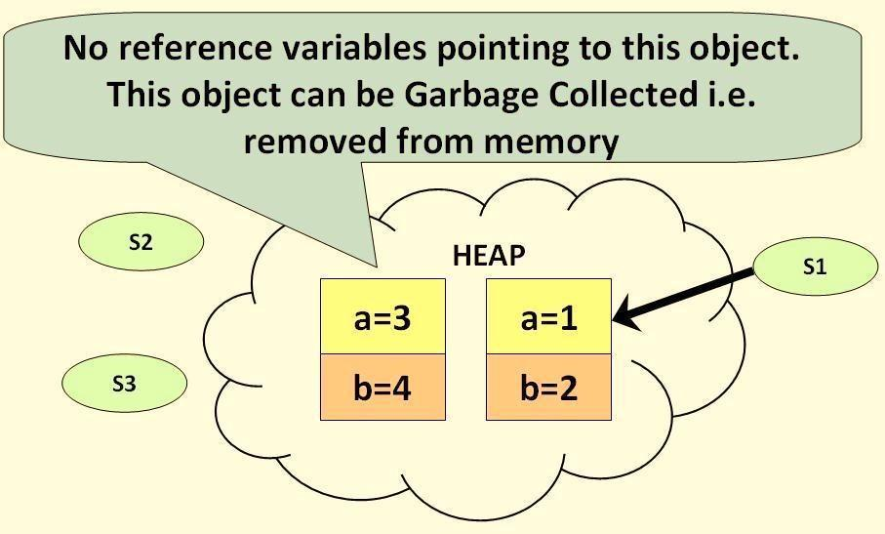
Java Fundamental

Topic 3 Introduction to Decisions making, Iteration & Array

Topic Goals

- To be able to implement decisions using

- If/else,switch/case….

- To understand how to group statements into block

- How to apply Iteration

- while,do-while,for loop….
- To become familiar with using arrays

This topic teaches you how to program simple and complex decisions as well as the various iteration constructs of the Java language.

The if/else Statement

‖if‖ is used to implement a decision. The if statement has two parts: a condition and a body. If the condition is true, the body of the statement is executed.

Syntax
if (condition)

{
//statement1

}
else

{
//statement2

}

If/else is used to execute a statement when a condition is true or false
Java Fundamental

if statement lets a program carry out different actions depending on a condition.

e.g:-
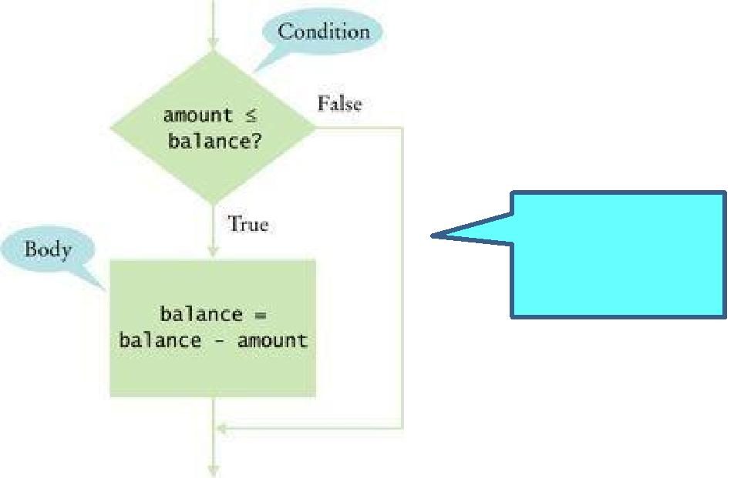

―your amout is low”

if (amount <= balance)
{
balance = balance - amount;
}

else
{
System.out.println(―your amount is low‖);

}
Java Fundamental

switch/case statement

Unlike if/else statements, the switch statement can have a number of possible execution paths. A switch works with the byte, short, char, and int primitive data types as well as with string too(from java 7).

switch(expression) { case const1:

/* do X */ break;

case const2: /* do Y */ break;
default:
/* do something else */

}

e.g:-

int dayOfWeek = 1; String dayString=""; switch (dayOfWeek) {

case 1: dayString = "Monday"; break;

case 2: dayString = "Tuesday"; break;

case 3: dayString = "Wednesday"; break;

case 4: dayString = "Thursday"; break;

case 5: dayString = "Friday"; break;

case 6: dayString = "Saturday"; break;

case 7: dayString = "Sunday"; break;

}
System.out.println(dayString);
Java Fundamental

Iteration/Loop

Loop statement executes a block of code repeatedly. A condition controls how often the loop is executed.

while loop

A while loop statement continually executes a block of code while a particular condition is true. Its syntax can be expressed as:

while (expression) { statement(s)
}

e.g:-

int count = 1;

while (count < 11) { System.out.println("Count value is: " + count); count++;

}

for Loop
The for statement provides a compact way to iterate over a range of values.

for (initialization; termination-condition; increment)
{
statement(s)
}

e.g:-

for (int i = 1; i <= 10; i++)
{
System.out.println("Value of i is: " + i);
}
Java Fundamental

Break Statement

In addition to defining the exit points from cases in a switch statement as well as the break statement stops the execution of a loop:

while (someCondition) { // Do something

if (someOtherCondition) { break;

}
// Do something else
}

Continue Statement

while (someCondition) {

if (someOtherCondition) { continue;

}
// Do something
}

Talking about Array

An array is a sequence/collection of values of the same type. The array construct provides

a better way of storing a collection of values.
Syntax
Datatype arrayName=new Datatype[length];

e.g:-

double[] data = new double[10];
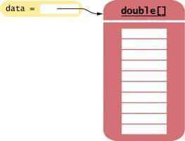
Java Fundamental

Array Initialization

You can initialize an array by allocating it and then filling each entry

int data={90,87,78,98,91}; or

int data=new int[5];

data [0]=90; data [1]=87; data [2]=78; data [3]=98; data [5]=91;

You can use loop to initialize array:-

Note: To take input from user, Java provides java.util.Scanner class which has various methods to accept values for different data types.
In order to take input first create object of java.util.Scanner class and call next…() method.

Scanner input=new Scanner(System.in);

for(int i=0; i<5; i++)
{

System.out.println(―enter your value‖); data[i]=input.nextInt();

}
Java Fundamental

Topic 4 Object-Orientation & class design

Topic Goals

- To become familiar with Object Orientation

- Declaration of class

- Object creation
- About method
- Package declaration
- Void, static keyword

In this topic you will learn about OOPs concept, designing classes, method declaration as well as how to use packages to organize your classes.

OOP is a way of conceptualizing a program's data into discrete "things" referred to as objects, each having its own properties and methods.

Follows are the most important features of object-oriented programming:-
- Encapsulation:- Binding data and operations of data together in a single unit

- Abstraction: - The ability to represent data at a very conceptual level without any details.

- Inheritance: - Reusability of code.

- Polymorphism: - Multiple definitions for a single name or functions with same name with different functionality

Some key features of the OOP

  - Emphasis on data rather than procedure
  - Programs are divided into entities known as objects

  - Data Structures are designed such that they characterize objects
  - Functions that operate on data of an object are tied together in data structures
  - Data is hidden and cannot be accessed by external functions

  - Objects communicate with each other through functions
  - New data and functions can be easily added whenever necessary
  - Follows bottom up design in program design

In object-oriented design, you discover classes, determine the responsibilities of classes, and describe the relationships between classes.

Java Fundamental

About classes

A class is the blueprint from which individual objects are created or a basic template that specifies the properties and behaviours of something. Classes provide a clean way to model the state and behavior of real world objects
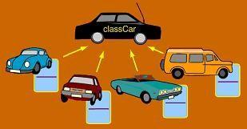

A class can contain fields and methods to describe the behavior of an object.

General syntax for a class declaration:-

<class modifiers>class<class name> <extends clause> <implements clause>
{

//variables or attribute declaration //method or behaviour declaration

}
Java Fundamental

e.g: -
class Car //A class
{

int speed = 0; //Attribute int gear = 1;
void changeGear(int newGear) //Behaviour
{
gear = newGear;
}

void speedUp(int increment) { speed = speed + increment;
}
void printStates() {
System.out.println(" speed:" + speed + " gear:" + gear);
}
}

A class can have any number of methods to access the value of various kinds variables.

A class can contain any of the following variable types.

- Local variables: - Variables defined inside methods, constructors or blocks are called local variables.

- Instance variables: - Instance variables are variables within a class but outside any method.

- Class variables - Class variables are variables declared with in a class, outside any method, with the static keyword.
Java Fundamental

Constructors: -

Java constructors are the special type of methods which are used to initialize objects.

Constructor’s features:-

- Constructor method has the same name as that of class.

- They are called or invoked when an object of class is created and can't be called explicitly.

- A constructor can be private.

- Abstract class can have constructor.

- A constructor can be overloaded or a class can have more than one constructor.

- Constructor can be parameterized.

e.g:-

class Car
{
Car()
{
System.out.println(―this is a constructor‖);

}
}

Constructors contain instructions to initialize objects. The constructor name is always the same as the class name.

Objects: -

If we consider the real-world we can find many objects around us, Cars, Dogs, etc. All these objects have a state and behavior.

If we consider a Car, then its state/attributes are-speed, gear etc behaviuor is speedup or movement.

Creating an Object:

Basically an object is created from a class. In Java, the new key word is used to create new objects.
Three steps to create an object of a class:-

- Declaration: A variable declaration with a variable name with an object type.

- Instantiation: The 'new' key word is used to create the object.
Java Fundamental

- Initialization: The 'new' keyword is followed by a call to a constructor. This call initializes the new object.

e.g:-
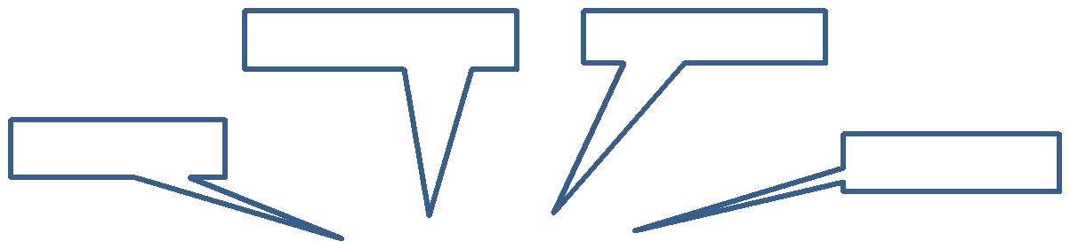

variable name | Java keyword
object type | constructor

Car obj = new Car();

Each object of a class has its own set of instance fields.
Java Fundamental

Package: -
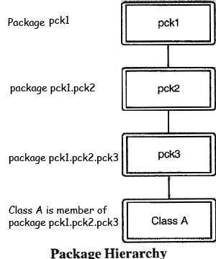

This is an encap s, interfaces
and subpackages et

.

Java Package: - it is a way of categorizing the classes and interfaces.

Note: - A package hierarchy represents an organization of the Java classes and interfaces or

.class. It does not represent the source code organization of the classes and interfaces as well as we can have nested package too.
Java Fundamental

Defining Packages: -

Syntax:

package <fully qualified package name>;

A package declaration must be the first statement in the source file. e.g: -

package mypack; // Package declaration

public class Car {

public static void printSpeed()
{
}
}

Using package (import): -

To use the contents of packages, import statement has been provided.

Syntax:

import <fully qualified type name>;

e.g;

package mypack1; // Package declaration

public class Car {

public static void printSpeed()
{
}

}
Java Fundamental

//creating TestCar class in mypack2 and calling Car class from mypack1

package mypack2; // Package declaration

import mypack1.Car; //importing Car class

public class TestCar {
public static void main(String [ ]args)
{

Car obj=new Car(); obj.printStates();
}

}

Import statements: - it is a way of giving the proper location for the compiler to find that particular class.

Java Access Modifiers:-

Access modifiers are used to implement concept of encapsulation.

Modifiers are keywords that you add to set access levels for classes, variables, methods and constructors.
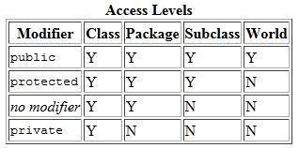
Java Fundamental

e.g: -

class Car
{

private int speed = 0; // attribute encapsulated public int gear = 1;
public void printStates()
{
System.out.println(" speed:" + speed + " gear:" + gear);
}
}

class TestCar
{
Public static void main (String [ ] args)
{
Car obj=new Car ();

System.out.println(―speed is ―+obj.speed);//error, private data cannot be

//accessed outside of
that class

System.out.println(―gear is ―+obj.gear);// can be access obj.printStates();
}
}

We can create a fully encapsulated class in java by making all the data members of the class private

Methods: -

A method is a set of instructions which is referred to by a name and can be invoked at any point in a program simply by utilizing the method's name and object.

Method declaration and definition Syntax: -

accessSpecifier returnType methodName(parameterType parameterName, . . . )
{
//…method body
}
Java Fundamental
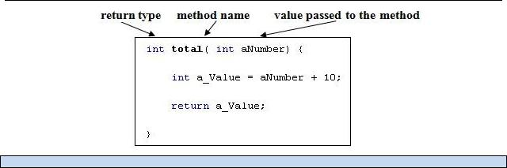

You can use any data type for a parameter of a method or a constructor

The void keyword allows us to create methods which do not return a value

Method Calling/ Invocation: -

Methods require an instance/object before they can be invoked.

Syntax:-

classObject.methodName (parameter);

e.g: -

class Car
{

int speed = 0; int gear = 1;
void changeGear(int newGear) //behaviour or method
{
gear = newGear;
}
void speedUp(int increment) //behaviour or method
{
speed = speed + increment;
}
Java Fundamental

void printStates() //behaviour or method
{
System.out.println(" speed:" + speed + " gear:" + gear);
}
public static void main(String []args)
{

Car obj=new Car(); //initializing object

Obj.printStates(); //method invocation

}
}

Java provides two basic kinds of methods: instance methods and class (or static) methods. Therefore Instance methods require an instance before they can be invoked, whereas class
methods do not.

final Keyword: -

In Java final keyword is used to put some restriction on its user. It can be used with followings:-

- variable

- method

- class

final variable: -

If you make any variable as final, you cannot change the value of that variable then it will be constant.

e.g: -

class Car

{

final int SPEED = 1; //speed is a constant void speedUp(int increment) {
SPEED = SPEED + increment; //speed cannot be changed
}
}
Java Fundamental

final method

If you mark any method as final, you cannot override it.

class Vehicle
{

Int speed,gear; void printStates()
{
System.out.println(" speed:" + speed + " gear:" + gear);

}
}

class Car extends Vehicle

{
String color, modelNo;

void printStates() //method overriding cannot be done on final method
{

System.out.println(" speed:" + speed + " gear:" + gear+” color:”+color+” modelNo:”+modelNo);
}
}

final class

If you mark any class as final, you cannot extend it.

final class Vehicle
{

Int speed,gear; void printStates()
{
System.out.println(" speed:" + speed + " gear:" + gear);

}
}

class Car extends Vehicle //vehicle cannot be inherit as it’s final class
{
}
Java Fundamental

This keyword: -

It is a reference variable that refers to the current object.

this keyword can be use: -

- this keyword can be used to refer current class instance variable.

- this() can be used to invoke current class constructor.

- this keyword can be used to invoke current class method (implicitly)

- this can be passed as an argument in the method call.

- this can be passed as argument in the constructor call.

- this keyword can also be used to return the current class instance.

e.g: -


Here this.speed is a class attribute as this belongs to current object of Car class.

class Car
{
int speed = 0;

void speedUp(int speed)
{

this.speed = speed * 10;
}

}

Static keyword:-

A static member is a member of a class that isn’t associated with an instance of a class.

Instead, the member belongs to the class itself. Therefore you can access the static member without creating object of that class.

The static keyword can be used for declaration of: -

1. variable (also known as class variable)

class Car { static int speed;
}

Java Fundamental

2. method (also known as class method)

class Car {
public static void printSpeed()
{
}
}

3. block

class Car{ static{
}
}

static block is used to initialize the static data member. It executes automatically at the time of classloading.

e.g:-

class Car
{

static int speed ; //static attribute/variable int gear = 1;

static //static block
{
Speed=10;
}

void speedUp(int increment) { speed = speed *gear;
}

static void printStates() //static method

{
System.out.println(" speed:" + speed + " gear:" + gear);
}
//main method
public static void main(String []args)
{
Car obj=new Car();//initializing object
Java Fundamental

Obj.speedup(); //non static method, need object

printStates(); //static method invocation, no need for object
}
}

Abstract

Abstraction is a process of hiding the implementation details and showing only functionality to the user.

for example in case of Car driving , you just plug the key and start the Car. You don't know the internal processing

We can implement abstraction in two ways:-
- Using Abstract class

- Using Interface.

Abstract class: -

An abstract class is declared with abstract keyword, can have abstract and non-abstract methods (method with body).
Point to remember:-
- It needs to be extended

- It cannot be instantiated.

- abstract keyword can only be used with class and method, not with variables.

- When you extends abstract class which has abstract method, you must define abstract method in sub/child class.

- Abstract class can have constructor, abstract/non methods and variable (static/non static).

Syntax: -

abstract class className;
Java Fundamental

e.g: -
abstract class Vehicle
{
public abstract void engine();
}

class Car extends Vehicle
{
public abstract void engine()
{
//…. Definition

}
}

Interface: -

If you want to make code more general and more reusable by focusing on the essential operations then interface can be used to express these common operations(to implement

abstraction).

An interface is a collection of abstract methods but not a class. A class implements an interface.

Working with an interface is similar to working with a class, but they are two different concepts. A class describes the attributes and behaviors of an object. An interface contains behaviors that a class implements.

Interface features:-

- You cannot instantiate an interface.

- An interface does not contain any constructors.

- All of the methods in an interface are abstract and public by default.

- An interface cannot contain instance fields. The only fields that can appear in an interface must be declared both static and final.

- An interface is not extended by a class; it is implemented by a class.
- An interface can extend multiple interfaces.

- It is necessary for the class which implement an interface to provide body/override all the method of that interface until unless that class is not an abstract class.

Syntax: -

public interface interfaceName{….}
Java Fundamental

Use the implements keyword to indicate that a class implements an interface.

eg.

public interface Vehicle {

void changeGear(int newValue); //by default method marked as abstract & public

void speedUp(int increment); //by default method marked as abstract & public
}

Then the Car class implements the Vehicle interface using following syntax:

class Vehicle implements Vehicle { int speed = 0;
int gear = 1;

public void changeGear(int newValue) //abstract method implementation
{
gear = newValue;
}

public void speedUp(int increment) ) //abstract method implementation
{
speed = speed + increment;
}
void printStates() {
System.out.println(" speed:" + speed + " gear:" + gear);
}
}
Java Fundamental

Source file declaration rules:

These rules are essential when declaring classes, import statements and package statements in a source file.

- There can be only one public class per source file.

- A source file can have multiple nonpublic classes.

- The public class name should be the name of the source file as well which should be appended by .java at the end.

- If the class is defined inside a package, then the package statement should be the first statement in the source file.

- If import statements are present then they must be written between the package statement and the class declaration. If there are no package statements then the import statement should be the first line in the source file.
Java Fundamental

Topic 5 Inheritance, Encapsulation & Polymorphism

Topic Goals

- To learn about inheritance

- To be able to invoke superclass constructors
- Implementation of encapsulation in inheritance
- To understand the concept of polymorphism

In this topic, you will learn an important strategy for reusability of code, implements the interface methods as well as different form off methods.

Inheritance

Object-oriented programming allows classes to inherit commonly used state and behavior from other classes in order to implement reusability. It set a parent-child relationship between two different objects.

When one object acquires all the properties and behaviours of parent/base object i.e. known as inheritance: -“extends” & “implements’ keywords are used to describe inheritance in Java.
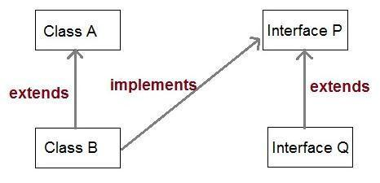
Java Fundamental

e.g:-
. | child | parent
 | public class Car extends | Vehicle
 | {
 | int numOfSeats;
 | //Set of statements defining
 | //a car’s state and behavior
 | }


The Car now shares the same state and behavior defined in class vehicle as well as can have its own behavior.

Types of Inheritance:-
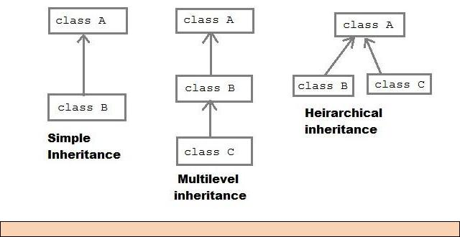

Note: - Multiple class inheritance is not supported in Java.

Inheritance is a mechanism for extending existing classes by adding methods and fields. You use extends keyword to inherit another class.

The more general class is called a superclass or parent. The more specialized class that inherits from the superclass is called the subclass or child.
Java Fundamental

e.g:-
class Vehicle
{
int speed,gear;
}

class Car extends Vehicle
{
void printStates()
{
System.out.println(" speed:" + speed + " gear:" + gear);
}
//main method
public static void main(String []args)
{

Car obj=new Car(); obj.printStates();
}
}

Super keyword: -

The super keyword I s used to call a constructor/attribute/method of the superclass.In other words

super keyword is used by sub/chiled class when it wants to use any property of its immediate parent class.

e.g:-
Java Fundamental

class Vehicle
{
int speed;


vehicle()

{
Speed=20;
}


void printStates()
{
System.out.println(" speed:" + speed);
}
}

class Car extends Vehicle
{
int gear;

Car(int gear)
{

super();

this.gear=gear;
}

void printStates()

{


super.printStates();

System.out.println(" gear:" + gear);
}

}
Java Fundamental

Data encapsulation in inheritance: -

It is a protective barrier that prevents the code and data being randomly accessed by other code defined outside the class. The major advantage of encapsulation is the ability to modify our implemented code without breaking the code of others who use our code. With this advantage Encapsulation gives maintainability, flexibility and extensibility to our code.

package mypack1;

class Vehicle
{

private int modelNo; // can be access within Vehicle

int noOfWheel; // can be access within mypack1

protected int gear; // can be access within mypack1& only by child class
// in another package

public int speed;

}

Points about Inheritance: -
- If you do not want to allow Inheritance for your class than you can make it final.

- Inheritance in Java represents IS-A relationship.

- Private members of the superclass are not inherited by the subclass and can only be indirectly accessed

- Members that have default accessibility in the superclass are also not inherited by subclasses in other packages.

- Since constructors and initializer blocks are not members of a class, they are not inherited by a subclass.

- A subclass can extend only one superclass or multiple class inheritance is not supported in Java.

- Any protected member including protected method and field are only accessible in Child class or Sub class outside the package on which they are declared.

Every class extends the Object class either directly or indirectly.

Java Fundamental

Polymorphism: -

Polymorphism is the ability of an object to take on many forms. When multiple classes implement the same interface, each class implements the methods of the interface in different ways.

Polymorphism denotes the principle that behavior can vary depending on the actual type of an object.

Types of polymorphism: -
- Compile time polymorphism/Overloading

- Runtime polymorphism/Overriding

Compile time polymorphism/Overloading:-

In method overloading, multiple methods having same name can appear in a class, but either with different signature or based on the number or type of arguments or all three.

class Car { int speed = 0 int gear = 1;

void changeGear(int newGear)
{
gear = newGear;
}

void speedUp(int increment)
{
speed = speed + increment;
}

void printStates()
{
System.out.println(" speed:" + speed + " gear:" + gear);
}

void printStates(int speed) //method overloading
{
System.out.println(" speed:" + speed);
}

public static void main(String []args)

{
Java Fundamental

Car obj=new Car(); obj.printStates();

obj.printStates(obj.speed);//invocation of over loaded method
}
}

Overloading Rules in Java: -

- You can overload a method by changing its signature- method signature is made of number of arguments, type of arguments and order of arguments.

- Return type is not a part of method signature. So overloading cannot be done on behalf of return type

- A method can be overloaded in the same class or in a subclass etc.

Runtime polymorphism/Overriding

Overriding is re-defining a method in a subclass with the same name and type signature as it was in its superclass.
class Vehicle
{

Int speed,gear; void printStates()
{

System.out.println(" speed:" + speed + " gear:" + gear);
}
}

class Car extends Vehicle

{
String color, modelNo;

void printStates() //method overriding
{

System.out.println(" speed:" + speed + " gear:" + gear+‖ color:‖+color+‖ modelNo:‖+modelNo);

}
//main method
public static void main(String []args)
{

Car obj=new Car (); obj.printStates();
}}
Java Fundamental

Overriding rules in Java: -

- If superclass method is default, then while overriding it in child class, it can be public, protected or no access, but cannot be private.

- If super class method is protected, while overriding it in child class, it can be public or protected but not anything else.

- If super class method is public, while overriding it in child class, it should be public because we cannot have weaker access than super class method.

- The argument list must exactly same that of the overridden method. If they don't match, you can end up with an overloaded method.

- The return type must be the same as, or a subtype of, the return type declared in the original overridden method in the superclass.

- You cannot override a method marked final.

- You cannot override a method marked static.

- If a class is not inherited, you cannot override its methods etc.
Java Fundamental

Topic 6 File input/output & Exception handling

Topic Goals

- To be able to read and write text files

- To learn how to throw exceptions

- About catch/finally

This topic discusses how to read or write data in a file as well as dealing with exceptions and their handling mechanism.

Java provides a standard way of reading from and writing to files. The java.io package contains near about all classes you might ever need to perform input and output (I/O) in Java.

Reading and Writing Text Files: -

A stream can be defined as a sequence of data. The InputStream is used to read data from a source and the OutputStream is used for writing data to a destination.

I/O Streams in Java: -

- Byte Streams: - It handles I/O of raw binary data.

- Character Streams: - It handles I/O of character data, automatically handling translation to and from the local character set.

- Buffered Streams: - It optimizes input and output by reducing the number of calls to the native API.

- Scanning and Formatting: - It allows a program to read and write formatted text etc.

To read text files, you can use the Scanner class.
Java Fundamental

FileReader reader = new FileReader("input.txt");
Scanner in = new Scanner(reader);

To write text files, you can use the PrintWriter class and the print/println methods.

PrintWriter out = new PrintWriter("output.txt"); out.println("Hello, World!");

You must close all files When you are done processing them. e.g: -
in.close();
out.close();

e.g:-

class FileIODemo

{
public static void main(String[] args) throws Exception
{
Scanner sc = new Scanner(System.in);

System.out.print(―Input file name: ‖);

String inputFileName = console.next();

System.out.print(―Output file name:‖);
String outputFileName = sc.next();

FileReader reader = new FileReader(inputFileName);

Scanner in = new Scanner(reader);

PrintWriter out = new PrintWriter(outputFileName);

while (in.hasNextLine())
{
String line = in.nextLine();

out.println( line);

}
out.close();}}
Java Fundamental

Exception: -

An exception is a problem that occurs during the execution of a program. It can occur for many different reasons like: -

- A user has entered invalid data.

- A file that needs to be opened cannot be found.

- A network connection has been lost in the middle of communication etc.

Kinds of Exception: -

- Checked exceptions: A checked exception is an exception that is typically a user error or a problem that cannot be foreseen by the programmer.

- Unchecked/Runtime exceptions: A runtime exception is an exception that occurs that probably could have been avoided by the programmer.

Errors are not exceptions.

Exception Hierarchy: -

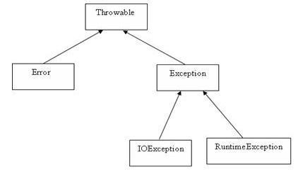

All exception classes are subtypes of the java.lang.Exception class. The exception class is a subclass of the Throwable class.

Java Fundamental

Catching Exceptions in Java:-

Exception can be handled using combination of the try and catch keywords.

Syntax: -

try
{

//Protected code }catch(ExceptionName e1)
{

//Catch block
}

e.g: -

Exception problem: -

public class ExceptionDemo{

public static void main(String args[])
{
int a[] = new int[2];

// in below line because of array size exception will arise
System.out.println("Access element three :" + a[3]);

System.out.println("main method end");//this msg will not be
print
}
}

//output: -Exception thrown :java.lang.ArrayIndexOutOfBoundsException: 3
Java Fundamental

Exception solution: -

public class ExcepTest{

public static void main(String args[]){ try{
int a[] = new int[2];
System.out.println("Access element three :" + a[3]);
}

catch(ArrayIndexOutOfBoundsException e){ System.out.println("Exception thrown :" + e);
}

System.out.println("main method end ");//msg will print

}
}

//output: -Exception thrown :java.lang.ArrayIndexOutOfBoundsException: 3 //main method end

The finally keyword is used to create a block of code that follows a try block. A finally block of code always executes, whether or not an exception has occurred.

If a method does not handle a checked exception, the method must declare it using the throws keyword.

You can throw an exception, either a newly instantiated one or an exception that you just caught, by using the throw keyword.

public class className
{

public void methodName(parameter) throws Exception
{
// Method implementation

throw new Exception();//created exception explicitly
}
//rest of class definition
}
Java Fundamental

Topic 7 Collection

Topic Goals

- Understanding Collection Framework

- To learn uses of some common collection

This topic introduces you to collection API, how to use them as well as working with some common collection.

A collection is an object that represents a group of objects/elements to store, retrieve, and manipulate those object/elements.

Or in other words a collections framework is a unified architecture for representing and manipulating collections.

It contains: -

- Interfaces and its implementations i.e. classes

- Algorithm

Advantages of a collections framework: -

- Reduces programming effort

- Increases performance

- General-purpose implementations

- Special-purpose implementations

- Concurrent implementations etc.

To work with collection you need to import java.util.* package.
Java Fundamental

List of Collection Interfaces: -

SN | Interfaces with Description
1 | The List Interface
 | This extends Collection and an instance of List stores an ordered collection of elements.
2 | The Set
 | This extends Collection to handle sets, which must contain unique elements
3 | The SortedSet
 | This extends Set to handle sorted sets
4 | The Map
 | This maps unique keys to values.
5 | The Map.Entry
 | This describes an element (a key/value pair) in a map. This is an inner class of Map.
6 | The SortedMap
 | This extends Map so that the keys are maintained in ascending order.
7 | The Enumeration
 | This is legacy interface and defines the methods by which you can enumerate (obtain one at a
 | time) the elements in a collection of objects. This legacy interface has been superceded by
 | Iterator.

List of some Collection classes: -

SN | Classes with Description
1 | AbstractList
 | Extends AbstractCollection and implements most of the List interface.
2 | LinkedList
 | Implements a linked list by extending AbstractSequentialList.
3 | ArrayList
 | Implements a dynamic array by extending AbstractList.
4 | AbstractSet
 | Extends AbstractCollection and implements most of the Set interface.
5 | HashSet
 | Extends AbstractSet for use with a hash table.
6 | LinkedHashSet
 | Extends HashSet to allow insertion-order iterations.
7 | TreeSet
 | Implements a set stored in a tree. Extends AbstractSet.
8 | AbstractMap
 | Implements most of the Map interface.
9 | HashMap
 | Extends AbstractMap to use a hash table.
10 | TreeMap
 | Extends AbstractMap to use a tree.

Java Fundamental
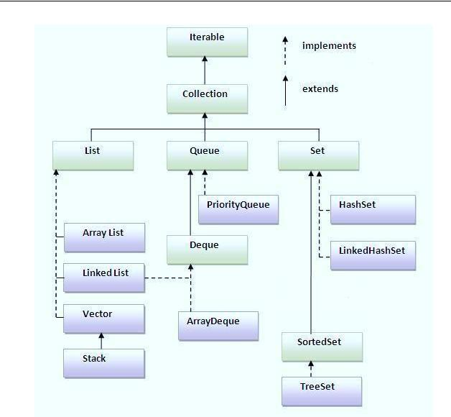

Working with some common collection interfaces/classes

Storing data using List/ArrayList

The java.util. ArrayList class extends AbstractList and implements the List interface. ArrayList supports dynamic arrays that can grow as needed.

Java Fundamental

ArrayList Features: -

- It uses a dynamic array for storing the elements.

- It can contain duplicate elements.

- It maintains insertion order and not synchronized.

- Random access of element can be done because array works at the index basis as well as manipulation is slow.

ArrayList list=new ArrayList();//creating old non-generic arraylist

ArrayList<String> list=new ArrayList<String>();//creating new generic arraylist

In generic collection, we specify the type in angular braces. Now ArrayList is forced to have only specified type of objects in it. If you try to add another type of object, it gives compile time error.

e.g: -

public class ArrayListDemo
{

public static void main(String args[]) { // create an array list
ArrayList<String> list = new ArrayList<String> ();//or List list=new ArrayList

System.out.println("Initial size of list: " + list.size());

// add elements to the array list list.add("C");

list.add("A");
list.add("E");

list.add("E");
list.add(90);//error,list can have only String object s

System.out.println("Size of list after additions:"+ list.size());

}
}

An ArrayList is ordered collection (also known as a sequence) as well as duplicity is allowed.
Java Fundamental

Storing data using HashSet/Set: -

The java.util.HashSet class implements the Set interface. It uses a hash table for storage. A hash table stores information by using a mechanism called hashing. It contains unique elements only.

HashSet<String> set=new HashSet<String>(); //generic HashSet set=new HashSet(); //non generic

e.g:-

public class HashSetDemo {

public static void main(String args[]) { // create a hash set
HashSet set = new HashSet();// or Set set=new HashSet()

- add elements to the hash set set.add("B");
set.add("A");
set.add("D");
set.add("D");
}
}

A HashSet is unordered collection as well as does not allow duplicity of data.

Two ways to iterate the elements of a collection:-
➢ By Iterator interface: -

It enables you to obtain or remove elements from collection.

e.g:-

public class HashSetDemo {

public static void main(String args[]) {
Java Fundamental

// create a hash set
HashSet set = new HashSet();// or Set set=new HashSet()

- add elements to the hash set

set.add("B");
set.add("A");
set.add("D");
set.add("D");

//obtaining data from set

Iterator itr = set.iterator(); while(itr.hasNext()) {

Object element = itr.next(); System.out.print(element + " ");
}

}
}

➢ By for-each loop: -
public class HashSetDemo {

public static void main(String args[]) { // create a hash set

HashSet<String> set = new HashSet<String> ();// or Set set=new HashSet()

- add elements to the hash set set.add("B");
set.add("A");
set.add("D");
set.add("D");
//obtaining data from set

for(String element:set)
{
System.out.println(element);
}
} }

Iterator can be used to obtain data from a List too.
Java Fundamental

Storing data using HashMap/Map: -

The java.util.HashMap class implementation of the Map interface. A HashMap contains values based on the key in form of key/value pair. It may have one null key and multiple null values.

e.g:-
public static void main(String args[]) {

// Create a hash map

HashMap map = new HashMap();// or Map map=new HashMap()

- Put elements to the map map.put("Meena",101); map.put("Lucky", 102);

  - Get a set of the entries from map Set set = map.entrySet();

  - Get an iterator

Iterator i = set.iterator();

// Display elements while(i.hasNext()) {

Map.Entry me = (Map.Entry)i.next();

System.out.print(me.getKey() + ": "); System.out.println(me.getValue());
}
}

A HashMap is unordered collection as well as does not allow duplicity of key.

HashSet contains only values whereas HashMap contains entry(key and value).
Java Fundamental

Topic 8 Threading

- About Threading & Multithreading

- Thread life cycle

- Some common methods of Thread class

This topic teaches you multiple path of execution in a program as well as different way of thread implementation.

A thread is an independent path of execution within a program. Java supports multithreading where multiple executions can perform simultaneously within a program. Thread is basically a lightweight sub-process and a smallest unit of processing.
Advantages of multithreading:-
- better use of system resources

- Parallelize tasks

- Enhanced performance

Life Cycle of a Thread: -
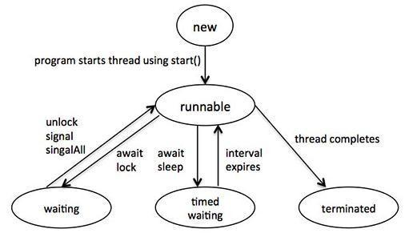
Java Fundamental

- New: A new thread begins its life cycle

- Runnable: A thread in this state is considered to be executing its task.

- Waiting: Here thread waits until it does not get call for next execution.

- Timed waiting: A runnable thread can enter the timed waiting state for a specified interval of time.

- Terminated: After finishing task, thread moves to this state.

Thread Creation

There are two ways to create thread in java;

- By implements of the Runnable interface (java.lang.Runnable)

- By extending the Thread class (java.lang.Thread)

By implements of the Runnable interface (java.lang.Runnable): -

e.g:-

class MyThread implements Runnable
{
public void run()

{
System.out.println(“this is your thread”);
}
public static void main(String []args]
{

MyThread myT=new MyThread(); Thread t=new Thread(myT); t.start();

}
}

By extending the Thread class (java.lang.Thread): -

e.g:-

class MyThread extends Thread

{
public void run()
{
Java Fundamental

System.out.println(“this is your thread”);
}
public static void main(String []args]
{

MyThread myT=new MyThread(); myT.start();
}
}

Some Common method of Thread class: -

SN | Methods with Description
1 | start()
 | Starts the thread in a separate path of execution, then invokes the run() method on this Thread
 | object.
2 | run()
 | If this Thread object was instantiated using a separate Runnable target, the run() method is
 | invoked on that Runnable object.
3 | setName(String name)
 | Changes the name of the Thread object. There is also a getName() method for retrieving the
 | name.
4 | setPriority(int priority)
 | Sets the priority of this Thread object. The possible values are between 1 and 10.
5 | setDaemon(boolean on)
 | A parameter of true denotes this Thread as a daemon thread.
6 | join(long millisec)
 | The current thread invokes this method on a second thread, causing the current thread to block
 | until the second thread terminates or the specified number of milliseconds passes.
7 | interrupt()
 | Interrupts this thread, causing it to continue execution if it was blocked for any reason.
8 | isAlive()
 | Returns true if the thread is alive, which is any time after the thread has been started but before
 | it runs to completion.

Java Fundamental

