***ERROR CHECKLIST***

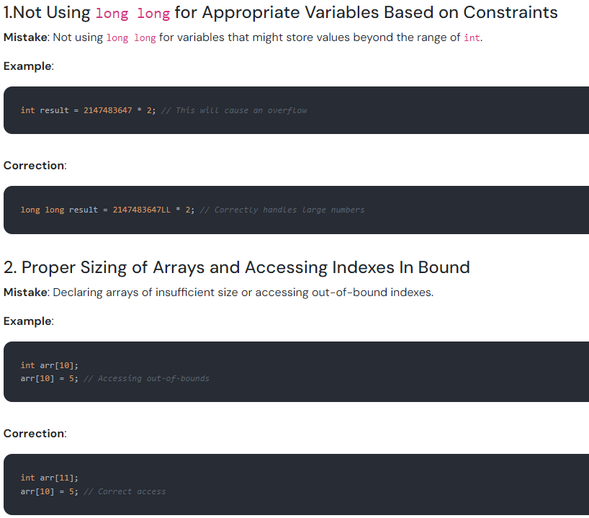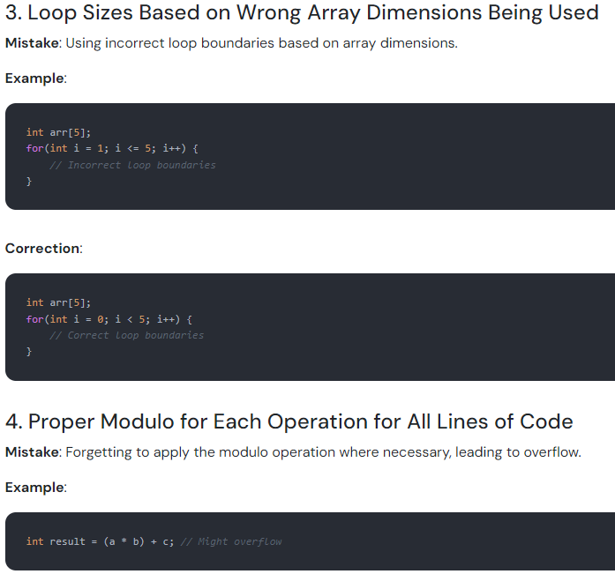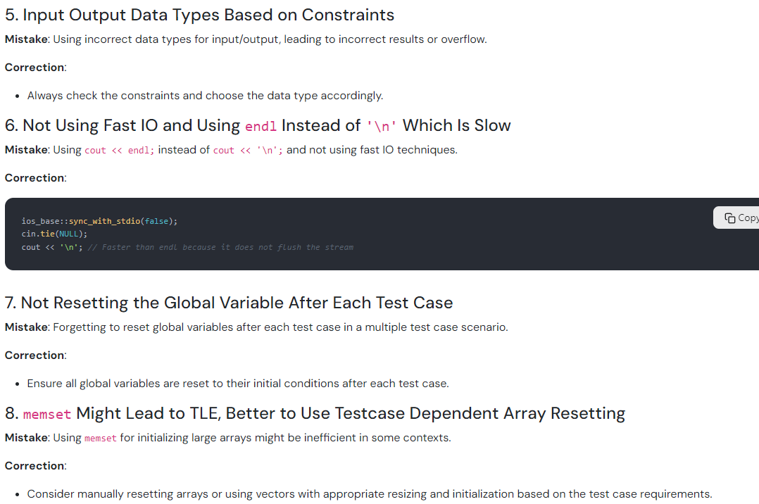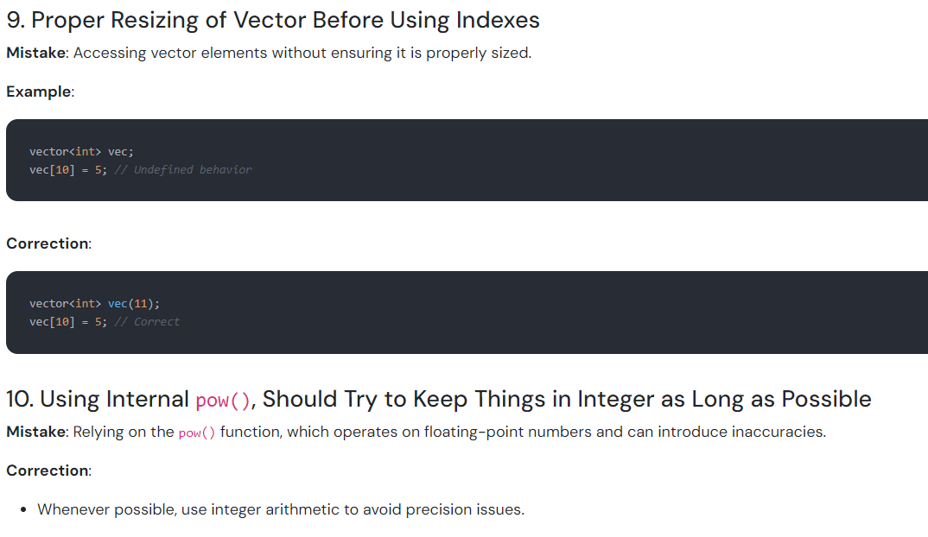

1. **Not converting 1-based indexes to 0-based while taking input.**

**Mistake:** int L, R; cin >> L >> R;

**Correction:** int L, R; cin >> L >> R; L- -, R- -;