Name: ayda Last name:zamanian

HW#: 5

1. nslookup Command(windows)

IP address for [www.shirazu.ac.ir](http://www.shirazu.ac.ir/):

nslookup www.shirazu.ac.ir

Server: UnKnown

Address: 10.0.2.3

Non-authoritative answer:

Name: www.shirazu.ac.ir

Address: 185.64.176.11

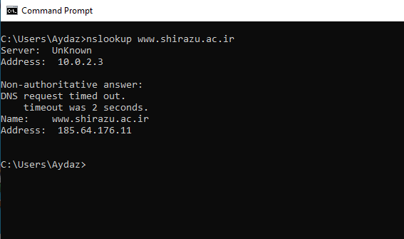

IP address for [www.yahoo.com](http://www.yahoo.com/):

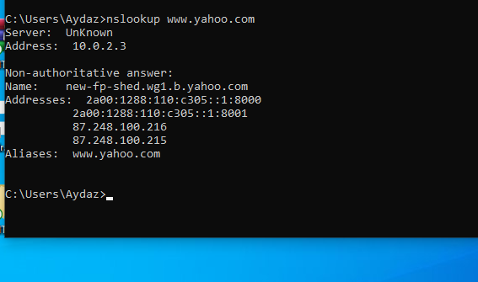

nslookup www.yahoo.com

Server: UnKnown

Address: 10.0.2.3

Non-authoritative answer:

Name: new-fp-shed.wg1.b.yahoo.com

Addresses: 2a00:1288:110:c305::1:8000

2a00:1288:110:c305::1:8001

87.248.100.216

87.248.100.215

Aliases: www.yahoo.com

IP address for [www.google.com](http://www.google.com/):

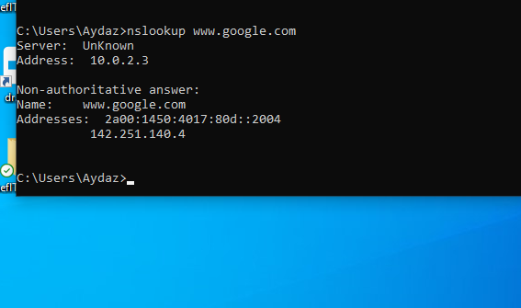

nslookup www.google.com

Server: UnKnown

Address: 10.0.2.3

Non-authoritative answer:

Name: www.google.com

Addresses: 2a00:1450:4017:808::2004

142.250.187.132

Change server to 8.8.8.8:

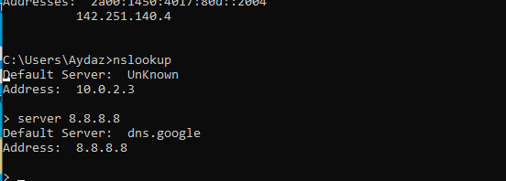

nslookup

server 8.8.8.8

Default Server: dns.google

Address: 8.8.8.8

What is email server for shirazu.ac.ir:

> set type=mx

> shirazu.ac.ir

Server: dns.google

Address: 8.8.8.8

Non-authoritative answer:

shirazu.ac.ir MX preference = 10, mail exchanger = mail.shirazu.ac.ir

shirazu.ac.ir MX preference = 20, mail exchanger = mxback.shirazu.ac.ir

>

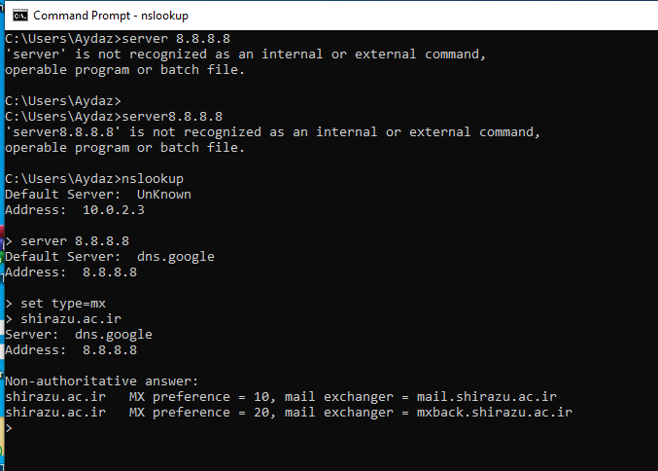

What is email servers for cse.shirazu.ac.ir

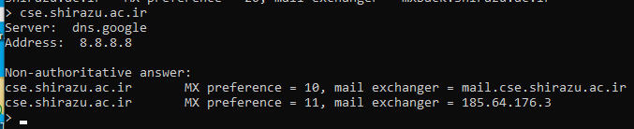

1. dig Command(linux)
   1. IP address of gmail.com in short form:

dig gmail.com +short

142.251.141.37

* 1. What is email server for gmail.com with change server to 8.8.8.8 (2 of them):

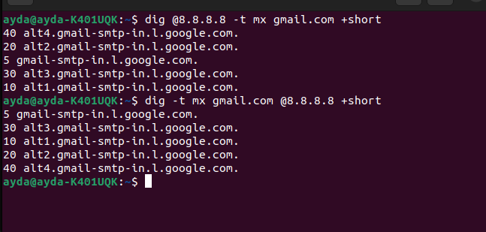

What is email server for yahoo.com (2 of them):

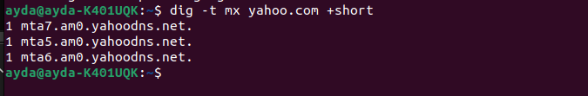

1. Host Command(linux)
   1. IP address of hotmail.com :

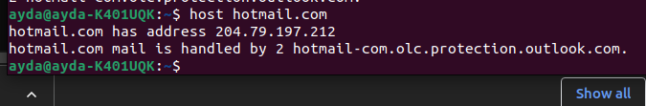

* 1. What is email server for hotmail.com:

