Name:ayda zamanian Session: 6 Date/Time:14th may

Write commands for each question and for results plz attach screen shot too.

1. What types of states are used in the **State** column in the Connections view?

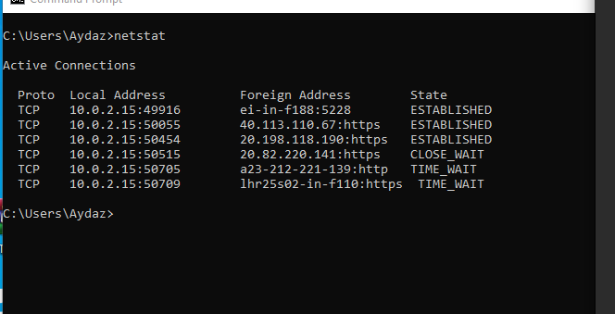

1. netstat Command (windows cmd)

Open [www.yahoo.com](http://www.yahoo.com/)

* 1. What is the IP address and port number on the server(yahoo) the client (your system) is connected to?

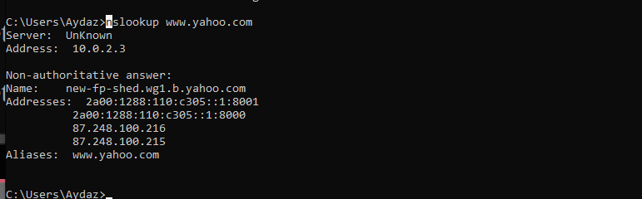

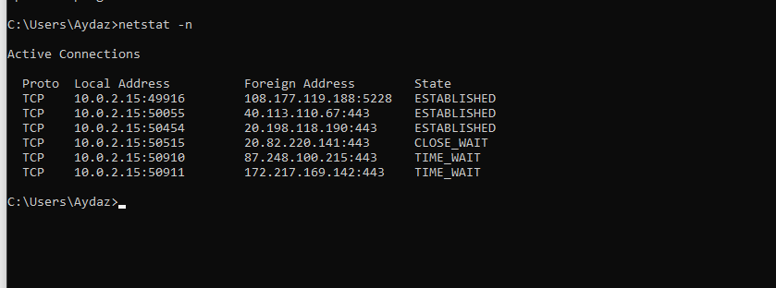

What is the port number used on the client system?

50910



* 1. What is the total received and sent bytes in Ethernet interface?

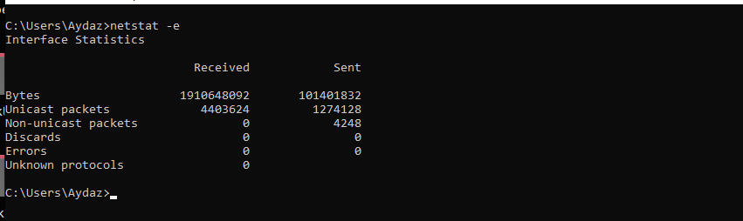

* 1. What is the number of failed connection attempts in TCP IPV4?

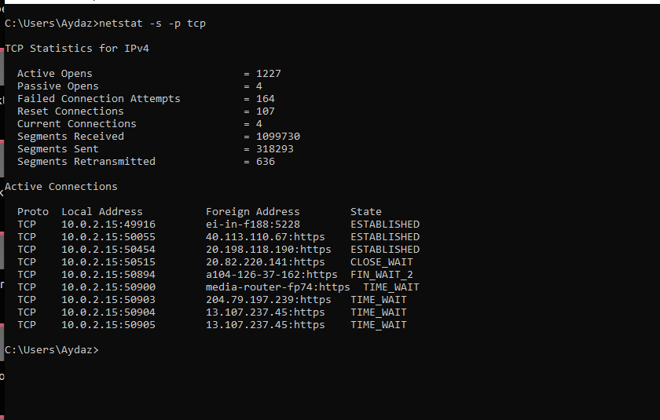

1. netstat Command (linux terminal)
   1. List active connections with their program names.

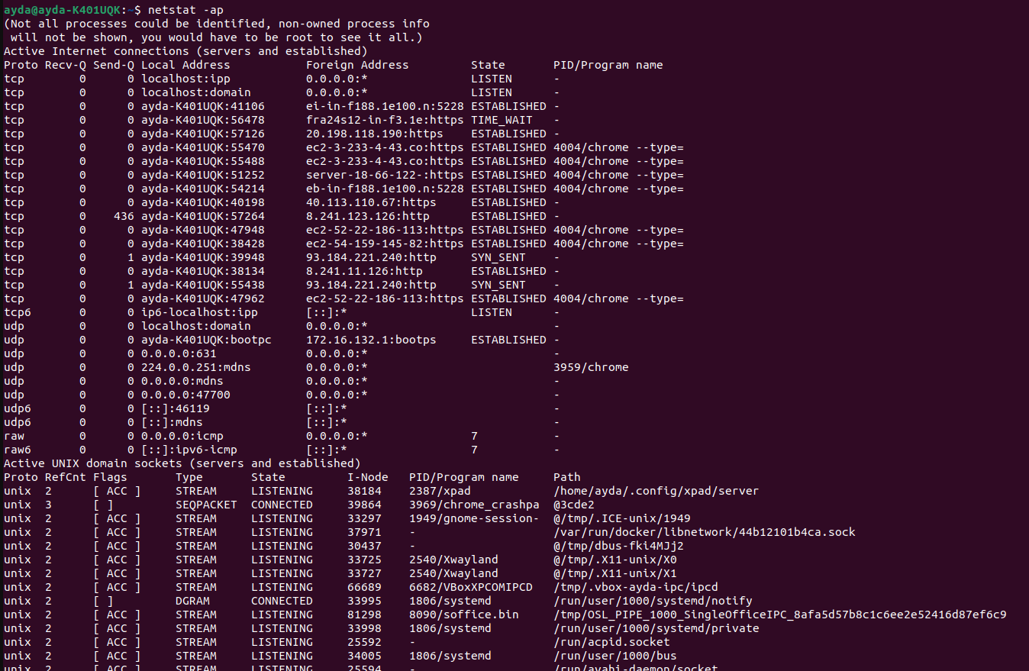

* 1. List active connections that their status is LISTENING.

netstat -l -p

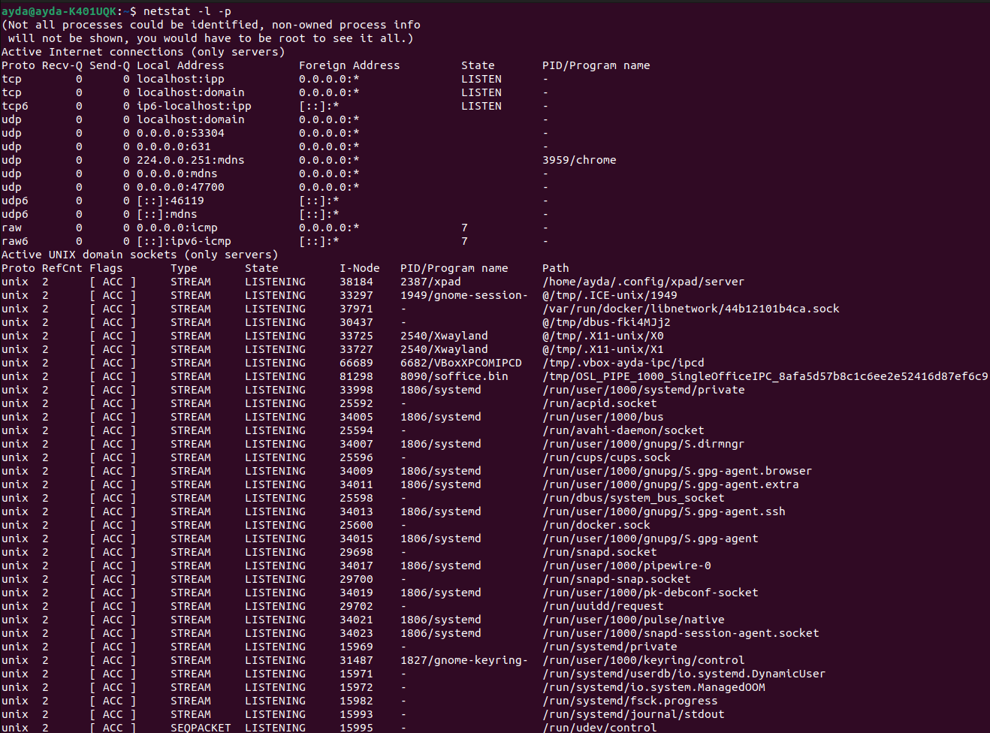

* 1. List active connections that their status is ESTABLISHED in numeric format.

netstat -n | grep “ESTABLISHED”

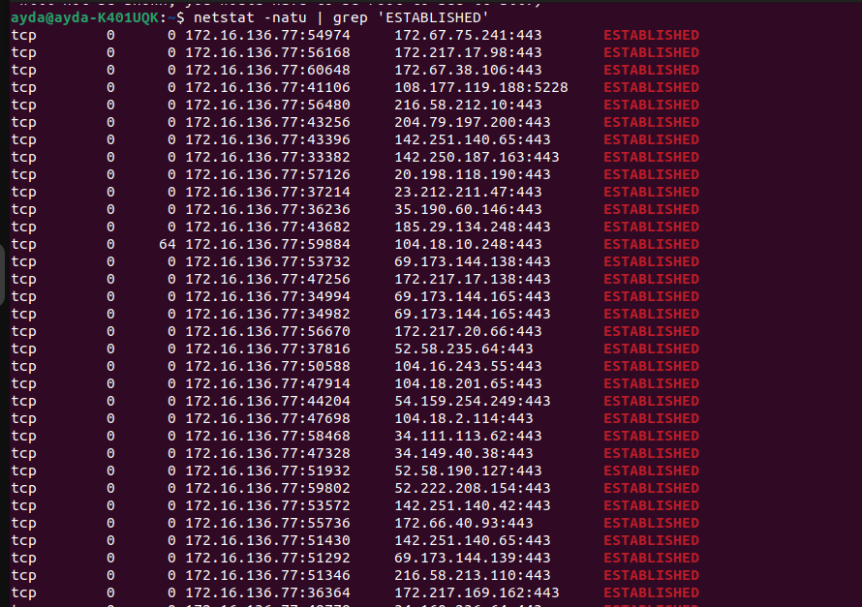

1. Nmap Command
   1. Check if ssh port is open in your host.

nmap -p 22 ip

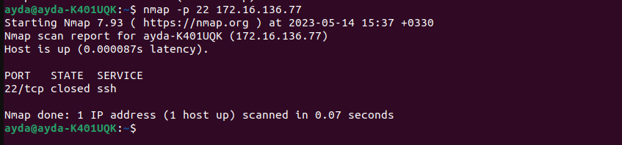

* 1. List interfaces and routing table of your host

