Name: Ayda Zamanian Session:8 Date/Time:28 may

the first command is:

Source nat: iptables -t nat -I POSTROUTING icmp -o eth0 -j MASQURADE

Write all necessary commands for each question.

1. Accept ping forward for 192.168.10.50 host through your router.RADE

iptables -t filter -I FORWARD -p icmp -s 192.168.10.50 -j ACCEPT

iptables -t filter -I FORWARD -p icmp -d 192.168.10.50 -j ACCEPT

1. Accept SSH request forward for 192.168.10.50 host through your router.

iptables -I FORWARD -p tcp —dport 22 -s 192.168.10.50 -j ACCEPT

Iptables -I FORWARD -p tcp —sport 22 -d 192.168.10.50 -j ACCEPT

1. Accept DNS request forward for 192.168.10.0/24 subnet host through your router.

iptables -I FORWARD -p udp –dport 53 -s 192.168.10.50 /24 -j ACCEPT

iptables -I FORWARD -p udp –sport 53 -d 192.168.10.50 /24 -j ACCEPT

1. Accept HTTP/HTTPS request forward for 192.168.10.50 host through your router.

iptables -I FORWARD -p tcp -m multiport —dports 80,443 -s 192.168.10.50 -j ACCEPT

iptables -I FORWARD -p tcp -m multiport —sports 80,443 -d 192.168.10.50 -j ACCEPT

1. Redirect <https://www.google.com/> to <https://shirazu.ac.ir/> for 192.168.10.50 host through your router.

Nslookup

google

Shirazu

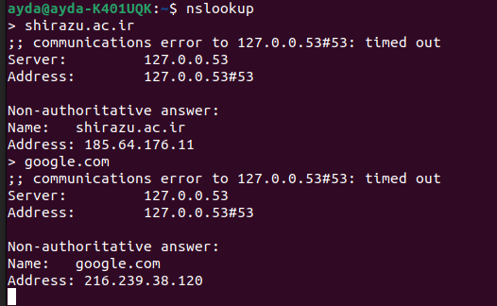

iptables -t nat -I PREROUTING -p tcp -m multiport —dports 80,443 -s 192.168.10.50 -216.239.38.120 -j DNAT —to 185.64.176.11