|  |  |  |
| --- | --- | --- |
|  | Journal of Urban Development and Management  https://www.acadlore.com/journals/JUDM |  |

|  |  |
| --- | --- |
| Optimization of Street Tree Species Based on Green Plot Ratio |  |
| Haoran Jia1,2, Yichuan Zhang1* |  |
| 1 School of Horticulture and Landscape Architecture, Henan Institute of Science and Technology, 453003 Xinxiang, China  2 School of Biological Engineering, Xinxiang Institute of Engineering, 453003 Xinxiang, China  * Correspondence: Yichuan Zhang (zhangyichuan@hist.edu.cn) | |

|  |  |  |  |  |
| --- | --- | --- | --- | --- |
| **Received:** 06-22-2022 | | **Revised:** 07-18-2022 | | **Accepted:** 08-01-2022 |
|  | |  | |  |
| **Citation:** H. R. Jia and Y. C. Zhang, “Optimization of street tree species based on green plot ratio,” *J. Urban Dev. Manag.*, vol. 1, no. 1, pp. 26-38, 2022. https://doi.org/10.56578/judm010104. | | | | |
|  | | |  | |
|  | © 2022 by the authors. Licensee Acadlore Publishing Services Limited, Hong Kong. This article can be downloaded for free, and reused and quoted with a citation of the original published version, under the CC BY 4.0 license. | | | |

**Abstract:** Street trees make up an important part of the eco-environment and landscape of urban roads. The species of street trees significantly affect the green volume of urban roads. The leaf area index (LAI) is often adopted to measure the ratio of green volume for urban roads, laying a scientific basis for optimizing street trees. This paper measures and analyses the LAI and green plot ratio (GPR) of 14 common street tree species in Xinxiang, a city in Central China’s Henan Province. The results show that, except for evergreens, the LAI values of deciduous trees varied significantly from month to month, forming a single-peaked curve. The LAI values of street trees have a significant positive correlation with the day of year (DOY) (P<0.01). As for the roads with a single row of street trees, the highest mean annual GPR values were achieved by *Juglans regia* Linn., followed in turn by *Ligustrum lucidum* Ait., *Sophora japonica* L., *Populus tomentosa* Carrière, *Fraxinus chinensis* Roxb. and *Platanus orientalis* Linn. Among the 12 common types of double-row road tree combinations, the GPR values all increased first and then decreased; the largest annual mean value belonged to the combination “*Sophora japonica* L.+ *Sophora japonica* L.” In the same section, the annual mean GPR value of double-row road trees was 3-7 times higher than that of single-row road trees. Our research demonstrates that the GPR can quantify the differences between different street tree species and combination types, and help to optimize the greening arrangement and plant configuration.

**Keywords:** Green plot ratio (GPR); Leaf area index (LAI); Urban roads; Street trees; Optimization

1. Introduction

Street trees are an important part of the eco-environment and landscape appearance of urban roads. Street trees have important roles in beautifying the environment [1], shading [2], improving microclimate [3], purifying air [4], intercepting rainwater [5], stagnating dust [6], improving biodiversity [7], etc. They have a significant impact on urban road landscape and urban ecology, providing important ecosystem service functions and values [8-10]. The current greening evaluation indicators usually include park green space per capita, green coverage, green space rate, green space per capita [11]. Although these indicators define the two-dimensional plane coverage area of green space and other constraints and limits, they don’t describe the specific plant configuration and ecological benefits. There is a lack of a more direct and effective three-dimensional evaluation index system that can define the type of plant configuration, plant canopy structure and so on [12].

A creative combination of building plot ratio and greenery, the concept of green plot ratio (GPR) was proposed by Boon Lay Ong in 2003. It refers to the average leaf area index (LAI) of greenery on a plot of land [13]. The LAI is an important element to reflect the growth and ecological characteristics of plants, to study the function of the plant canopy, and to quantify the ecological capacity and exchange properties of the Earth [14, 15]. Intensive urbanisation has led to a sharp decline in the LAI of urban forests, affecting the quality of the urban ecosystem [16]. Higher LAI values are beneficial for improving the heating and cooling energy performance of buildings and reducing energy consumption [17]. Studies have shown that design patterns of multi-storey vertical structures and proper nurturing of plant communities can increase the amount of plant leaf area [18], but the leaf area of a single tree has a negative linear relationship with stand density, so the planting density of plants should be controlled in design [19]. There are currently two main types of LAI measurements. One is direct measurement using instruments, generally used for small-scale studies [20]; the other is LAI inversion using vegetation remote sensing data, which is generally used for large scale studies [21, 22]. In general, LAI varies considerably between plant types for example, leaf area of evergreen trees is relatively constant throughout the year, while seasonal variation in leaf area of deciduous trees is much greater [23].

A LAI-based GPR can more widely reflect the current development intensity of green areas and the ecological differences in different plant configurations, providing a comprehensive and effective quantitative indicator for the optimal plant configuration of green areas. Most of the existing studies related to LAI took the time period of the plant growing season as the study interval. But the LAI of plants changes dynamically within a year, and the lack of complete information may make the results less accurate [24]. This paper takes the inter-month LAI measurements of commonly used street trees in Xinxiang City as the basis to explore the characteristics of different street trees and combinations with different street tree species following the changes of road GPR, and to further provide a scientific basis for the optimization of street tree species.

**2. Overview of the Study Area**

Xinxiang is located in the northern part of Henan Province, China, adjacent to the northern bank of the Yellow River, with geographical coordinates of 35°18’N and 113°54’E (Figure 1). It has a warm temperate continental monsoon climate with four distinct seasons, and an annual average temperature of 14℃. The terrain in the main urban area of Xinxiang is flat, with a clearly-graded road green space system. The urban road vegetation is rich in variety and grows well. The main urban roads have been built up for quite a long time. Street trees are of various types and in a relatively stable state of growth.

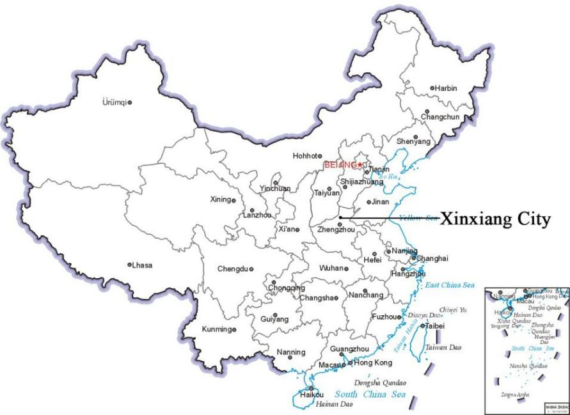

**Figure 1.** Geographical location map of Xinxiang City

**3. Research Methodology**

**3.1 Selection of Samples**

Within the main urban area of Xinxiang City, we selected plots with varying boundary line of roads and mature ecological characteristics of street trees as experimental sample sites, mainly the middle section of Xinfei Avenue, the middle and south sections of Xinzhong Avenue, the east section of Jinsui Avenue, the middle section of Xinyi Street, the east section of Hualan Avenue, the middle section of Jiefang Avenue and the east section of Hongli Avenue. After survey, we selected 14 commonly used street tree species in Xinxiang for the study, with 20 samples of each plant species (Table 1). As observation subjects, the plant samples were in excellent growth condition, unshaded and relatively isolated around, without dead branches or with few dead branches, and they were marked accordingly.

**Table 1.** Basic information on a sample of 14 common street trees in Xinxiang

|  |  |  |  |  |  |
| --- | --- | --- | --- | --- | --- |
| **Serial number** | **Plant name** | **Sample size** | **Crown width (m)** | **Tree height (m)** | **Diameter at breast height (cm)** |
| 1 | Platanus orientalis Linn. | 20 | 10.8-14.5 | 9.8-16.9 | 23-45 |
| 2 | Triadica sebifera (L.) Small | 20 | 6.5-8.9 | 9.2-12.9 | 21-36 |
| 3 | Fraxinus chinensis Roxb. | 20 | 6.5-12.4 | 8.5-14.2 | 25-38 |
| 4 | Koelreuteria paniculata Laxm. | 20 | 7.8-13 | 8.7-13.3 | 28-40 |
| 5 | Ligustrum lucidum Ait. | 20 | 6.2-9.5 | 6.5-10.9 | 22-35 |
| 6 | Sophora japonica L. | 20 | 10.5-12.6 | 8.9-13.8 | 21-36 |
| 7 | Melia azedarach Linn. | 20 | 11.2-13.2 | 8.6-12.8 | 22-42 |
| 8 | Pterocarya stenoptera C. DC. | 20 | 8.8-12.2 | 9.1-11.8 | 23-37 |
| 9 | Juglans regia Linn. | 20 | 11.1-13.5 | 10.5-14.5 | 32-48 |
| 10 | Firmiana simplex (L.) W. Wight | 20 | 5.8-7.9 | 6.2-8.7 | 18-29 |
| 11 | Sophora japonica 'Winter Gold' | 20 | 6.8-8.3 | 4.5-6.2 | 12-26 |
| 12 | Catalpa bungei C.A. Mey. | 20 | 6.9-10.5 | 10.5-13.2 | 24-41 |
| 13 | Salix babylonica Linn. | 20 | 6.8-10.6 | 6.8-9.2 | 16-32 |
| 14 | Populus tomentosa Carrière | 20 | 9.5-12.8 | 13.2-18.9 | 24-42 |

**3.2 Sample Data Collection and Calculation**

We used the plant canopy analyser LP-80 as a LAI measurement tool, in which 80 sensors receive radiation and automatically calculate the LAI value of the measurement object. This tool has the advantages of small size and light weight, easy operation and fast data reading, and is suitable for rapid LAI measurement of tree species. To measure LAI for a single sample, the lower sensor of LP-80 is placed horizontally at 1m below the sample canopy (the upper sensor is placed in an unobstructed area outside the canopy cover) to collect LAI, and at least 6 measurements are taken at the same height and in different directions below the canopy for each measurement and then averaged.

From March 2019 to February 2020, the 20th-30th of each month was chosen as the observation period for the LAI measurement of the selected sample plants for one year, and data collection only took place in a clear and cloudless weather.

The data obtained from the experimental measurements are the LAI of a single plant sample, which is defined as the ratio of the sum of all leaf areas of the plant to the plant's footprint.

|  |  |
| --- | --- |
| LAI = LA/s | (1) |

where, LAI is the LAI of a single plant, LA is the sum of the leaf area of a single plant and s is the projected area of the canopy of a single plant.

The GPR is defined as the ratio of the sum of the leaf areas of greenery in the plot to the area of the plot.

|  |  |
| --- | --- |
|  | (2) |

where, LAI is the LAI of a single plant, s is the projected area of the canopy of a single plant, S is the area of the plot and i is the different plant categories.

Only street trees were analysed in this experiment, and other plants in the middle-of-the-road green belt and protective green belt were not considered for the time being. For comparison purposes, it required standardised road length, border line of roads, planting spacing and crown width. Based on the urban road planning and actual measurements in Xinxiang, we used the following settings: The urban road length was 1000m, the border line of roads was 80m, the spacing of the street trees was 5m, and the plant crown width was set at 10m (close to the sample mean). Statistics and analysis were carried out using MS Excel and SPSS software.

**4. Results and Analysis**

**4.1 LAI Dynamics of 14 Commonly Used Street Trees in Xinxiang**

4.1.1 Inter-monthly variation and seasonal dynamics of LAI values for street trees

After conducting categorical measurement of the selected samples, we tallied the values and plotted the inter-monthly variation in LAI values (Figure 2). Among the 14 commonly used street tree species, the LAI values of 13 species varied significantly from month to month, showing a "single-peaked" trend of increasing first and then decreasing, except for the evergreen *Ligustrum lucidum*, which showed little variation from month to month (Figure 3). The analysis revealed that:

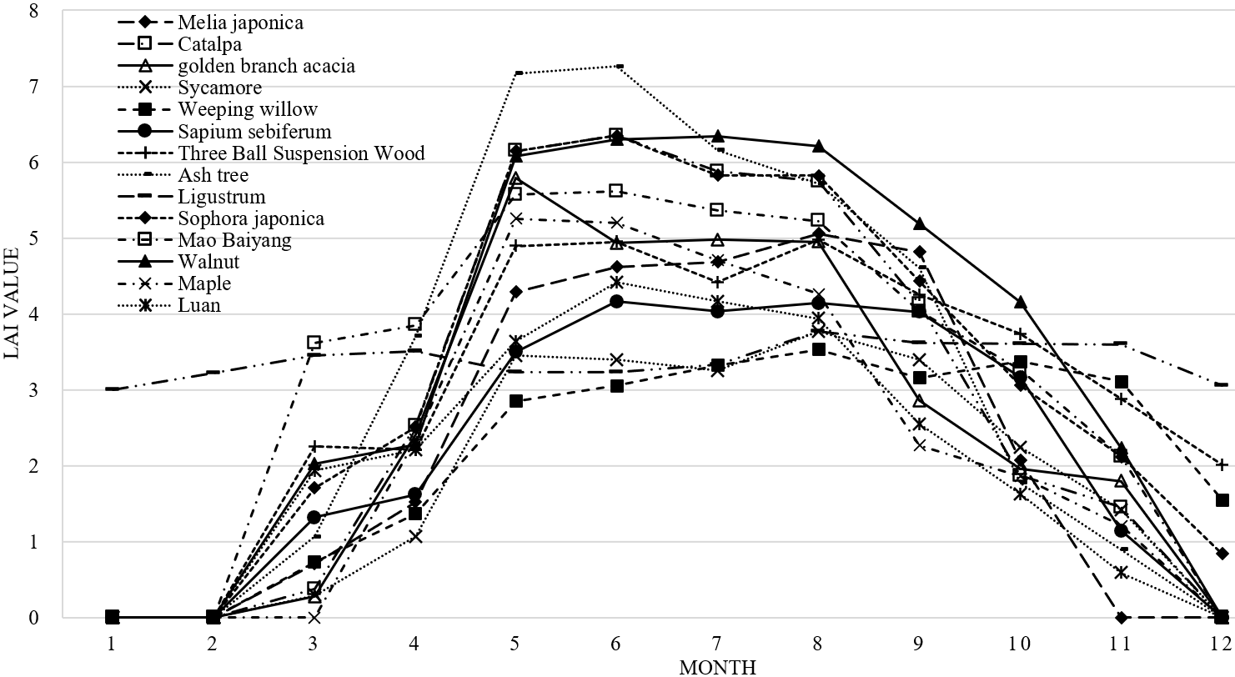

**Figure 2.** Inter-month variation in LAI values of 14 commonly used street trees in Xinxiang city

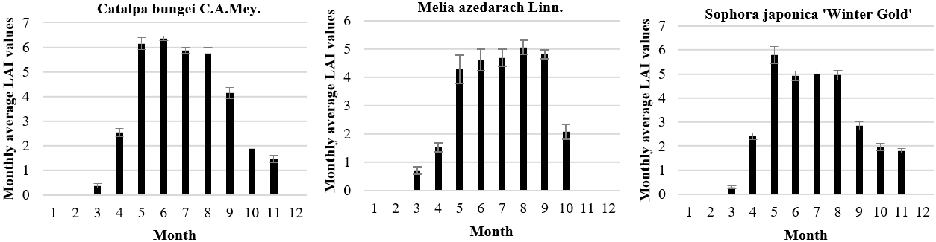

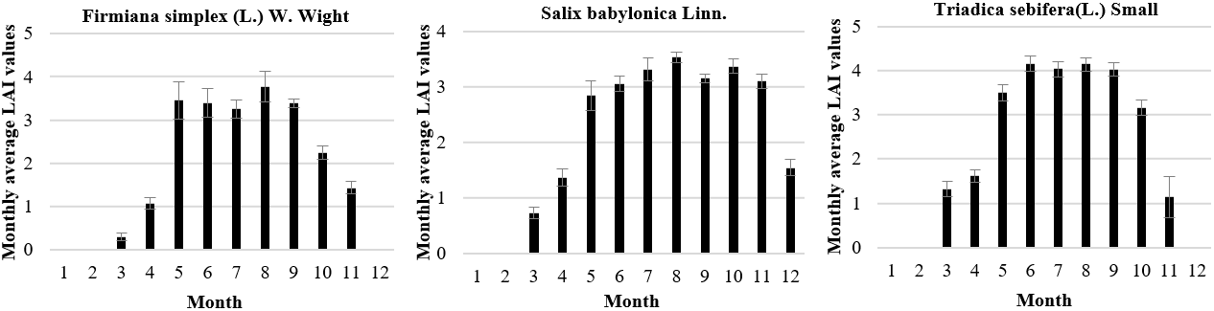

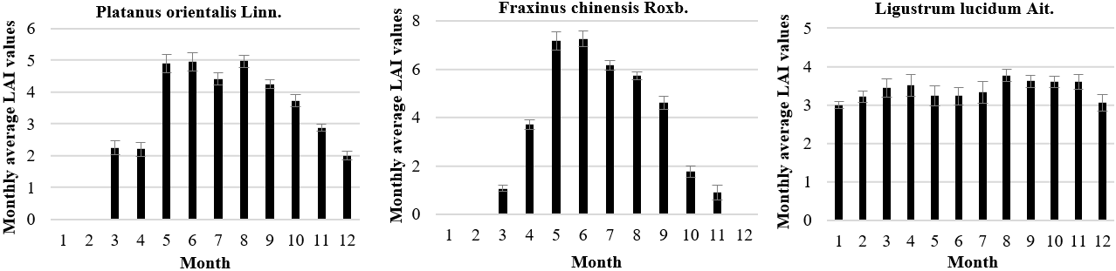

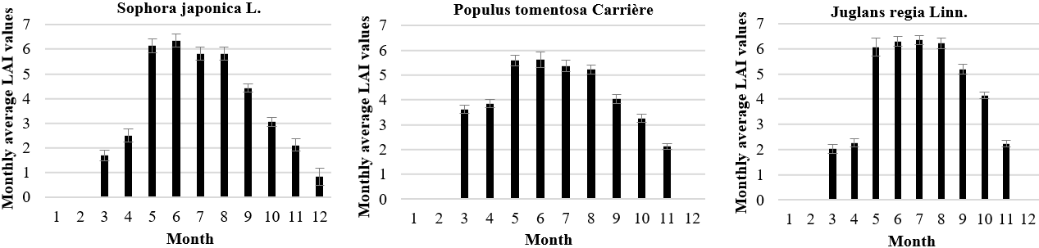

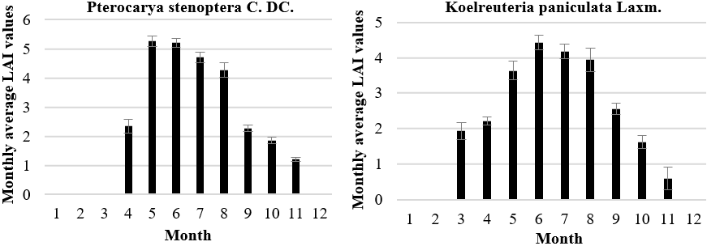

**Figure 3.** Inter-month variation in LAI values of 14 commonly used street trees in Xinxiang

**Table 2.** Statistics on the average annual LAI values of 14 commonly used street tree species

|  |  |  |  |  |  |  |  |
| --- | --- | --- | --- | --- | --- | --- | --- |
|  | **Melia azedarach Linn.** | **Catalpa bungei C.A.Mey.** | **Sophora japonica 'Winter Gold'** | **Firmiana simplex (L.) W. Wight** | **Salix babylonica Linn.** | **Triadica sebifera (L.) Small** | **Platanus orientalis Linn.** |
| Annual average | 2.31 | 2.87 | 2.50 | 1.86 | 2.17 | 2.26 | 3.05 |
| Standard deviation | 2.20 | 2.63 | 2.21 | 1.56 | 1.36 | 1.75 | 1.80 |
| Maximum value | 5.06 | 6.36 | 5.79 | 3.77 | 3.53 | 4.16 | 4.98 |
| Minimum value | 0.00 | 0.00 | 0.00 | 0.00 | 0.00 | 0.00 | 0.00 |
| Variance | 4.84 | 6.89 | 4.86 | 2.41 | 1.84 | 3.05 | 3.23 |
|  | **Fraxinus chinensis Roxb.** | **Ligustrum lucidum Ait.** | **Sophora japonica L.** | **Populus tomentosa Carrière** | **Juglans regia Linn.** | **Pterocarya stenoptera C. DC.** | **Koelreuteria paniculata Laxm.** |
| Annual average | 3.20 | 3.39 | 3.23 | 3.22 | 3.40 | 2.26 | 2.09 |
| Standard deviation | 2.89 | 0.24 | 2.41 | 2.20 | 2.61 | 2.12 | 1.69 |
| Maximum value | 7.26 | 3.77 | 6.35 | 5.61 | 6.34 | 5.25 | 4.42 |
| Minimum value | 0.00 | 3.00 | 0.00 | 0.00 | 0.00 | 0.00 | 0.00 |
| Variance | 8.37 | 0.05 | 5.80 | 4.85 | 6.83 | 4.48 | 2.85 |

(1) LAI values for the evergreen *Ligustrum lucidum* increased slightly by around 0.2 in March and April and in August and November, remaining largely unchanged at around 3.2 in the other months.

(2) Most of the 13 deciduous tree species reached their peak LAI values from May through August. Among them, *Fraxinus chinensis* Roxb., *Catalpa bungei* C.A.Mey., *Sophora japonica* L., *Sophora japonica* 'Winter Gold', *Pterocarya stenoptera* C. DC., and *Populus tomentosa* Carrière reached their peak LAI values in May and June and then gradually declined, with varying decreasing degree; *Platanus orientalis* Linn., *Firmiana simplex* (L.) W. Wight, and *Koelreuteria paniculata* Laxm. were able to maintain high LAI values from May through August and then started to decline until they were recorded as zero after defoliation (Figure 2).

(3) Of the 13 deciduous trees, *Melia azedarach* Linn. was the first to lose its leaves till an LAI value of 0 in November, followed by *Catalpa bungei* C.A.Mey., *Sophora japonica* 'Winter Gold', *Firmiana simplex* (L.) W. Wight, *Triadica sebifera*(L.) Small, *Fraxinus chinensis* Roxb., *Populus tomentosa* Carrière, *Juglans regia* Linn., *Pterocarya stenoptera* C. DC., and *Koelreuteria paniculata* Laxm. with an LAI value of 0 in December, and finally *Salix babylonica* Linn., *Sophora japonica* L., and *Platanus orientalis* Linn. with an LAI value of 0 in January.

(4) The annual mean LAI was calculated for each tree species and analysed for comparison (Table 2). The largest inter-month variation in all samples was for *Fraxinus chinensis* Roxb., the smallest variation was for *Ligustrum lucidum* Ait., and the largest single-month LAI value was 7.26 for *Fraxinus chinensis* Roxb.

(5) In the seasonal dynamics (Figure 4), the 13 deciduous tree street trees conformed to a "single-peaked" trend of maximum summer variation, except for *Ligustrum lucidum* Ait., which reached its maximum LAI value in autumn. The seasonal variation in LAI values varied significantly by species. The highest LAI value in spring was 4.35 for *Populus tomentosa* Carrière, 6.38 for *Fraxinus chinensis* Roxb. in summer, 3.86 for *Juglans regia* Linn. in autumn and 3.09 for *Ligustrum lucidum* Ait. in winter.

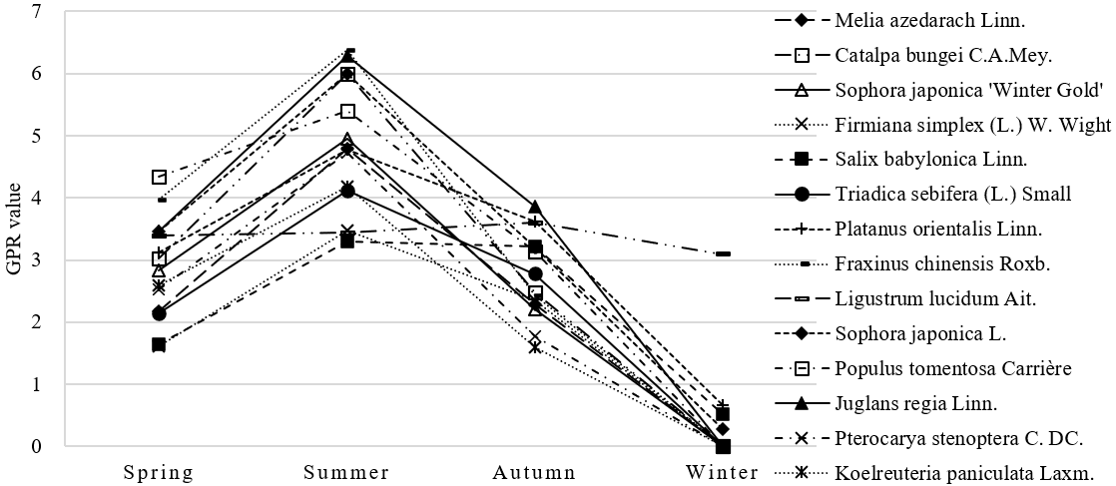

**Figure 4.** Seasonal dynamics of LAI values of 14 common roadside trees in Xinxiang

4.1.2 Day-order dynamics of LAI values for row trees

The LAI values of the 13 deciduous tree species were highly positively correlated with the date of year (DOY) at a highly significant level (P<0.01), combined with the inter-month variation in LAI values of the street tree species. The regression equation for each tree species was obtained by SPSS software (Table 3), and the R2 for all deciduous trees except *Ligustrum lucidum* Ait. was greater than 0.75 and P<0.01, showing a significant positive correlation.

**Table 3.** LAI values of 14 commonly used street tree species in Xinxiang City in relation to the fitted DOY

|  |  |  |  |  |
| --- | --- | --- | --- | --- |
| **Tree species** | **Sample size** | **Regression equation** | | **Estimated standard error** |
| Melia azedarach Linn. | 20 | L=0.079t-0.000195t2-3.415 | R2=0.815** | 1.047 |
| Catalpa bungei C.A.Mey. | 20 | L=0.094t-0.000233t2-3.913 | R2=0.818** | 1.238 |
| Sophora japonica 'Winter Gold' | 20 | L=0.078t-0.000193t2-3.166 | R2=0.797** | 1.097 |
| Firmiana simplex (L.) W. Wight | 20 | L=0.056t-0.000133t2-2.477 | R2=0.829** | 0.711 |
| Salix babylonica Linn. | 20 | L=0.042t-0.000086t2-1.769 | R2=0.903** | 0.468 |
| Triadica sebifera(L.) Small | 20 | L=0.065t-0.000155t2-2.699 | R2=0.877** | 0.679 |
| Platanus orientalis Linn. | 20 | L=0.064t-0.000146t2-2.34 | R2=0.897** | 0.637 |
| Fraxinus chinensis Roxb. | 20 | L=0.103t-0.000262t2-4.016 | R2=0.839** | 1.286 |
| Sophora japonica L. | 20 | L=0.088t-0.000214t2-3.469 | R2=0.868** | 0.969 |
| Populus tomentosa Carrière | 20 | L=0.085t-0.000214t2-2.789 | R2=0.948** | 0.554 |
| Juglans regia Linn. | 20 | L=0.097t-0.000237t2-3.969 | R2=0.88** | 1.001 |
| Pterocarya stenoptera C. DC. | 20 | L=0.073t-0.000184t2-3.016 | R2=0.763** | 1.138 |
| Koelreuteria paniculata Laxm. | 20 | L=0.063t-0.00016t2-2.281 | R2=0.913** | 0.55 |
| Ligustrum lucidum Ait. | 20 | L=EXP（1.257-4.364/t） | R2=0.334* | 0.062 |

Note: a: L refers to plant LAI (m2/m2), t refers to DOY (order of the day in the year); b: ** indicates highly significant at p<0.01 level

The LAI values of the 13 deciduous tree street trees fitted the regression against DOY significantly better than those of *Ligustrum lucidum* Ait. (R2 was significantly different), and the LAI values with DOY fitted the quadratic curve better. The best regression fit was obtained for *Populus tomentosa* Carrière (R2 = 0.948), followed by *Koelreuteria paniculata* Laxm. (R2 = 0.913), while the regression fit for the evergreen *Ligustrum lucidum* Ait. (R2) was relatively low. Based on the regression fit equation, the LAI values of the 14 street tree species could be estimated for any day of the year, further clarifying the differences in LAI values between tree species.

**4.2 GPR of Roads with Different Street Tree Species**

4.2.1 GPR of roads with single row street trees

Single species of street tree plants are distributed on both sides of the road (Figure 5), and most Xinxiang city branch roads, city secondary roads and old city urban trunk roads mostly adopt this form of street tree layout. In particular, the original border line of the main roads in the old city is narrow. While meeting the needs of vehicles and pedestrians, no other forms of greening (such as middle-of-the-road green belts, protective green belts, etc.) can be carried out.

The GPR of the current road can be converted to , where GPR is the green plot ratio of the current road, LAI is the LAI of the current road tree, 5 is the radius of the plant canopy in meters, 200 is the number of single row of road trees, 2 represents the 2 tree rows on both sides of the road, 1000 is the road length in meters, 80 is the width of the border line of the road in meters. The equation was simplified as .

The inter-month variation in GPR values for the 14 commonly used street trees on the current road (Figure 6) is generally consistent with the inter-month variation in their LAI values, with the maximum GPR value for a single month being 2.85 for *Fraxinus chinensis* Roxb. in June. *Firmiana simplex* (L.) W. Wight 0.73< *Koelreuteria paniculata* Laxm. 0.82 < *Salix babylonica* Linn. 0.85 < *Triadica sebifera*(L.) Small 0.886 < *Pterocarya stenoptera* C. DC. 0.89 < *Melia azedarach* Linn. 0.91 < *Sophora japonica* 'Winter Gold' 0.98 < Catalpa bungei C.A.Mey. 1.13 < *Platanus orientalis* Linn. 1.20 < *Fraxinus chinensis* Roxb. 1.26 < *Populus tomentosa* Carrière 1.265 < *Sophora japonica* L.1.27 < *Ligustrum lucidum* Ait.1.33 < *Juglans regia* Linn.1.34 (some three decimal places are for ranking comparison only).

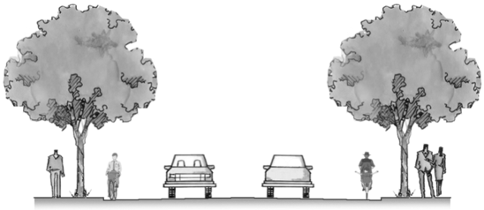

**Figure 5.** Illustration of the road section with a single row of street trees

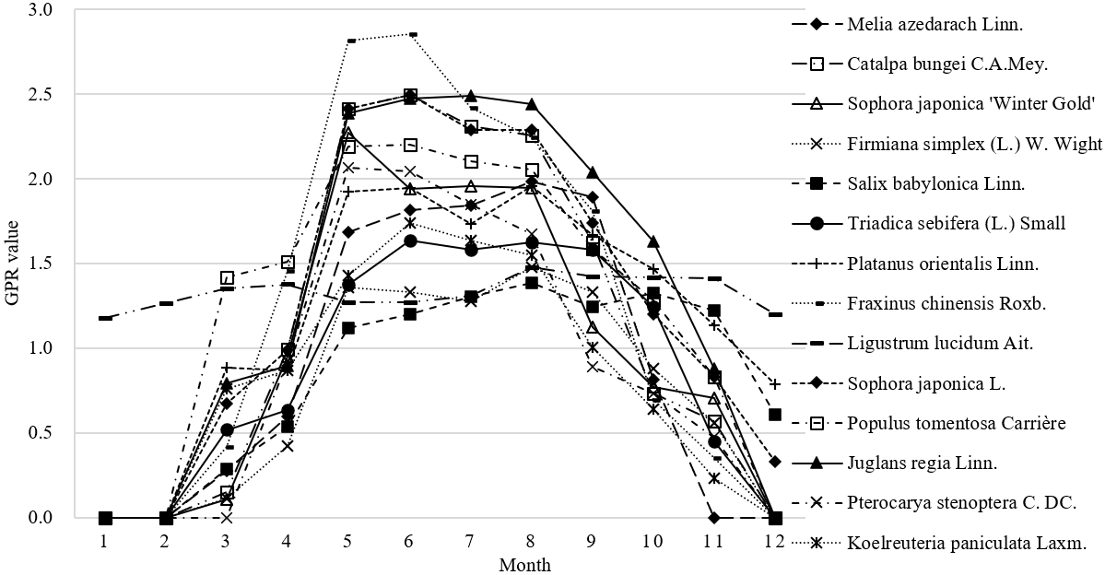

**Figure 6.** Inter-monthly variation in GPR values for 14 commonly used street trees

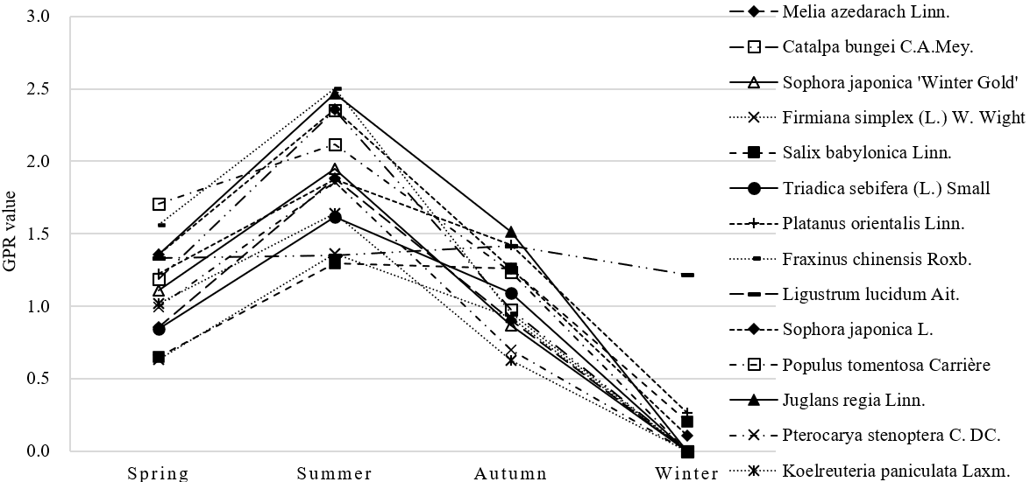

**Figure 7.** Seasonal variation in GPR values for 14 commonly used street trees

Among the seasonal changes in GPR values of the 14 street tree species commonly used in Xinxiang (Figure 7), all 13 deciduous trees had the highest GPR values in summer, except for *Ligustrum lucidum* Ait., which had the highest GPR values in autumn. This was in line with the seasonal dynamics of street tree LAI values, which were all in line with the "single-peaked" trend. The highest GPR in spring was 1.71 for *Populus tomentosa* Carrière, 2.50 in summer for *Fraxinus chinensis* Roxb., 1.52 in autumn for *Juglans regia* Linn. and 1.21 in winter for *Ligustrum lucidum* Ait.

4.2.2 GPR of roads with double-row trees on each roadside

This type is mostly suitable for major urban arterial roads with relatively wide road borderline and separate green belt for non-motorised lane (Figure 8). Double-row trees provide longer shade space in summer and have a better multi-layered landscape effect, but there are certain requirements for road width.

After GPR conversion for the current road configuration of two street tree types A and B, , where GPR is the green plot ratio of the road section, LAI A and LAI B are the single LAI of the two street tree types A and B respectively, 5 is the plant canopy radius in metres, 200 is the number of single row street trees, 4 refers to the total of 4 rows of street trees on both sides of the road, 1000 is the length of the road in metres, 80 is the width of the road borderline in metres, the equation is simplified as GPR=(LAIA+LAIB)×0.25×π. After pairing the 14 street tree species, there are 105 combinations (Figure 9). The largest LAI value is 6.8 for the "*Juglans regia* Linn. + *Juglans regia* Linn." combination and the smallest is 3.71 for the "*Firmiana simplex* (L.) W. Wight + *Firmiana simplex* (L.) W. Wight" combination, with a difference in LAI value of 3.09. Research revealed that only 12 combinations are actually used in Xinxiang. The GPR values of the current roads were calculated and analysed to obtain the inter-month variation of the current road GPR values (Figure 10).

The inter-month variation in GPR values for the 12 common combinations of double-row street tree species was zero in January, except for two combinations containing the evergreen *Ligustrum lucidum* Ait., which had a GPR value of 2.34. The combination “*Fraxinus chinensis* Roxb.+ *Sophora japonica* L.” had the most significant inter-month variation in GPR values, which had the highest GPR value of all combinations in June at 10.64; the one with relatively less variation was the "*Koelreuteria paniculata* Laxm.+ *Ligustrum lucidum* Ait." combination. In Table 4, the highest GPR value in spring was for “*Sophora japonica* L.+ *Populus tomentosa* Carrière” (6.13) and the lowest was for “*Platanus orientalis* Linn.+ *Triadica sebifera*(L.) Small” (4.13); in summer, the highest was for “*Fraxinus chinensis* Roxb.+ *Sophora japonica* L.” (9.72) and the lowest was for “*Koelreuteria paniculata* Laxm.+ *Ligustrum lucidum* Ait.” (5.99); in autumn, the highest was for “*Platanus orientalis* Linn.+ *Platanus orientalis* Linn.” (5.69) and the lowest was for “*Fraxinus chinensis* Roxb.+ *Firmiana simplex* (L.) W. Wight” (3.77); in winter, the highest was for “*Platanus orientalis* Linn.+ *Ligustrum lucidum* Ait.” (2.96) and the lowest was for “*Fraxinus chinensis* Roxb.+ *Firmiana simplex* (L.) W. Wight” (0). The highest annual average GPR of the 12 combinations was *Sophora japonica* L.+ *Sophora japonica* L." and the lowest was “*Fraxinus chinensis* Roxb.+ *Firmiana simplex* (L.) W. Wight” (0). Among the 14 common paired combinations of street tree species ranked by LAI values, 8 of the 12 common combinations of double-row street tree species in Xinxiang were in the top 50%, accounting for 66.7%, and 5 of the top 20, accounting for 62.5%.

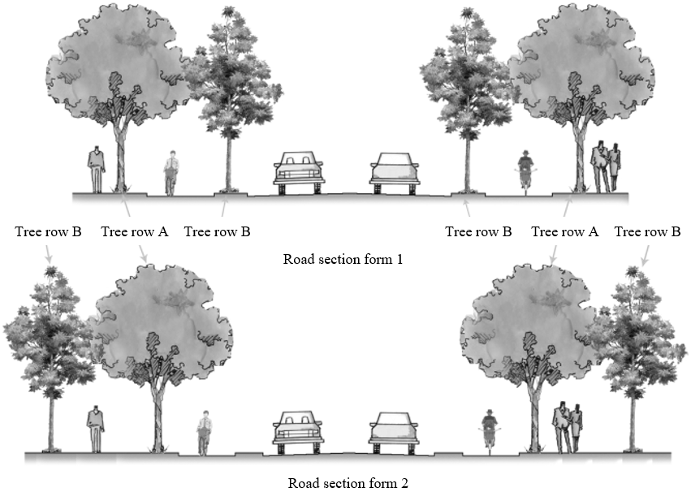

**Figure 8.** Illustration of the road section with double-row trees on each roadside

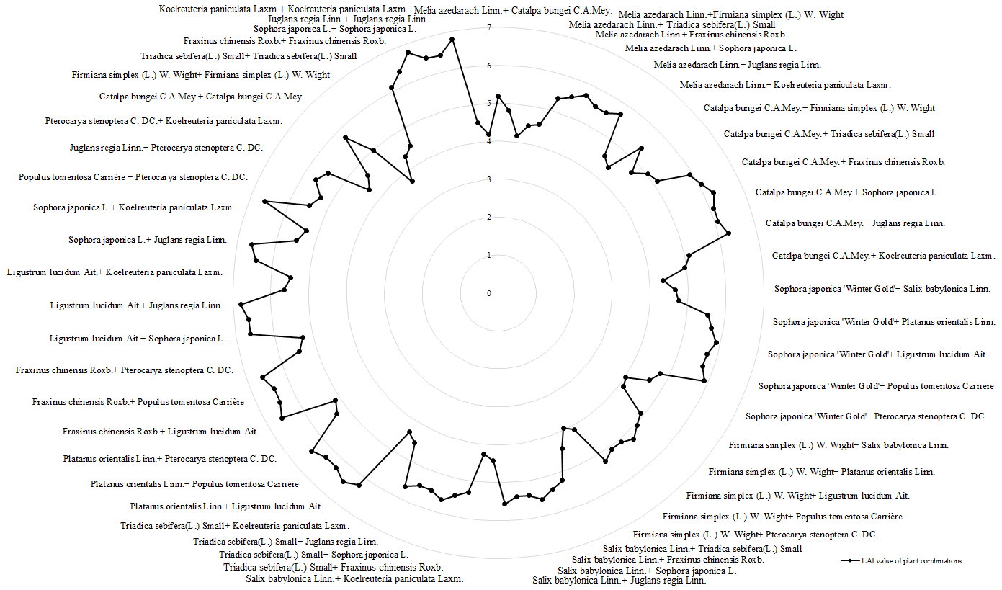

**Figure 9.** Double row street tree combinations of 14 commonly used street tree species

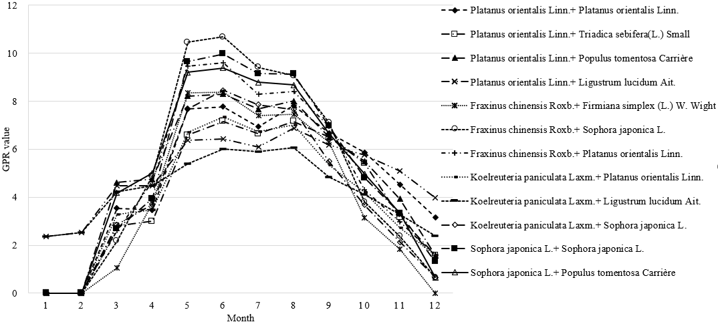

**Figure 10.** Inter-month variation in GPR values for 12 common combinations of double-row street tree species

**Table 4.** Seasonal dynamics and annual averages of GPR values for 12 common combinations of double-row street tree species in Xinxiang City

|  |  |  |  |  |  |  |  |  |
| --- | --- | --- | --- | --- | --- | --- | --- | --- |
| **Serial number** | **Street tree A** | **Street tree B** | **Ranking of tree species combinations** | **Spring** | **Summer** | **Autumn** | **Winter** | **Annual average** |
| 1 | Sophora japonica L | Sophora japonica L | 10 | 5.43 | 9.42 | 5.03 | 0.44 | 5.08 |
| 2 | Sophora japonica L | Populus tomentosa Carrière | 12 | 6.13 | 8.95 | 4.98 | 0.22 | 5.07 |
| 3 | Platanus orientalis Linn. | Ligustrum lucidum Ait. | 14 | 5.12 | 6.46 | 5.68 | 2.96 | 5.05 |
| 4 | Fraxinus chinensis Roxb. | Sophora japonica L. | 15 | 5.84 | 9.72 | 4.42 | 0.22 | 5.05 |
| 5 | Platanus orientalis Linn. | Populus tomentosa Carrière | 20 | 5.86 | 8.00 | 5.31 | 0.53 | 4.92 |
| 6 | Fraxinus chinensis Roxb. | Platanus orientalis Linn. | 22 | 5.58 | 8.76 | 4.75 | 0.53 | 4.90 |
| 7 | Platanus orientalis Linn. | Platanus orientalis Linn. | 24 | 4.90 | 7.51 | 5.69 | 1.05 | 4.79 |
| 8 | Koelreuteria paniculata Laxm. | Ligustrum lucidum Ait. | 50 | 4.71 | 5.99 | 4.08 | 2.43 | 4.30 |
| 9 | Koelreuteria paniculata Laxm. | Sophora japonica L. | 59 | 4.75 | 7.99 | 3.77 | 0.22 | 4.18 |
| 10 | Platanus orientalis Linn. | Triadica sebifera(L.) Small | 60 | 4.13 | 6.98 | 5.03 | 0.53 | 4.17 |
| 11 | Koelreuteria paniculata Laxm. | Platanus orientalis Linn. | 68 | 4.49 | 7.04 | 4.09 | 0.53 | 4.04 |
| 12 | Fraxinus chinensis Roxb. | Firmiana simplex (L.) W. Wight | 73 | 4.39 | 7.74 | 3.75 | 0.00 | 3.97 |

Note: The ranking of combinations is for the LAI value of paired combinations of 14 commonly used street tree species (105 combinations in total)

**5. Discussion and Conclusions**

**5.1 LAI Values of 14 Commonly Used Street Tree Species in Xinxiang**

In the LAI measurements of the 14 commonly used street trees, the LAI values of deciduous trees were significantly higher than those of evergreens in summer, and the inter-month variation in LAI values was consistent with a “single-peaked” trend. But the LAI values of most deciduous trees were lower than those of evergreens in spring and autumn. We found that the LAI values of individual plants in summer (June to August) were not representative of their annual average LAI values. For example, the summer LAI of *Fraxinus chinensis* Roxb. was 6.38, the highest among the 14 commonly used street trees, but its annual average LAI was only 3.2, lower than that of *Juglans regia* Linn., *Ligustrum lucidum* Ait., *Sophora japonica* L. and *Populus tomentosa* Carrière. *Firmiana simplex* (L.) W. Wight has the lowest annual average LAI 1.86, which had a higher summer LAI of 3.47 than the LAI 3.44 of *Ligustrum lucidum* Ait. This experiment showed that LAI studies of plants should not only consider the months of June to September. It is necessary to measure the LAI of plants throughout the year in order to reflect the current leaf area changes of plants in a more comprehensive and truthful way. The annual mean LAI values for some of the plants obtained in this experiment are similar to those measured by Xiaoyu Shen in her experiments in Beijing from June to September [25], where the range of summer LAI values for some of the deciduous trees measured were broadly consistent. However, the differences are more pronounced when comparing LAI values for different plants. This may be related to the different time scales of the measurements, the different geographical locations of the samples and the way in which the subjects were selected.

The study showed that the LAI values of 14 common street tree species had a high level of significant correlation with DOY. 13 deciduous tree species showed a good fit (P<0.01) and a quadratic regression equation for DOY was fitted. The LAI values of evergreen *Ligustrum lucidum* Ait. were relatively poorly fitted to the DOY regression (R2=0.034, P<0.05), and an S regression equation was fitted. The regression analysis of LAI values on morphological parameters such as crown width and tree height for the measured samples could not obtain valid results (P>0.05). The correlation between LAI values and morphological indicators of landscape plants (crown width and height) was not significant. This may be due to the fact that this experiment was conducted on urban road street trees, which are different from areas with a higher degree of naturalness such as farmland and woodland. Street trees require regular branch pruning during planting and management, and their crown width and diameter at breast height are more subject to artificial influence and do not correlate significantly with LAI values.

**5.2 Road GPR of 14 Commonly Used Street Tree Species in Xinxiang City**

According to the GPR formula, plant canopy and road plot area can be considered as coefficients of variation, hence the larger the LAI value, the larger the GPR value, and the inter-month variation of GPR values follows the trend of increasing first and then decreasing. Among the single row street tree types in the experimental section, the largest average annual GPR value (1.34) was for *Juglans regia* Linn., followed by *Ligustrum lucidum* Ait., *Sophora japonica* L., *Populus tomentosa* Carrière, *Fraxinus chinensis* Roxb. and *Platanus orientalis* Linn., while *Firmiana simplex* (L.) W. Wight had the smallest GPR value of 0.73 as a street tree. *Sophora japonica* L., *Populus tomentosa* Carrière and *Platanus orientalis* Linn. had average annual GPR values of 1.27, 1.265 and 1.20 respectively, second only to evergreen *Ligustrum lucidum* Ait. The annual mean GPR of *Fraxinus chinensis* Roxb. at 1.26 was slightly higher than that of *Platanus orientalis* Linn. The LAI of *Fraxinus chinensis* Roxb. was significantly higher than that of the other experimental samples from May to September. In the north, where winters are cold and summers are hot, a higher LAI value provides better shade and more adequate sunlight after the leaves have fallen in winter. Therefore, the use of *Fraxinus chinensis* Roxb. as urban street trees has gradually increased in recent years compared to other tree species. *Koelreuteria paniculata* Laxm. and *Triadica sebifera*(L.) Small have an average annual GPR of only 0.82 and 0.89 respectively. Although their summer GPR of around 1.62 is at the middle level and has outstanding landscape features with purple-red fruits and rich leaf colour during seasonal changes, their GPR declines rapidly in autumn, which is not conducive to the improvement of the overall GPR of roads in autumn and winter.

We can see that when it comes to single row street tree selection, *Juglans regia* Linn., *Ligustrum lucidum* Ait., *Sophora japonica* L., *Populus tomentosa* Carrière, *Platanus orientalis* Linn. and *Fraxinus chinensis* Roxb. have slightly greater road GPR values than other plants when used as street trees, and are more widely used in practice. *Triadica sebifera*(L.) Small, *Koelreuteria paniculata* Laxm. and *Catalpa bungei* C.A.Mey. have relatively small average annual GPR values and can be used on a few roads alone or with other tree species, and are not suitable for a large number of single applications.

Higher road GPR can be achieved when street tree species are combined in pairs to form double row street trees. Experiments have shown that the annual average GPR of the double-row street tree type on the same section of road using 14 commonly used street tree species is 3-7 times higher than that of the single-row street tree type. The higher the GPR value of the road, the greater the total leaf area of the plant, and the better the ecological benefits of the current road plant. Among the 12 road tree combinations commonly used in Xinxiang, the combination " *Sophora japonica* L.+ *Sophora japonica* L." has the highest annual average GPR, but the largest GPR in summer is for " *Fraxinus chinensis* Roxb.+ *Sophora japonica* L.". The inter-monthly variation, seasonal dynamics and annual mean values of GPR for the double-row street tree combination types are strongly influenced by the combination. Therefore, the GPR values of different tree species combinations can be measured according to the measured LAI values or the daily regression equation, so that the optimization of roadside tree species can be carried out in a targeted manner, or even the roadside GPR values can be estimated for a particular day. For example, the DOY of March 12 is 71, and the current road GPR value is estimated to be 3.06 when using the combination of " *Fraxinus chinensis* Roxb.+ *Sophora japonica* L." by substituting the DOY into regression equation. With the majority of deciduous trees having lost their leaves by December, evergreens tend to have more stable LAI values. Hence, the GPR of a road tree combination containing evergreen *Ligustrum lucidum* Ait. is much greater than that of other combinations. This shows that in the cold winter months in the north, the use of evergreen plants such as *Ligustrum lucidum* Ait. can greatly improve the GPR of green spaces in winter, and that evergreen plants are important for the urban green space ecosystem as a whole, both in terms of landscape significance and ecological benefits. 105 combinations of 14 common street tree species are available, but only 12 double-row street tree combinations have been used in Xinxiang, so it’s impossible to carry out a status quo experimental comparison for the remaining 93. In the simulations, the GPR values of nine combinations are greater than the 12 common combinations in Xinxiang. For example, the current road GPR value of "*Juglans regia* Linn.+ *Juglans regia* Linn." is 5.34, " *Juglans regia* Linn.+ *Ligustrum lucidum* Ait." is 5.33, "*Ligustrum lucidum* Ait.+ *Ligustrum lucidum* Ait." is 5.31, and “*Ligustrum lucidum* Ait.+ *Sophora japonica* L.” is 5.20, etc. It takes further comparative analysis to conclude whether these combinations with higher GPR values have both better landscape and ecological benefits, and whether they can be applied in practice.

**6. Conclusion**

The GPR is calculated using the LAI as the main parameter, inheriting the LAI characteristics to reflect the growth state and ecological impact of plants. This experiment to measure the LAI of 14 commonly used street tree species in Xinxiang is an in-depth exploration of the growth patterns and ecological characteristics of street tree species there. The conversion of the LAI values of the 14 commonly used street tree species into GPR values can be used as one of the important indicators for evaluating the merits of street tree plant configurations It enables comparative analysis of street tree types in the form of quantitative data, delivers scientific evaluation of the differences among street tree combinations, hence provides a more scientific and effective theoretical basis for the optimization of street tree species in Xinxiang.

This study has shown that among single row street trees, the GPR values of *Ligustrum lucidum* Ait., *Juglans regia* Linn., *Sophora japonica* L., *Populus tomentosa* Carrière, *Fraxinus chinensis* Roxb. and *Platanus orientalis* Linn. are significantly better than those of other commonly used tree species, and are suitable as major street tree species. The average annual GPR of a combination of double-row street trees is 3-7 times higher than that of single-row street trees, providing richer plant layers and better landscape effects, as well as being more conducive to the organisation of traffic on urban roads. Among the 12 common two-row street tree combinations, "*Sophora japonica* L.+ *Sophora japonica* L." has the highest GPR, followed by "*Fraxinus chinensis* Roxb.+ *Sophora japonica* L.", "*Sophora japonica* L.+ *Populus tomentosa* Carrière", and “*Platanus orientalis* Linn.+ *Ligustrum lucidum* Ait.”. These can be used as common road combinations to maintain a high GPR value while enriching the road landscape. Meanwhile, through simulation, we found that there are still more double-row street tree species combinations with GPR values greater than 12 common combinations, such as "*Ligustrum lucidum* Ait. + *Sophora japonica* L." and " *Fraxinus chinensis* Roxb.+ *Ligustrum lucidum* Ait.". As there is no current situation to compare them, it takes further landscape evaluation to verify their feasibility. Therefore, in urban roads where possible, double-row street tree species combinations should be selected. Combined with the comparison of GPR values, it’s better to select the best street tree species and combinations that meet the landscape design requirements and maximise ecological benefits, so as to further improve the urban ecosystem.

The object of this study is urban road plantings, which are subject to artificial influences such as pruning, de-branching and weeding. Hence, the number of samples should be increased to reduce the bias in the measurement of LAI values. In this study, LAI was only measured for 58 commonly used road plants. Actual road scenarios involve a bigger variety of plant species. Accordingly, we may increase the number of research samples in the future to improve the coverage of road plant species. There are diverse combinations of urban road plantings. This study only explores the green plot ratio based on single- and double-row planting patterns. Other combination types need further research.

Fundings

This paper was supported by the Key Technology for Rapid Assessment of Urban Ecological Green Volume Based on UAV Multispectral Remote Sensing, which entered the list of the Henan Provincial Science and Technology Breakthrough Program (Grant No.: 222102320221); the Research and Development of Key Technology for Coupling Ecological Restoration and Landscape Reconstruction of Urban Chalk Waste Land along The Yellow River in Henan, which entered the list of the Henan Provincial Science and Technology Breakthrough Program (Grant No.: 212102310841).

Data Availability

The data used to support the findings of this study are available from the corresponding author upon request.

Conflicts of Interest

The authors declare that they have no conflicts of interest.

References

1. T. Hu, D. Wei, Y. Su, X. Wang, J. Zhang, X. Sun, and Q. Guo, “Quantifying the shape of urban street trees and evaluating its influence on their aesthetic functions based mobile lidar data,” *ISPRS J. Photogramm.*, vol. 184, pp. 203-214, 2022. <https://doi.org/10.1016/j.isprsjprs.2022.01.002>.
2. A. M. Shah, G. Liu, Z. Huo, Q. Yang, W. Zhang, F. Meng, and S. Ulgiati, “Assessing environmental services and disservices of urban street trees. an application of the emergy accounting,” *Resour. Conserv. Recy.*, vol. 186, Article ID: 106563, 2022. <https://doi.org/10.1016/j.resconrec.2022.106563>.
3. J. Yao, M. Liu, N. Chen, W. Chen, C. Miao, X. Wang, and X. He, “The spatial variation of air purification benefit provided by street tree assemblages in Shenyang, China,” *Urban Ecosyst*., vol. 25, no. 3, pp. 725-732, 2022. <https://doi.org/10.1007/s11252-021-01183-7>.
4. S. Gillner, J. Vogt, A. Tharang, S. Dettmann, and A. Roloff, “Role of street trees in mitigating effects of heat and drought at highly sealed urban sites,” *Landscape Urban Plan.*, vol. 143, pp. 33-42, 2015. <https://doi.org/10.1016/j.landurbplan.2015.06.005>.
5. W. R. Selbig, S. P. Loheide II, W. Shuster, B. C. Scharenbroch, R. C. Coville, J. Kruegler, and D. Nowak, “Quantifying the stormwater runoff volume reduction benefits of urban street tree canopy,” *Sci. Total Environ.*, vol. 806, Article ID: 151296, 2022. <https://doi.org/10.1016/j.scitotenv.2021.151296>.
6. X. Jin, L. Yang, X. Du, and Y. Yang, “Transport characteristics of PM2. 5 inside urban street canyons: The effects of trees and vehicles,” *Build. Simul*., vol. 10, no. 3, pp. 337-350, 2016. <https://doi.org/10.1007/s12273-016-0324-1>.
7. J. Liu and F. Slik, “Are street trees friendly to biodiversity,” *Landscape Urban Plan*., vol. 218, Article ID: 104304, 2022. <https://doi.org/10.1016/j.landurbplan.2021.104304>.
8. A. M. Coutts, E. C. White, N. J. Tapper, J. Beringer, and S. J. Livesley, “Temperature and human thermal comfort effects of street trees across three contrasting street canyon environments,” *Theor. Appl. Climatol*., vol. 124, no. 1, pp. 55-68, 2015. <https://doi.org/10.1007/s00704-015-1409-y>.
9. R. Revelli and A. Porporato, “Ecohydrological model for the quantification of ecosystem services provided by urban street trees,” *Urban Ecosyst.*, vol. 21, no. 3, pp. 489-504, 2018. <https://doi.org/10.1007/s11252-018-0741-2>.
10. J. A. Salmond, M. Tadaki, S. Vardoulakis, K. Arbuthnott, A. Coutts, M. Demuzere, and B. W. Wheeler, “Health and climate related ecosystem services provided by street trees in the urban environment,” *Environ. Health*, vol. 15, no. 1, pp. 95-111, 2016. <https://doi.org/10.1186/s12940-016-0103-6>.
11. F. X. Li, M. Li, and X. G. Feng, “High-Precision Method for Estimating the Three-Dimensional Green Quantity of an Urban Forest,” *J. Indian. Soc. Remote. Sens*., vol. 202, no. 149, pp. 1407-1417, 2021. <https://doi.org/10.1007/s12524-021-01316-7>.
12. S. Zheng, C. Meng, J. Xue, Y. Wu, J. Liang, L. Xin, and L. Zhang, “UAV-based spatial pattern of three-dimensional green volume and its influencing factors in Lingang New City in Shanghai, China,” *Front. Earth. Sci.*, vol. 15, no. 3, pp. 543-552, 2021. <https://doi.org/10.1007/s11707-021-0896-7>.
13. B. L. Ong, “Green plot ratio: An ecological measure for architecture and urban planning,” *Landscape Urban Plan*., vol. 63, no. 4, pp. 197-211, 2003. <https://doi.org/10.1016/S0169-2046(02)00191-3>.
14. C. Leuschner, S. Voß, A. Foetzki, and Y. Clases, “Variation in leaf area index and stand leaf mass of European beech across gradients of soil acidity and precipitation,” *Plant Ecol*., vol. 186, no. 2, pp. 247-258, 2006. <https://doi.org/10.1007/s11258-006-9127-2>.
15. G. Moser, D. Hertel, and C. Leuschner, “Altitudinal change in LAI and stand leaf biomass in tropical montane forests: a transect study in Ecuador and a pan-tropical meta-analysis,” *Ecosyst*., vol. 10, no. 6, pp. 924-935, 2007. <https://doi.org/10.1007/s10021-007-9063-6>.
16. Z. Ren, Y. Du, X. He, R. Pu, H. Zheng, and H. Hu, “Spatiotemporal pattern of urban forest leaf area index in response to rapid urbanization and urban greening,” *J. Forestry Res*., vol. 29, no. 3, pp. 785-796, 2017. <https://doi.org/10.1007/s11676-017-0480-x>.
17. S. Poddar, D. Park, and S. Chang, “Energy performance analysis of a dormitory building based on different orientations and seasonal variations of leaf area index,” *Energy Effic*., vol. 10, no. 4, pp. 887-903, 2017. <https://doi.org/10.1007/s12053-016-9487-y>.
18. D. Yan, L. S. Zhao, and Y. X. Zhao, “Quantity of plant leaf area on three major public squares in Kunming City, China,” *J. Forestry Res*., vol. 15, no. 4, pp. 291-294, 2004. <https://doi.org/10.1007/BF02844955>.
19. J. Yin, F. He, G. Qiu, K. He, J. Tian, W. Zhang, and J. Liu, “Characteristics of leaf areas of plantations in semiarid hills and gully loess regions,” *Fronti. Forestry China*, vol. 4, no. 3, pp. 351-357, 2009. <https://doi.org/10.1007/s11461-009-0056-9>.
20. W. A. White, M. M. Alsina, H. Nieto, L. G. McKee, F. Gao, and W. P. Kustas, “Determining a robust indirect measurement of leaf area index in California vineyards for validating remote sensing-based retrievals,” *Irrigation Sci*., vol. 37, no. 3, pp. 269-280, 2018. <https://doi.org/10.1007/s00271-018-0614-8>.
21. L. Y. Fan, Y. Z. Gao, H. E. B. C. Brück, and C. Bernhofer, “Investigating the relationship between NDVI and LAI in semi-arid grassland in Inner Mongolia using in-situ measurements,” *Theor. Appl. Climatol*., vol. 95, no. 1, pp. 151-156, 2008. <https://doi.org/10.1007/s00704-007-0369-2>.
22. J. Zhao, Y. Wang, H. Zhang, Z. Zhang, X. Guo, S. Yu, and W. Du, “Spatially and temporally continuous LAI datasets based on the mixed pixel decomposition method,” *SpringerPlus*, vol. 5, no. 1, pp. 516-516, 2016. <https://doi.org/10.1186/s40064-016-2166-9>.
23. E. B. Peters and J. P. McFadden, “Influence of seasonality and vegetation type on suburban microclimates,” *Urban Ecosyst*., vol. 13, no. 4, pp. 443-460, 2010. <https://doi.org/10.1007/s11252-010-0128-5>.
24. G. Perez, J. Coma, M. Chafer, and L. F. Cabeza, “Seasonal influence of leaf area index (LAI) on the energy performance of a green façade,” *Build. Environ*., vol. 207, Article ID: 108497, 2022. <https://doi.org/10.1016/j.buildenv.2021.108497>.
25. X. Y. Shen, “Study on the leaf area index model of common garden plants in Beijing,” Master Thesis, Beijing Forestry University, Beijing, 2007.