Appendix

Table A1. Potential identification

No | House Location | Coordinate | Solar Radiation kWh/m²/day | Roof Area  m² | Shadow
1 | Roof No. 1 | 7°42'35.10"S 110°12'36.75"E | 4.80 | 27.12 | Without any shadow
2 | Roof No. 2 | 7°42'33.05"S 110°12'41.70"E | 4.80 | 243.49 | Without any shadow
3 | Roof No. 3 | 7°42'32.75"S 110°12'41.55"E | 4.80 | 273.14 | Without any shadow
4 | Roof No. 4 | 7°42'34.21"S 110°12'41.77"E | 4.80 | 284.61 | Without any shadow
5 | Roof No. 5 | 7°42'29.15"S 110°12'41.03"E | 4.80 | 112.68 | Without any shadow
6 | Roof No. 6 | 7°42'29.15"S 110°12'41.42"E | 4.80 | 36.77 | Without any shadow
7 | Roof No. 7 | 7°42'31.28"S 110°12'47.17"E | 4.80 | 159.26 | Without any shadow
8 | Roof No. 8 | 7°42'29.91"S 110°12'41.28"E | 4.80 | 195.77 | Without any shadow
9 | Roof No. 9 | 7°42'29.08"S 110°12'43.16"E | 4.80 | 144.68 | Without any shadow
10 | Roof No. 10 | 7°42'28.98"S 110°12'41.96"E | 4.80 | 104.27 | Without any shadow
11 | Roof No. 11 | 7°42'29.06"S 110°12'43.09"E | 4.80 | 94.55 | Without any shadow
12 | Roof No. 12 | 7°42'31.70"S 110°12'35.06"E | 4.80 | 71.80 | Without any shadow
13 | Roof No. 13 | 7°42'29.08"S 110°12'42.58"E | 4.80 | 350.82 | Without any shadow
14 | Roof No. 14 | 7°42'29.06"S 110°12'42.77"E | 4.80 | 217.99 | Without any shadow
15 | Roof No. 15 | 7°42'29.35"S 110°12'41.25"E | 4.80 | 181.10 | Without any shadow
16 | Roof No. 16 | 7°42'29.23"S 110°12'44.09"E | 4.80 | 149.43 | Without any shadow
17 | Roof No. 17 | 7°42'29.13"S 110°12'45.30"E | 4.80 | 345.33 | Without any shadow
18 | Roof No. 18 | 7°42'29.11"S 110°12'45.23"E | 4.80 | 232.06 | Without any shadow
19 | Roof No. 19 | 7°42'32.67"S 110°12'43.53"E | 4.80 | 237.87 | Without any shadow
20 | Roof No. 20 | 7°42'32.94"S 110°12'33.79"E | 4.80 | 89.55 | Without any shadow
21 | Roof No. 21 | 7°42'29.15"S 110°12'44.70"E | 4.80 | 87.98 | Without any shadow
22 | Roof No. 22 | 7°42'37.36"S 110°12'32.89"E | 4.80 | 45.84 | Without any shadow
23 | Roof No. 23 | 7°42'29.16"S 110°12'45.12"E | 4.80 | 39.31 | Without any shadow
24 | Roof No. 24 | 7°42'37.28"S 110°12'36.53"E | 4.80 | 90.47 | Without any shadow
25 | Roof No. 25 | 7°42'35.96"S 110°12'36.83"E | 4.80 | 72.30 | Without any shadow
26 | Roof No. 26 | 7°42'35.99"S 110°12'36.83"E | 4.80 | 93.46 | Without any shadow
27 | Roof No. 27 | 7°42'36.19"S 110°12'36.50"E | 4.80 | 217.33 | Without any shadow
28 | Roof No. 28 | 7°42'35.65"S 110°12'36.80"E | 4.80 | 197.62 | Without any shadow
29 | Roof No. 29 | 7°42'35.76"S 110°12'37.23"E | 4.80 | 98.21 | Without any shadow
30 | Roof No. 30 | 7°42'35.40"S 110°12'38.21"E | 4.80 | 139.91 | Without any shadow
31 | Roof No. 31 | 7°42'34.30"S 110°12'40.29"E | 4.80 | 151.56 | Without any shadow
32 | Roof No. 32 | 7°42'36.74"S 110°12'37.30"E | 4.80 | 147.55 | Without any shadow
33 | Roof No. 33 | 7°42'33.71"S 110°12'42.82"E | 4.80 | 188.31 | Without any shadow
34 | Roof No. 34 | 7°42'33.75"S 110°12'40.63"E | 4.80 | 152.64 | Without any shadow
35 | Roof No. 35 | 7°42'33.75"S 110°12'42.46"E | 4.80 | 277.47 | Without any shadow
36 | Roof No. 36 | 7°42'38.22"S 110°12'38.53"E | 4.80 | 186.78 | Without any shadow
37 | Roof No. 37 | 7°42'38.30"S 110°12'39.03"E | 4.80 | 163.87 | Without any shadow
38 | Roof No. 38 | 7°42'38.23"S 110°12'39.52"E | 4.80 | 197.17 | Without any shadow
39 | Roof No. 39 | 7°42'38.11"S 110°12'39.90"E | 4.80 | 188.63 | Without any shadow
40 | Roof No. 40 | 7°42'38.13"S 110°12'40.16"E | 4.80 | 168.66 | Without any shadow
41 | Roof No. 41 | 7°42'38.20"S 110°12'40.38"E | 4.80 | 51.49 | Without any shadow
42 | Roof No. 42 | 7°42'38.22"S 110°12'40.38"E | 4.80 | 146.45 | Without any shadow
43 | Roof No. 43 | 7°42'36.76"S 110°12'40.23"E | 4.80 | 175.74 | Without any shadow
44 | Roof No. 44 | 7°42'37.08"S 110°12'39.35"E | 4.80 | 226.80 | Without any shadow
45 | Roof No. 45 | 7°42'37.12"S 110°12'38.84"E | 4.80 | 355.61 | Without any shadow
46 | Roof No. 46 | 7°42'36.67"S 110°12'39.96"E | 4.80 | 252.99 | Without any shadow
47 | Roof No. 47 | 7°42'36.33"S 110°12'39.27"E | 4.80 | 118.68 | Without any shadow
48 | Roof No. 48 | 7°42'39.07"S 110°12'39.62"E | 4.80 | 138.92 | Without any shadow
49 | Roof No. 49 | 7°42'38.97"S 110°12'40.12"E | 4.80 | 44.80 | Without any shadow
50 | Roof No. 50 | 7°42'38.88"S 110°12'40.38"E | 4.80 | 56.68 | Without any shadow
51 | Roof No. 51 | 7°42'38.64"S 110°12'41.16"E | 4.80 | 131.58 | Without any shadow
52 | Roof No. 52 | 7°42'39.21"S 110°12'40.27"E | 4.80 | 106.14 | Without any shadow
53 | Roof No. 53 | 7°42'39.42"S 110°12'40.24"E | 4.80 | 26.00 | Without any shadow

Table A2. The number of electrical appliances/electronic devices

Name of goods | No. 1–16
Refrigerator | 0 | 1 | 1 | 1 | 1 | 0 | 1 | 0 | 1 | 1 | 0 | 1 | 0 | 0 | 0 | 0
Rice cooker | 0 | 1 | 1 | 1 | 1 | 0 | 1 | 1 | 1 | 1 | 1 | 1 | 1 | 1 | 1 | 1
Blender | 0 | 1 | 1 | 1 | 1 | 0 | 1 |  | 1 | 1 | 1 | 1 |  | 1 |  | 1
Air conditioner | 0 | 0 | 0 | 0 | 0 | 0 | 0 | 0 | 0 | 0 | 0 | 0 | 0 | 0 | 0 | 0
Fan | 0 | 2 | 2 | 3 | 2 | 0 | 1 | 1 | 1 | 2 | 1 | 1 | 1 | 1 | 2 | 1
Television (TV) | 0 | 1 | 1 | 2 | 1 | 0 | 1 | 1 | 1 | 1 | 1 | 2 | 1 | 1 | 1 | 1
Computer/Laptop | 0 | 1 | 0 | 0 | 0 | 0 | 1 | 0 | 0 | 0 | 0 | 0 | 0 | 0 | 0 | 0
Iron | 0 | 1 | 1 | 2 | 1 | 0 | 1 | 1 | 1 | 1 | 1 | 1 | 0 | 1 | 1 | 1
Freezer | 0 | 1 | 0 | 1 | 0 | 0 | 1 | 0 | 0 | 0 | 1 | 0 | 0 | 1 | 0 | 0
Water pump | 0 | 1 | 0 | 0 | 0 | 0 | 0 | 0 | 1 | 0 | 0 | 0 | 1 | 0 | 0 | 1
Light | 0 | 10 | 7 | 13 | 9 | 0 | 11 | 8 | 10 | 7 | 8 | 11 | 8 | 10 | 8 | 12
Overlock machine | 0 | 0 | 0 | 0 | 0 | 0 | 0 | 0 | 0 | 0 | 0 | 0 | 0 | 0 | 0 | 0
Sewing machine | 0 | 0 | 1 | 0 | 0 | 0 | 0 | 0 | 0 | 0 | 0 | 0 | 0 | 0 | 0 | 0
Welding machine | 0 | 0 | 0 | 0 | 0 | 0 | 0 | 0 | 0 | 0 | 0 | 0 | 0 | 0 | 0 | 0
Washing machine | 0 | 1 |  | 1 | 1 | 0 | 1 | 0 | 1 | 0 | 0 | 1 | 0 | 0 | 0 | 0
Compressor | 0 | 0 | 0 | 0 | 0 | 0 | 0 | 0 | 0 | 0 | 0 | 0 | 0 | 0 | 0 | 0
Lathe | 0 | 0 | 0 | 0 | 0 | 0 | 0 | 0 | 0 | 0 | 0 | 0 | 0 | 0 | 0 | 0
Name of goods | No. 17–32
Refrigerator | 0 | 0 | 1 | 0 | 0 | 1 | 0 | 1 | 0 | 0 | 0 | 1 | 1 | 0 | 0 | 0
Rice cooker | 1 | 1 | 1 | 1 | 1 | 1 | 1 | 1 | 1 | 1 | 1 | 1 | 1 | 1 | 1 | 1
Blender | 1 | 1 | 1 | 1 | 1 | 1 | 0 | 1 | 0 | 0 | 1 | 1 | 1 | 0 | 1 | 1
Air conditioner | 1 | 0 | 0 | 0 | 0 | 0 | 0 | 0 | 0 | 0 | 0 | 0 | 1 | 0 | 1 | 0
Fan | 2 | 2 | 1 | 2 | 1 | 2 | 1 | 1 | 1 | 1 | 1 | 2 | 1 | 1 | 1 | 1
Television (TV) | 2 | 1 | 1 | 1 | 2 | 1 | 1 | 1 | 1 | 1 | 1 | 1 | 2 | 1 | 2 | 1
Computer / Laptop | 1 | 0 | 1 | 0 | 0 | 0 | 0 | 1 | 0 | 1 | 0 | 2 | 1 | 0 | 1 | 0
Iron | 2 | 1 | 1 | 1 | 2 | 1 | 0 | 1 | 1 | 10 | 1 | 1 | 2 | 1 | 2 | 1
Freezer | 1 | 0 | 1 | 0 | 1 | 0 | 0 | 1 | 0 | 1 | 0 | 1 | 0 | 0 | 0 | 0
Water pump | 0 | 0 | 1 | 0 | 0 | 0 | 1 | 0 | 0 | 1 | 0 | 1 | 0 | 0 | 0 | 0
Light | 14 | 12 | 10 | 7 | 10 | 9 | 7 | 11 | 8 | 10 | 7 | 15 | 13 | 10 | 12 | 9
Overlock machine | 0 | 0 | 0 | 0 | 0 | 0 | 0 | 0 | 0 | 0 | 0 | 1 | 0 | 0 | 0 | 0
Sewing machine | 0 | 0 | 0 | 0 | 0 | 0 | 0 | 0 | 0 | 0 | 0 | 1 | 0 | 0 | 0 | 0
Welding machine | 0 | 1 | 0 | 0 | 0 | 0 | 0 | 0 | 0 | 0 | 0 | 0 | 0 | 0 | 0 | 0
Washing machine | 1 | 0 | 0 | 0 | 0 | 0 | 0 | 0 | 0 | 0 | 0 | 1 | 0 | 0 | 1 | 0
Compressor | 0 | 0 | 0 | 0 | 0 | 0 | 0 | 0 | 0 | 0 | 0 | 1 | 0 | 0 | 0 | 0
Lathe | 0 | 0 | 0 | 0 | 0 | 0 | 0 | 0 | 0 | 0 | 0 | 0 | 0 | 0 | 0 | 0
Name of goods | No. 33-48
Refrigerator | 1 | 1 | 1 | 1 | 1 | 1 | 1 | 1 | 1 | 1 | 1 | 1 | 1 | 1 | 1 | 1
Rice cooker | 1 | 1 | 1 | 1 | 1 | 1 | 1 | 1 | 1 | 1 | 1 | 1 | 1 | 1 | 1 | 1
Blender | 1 | 1 | 1 | 1 | 1 | 1 | 1 | 1 | 1 | 1 | 1 | 1 | 1 | 1 | 1 | 1
Air conditioner | 1 | 0 | 0 | 0 | 0 | 0 | 0 | 0 | 0 | 0 | 0 | 0 | 1 | 0 | 0 | 0
Fan | 1 | 1 | 2 | 1 | 1 | 1 | 1 | 1 | 1 | 2 | 3 | 1 | 2 | 0 | 0 | 1
Television (TV) | 2 | 1 | 1 | 1 | 1 | 2 | 1 | 2 | 1 | 2 | 1 | 1 | 3 | 1 | 1 | 1
Computer / Laptop | 0 | 0 | 0 | 0 | 1 | 1 | 0 | 1 | 0 | 1 | 0 | 1 | 1 | 1 | 0 | 1
Iron | 2 | 1 | 2 | 1 | 2 | 2 | 1 | 2 | 1 | 2 | 1 | 2 | 2 | 0 | 1 | 2
Freezer | 1 | 0 | 0 | 1 | 1 | 0 | 0 | 0 | 0 | 0 | 0 | 0 | 0 | 0 | 0 | 0
Water pump | 0 | 0 | 0 | 0 | 0 | 0 | 0 | 0 | 0 | 0 | 0 | 0 | 0 | 0 | 0 | 0
Light | 12 | 11 | 9 | 13 | 8 | 11 | 11 | 9 | 10 | 16 | 9 | 11 | 14 | 7 | 11 | 10
Overlock machine | 0 | 0 | 0 | 0 | 0 | 0 | 0 | 0 | 0 | 0 | 0 | 0 | 0 | 0 | 0 | 0
Sewing machine | 0 | 0 | 0 | 0 | 0 | 0 | 0 | 0 | 0 | 0 | 0 | 0 | 0 | 0 | 0 | 0
Welding machine | 0 | 0 | 0 | 0 | 0 | 0 | 0 | 0 | 0 | 0 | 0 | 1 | 0 | 0 | 0 | 0
Washing machine | 1 | 0 | 0 | 1 | 0 | 0 | 0 | 0 | 0 | 0 | 0 | 0 | 0 | 0 | 0 | 0
Compressor | 0 | 0 | 0 | 0 | 0 | 0 | 0 | 0 |  | 0 | 0 | 0 | 0 | 0 | 0 | 0
Lathe | 0 | 0 | 0 | 0 | 0 | 0 | 0 | 0 | 1 | 0 | 0 | 0 | 0 | 0 | 0 | 0
Name of goods | No. 49–53
Refrigerator | 0 | 0 | 1 | 1 | 0 | - | - | - | - | - | - | - | - | - | - | -
Rice cooker | 0 | 0 | 1 | 1 | 0 | - | - | - | - | - | - | - | - | - | - | -
Blender | 0 | 0 | 1 | 1 | 0 | - | - | - | - | - | - | - | - | - | - | -
Air conditioner | 0 | 0 |  |  | 0 | - | - | - | - | - | - | - | - | - | - | -
Fan | 0 | 0 | 1 | 1 | 0 | - | - | - | - | - | - | - | - | - | - | -
Television (TV) | 0 | 0 | 2 | 1 | 0 | - | - | - | - | - | - | - | - | - | - | -
Computer / Laptop | 0 | 0 | 1 | 0 | 0 | - | - | - | - | - | - | - | - | - | - | -
Iron | 0 | 0 | 2 | 1 | 0 | - | - | - | - | - | - | - | - | - | - | -
Freezer | 0 | 0 | 0 | 0 | 0 | - | - | - | - | - | - | - | - | - | - | -
Water pump | 0 | 0 | 0 | 0 | 0 | - | - | - | - | - | - | - | - | - | - | -
Light | 0 | 0 | 9 | 7 | 0 | - | - | - | - | - | - | - | - | - | - | -
Overlock machine | 0 | 0 | 0 | 0 | 0 | - | - | - | - | - | - | - | - | - | - | -
Sewing machine | 0 | 0 | 0 | 0 | 0 | - | - | - | - | - | - | - | - | - | - | -
Welding machine | 0 | 0 | 0 | 0 | 0 | - | - | - | - | - | - | - | - | - | - | -
Washing machine | 0 | 0 | 0 | 0 | 0 | - | - | - | - | - | - | - | - | - | - | -
Compressor | 0 | 0 | 0 | 0 | 0 | - | - | - | - | - | - | - | - | - | - | -
Lathe | 0 | 0 | 0 | 0 | 0 | - | - | - | - | - | - | - | - | - | - | -

Table A3. Daily and monthly kWh requirements

No. | House | kWh Required per Day | Monthly kWh Requirement
 | House number 1 | 0.00 kWh | 0.00 kWh
 | House number 2 | 24.59 kWh | 737.70 kWh
 | House number 3 | 17.53 kWh | 525.75 kWh
 | House number 4 | 26.21 kWh | 786.15 kWh
 | House number 5 | 17.64 kWh | 529.05 kWh
 | House number 6 | 0.00 kWh | 0.00 kWh
 | House number 7 | 23.98 kWh | 719.25 kWh
 | House number 8 | 10.49 kWh | 314.70 kWh
 | House number 9 | 17.53 kWh | 525.75 kWh
 | House number 10 | 16.93 kWh | 507.75 kWh
 | House number 11 | 16.49 kWh | 494.70 kWh
 | House number 12 | 18.42 kWh | 552.45 kWh
 | House number 13 | 10.39 kWh | 311.70 kWh
 | House number 14 | 16.93 kWh | 507.75 kWh
 | House number 15 | 11.03 kWh | 330.90 kWh
 | House number 16 | 11.54 kWh | 346.05 kWh
 | House number 17 | 26.41 kWh | 792.30 kWh
 | House number 18 | 18.05 kWh | 541.50 kWh
 | House number 19 | 23.17 kWh | 695.10 kWh
 | House number 20 | 15.87 kWh | 476.10 kWh
 | House number 21 | 24.22 kWh | 726.60 kWh
 | House number 22 | 17.54 kWh | 526.20 kWh
 | House number 23 | 16.12 kWh | 483.60 kWh
 | House number 24 | 18.94 kWh | 568.20 kWh
 | House number 25 | 16.73 kWh | 501.90 kWh
 | House number 26 | 17.89 kWh | 536.70 kWh
 | House number 27 | 16.67 kWh | 500.10 kWh
 | House number 28 | 35.93 kWh | 1.077.90 kWh
 | House number 29 | 18.74 kWh | 562.20 kWh
 | House number 30 | 16.91 kWh | 507.30 kWh
 | House number 31 | 24.64 kWh | 739.20 kWh
 | House number 32 | 17.68 kWh | 530.40 kWh
 | House number 33 | 24.96 kWh | 748.80 kWh
 | House number 34 | 17.61 kWh | 528.30 kWh
 | House number 35 | 18.60 kWh | 558.00 kWh
 | House number 36 | 24.15 kWh | 724.50 kWh
 | House number 37 | 18.00 kWh | 540.00 kWh
 | House number 38 | 18.90 kWh | 567.00 kWh
 | House number 39 | 17.58 kWh | 527.40 kWh
 | House number 40 | 17.94 kWh | 538.20 kWh
 | House number 41 | 24.52 kWh | 735.60 kWh
 | House number 42 | 20.46 kWh | 613.80 kWh
 | House number 43 | 18.39 kWh | 551.70 kWh
 | House number 44 | 20.68 kWh | 620.40 kWh
 | House number 45 | 19.83 kWh | 594.90 kWh
 | House number 46 | 15.75 kWh | 472.50 kWh
 | House number 47 | 17.97 kWh | 539.10 kWh
 | House number 48 | 17.46 kWh | 523.80 kWh
 | House number 49 | 0.00 kWh | 0.00 kWh
 | House number 50 | 0.00 kWh | 0.00 kWh
 | House number 51 | 18.58 kWh | 557.40 kWh
 | House number 52 | 16.39 kWh | 491.70 kWh
 | House number 53 | 0.00 kWh | 0.00 kWh
Refrigerator |  | 250 W |  | 24 hours
Rice Cooker |  | 300 W |  | 24 hours
Blender |  | 300 W |  | 0.25 Hours
Air Conditioner |  | 500 W |  | 8 Hours
Electric Fan |  | 45 W |  | 12 Hours
Television |  | 120 W |  | 8 Hours
Laptop |  | 65 W |  | 8 Hours
Iron |  | 350 W |  | 1 hour
Freezer |  | 250 W |  | 24 hours
Water Pump |  | 250 W |  | 1 hour
Light |  | 15 W |  | 12 Hours
Overlock Machine |  | 250 W |  | 6 Hours
Sewing Machine |  | 100 W |  | 6 Hours
Welding Machine |  | 900 W |  | 2 hours
Washing Machine |  | 350 W |  | 1 hour
Compressor |  | 750 W |  | 2 hours
Lathe |  | 1500 W |  | 4 Hours
$$\text{kWh}/\text{ day }=\sum{\left(\frac{\text{ Number of Appliances × Power }\left(\text{W}\right)×\text{ Usage Hours }}{1000}\right)}$$
$$\text{kWh}/\text{ month }=\text{kWh}/\text{ day }×30$$
Table A4. Monthly PLN billing

Month
January | 0 | 93.000 | 78.000 | 158.000 | 81.000 | 0 | 79.000 | 49.000 | 61.000 | 51.000 | 39.000 | 68.000 | 49.000 | 50.000 | 59.000 | 54.000
February | 0 | 95.000 | 80.000 | 160.000 | 80.000 | 0 | 80.000 | 50.000 | 60.000 | 50.000 | 40.000 | 70.000 | 50.000 | 50.000 | 60.000 | 55.000
March | 0 | 96.000 | 82.000 | 162.000 | 79.000 | 0 | 82.000 | 51.000 | 59.000 | 49.000 | 41.000 | 71.000 | 51.000 | 49.000 | 61.000 | 56.000
April | 0 | 94.000 | 81.000 | 159.000 | 80.000 | 0 | 80.000 | 50.000 | 60.000 | 50.000 | 40.000 | 69.000 | 50.000 | 50.000 | 60.000 | 55.000
May | 0 | 95.000 | 79.000 | 161.000 | 82.000 | 0 | 81.000 | 49.000 | 61.000 | 51.000 | 39.000 | 70.000 | 49.000 | 51.000 | 59.000 | 54.000
June | 0 | 97.000 | 80.000 | 163.000 | 81.000 | 0 | 79.000 | 50.000 | 60.000 | 50.000 | 40.000 | 72.000 | 50.000 | 50.000 | 60.000 | 56.000
July | 0 | 94.000 | 78.000 | 159.000 | 79.000 | 0 | 81.000 | 51.000 | 59.000 | 49.000 | 41.000 | 69.000 | 51.000 | 49.000 | 61.000 | 55.000
August | 0 | 95.000 | 80.000 | 160.000 | 80.000 | 0 | 80.000 | 50.000 | 60.000 | 50.000 | 40.000 | 70.000 | 50.000 | 50.000 | 60.000 | 55.000
September | 0 | 96.000 | 81.000 | 161.000 | 81.000 | 0 | 81.000 | 49.000 | 61.000 | 51.000 | 39.000 | 71.000 | 49.000 | 51.000 | 59.000 | 54.000
October | 0 | 94.000 | 79.000 | 159.000 | 80.000 | 0 | 79.000 | 50.000 | 60.000 | 50.000 | 40.000 | 69.000 | 50.000 | 50.000 | 60.000 | 55.000
November | 0 | 95.000 | 80.000 | 160.000 | 79.000 | 0 | 80.000 | 51.000 | 59.000 | 49.000 | 41.000 | 70.000 | 51.000 | 49.000 | 61.000 | 56.000
December | 0 | 96.000 | 82.000 | 162.000 | 81.000 | 0 | 82.000 | 50.000 | 60.000 | 50.000 | 40.000 | 71.000 | 50.000 | 50.000 | 60.000 | 55.000
Mean monthly bill | 0 | 95.000 | 80.000 | 160.000 | 80.000 | 0 | 80.000 | 50.000 | 60.000 | 50.000 | 40.000 | 70.000 | 50.000 | 50.000 | 60.000 | 55.000
Month
January | 88.500 | 82.500 | 83.000 | 47.500 | 87.000 | 56.500 | 37.500 | 62.500 | 51.000 | 47.000 | 48.000 | 95.500 | 85.500 | 66.000 | 175.500 | 57.000
February | 90.500 | 84.000 | 84.500 | 49.000 | 89.000 | 58.000 | 39.000 | 64.000 | 53.000 | 48.500 | 49.000 | 98.000 | 88.000 | 68.000 | 178.000 | 59.000
March | 91.000 | 85.500 | 86.000 | 50.000 | 91.000 | 60.000 | 40.000 | 65.000 | 55.000 | 49.500 | 50.000 | 100.000 | 90.000 | 70.000 | 180.000 | 60.000
April | 89.500 | 84.500 | 85.000 | 49.500 | 90.000 | 59.500 | 40.500 | 66.000 | 56.000 | 50.000 | 51.000 | 101.000 | 91.000 | 71.000 | 182.000 | 61.000
May | 92.000 | 87.000 | 87.500 | 51.000 | 93.000 | 62.000 | 42.000 | 68.000 | 58.000 | 52.000 | 53.000 | 104.000 | 94.000 | 73.000 | 184.000 | 63.000
June | 91.500 | 86.000 | 86.500 | 50.500 | 92.000 | 61.000 | 41.000 | 67.000 | 57.000 | 51.000 | 52.000 | 103.000 | 93.000 | 72.000 | 183.000 | 62.000
July | 89.000 | 84.000 | 84.000 | 49.000 | 89.000 | 58.000 | 39.500 | 64.000 | 54.000 | 49.000 | 49.500 | 99.000 | 89.000 | 69.000 | 179.000 | 59.500
August | 90.000 | 85.000 | 85.500 | 50.000 | 90.000 | 60.000 | 40.000 | 65.000 | 55.000 | 50.000 | 50.000 | 100.000 | 90.000 | 70.000 | 180.000 | 60.000
September | 88.000 | 83.500 | 84.000 | 48.500 | 88.000 | 57.500 | 38.500 | 63.000 | 53.500 | 48.000 | 49.000 | 97.500 | 87.500 | 67.500 | 177.000 | 58.500
October | 90.500 | 85.500 | 86.000 | 50.000 | 91.000 | 60.500 | 40.500 | 66.000 | 56.000 | 50.500 | 51.000 | 101.500 | 91.000 | 71.000 | 181.000 | 61.000
November | 91.000 | 86.000 | 86.500 | 50.500 | 92.000 | 61.000 | 41.000 | 67.000 | 57.000 | 51.000 | 52.000 | 102.000 | 92.000 | 72.000 | 182.000 | 62.000
December | 89.500 | 85.000 | 85.500 | 49.500 | 90.000 | 59.000 | 40.000 | 66.000 | 55.500 | 50.000 | 50.500 | 99.500 | 89.500 | 69.500 | 180.500 | 60.500
Mean monthly bill | 90.000 | 85.000 | 85.000 | 50.000 | 90.000 | 60.000 | 40.000 | 65.000 | 55.000 | 50.000 | 50.000 | 100.000 | 90.000 | 70.000 | 180.000 | 60.000
Month
January | 77.000 | 57.500 | 58.000 | 61.500 | 46.500 | 52.000 | 52.500 | 66.000 | 126.000 | 96.500 | 72.000 | 47.500 | 77.000 | 58.000 | 52.000 | 47.000
February | 78.500 | 59.000 | 59.500 | 63.000 | 48.000 | 53.500 | 54.000 | 68.000 | 128.000 | 98.000 | 73.000 | 48.500 | 78.000 | 59.000 | 53.000 | 48.000
March | 80.000 | 60.000 | 60.000 | 65.000 | 49.000 | 55.000 | 55.000 | 70.000 | 130.000 | 100.000 | 75.000 | 50.000 | 80.000 | 60.000 | 55.000 | 50.000
April | 81.000 | 61.000 | 61.000 | 66.000 | 50.000 | 56.000 | 56.000 | 71.000 | 131.000 | 101.000 | 76.000 | 51.000 | 81.000 | 61.000 | 56.000 | 51.000
May | 83.000 | 63.000 | 63.000 | 68.000 | 53.000 | 58.000 | 58.000 | 74.000 | 135.000 | 104.000 | 79.000 | 53.000 | 84.000 | 63.000 | 58.000 | 53.000
June | 82.000 | 62.000 | 62.000 | 67.000 | 52.000 | 57.000 | 57.000 | 73.000 | 134.000 | 103.000 | 78.000 | 52.000 | 83.000 | 62.000 | 57.000 | 52.000
July | 79.000 | 59.500 | 59.000 | 64.000 | 49.000 | 54.000 | 54.000 | 69.000 | 129.000 | 99.000 | 74.000 | 49.000 | 79.000 | 60.000 | 54.000 | 49.000
August | 80.000 | 60.000 | 60.000 | 65.000 | 50.000 | 55.000 | 55.000 | 70.000 | 130.000 | 100.000 | 75.000 | 50.000 | 80.000 | 60.000 | 55.000 | 50.000
September | 78.500 | 58.500 | 59.000 | 63.500 | 48.500 | 53.500 | 54.000 | 68.500 | 128.500 | 98.500 | 73.500 | 49.000 | 78.500 | 59.000 | 53.500 | 48.500
October | 80.500 | 61.000 | 61.000 | 66.000 | 51.000 | 56.000 | 56.000 | 71.500 | 132.000 | 101.500 | 76.000 | 51.000 | 81.000 | 61.000 | 56.000 | 51.000
November | 81.000 | 60.500 | 60.500 | 65.500 | 50.500 | 55.500 | 55.500 | 71.000 | 131.500 | 100.500 | 75.500 | 50.500 | 80.500 | 60.500 | 55.500 | 50.500
December | 79.500 | 59.500 | 59.500 | 64.500 | 49.500 | 54.500 | 54.500 | 69.500 | 129.500 | 99.500 | 74.500 | 49.500 | 79.500 | 59.500 | 54.500 | 49.500
Mean monthly bill | 80.000 | 60.000 | 60.000 | 65.000 | 50.000 | 55.000 | 55.000 | 70.000 | 130.000 | 100.000 | 75.000 | 50.000 | 80.000 | 60.000 | 55.000 | 50.000
Month
January | 0 | 0 | 47.000 | 42.500 | 0 | _ | _ | _ | _ | _ | _ | _ | _ | _ | _ | _
February | 0 | 0 | 48.500 | 43.500 | 0 | _ | _ | _ | _ | _ | _ | _ | _ | _ | _ | _
March | 0 | 0 | 49.000 | 44.000 | 0 | _ | _ | _ | _ | _ | _ | _ | _ | _ | _ | _
April | 0 | 0 | 50.000 | 45.000 | 0 | _ | _ | _ | _ | _ | _ | _ | _ | _ | _ | _
May | 0 | 0 | 52.500 | 47.000 | 0 | _ | _ | _ | _ | _ | _ | _ | _ | _ | _ | _
June | 0 | 0 | 51.500 | 46.000 | 0 | _ | _ | _ | _ | _ | _ | _ | _ | _ | _ | _
July | 0 | 0 | 50.500 | 45.500 | 0 | _ | _ | _ | _ | _ | _ | _ | _ | _ | _ | _
August | 0 | 0 | 50.000 | 45.000 | 0 | _ | _ | _ | _ | _ | _ | _ | _ | _ | _ | _
September | 0 | 0 | 49.500 | 44.500 | 0 | _ | _ | _ | _ | _ | _ | _ | _ | _ | _ | _
October | 0 | 0 | 50.500 | 45.500 | 0 | _ | _ | _ | _ | _ | _ | _ | _ | _ | _ | _
November | 0 | 0 | 51.000 | 46.000 | 0 | _ | _ | _ | _ | _ | _ | _ | _ | _ | _ | _
December | 0 | 0 | 49.500 | 45.000 | 0 | _ | _ | _ | _ | _ | _ | _ | _ | _ | _ | _
Mean monthly bill | 0 | 0 | 50.000 | 45.000 | 0 | _ | _ | _ | _ | _ | _ | _ | _ | _ | _ | _

Image Appendix

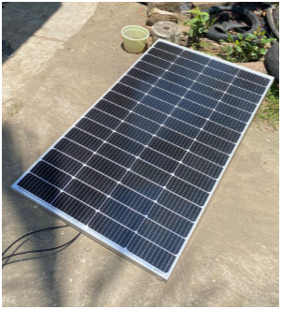 | 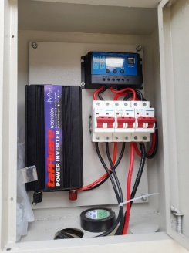
Figure 1: 300 Wp Panel | Figure 2: Installation of the control panel (solar charge controller, MCB, inverter)
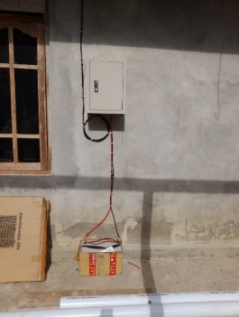 | 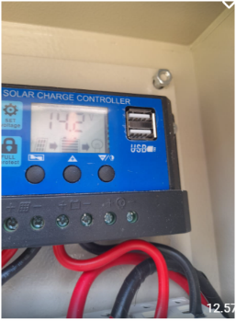
Figure 3: Installation diagram | Figure 4: Solar battery charge controller
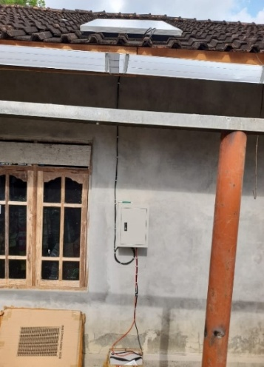 | 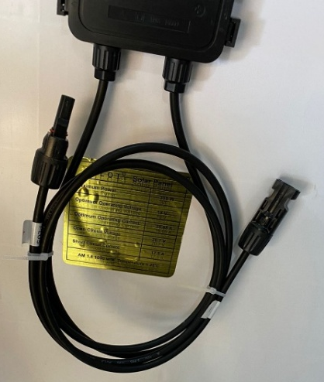
Figure 5: Solar panel installation; control panel with battery | Figure 6: Federal 6mm² black NYA cable
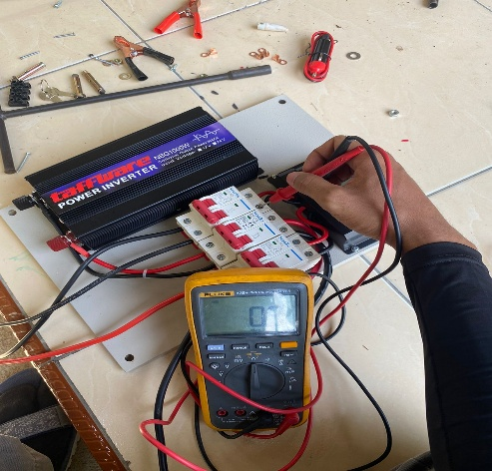 | 
Figure 7: Installation and assembly of materials | Figure 8: Handover of the rooftop solar power plant (PLTS) system to the community
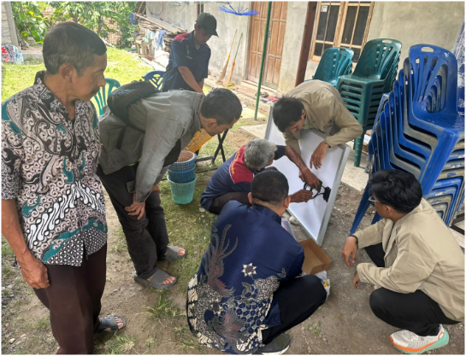 | 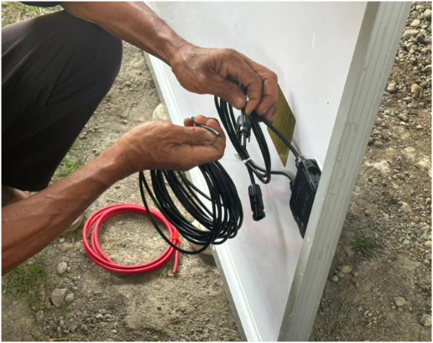
Figure 9: Solar PV installation training | Figure 10: Splicing practice
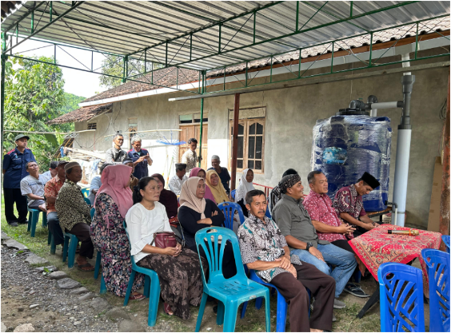 | 
Figure 11: FGD and handover of materials | Figure 12: Photo with residents

