**Data Access**

Rahul M. Kashyap

Information Technology, Arizona State University

IFT 598 Managing Intelligent Devices in an Enterprise Environment

Dr. Dinesh Sthapit

Febuary 17, 2023

**Data Access**

**Step 1 and 2:**

**Step 3:**

**Step 4**

**Step 5**

**Step 6**

**Step 7**

**Step 8a**

**Step 8b**

**Testing the API**

Get Shows below. Other method’s skeletal structures have been created in the Sales Controller file.

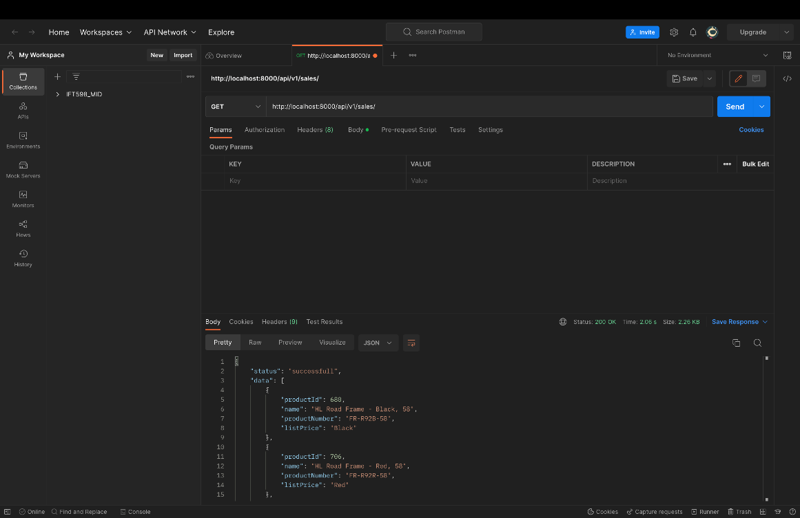**GitHub Link:** [Acallan24/IFT598_MID_LABS: IFT598 Middleware Labs ASU (github.com)](https://github.com/Acallan24/IFT598_MID_LABS)