**Object Relational Mapping**

Rahul M. Kashyap

Information Technology, Arizona State University

IFT 458/598: Middleware Programming & Database Security

Dr. Dinesh Sthapit

Febuary 27, 2023

**Object Relational Mapping**

**Making Prisma Work by importing the sample project.**

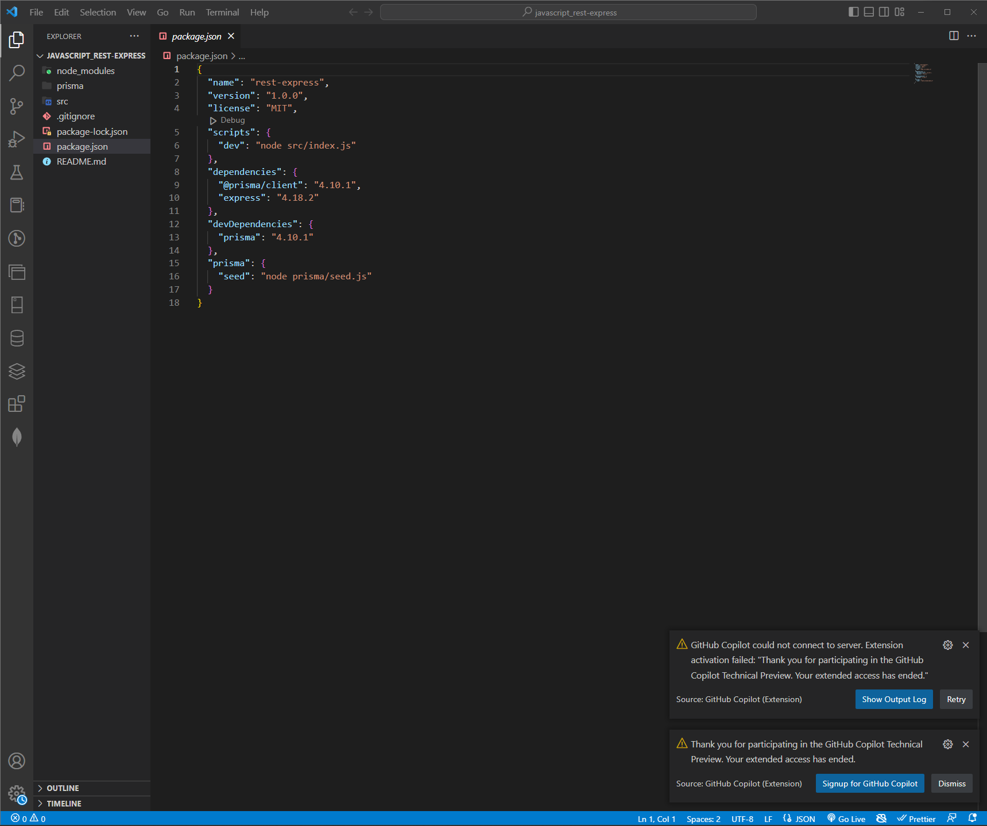

**Migrating the Database**

**Running the Project with feed**

1. **What is ORM? (Ref must be from the above links)**
   * ORM also known as Object Relational Mapping is a technique in which one is able to query and manipulate the data form the database using object-oriented paradigm. It creates an abstract form your code behind so that one does not essentially use SQL.
2. **What are the benefits of using ORM?**
   * The benefits of using ORM include:
     1. Resign the amount of code needed to write in order to maintain the database.
     2. It also lets your code be more portable so that one can migrate databases easily and also sort through the raw SQL queries.
     3. Provides higher level of abstraction and security.
     4. Support complex queries.
3. **What technology is PRIMA ORM replacing in your previous assignments?**

Prisma itself is replacing the MongoDB built in driver. This will allow us to interact with the database using only Node.js. It also provides a high-level interface which is easy for the database operations and also even supports the relational and non-relation databases.

**Code:** [Acallan24/IFT598_MID_LABS: IFT598 Middleware Labs ASU (github.com)](https://github.com/Acallan24/IFT598_MID_LABS)

**Reference**

Maggio, A. (2020, October 4). *What is ORM? Object-Relational Mapping Explained*. ICTShore.com. https://www.ictshore.com/software-design/what-is-orm/

P. (n.d.). *prisma-examples/javascript/rest-express at latest · prisma/prisma-examples*. GitHub. https://github.com/prisma/prisma-examples/tree/latest/javascript/rest-express

Pedamkar, P. (2022, June 21). *What is ORM?* EDUCBA. https://www.educba.com/what-is-orm/

*Start from scratch with MongoDB (15 min) | typescript-mongodb*. (n.d.). Prisma. <https://www.prisma.io/docs/getting-started/setup-prisma/start-from-scratch/mongodb-typescript-mongodb>