FOR OFFICIAL USE ONLY

Brief analysis of parks online booking data

Department for Environment and Water

Environmental and Information Science Unit

Thursday, 31 May, 2018

Table of Contents

1 Introduction 3

1.1 Strategic context 3

1.2 This study 3

2 Methods 4

2.1 Data collection: the survey questions 4

2.2 Data collation 4

2.3 Workflow 4

2.4 First cleanup 5

2.5 Second cleanup 5

2.6 Data analysis 6

2.6.1 Grouping the booking experience results 6

2.6.2 Per cent calculations 6

2.6.3 Sentiment analyses 6

3 Results 8

3.1 Booking experience 8

3.2 Preferred method of booking 10

3.3 Internet connectivity 13

3.4 Other results 14

4 Discussion and conculsions 15

5 Appendix 16

5.1 R packages used 16

5.2 Experience classification 16

5.3 Time of day 17

5.4 Date of booking 18

5.5 Heatmap 19

5.6 Time taken 20

5.7 Frequent words 21

5.8 Random examples 22

5.9 Synonyms 23

6 References 37

# Introduction

The Department for Environment and Water manages a large number of parks and sites. Customers can stay in heritage accommodation and in camp sites, and also pay entry fees, and hire fees for tennis courts and other areas. Most of these facilities can be booked in advance.

In [2014](https://playandgo.com.au/index.php/national-parks-sa-new-online-booking-system/), an [online booking system](https://www.environment.sa.gov.au/parks/booking) was first trialed, available through the Department’s website. As the new system was rolled out across the State, the ability to book on arrival at a campsite or park entry using an envelope and ‘iron-ranger’ box system was removed. The online bookings rollout was completed by July 2017.

## Strategic context

The [*People and Parks*](http://www.environment.sa.gov.au/files/sharedassets/public/park_management/cons-gen-people-parks-strategy.pdf) Strategy includes:

* Strategy 4 (Involve people in setting the future directions for recreation and tourism in parks). And in particular:
  + Action 4.3 Initiate a renewed commitment to customer service by DEWNR staff and partners, which demonstrates consistent high standards, encourages outstanding visitor service and sets targets for response times
* Strategy 6 (Develop an understanding of the social, health and economic benefits of parks), which includes:
  + Action 6.1: Develop and implement methodologies for measuring the People and Parks targets.

## This study

This study aims to evaluate the online booking experience. It is hoped this evaluation will also lead to improved implementation of the system.

Internal discussions led to the following questions about the ‘ease of use’ experience of the online booking system:

* How is the online booking experience perceived by users?
* What aspect of the experience led to that perception?
* What should be a focus for improvement?

Prior to this study there was anecdotal evidence of dissatisfaction with online booking. Common complaints were:

* lack of spontaneity of the new system
* lack of internet connection in remote areas.

There was some positive feedback, but this seemed to be outweighed by negative comments. A common positive remark was that to reserve a campsite, there was no need to arrive early, for example at popular places on a long weekend.

# Methods

## Data collection: the survey questions

Between November 2017 and January 2018 all users of the online booking system for vehicle entry or camping were asked to rate their booking experience. This optional survey was offered on completion of the booking:

* on the thank you page of the website if [booked online](https://www.environment.sa.gov.au/parks/booking)
* via the booking agent if booked by phone or through an [agent](https://www.environment.sa.gov.au/parks/entry-fees/online-booking-information/where-can-i-book).

The purpose of the survey was to find out how people were finding the booking experience and to gain feedback on what could be done to improve the experience. Users were asked to answer 4 questions rating their booking experience:

* Please score your overall booking experience (0 to 10).
  + Why?
* What method of booking would you prefer?. Users were asked to select from Online, In person, email, by phone, by post
* Why would you prefer this method?

Other data collected with each response were:

* Receipt Number
* Respondent ID
* URL From
* Response Submission DateTime
* Time Taken To Complete (minutes)

9025 responses were received.

## Data collation

Data were collated into a single excel file: [data/booking-feedback-survey-results-final.xlsx](R:/IST/SRC/MonSurv/MERF/DocWorksp/RC/projects/Parks/data/booking-feedback-survey-results-final.xlsx).

## Workflow

All data analysis and report writing was done in a single scripted workflow (script file: [code/Parks.Rmd](R:/IST/SRC/MonSurv/MERF/DocWorksp/RC/projects/Parks/code/Parks.Rmd)) using the programs ‘R’ and ‘R-studio’.

[R](https://www.r-project.org/) (R Core Team 2017) is an open-source platform which makes available a library of packages that can be used and modified as necessary. [R-studio](https://www.rstudio.com/) provides a range of user-friendly features to facilitate interaction with R. The packages used are listed in the appendix: R packages used Table 1.

All data, code and outputs are stored in <R:/IST/SRC/MonSurv/MERF/DocWorksp/RC/projects/Parks>. This word document was copied to the iShare page: [Online Booking System](http://communities.ishare.env.sa.gov.au/sites/BCM1021_1023/Online%20Booking%20System/Statistics).

## First cleanup

The 5 rows of data resulting from tests of the system were removed, resulting in the 9025 responses analysed.

The free text fields Why? and Why would you prefer this method? were split into individual words. Numbers and punctuation were removed. Very common words such as ‘to’, ‘the’ or ‘and’ were removed using the stop_words data set provided with the tidytext package (Robinson and Silge 2018).

## Second cleanup

Figure 1 shows the top 30 most frequent words after the first cleanup. Many words were being used interchangeably (and/or were spelled incorrectly) and were therefore replaced by an equivalent word (a synonym). For example, the words fasr, fast, faster, quick, quicke, quicker, quickest, quickly, quiet, quixk and quuck were all replaced with the word fast. The appendix: synonyms Table 6 lists the words that were replaced with a synonym (and words that occurred on more than 15 times).

Responses such as ‘not easy’ - that is a word preceded by a negative qualifier - were not thoroughly checked. However, some manual checking was done. The most frequently used word ‘easy’ was found in the word pair ‘not easy’ in only 27 responses, out of the total 9025 (or just 0.3%). This low level indicated that for practical purposes it was safe to ignore these negatives.

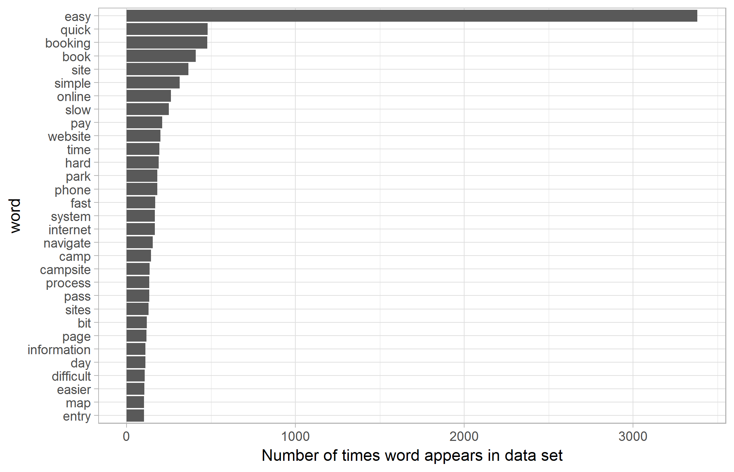

Figure 1 Frequency of words after initial cleaning: top 30 words

## Data analysis

### Grouping the booking experience results

The first question was: Please score your overall booking experience (0 to 10). The 11 possible answers (including ‘no response’) were classified into poor, moderate, good and no data as per the appendix: experience classification Table 2.

### Per cent calculations

In each case where percentages are used this is a per cent of the total survey responses (9025), unless stated otherwise.

### Sentiment analyses

When a person reads a piece of text, they tend to use their understanding of the intent of words to get a feeling about whether the text is positive or negative. There are now text-mining programs which can partly automate this process (see [sentiment analysis](https://en.wikipedia.org/wiki/Sentiment_analysis) for more information).

The sentiment of words used to describe the booking experience were classified using a dictionary of positive and negative words: the Bing lexicon (Hu and Liu n.d.). The Bing lexicon contains 6785 words classified into 2 sentiments: negative and positive. Words that did not occur in the Bing lexicon were given sentiment = ‘no sentiment’, except for ‘simple’ which was classified as positive. The word ‘prefer’ was classifed in the Bing lexicon as positive but was used in this data set to indicate preference for an alternative booking method. Thus it was classified here as negative.

The word ‘booked’ was removed from sentiment analysis as it represented the primary subject matter.

# Results

## Booking experience

Figure 2 shows the number of responses that fell into each booking experience classification - poor, moderate, good and no data. The majority (72%) of responses were classified as a good experience.

The first question, Please score your overall booking experience (0 to 10) was followed by the Question: Why?. Figure 3 shows the sentiment analysis of answers to the question, ‘Why?’. As would be expected, bookings that were rated as good were described using positive sentiments. As the booking experience became more difficult, the words used to describe the experience became increasingly negative.

Figure 4 shows a word cloud for the top 15 words in each sentiment-group. Responses rated as easy were more likely to be described as: convenient, easy, fast, friendly and simple. Conversely as responses were rated as increasingly difficult, the words used to describe the experience were likely to be: confusing, hard, issues, prefer and slow. Commonly used words with no sentiment included: camp, online, park, pay and sites.

The most commonly used words to describe the booking experience were easy and fast. 43% of responses used at least one of those words.

Figure 5 shows the same word cloud split into each booking experience classification. This shows that whether a response was classified as poor, medium or good, both positive and negative words were used. Also that the most common words occurred in all three response classifications.

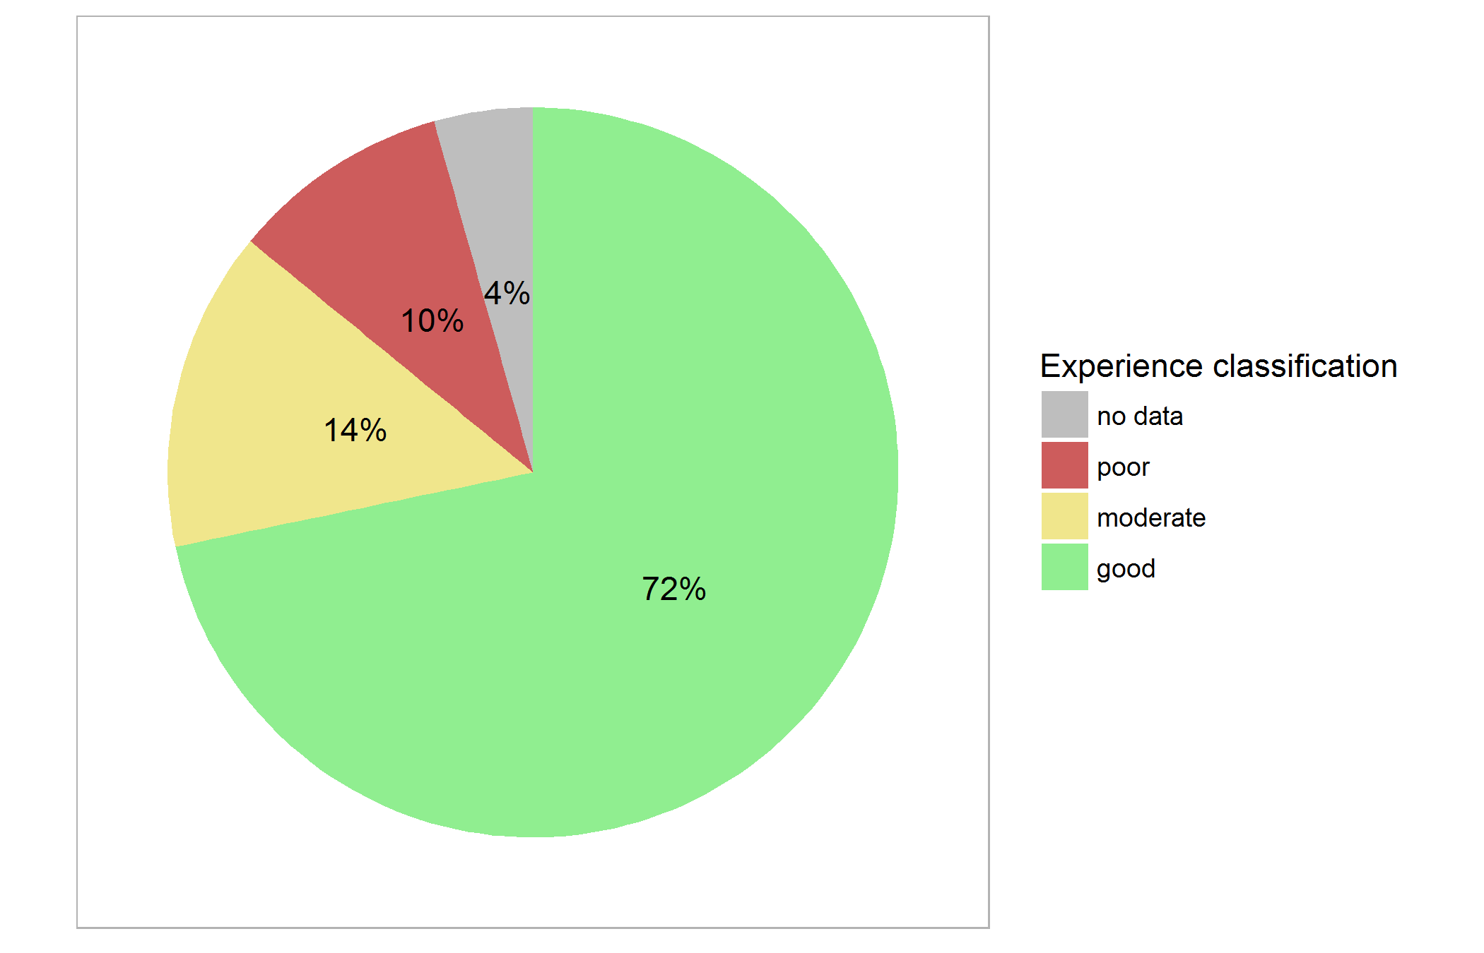

Figure 2 Per cent of responses that fell into each experience classification

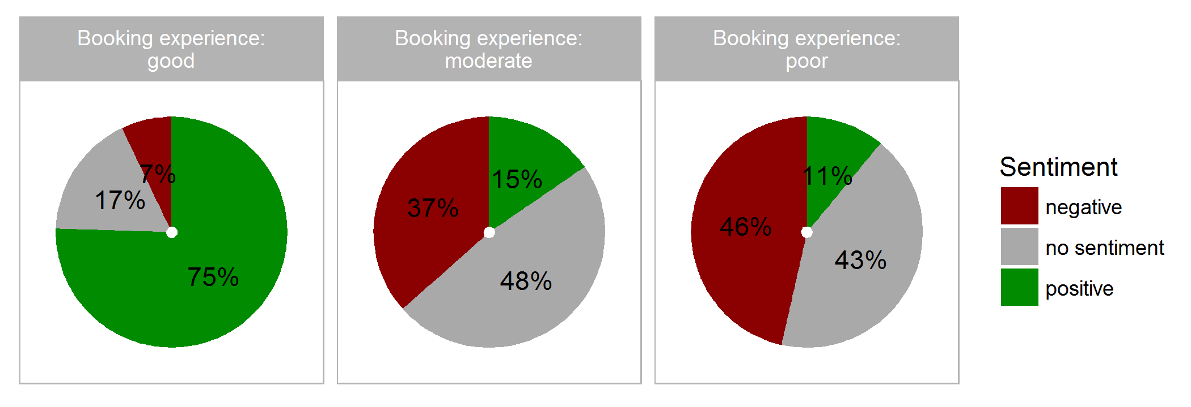

Figure 3 Per cent of responses *within each experience classification* with each overall sentiment

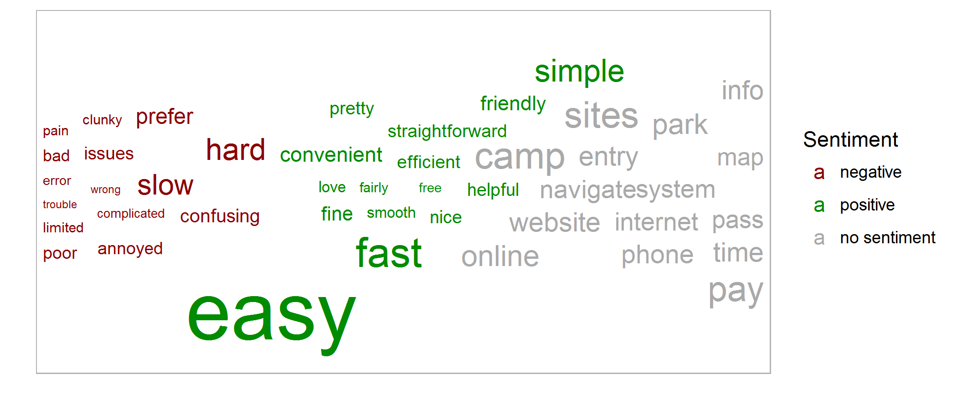

Figure 4 Word cloud - which words best indicate each sentiment associated with the online booking experience. Limited to the top 15 in each sentiment

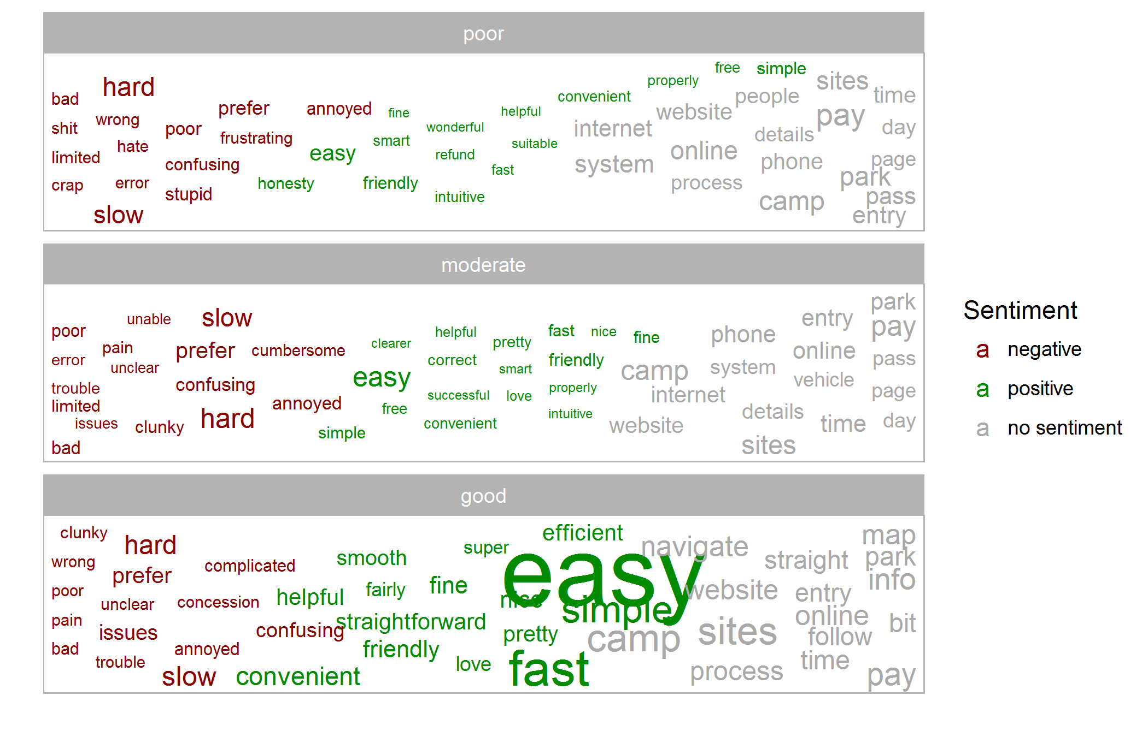

Figure 5 Word cloud - which words are most commonly associated with each experience group

## Preferred method of booking

Using the responses to the question: What method of booking would you prefer?, Figure 6 shows the number of responses that fell in each preference class. Figure 7 shows word clouds for words used to describe each of the booking method preferences based on the question ‘Why would you prefer this method?’.

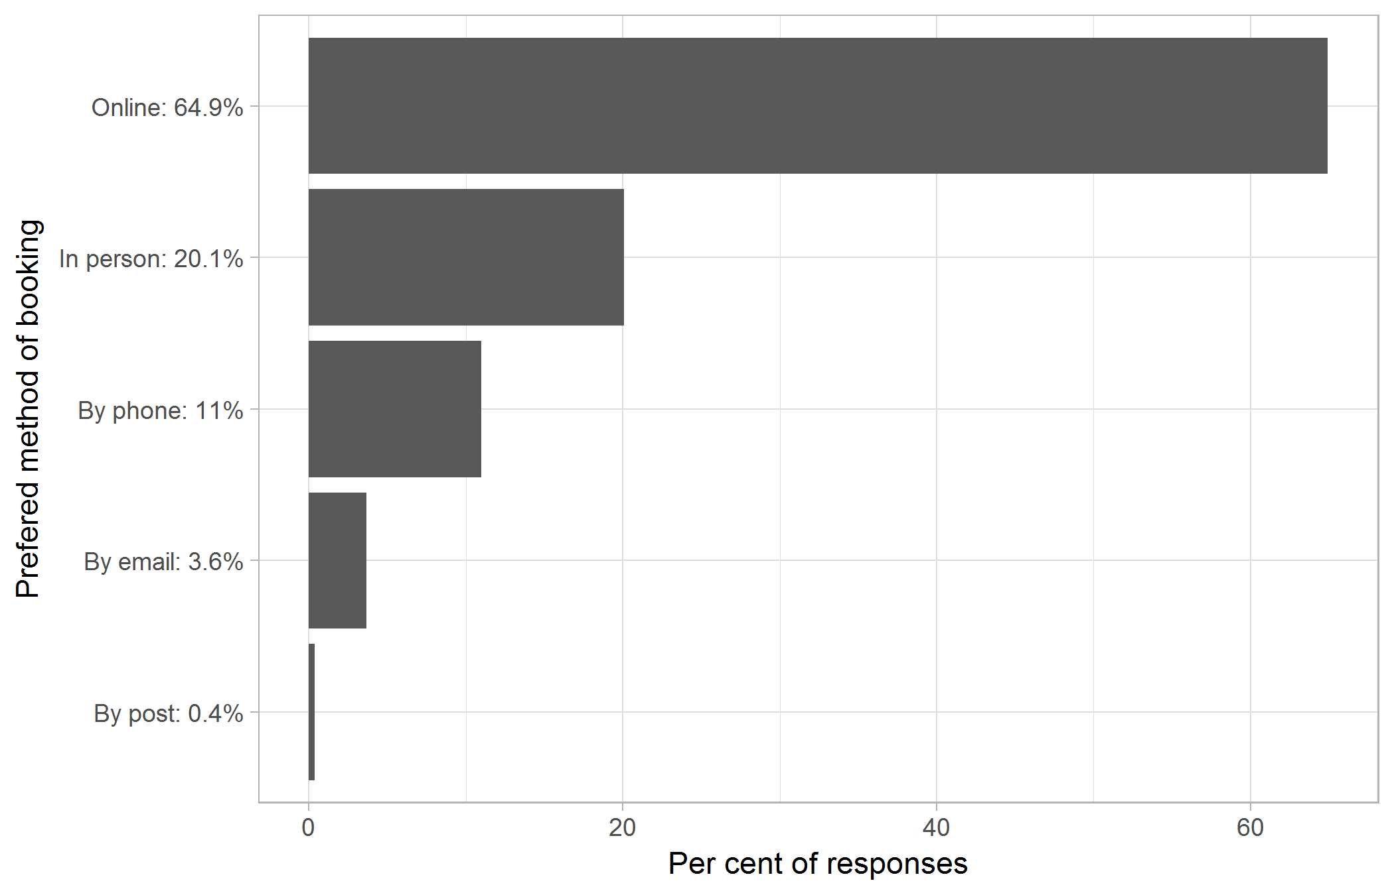

Figure 6 Number of responses that fell into each preference class

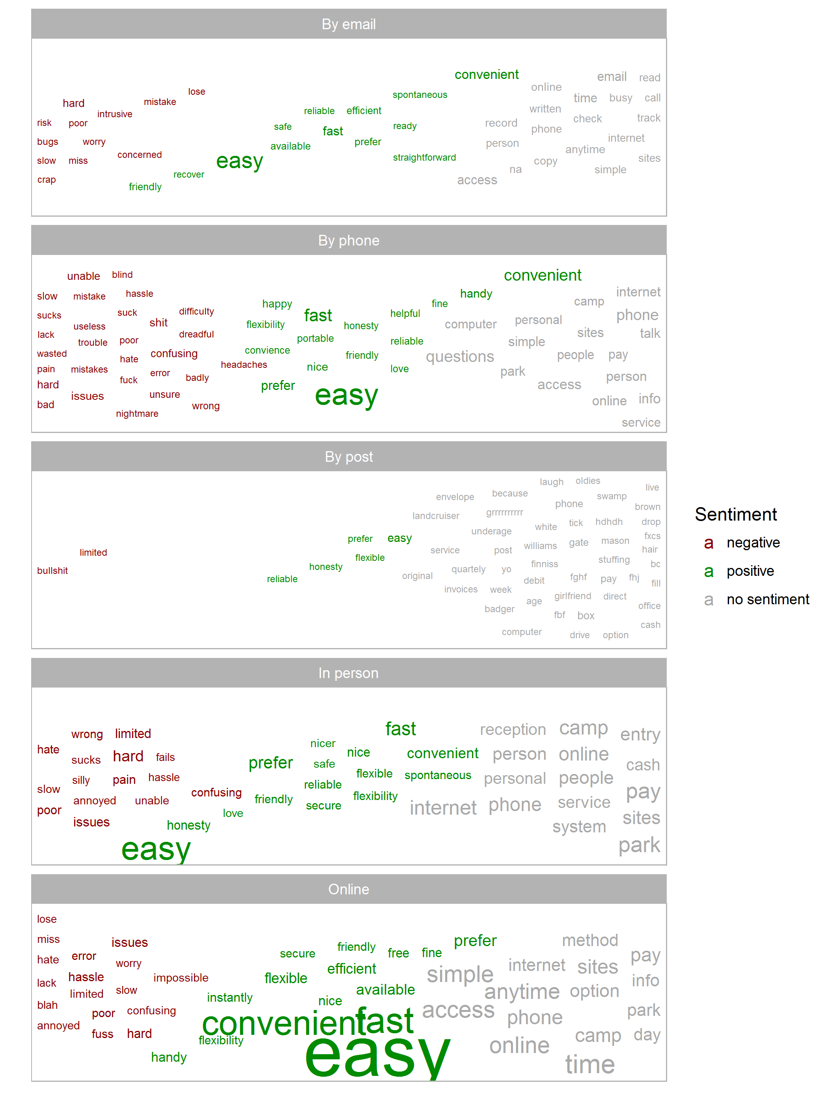

Figure 7 Word cloud for words used to describe booking type preferences

## Internet connectivity

Looking at the users’ responses, it appeared there are a number of words that could be associated with ‘internet connectivity’: online, website, phone, system, internet, page, service, connection, coverage, mobile, signal, bandwidth, browser, computer, web and reception.

Sentiment analysis was used on words that occurred next to these possible internet connectivity words (Figure 8). There are many more words with negative sentiment in this list than in the overall word analysis (see appendix: frequent words Figure 12).

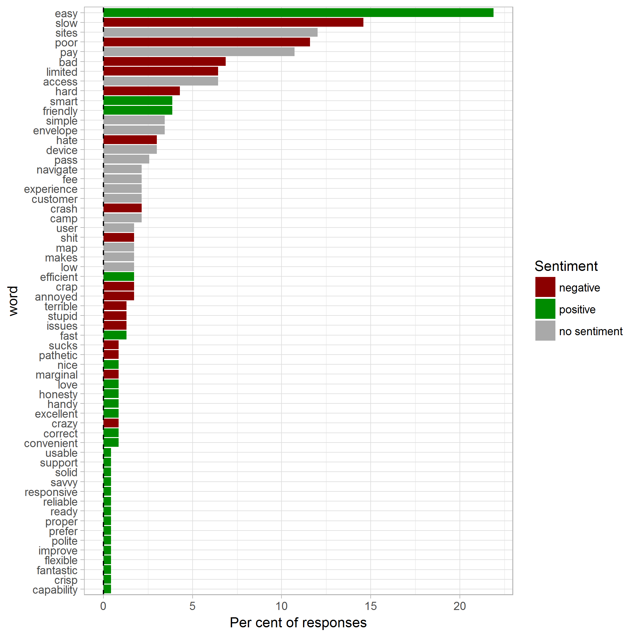

Figure 8 Top 15 words in each sentiment-group that appeared next to one of the words: online, website, phone, system, internet, page, service, connection, coverage, mobile, signal, bandwidth, browser, computer, web and reception

## Other results

The results of several other fields are summarised in the appendix:

* Time of day
* Date of booking
* Heatmap of bookings made by time of day and date
* Time taken to make a booking. The majority of bookings (85.2%) took less than two minutes to make (see appendix time taken Table 4)
* The top 15 most frequent words in each sentiment-group
* Random examples of comments from each experience classification

# Discussion and conculsions

From this brief analysis the following conclusions are made:

* The majority (72%) of user responses suggested the experience was good and used words like convenient, easy, fast and simple to describe it
* A minority (10%) of user responses suggested the experience was poor and used words like hard, poor, prefer and slow to describe it
* The most frequent negative words used to describe the system were ‘hard’ and ‘slow’ (even some of responses that rate the system as easy have a comment on the speed)
* The majority of people have a preference for booking online followed by a preference for booking in person then by phone
* Even those who have a preference for other methods of booking found the system easy
* The majority of bookings (85.2%) took less than two minutes to make

Further analysis of subjective groups of common words used to describe the experience but with no sentiment attached to them suggest (tenuously) ‘internet connectivity’ may be an issue. Given that a user required sufficient internet connectivity to complete a booking, this issue may be more widespread.

Correlation between slowness of booking experience and the peak booking times may be worth investigating further. An alternative may be that booking is slow as internet reception/service is poor for many users when they are arriving at parks and trying to book.

# Appendix

## R packages used

Table 1 R (R Core Team 2017) packages used in the production of this report

|  |  |
| --- | --- |
| Package | Citation |
| bookdown | Xie (2018a) |
| ggrepel | Slowikowski (2018) |
| knitr | Xie (2018b) |
| lubridate | Spinu *et al.* (2018) |
| readxl | Wickham and Bryan (2018) |
| repmis | Gandrud (2016) |
| tidytext | Robinson and Silge (2018) |
| tidyverse | Wickham (2017) |

## Experience classification

Table 2 shows how the booking experience results were grouped.

Table 2 Intervals used to classify the scores given in the field Please score your overall booking experience (0 to 10).

|  |  |  |  |
| --- | --- | --- | --- |
| Experience score | Experience classification | Number of responses | Per cent of responses |
| 0 | poor | 340 | 3.8 |
| 1 | poor | 156 | 1.7 |
| 2 | poor | 160 | 1.8 |
| 3 | poor | 220 | 2.4 |
| 4 | moderate | 176 | 2.0 |
| 5 | moderate | 714 | 7.9 |
| 6 | moderate | 390 | 4.3 |
| 7 | good | 782 | 8.7 |
| 8 | good | 1291 | 14.3 |
| 9 | good | 913 | 10.1 |
| 10 | good | 3488 | 38.6 |
| - | no data | 395 | 4.4 |

## Time of day

Using the field Response Submission DateTime the time of day the booking was made was extracted. Table 3 and Figure 9 show a peak in booking during the middle of the day.

Table 3 Hour of day a booking was made was classified to groups

|  |  |  |  |
| --- | --- | --- | --- |
| hour | Hour Group | Number of responses | Per cent of responses |
| 0 | non-peak | 68 | 0.8 |
| 1 | non-peak | 28 | 0.3 |
| 2 | non-peak | 11 | 0.1 |
| 3 | non-peak | 8 | 0.1 |
| 4 | non-peak | 4 | 0.0 |
| 5 | non-peak | 8 | 0.1 |
| 6 | non-peak | 28 | 0.3 |
| 7 | non-peak | 80 | 0.9 |
| 8 | non-peak | 237 | 2.6 |
| 9 | non-peak | 471 | 5.2 |
| 10 | non-peak | 817 | 9.1 |
| 11 | peak | 1032 | 11.4 |
| 12 | peak | 961 | 10.6 |
| 13 | non-peak | 816 | 9.0 |
| 14 | non-peak | 753 | 8.3 |
| 15 | non-peak | 617 | 6.8 |
| 16 | non-peak | 544 | 6.0 |
| 17 | non-peak | 491 | 5.4 |
| 18 | non-peak | 425 | 4.7 |
| 19 | non-peak | 417 | 4.6 |
| 20 | non-peak | 376 | 4.2 |
| 21 | non-peak | 354 | 3.9 |
| 22 | non-peak | 325 | 3.6 |
| 23 | non-peak | 154 | 1.7 |

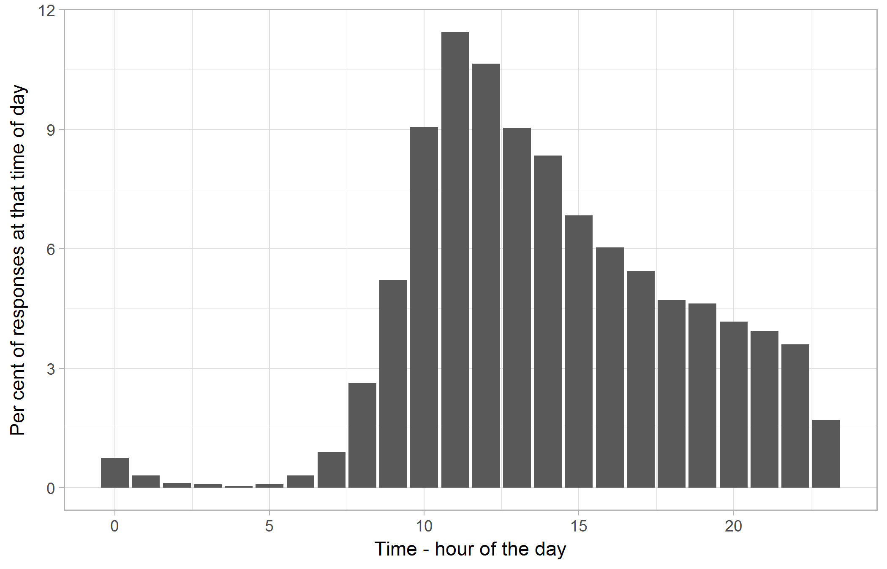

Figure 9 Per cent of responses that occurred at each hour of the day

## Date of booking

Figure 10 shows the distribution of bookings against date.

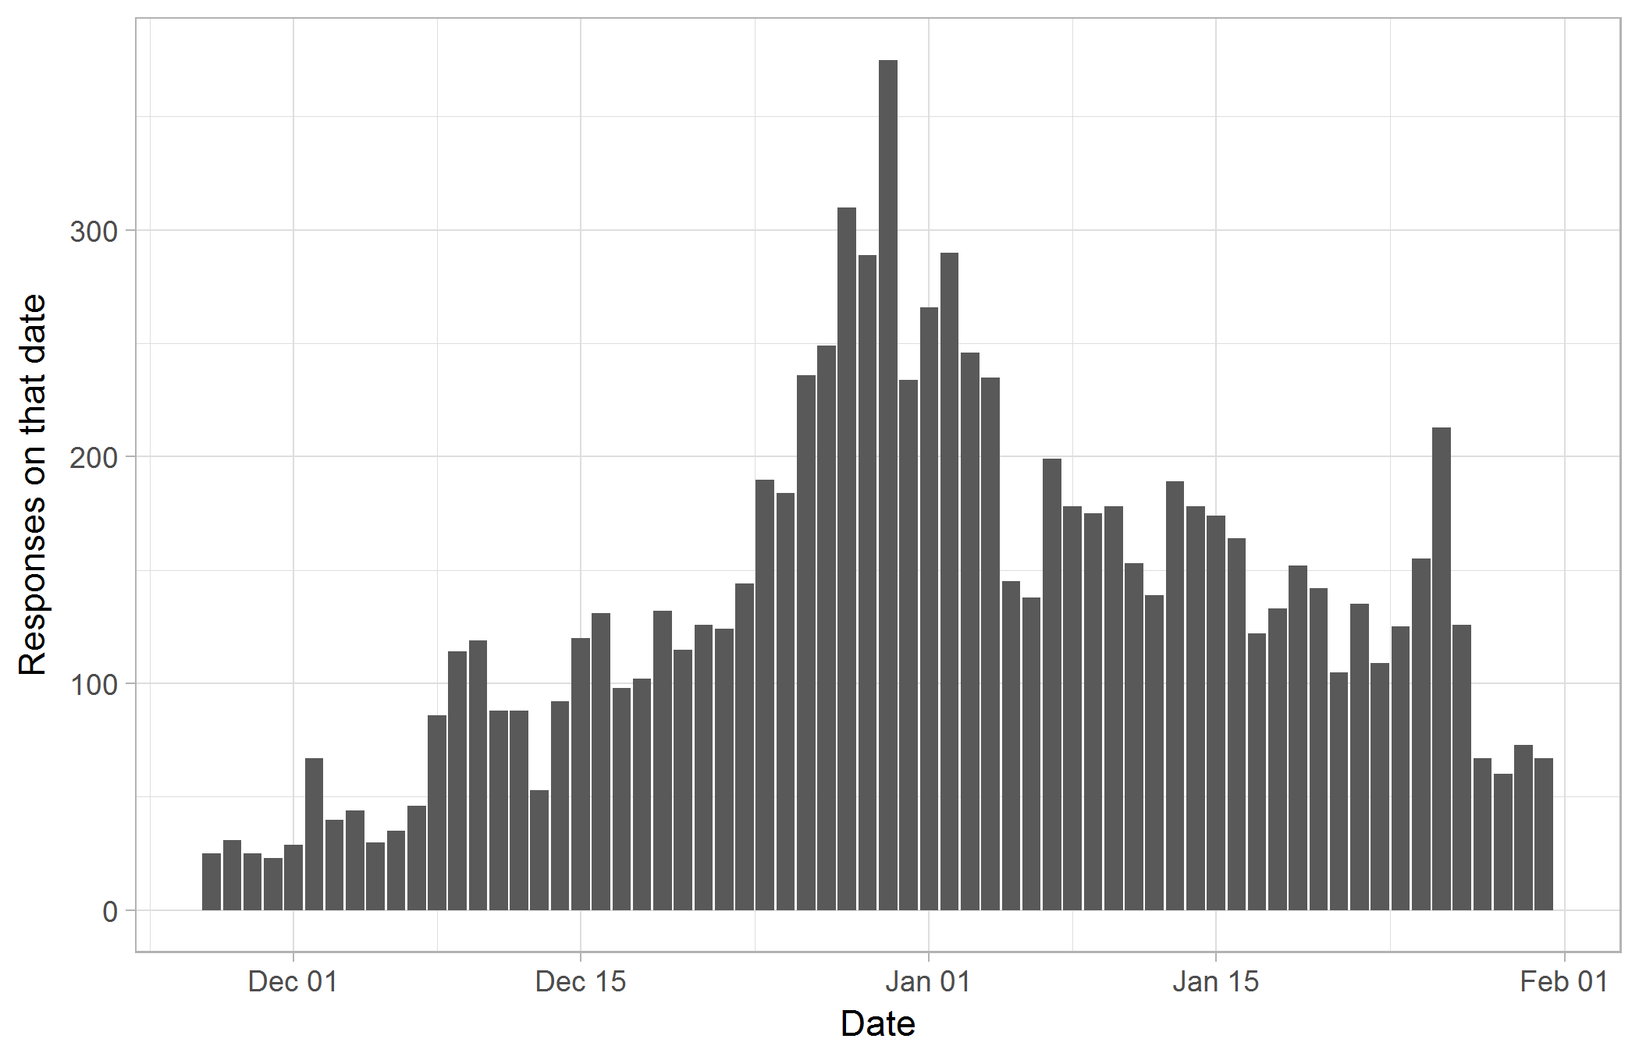

Figure 10 Number of responses that occurred on each date

## Heatmap

Figure 11 shows a heatmap of bookings throughout the survey period.

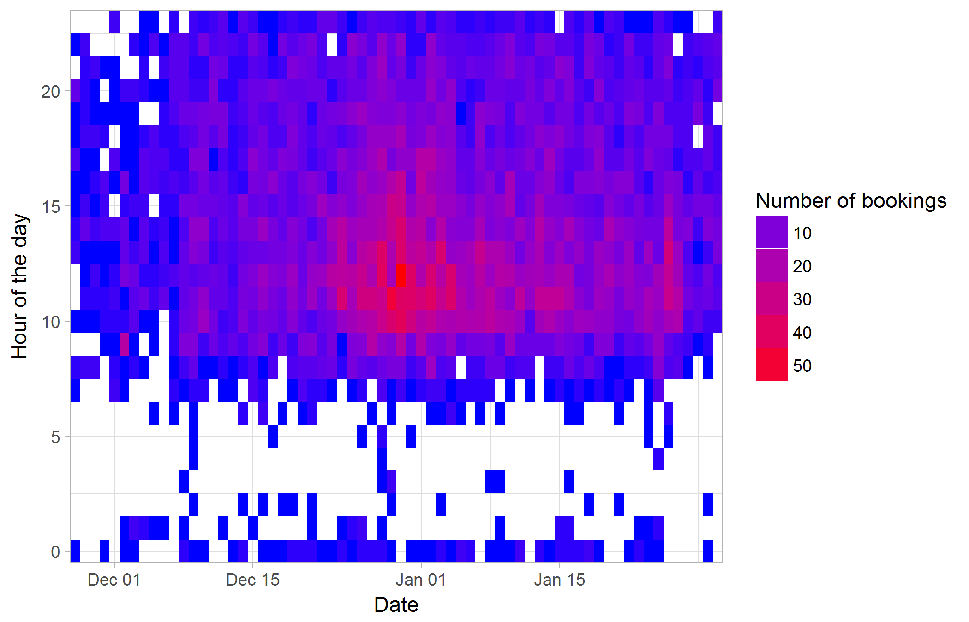

Figure 11 Heatmap of bookings made during the survey period

## Time taken

Table 4 summarises results from Time Taken To Complete (minutes). The majority of bookings took less than one minute to make.

Table 4 Time taken to make a booking

|  |  |  |
| --- | --- | --- |
| Time taken (minutes) | Number of responses | Per cent of responses |
| 0 | 4707 | 52.2 |
| 1 | 2983 | 33.1 |
| 2 | 711 | 7.9 |
| 3 | 241 | 2.7 |
| 4 | 102 | 1.1 |
| 5 | 63 | 0.7 |
| 6 | 40 | 0.4 |
| 7 | 19 | 0.2 |
| 8 | 30 | 0.3 |
| 9 | 14 | 0.2 |
| 10 | 11 | 0.1 |
| Greater than 10 minutes | 104 | 1.2 |

## Frequent words

Figure 12 the top 15 words in each sentiment-group used in response to Why?.

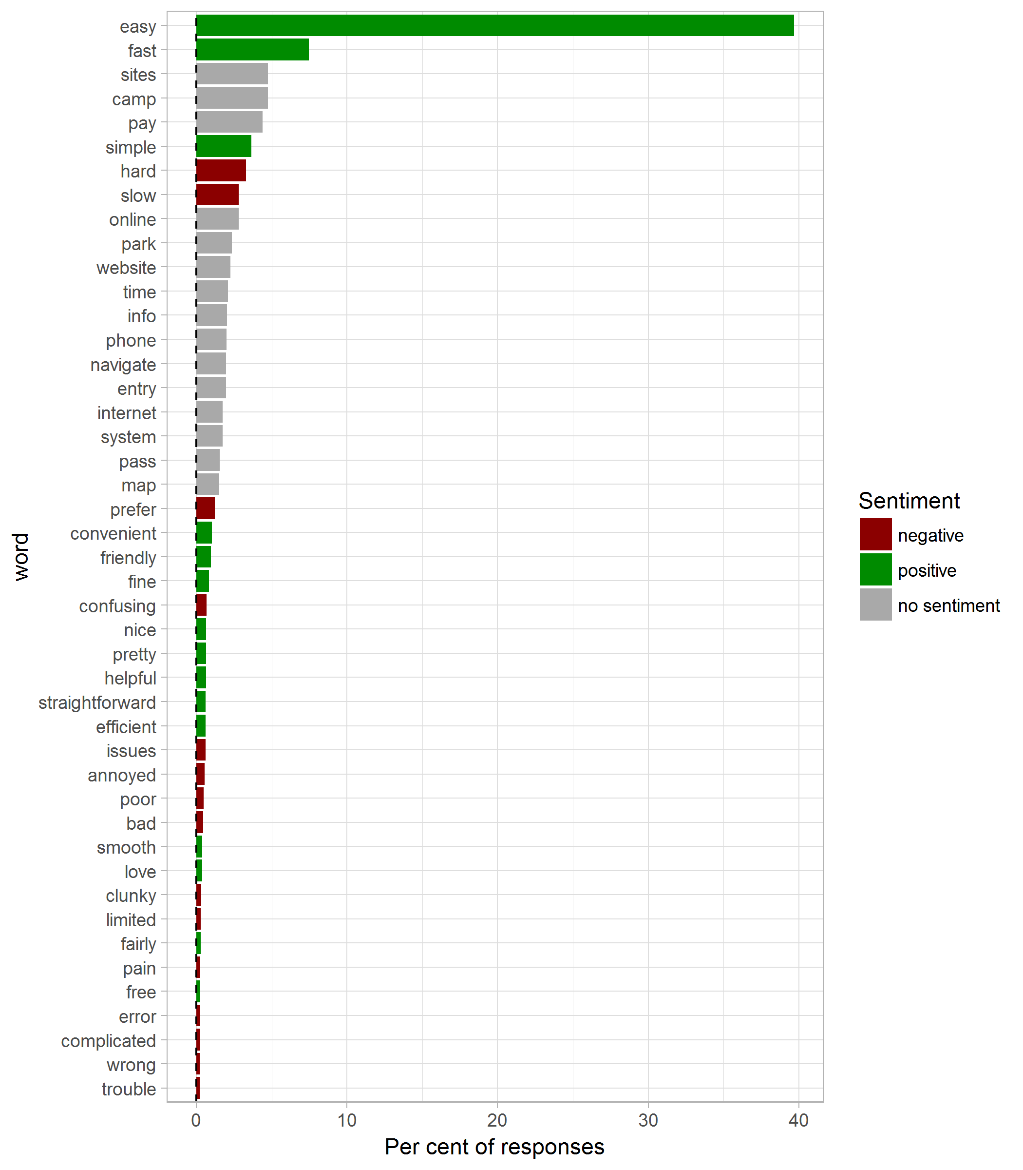

Figure 12 Sentiment assigned to words that occurred in descriptions of the booking experience: the top 15 words in each sentiment-group

## Random examples

Table 5 shows the full text for five randomly drawn examples, that have more than ten characters, from each experience classification.

Table 5 Five randomly drawn responses from each of the experience classifications

|  |  |  |
| --- | --- | --- |
| Original ease of use score | Classified ease of use score | Why was that score given? |
| 0 | poor | Not good, cause need park pass number to booking, but park pass can not buy online, so I need come Island first then booking! |
| 0 | poor | this is bs. bring back money option |
| 1 | poor | Old system way better, get a season’s entry pass/camping pass for 12 months. This way is another example of the parks trying to make life more difficult for users. Been going on for years. |
| 2 | poor | Page would not load, time consuming and not convenient with limited phone service. |
| 3 | poor | New South Wales was not an option in the drop down lists of where i’m from. Also, it was not obvious that booking a vehicle entry also meant you paid per person, especially when I had to select the vehicle registration of the children?… |
| 4 | moderate | Has some trouble booting and it never took me to the cart other then that great site |
| 5 | moderate | Hard to find, slow. |
| 5 | moderate | pretty simple, nothing special. |
| 6 | moderate | not very computer savy |
| 6 | moderate | don’t like typing |
| 9 | good | Very simple to use but pdf map lacked details and would have been nice to select our campsite location |
| 10 | good | Website is friendly! Easy to use and practical Well done |
| 10 | good | Simple and easy |
| 10 | good | easy to use |
| 10 | good | QUICK AND EASY |
| - | no data | Ease of use |
| - | no data | SEEMS LIGIT |
| - | no data | Quick and Easy |
| - | no data | Relatively straight forward but hard if not having planned ahead due to limited reception |
| - | no data | Nice and easy |

## Synonyms

Table 6 shows words that were replaced with a synonym (see second cleanup).

Table 6 Frequently used words (more than 15 instances) and words replaced with a synonym

|  |  |  |
| --- | --- | --- |
| original | replacement | n |
| acceptable | accept | 1 |
| accepting | accept | 2 |
| accepted | accept | 8 |
| accept | accept | 15 |
| accessable | access | 1 |
| accessibility | access | 1 |
| accessing | access | 1 |
| acsess | access | 1 |
| accessible | access | 5 |
| access | access | 71 |
| accidentally | accident | 1 |
| accommodations | accommodate | 1 |
| accomodation | accommodate | 6 |
| accommodation | accommodate | 8 |
| accountability | account | 1 |
| acknowledgement | acknowledged | 1 |
| acknwledge | acknowledged | 1 |
| activities | activity | 1 |
| ad | add | 1 |
| addition | add | 2 |
| added | add | 9 |
| adding | add | 12 |
| additional | add | 14 |
| add | add | 29 |
| adel | adelaide | 3 |
| adults | adult | 9 |
| advanced | advance | 1 |
| advance | advance | 26 |
| advise | advice | 1 |
| advising | advice | 1 |
| aged | age | 1 |
| ages | age | 14 |
| agreeing | agree | 1 |
| ahhhhhhh | ahhh | 1 |
| boooooooooo | ahhh | 1 |
| ffs | ahhh | 1 |
| aaaa | ahhh | 2 |
| aaa | ahhh | 3 |
| aa | ahhh | 4 |
| airconditioned | aircon | 1 |
| allocated | allocate | 3 |
| allowance | allowed | 1 |
| allowing | allowed | 1 |
| alphbetically | alphabetical | 1 |
| amentiy | amenity | 1 |
| amenities | amenity | 7 |
| angered | annoyed | 1 |
| annyoing | annoyed | 1 |
| annoying | annoyed | 47 |
| answered | answer | 2 |
| answering | answer | 2 |
| answers | answer | 4 |
| appearing | appeared | 2 |
| appears | appeared | 3 |
| australian | aussie | 2 |
| australia | aussie | 8 |
| automatically | automatic | 6 |
| avaialable | available | 1 |
| availabilty | available | 1 |
| availablity | available | 1 |
| availble | available | 1 |
| availability | available | 11 |
| awesomely | awesome | 1 |
| awkward | awkard | 3 |
| ackward | awkward | 1 |
| bad | bad | 43 |
| basically | basic | 1 |
| bay | bay | 16 |
| beaches | beach | 2 |
| beach | beach | 19 |
| butiful | beautiful | 1 |
| bcaus | because | 1 |
| becausd | because | 1 |
| becayse | because | 1 |
| becuae | because | 1 |
| becuse | because | 1 |
| cuz | because | 1 |
| becouse | because | 4 |
| coz | because | 14 |
| cos | because | 17 |
| bit | bit | 119 |
| blocks | block | 1 |
| box | box | 38 |
| buttons | button | 1 |
| button | button | 32 |
| buying | buy | 6 |
| buy | buy | 30 |
| calling | call | 1 |
| calls | call | 1 |
| called | call | 5 |
| campping | camp | 1 |
| canping | camp | 1 |
| caping | camp | 1 |
| camped | camp | 4 |
| camps | camp | 4 |
| camper | camp | 6 |
| campers | camp | 7 |
| campgrounds | camp | 10 |
| campground | camp | 41 |
| camping | camp | 84 |
| campsites | camp | 90 |
| campsite | camp | 136 |
| camp | camp | 144 |
| cancellation | cancel | 1 |
| canceled | cancel | 2 |
| cancelling | cancel | 2 |
| cancelled | cancel | 6 |
| car | car | 60 |
| card | card | 66 |
| cars | cars | 24 |
| cart | cart | 47 |
| cash | cash | 49 |
| challenged | challenge | 1 |
| challenging | challenge | 1 |
| chances | chance | 1 |
| changing | change | 4 |
| changed | change | 5 |
| change | change | 40 |
| charges | charge | 1 |
| charging | charge | 2 |
| charged | charge | 10 |
| check | check | 23 |
| children | child | 4 |
| chosen | choice | 1 |
| chosing | choice | 1 |
| choices | choice | 2 |
| choosing | choice | 7 |
| chose | choice | 10 |
| choose | choice | 25 |
| clicking | click | 2 |
| clicked | click | 4 |
| clicks | click | 5 |
| closing | close | 1 |
| closure | close | 1 |
| closed | close | 2 |
| clunky | clunky | 28 |
| comments | comment | 2 |
| comparing | compare | 1 |
| comparison | compare | 2 |
| compared | compare | 5 |
| completely | complete | 2 |
| completed | complete | 6 |
| complete | complete | 27 |
| compicate | complicated | 1 |
| complications | complicated | 4 |
| complicated | complicated | 17 |
| comput | computer | 1 |
| computur | computer | 1 |
| computers | computer | 5 |
| computer | computer | 39 |
| concessional | concession | 1 |
| concessions | concession | 1 |
| concession | concession | 15 |
| conditions | condition | 18 |
| conformation | confirm | 2 |
| confirmed | confirm | 5 |
| confirmation | confirm | 30 |
| confusin | confusing | 1 |
| confusion | confusing | 8 |
| confused | confusing | 12 |
| confusing | confusing | 42 |
| connected | connection | 1 |
| connections | connection | 1 |
| connexion | connection | 1 |
| connection | connection | 32 |
| consuming | consuming | 24 |
| conveinent | convenient | 1 |
| conveninet | convenient | 1 |
| convienct | convenient | 1 |
| convineant | convenient | 1 |
| convineint | convenient | 1 |
| convinent | convenient | 1 |
| covineint | convenient | 1 |
| convienent | convenient | 2 |
| convinient | convenient | 3 |
| convenience | convenient | 4 |
| convenient | convenient | 76 |
| coulnt | couldnt | 1 |
| cove | coverage | 2 |
| cover | coverage | 5 |
| coverage | coverage | 36 |
| crashing | crash | 4 |
| crashed | crash | 6 |
| credit | credit | 41 |
| cumbersone | cumbersome | 1 |
| cumbersome | cumbersome | 15 |
| customer’s | customer | 1 |
| customers | customer | 1 |
| customer | customer | 17 |
| date | date | 21 |
| dates | date | 21 |
| day | day | 111 |
| days | days | 42 |
| deciding | decide | 1 |
| decided | decide | 2 |
| decisions | decide | 2 |
| decision | decide | 5 |
| desciptions | descriptions | 1 |
| descriptive | descriptions | 1 |
| description | descriptions | 26 |
| descriptions | descriptions | 30 |
| detailing | details | 1 |
| detailed | details | 8 |
| detail | details | 17 |
| details | details | 95 |
| didnt | didnt | 17 |
| dont | dont | 28 |
| driver | drive | 2 |
| driving | drive | 10 |
| eas | easy | 1 |
| easie | easy | 1 |
| easiness | easy | 1 |
| easly | easy | 1 |
| eassy | easy | 1 |
| easyer | easy | 1 |
| easyto | easy | 1 |
| eeasssssy | easy | 1 |
| eay | easy | 2 |
| esy | easy | 2 |
| easiest | easy | 3 |
| esay | easy | 4 |
| eazy | easy | 6 |
| easily | easy | 28 |
| ease | easy | 71 |
| easier | easy | 105 |
| easy | easy | 3380 |
| efficiency | efficient | 1 |
| efficent | efficient | 3 |
| efficient | efficient | 51 |
| emails | email | 2 |
| emailed | email | 4 |
| email | email | 26 |
| entert | entry | 1 |
| entrence | entry | 1 |
| enterance | entry | 2 |
| entrances | entry | 2 |
| entries | entry | 4 |
| entering | entry | 13 |
| entered | entry | 16 |
| entrance | entry | 31 |
| enter | entry | 34 |
| entry | entry | 103 |
| envelop | envelope | 1 |
| enveloppe | envelope | 1 |
| envelopes | envelope | 2 |
| errors | error | 3 |
| error | error | 20 |
| excellent | excellent | 16 |
| experienced | experience | 1 |
| experience | experience | 39 |
| extra | extra | 15 |
| fairly | fairly | 26 |
| fasr | fast | 1 |
| quicke | fast | 1 |
| quickest | fast | 1 |
| quixk | fast | 1 |
| quuck | fast | 1 |
| quiet | fast | 2 |
| faster | fast | 5 |
| quickly | fast | 5 |
| quicker | fast | 9 |
| fast | fast | 170 |
| quick | fast | 480 |
| fees | fee | 29 |
| fee | fee | 37 |
| feedback | feedback | 24 |
| fill | fill | 17 |
| finalise | finalise | 15 |
| fine | fine | 78 |
| folow | follow | 1 |
| follow | follow | 85 |
| forms | form | 10 |
| form | form | 46 |
| forward | forward | 84 |
| foundd | found | 1 |
| found | found | 38 |
| free | free | 24 |
| companion | friend | 1 |
| companions | friend | 1 |
| company | friend | 1 |
| friend’s | friend | 1 |
| buddies | friend | 2 |
| buddy | friend | 4 |
| friends | friend | 5 |
| friendly | friendly | 86 |
| gate | gate | 37 |
| ground | ground | 15 |
| hardest | hard | 1 |
| hardto | hard | 1 |
| harrd | hard | 1 |
| hars | hard | 1 |
| harder | hard | 3 |
| difficult | hard | 106 |
| hard | hard | 190 |
| hate | hate | 17 |
| helpfull | helpful | 1 |
| helpful | helpful | 58 |
| idea | idea | 19 |
| indiviaul | individual | 1 |
| individually | individual | 3 |
| individual | individual | 20 |
| informatin | info | 1 |
| informationrequested | info | 1 |
| informations | info | 2 |
| informed | info | 3 |
| informative | info | 12 |
| info | info | 61 |
| information | info | 112 |
| initially | initially | 15 |
| instructions | instruction | 19 |
| interface | interface | 19 |
| internet | internet | 166 |
| intuitive | intuitive | 16 |
| issue’s | issues | 1 |
| issue | issues | 17 |
| issues | issues | 36 |
| layout | layout | 20 |
| limited | limited | 26 |
| line | line | 19 |
| links | link | 9 |
| link | link | 22 |
| loads | load | 1 |
| loading | load | 11 |
| load | load | 40 |
| located | location | 7 |
| locations | location | 8 |
| location | location | 21 |
| lot | lot | 20 |
| lovely | love | 4 |
| loved | love | 5 |
| love | love | 28 |
| makes | makes | 17 |
| mao | map | 1 |
| mapping | map | 1 |
| maps | map | 43 |
| map | map | 103 |
| method | method | 22 |
| minutes | minutes | 18 |
| mobilephone | mobile | 1 |
| mobiles | mobile | 1 |
| mobile | mobile | 76 |
| money | money | 18 |
| multipass | multiple | 1 |
| multiples | multiple | 1 |
| multiple | multiple | 55 |
| na | na | 64 |
| national | national | 36 |
| navagate | navigate | 1 |
| navigates | navigate | 1 |
| navigatw | navigate | 1 |
| navirgate | navigate | 1 |
| navigating | navigate | 8 |
| navigation | navigate | 12 |
| navigate | navigate | 155 |
| nice | nice | 60 |
| night | night | 18 |
| nights | nights | 15 |
| office | office | 20 |
| online | online | 263 |
| options | option | 23 |
| option | option | 72 |
| pages | page | 10 |
| page | page | 117 |
| paid | paid | 27 |
| painfull | pain | 1 |
| painful | pain | 4 |
| pain | pain | 20 |
| parka | park | 1 |
| parked | park | 1 |
| parkvic | park | 1 |
| parking | park | 4 |
| parks | park | 59 |
| park | park | 182 |
| passes | pass | 24 |
| pass | pass | 133 |
| pays | pay | 1 |
| payed | pay | 2 |
| paypass | pay | 2 |
| paywave | pay | 2 |
| purchasing | pay | 2 |
| purchases | pay | 4 |
| payments | pay | 6 |
| purchased | pay | 6 |
| purchase | pay | 27 |
| paying | pay | 30 |
| paypal | pay | 70 |
| payment | pay | 97 |
| pay | pay | 210 |
| people’s | people | 1 |
| peoples | people | 3 |
| people | people | 75 |
| permits | permit | 8 |
| permit | permit | 28 |
| person | person | 66 |
| phome | phone | 1 |
| phoned | phone | 2 |
| phoning | phone | 2 |
| phones | phone | 5 |
| phone | phone | 181 |
| photos | photos | 85 |
| pictues | pictures | 1 |
| picturesare | pictures | 1 |
| picturess | pictures | 1 |
| picture | pictures | 7 |
| pictures | pictures | 44 |
| poorly | poor | 1 |
| poo | poor | 2 |
| poor | poor | 43 |
| pre | pre | 18 |
| preferable | prefer | 1 |
| preferably | prefer | 1 |
| preferrnce | prefer | 1 |
| preference | prefer | 3 |
| preferred | prefer | 19 |
| prefer | prefer | 86 |
| pretty | pretty | 57 |
| previous | previous | 16 |
| procwess | process | 1 |
| processing | process | 2 |
| processed | process | 3 |
| process | process | 134 |
| provider | provided | 1 |
| providing | provided | 4 |
| provide | provided | 14 |
| provided | provided | 20 |
| questionaire | questions | 1 |
| questioned | questions | 1 |
| question | questions | 8 |
| questions | questions | 18 |
| receipt | receipt | 21 |
| reception | reception | 83 |
| regos | registration | 1 |
| rego | registration | 9 |
| registration | registration | 24 |
| require | required | 4 |
| requirements | required | 4 |
| requirement | required | 5 |
| requires | required | 7 |
| required | required | 38 |
| screens | screen | 6 |
| screen | screen | 29 |
| search | search | 15 |
| select | select | 26 |
| servise | service | 1 |
| services | service | 5 |
| service | service | 96 |
| signal | signal | 24 |
| simplier | simple | 1 |
| simplify | simple | 1 |
| simpler | simple | 3 |
| simplicity | simple | 5 |
| simply | simple | 6 |
| simple | simple | 314 |
| single | single | 15 |
| site’s | sites | 1 |
| siteq | sites | 1 |
| sites | sites | 129 |
| site | sites | 366 |
| slowed | slow | 1 |
| slowest | slow | 1 |
| slowish | slow | 1 |
| slowly | slow | 1 |
| slowwwww | slow | 1 |
| sluggish | slow | 1 |
| slow | slow | 250 |
| smoothly | smooth | 9 |
| smooth | smooth | 27 |
| spots | spot | 9 |
| spot | spot | 39 |
| staff | staff | 21 |
| stay | stay | 15 |
| straight | straight | 89 |
| straighforward | straightforward | 2 |
| straightforward | straightforward | 53 |
| stupid | stupid | 16 |
| super | super | 18 |
| systen | system | 1 |
| systm | system | 1 |
| systems | system | 2 |
| system | system | 166 |
| taking | takes | 3 |
| takes | takes | 35 |
| timer | time | 1 |
| tine | time | 1 |
| timed | time | 2 |
| timely | time | 2 |
| timley | time | 2 |
| time | time | 194 |
| times | times | 48 |
| trip | trip | 15 |
| trouble | trouble | 19 |
| unclear | unclear | 15 |
| understnad | understand | 1 |
| understood | understand | 1 |
| understanding | understand | 4 |
| understand | understand | 45 |
| users | user | 2 |
| user | user | 74 |
| vechile | vehicle | 1 |
| vechicle | vehicle | 3 |
| vehicles | vehicle | 18 |
| vehicle | vehicle | 99 |
| view | view | 15 |
| visitinb | visit | 1 |
| visited | visit | 6 |
| visiting | visit | 7 |
| visit | visit | 25 |
| web | web | 33 |
| webpages | website | 1 |
| webpage | website | 3 |
| websites | website | 4 |
| website | website | 201 |
| wrong | wrong | 19 |

# References

Gandrud, C. (2016). ‘Repmis: Miscellaneous tools for reproducible research’. Available at: <https://CRAN.R-project.org/package=repmis>

Hu, M., and Liu, B. Mining and summarizing customer reviews. In ‘KDD-2004 - proceedings of the tenth acm sigkdd international conference on knowledge discovery and data mining’. (Eds R. Kohavi, J. Gehrke, W. DuMouchel, and J. Ghosh.) pp. 168–177 Available at: <https://www.cs.uic.edu/~liub/publications/kdd04-revSummary.pdf>

R Core Team (2017). R: A Language and Environment for Statistical Computing. Report. R Foundation for Statistical Computing, Vienna, Austria. Available at: <https://www.R-project.org/>

Robinson, D., and Silge, J. (2018). ‘Tidytext: Text mining using ’dplyr’, ’ggplot2’, and other tidy tools’. Available at: <https://CRAN.R-project.org/package=tidytext>

Slowikowski, K. (2018). ‘Ggrepel: Automatically position non-overlapping text labels with ’ggplot2’’. Available at: <https://CRAN.R-project.org/package=ggrepel>

Spinu, V., Grolemund, G., and Wickham, H. (2018). ‘Lubridate: Make dealing with dates a little easier’. Available at: <https://CRAN.R-project.org/package=lubridate>

Wickham, H. (2017). ‘Tidyverse: Easily install and load the ’tidyverse’’. Available at: <https://CRAN.R-project.org/package=tidyverse>

Wickham, H., and Bryan, J. (2018). ‘Readxl: Read excel files’. Available at: <https://CRAN.R-project.org/package=readxl>

Xie, Y. (2018a). ‘Bookdown: Authoring books and technical documents with r markdown’. Available at: <https://CRAN.R-project.org/package=bookdown>

Xie, Y. (2018b). ‘Knitr: A general-purpose package for dynamic report generation in r’. Available at: <https://CRAN.R-project.org/package=knitr>