FOR OFFICIAL USE ONLY

Brief analysis of data from the scientific research permit database

Department for Environment and Water

Environmental Science and Information Branch

Friday, 24 August, 2018

Table of Contents

# Key messages

**How many projects have there been?**

* 6199 projects have been issued with scientific research permits between 1970 and 2017
* During the same time period 4434 renewals were issued
* Thus, a total of 10633 permits were issued.

**Who undertook the projects?**

Most project were undertaken by universities (39.4%) or government institutions (18.4%).

Universities were mostly South Australian (27.1% of permits), followed by interstate (9.1%) then overseas (3.2%).

**How many students?**

This information is not available from the current data set.

**Themes**

The data are tagged with various themes. For example:

* the most common theme is Survey which is used to tag 84.1% of permits
* 3.2% of permits are tagged with “Conservation/Threatened species”
* 1.3% of permits are tagged with “Feral/Introduced species” and/or “Invasive/abundant/pest sp”

**Marine mammal research**

3% of permits were for marine mammal research.

**Long term research**

There are 35 projects that ran for at least 20 years. For example:

* *Factors influencing the distribution and abundance of biota in South Australian wetlands.* has been running since 1991
* *Comparison of the habitat, population viability and movement of Yellow-footed Rock-wallabies in the Flinders Ranges and Gawler Ranges* has been running since 1997

# Introduction

The [*National Parks and Wildlife Act 1972*](http://www.legislation.sa.gov.au/LZ/C/A/NATIONAL%20PARKS%20AND%20WILDLIFE%20ACT%201972.aspx) and the [*Wilderness Protection Act 1992*](https://www.legislation.sa.gov.au/LZ/C/A/WILDERNESS%20PROTECTION%20ACT%201992.aspx) require that any scientific research on a reserve, in a wilderness area or involving protected species of flora and fauna is approved under a [Scientific Research Permit](https://www.environment.sa.gov.au/topics/plants-and-animals/permits-and-licences/scientific-research-permits).

Generally, a permit is needed for the following (but there are complexities involved, so if in doubt, talk to the scientific research coordinator):

* any research (which may include geological research, mapping, visitor related or remote sensing) carried out in any of the state’s protected areas, such as National Parks, Wilderness Protected Areas, departmental reserves, Marine Parks, roadside reserves and conservation areas
* collecting or interfering with any protected animal or plant in the wild. This includes on public land, private property, pastoral leases, and Aboriginal land
* any research involving marine mammals.

A scientific research permit database is used to manage these permits. The primary purpose of the database is permit management. Due to the nature of these data, the database also enables inference regarding parks related research, such as:

* Long-term projects
* Who is doing the research?
  + What researchers?
  + What institutions (and where are they)?
* What are they researching?
  + What common themes emerge from researcher descriptions?
  + What trends are there in DEW assigned research topics?
* Where has the research occured?
  + Regions
  + Parks
  + and their trends

Permits are also issued under the [*Marine Parks Act 2007*](https://www.legislation.sa.gov.au/LZ/C/R/Marine%20Parks%20Regulations%202008.aspx). These permits are managed under a different system to the research permit database. The data presented here will include research in a Marine Park only where the research overlaps with a *NPW Act 1972*/*WP Act 1992* reserve and/or involves species protected under the *NPW Act 1972*.

# Methods

## Data curation

DEW manages scientific research permit applications. Researchers download and complete a [form for a scientific research permit](https://www.environment.sa.gov.au/files/sharedassets/public/permits_and_licences/plants_and_animals/scientific-research-permit-application-form.pdf) and email this to [DEWresearchpermits@sa.gov.au](mailto:DEWresearchpermits@sa.gov.au). On completion of their permit researchers are required to submit a report and complete a [data returns template](https://data.environment.sa.gov.au/Content/Publications/bdbsa-data-returns-template-gen.xlsx) with details of any species encountered.

The Environmental Information Team processes the permit application:

* The scientific research permits coordinator (Frank Kutsche) receives the permit, liaises with stakeholders (and the researchers) regarding the permit and enters permit metadata into the scientific permit database
* The BDBSA analyst/programmer (Robert Chance) manages the research permit database architecture and structure (as part of the Biological Databases of South Australia [BDBSA](https://www.environment.sa.gov.au/topics/Science/Information_data/Biological_databases_of_South_Australia))
* The scientific officer – biological data (Helen Owens) oversees the upload of data returns templates into BDBSA.

## Permits and renewals

Generally, permits are issued for a year, with researchers applying for a permit renewal for each year of their project. In this case, the PERMITNR issued to the researcher remains the same, with a new PERMITSEQ number attached to the end of the PERMITNR for each renewal. Due to a range of complexities in managing these data (for example a change in the window for renewal application from three months to twelve months) this may not occur for every project (i.e. some projects may receive more than one PERMITNR). Thus, there are likely to be more PERMITNRs than projects in the dataset.

In this report:

* PERMITNR is assumed to uniquely identify each different project.
* a project (PERMITNR) is identified as having occured over more than one year where that project is associated with more than one issue year (based on the year component of the ISSUED_DATE field).

*Project*, as used here, refers to a single PERMITNR. *Permit*, as used here, refers to the combination of PERMITNR and ISSUED_DATE - i.e. permits and any renewals of that permit.

## Data extraction

At the end of July 2018 Robert Chance (DEW) extracted all currently maintained tables from the scientific permits system into a Microsoft Access database, including establishment of database structure. The database was queried for each:

* project (via the field PERMITNR)
* researcher (SURNAME and INITIALS)
* type of institution (ORGANISATIONDESC)
* research description (RESEARCHDESC)
* subject description (SUBJECTDESC)
* natural resources management region (REGION)
* park (PARK_NAME)

The field ORGANISATIONDESC was split into two new fields: location (Overseas, Interstate/National, SA and Not specified) and orgType (University, Government, Museum/Herbarium, Private, TAFE/CAE, NGO, Zoo, Individual, Other and School).

## Data processing

### Workflow

All data, code and outputs from the project are stored in DEW’s [SVN](https://subversion.apache.org/) server at (logon required <https://subversion.dev.env.sa.gov.au/svn/repos/science/SciPer>). This word document was copied to the iShare page: [research permits/analysis](http://communities.ishare.env.sa.gov.au/sites/BCM1019/Research%20Permits/Analysis).

Data analysis and report writing was done in a single scripted workflow (script file: <https://subversion.dev.env.sa.gov.au/svn/repos/science/SciPer/code/SciPer.Rmd>) using the programs ‘R’ and ‘R-studio’. [R](https://www.r-project.org/) (R Core Team 2017) is a free software environment for statistical computing and graphics. Base R can be extended using a library of packages. The packages used for this report are listed in Table 1. [R-studio](https://www.rstudio.com/) provides a range of user-friendly features to facilitate interaction with R.

Throughout this report fields from the scientific research permits database are identified by specific formatting, i.e. PERMINTNR or ISSUED_DATE.

### Analysis

All plots were done using the ggplot2 package (Wickham and Chang *et al.* 2018). Where trend lines appear on plots they use default settings from the geom_smooth function in ggplot2, unless otherwise stated. Thus, the fitted line is, ‘chosen based on the size of the largest group (across all panels). loess() (R Core Team 2017) is used for less than 1000 observations; otherwise mgcv::gam() (Wood 2017) is used with formula = ’ (Wickham and Chang *et al.* 2018). Confidence intervals displayed around the fitted line are 95%.

Researcher assigned words were taken from the PROJTITLE and PROJECTABSTRACT fields. These two fields were split into individual words. Numbers and punctuation were removed. Very common words such as ‘to’, ‘the’ or ‘and’ were removed using the stop_words data set provided with the tidytext package (Robinson and Silge 2018).

Table 1 R (R Core Team 2017) packages used in the production of this report

|  |  |
| --- | --- |
| Package | Citation |
| base | R Core Team (2017) |
| bookdown | Xie (2018a) |
| dplyr | Wickham and François *et al.* (2018) |
| forcats | Wickham (2018a) |
| ggplot2 | Wickham and Chang *et al.* (2018) |
| ggrepel | Slowikowski (2018) |
| knitr | Xie (2018b) |
| labdsv | Roberts (2016) |
| lubridate | Spinu *et al.* (2018) |
| mgcv | Wood (2017) |
| purrr | Henry and Wickham (2017) |
| readr | Wickham *et al.* (2017) |
| sf | Pebesma (2018) |
| SnowballC | Bouchet-Valat (2014) |
| stringr | Wickham (2018b) |
| tibble | Müller and Wickham (2018) |
| tidyr | Wickham and Henry (2018) |
| tidytext | Robinson and Silge (2018) |
| tmap | Tennekes (2018a) |
| tmaptools | Tennekes (2018b) |
| vegan | Oksanen *et al.* (2018) |

# Results

## Overall summary

### Length of time for which permits or renewals are issued

Figure 1 shows the number of days for which permits are issued. Most permits are issued for a year, some are issued for less than a year and very few are issued for longer than one year. The longest permit issued was for 1824 days or about 5 years for the project *Kangaroo Island and South East Koala monitoring.*

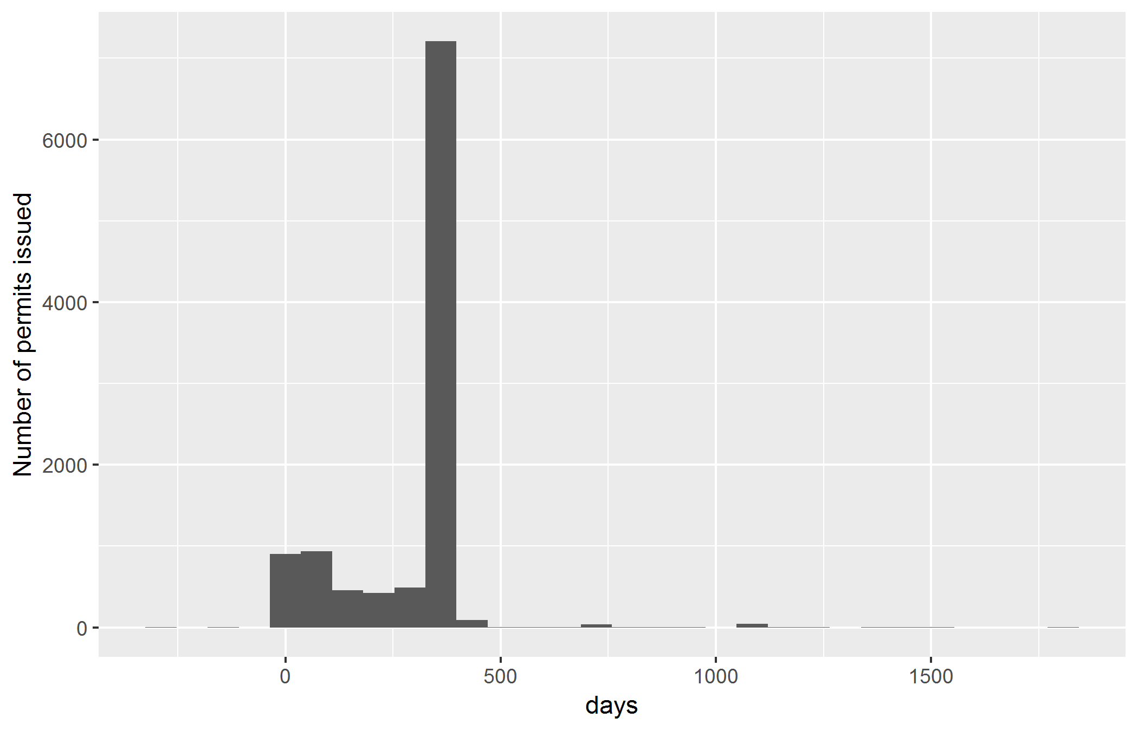

Figure 1 Number of days for which permits are issued

### Number of permits or renewals

In total the dataset contains 6199 unique permits that have been issued on 10633 occasions. There has been an increase in the number of permits or renewals issued but with a previous peak in the late 1980s-1990s (Figure 2).

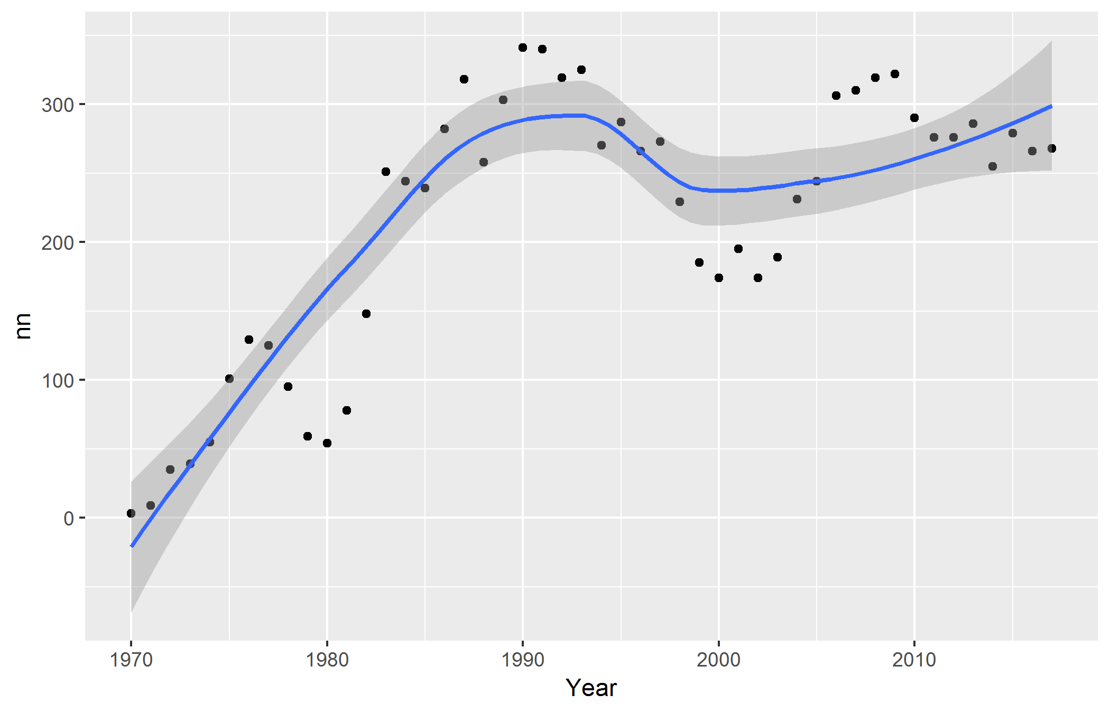

Figure 2 Trends in number of permits issued

## Who is doing the research?

### Researchers

The overall pattern for number of researchers (Figure 3) is very similar to that for permits or renewals (Figure 2).

Figure 3 shows the researchers with the most permits or renewals issued.

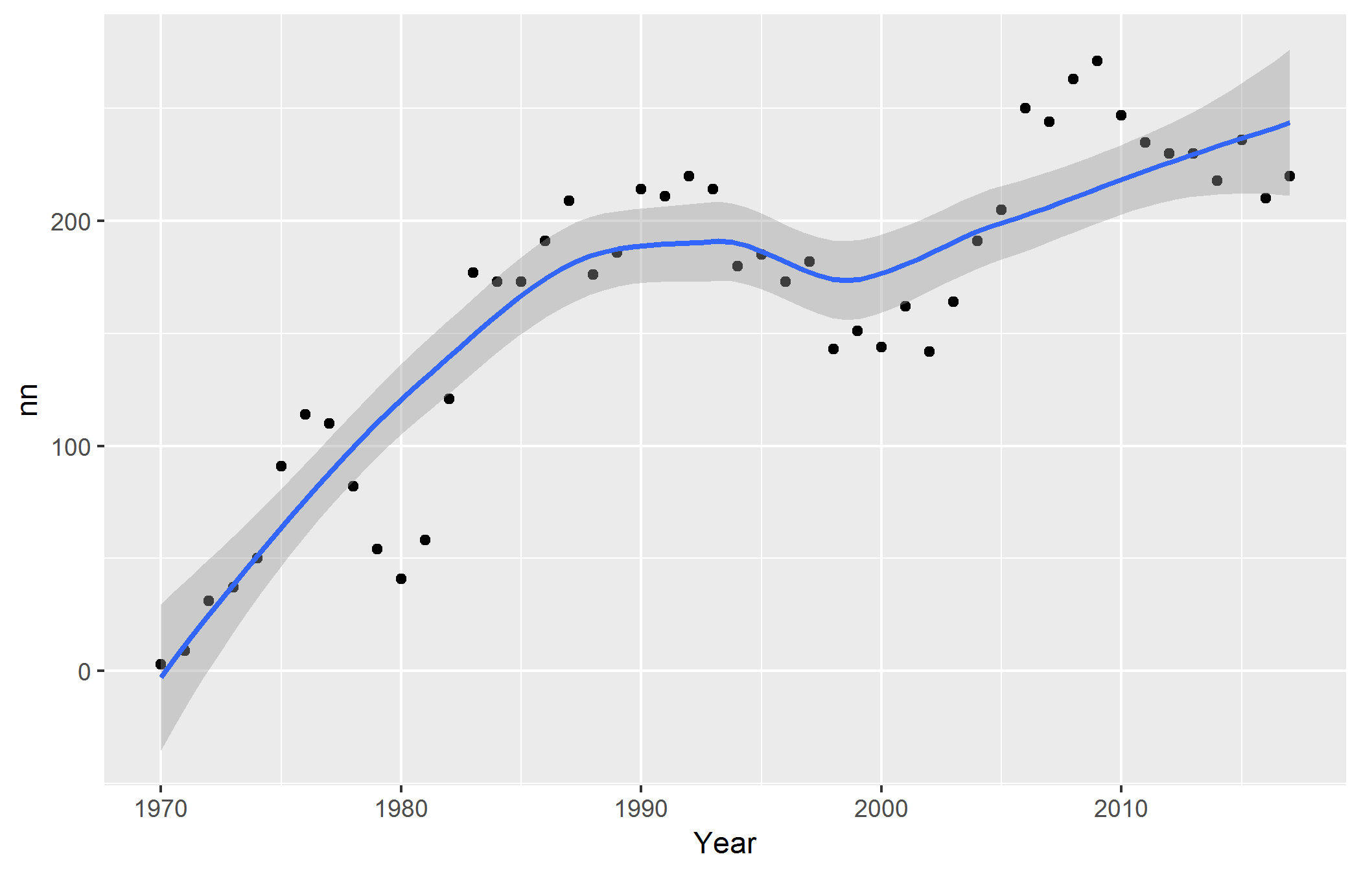

Figure 3 Trends in number of researchers

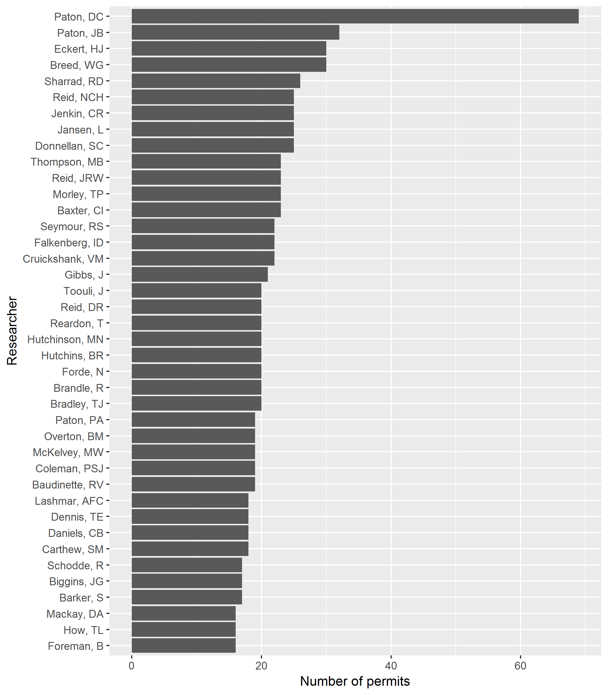

Figure 4 Researchers with the most permits issued

### Insitution types

Figure 5 shows trends through time for each type of institution (ORGANISATIONDESC). A permit can have more than one institution. For example, researchers that put bands on birds or bats are assigned to both their home institution (usually a university) as well as the Australian Bird and Bat Banding Scheme ([ABBBS](http://www.environment.gov.au/science/bird-and-bat-banding)).

Figure 6 shows the most frequently encountered institution descriptions within the research permits database. Figure 7 shows the same data as a word cloud.

Note that until the mid-1990s staff from DEW were not required to apply for scientific research permits.

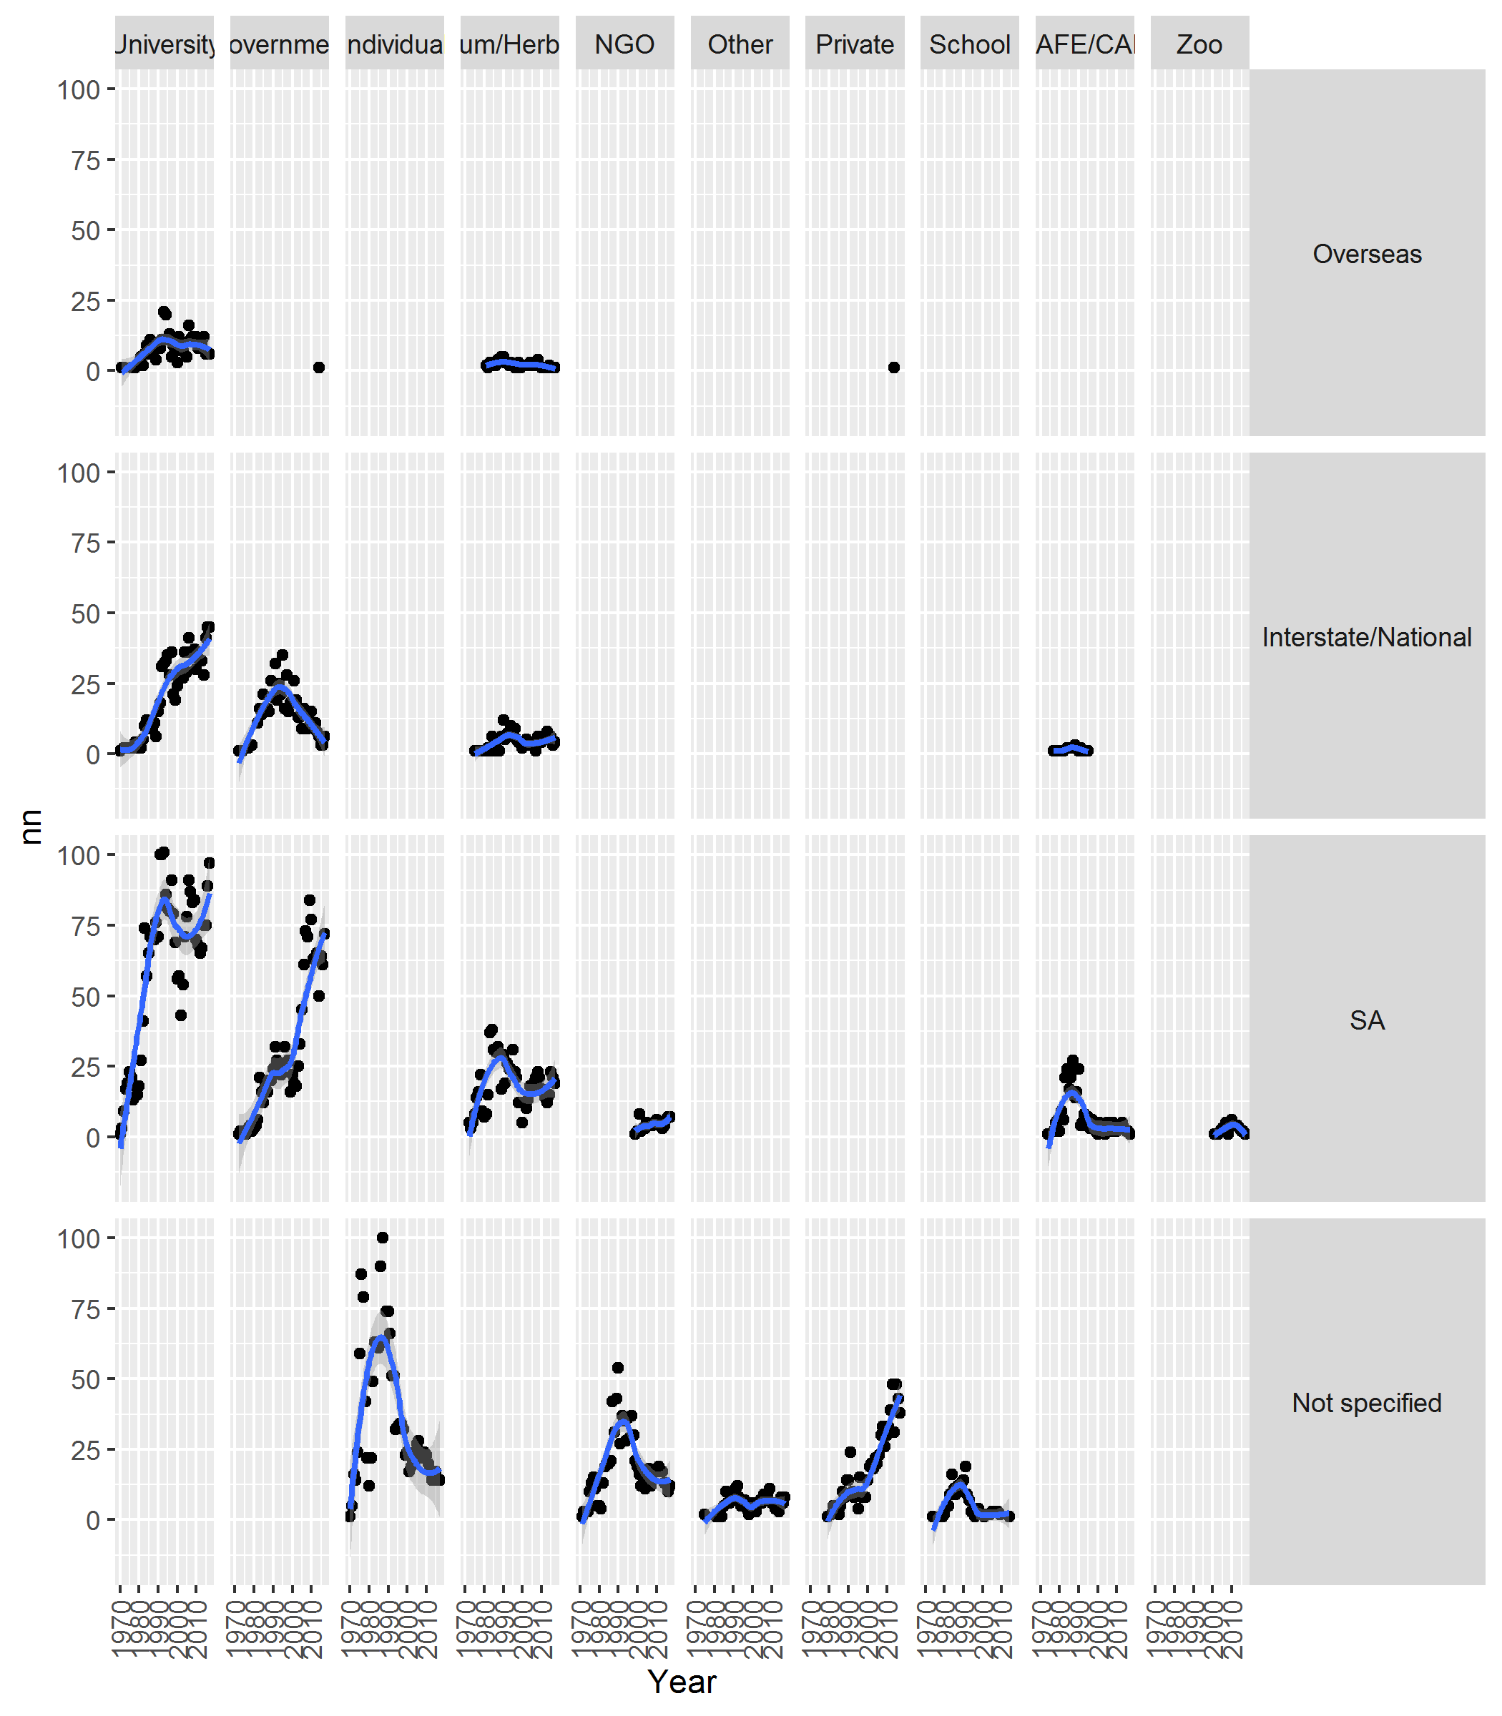

Figure 5 Trends in institution type

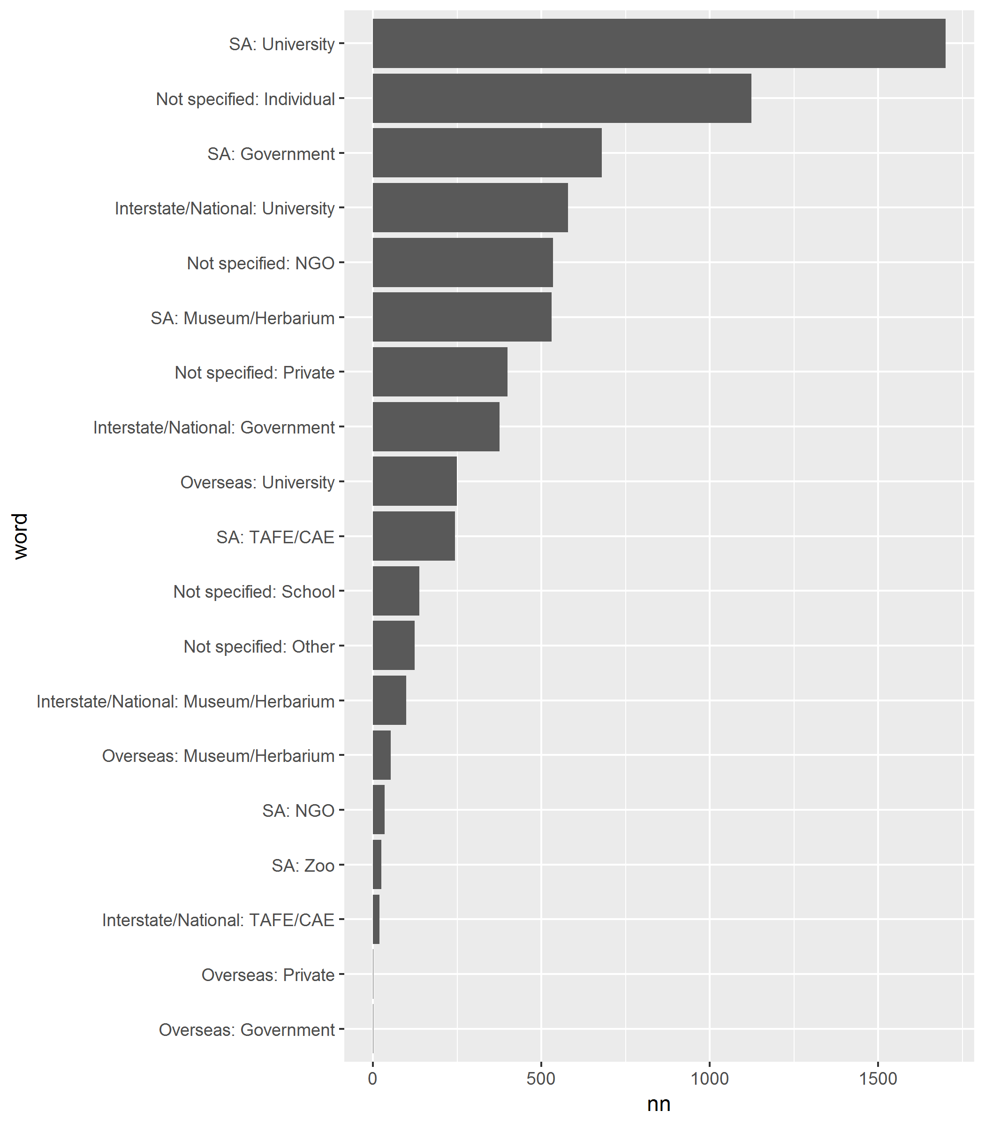

Figure 6 Count of institution type

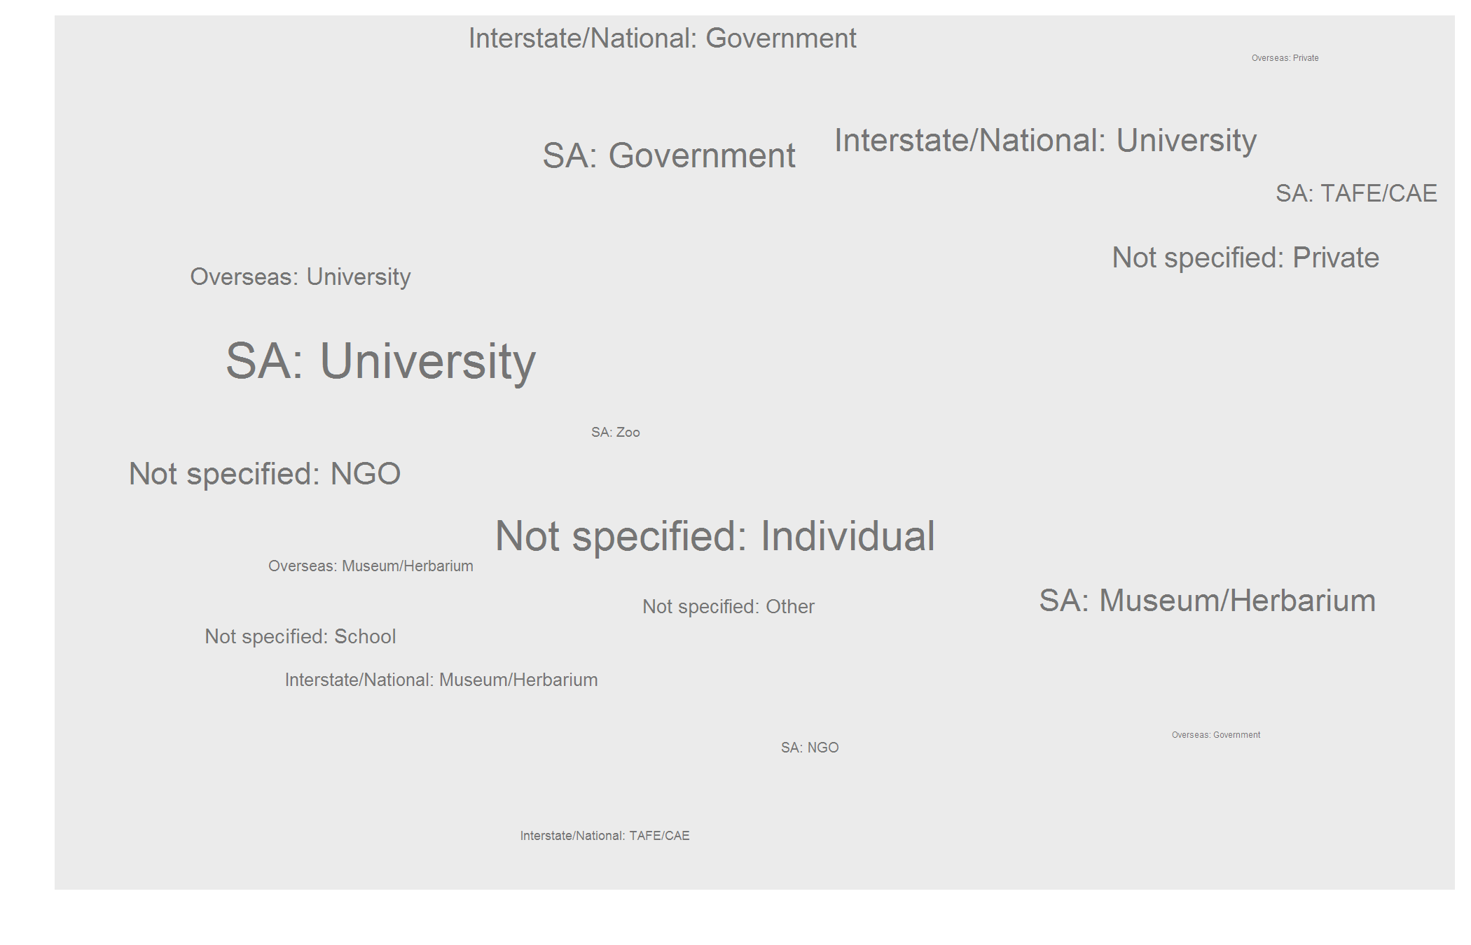

Figure 7 Wordcloud of the most frequently encountered institution types

## What is being researched?

### Words used by researchers to describe their research

Figures 8 and 9 shows the most frequently encountered words in the PROJTITLE and PROJECTABSTRACT fields. These fields are provided by the researcher.

Figure 9 shows the same data as Figure 8 but as a word cloud.

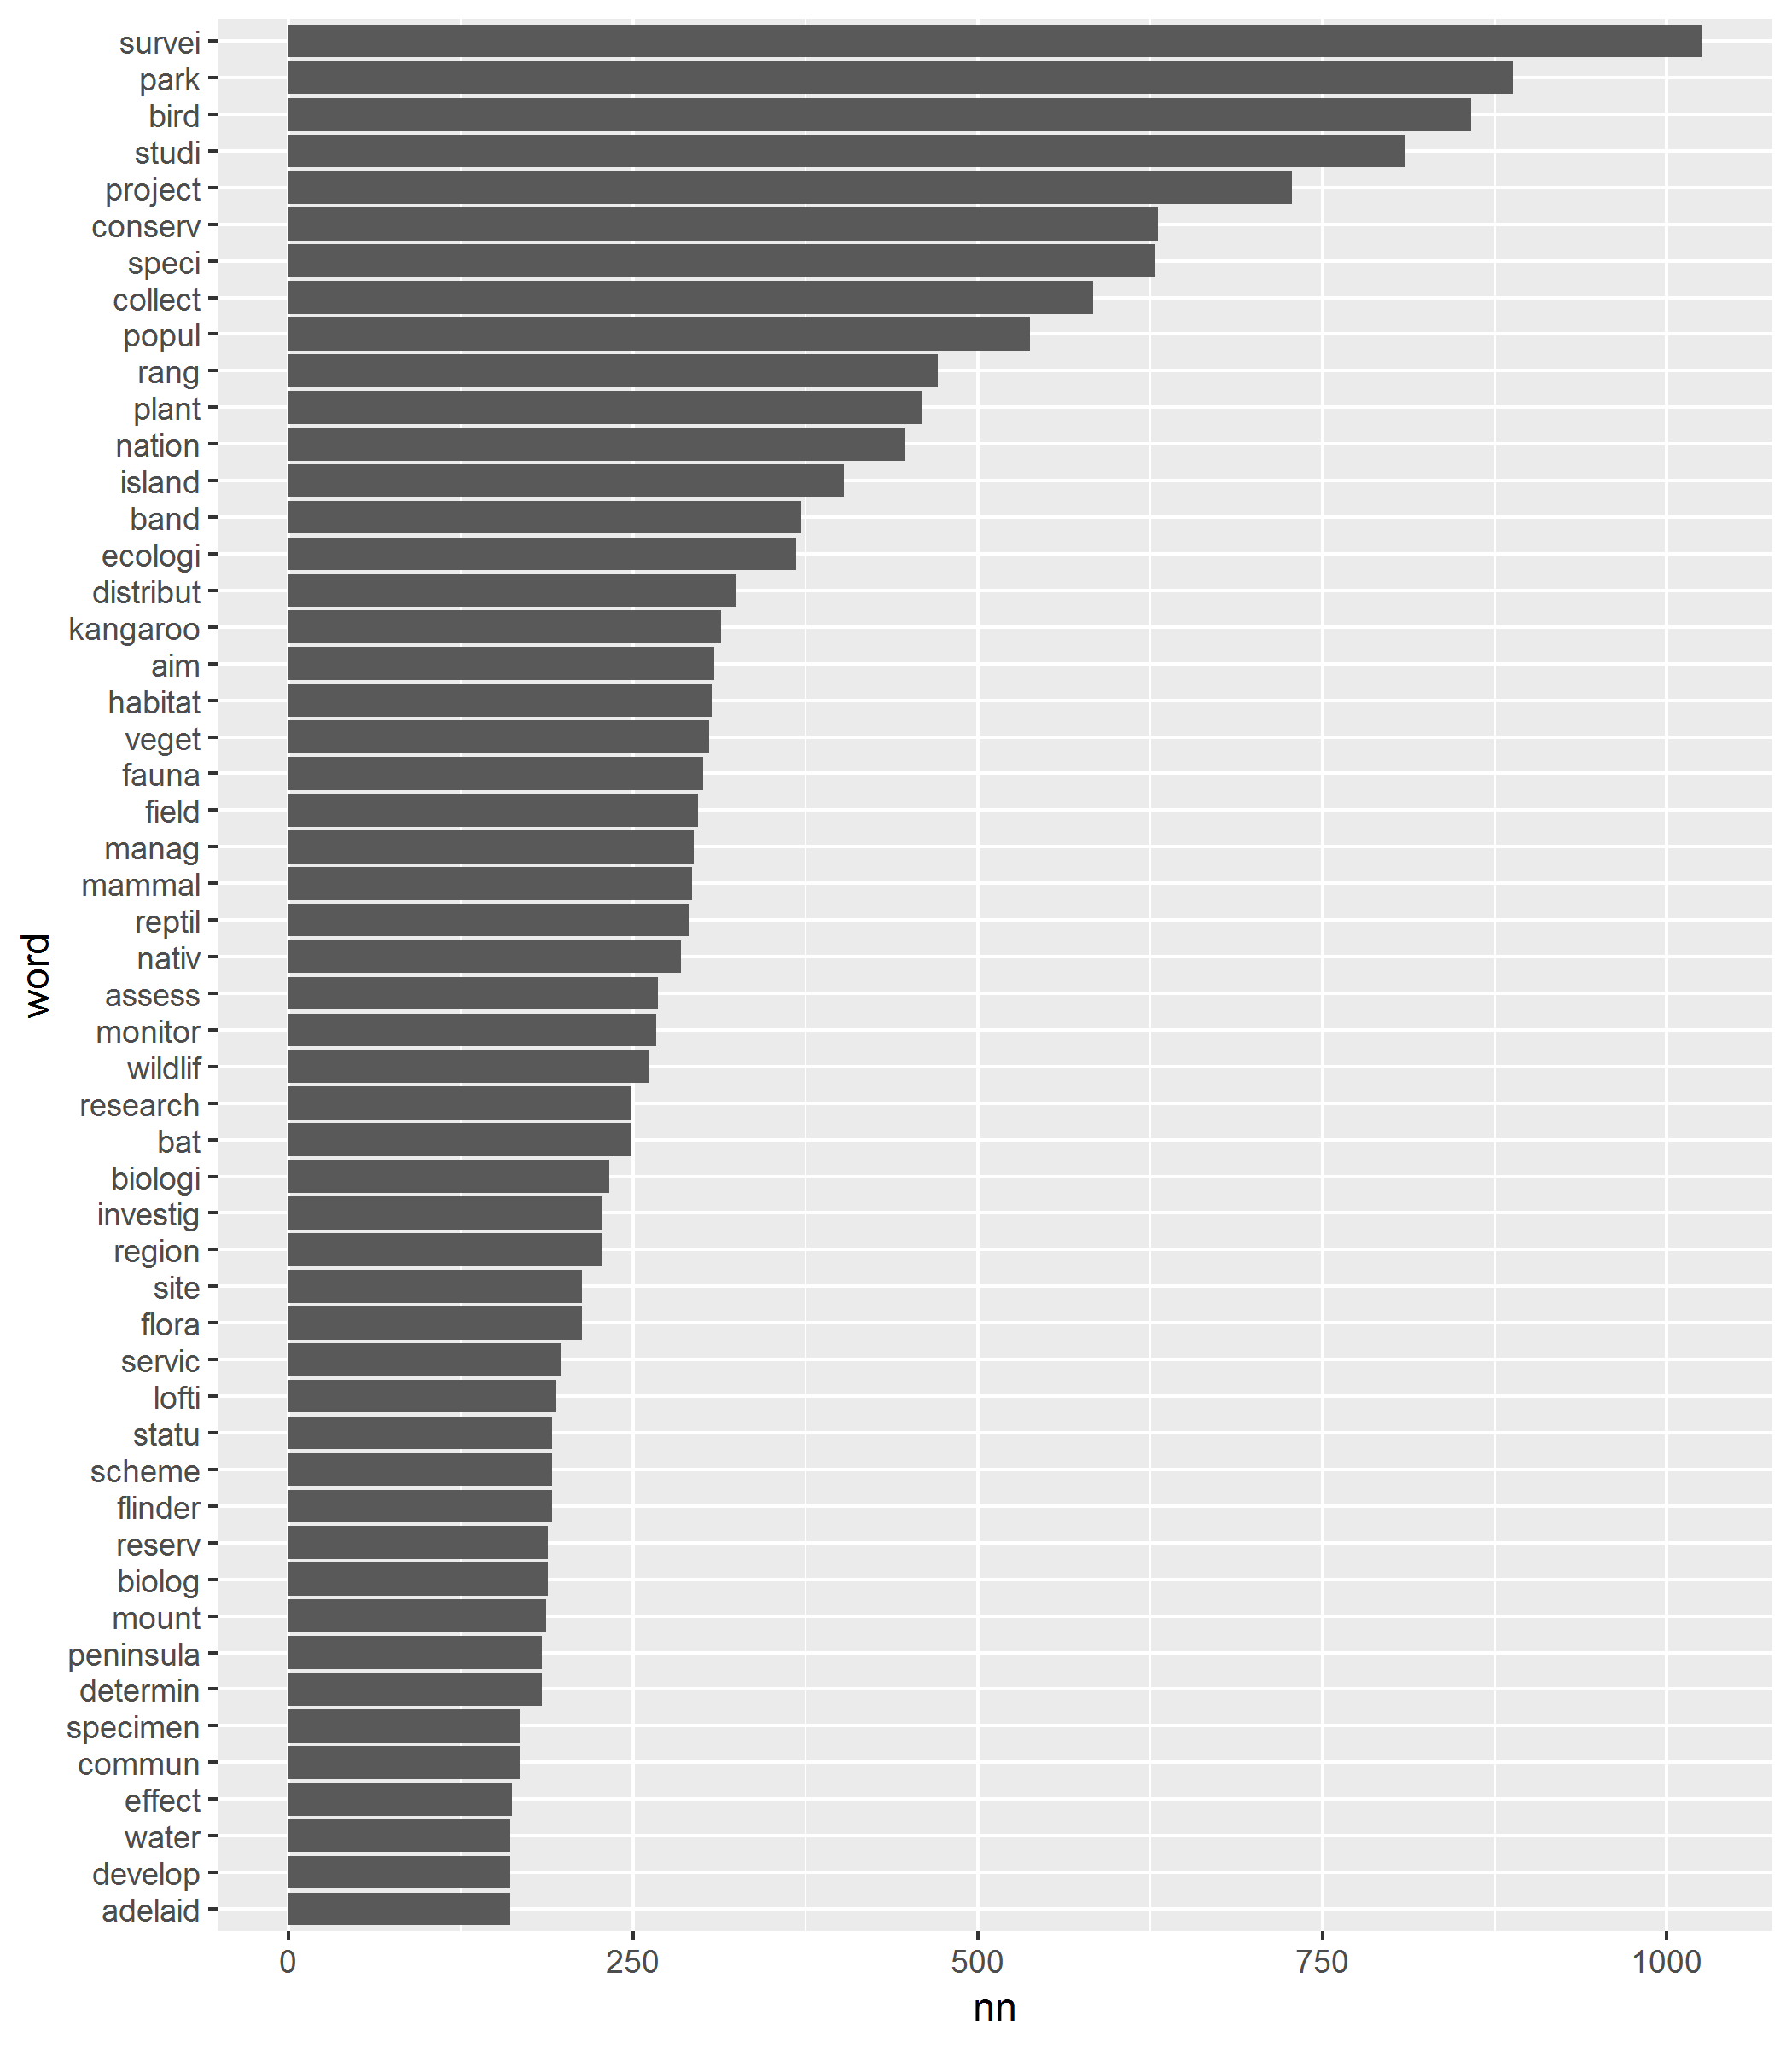

Figure 8 Most frequent words used in the title and abstract field of each permit

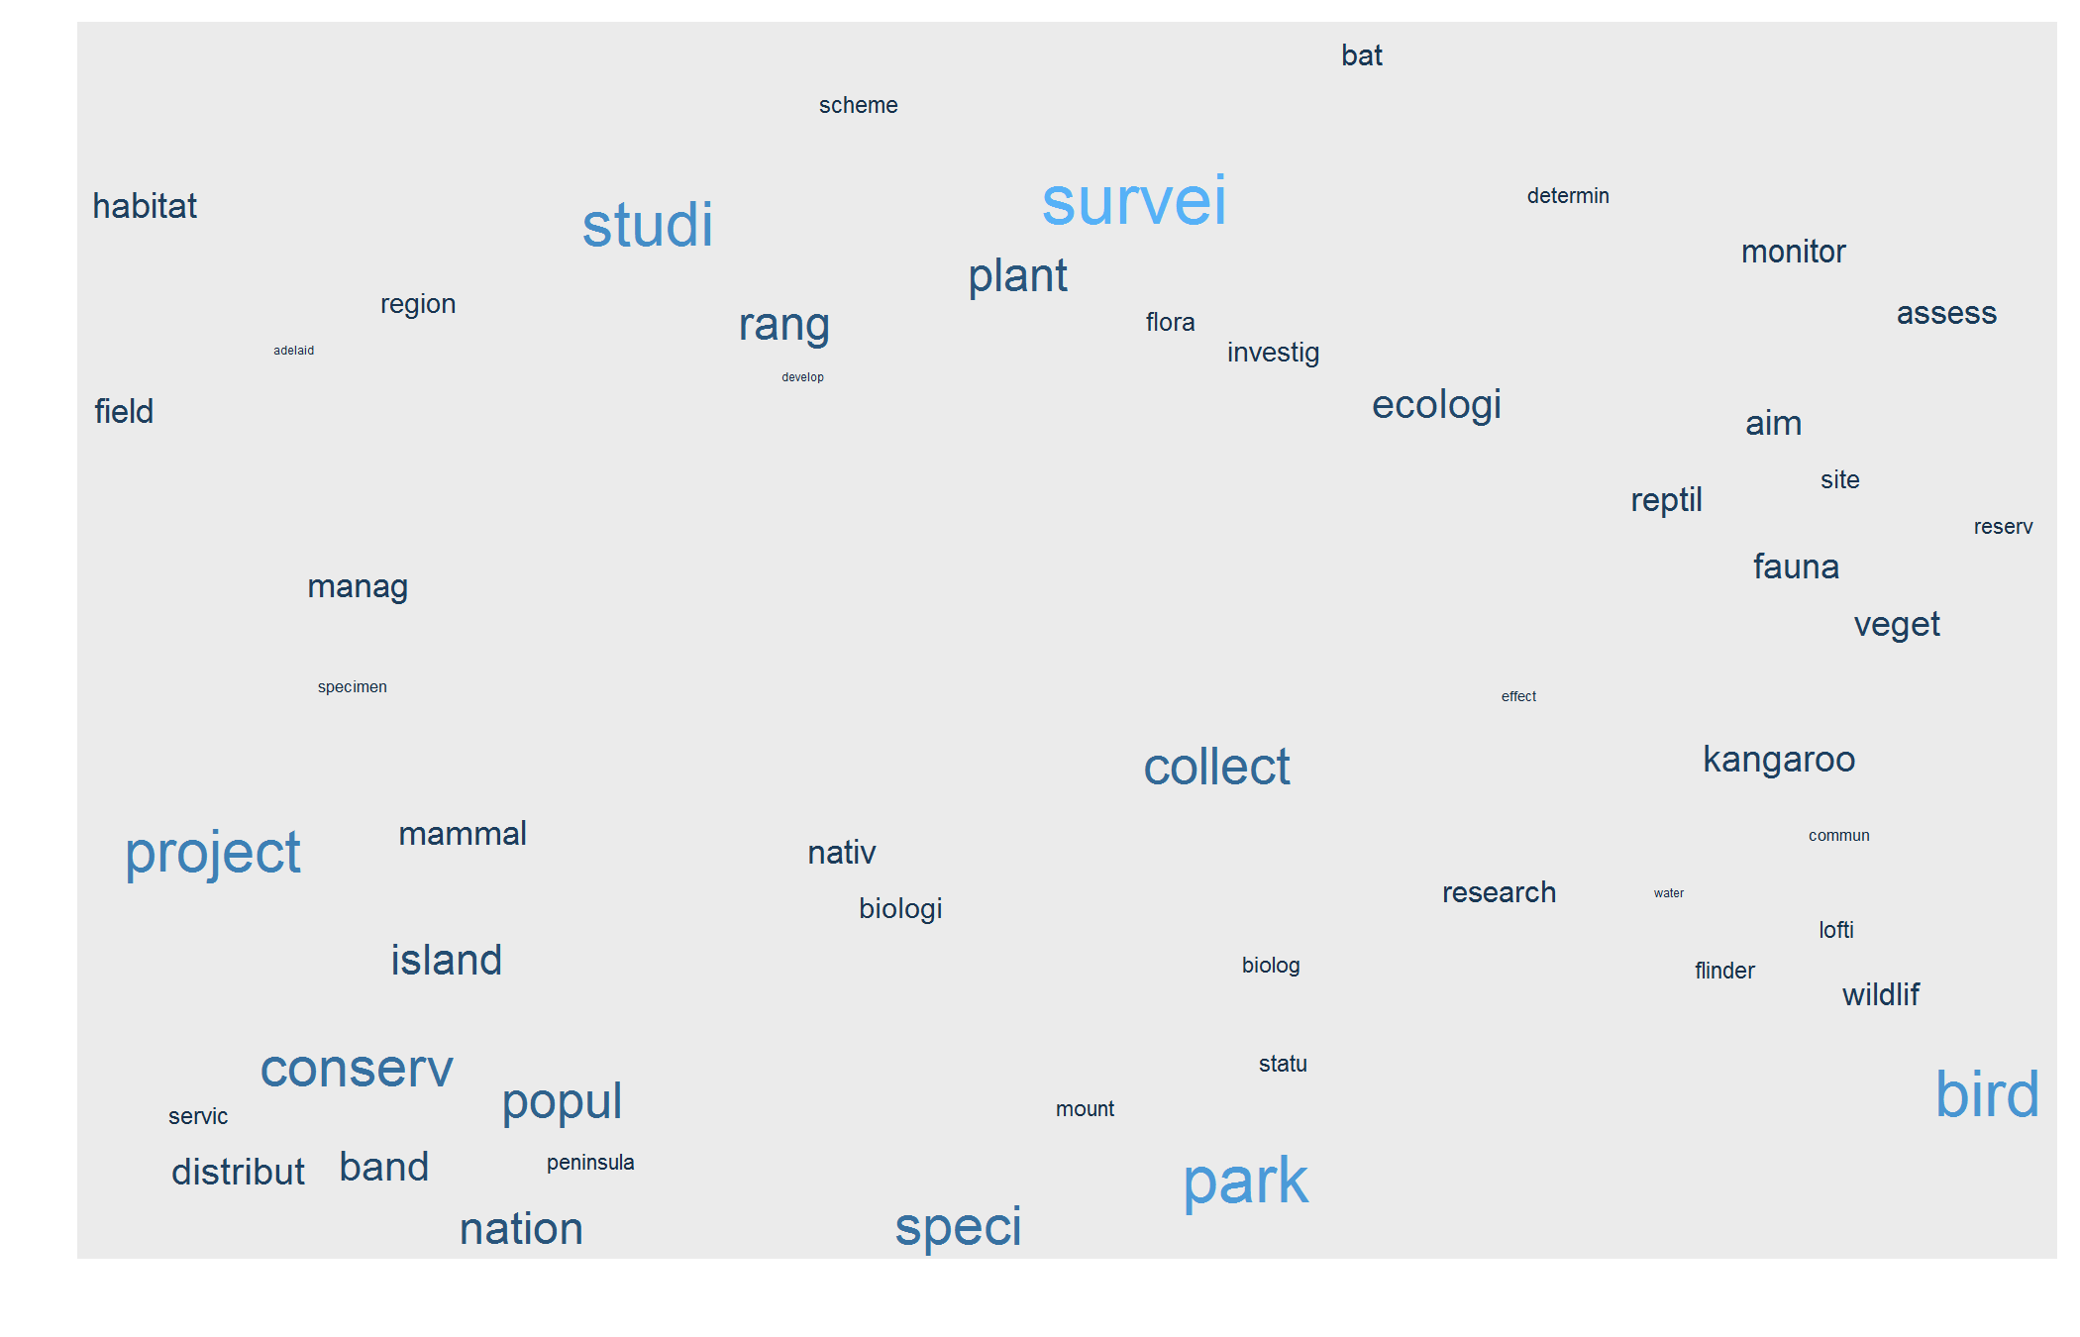

Figure 9 Wordcloud of the most frequently encountered words in the title and abstract field for each permit

## Run 0 stress 0.08519792   
## Run 1 stress 0.08519792   
## ... Procrustes: rmse 9.935402e-06 max resid 2.030944e-05   
## ... Similar to previous best  
## Run 2 stress 0.09033304   
## Run 3 stress 0.08519812   
## ... Procrustes: rmse 0.0001735517 max resid 0.0005472262   
## ... Similar to previous best  
## Run 4 stress 0.2094306   
## Run 5 stress 0.09460921   
## Run 6 stress 0.09460909   
## Run 7 stress 0.09460909   
## Run 8 stress 0.09460917   
## Run 9 stress 0.09460923   
## Run 10 stress 0.3692398   
## Run 11 stress 0.1004105   
## Run 12 stress 0.09460915   
## Run 13 stress 0.09460915   
## Run 14 stress 0.09460912   
## Run 15 stress 0.08519795   
## ... Procrustes: rmse 5.387625e-05 max resid 0.0001174875   
## ... Similar to previous best  
## Run 16 stress 0.1004105   
## Run 17 stress 0.0946091   
## Run 18 stress 0.09025285   
## Run 19 stress 0.09460912   
## Run 20 stress 0.1004105   
## *** Solution reached

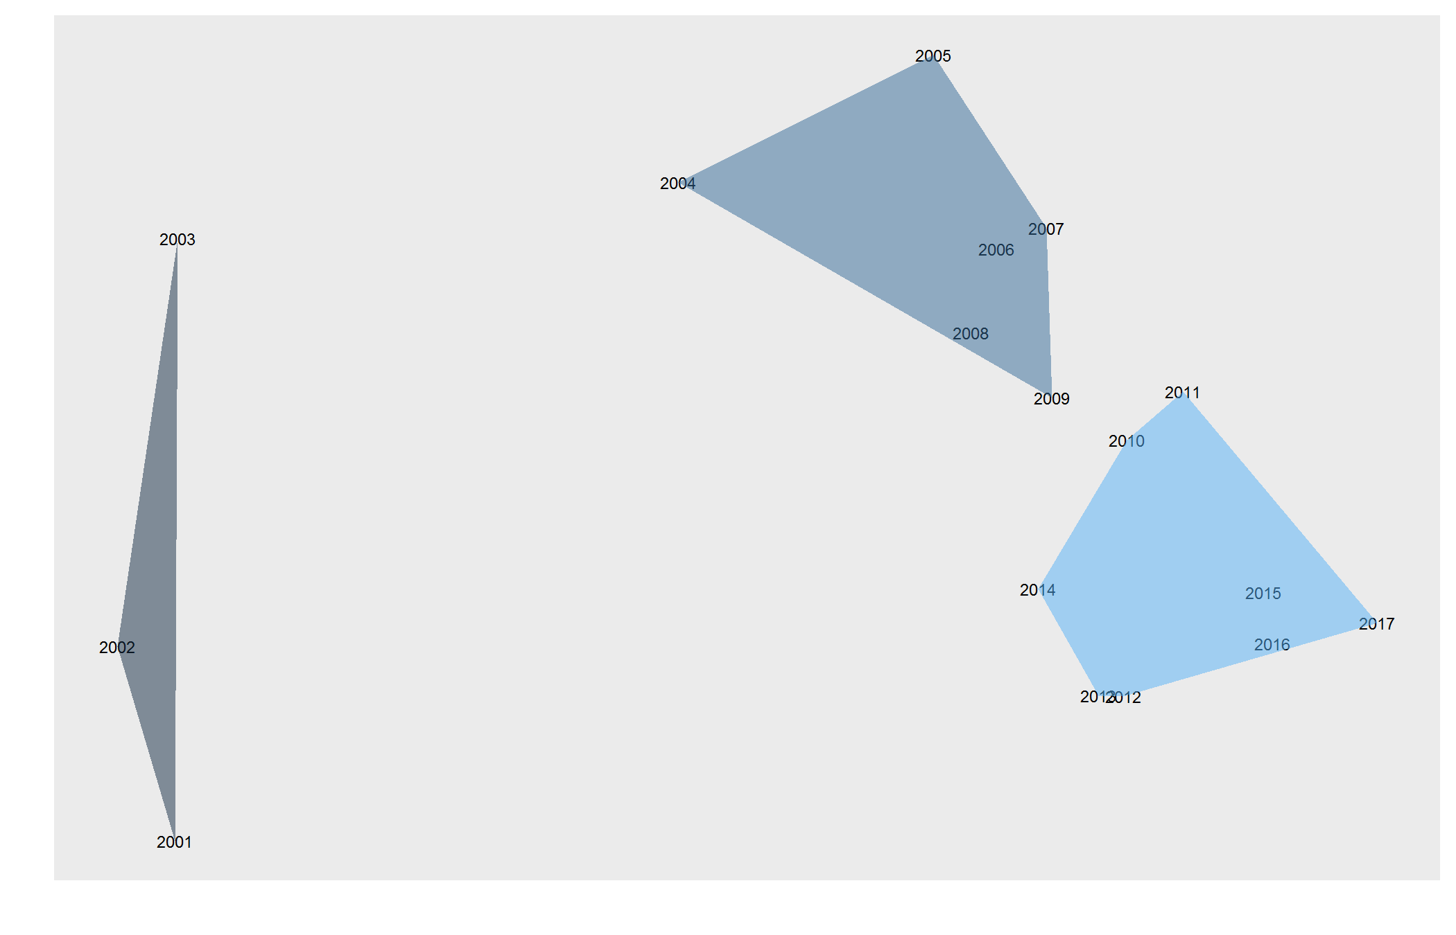

Figure 10 Map of dissimilarity between years based on words used in project titles for those years, with natural groupings

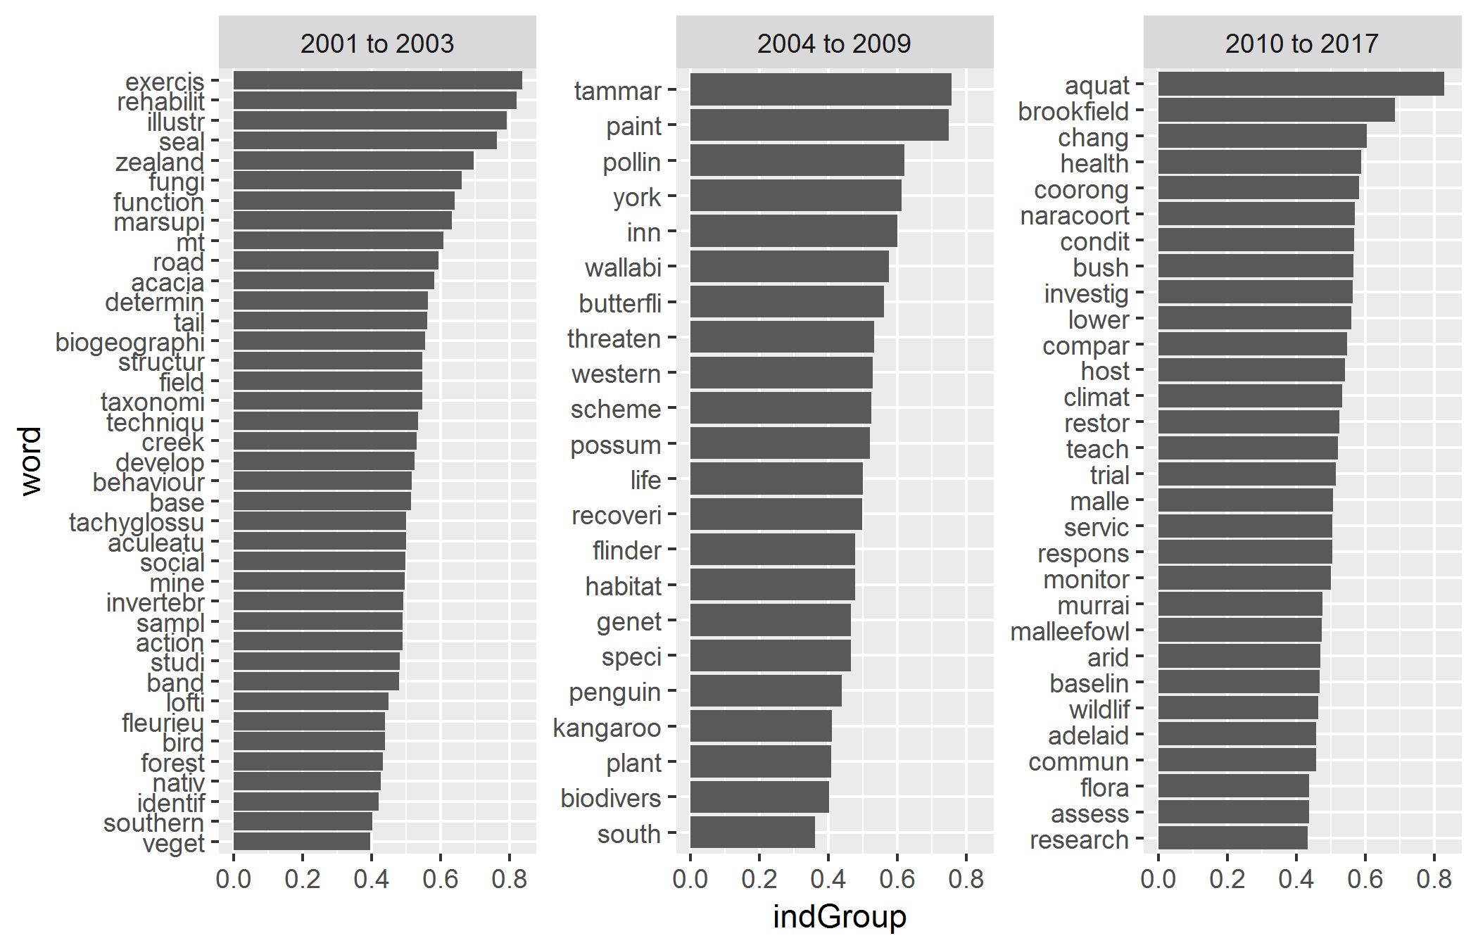

Figure 11 Words that best indicate natural groupings used above

### Topics assigned by coordinator to describe research

Figure 12 shows the most frequently encountered topics assigned by the coordinator. One permit may have several topics. Figure 13 shows the same data as a word cloud. Topics are an almagamation of the fields RESEARCHDESC and SUBJECTDESC.

Figure 14 shows trends through time for the most frequently encountered topics.

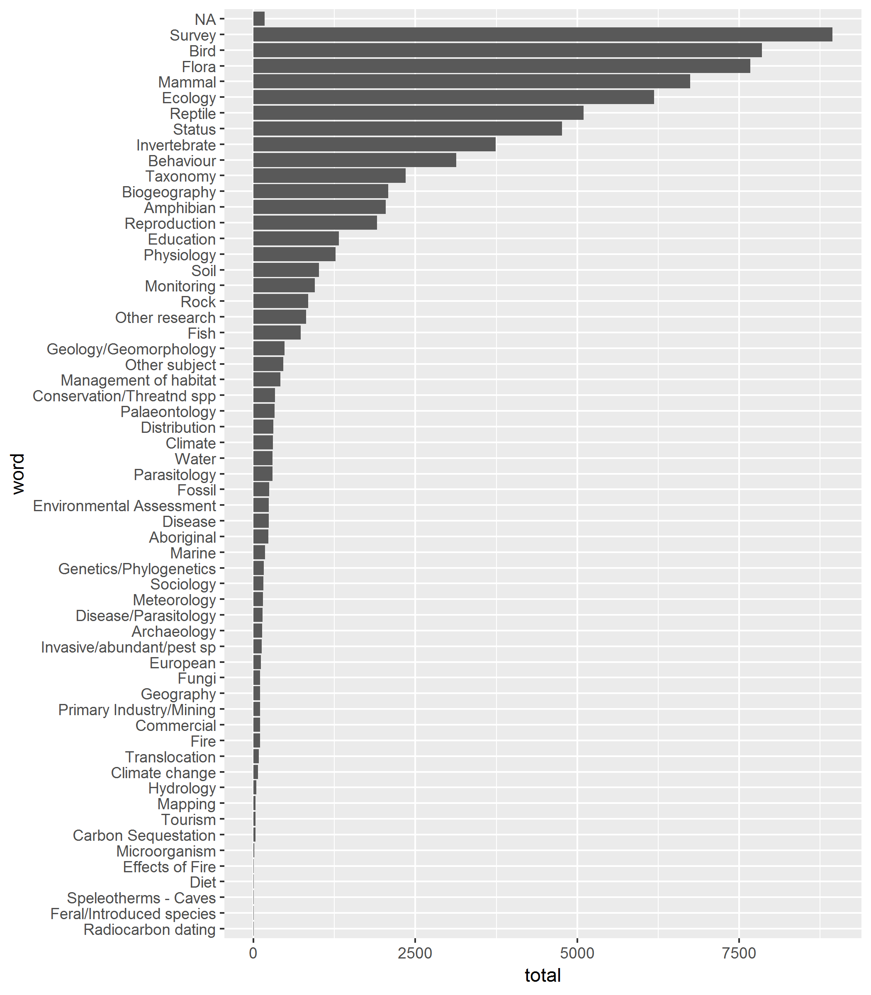

Figure 12 Count of assigned topics

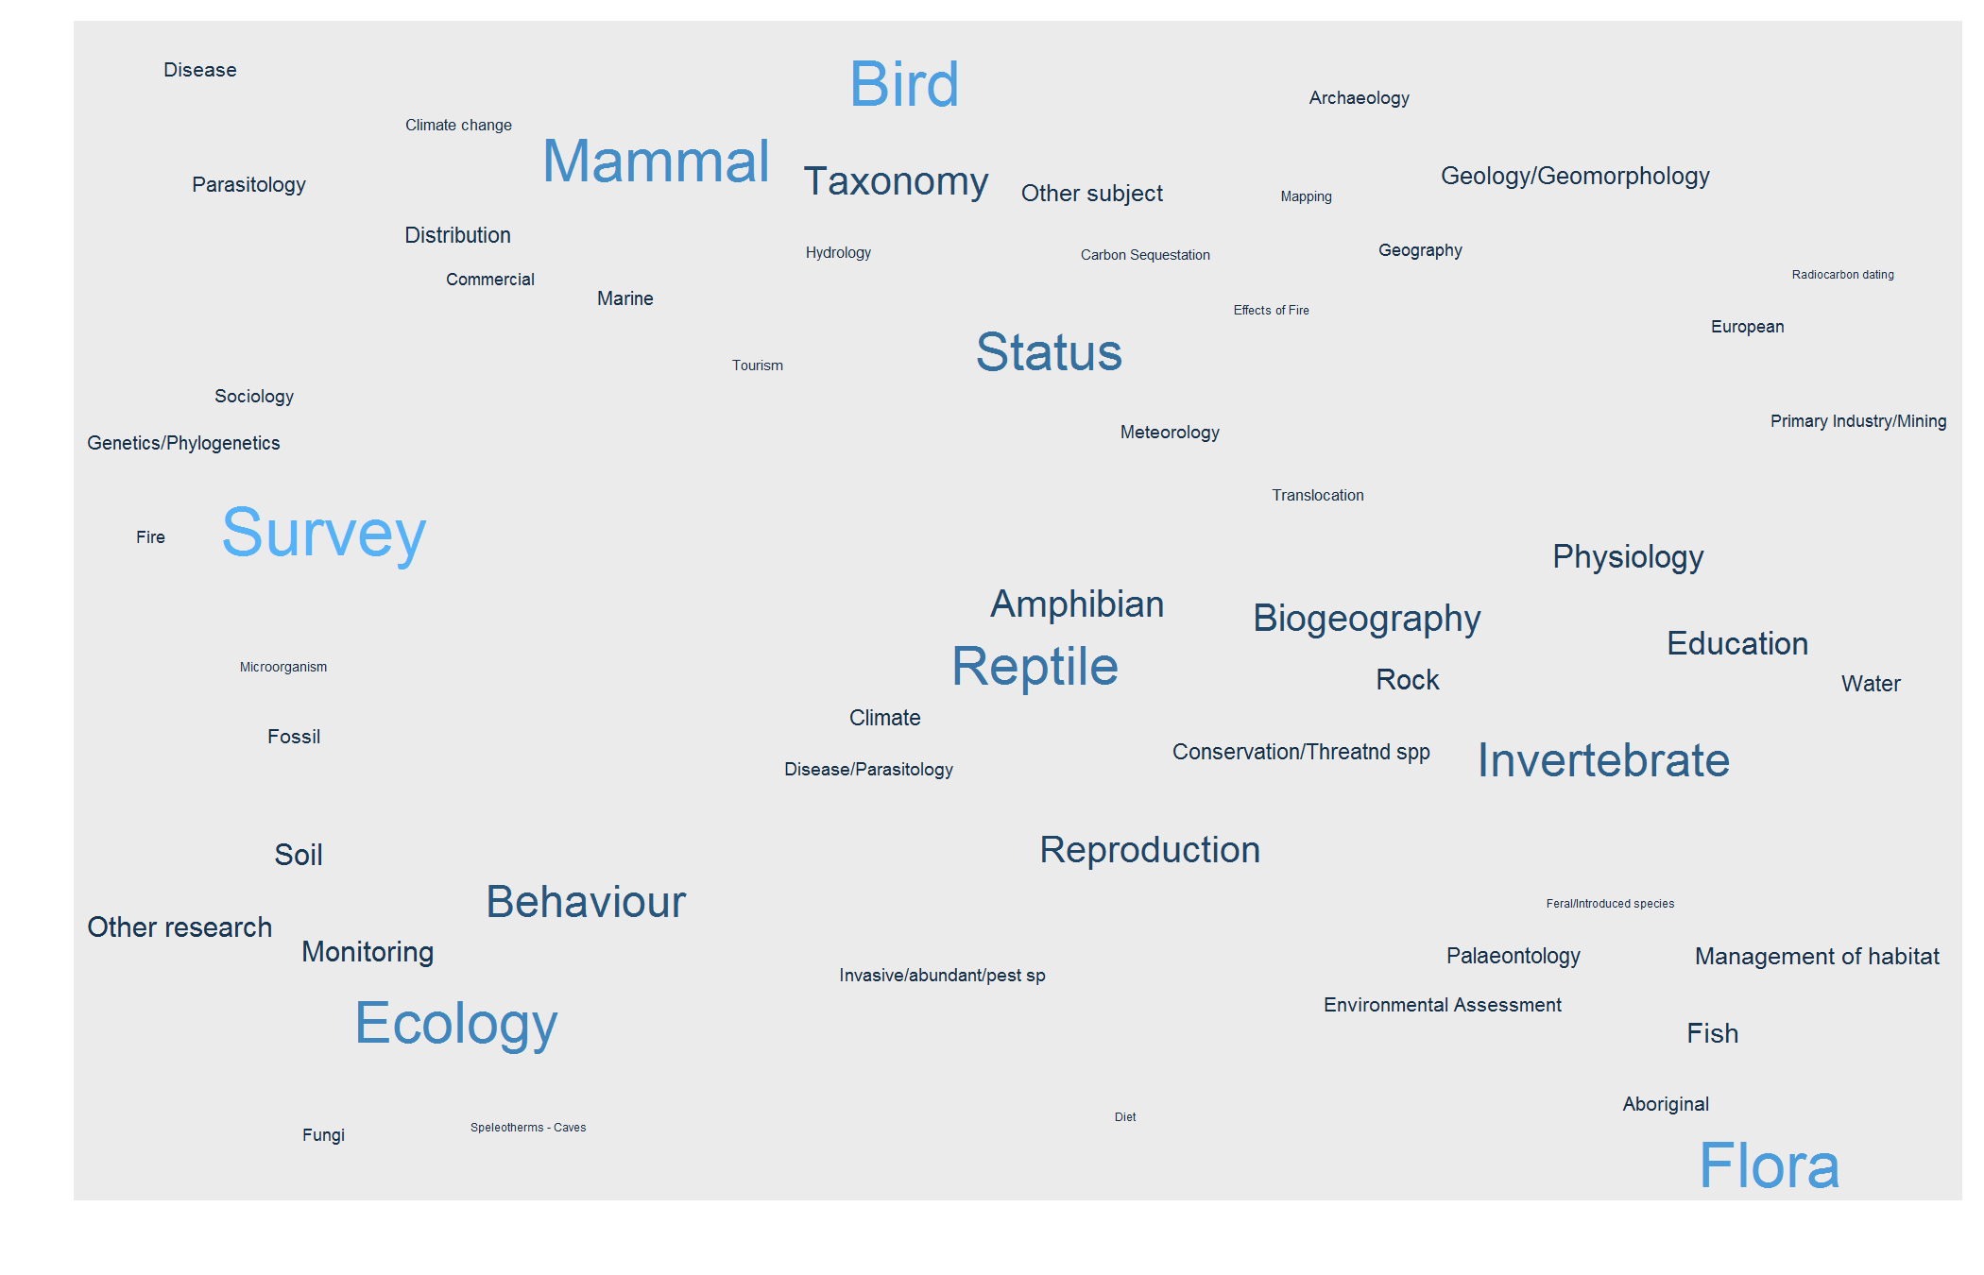

Figure 13 Wordcloud of the most frequently encountered assigned topics

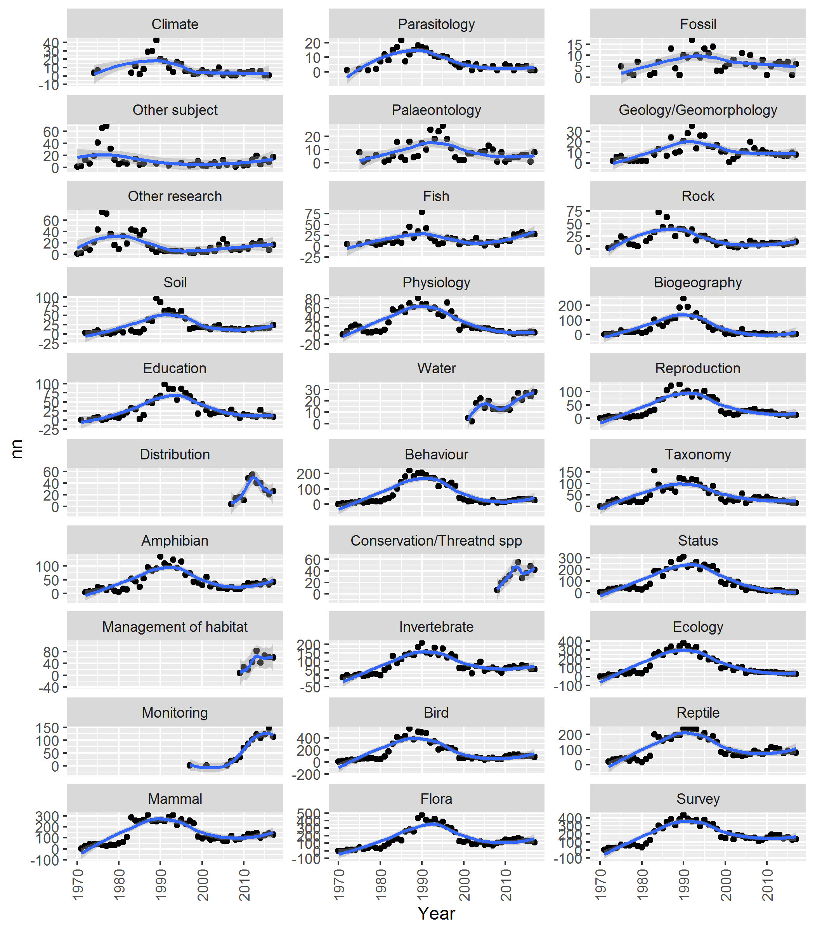

Figure 14 Trends in assigned topics

### Long term permits

Several permits have run for more than 20 years (Table 2).

At times a new permit will be issued for the same project. This analysis has not been able to account for those instances so the number of long term projects is likely to be greater than identified here.

Table 2 Permits that have run for longer than 20 years

|  |  |  |  |  |
| --- | --- | --- | --- | --- |
| Researcher | First year | Last year | Renewals | Title |
| Rismiller, PD | 1991 | 2017 | 26 | The ecology of the Kangaroo Island Echidna (Tachyglossus aculeatus multiaculeatus) |
| Rismiller, PD | 1991 | 2017 | 26 | Ecology of island reptiles. |
| Conran, JG | 1990 | 2017 | 26 | Collection of plant material for teaching purposes. |
| Cairns, SC | 1991 | 2017 | 24 | Population dynamics of Red Kangaroos in South Australia. |
| Klau OAM, WL | 1991 | 2015 | 24 | Density and movement of birds in the Mid and Upper North and Eyre Peninsula areas of South Australia. |
| Gardner, M | 1993 | 2017 | 23 | Behaviour and ecology of skinks. |
| Paton, DC | 1991 | 2017 | 21 | Factors influencing the distribution and abundance of biota in South Australian wetlands. |
| Paton, DC | 1993 | 2017 | 21 | Reproductive performances, survival and population dynamics of plants. |
| Rismiller, PD | 1996 | 2017 | 21 | Body temperature and breeding biology of Rosenberg’s Goanna. |
| Paton, DC | 1993 | 2017 | 21 | Studies into the ecology and population dynamics of selected bird groups. |
| Pickett, M | 1995 | 2016 | 21 | Emu-wren Stipiturus spp. research and recovery - banding, monitoring and genetic studies. |
| Needham, DJ | 1994 | 2016 | 20 | Aerial survey and photographic identification of Southern Right Whales (Eubalaena australis) in South Australian waters west of Adelaide. |
| Overton, BM | 1991 | 2015 | 20 | On-going base data collection of all plant species for the South Australian Herbarium and reference collection. |
| Standen, R | 1995 | 2017 | 20 | A comprehensive long-term study of waders and terns in Victoria and South Australia. |
| Kovac, KJ | 1990 | 2014 | 20 | Environmental monitoring of the Olympic Dam Project, South Australia. |
| Taylor, R | 1993 | 2017 | 20 | Botanical surveys, monitoring, revegetation trials, local herbariums and herbicide trials in South Australia. |
| Overton, BM | 1991 | 2015 | 19 | Opportunistic collection of small vertebrates and invertebrates (including road-kills) on Kangaroo Island. |
| Pruett-Jones, S | 1992 | 2017 | 19 | Comparative Biology and Behaviour of Australian Fairy-wrens. |
| Matejcic, PJ | 1991 | 2013 | 19 | General surveys of the mammals of SA. |
| Lethbridge, M | 1997 | 2017 | 18 | Comparison of the habitat, population viability and movement of Yellow-footed Rock-wallabies in the Flinders Ranges and Gawler Ranges |
| Grund, RB | 1997 | 2017 | 18 | Butterflies of South Australia. |
| Williams, I | 1992 | 2013 | 18 | Reptile and amphibian distribution and status in South Australia. |
| Whalen, MA | 1995 | 2016 | 18 | Ecology and life history of South Australian Frankenias. |
| Bannister, JL | 1994 | 2014 | 17 | Aerial survey for Southern Right Whales, southern coast of Australia. |
| Renfree, MB | 1989 | 2017 | 17 | Reproductive physiology and developmental molecular biology of marsupials. |
| McArthur, AJ | 1991 | 2015 | 15 | Review of the genus Camponotus and other ants (Formicidae). |
| Kemper, CM | 1990 | 2012 | 15 | General collection permit issued to the Curator of Mammals, South Australian Museum. |
| Conran, JG | 1992 | 2017 | 15 | Molecular and morphological adaptations and evolution in the Australian Flora. |
| Mackay, DA | 1993 | 2015 | 14 | An experimental study of an ant-plant mutualism. |
| Leigh, CM | 1996 | 2017 | 11 | Comparative morphology of vertebrates. |
| Woodman, JB | 1989 | 2009 | 11 | Reference material for paintings of South Australian flora. |
| Reid, DR | 1990 | 2011 | 6 | Monitoring Bird Populations in and around Scott Creek Conservation Park |
| Johnston, G | 1990 | 2010 | 5 | Behaviour and ecology of pelicans and cormorants in South Australia |
| Grandison, RE | 1975 | 2005 | 1 | The status of Eucalyptus macrorhyncha in South Australia. |
| Plummer, PS | 1976 | 2004 | 1 | Palaeogeography of the upper Brachina Subgroup (late Precambrian), Flinders Ranges. |

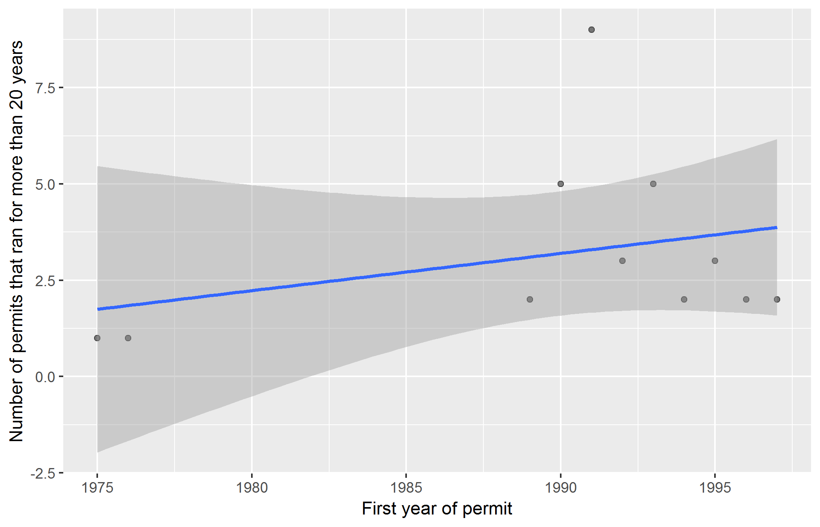

Figure 15 Number of permits issued in a year that ran for more than 20 years

## Where is the research occurring?

### Region

Figure 16 shows trends through time for each region (retrieved from the field REGION in the table PAMS_NPWSAREGIONS_SPVIEW). One permit may have several regions.

Figure 17 shows the most frequently encountered regions within the research permits database. Figure ?? shows the same data as a word cloud.

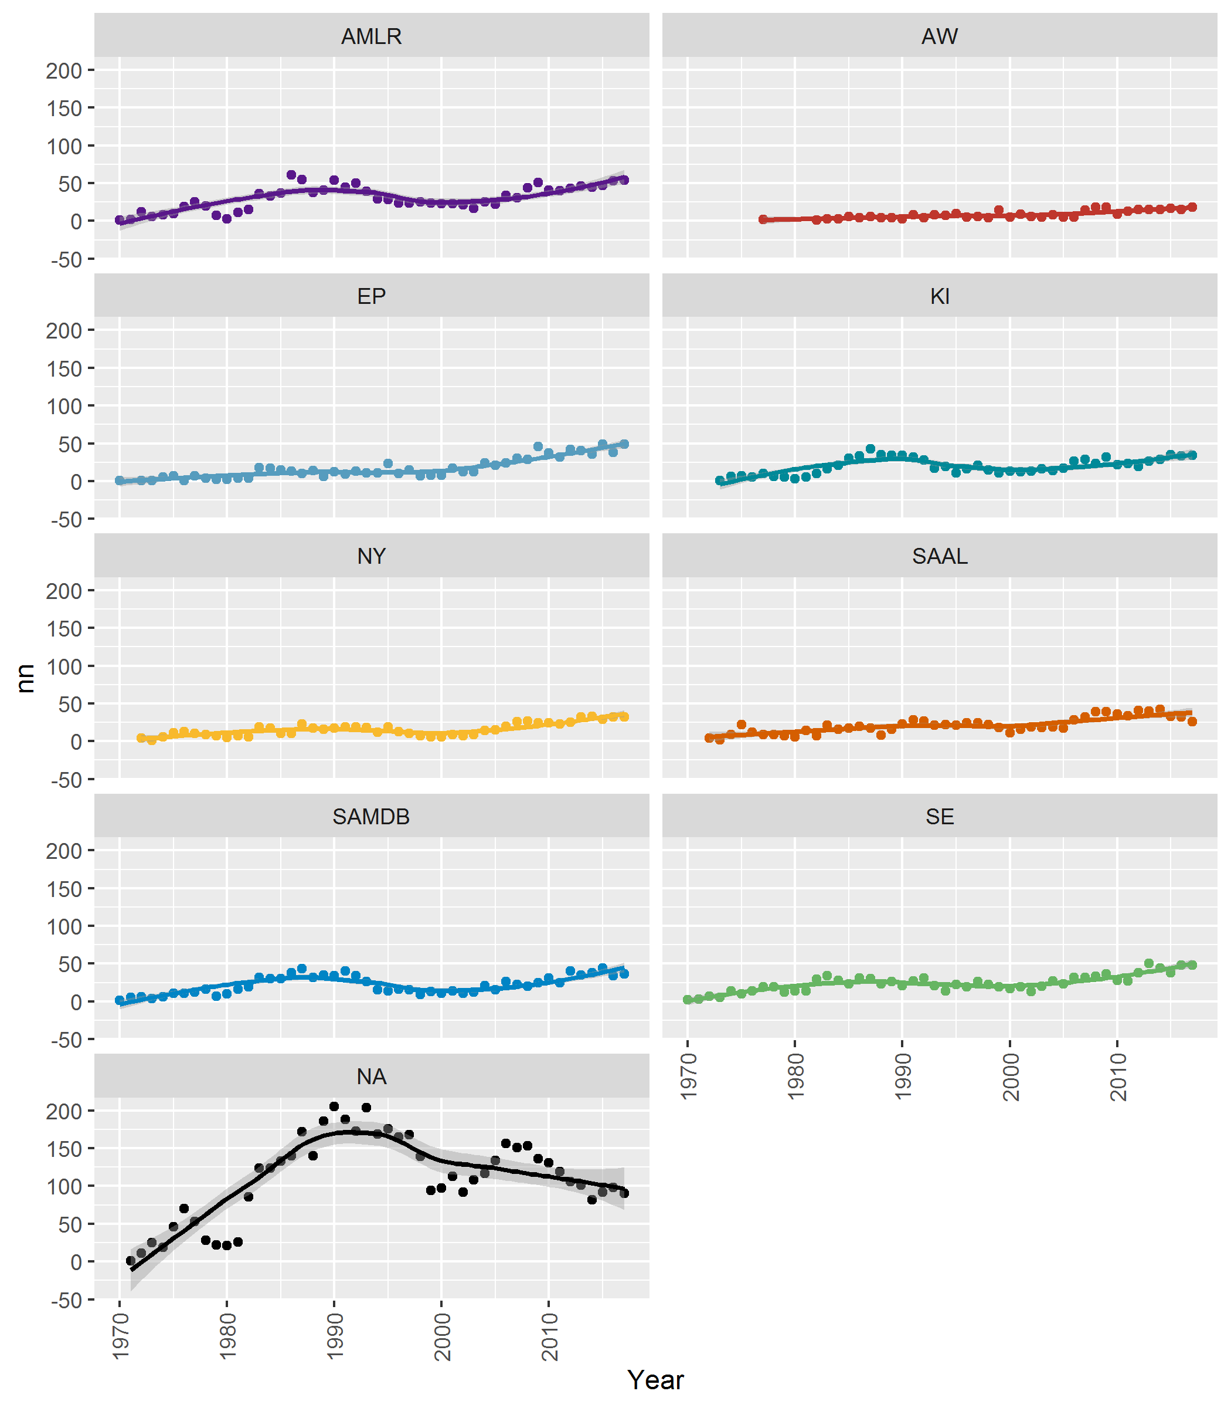

Figure 16 Trends in regions

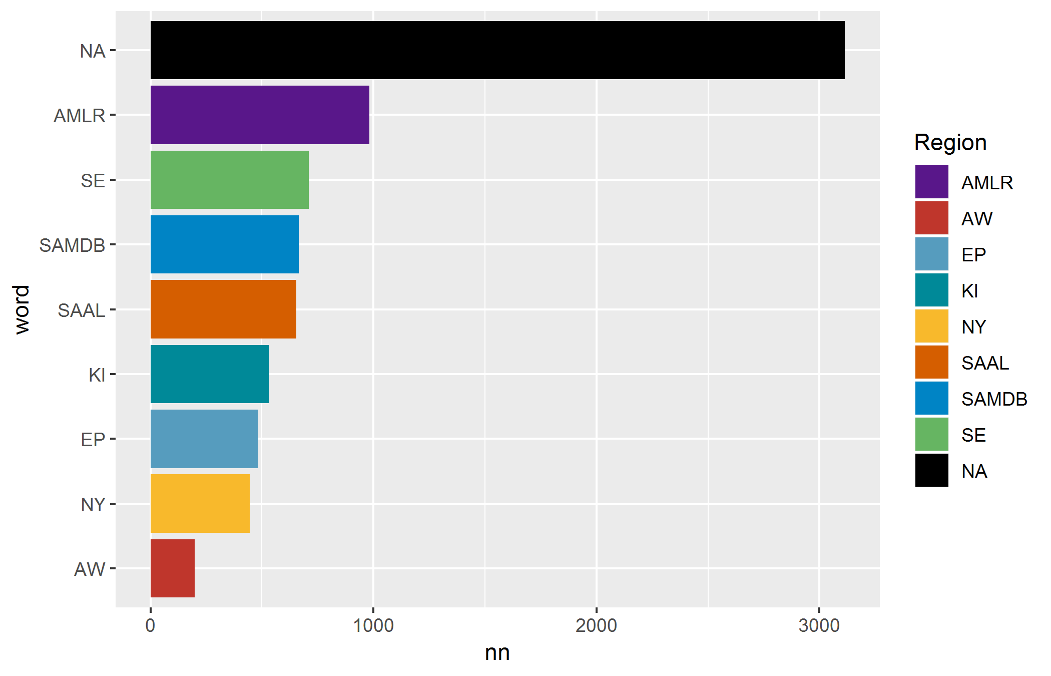

Figure 17 Count of regions

### Park

There are 342 unique park names in the data set.

Parks that have changed names only appear in the dataset from the date of their name change (e.g. Ravine des Casoars Wildnerness Protection Area was originally part of Flinders Chase National Park). The appendix Table 3 lists each park with the minimum and maximum years.

Figure 18 shows trends through time for the most frequently encountered parks. Most permits have several parks, but in many cases the researcher may not visit all the parks listed on their permit.

Figure 19 shows trends through time for the most frequently encountered parks in the last 10 years.

Figure 20 shows the most frequently encountered parks. Figure 21 shows the same data as a word cloud.

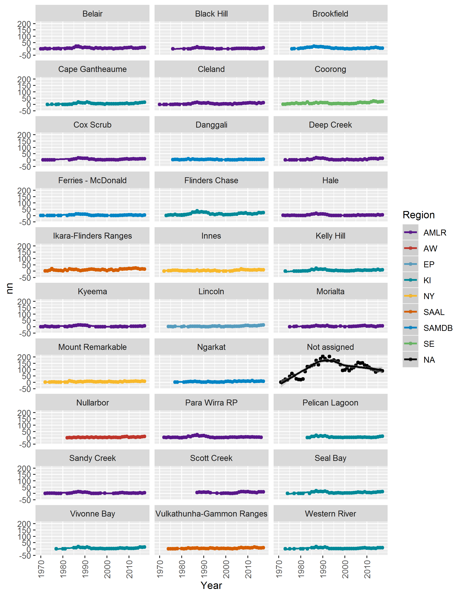

Figure 18 Trends in parks - filtered to parks with more than N permits

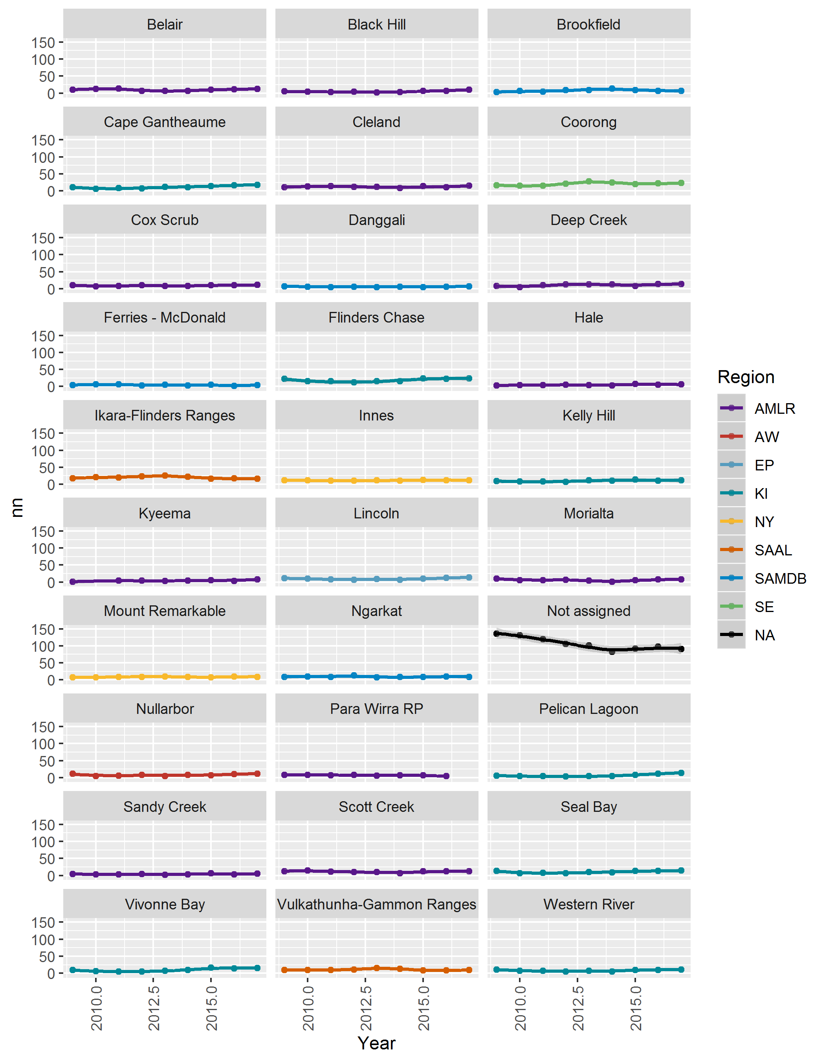

Figure 19 Trends in parks - filtered to years greater than X and parks with more than N permits

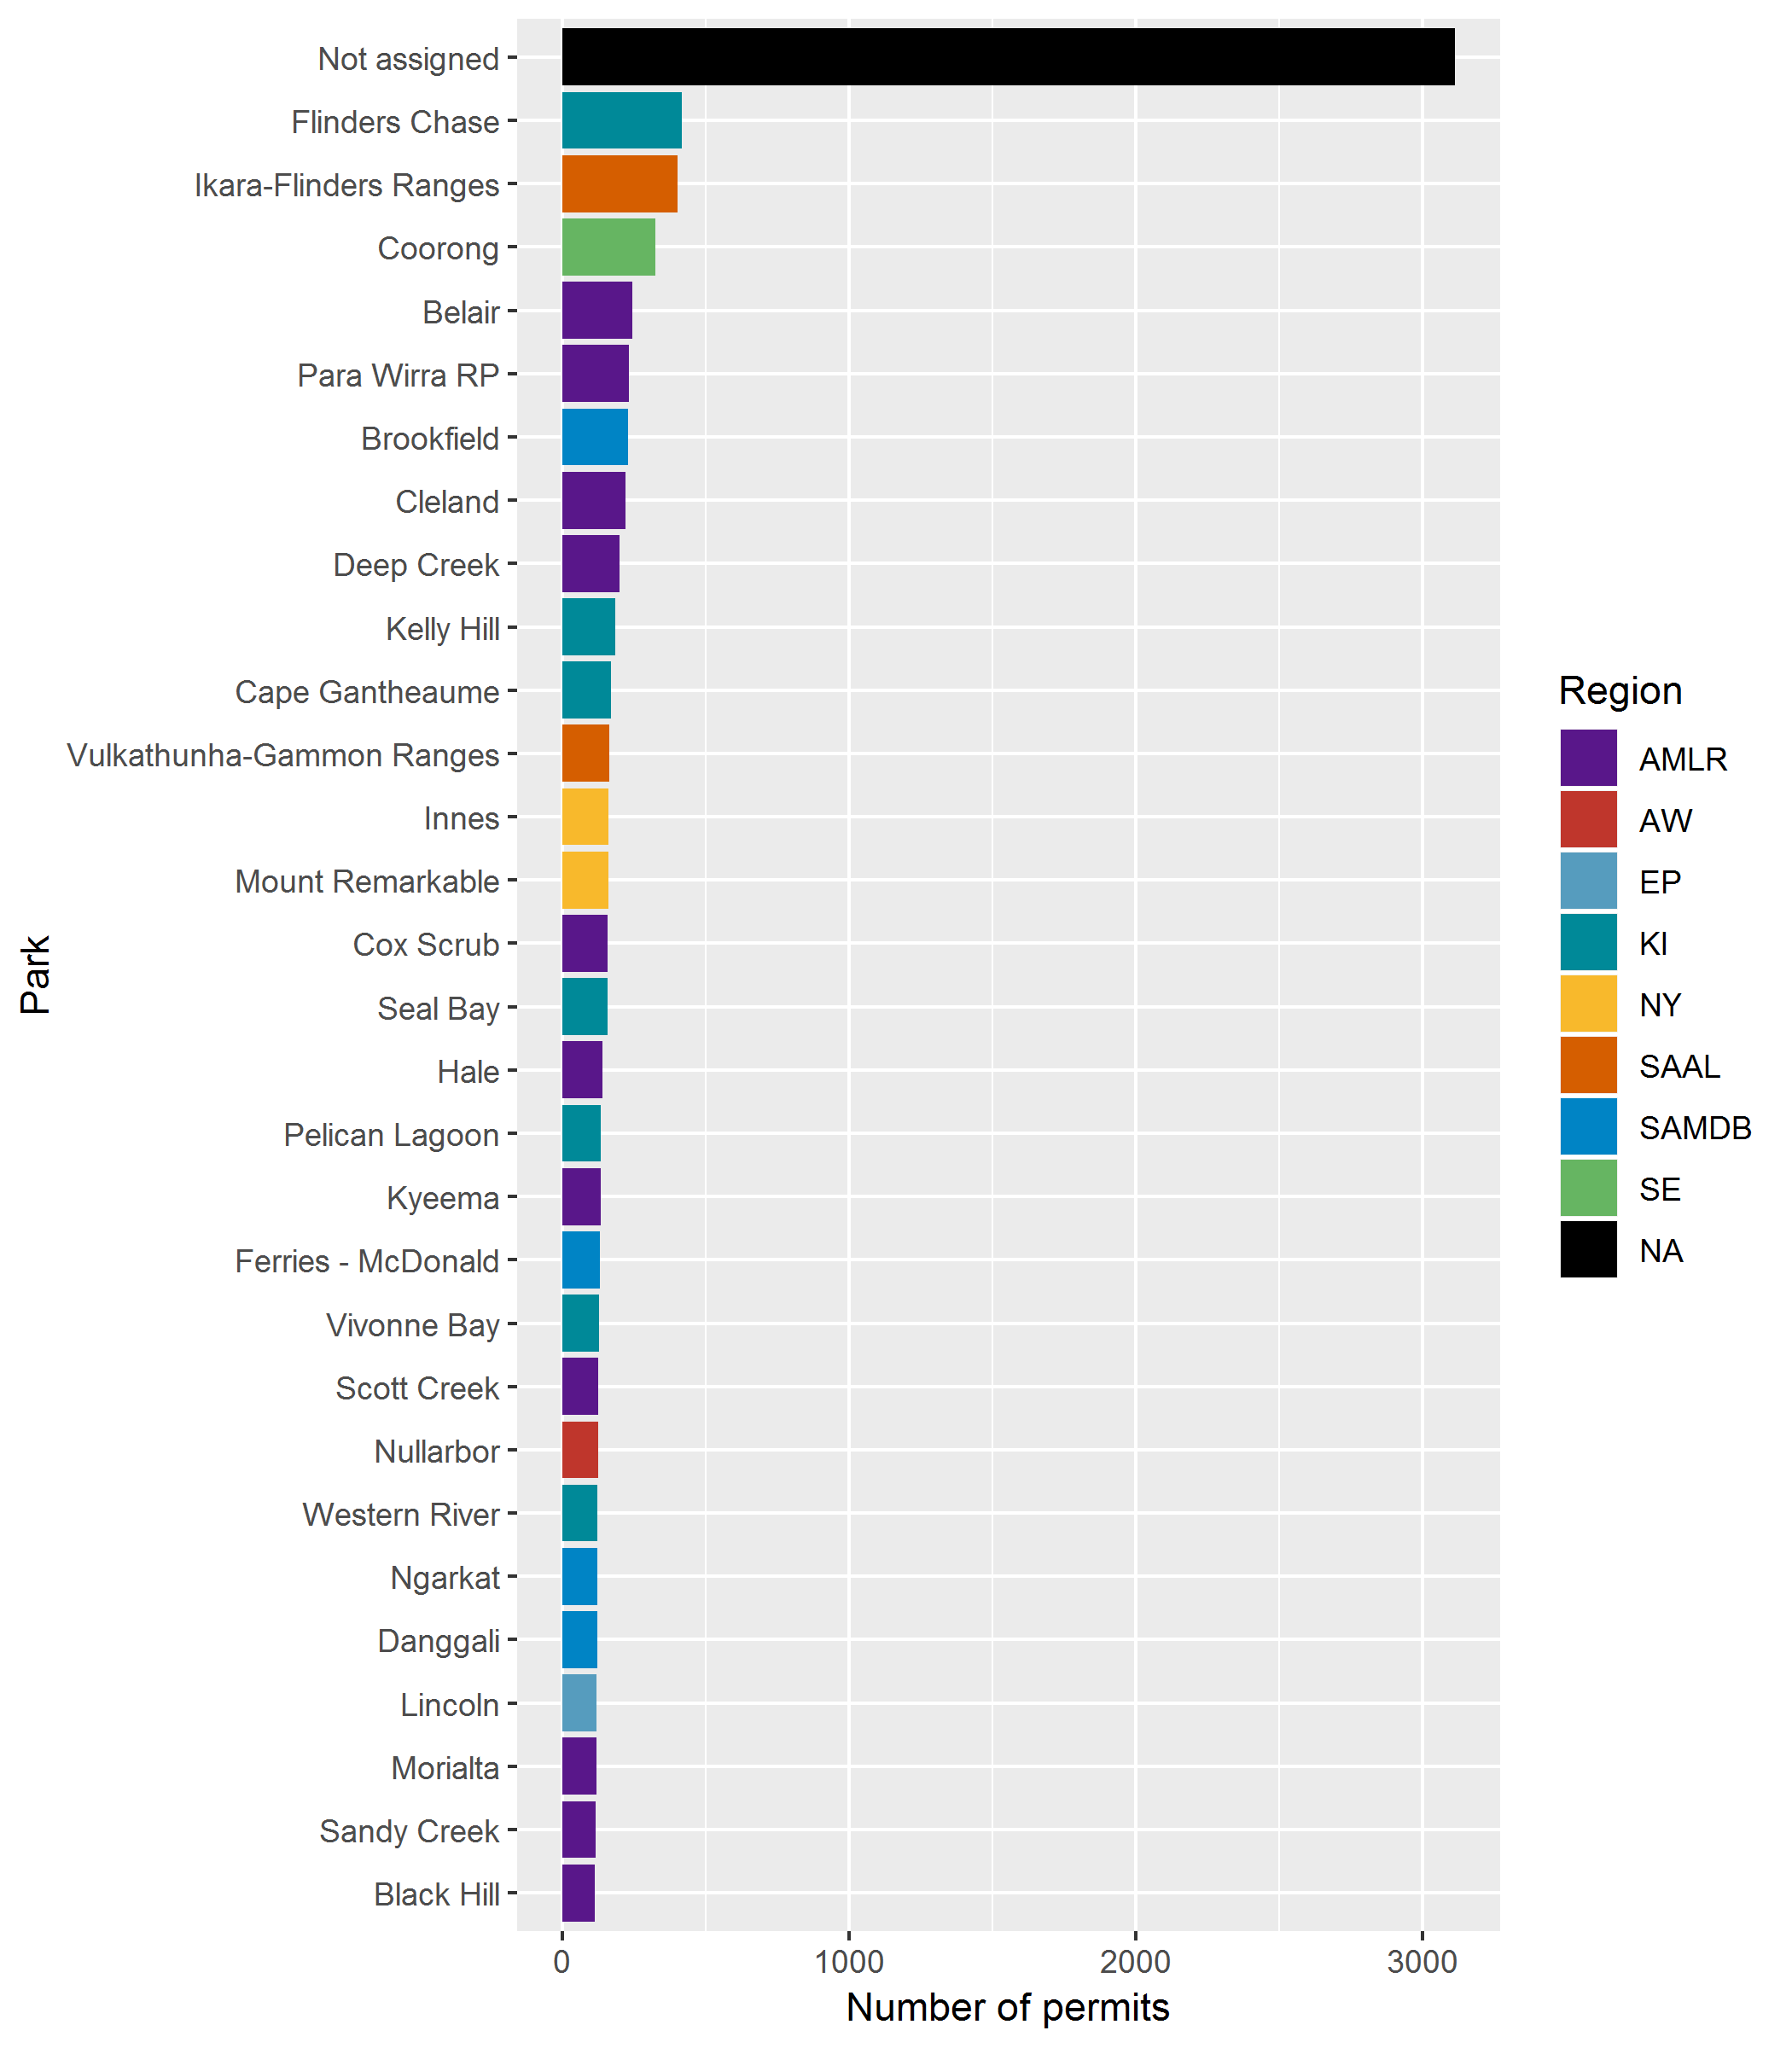

Figure 20 Count of parks

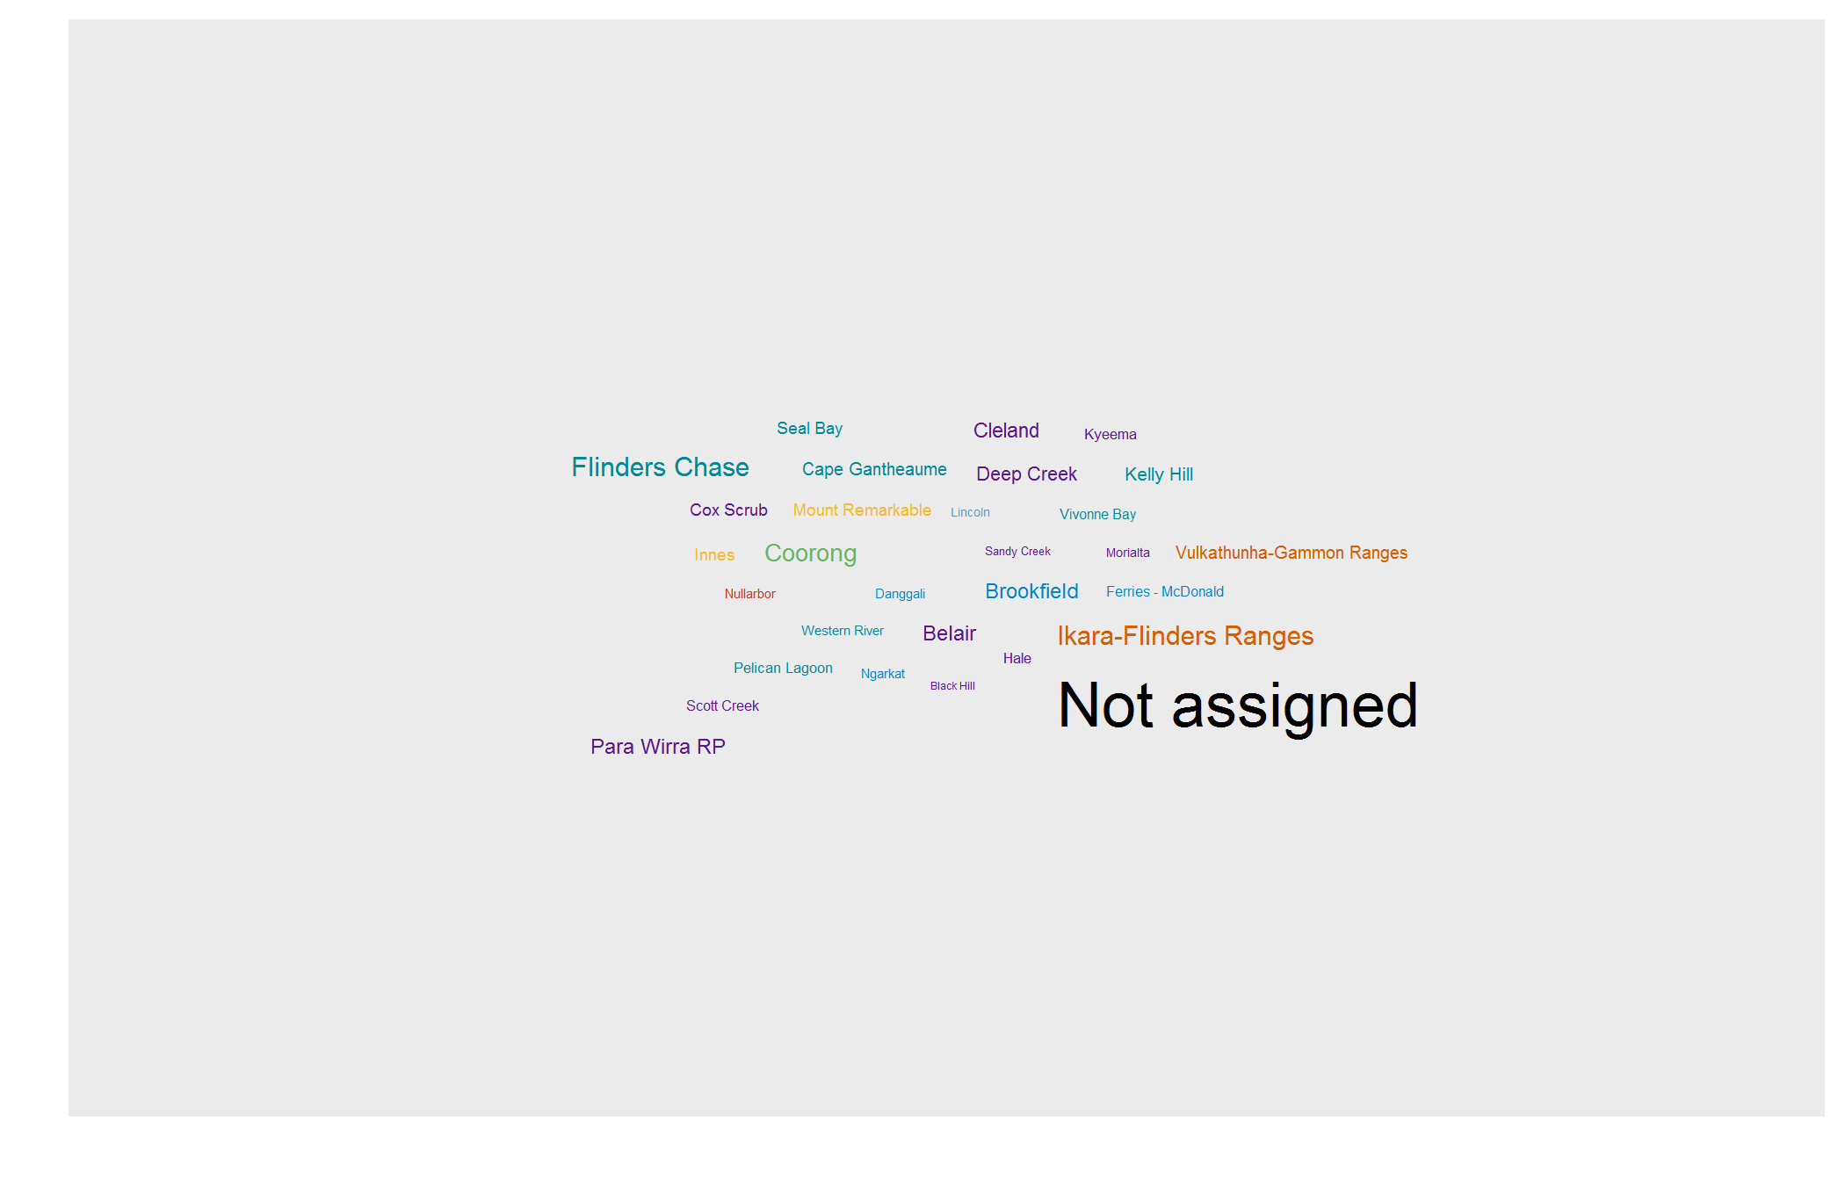

Figure 21 Wordcloud of the most frequently encountered parks

### Research within individal parks

Figure 22 shows the most frequently encountered topics within individual parks (for the most frequently permited park in each region).

Note that post-2000 (a subjectively chosen date threshold) the instances of individual parks drops off, whereas NA (no park assigned) remains similar.

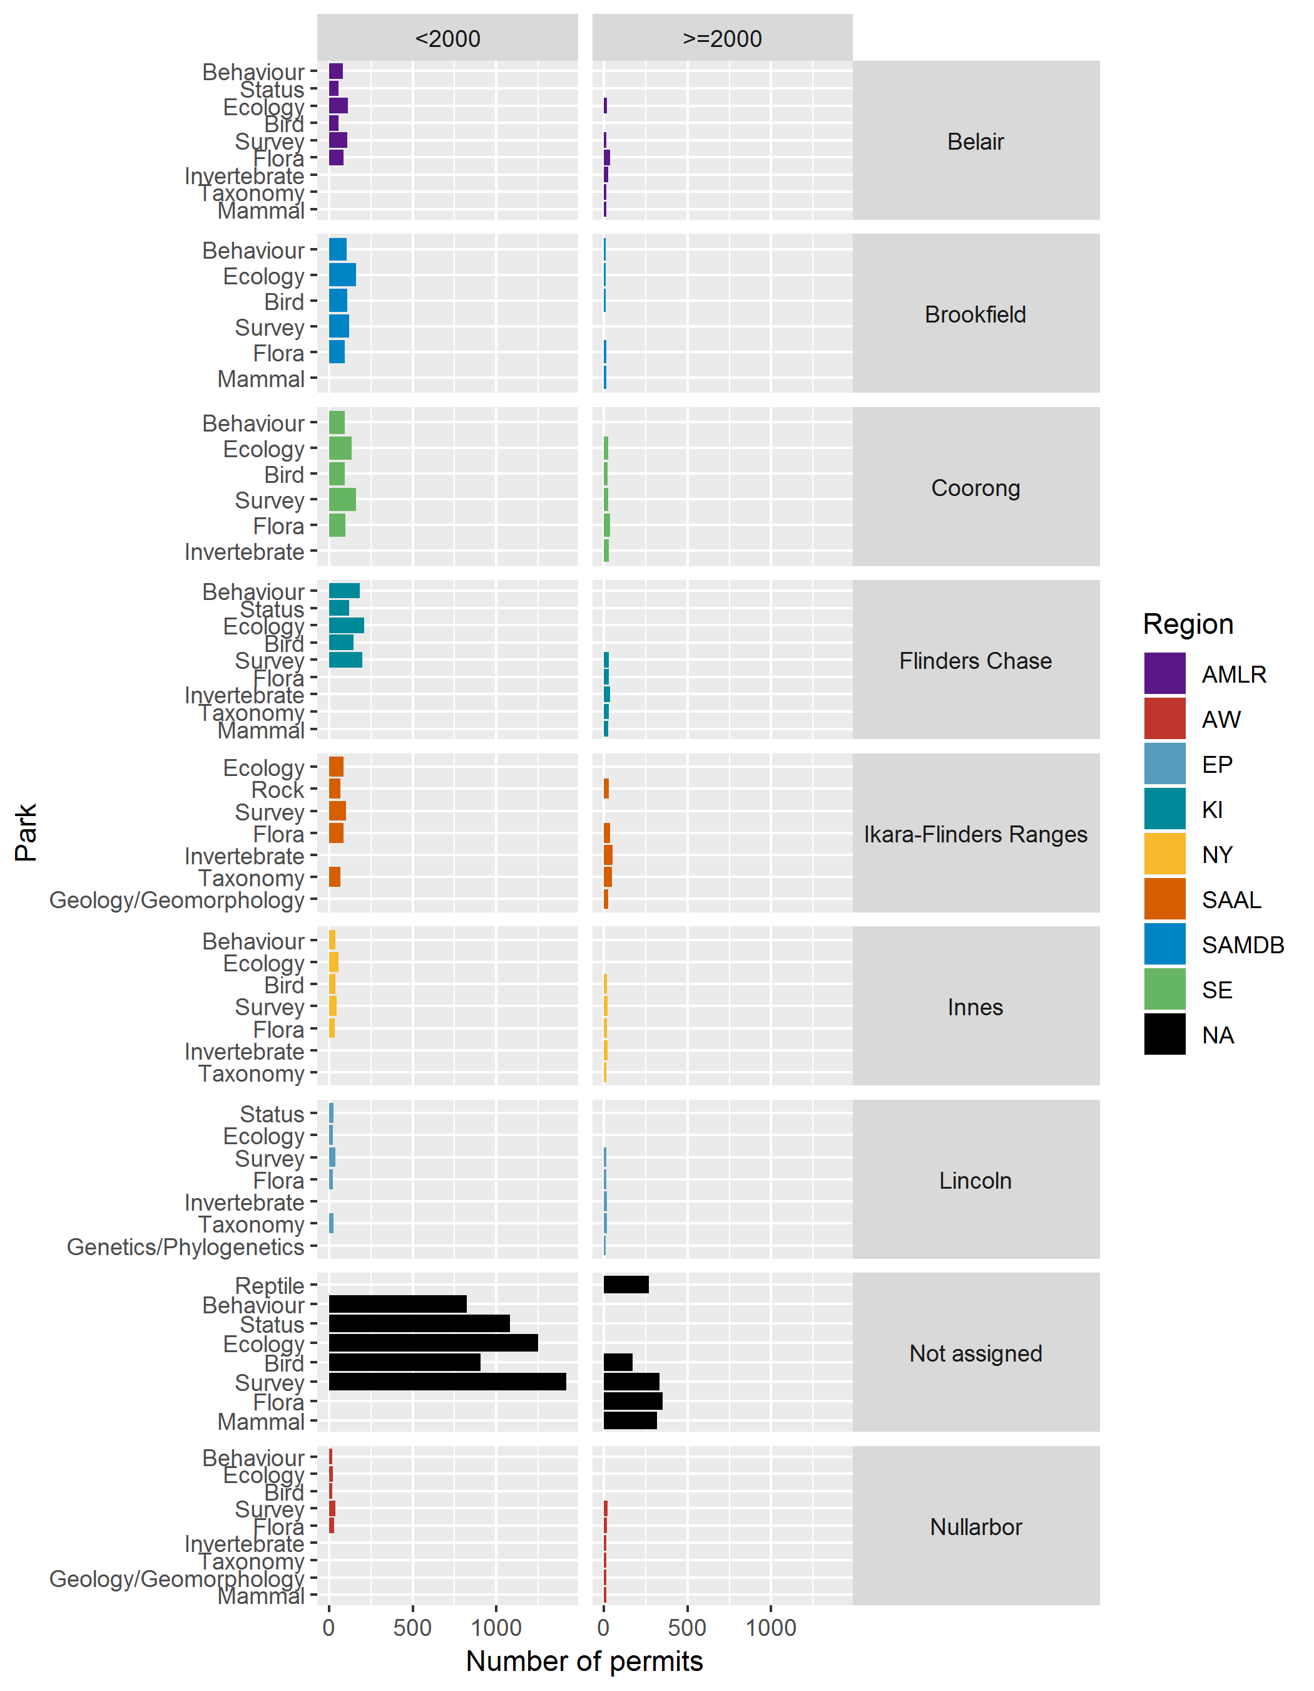

Figure 22 Frequently encountered topics within individual parks for the most frequently permited park in each region

### Map

Figure 23 shows the geographic distribution of permits (by reserves). Figure 24 shows the same data by region.

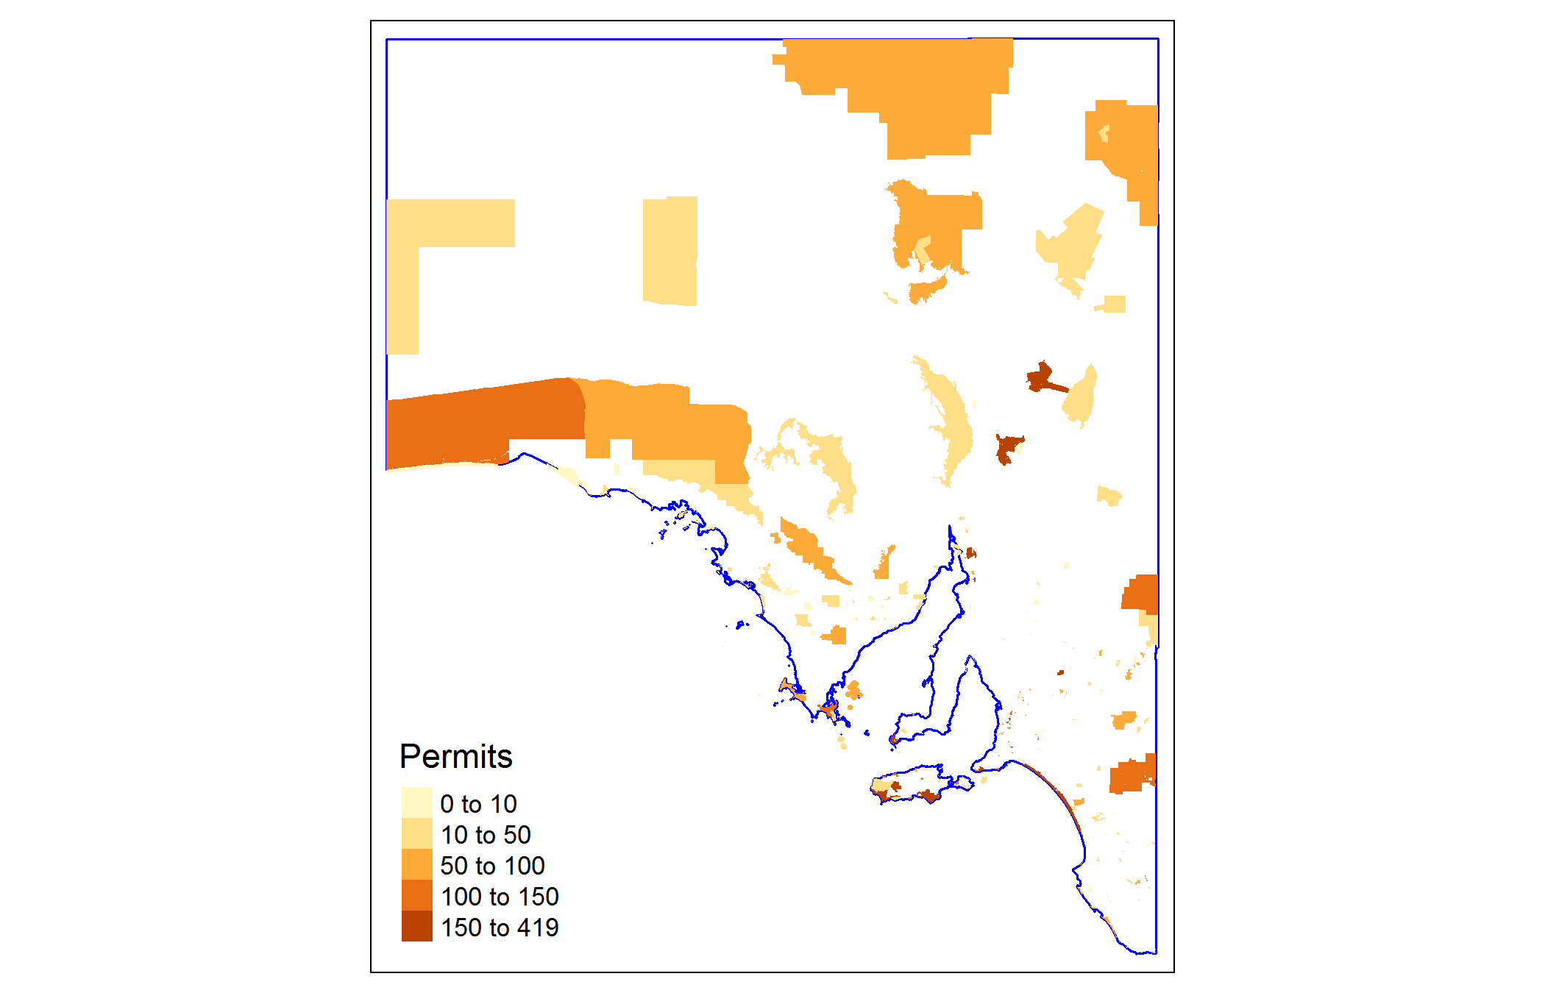

Figure 23 Geographic distribution of permits issued to work on a park

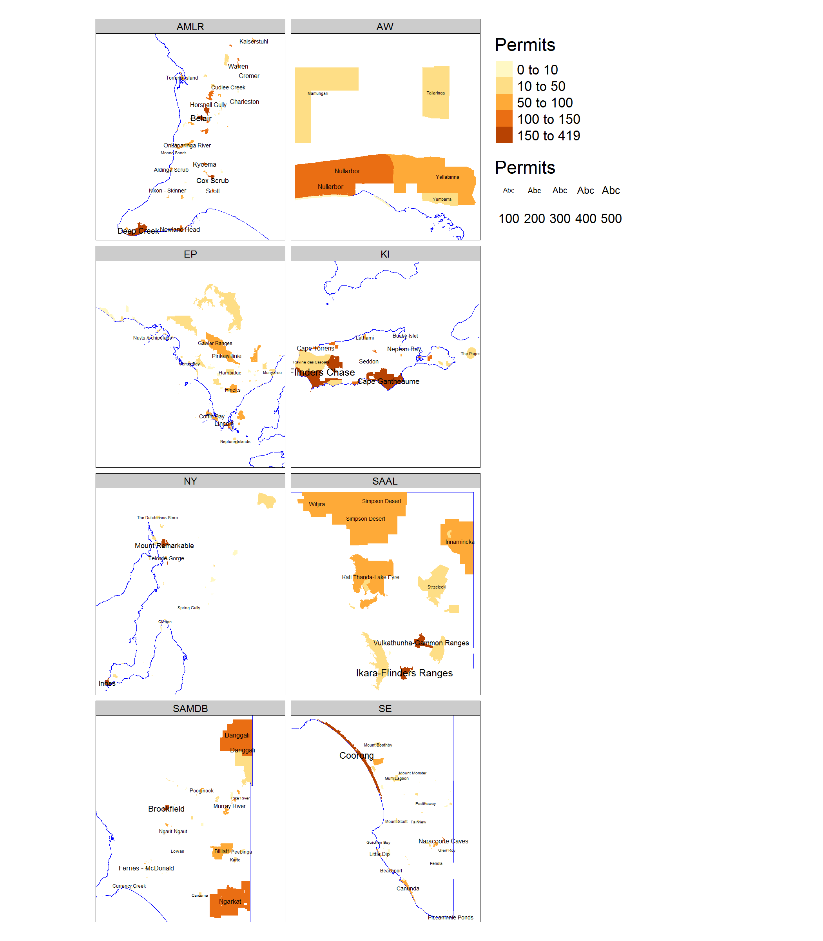

Figure 24 Geographic distribution of permits issued to work on a park

# Appendix

Table 3 shows each park with its first and last year and total number of permits.

Table 3 Parks, their regions, minimum and maximum years with a permit and total number of permits

|  |  |  |  |  |
| --- | --- | --- | --- | --- |
| Park | Region | First | Last | Permits |
| Aberdour | SE | 2003 | 2017 | 21 |
| Acraman Creek | EP | 2001 | 2017 | 16 |
| Aldinga Scrub | AMLR | 1975 | 2017 | 138 |
| Althorpe Islands | NY | 1977 | 2017 | 40 |
| Angove | AMLR | 2015 | 2017 | 3 |
| Anstey Hill | AMLR | 1992 | 2017 | 62 |
| Avoid Bay Islands | EP | 1977 | 2017 | 13 |
| Baird Bay Islands | EP | 1977 | 2017 | 22 |
| Bakara | SAMDB | 1987 | 2017 | 59 |
| Bangham | SE | 1978 | 2017 | 35 |
| Barwell | EP | 1995 | 2016 | 10 |
| Bascombe Well | EP | 1975 | 2017 | 29 |
| Baudin | KI | 2012 | 2017 | 32 |
| Baudin Rocks | SE | 1972 | 2017 | 38 |
| Beachport | SE | 1975 | 2017 | 88 |
| Beatrice Islet | KI | 1977 | 2017 | 88 |
| Belair | AMLR | 1970 | 2017 | 333 |
| Belt Hill | SE | 1973 | 1995 | 17 |
| Bernouilli | SE | 2013 | 2017 | 7 |
| Beyeria | KI | 1986 | 2017 | 167 |
| Big Heath | SE | 1973 | 2016 | 48 |
| Billiatt | SAMDB | 1971 | 2017 | 117 |
| Bimbowrie | NY | 2013 | 2017 | 17 |
| Bird Islands | NY | 1976 | 2017 | 22 |
| Black Hill | AMLR | 1976 | 2017 | 155 |
| Black Rock | NY | 1975 | 2016 | 28 |
| Blackwood Forest | AMLR | 2012 | 2015 | 2 |
| Bool Lagoon | SE | 1978 | 2017 | 86 |
| Boondina | EP | 2014 | 2016 | 2 |
| Brookfield | SAMDB | 1976 | 2017 | 330 |
| Brownhill Creek | AMLR | 1974 | 2017 | 102 |
| Bucks Lake | SE | 1978 | 2015 | 22 |
| Bullock Hill | AMLR | 2015 | 2017 | 5 |
| Bunkers | SAAL | 2016 | 2017 | 4 |
| Busby Islet | KI | 1977 | 2015 | 87 |
| Butcher Gap | SE | 2002 | 2017 | 8 |
| Calectasia | SE | 1978 | 1998 | 15 |
| Calpatanna Waterhole | EP | 1977 | 2016 | 15 |
| Canunda | SE | 1970 | 2017 | 131 |
| Cap Island | EP | 1977 | 2017 | 11 |
| Cape Blanche | EP | 2012 | 2017 | 13 |
| Cape Bouguer | KI | 2012 | 2017 | 30 |
| Cape Gantheaume | KI | 1973 | 2017 | 333 |
| Cape Hart CP | KI | 1973 | 2011 | 180 |
| Cape Torrens | KI | 1973 | 2017 | 223 |
| Cape Willoughby | KI | 2011 | 2017 | 23 |
| Caralue Bluff | EP | 2015 | 2017 | 2 |
| Carappee Hill | EP | 1974 | 2016 | 14 |
| Caratoola | EP | 1985 | 1991 | 3 |
| Carcuma | SAMDB | 1973 | 2017 | 37 |
| Caroona Creek | NY | 2012 | 2017 | 8 |
| Carpenter Rocks | SE | 2014 | 2017 | 6 |
| Carribie | NY | 1987 | 2016 | 14 |
| Chadinga | EP | 2015 | 2017 | 6 |
| Charleston | AMLR | 1976 | 2017 | 135 |
| Chowilla | SAMDB | 2011 | 2017 | 39 |
| Cleland | AMLR | 1970 | 2017 | 337 |
| Clements Gap | NY | 1975 | 2016 | 18 |
| Clinton | NY | 1975 | 2017 | 38 |
| Cobbler Creek | AMLR | 1990 | 2017 | 28 |
| Cocata | EP | 1988 | 2016 | 10 |
| Coffin Bay | EP | 1980 | 2017 | 134 |
| Cooltong | SAMDB | 2012 | 2017 | 18 |
| Coorong | SE | 1972 | 2017 | 541 |
| Corrobinnie Hill | EP | 1981 | 2006 | 5 |
| Cox Scrub | AMLR | 1971 | 2017 | 260 |
| Cromer | AMLR | 1983 | 2017 | 159 |
| Cudlee Creek | AMLR | 1984 | 2017 | 77 |
| Currency Creek | SAMDB | 1983 | 2017 | 59 |
| Custon | SE | 2014 | 2014 | 1 |
| Cygnet Estuary | KI | 2015 | 2017 | 16 |
| Danggali | SAMDB | 1976 | 2017 | 193 |
| Darke Range | EP | 1981 | 2017 | 7 |
| Deep Creek | AMLR | 1973 | 2017 | 271 |
| Desert Camp | SE | 1973 | 2017 | 25 |
| Dingley Dell | SE | 1978 | 2017 | 19 |
| Douglas Point | SE | 2015 | 2017 | 7 |
| Dudley | KI | 1973 | 2017 | 223 |
| Eastern Spencer Gulf | NY | 2012 | 2016 | 7 |
| Eba Island | EP | 1977 | 2017 | 8 |
| Ediacara | SAAL | 2013 | 2017 | 7 |
| Elliot Price | SAAL | 1972 | 2017 | 37 |
| Encounter | AMLR | 2012 | 2017 | 14 |
| Eric Bonython | AMLR | 1970 | 2017 | 83 |
| Eurilla | AMLR | 1983 | 2015 | 80 |
| Ewens Ponds | SE | 1977 | 2017 | 51 |
| Fairview | SE | 1972 | 2016 | 37 |
| Far West Coast | AW | 2014 | 2017 | 7 |
| Ferguson | AMLR | 1977 | 2017 | 64 |
| Ferries - McDonald | SAMDB | 1970 | 2017 | 179 |
| Finniss | AMLR | 1984 | 2017 | 98 |
| Flinders Chase | KI | 1973 | 2017 | 671 |
| Fort Glanville | AMLR | 1978 | 2016 | 7 |
| Fowlers Bay | EP | 2013 | 2017 | 19 |
| Franklin Harbor | EP | 1975 | 2017 | 35 |
| Furner | SE | 1977 | 2016 | 35 |
| Gambier Islands | EP | 1977 | 2017 | 13 |
| Gambier Islands Group | EP | 2014 | 2017 | 4 |
| Gawler Ranges | EP | 2002 | 2017 | 97 |
| Geegeela | SE | 2014 | 2017 | 5 |
| Giles | AMLR | 2012 | 2017 | 8 |
| Glen Roy | SE | 1973 | 2017 | 34 |
| Goose Island | NY | 1972 | 2017 | 21 |
| Gower | SE | 1977 | 2015 | 34 |
| Granite Island | AMLR | 2012 | 2017 | 12 |
| Grass Tree | SE | 1973 | 1995 | 18 |
| Great Australian Bight Marine | AW | 2013 | 2017 | 4 |
| Greenhill | AMLR | 1973 | 2016 | 74 |
| Greenly Island | EP | 1977 | 2017 | 25 |
| Guichen Bay | SE | 1977 | 2017 | 54 |
| Gum Lagoon | SE | 1989 | 2017 | 85 |
| Gum Tree Gully | AMLR | 2016 | 2017 | 5 |
| Hacks Lagoon | SE | 1978 | 2017 | 37 |
| Hale | AMLR | 1972 | 2017 | 211 |
| Hallett Cove | AMLR | 1973 | 2016 | 111 |
| Hambidge | EP | 1972 | 2017 | 70 |
| Heggaton | EP | 2015 | 2017 | 4 |
| Hesperilla | AMLR | 2015 | 2017 | 4 |
| Hincks | EP | 1970 | 2017 | 107 |
| Hogwash Bend | SAMDB | 2014 | 2017 | 4 |
| Hopkins Creek | NY | 2012 | 2017 | 5 |
| Horsnell Gully | AMLR | 1972 | 2017 | 139 |
| Ikara-Flinders Ranges | SAAL | 1972 | 2017 | 577 |
| Innamincka | SAAL | 1989 | 2017 | 171 |
| Innes | NY | 1972 | 2017 | 288 |
| Investigator | EP | 2013 | 2015 | 6 |
| Investigator Group | EP | 1977 | 2017 | 19 |
| Ironstone Hill | EP | 2012 | 2017 | 18 |
| Jip Jip | SE | 1973 | 1995 | 27 |
| Kaiserstuhl | AMLR | 1981 | 2017 | 140 |
| Kanku-Breakaways | SAAL | 2013 | 2017 | 2 |
| Kapunda Island | SAMDB | 1975 | 1996 | 23 |
| Karte | SAMDB | 1972 | 2017 | 58 |
| Kathai | EP | 1981 | 2013 | 4 |
| Kati Thanda-Lake Eyre | SAAL | 1986 | 2017 | 117 |
| Kellidie Bay | EP | 1974 | 2017 | 60 |
| Kelly Hill | KI | 1973 | 2017 | 317 |
| Kelvin Powrie | SE | 1974 | 2013 | 24 |
| Kenneth Stirling | AMLR | 1997 | 2017 | 22 |
| Kinchina | SAMDB | 2017 | 2017 | 1 |
| Kulliparu | EP | 1990 | 2017 | 12 |
| Kyeema | AMLR | 1970 | 2017 | 167 |
| Lake Frome | SAAL | 1992 | 2017 | 31 |
| Lake Frome | SE | 2015 | 2015 | 2 |
| Lake Gairdner | EP | 1991 | 2017 | 35 |
| Lake Gilles | EP | 1974 | 2017 | 143 |
| Lake Hawdon South | SE | 2013 | 2017 | 6 |
| Lake Newland | EP | 1997 | 2017 | 26 |
| Lake Robe | SE | 2013 | 2013 | 1 |
| Lake St Clair | SE | 2014 | 2017 | 4 |
| Lake Torrens | SAAL | 1991 | 2017 | 46 |
| Lashmar | KI | 2013 | 2017 | 32 |
| Lathami | KI | 1987 | 2017 | 167 |
| Laura Bay | EP | 1975 | 2017 | 12 |
| Lawari | SAMDB | 2017 | 2017 | 1 |
| Lenswood RP | AMLR | 1984 | 1992 | 63 |
| Lesueur | KI | 2011 | 2017 | 43 |
| Leven Beach | NY | 1989 | 2017 | 40 |
| Lincoln | EP | 1974 | 2017 | 184 |
| Lipson Island | EP | 1977 | 2017 | 17 |
| Little Dip | SE | 1976 | 2017 | 124 |
| Loch Luna | SAMDB | 1987 | 2017 | 44 |
| Long Island | SAMDB | 1983 | 1996 | 3 |
| Lowan | SAMDB | 1975 | 2017 | 45 |
| Lower Glenelg River | SE | 2013 | 2015 | 3 |
| Lower South East | SE | 2012 | 2017 | 8 |
| Lower Yorke Peninsula | NY | 2012 | 2016 | 8 |
| Maize Island Lagoon | SAMDB | 1982 | 2017 | 43 |
| Malkumba-Coongie Lakes | SAAL | 2012 | 2017 | 20 |
| Mamungari | AW | 1984 | 2016 | 48 |
| Mantung | SAMDB | 2015 | 2017 | 2 |
| Marino | AMLR | 1989 | 2016 | 30 |
| Mark Oliphant | AMLR | 1978 | 2017 | 144 |
| Marne Valley | SAMDB | 1981 | 2017 | 71 |
| Martin Washpool | SE | 1976 | 2017 | 37 |
| Martindale Hall | NY | 2009 | 2012 | 4 |
| Mary Seymour | SE | 1978 | 2016 | 26 |
| Media Island | SAMDB | 1975 | 1996 | 23 |
| Memory Cove | EP | 2012 | 2017 | 26 |
| Messent | SE | 1973 | 2017 | 90 |
| Middlecamp Hills | EP | 1981 | 2017 | 10 |
| Minlacowie | NY | 2015 | 2015 | 1 |
| Moana Sands | AMLR | 1978 | 2017 | 41 |
| Mokota | NY | 2011 | 2017 | 5 |
| Monarto | SAMDB | 1984 | 2017 | 144 |
| Monarto Woodlands | SAMDB | 2017 | 2017 | 1 |
| Montacute | AMLR | 1983 | 2017 | 92 |
| Moorook | SAMDB | 1982 | 2017 | 46 |
| Morgan | SAMDB | 1982 | 2017 | 49 |
| Morialta | AMLR | 1975 | 2017 | 169 |
| Mount Billy | AMLR | 2011 | 2017 | 8 |
| Mount Boothby | SE | 1972 | 2017 | 65 |
| Mount Brown | NY | 2012 | 2017 | 17 |
| Mount Dutton Bay | EP | 1977 | 2017 | 15 |
| Mount George | AMLR | 2012 | 2017 | 8 |
| Mount Magnificent | AMLR | 1970 | 2017 | 106 |
| Mount Monster | SE | 1976 | 2017 | 50 |
| Mount Remarkable | NY | 1972 | 2017 | 244 |
| Mount Rescue CP | SE | 1971 | 2010 | 76 |
| Mount Scott | SE | 1977 | 2017 | 49 |
| Mount Shaugh CP | SE | 1973 | 2004 | 18 |
| Mount Taylor | KI | 1973 | 2017 | 174 |
| Mowantjie Willauwar | SAMDB | 2013 | 2017 | 4 |
| Mud Islands | SAMDB | 1983 | 2013 | 6 |
| Mullinger Swamp | SE | 1978 | 2017 | 17 |
| Munyaroo | EP | 1981 | 2017 | 55 |
| Murray River | SAMDB | 1972 | 2017 | 121 |
| Murrunatta | EP | 1981 | 2015 | 19 |
| Mylor | AMLR | 2012 | 2017 | 6 |
| Myponga | AMLR | 1973 | 2017 | 105 |
| Naracoorte Caves | SE | 1973 | 2017 | 167 |
| Nene Valley | SE | 1975 | 2017 | 50 |
| Nepean Bay | KI | 1977 | 2017 | 203 |
| Neptune Islands | EP | 1977 | 2017 | 60 |
| Neptune Islands Group (Ron and Valerie Taylor) | EP | 2013 | 2017 | 14 |
| Newland Head | AMLR | 1978 | 2017 | 209 |
| Ngarkat | SAMDB | 1977 | 2017 | 224 |
| Ngaut Ngaut | SAMDB | 1982 | 2017 | 72 |
| Nicolas Baudin Island | EP | 2014 | 2017 | 7 |
| Nixon - Skinner | AMLR | 1973 | 2016 | 88 |
| Not assigned | NA | 1971 | 2017 | 5184 |
| Nullarbor | AW | 1982 | 2017 | 183 |
| Nuyts Archipelago | EP | 1977 | 2017 | 65 |
| Nuyts Reef | EP | 1977 | 2017 | 10 |
| O’Halloran Hill | AMLR | 1990 | 2015 | 12 |
| Olive Island | EP | 1977 | 2017 | 27 |
| Onkaparinga River | AMLR | 1987 | 2017 | 136 |
| Padthaway | SE | 1973 | 2017 | 36 |
| Pandappa | NY | 1982 | 2017 | 31 |
| Para Wirra | AMLR | 2016 | 2017 | 18 |
| Para Wirra RP | AMLR | 1972 | 2016 | 326 |
| Parndana | KI | 1973 | 2017 | 227 |
| Peachna | EP | 2015 | 2017 | 2 |
| Peebinga | SAMDB | 1971 | 2017 | 68 |
| Pelican Lagoon | KI | 1983 | 2017 | 254 |
| Penambol | SE | 2015 | 2017 | 4 |
| Penguin Island | SE | 1970 | 2017 | 28 |
| Penola | SE | 1973 | 2017 | 64 |
| Piccaninnie Ponds | SE | 1970 | 2017 | 123 |
| Pigface Island | EP | 1977 | 2017 | 10 |
| Pike River | SAMDB | 1982 | 2017 | 40 |
| Pine Hill Soak | SE | 2006 | 2017 | 6 |
| Pinkawillinie | EP | 1975 | 2017 | 116 |
| Point Bell | EP | 2013 | 2017 | 7 |
| Point Davenport | NY | 1990 | 2017 | 15 |
| Point Labatt | EP | 1977 | 2017 | 21 |
| Poocher Swamp | SE | 2002 | 2007 | 4 |
| Pooginook | SAMDB | 1971 | 2017 | 99 |
| Poonthie Ruwe | SAMDB | 2013 | 2017 | 5 |
| Port Gawler CP | AMLR | 1977 | 2017 | 94 |
| Porter Scrub | AMLR | 2011 | 2017 | 4 |
| Pualco Range | NY | 2013 | 2017 | 5 |
| Pullen Island | AMLR | 1977 | 2017 | 22 |
| Pureba | EP | 1988 | 2016 | 17 |
| Ramco Point | SAMDB | 2016 | 2017 | 2 |
| Ramsay | NY | 2015 | 2015 | 1 |
| Ravine des Casoars | KI | 2011 | 2017 | 64 |
| Red Banks | NY | 2012 | 2017 | 10 |
| Reedy Creek | SE | 1977 | 1995 | 16 |
| Ridley | SAMDB | 1975 | 2017 | 78 |
| Rilli Island | SAMDB | 1975 | 1996 | 23 |
| Rocky Island (North) | EP | 1977 | 2017 | 13 |
| Rocky Island (South) | EP | 1977 | 2017 | 12 |
| Roonka | SAMDB | 1978 | 2017 | 45 |
| Rudall | EP | 1977 | 2017 | 12 |
| Salt Lagoon Islands | SAMDB | 1979 | 2015 | 12 |
| Sandy Creek | AMLR | 1972 | 2017 | 166 |
| Sceale Bay | EP | 2012 | 2017 | 18 |
| Scorpion Springs CP | SAMDB | 1973 | 2004 | 49 |
| Scott | AMLR | 1973 | 2017 | 158 |
| Scott Creek | AMLR | 1987 | 2017 | 222 |
| Seal Bay | KI | 1974 | 2017 | 306 |
| Searcy Bay | EP | 2012 | 2017 | 13 |
| Seddon | KI | 1973 | 2017 | 173 |
| Sheoak Hill | EP | 1981 | 2017 | 20 |
| Shepherds Hill | AMLR | 1976 | 2017 | 85 |
| Simpson | KI | 2012 | 2017 | 26 |
| Simpson Desert | SAAL | 1972 | 2017 | 100 |
| Sinclair Island | EP | 1977 | 2017 | 7 |
| Sir Joseph Banks Group | EP | 1973 | 2017 | 115 |
| Sleaford Mere | EP | 1981 | 2017 | 23 |
| Southern Kangaroo Island | KI | 2014 | 2017 | 7 |
| Southern Spencer Gulf | NY | 2012 | 2016 | 8 |
| Spring Gully | NY | 1973 | 2017 | 60 |
| Spring Mount | AMLR | 1973 | 2017 | 99 |
| Stipiturus | AMLR | 2015 | 2017 | 10 |
| Strzelecki | SAAL | 1992 | 2017 | 76 |
| Sturt Gorge | AMLR | 1984 | 2017 | 94 |
| Swan Reach | SAMDB | 1975 | 2017 | 108 |
| Talapar | SE | 1978 | 1995 | 15 |
| Talisker | AMLR | 1987 | 2017 | 68 |
| Tallaringa | AW | 1992 | 2017 | 46 |
| Tantanoola Caves | SE | 1978 | 2017 | 32 |
| Telford Scrub | SE | 1988 | 2017 | 25 |
| Telowie Gorge | NY | 1975 | 2017 | 127 |
| The Dutchmans Stern | NY | 1987 | 2017 | 69 |
| The Elbow RP | AMLR | 1984 | 1992 | 61 |
| The Knoll | AMLR | 1984 | 2015 | 56 |
| The Pages | KI | 1977 | 2017 | 69 |
| The Plug Range | EP | 2015 | 2017 | 3 |
| Thorny Passage | EP | 2013 | 2017 | 15 |
| Tilley Swamp | SE | 2012 | 2016 | 7 |
| Tolderol | SAMDB | 1978 | 2017 | 30 |
| Torrens Island | AMLR | 1977 | 2017 | 74 |
| Totness | AMLR | 1976 | 2017 | 98 |
| Troubridge Island | NY | 1978 | 2017 | 45 |
| Tucknott Scrub | EP | 2013 | 2013 | 1 |
| Tumby Island | EP | 1977 | 2017 | 17 |
| Upper Gulf St Vincent | NY | 2012 | 2016 | 6 |
| Upper South East | SE | 2012 | 2017 | 9 |
| Upper Spencer Gulf | NY | 2013 | 2016 | 5 |
| Venus Bay | EP | 1977 | 2017 | 67 |
| Verran Tanks | EP | 1981 | 2016 | 11 |
| Vivonne Bay | KI | 1977 | 2017 | 266 |
| Vulkathunha-Gammon Ranges | SAAL | 1974 | 2017 | 265 |
| Wabma Kadarbu Mound Springs | SAAL | 2011 | 2017 | 35 |
| Wahgunyah | EP | 2013 | 2017 | 10 |
| Waitpinga | AMLR | 1973 | 2017 | 100 |
| Waldegrave Islands | EP | 1975 | 2017 | 15 |
| Wanilla | EP | 1981 | 2017 | 20 |
| Wanilla Land Settlement | EP | 2013 | 2013 | 1 |
| Warren | AMLR | 1970 | 2017 | 161 |
| Warrenben | NY | 1976 | 2017 | 44 |
| West Coast Bays | EP | 2013 | 2017 | 9 |
| West Island | AMLR | 1977 | 2017 | 62 |
| Western Kangaroo Island | KI | 2014 | 2017 | 7 |
| Western River | KI | 1973 | 2017 | 242 |
| Wharminda | EP | 1981 | 2011 | 7 |
| Whidbey Isles | EP | 1977 | 2017 | 16 |
| White Dam | SAMDB | 1976 | 2017 | 33 |
| Whyalla | EP | 1983 | 2017 | 46 |
| Wills Creek | NY | 2012 | 2017 | 15 |
| Windy Point RP | AMLR | 1984 | 2008 | 44 |
| Winninowie | NY | 1992 | 2017 | 50 |
| Witjira | SAAL | 1986 | 2017 | 126 |
| Wittelbee | EP | 1977 | 2017 | 15 |
| Woakwine | SE | 2015 | 2017 | 5 |
| Wolseley Common | SE | 2014 | 2014 | 1 |
| Yalpara | NY | 1987 | 2016 | 6 |
| Yeldulknie | EP | 1992 | 2017 | 10 |
| Yellabinna | AW | 1988 | 2017 | 88 |
| Yulte | AMLR | 1984 | 2017 | 87 |
| Yumbarra | AW | 1977 | 2017 | 53 |

# References

Bouchet-Valat, M. (2014). ‘SnowballC: Snowball stemmers based on the c libstemmer utf-8 library’. Available at: <https://CRAN.R-project.org/package=SnowballC>

Henry, L., and Wickham, H. (2017). ‘Purrr: Functional programming tools’. Available at: <https://CRAN.R-project.org/package=purrr>

Müller, K., and Wickham, H. (2018). ‘Tibble: Simple data frames’. Available at: <https://CRAN.R-project.org/package=tibble>

Oksanen, J., Blanchet, F. G., Friendly, M., Kindt, R., Legendre, P., McGlinn, D., Minchin, P. R., O’Hara, R. B., Simpson, G. L., Solymos, P., Stevens, M. H. H., Szoecs, E., and Wagner, H. (2018). ‘Vegan: Community ecology package’. Available at: <https://CRAN.R-project.org/package=vegan>

Pebesma, E. (2018). ‘Sf: Simple features for r’. Available at: <https://CRAN.R-project.org/package=sf>

R Core Team (2017). ‘R: A language and environment for statistical computing’. (R Foundation for Statistical Computing: Vienna, Austria.) Available at: <https://www.R-project.org/>

Roberts, D. W. (2016). ‘Labdsv: Ordination and multivariate analysis for ecology’. Available at: <https://CRAN.R-project.org/package=labdsv>

Robinson, D., and Silge, J. (2018). ‘Tidytext: Text mining using ’dplyr’, ’ggplot2’, and other tidy tools’. Available at: <https://CRAN.R-project.org/package=tidytext>

Slowikowski, K. (2018). ‘Ggrepel: Automatically position non-overlapping text labels with ’ggplot2’’. Available at: <https://CRAN.R-project.org/package=ggrepel>

Spinu, V., Grolemund, G., and Wickham, H. (2018). ‘Lubridate: Make dealing with dates a little easier’. Available at: <https://CRAN.R-project.org/package=lubridate>

Tennekes, M. (2018a). ‘Tmap: Thematic maps’. Available at: <https://CRAN.R-project.org/package=tmap>

Tennekes, M. (2018b). ‘Tmaptools: Thematic map tools’. Available at: <https://CRAN.R-project.org/package=tmaptools>

Wickham, H. (2018a). ‘Forcats: Tools for working with categorical variables (factors)’. Available at: <https://CRAN.R-project.org/package=forcats>

Wickham, H. (2018b). ‘Stringr: Simple, consistent wrappers for common string operations’. Available at: <https://CRAN.R-project.org/package=stringr>

Wickham, H., and Henry, L. (2018). ‘Tidyr: Easily tidy data with ’spread()’ and ’gather()’ functions’. Available at: <https://CRAN.R-project.org/package=tidyr>

Wickham, H., Chang, W., Henry, L., Pedersen, T. L., Takahashi, K., Wilke, C., and Woo, K. (2018). ‘Ggplot2: Create elegant data visualisations using the grammar of graphics’. Available at: <https://CRAN.R-project.org/package=ggplot2>

Wickham, H., François, R., Henry, L., and Müller, K. (2018). ‘Dplyr: A grammar of data manipulation’. Available at: <https://CRAN.R-project.org/package=dplyr>

Wickham, H., Hester, J., and Francois, R. (2017). ‘Readr: Read rectangular text data’. Available at: <https://CRAN.R-project.org/package=readr>

Wood, S. (2017). ‘Mgcv: Mixed gam computation vehicle with automatic smoothness estimation’. Available at: <https://CRAN.R-project.org/package=mgcv>

Xie, Y. (2018a). ‘Bookdown: Authoring books and technical documents with r markdown’. Available at: <https://CRAN.R-project.org/package=bookdown>

Xie, Y. (2018b). ‘Knitr: A general-purpose package for dynamic report generation in r’. Available at: <https://CRAN.R-project.org/package=knitr>