// 1

create database student;
use student;

// 2
create table StudentBasicInformation(RollNumber varchar(7) primary key, FirstName varchar(30), Surname varchar(30),Gender varchar(6),Address varchar(100), Email varchar(30), ContactNo numeric(10,0));
create table StudentPaymentDetails(RollNumber varchar(7) primary key,AmountPaid numeric(12,2),BalanceAmount numeric(12,2), REFNO varchar(8),DiscountAmount numeric(10,2), DueDate date);
create table StudentSubjectInformation(SubjectOpted varchar(35), RollNumber varchar(7), SubjectTotalMarks INT, StudentObtainedMarks INT, StudentMarksPercentage float, Result varchar(10), primary key(RollNumber,SubjectOpted));
create table SubjectScholarshipInformation(ApplicationID varchar(10) primary key,RollNumber varchar(7), ScholarshipName varchar(30), ScholarshipDescription varchar(100), ScholarshipAmount numeric(10,2),ScholarshipCategory varchar(30), status varchar(25));

// 3

//--------------- StudentBasicInformation ---------------//
insert into StudentBasicInformation values("2019001","Sujindar", "Selvaraj","MALE","Coimbatore", "sujindar@gmail.com", 1234567890);
insert into StudentBasicInformation values("2019002","Sujindar1", "Selvaraj1","MALE", "Chennai", "sujindar1@gmail.com", 1236784211);
insert into StudentBasicInformation values("2019003","Sujindar2", "Selvaraj2","MALE", "Pondicherry", "sujindar2@gmail.com", 5546784211);
insert into StudentBasicInformation values("2019004","Sujindar3", "Selvaraj3","MALE", "Trichy", "sujindar3@gmail.com", 6912784211);
insert into StudentBasicInformation values("2019005","Sujindar4", "Selvaraj4","MALE", "Madurai", "sujindar4@gmail.com", 8811584211);
insert into StudentBasicInformation values("2019006","Sujindar5", "Selvaraj5","MALE", "Kanyakumari", "sujindar5@gmail.com", 7819361811);
insert into StudentBasicInformation values("2019007","Sujindar6", "Selvaraj6","MALE","Tirupur", "sujindar6@gmail.com", 4310944672);
insert into StudentBasicInformation values("2019008","Sujindar7", "Selvaraj7","MALE", "Bengaluru", "sujindar7@gmail.com", 8912043782);
insert into StudentBasicInformation values("2019009","Sujindar8", "Selvaraj8","MALE", "Mysore", "sujindar8@gmail.com", 7699210001);
insert into StudentBasicInformation values("2019010","Sujindar9", "Selvaraj9","MALE", "Pune", "sujindar9@gmail.com", 8763429015);

//--------------- StudentPaymentDetails---------------//
insert into StudentPaymentDetails values("2019001",50000,50000,"RT6789",0,STR_TO_DATE('20-01-2020', '%d-%m-%Y'));
insert into StudentPaymentDetails values("2019002",75000,25000,"RT9240",0,STR_TO_DATE('15-01-2020', '%d-%m-%Y'));
insert into StudentPaymentDetails values("2019003",80000,20000,"RT5543",0,STR_TO_DATE('11-01-2020', '%d-%m-%Y'));
insert into StudentPaymentDetails values("2019004",80000,20000,"RT7296",0,STR_TO_DATE('11-01-2020', '%d-%m-%Y'));
insert into StudentPaymentDetails values("2019005",50000,50000,"RT7255",0,STR_TO_DATE('11-01-2020', '%d-%m-%Y'));
insert into StudentPaymentDetails values("2019006",50000,50000,"RT1695",0,STR_TO_DATE('15-01-2020', '%d-%m-%Y'));
insert into StudentPaymentDetails values("2019007",60000,40000,"RT2438",0,STR_TO_DATE('15-01-2020', '%d-%m-%Y'));
insert into StudentPaymentDetails values("2019008",90000,10000,"RT2937",0,STR_TO_DATE('05-01-2020', '%d-%m-%Y'));
insert into StudentPaymentDetails values("2019009",30000,70000,"RT8190",0,STR_TO_DATE('07-01-2020', '%d-%m-%Y'));
insert into StudentPaymentDetails values("2019010",30000,70000,"RT7333",0,STR_TO_DATE('05-01-2020', '%d-%m-%Y'));

//--------------- StudentSubjectInformation ---------------//

insert into StudentSubjectInformation values("CSE","2019001",1000,745,NULL,"PASS");
insert into StudentSubjectInformation values("SPORTS","2019001",1000,445,NULL,"PASS");
insert into StudentSubjectInformation values("EXTRA-CURRICULAR","2019001",1000,645,NULL,"PASS");
insert into StudentSubjectInformation values("ECE","2019002",1000,895,NULL,"PASS");
insert into StudentSubjectInformation values("SPORTS","2019002",1000,795,NULL,"PASS");
insert into StudentSubjectInformation values("EXTRA-CURRICULAR","2019002",1000,595,NULL,"PASS");
insert into StudentSubjectInformation values("SPORTS","2019003",1000,682,NULL,"PASS");
insert into StudentSubjectInformation values("EEE","2019003",1000,782,NULL,"PASS");
insert into StudentSubjectInformation values("EXTRA-CURRICULAR","2019003",1000,482,NULL,"PASS");
insert into StudentSubjectInformation values("EEE","2019004",1000,899,NULL,"PASS");
insert into StudentSubjectInformation values("SPORTS","2019004",1000,599,NULL,"PASS");
insert into StudentSubjectInformation values("EXTRA-CURRICULAR","2019004",1000,699,NULL,"PASS");
insert into StudentSubjectInformation values("EXTRA-CURRICULAR","2019005",1000,780,NULL,"PASS");
insert into StudentSubjectInformation values("SPORTS","2019005",1000,663,NULL,"PASS");
insert into StudentSubjectInformation values("EEE","2019005",1000,793,NULL,"PASS");
insert into StudentSubjectInformation values("ECE","2019006",1000,983,NULL,"PASS");
insert into StudentSubjectInformation values("SPORTS","2019006",1000,624,NULL,"PASS");
insert into StudentSubjectInformation values("EXTRA-CURRICULAR","2019006",1000,735,NULL,"PASS");
insert into StudentSubjectInformation values("SPORTS","2019007",1000,664,NULL,"PASS");
insert into StudentSubjectInformation values("EXTRA-CURRICULAR","2019007",1000,893,NULL,"PASS");
insert into StudentSubjectInformation values("CSE","2019007",1000,922,NULL,"PASS");
insert into StudentSubjectInformation values("CSE","2019008",1000,879,NULL,"PASS");
insert into StudentSubjectInformation values("EXTRA-CURRICULAR","2019008",1000,921,NULL,"PASS");
insert into StudentSubjectInformation values("SPORTS","2019008",1000,576,NULL,"PASS");
insert into StudentSubjectInformation values("ECE","2019009",1000,975,NULL,"PASS");
insert into StudentSubjectInformation values("SPORTS","2019009",1000,722,NULL,"PASS");
insert into StudentSubjectInformation values("EXTRA-CURRICULAR","2019009",1000,421,NULL,"PASS");
insert into StudentSubjectInformation values("CSE","2019010",1000,650,NULL,"PASS");
insert into StudentSubjectInformation values("SPORTS","2019010",1000,432,NULL,"PASS");
insert into StudentSubjectInformation values("EXTRA-CURRICULAR","2019010",1000,521,NULL,"PASS");

//--------------- SubjectScholarshipInformation ---------------//

insert into SubjectScholarshipInformation values("SP101","2019001",NULL,NULL,NULL,NULL,"APPLIED");
insert into SubjectScholarshipInformation values("SP102","2019002",NULL,NULL,NULL,NULL,"APPLIED");
insert into SubjectScholarshipInformation values("SP103","2019003",NULL,NULL,NULL,NULL,"APPLIED");
insert into SubjectScholarshipInformation values("SP104","2019004",NULL,NULL,NULL,NULL,"APPLIED");
insert into SubjectScholarshipInformation values("SP105","2019005",NULL,NULL,NULL,NULL,"APPLIED");
insert into SubjectScholarshipInformation values("SP107","2019007",NULL,NULL,NULL,NULL,"APPLIED");
insert into SubjectScholarshipInformation values("SP108","2019008",NULL,NULL,NULL,NULL,"APPLIED");
insert into SubjectScholarshipInformation values("SP109","2019009",NULL,NULL,NULL,NULL,"APPLIED");

// 4 SNAPS
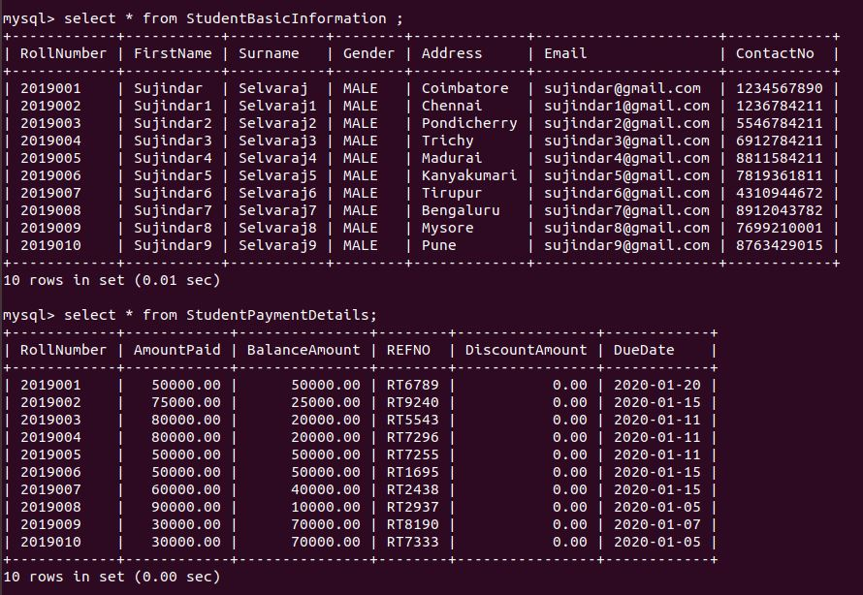

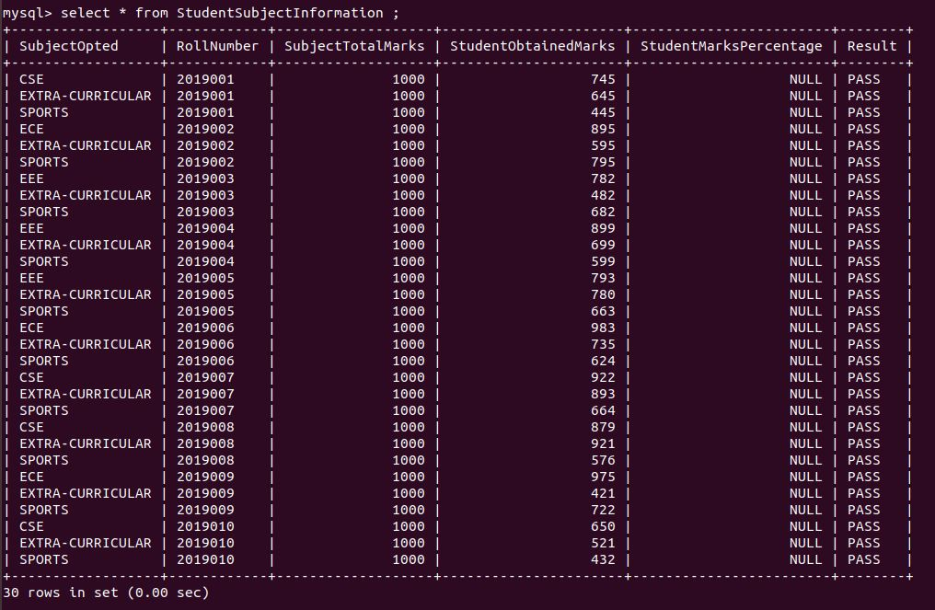

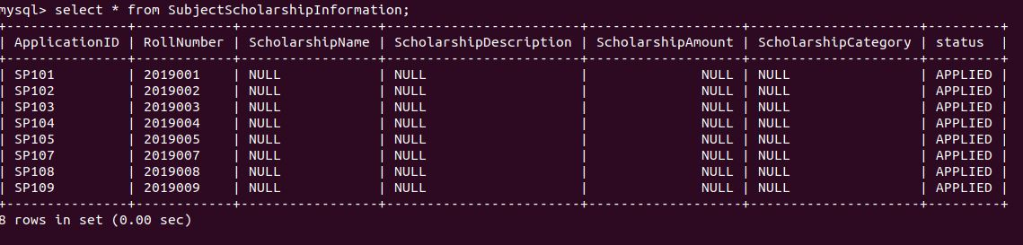

// 5

//--------------- Updating StudentBasicInformation ---------------//

update StudentBasicInformation set Gender="FEMALE" where RollNumber="2019006";
update StudentBasicInformation set Gender="FEMALE" where RollNumber="2019007";
update StudentBasicInformation set Gender="FEMALE" where RollNumber="2019008";
update StudentBasicInformation set Gender="FEMALE" where RollNumber="2019009";
update StudentBasicInformation set Gender="FEMALE" where RollNumber="2019010";

//--------------- Updating StudentPaymentDetails ---------------//
update StudentPaymentDetails set AmountPaid = 80000,BalanceAmount = 20000 where RollNumber = "2019005";
update StudentPaymentDetails set AmountPaid = 70000,BalanceAmount = 30000 where RollNumber = "2019006";
update StudentPaymentDetails set AmountPaid = 70000,BalanceAmount = 30000 where RollNumber = "2019007";
update StudentPaymentDetails set AmountPaid = 50000,BalanceAmount = 50000 where RollNumber = "2019009";
update StudentPaymentDetails set AmountPaid = 70000,BalanceAmount = 30000 where RollNumber = "2019010";

//--------------- Updating StudentSubjectInformation ---------------//
update StudentSubjectInformation set Result = "FAIL" where RollNumber = "2019001" and SubjectOpted = "SPORTS";
update StudentSubjectInformation set Result = "FAIL" where RollNumber = "2019003" and SubjectOpted = "EXTRA-CURRICULAR";
update StudentSubjectInformation set Result = "FAIL" where RollNumber = "2019009" and SubjectOpted = "EXTRA-CURRICULAR";
update StudentSubjectInformation set Result = "FAIL" where RollNumber = "2019010" and SubjectOpted = "SPORTS";
update StudentSubjectInformation set StudentObtainedMarks = 393,RESULT = "FAIL" where RollNumber="2019005";

// 6 SNAPS

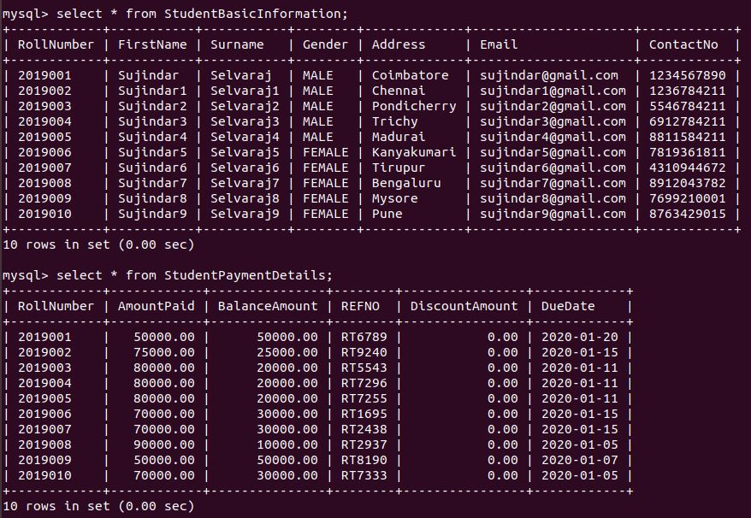
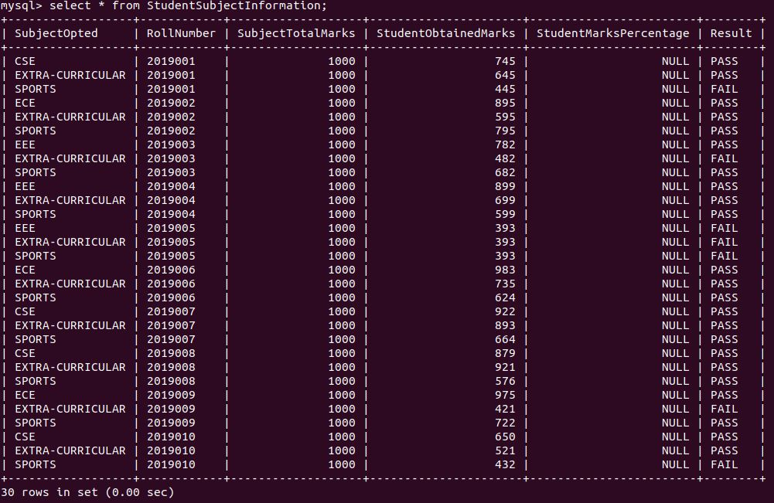

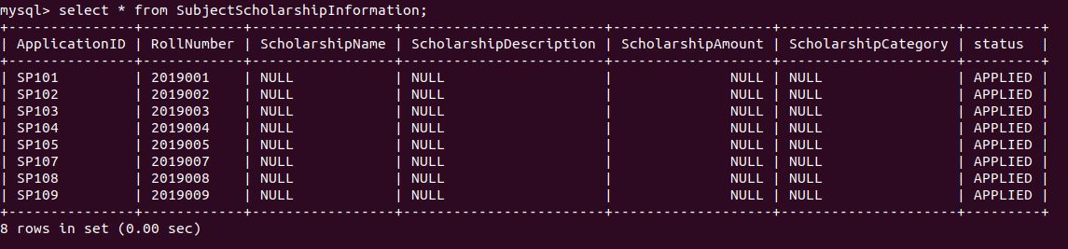

// 9

select * from StudentSubjectInformation;

delimiter //

CREATE PROCEDURE fillPercentage() BEGIN update StudentSubjectInformation set StudentMarksPercentage = StudentSubjectInformation.StudentObtainedMarks/SubjectTotalMarks * 100; end //

delimiter ;

call fillPercentage();

select * from StudentSubjectInformation;

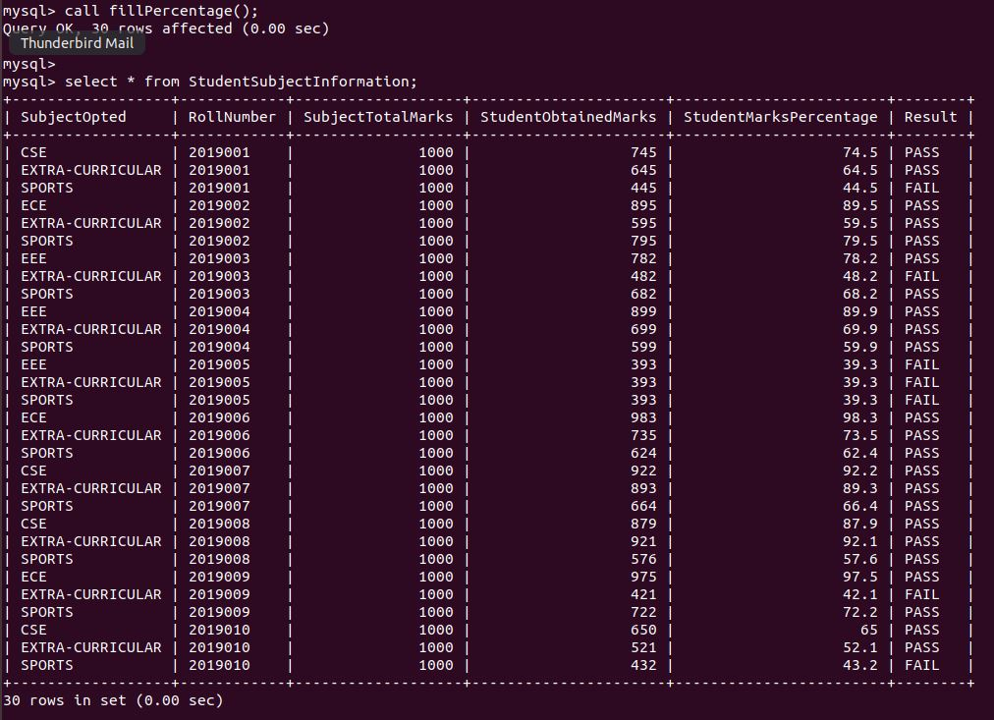
// 10

select * from SubjectScholarshipInformation;
delimiter //
create PROCEDURE fillCategory(SNAME varchar(30), SDESCRIPTION varchar(30), SAMOUNT float, SCATEGORY varchar(30))

BEGIN

Declare RollNo varchar(7);

SET RollNo = (select RollNumber from StudentSubjectInformation A inner join
(select MAX(StudentMarksPercentage) as Percentage from StudentSubjectInformation X inner join SubjectScholarshipInformation Y where SubjectOpted = SCATEGORY and Y.status = "APPLIED" and Y.RollNumber = X.RollNumber) B inner join
(select RollNumber as RNumber from SubjectScholarshipInformation where status = "APPLIED") C
where A.SubjectOpted = SCATEGORY and A.StudentMarksPercentage = B.Percentage and A.RollNumber = C.RNumber);

update SubjectScholarshipInformation set ScholarshipCategory=SCATEGORY,status = "APPROVED",ScholarshipName=SNAME,ScholarshipDescription=SDESCRIPTION,ScholarshipAmount=SAMOUNT where RollNumber = RollNo;
end//
delimiter ;
select * from SubjectScholarshipInformation;
call fillCategory("Scholarship-1","Scholarship for students",7500,"SPORTS");
call fillCategory("Scholarship-2","Scholarship for students",5500,"EXTRA-CURRICULAR");
call fillCategory("Scholarship-3","Scholarship for students",3500,"CSE");
call fillCategory("Scholarship-4","Scholarship for students",2500,"SPORTS");
select * from SubjectScholarshipInformation;
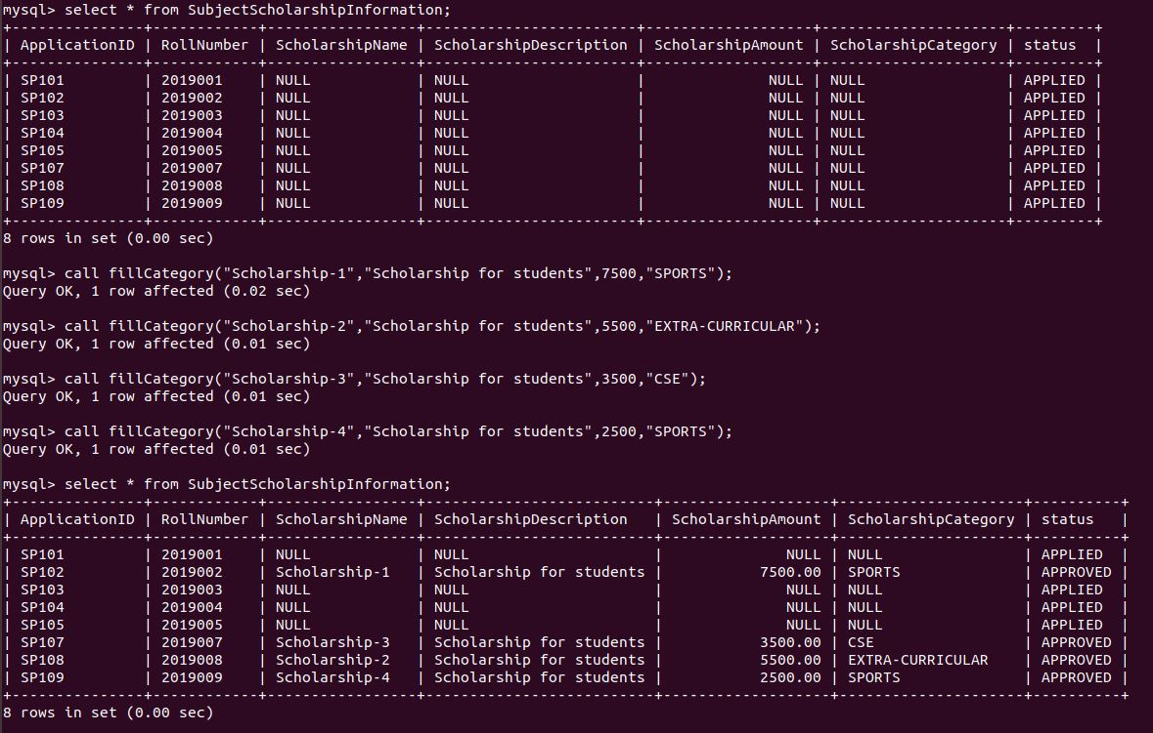

// 7
select A.*,B.ScholarshipAmount from StudentBasicInformation A inner join SubjectScholarshipInformation B on A.RollNumber = B.RollNumber where B.ScholarshipAmount > 5000;

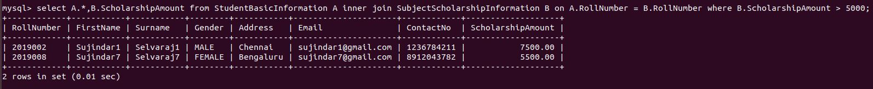

// 8
select A.*,B.status from StudentBasicInformation A inner join SubjectScholarshipInformation B on A.RollNumber = B.RollNumber where B.Status != "APPROVED";

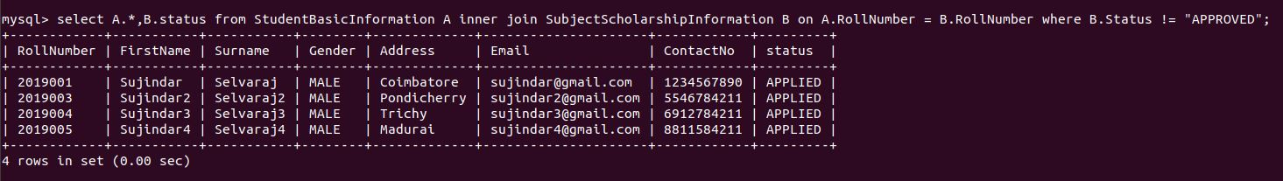
// 11

create view balanceAmount as select A.*,B.BalanceAmount from StudentBasicInformation A inner join StudentPaymentDetails B where A.RollNumber = B.RollNumber;
select * from balanceAmount;

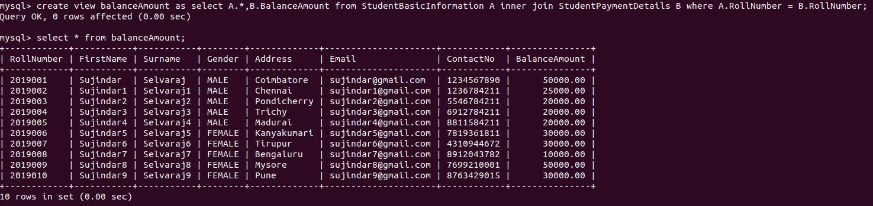

// 12

select A.*,B.status from StudentBasicInformation A left join SubjectScholarshipInformation B on A.RollNumber = B.RollNumber where (B.status = "APPLIED" or B.status is NULL) ;

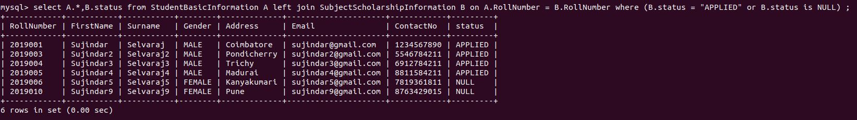

// 13

delimiter //
create procedure balanceAmountWithRollNumber(rollNo varchar(7)) BEGIN select BalanceAmount from StudentPaymentDetails where RollNumber = rollNo; END//
delimiter ;
call balanceAmountWithRollNumber("2019001");
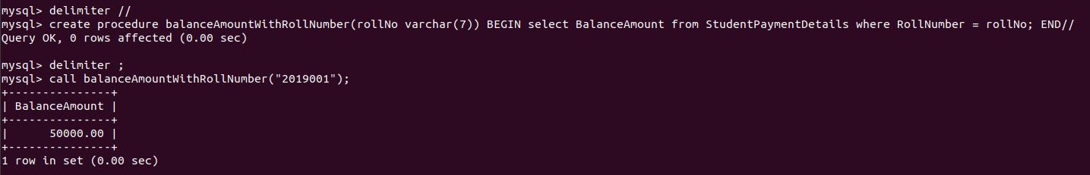
// 14

select * from StudentSubjectInformation B where 5>( select count(*) from StudentSubjectInformation C where C.StudentMarksPercentage > B.StudentMarksPercentage) order by StudentMarksPercentage desc;

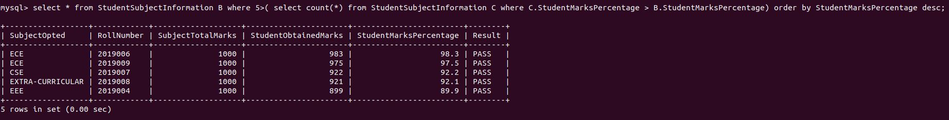

// 15

select A.*,B.status from StudentBasicInformation A inner join SubjectScholarshipInformation B on A.RollNumber = B.RollNumber order by RollNumber;
select A.*,B.status as Scholarship_Status from StudentBasicInformation A left outer join SubjectScholarshipInformation B on A.RollNumber = B.RollNumber order by RollNumber;

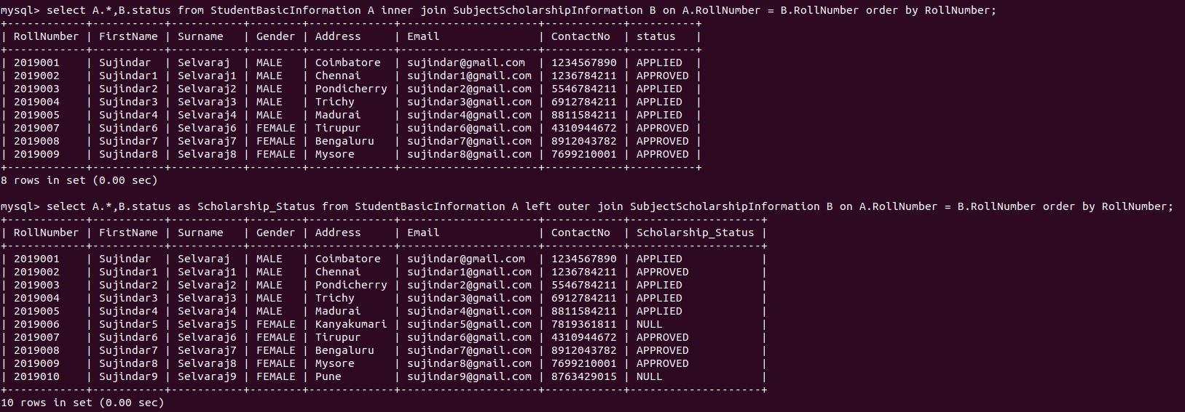
a) inner join – returns all the rows of the table only if the condition is satisfied. Here in the first query it gives information about the students who applied for scholarship.

b) left join – returns all the rows where the condition is satisfied and also the remaining rows of left table. In the second query we get the information about all the students (even if they did not apply for scholarship) and their scholarship status.

c) right join – opposite of left join.

// 16

a) delete – DML command, used to delete rows from a table. Can specify where clause to delete select rows. The memory is not freed.

b) truncate – DDL command, used to delete all the rows from the table, but the table remains. It frees the memory.

c) drop – DDL command, used to drop the entire table, procedure, index etc or entire database.

// 17

select ScholarShipCategory,count(*) from SubjectScholarshipInformation where status = "APPROVED" group by ScholarshipCategory;

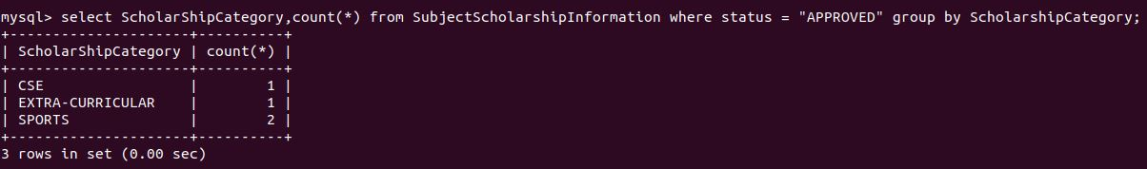

// 18

select ScholarShipCategory,count(*) from SubjectScholarshipInformation where status = "APPROVED" group by ScholarshipCategory having count(*) >= all (select count(*) from SubjectScholarshipInformation where status = "APPROVED" group by ScholarshipCategory);

// 19
select A.*,B.StudentMarksPercentage,C.ScholarshipAmount from StudentBasicInformation A inner join StudentSubjectInformation B inner join SubjectScholarshipInformation C where A.RollNumber = B.RollNumber and A.RollNumber = C.RollNumber order by B.StudentMarksPercentage desc,C.ScholarshipAmount desc limit 1;

// 20

a) Triggers – set of sql statements executed on occurence of a event. (insert,update,delete);

b) Stored Procedure – set of sql statements, which can take set of input and giving output is optional. Can perform DML, DDL inside the procedure.

c) View – Select statement, generally used to restrict the users to access entire view of the table. Its also called as virtual table.

d) Functions – Set of sql statement, which can take only input and always returns an output. Can perform only DQL inside the function.

