IUStudent

Team Members: Dženan Hodžić, Ammar Rahić, Burak Durmaz, Oğuzhan Yıldız, Abdullah Fatota

Date: 12/4/2019

Document Revision History:

* Rev 1.0 15/4/2019 – Initial Version

# Objectives

IUStudent is a primarily android mobile application, requiring an Android running phone in order to use it. Since almost all IUS students carry their mobile phones with them, it would be more convenient to have all the student necessary information in one easily accessible place. The main goal IUStudent is to help students organise their academic life, classes, events, homeworks, quizzes and so on. Each student will have their own, unique profile, which there will be able to customize to suit their needs. Besides the courses student can follow the groups, there are run by an administrator or an appointed person, they will provide students with information regarding the group them/objective, for example, if student is interested in upcoming talks or events they can follow a group that will provide them with exact information, if form of a notification as soon as possible, or if they are interested in a student exchange program, they can follow the group for that, so they don’t miss out on any opportunities. Customisation can be done by following classes that they are attending, which, if they enable to, will send them all the necessary information about the course, in form of a notification or it can be seen by looking at course profile, where they can look at its time table, assignments/homework, file or anything that professor wants to upload/share with students. All of this information that student is interested will automatically be added to their unique calendar, creating a visual picture of their everyday student life. Users can also look up things using the search option. Things that can be searched for are courses, classrooms, professor/staff and events that are in the database. Searching a course will provide the user with some basic information about it, place and time of lectures, the name of a professor who will teach the course and syllabus. Searching a professor will provide the user with some basic information about the professor, what course they are teaching, there email and credentials, and a time table with their lecture and office hours. Searching an event will provide the user with some basic information about the event, what is about, when it being held and where, duration and so on.

# System Decomposition/Design

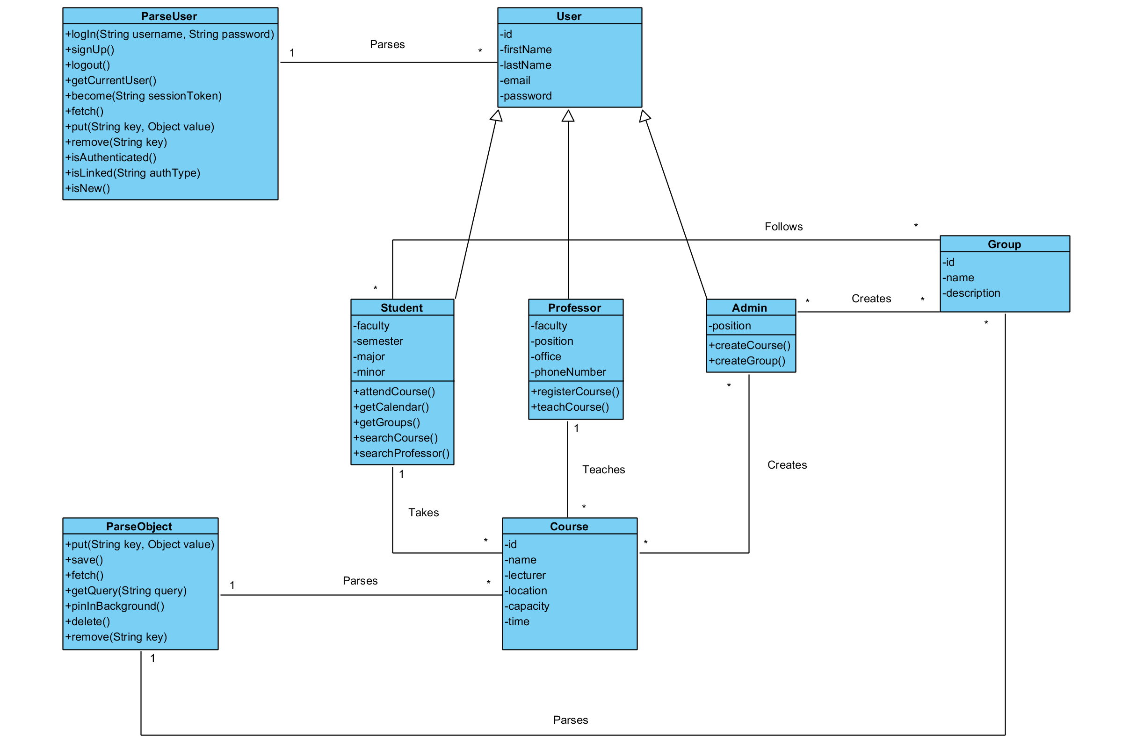

# Dynamic Models

## Signing Up

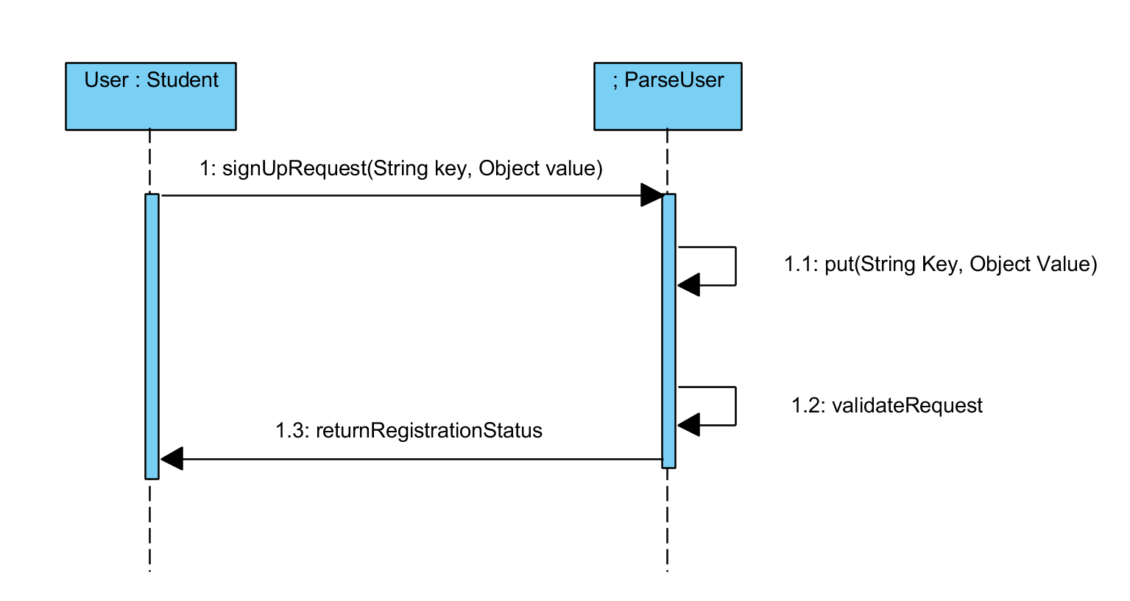

## Logging In

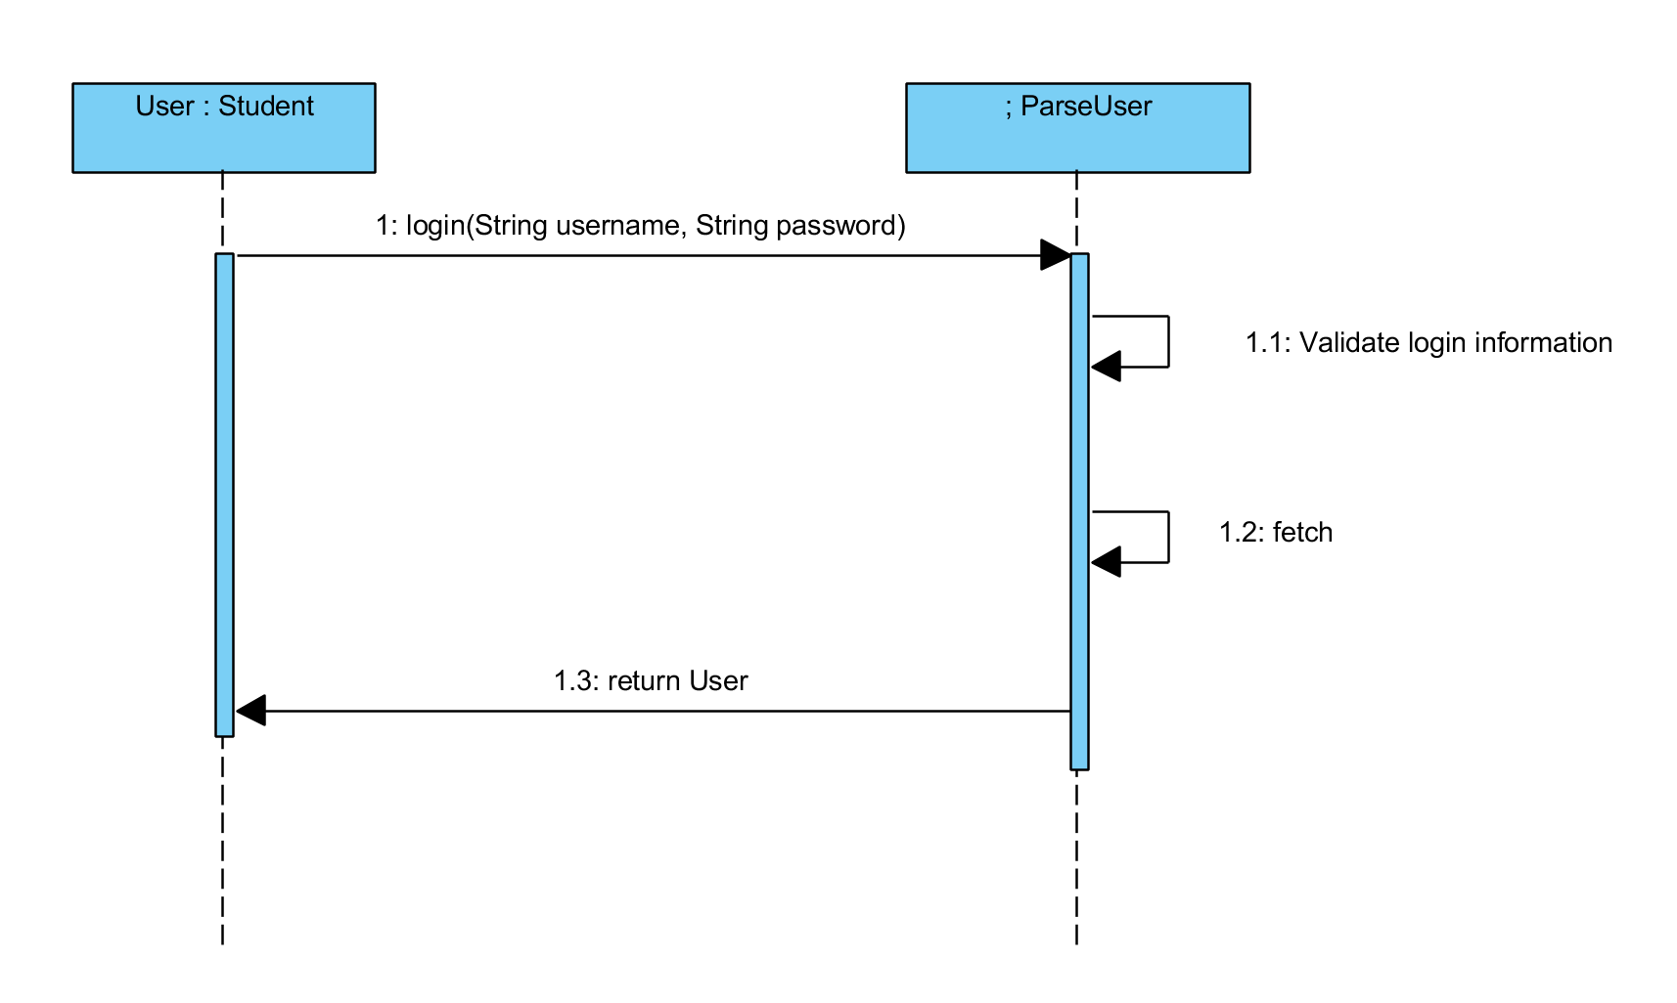

## Course Creation

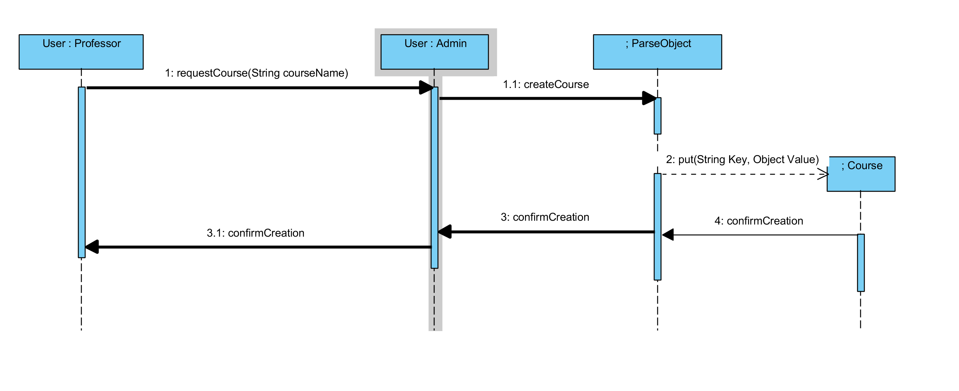

## Group Creation

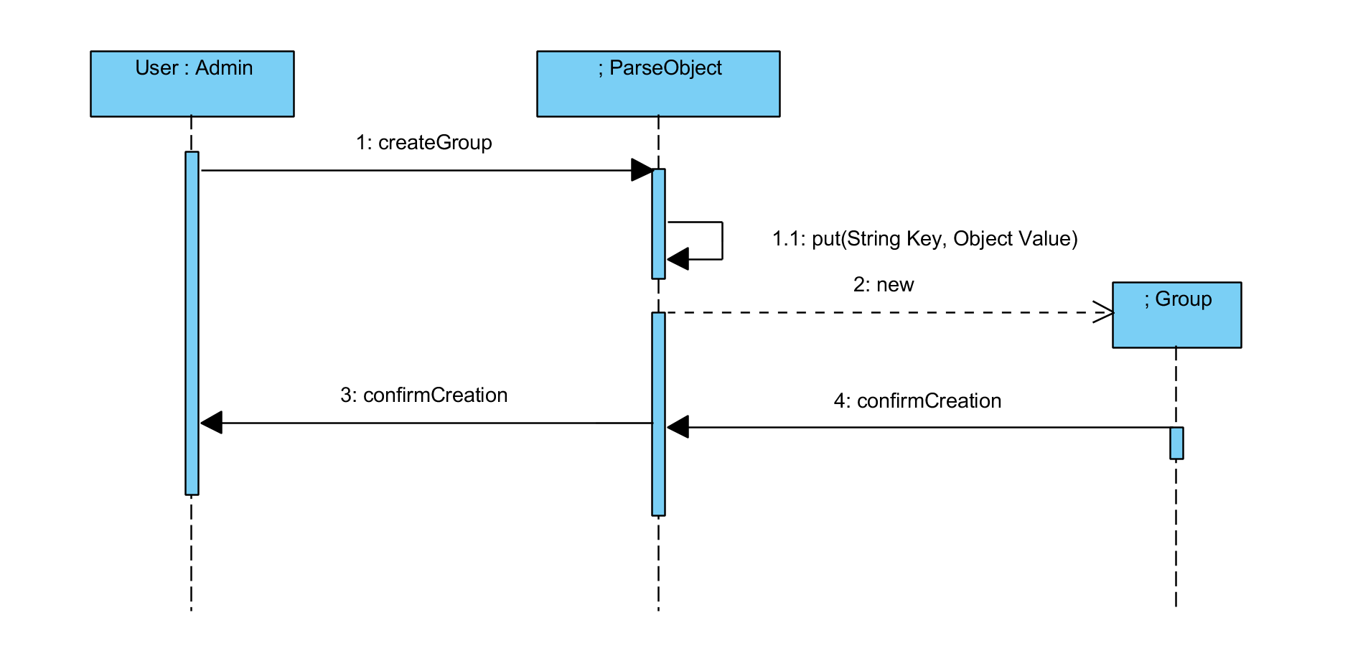

## Course Registration

# 

# User Interface

Welcome Screen - The first screen you are welcomed to when you open the application

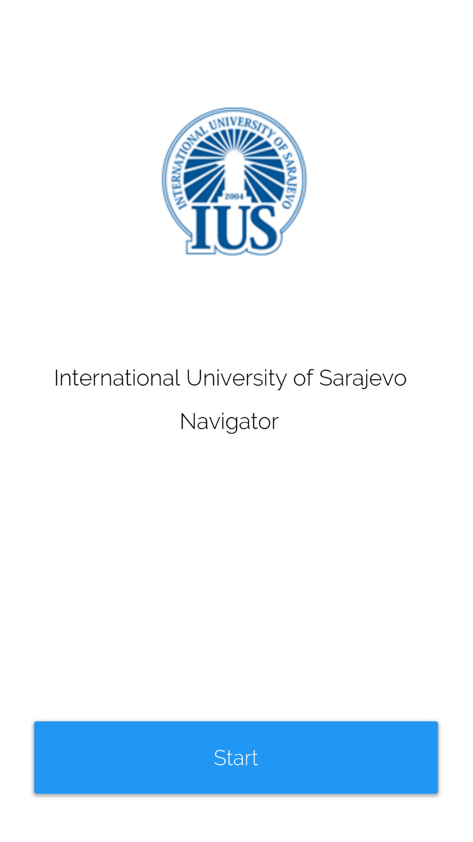

Sign In screen - After Pressing start you are given the ability to log into the application. If you don’t have an account you can sign up for one.

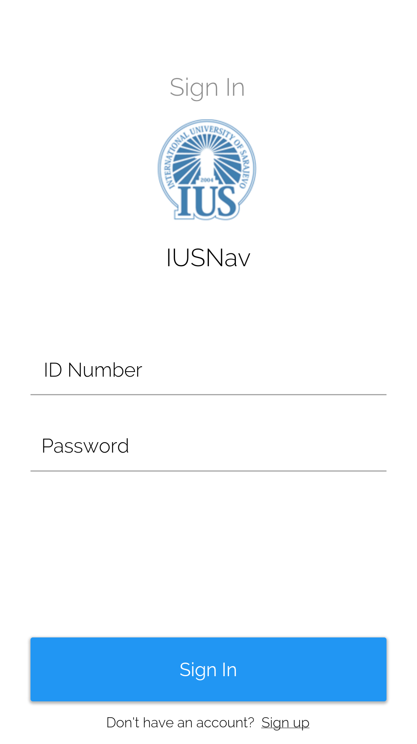

3. Sign Up Screen – If you don’t already have an account you are given the chance to register for one on this page

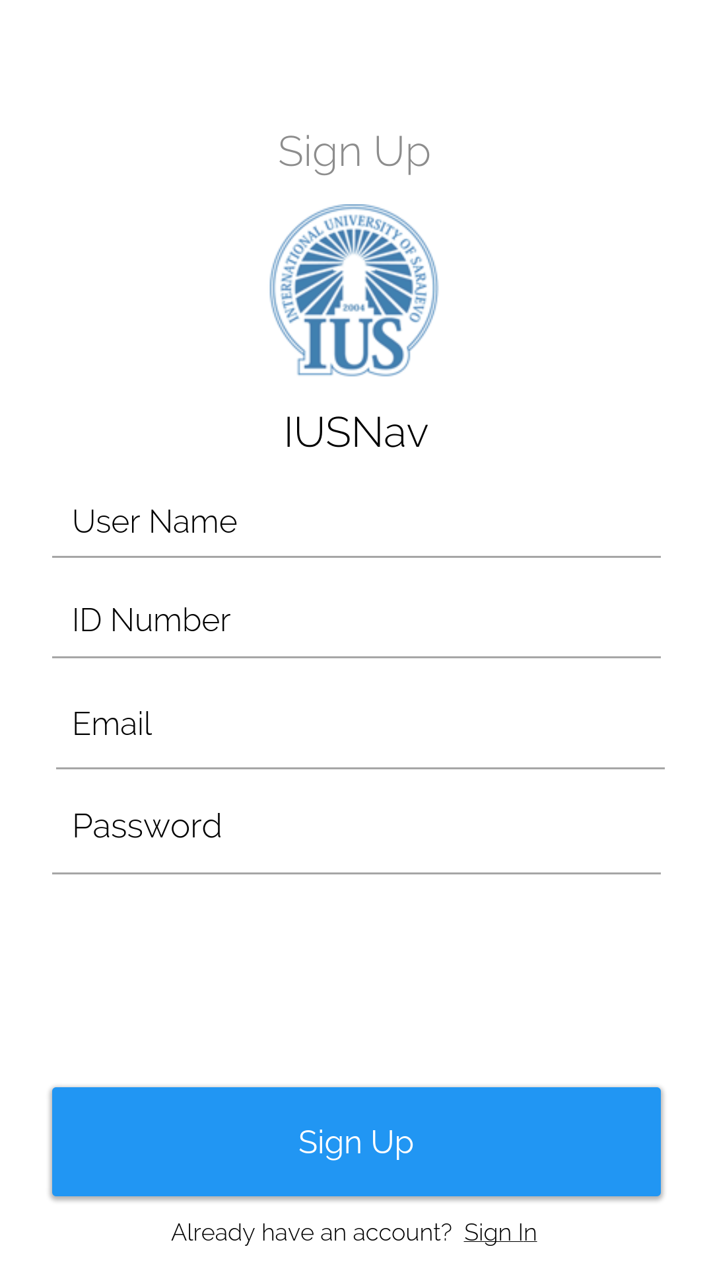

Search Professor Screen – Allow the user to search for a professors office

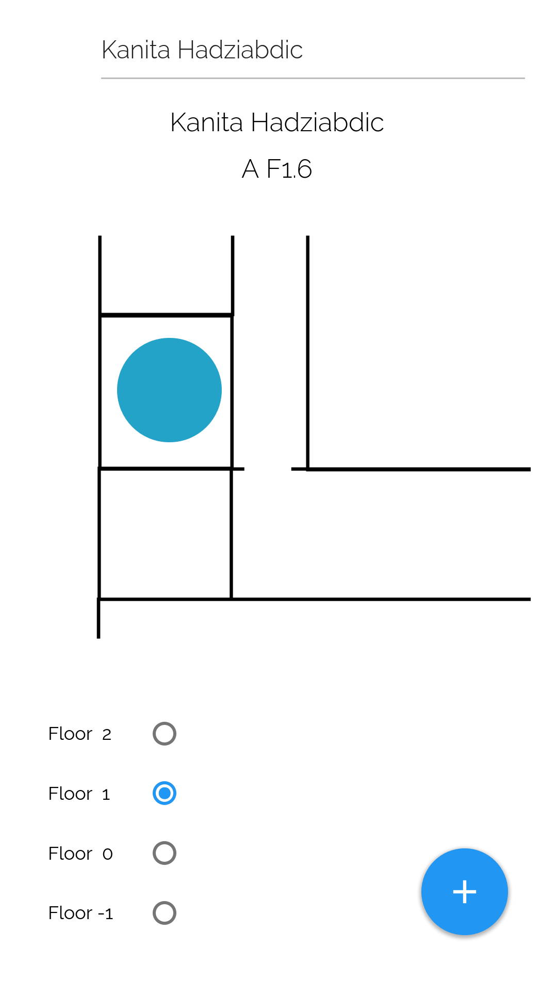

Professor Screen – Shows information about a particular professor taken from the IUS website

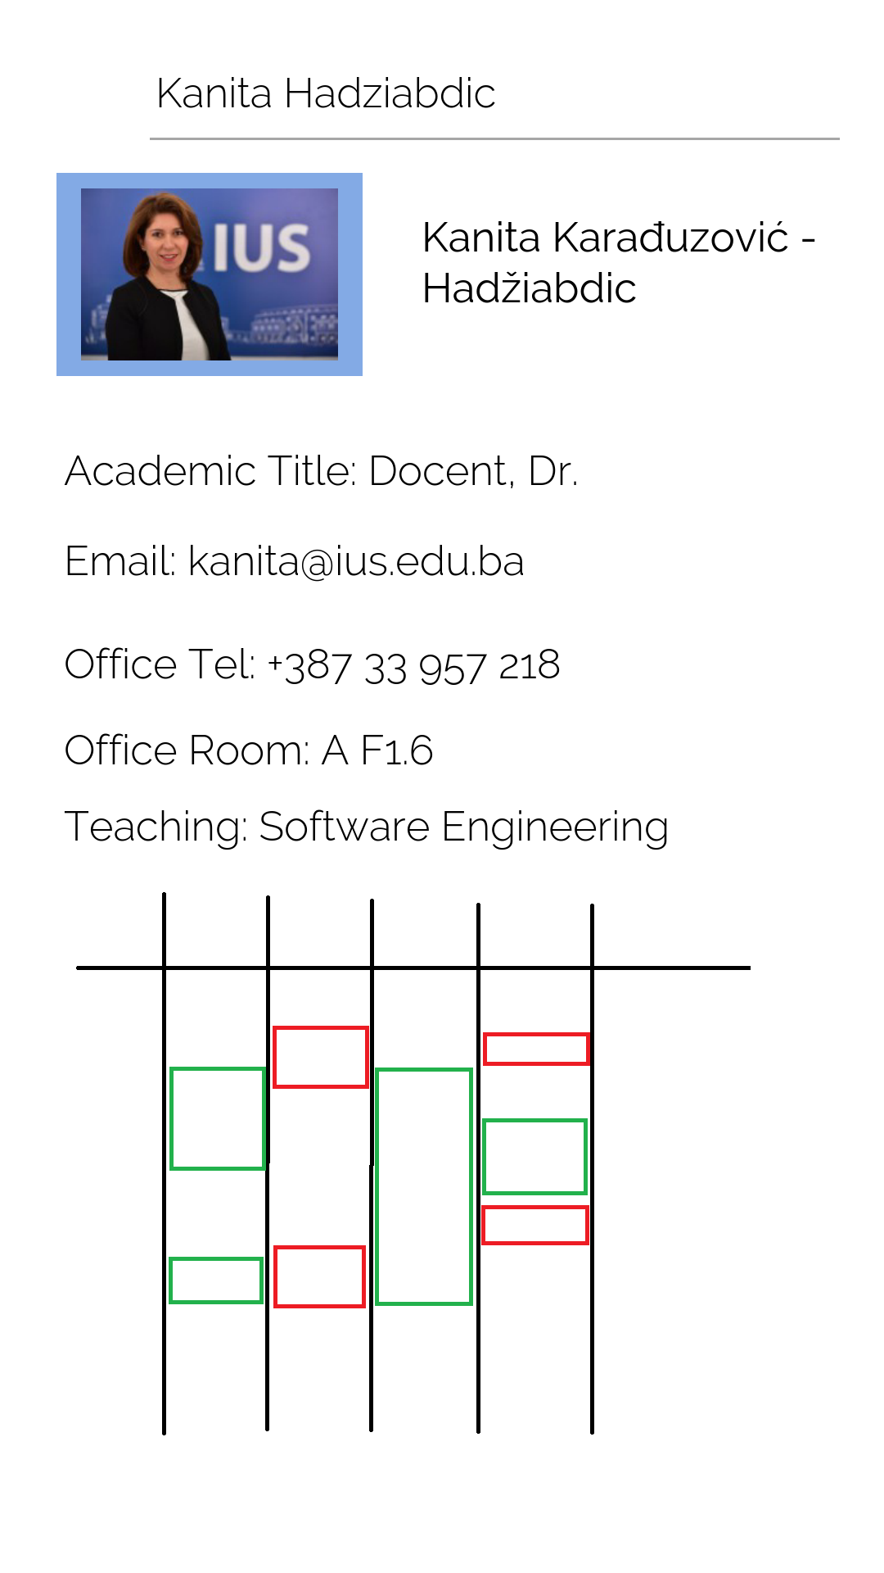

Search Class Screen – Allows students to search for a particular class and its location

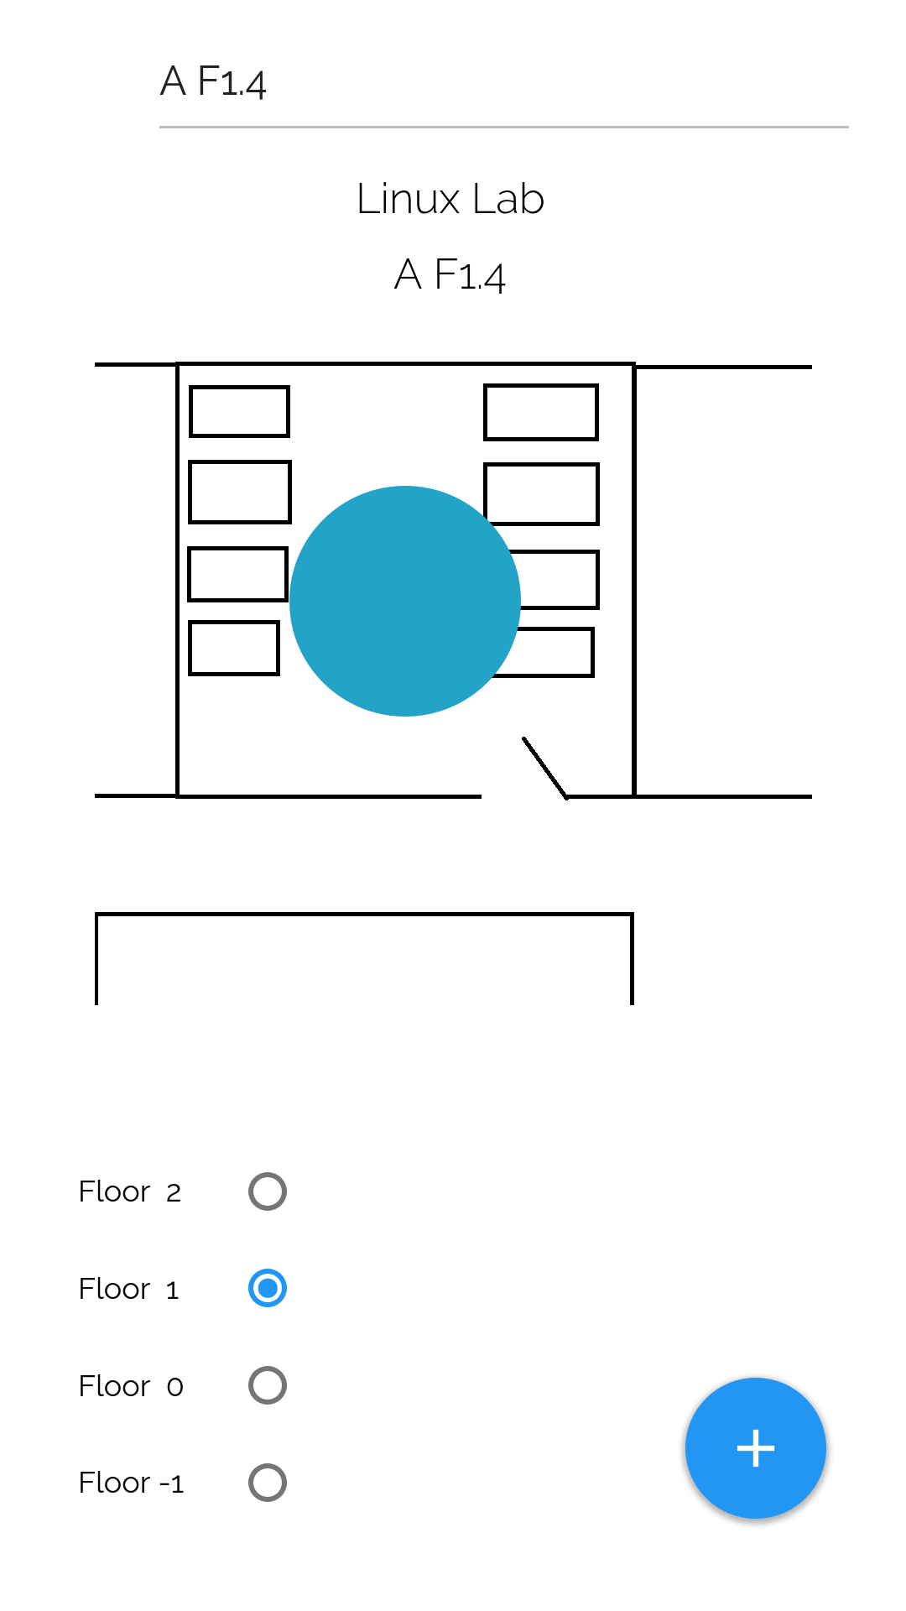

Main Screen – Shows information that the student has followed such as talks, or information relevant to specific classes

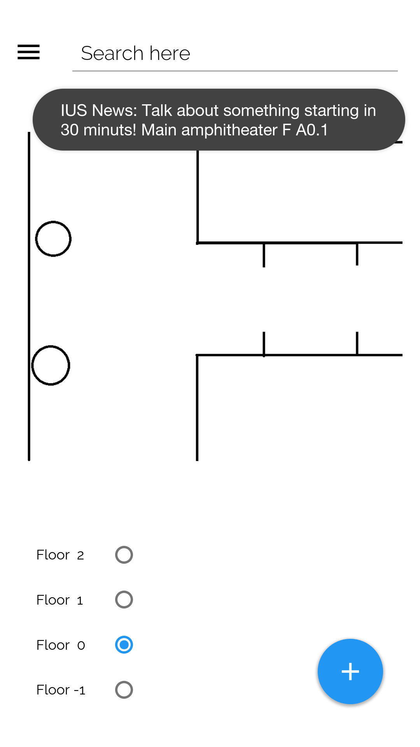

News Screen – Shows news from the IUS website



Calendar – Shows the students calendar with class locations and times

