Java大作业
19084129 李奕澄
一、作业要求
设计一个对一元二次方程根的计算程序，且要求输入不是数字时报错，使用MVC格式。
二、作业内容
import java.awt.*;
import java.awt.event.*;
import javax.swing.*;
public class MVCCalculator{
public static void main(String args[]){
MVCWin win=new MVCWin();
}
}
class Lader{
private double a,b,c;
public String getroots(){
double z=0;double f=0;double z1=0;double z2=0;
if (a==0)
{if (b==0)
{if (c==0) return "Any real roots";
else return "no roots";
}
else return "x="+-c/b;
}
else
{z=b*b-4*a*c;
if (z<0)
{z=-z;
f=Math.sqrt(z);
return "x1="+(-b)/(2*a)+"+"+f/(2*a)+"i"+"\n"+"x2="+(-b)/(2*a)+"-"+f/(2*a)+"i";
}
else
{f=Math.sqrt(z);
if (f==0)
{z1=-b/(2*a)+f/(2*a);
return "x1=x2="+z1;
}
else
{z1=-b/(2*a)+f/(2*a);
z2=-b/(2*a)-f/(2*a);
return "x1="+z1+"\n"+"x2="+z2;
}
}
}
}
public void seta(double a){
this.a=a;
}
public void setb(double b){
this.b=b;
}
public void setc(double c){
this.c=c;
}
}
class MVCWin extends JFrame implements ActionListener{
Lader lader;
JTextField num1,num2,num3;
JTextArea showArea;
JButton EndButton;
MVCWin(){
lader=new Lader();
num1=new JTextField(5);
num2=new JTextField(5);
num3=new JTextField(5);
showArea=new JTextArea();
EndButton=new JButton("End");
JPanel pNorth=new JPanel();
pNorth.add(num1);
pNorth.add(new JLabel("x^2+"));
pNorth.add(num2);
pNorth.add(new JLabel("x+"));
pNorth.add(num3);
pNorth.add(EndButton);
EndButton.addActionListener(this);
add(pNorth,BorderLayout.NORTH);
add(new JScrollPane(showArea),BorderLayout.CENTER);
setBounds(100,100,420,280);
setVisible(true);
setDefaultCloseOperation(JFrame.DISPOSE_ON_CLOSE);
}

public void actionPerformed(ActionEvent e){
try{
double a=Double.parseDouble(num1.getText().trim());
double b=Double.parseDouble(num2.getText().trim());
double c=Double.parseDouble(num3.getText().trim());
lader.seta(a) ;
lader.setb(b);
lader.setc(c);
showArea.append(lader.getroots()+"\n");
}
catch(Exception ex){
showArea.append("Please input number\n");
}
}
}
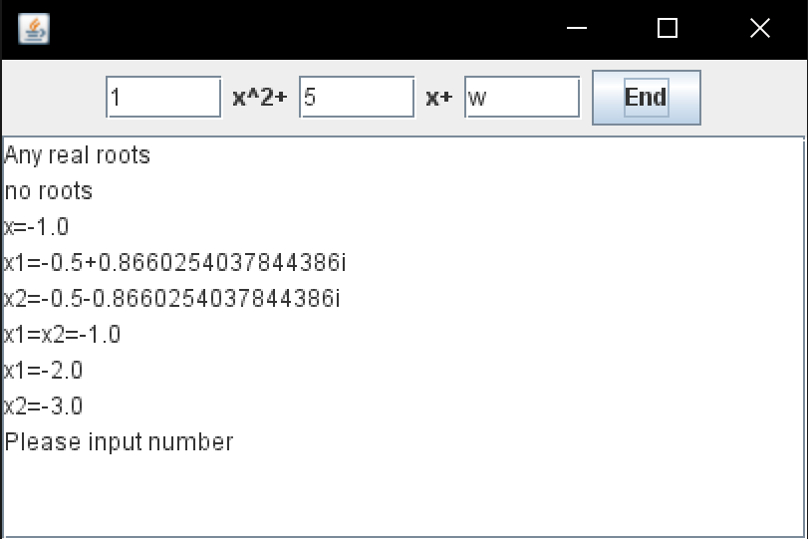
三、作业结果

