病人管理系统

19084129-李奕澄

代码：

Mainwindow.h

#ifndef MAINWINDOW_H

#define MAINWINDOW_H

#include <QMainWindow>

#include <QStringListModel>

#include <QStandardItemModel>

#include <QModelIndex>

#include <mainwindow2.h>

#include <mainwindow3.h>

namespace Ui {

class MainWindow;

}

#pragma execution_character_set("utf-8")

class MainWindow : public QMainWindow

{

Q_OBJECT

public:

explicit MainWindow(QWidget *parent = nullptr);

~MainWindow();

private slots:

void on_pushButtonAdd_clicked();

void on_pushButtonDrug_clicked();

private:

Ui::MainWindow *ui;

QStandardItemModel* model;//创建一个model的值

};

#endif // MAINWINDOW_H

Mainwindow2.h

#ifndef MAINWINDOW2_H

#define MAINWINDOW2_H

#include <QMainWindow>

#include <QStringListModel>

#include <QStandardItemModel>

#include <QModelIndex>

#include <mainwindow.h>

namespace Ui {

class MainWindow2;

}

class MainWindow2 : public QMainWindow

{

Q_OBJECT

public:

explicit MainWindow2(QWidget *parent = nullptr);

~MainWindow2();

private slots:

void on_pushButtonDetermine_clicked();

void on_pushButtonCancel_clicked();

private:

Ui::MainWindow2 *ui;

QStandardItemModel* model;//创建一个model的值

};

#endif // MAINWINDOW2_H

Mainwindow3.h

#ifndef MAINWINDOW3_H

#define MAINWINDOW3_H

#include <QMainWindow>

#include <QStringListModel>

#include <QStandardItemModel>

#include <QModelIndex>

#include <mainwindow.h>

namespace Ui {

class MainWindow3;

}

#pragma execution_character_set("utf-8")

class MainWindow3 : public QMainWindow

{

Q_OBJECT

public:

explicit MainWindow3(QWidget *parent = nullptr);

~MainWindow3();

private slots:

void on_pushButtonSubmit_clicked();

private:

Ui::MainWindow3 *ui;

QStandardItemModel* model;//创建一个model的值

};

#endif // MAINWINDOW3_H

Main.cpp

#include "mainwindow.h"

#include <QApplication>

int main(int argc, char *argv[])

{

QApplication a(argc, argv);

MainWindow w;

w.show();

return a.exec();

}

Mainwindow.cpp

#include "mainwindow.h"

#include "ui_mainwindow.h"

#include <QDebug>

#include <QMessageBox>

MainWindow::MainWindow(QWidget *parent)

: QMainWindow(parent)

, ui(new Ui::MainWindow)

{

ui->setupUi(this);

ui->tableView->setSortingEnabled(true);

model = new QStandardItemModel(this);

QStringList labels = QObject::trUtf8("编号,姓名,地址,手机,生日,性别").simplified().split(",");

model->setHorizontalHeaderLabels(labels);

ui->tableView->setModel(model);

ui->tableView->show();

QTextCodec::setCodecForLocale(QTextCodec::codecForLocale());//设置显示中文

db = QSqlDatabase::addDatabase("QMYSQL");

db.setHostName("127.0.0.1");

db.setDatabaseName("test");

db.setUserName("root");

db.setPassword("123456");

if(!db.open()) //如果数据库打开失败，会弹出一个警告窗口

{

QMessageBox::warning(this, "警告", "数据库打开失败");

}

else

{

ui->textEdit->setText("数据库打开成功");

}

ui->tableView->setSortingEnabled(true);

ui->tableView->setModel(pModel);

model = new QStandardItemModel(this);

QStringList labels = QObject::trUtf8("编号,姓名,地址,手机,生日,性别").simplified().split(",");

model->setHorizontalHeaderLabels(labels);

ui->tableView->setModel(model);

ui->tableView->show();

}

MainWindow::~MainWindow()

{

delete ui;

}

void MainWindow::selectBoxSlot()//查询状态

{

bool ok=db.open();

if(ok)

{

QSqlQueryModel *model = new QSqlQueryModel(ui->tableView);

model->setQuery(QString("select box_id,case box_state when 1 then '待取' "

"else '已取' end as box_state,case box_size when 1 "

"then '大' when 2 then '中' else '小' end as box_size "

"from box;"));

ui->tableView->setModel(model);//数据放置进去

}

else

{

QMessageBox::warning(this,"错误","未连接，请检查.");

}

}

void Widget::on_deletebutton_clicked()

{

//通过 view去获取被选中部分的数据的model

QItemSelectionModel *itemmodle=tableview->selectionModel();

//通过选中的数据结构 获取这些格子的 ModelIndex

QModelIndexList selectList=itemmodle->selectedIndexes();

QList<int>listRow;

for(int i=0;i<selectList.size();++i){

QModelIndex index=selectList.at(i);

listRow<<index.row();

}

while(listRow.size()>0){

int row =listRow.at(0);

listRow.removeAll(row);//删除重复的行数

model_->removeRow(row);

}

if(model_->submitAll())

{

QMessageBox::information(this,"information","Delete Success!!!");

}

}

void MainWindow::on_pushButtonAdd_clicked()

{

this->close();

MainWindow2 *pic2 =new MainWindow2();

pic2 -> show();

}

void MainWindow::on_pushButtonUpdate_clicked()

{

    QSqlTableModel *pMode = dynamic_cast<QSqlTableModel *>(ui->tableView->model());

    pMode->database().transaction(); //开始事务操作

    if (pMode->submitAll()) // 提交所有被修改的数据到数据库中

    {

        pMode->database().commit(); //提交成功，事务将真正修改数据库数据

    } else {

        pMode->database().rollback(); //提交失败，事务回滚

        QMessageBox::warning(this, tr("tableModel"),tr("数据库错误: %1").arg(pMode->lastError().text()));

    }

    pMode->revertAll(); //撤销修改

}

void MainWindow::on_pushButtonSearch_clicked()

{

QString searchname = ui->lineEditName->text();

if(searchname == NULL)

{

ui->textEdit->setText("请输入需要查询的人名");

}

else

{

//从数据库中查询是否有这么一个人

QString str = QString("select *from student where name = '%1'").arg(searchname);

QSqlQuery query;

query.exec(str);

QString name,locaton,birthday,gender;

int number,phone;

while (query.next())

{

number = query.value(0).toInt();

name = query.value(1).toString();

location = query.value(2).toString();

phone = query.value(3).toInt();

birthday = query.value(4).toString();

gender = query.value(5).toString();

}

if(name == NULL)

{

QString a = QString("没有叫%1的人，请重新输入人名").arg(searchname);

}

else

{

model->setItem(0, 0, new QStandardItem(number));

model->setItem(0, 1, new QStandardItem(name));

model->setItem(0, 2, new QStandardItem(location));

model->setItem(0, 3, new QStandardItem(phone));

model->setItem(0, 4, new QStandardItem(birthday));

model->setItem(0, 5, new QStandardItem(gender));

}

}

}

void MainWindow::on_pushButtonDrug_clicked()

{

this->close();

MainWindow3 *pic3 =new MainWindow3();

pic3 -> show();

}

Mainwindow2.cpp

#include "mainwindow2.h"

#include "ui_mainwindow2.h"

#include <QDebug>

#include <QMessageBox>

MainWindow2::MainWindow2(QWidget *parent) :

QMainWindow(parent),

ui(new Ui::MainWindow2)

{

ui->setupUi(this);

}

MainWindow2::~MainWindow2()

{

delete ui;

}

void MainWindow2::on_pushButtonDetermine_clicked()

{

ui->lineEditName->clear();

ui->lineEditLocation->clear();

ui->lineEditPhone->clear();

ui->lineEditBirthday->clear()

ui->lineEditGender->clear();;

QSqlRecord number=model_->record();

model_->insertRecord(-1,number);

QSqlRecord name=model_->record();

model_->insertRecord(-1,name);

QSqlRecord location=model_->record();

model_->insertRecord(-1,location);

QSqlRecord phone=model_->record();

model_->insertRecord(-1,phone);

QSqlRecord birthady=model_->record();

model_->insertRecord(-1,birthday);

QSqlRecord gender=model_->record();

model_->insertRecord(-1,gender);

QMessageBox::about(NULL, "提示", "添加成功！");

MainWindow *father = new MainWindow();

this -> close();

father -> show();

}

void MainWindow2::on_pushButtonCancel_clicked()

{

MainWindow *father = new MainWindow();

this -> close();

father -> show();

}

Mainwindow3.cpp

#include "mainwindow3.h"

#include "ui_mainwindow3.h"

#include <QDebug>

#include <QMessageBox>

MainWindow3::MainWindow3(QWidget *parent) :

QMainWindow(parent),

ui(new Ui::MainWindow3)

{

ui->setupUi(this);

ui->tableView3_1->setSortingEnabled(true);

model = new QStandardItemModel(this);

ui->tableView3_1->setModel(model);

ui->tableView3_1->show();

ui->tableView3_2->setSortingEnabled(true);

model = new QStandardItemModel(this);

QStringList label = QObject::trUtf8("编号,处方,医生编号,病人编号").simplified().split(",");

model->setHorizontalHeaderLabels(label);

ui->tableView3_2->setModel(model);

ui->tableView3_2->show();

}

MainWindow3::~MainWindow3()

{

delete ui;

}

void MainWindow3::on_pushButtonSubmit_clicked()

{

number = query.value(0).toInt();

chufang = query.value(1).toInt();

IDdoctor = query.value(2).toString();

IDpatient = query.value(3).toInt();

for i=0;i<number.size;i++

{

model->setItem(i, 0, new QStandardItem(number));

model->setItem(i, 1, new QStandardItem(chufang));

model->setItem(i, 2, new QStandardItem(lDdoctor));

model->setItem(i, 3, new QStandardItem(IDpatient));

}

QMessageBox::about(NULL, "提示", "开药成功！");

}

Mainwindow.ui

<?xml version="1.0" encoding="UTF-8"?>

<ui version="4.0">

<class>MainWindow</class>

<widget class="QMainWindow" name="MainWindow">

<property name="geometry">

<rect>

<x>0</x>

<y>0</y>

<width>1739</width>

<height>1194</height>

</rect>

</property>

<property name="windowTitle">

<string>MainWindow</string>

</property>

<widget class="QWidget" name="centralWidget">

<widget class="QTableView" name="tableView">

<property name="geometry">

<rect>

<x>160</x>

<y>50</y>

<width>1471</width>

<height>731</height>

</rect>

</property>

</widget>

<widget class="QLabel" name="label">

<property name="geometry">

<rect>

<x>50</x>

<y>890</y>

<width>81</width>

<height>41</height>

</rect>

</property>

<property name="text">

<string>姓名：</string>

</property>

</widget>

<widget class="QLineEdit" name="lineEdit1">

<property name="geometry">

<rect>

<x>150</x>

<y>870</y>

<width>461</width>

<height>91</height>

</rect>

</property>

</widget>

<widget class="QLabel" name="label_2">

<property name="geometry">

<rect>

<x>660</x>

<y>880</y>

<width>141</width>

<height>61</height>

</rect>

</property>

<property name="text">

<string>性别：</string>

</property>

</widget>

<widget class="QLineEdit" name="lineEdit2">

<property name="geometry">

<rect>

<x>750</x>

<y>870</y>

<width>471</width>

<height>91</height>

</rect>

</property>

</widget>

<widget class="QPushButton" name="pushButtonSearch">

<property name="geometry">

<rect>

<x>10</x>

<y>1010</y>

<width>231</width>

<height>91</height>

</rect>

</property>

<property name="text">

<string>查询</string>

</property>

</widget>

<widget class="QPushButton" name="pushButtonUpdate">

<property name="geometry">

<rect>

<x>260</x>

<y>1010</y>

<width>211</width>

<height>91</height>

</rect>

</property>

<property name="text">

<string>提交修改</string>

</property>

</widget>

<widget class="QPushButton" name="pushButtonAdd">

<property name="geometry">

<rect>

<x>490</x>

<y>1010</y>

<width>241</width>

<height>91</height>

</rect>

</property>

<property name="text">

<string>添加记录</string>

</property>

</widget>

<widget class="QPushButton" name="pushButtonDelete">

<property name="geometry">

<rect>

<x>750</x>

<y>1010</y>

<width>261</width>

<height>91</height>

</rect>

</property>

<property name="text">

<string>删除记录</string>

</property>

</widget>

<widget class="QPushButton" name="pushButtonQuash">

<property name="geometry">

<rect>

<x>1030</x>

<y>1010</y>

<width>241</width>

<height>91</height>

</rect>

</property>

<property name="text">

<string>撤销修改</string>

</property>

</widget>

<widget class="QPushButton" name="pushButtonDrug">

<property name="geometry">

<rect>

<x>1290</x>

<y>1010</y>

<width>261</width>

<height>91</height>

</rect>

</property>

<property name="text">

<string>开药</string>

</property>

</widget>

</widget>

<widget class="QMenuBar" name="menuBar">

<property name="geometry">

<rect>

<x>0</x>

<y>0</y>

<width>1739</width>

<height>21</height>

</rect>

</property>

</widget>

<widget class="QToolBar" name="mainToolBar">

<attribute name="toolBarArea">

<enum>TopToolBarArea</enum>

</attribute>

<attribute name="toolBarBreak">

<bool>false</bool>

</attribute>

</widget>

<widget class="QStatusBar" name="statusBar"/>

</widget>

<layoutdefault spacing="6" margin="11"/>

<resources/>

<connections/>

</ui>

Mainwindow2.ui

<?xml version="1.0" encoding="UTF-8"?>

<ui version="4.0">

<class>MainWindow2</class>

<widget class="QMainWindow" name="MainWindow2">

<property name="geometry">

<rect>

<x>0</x>

<y>0</y>

<width>800</width>

<height>600</height>

</rect>

</property>

<property name="windowTitle">

<string>MainWindow</string>

</property>

<widget class="QWidget" name="centralwidget">

<widget class="QLineEdit" name="lineEdit2_1">

<property name="geometry">

<rect>

<x>190</x>

<y>60</y>

<width>271</width>

<height>51</height>

</rect>

</property>

</widget>

<widget class="QLineEdit" name="lineEdit2_2">

<property name="geometry">

<rect>

<x>190</x>

<y>120</y>

<width>271</width>

<height>51</height>

</rect>

</property>

</widget>

<widget class="QLineEdit" name="lineEdit2_3">

<property name="geometry">

<rect>

<x>190</x>

<y>180</y>

<width>271</width>

<height>51</height>

</rect>

</property>

</widget>

<widget class="QLineEdit" name="lineEdit2_4">

<property name="geometry">

<rect>

<x>190</x>

<y>240</y>

<width>271</width>

<height>51</height>

</rect>

</property>

</widget>

<widget class="QLineEdit" name="lineEdit2_5">

<property name="geometry">

<rect>

<x>190</x>

<y>300</y>

<width>271</width>

<height>51</height>

</rect>

</property>

</widget>

<widget class="QLabel" name="label">

<property name="geometry">

<rect>

<x>50</x>

<y>70</y>

<width>141</width>

<height>31</height>

</rect>

</property>

<property name="text">

<string>姓名：</string>

</property>

</widget>

<widget class="QLabel" name="label_2">

<property name="geometry">

<rect>

<x>50</x>

<y>130</y>

<width>141</width>

<height>31</height>

</rect>

</property>

<property name="text">

<string>地址：</string>

</property>

</widget>

<widget class="QLabel" name="label_3">

<property name="geometry">

<rect>

<x>50</x>

<y>190</y>

<width>141</width>

<height>31</height>

</rect>

</property>

<property name="text">

<string>手机：</string>

</property>

</widget>

<widget class="QLabel" name="label_4">

<property name="geometry">

<rect>

<x>50</x>

<y>250</y>

<width>141</width>

<height>31</height>

</rect>

</property>

<property name="text">

<string>生日：</string>

</property>

</widget>

<widget class="QLabel" name="label_5">

<property name="geometry">

<rect>

<x>50</x>

<y>310</y>

<width>141</width>

<height>31</height>

</rect>

</property>

<property name="text">

<string>性别：</string>

</property>

</widget>

<widget class="QPushButton" name="pushButtonDetermine">

<property name="geometry">

<rect>

<x>550</x>

<y>80</y>

<width>221</width>

<height>101</height>

</rect>

</property>

<property name="text">

<string>确定</string>

</property>

</widget>

<widget class="QPushButton" name="pushButtonCancel">

<property name="geometry">

<rect>

<x>550</x>

<y>210</y>

<width>221</width>

<height>101</height>

</rect>

</property>

<property name="text">

<string>取消</string>

</property>

</widget>

</widget>

<widget class="QMenuBar" name="menubar">

<property name="geometry">

<rect>

<x>0</x>

<y>0</y>

<width>800</width>

<height>21</height>

</rect>

</property>

</widget>

<widget class="QStatusBar" name="statusbar"/>

</widget>

<resources/>

<connections/>

</ui>

Mainwindow3.ui

<?xml version="1.0" encoding="UTF-8"?>

<ui version="4.0">

<class>MainWindow3</class>

<widget class="QMainWindow" name="MainWindow3">

<property name="geometry">

<rect>

<x>0</x>

<y>0</y>

<width>1459</width>

<height>1113</height>

</rect>

</property>

<property name="windowTitle">

<string>MainWindow</string>

</property>

<widget class="QWidget" name="centralwidget">

<widget class="QTableView" name="tableView3_1">

<property name="geometry">

<rect>

<x>30</x>

<y>10</y>

<width>1411</width>

<height>211</height>

</rect>

</property>

</widget>

<widget class="QLineEdit" name="lineEdit3_1">

<property name="geometry">

<rect>

<x>30</x>

<y>240</y>

<width>1411</width>

<height>81</height>

</rect>

</property>

</widget>

<widget class="QTableView" name="tableView3_2">

<property name="geometry">

<rect>

<x>30</x>

<y>340</y>

<width>1411</width>

<height>521</height>

</rect>

</property>

</widget>

<widget class="QPushButton" name="pushButtonSubmit">

<property name="geometry">

<rect>

<x>560</x>

<y>880</y>

<width>351</width>

<height>171</height>

</rect>

</property>

<property name="text">

<string>提交</string>

</property>

</widget>

</widget>

<widget class="QMenuBar" name="menubar">

<property name="geometry">

<rect>

<x>0</x>

<y>0</y>

<width>1459</width>

<height>21</height>

</rect>

</property>

</widget>

<widget class="QStatusBar" name="statusbar"/>

</widget>

<resources/>

<connections/>

</ui>

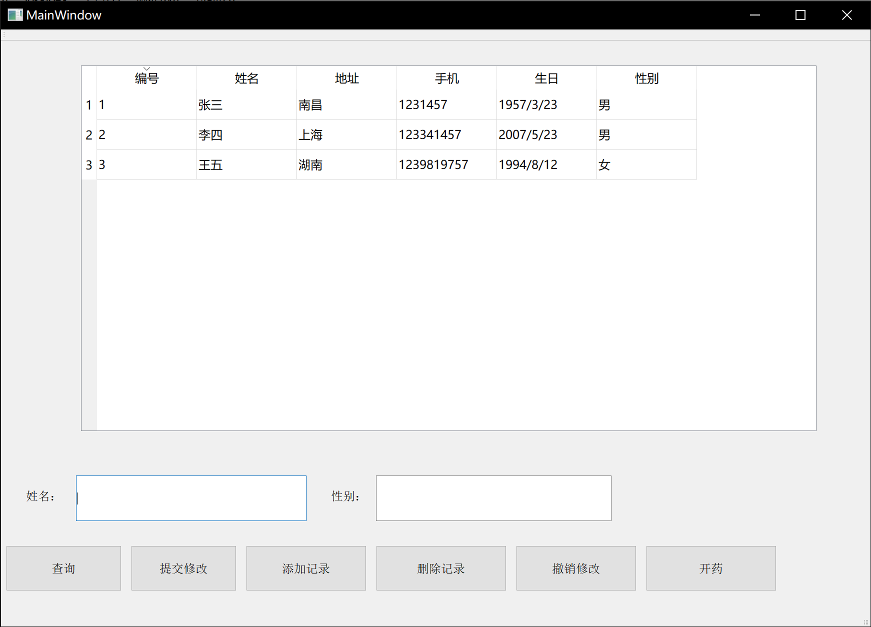结果：

