以下配置针对ros2 humble，ubuntu22.04系统（ros2 humble通过fishros一键安装即可，请务必也在无conda等虚拟环境的情况下安装ros2）
以下教程建议全程禁用 conda 及其他虚拟环境.特别提醒：即使是conda安装后自动启动的base环境也不可以，使用conda deactivate退出base环境。
请先观看《基于ardupilot的gazebo仿真环境配置教程.docx》，配置好ardupilot，gazebo，ardupilot_gazebo插件以后再看此教程
0．退出虚拟环境
bash
conda deactivate
conda config --set auto_activate false
使用命令行conda config --set auto_activate false配置 conda 不自动激活 base，这样不用每次开新终端时都执行conda deactivate。建议：不仅配置环境的时候不要使用虚拟环境，运行仿真的时候也不要使用虚拟环境。（特别是conda会对ros2 gazebo等这些硬件相关的工具的环境变量造成巨大的篡改，导致难以解释和解决的错误；即使是venv也很费事，为了简单就禁用虚拟环境吧）
- 安装mavros并下载地理信息数据
bash
sudo apt install ros-humble-mavros ros-humble-mavros-extras

sudo /opt/ros/humble/lib/mavros/install_geographiclib_datasets.sh
- 创建状态机代码的ROS2工作环境
bash
# 创建工作空间
mkdir -p ~/ws_offboard/src
cd ~/ws_offboard/src

# 创建功能包（包含依赖 mavros_msgs, geometry_msgs, rclcpp）
ros2 pkg create offboard_control --build-type ament_cmake --dependencies rclcpp geometry_msgs mavros_msgs

2.1编写状态机代码
在~/ws_offboard/src/offboard_control/src/文件夹下创建一个cpp代码，名字为offb_node.cpp，以下是代码内容：
cpp
/**
* @file offb_node.cpp
* @brief Pure takeoff solution 鈥?no setpoint during takeoff to avoid conflict.
*/

#include <rclcpp/rclcpp.hpp>
#include <geometry_msgs/msg/pose_stamped.hpp>
#include <mavros_msgs/msg/state.hpp>
#include <mavros_msgs/srv/command_bool.hpp>
#include <mavros_msgs/srv/set_mode.hpp>
#include <mavros_msgs/srv/command_tol.hpp>
#include <nav_msgs/msg/odometry.hpp>

#include <chrono>
#include <memory>
#include <string>
#include <vector>
#include <cmath>

using namespace std::chrono_literals;

enum class MissionState {
WAITING_FCU,
SETTING_GUIDED,
ARMING,
TAKEOFF,
FLYING_WAYPOINTS,
LANDING,
DONE
};

class OffboardControl : public rclcpp::Node {
public:
OffboardControl() : Node("offb_node") {
// QoS compatible with mavros
rclcpp::QoS odom_qos = rclcpp::QoS(rclcpp::KeepLast(10)).best_effort();
rclcpp::QoS state_qos = rclcpp::QoS(rclcpp::KeepLast(10)).best_effort();

state_sub_ = this->create_subscription<mavros_msgs::msg::State>(
"/mavros/state", state_qos,
std::bind(&OffboardControl::state_cb, this, std::placeholders::_1));

local_pos_sub_ = this->create_subscription<nav_msgs::msg::Odometry>(
"/mavros/local_position/odom", odom_qos,
std::bind(&OffboardControl::local_pos_cb, this, std::placeholders::_1));

setpoint_pub_ = this->create_publisher<geometry_msgs::msg::PoseStamped>(
"/mavros/setpoint_position/local", rclcpp::QoS(10).reliable());

arming_cli_ = this->create_client<mavros_msgs::srv::CommandBool>("/mavros/cmd/arming");
set_mode_cli_ = this->create_client<mavros_msgs::srv::SetMode>("/mavros/set_mode");
takeoff_cli_ = this->create_client<mavros_msgs::srv::CommandTOL>("/mavros/cmd/takeoff");
land_cli_ = this->create_client<mavros_msgs::srv::CommandTOL>("/mavros/cmd/land");

timer_ = this->create_wall_timer(50ms, std::bind(&OffboardControl::control_loop, this));

current_target_ = {0.0, 0.0, 0.0};
publish_setpoint_enabled_ = true;

RCLCPP_INFO(this->get_logger(), "Offboard node started (pure takeoff mode)");
}

private:
void state_cb(const mavros_msgs::msg::State::SharedPtr msg) {
current_state_ = *msg;
}

void local_pos_cb(const nav_msgs::msg::Odometry::SharedPtr msg) {
current_altitude_ = msg->pose.pose.position.z;
current_position_.x = msg->pose.pose.position.x;
current_position_.y = msg->pose.pose.position.y;
}

void publish_setpoint(double x, double y, double z) {
if (!publish_setpoint_enabled_) return;
geometry_msgs::msg::PoseStamped sp;
sp.header.stamp = this->now();
sp.header.frame_id = "map";
sp.pose.position.x = x;
sp.pose.position.y = y;
sp.pose.position.z = z;
sp.pose.orientation.w = 1.0;
setpoint_pub_->publish(sp);
current_target_ = {x, y, z};
}

void call_set_mode(const std::string& mode) {
if (!set_mode_cli_->service_is_ready()) return;
auto req = std::make_shared<mavros_msgs::srv::SetMode::Request>();
req->custom_mode = mode;
auto future = set_mode_cli_->async_send_request(req);
pending_set_mode_future_ = future.future.share();
RCLCPP_INFO(get_logger(), "Requested mode: %s", mode.c_str());
}

void call_arm(bool arm) {
if (!arming_cli_->service_is_ready()) return;
auto req = std::make_shared<mavros_msgs::srv::CommandBool::Request>();
req->value = arm;
auto future = arming_cli_->async_send_request(req);
pending_arm_future_ = future.future.share();
RCLCPP_INFO(get_logger(), "Requested arming: %s", arm ? "true" : "false");
}

void call_takeoff(float alt) {
if (!takeoff_cli_->service_is_ready()) {
RCLCPP_WARN(get_logger(), "Takeoff service not ready");
return;
}
auto req = std::make_shared<mavros_msgs::srv::CommandTOL::Request>();
req->altitude = alt;
auto future = takeoff_cli_->async_send_request(req);
pending_takeoff_future_ = future.future.share();
RCLCPP_INFO(get_logger(), "Takeoff command sent to %.1f m", alt);
}

void call_land() {
if (!land_cli_->service_is_ready()) return;
auto req = std::make_shared<mavros_msgs::srv::CommandTOL::Request>();
land_cli_->async_send_request(req);
RCLCPP_INFO(get_logger(), "Land command sent");
}

void control_loop() {
if (publish_setpoint_enabled_) {
publish_setpoint(current_target_.x, current_target_.y, current_target_.z);
}

if (pending_set_mode_future_.valid() &&
pending_set_mode_future_.wait_for(0s) == std::future_status::ready) {
auto result = pending_set_mode_future_.get();
if (result->mode_sent) {
RCLCPP_INFO(get_logger(), "GUIDED mode confirmed");
guided_mode_confirmed_ = true;
} else {
RCLCPP_WARN(get_logger(), "Set mode failed, will retry");
}
pending_set_mode_future_ = {};
}

if (pending_arm_future_.valid() &&
pending_arm_future_.wait_for(0s) == std::future_status::ready) {
auto result = pending_arm_future_.get();
if (result->success) {
RCLCPP_INFO(get_logger(), "Arming confirmed");
armed_confirmed_ = true;
current_target_ = {0.0, 0.0, TAKEOFF_ALT};
RCLCPP_INFO(get_logger(), "Setpoint target set to (0,0,%.1f) (will be published after takeoff)", TAKEOFF_ALT);
} else {
RCLCPP_WARN(get_logger(), "Arming failed, will retry");
}
pending_arm_future_ = {};
}

if (pending_takeoff_future_.valid() &&
pending_takeoff_future_.wait_for(0s) == std::future_status::ready) {
auto result = pending_takeoff_future_.get();
if (result->success) {
RCLCPP_INFO(get_logger(), "Takeoff command accepted by FCU");
} else {
RCLCPP_WARN(get_logger(), "Takeoff command rejected");
}
pending_takeoff_future_ = {};
}

switch (mission_state_) {
case MissionState::WAITING_FCU:
if (current_state_.connected) {
RCLCPP_INFO(get_logger(), "FCU connected");
mission_state_ = MissionState::SETTING_GUIDED;
}
break;

case MissionState::SETTING_GUIDED:
if (current_state_.mode == "GUIDED") {
guided_mode_confirmed_ = true;
}
if (!guided_mode_confirmed_ && !pending_set_mode_future_.valid()) {
call_set_mode("GUIDED");
} else if (guided_mode_confirmed_) {
mission_state_ = MissionState::ARMING;
}
break;

case MissionState::ARMING:
if (current_state_.armed) {
armed_confirmed_ = true;
}
if (!armed_confirmed_ && !pending_arm_future_.valid()) {
call_arm(true);
} else if (armed_confirmed_) {
mission_state_ = MissionState::TAKEOFF;
}
break;

case MissionState::TAKEOFF: {
static bool takeoff_sent = false;
publish_setpoint_enabled_ = false;

if (!takeoff_sent) {
call_takeoff(TAKEOFF_ALT);
takeoff_sent = true;
takeoff_start_time_ = this->now();
}
if (current_altitude_ >= TAKEOFF_ALT * 0.95) {
RCLCPP_INFO(get_logger(), "Takeoff reached target altitude (%.2f m)", current_altitude_);
publish_setpoint_enabled_ = true;
mission_state_ = MissionState::FLYING_WAYPOINTS;
takeoff_sent = false;
waypoint_index_ = 0;
last_waypoint_time_ = this->now();
current_target_ = {0.0, 0.0, TAKEOFF_ALT};
} else if ((this->now() - takeoff_start_time_).seconds() > 60.0) {
RCLCPP_WARN(get_logger(), "Takeoff timeout (60s), forcing to waypoints");
publish_setpoint_enabled_ = true;
mission_state_ = MissionState::FLYING_WAYPOINTS;
takeoff_sent = false;
}
break;
}

case MissionState::FLYING_WAYPOINTS: {
const std::vector<std::array<double, 2>> waypoints = {
{0.0, 0.0}, {5.0, 0.0}, {5.0, 5.0}, {0.0, 5.0}, {0.0, 0.0}
};
double z = TAKEOFF_ALT;

if (waypoint_index_ < waypoints.size()) {
double target_x = waypoints[waypoint_index_][0];
double target_y = waypoints[waypoint_index_][1];
current_target_ = {target_x, target_y, z};

double dx = current_position_.x - target_x;
double dy = current_position_.y - target_y;
double dist = std::hypot(dx, dy);
if (dist < 0.5) {
if ((this->now() - last_waypoint_time_).seconds() > 2.0) {
RCLCPP_INFO(get_logger(), "Waypoint %zu reached", waypoint_index_+1);
waypoint_index_++;
last_waypoint_time_ = this->now();
}
} else {
last_waypoint_time_ = this->now();
}
} else {
mission_state_ = MissionState::LANDING;
}
break;
}

case MissionState::LANDING: {
static bool land_sent = false;
if (!land_sent) {
call_land();
land_sent = true;
current_target_ = {current_position_.x, current_position_.y, 0.0};
}
if (current_altitude_ < 0.2) {
RCLCPP_INFO(get_logger(), "Landed, mission complete");
mission_state_ = MissionState::DONE;
}
break;
}

case MissionState::DONE:
RCLCPP_INFO(get_logger(), "Shutting down");
rclcpp::shutdown();
break;
}
}
rclcpp::Subscription<mavros_msgs::msg::State>::SharedPtr state_sub_;
rclcpp::Subscription<nav_msgs::msg::Odometry>::SharedPtr local_pos_sub_;
rclcpp::Publisher<geometry_msgs::msg::PoseStamped>::SharedPtr setpoint_pub_;
rclcpp::Client<mavros_msgs::srv::CommandBool>::SharedPtr arming_cli_;
rclcpp::Client<mavros_msgs::srv::SetMode>::SharedPtr set_mode_cli_;
rclcpp::Client<mavros_msgs::srv::CommandTOL>::SharedPtr takeoff_cli_;
rclcpp::Client<mavros_msgs::srv::CommandTOL>::SharedPtr land_cli_;
rclcpp::TimerBase::SharedPtr timer_;

mavros_msgs::msg::State current_state_;
double current_altitude_ = 0.0;
struct { double x=0, y=0; } current_position_;
MissionState mission_state_ = MissionState::WAITING_FCU;

struct Target { double x=0, y=0, z=0; } current_target_;
bool publish_setpoint_enabled_ = true;

const double TAKEOFF_ALT = 2.0;
size_t waypoint_index_ = 0;
rclcpp::Time last_waypoint_time_;
rclcpp::Time takeoff_start_time_;

std::shared_future<std::shared_ptr<mavros_msgs::srv::SetMode::Response>> pending_set_mode_future_;
std::shared_future<std::shared_ptr<mavros_msgs::srv::CommandBool::Response>> pending_arm_future_;
std::shared_future<std::shared_ptr<mavros_msgs::srv::CommandTOL::Response>> pending_takeoff_future_;
bool guided_mode_confirmed_ = false;
bool armed_confirmed_ = false;
};

int main(int argc, char **argv) {
rclcpp::init(argc, argv);
auto node = std::make_shared<OffboardControl>();
rclcpp::spin(node);
rclcpp::shutdown();
return 0;
}
以上状态机代码执行的效果是：无人机先起飞，再在（与地面平行的）平面内飞了一个矩形，最后降落回起飞点。
因为我的环境有两个缺陷：执行mode guided以后有可能不进入GUIDED模式；执行arm throttle以后有可能解锁失败，即使成功也有可能快速又锁上。状态机代码针对以上两点做了相应的处理：多次执行mode guided直到进入GUIDED模式，多次执行arm throttle，只要检测到解锁成功立马执行takeoff指令（防止重新被锁上）。
希望有人可以改进我的环境配置方法，进而解决这两个缺陷
2.2修改编译配置相关文件
编辑~/ws_offboard/src/offboard_control下的 CMakeLists.txt和 package.xml
CMakeLists.txt
cmake_minimum_required(VERSION 3.8)
project(offboard_control)

if(CMAKE_COMPILER_IS_GNUCXX OR CMAKE_CXX_COMPILER_ID MATCHES "Clang")
add_compile_options(-Wall -Wextra -Wpedantic)
endif()

# find dependencies
find_package(ament_cmake REQUIRED)
find_package(rclcpp REQUIRED)
find_package(geometry_msgs REQUIRED)
find_package(mavros_msgs REQUIRED)
find_package(nav_msgs REQUIRED)

if(BUILD_TESTING)
find_package(ament_lint_auto REQUIRED)
# the following line skips the linter which checks for copyrights
# comment the line when a copyright and license is added to all source files
set(ament_cmake_copyright_FOUND TRUE)
# the following line skips cpplint (only works in a git repo)
# comment the line when this package is in a git repo and when
# a copyright and license is added to all source files
set(ament_cmake_cpplint_FOUND TRUE)
ament_lint_auto_find_test_dependencies()
endif()

ament_package()

add_executable(offb_node src/offb_node.cpp)
target_include_directories(offb_node PUBLIC
$<BUILD_INTERFACE:${CMAKE_CURRENT_SOURCE_DIR}/include>
$<INSTALL_INTERFACE:include/offboard_control>)
target_compile_features(offb_node PUBLIC c_std_99 cxx_std_17)
ament_target_dependencies(offb_node rclcpp geometry_msgs mavros_msgs nav_msgs )

install(TARGETS offb_node
DESTINATION lib/${PROJECT_NAME})

package.xml
<?xml version="1.0"?>
<?xml-model href="http://download.ros.org/schema/package_format3.xsd" schematypens="http://www.w3.org/2001/XMLSchema"?>
<package format="3">
<name>offboard_control</name>
<version>0.0.0</version>
<description>TODO: Package description</description>
<maintainer email="zxx@todo.todo">zxx</maintainer>
<license>TODO: License declaration</license>

<buildtool_depend>ament_cmake</buildtool_depend>

<depend>rclcpp</depend>
<depend>geometry_msgs</depend>
<depend>mavros_msgs</depend>
<depend>nav_msgs</depend>

<test_depend>ament_lint_auto</test_depend>
<test_depend>ament_lint_common</test_depend>

<export>
<build_type>ament_cmake</build_type>
</export>
</package>
2.3开始编译
bash
cd ~/ws_offboard
colcon build --packages-select offboard_control
source install/setup.bash
编译成功以后终于可以开始运行状态机代码了
3运行状态机代码
开启终端1：运行gazebo（以下命令行中的export是针对Nvidia显卡，详情请看《基于ardupilot的gazebo仿真环境配置教程.docx》）
bash1
export __NV_PRIME_RENDER_OFFLOAD=1
export __GLX_VENDOR_LIBRARY_NAME=nvidia
export __VK_LAYER_NV_optimus=NVIDIA_only
gz sim -v4 -r ~/ardupilot_gazebo/worlds/iris_runway.sdf
正常运行结果如下图
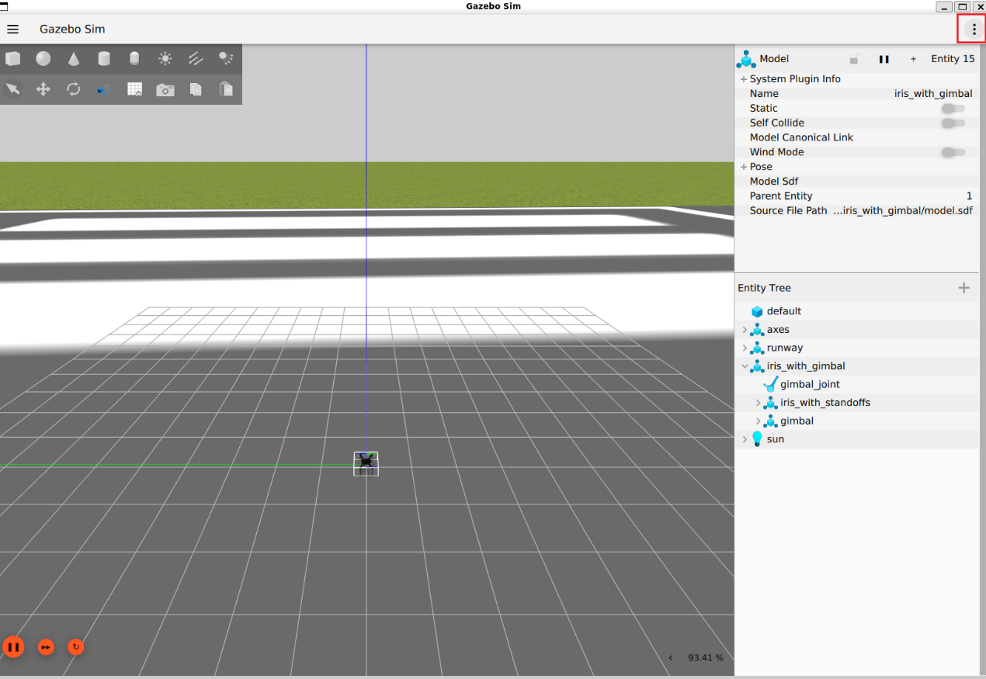
开启终端2：运行飞控ardupilot
bash2
cd ~/ardupilot/Tools/autotest
python3 ./sim_vehicle.py -v ArduCopter -f gazebo-iris --model JSON --map --console --out=udp:127.0.0.1:14550
正常运行结果：
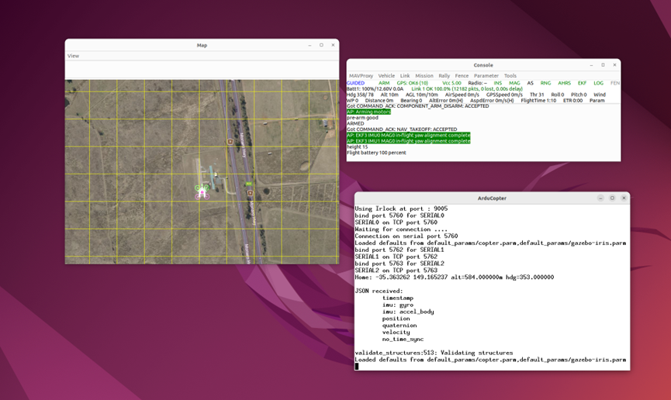
应该会出现如图三个窗口：Map（世界地图），Console(临时控制台，里面是你的状态机代码对应的输出)，ArduCopter
（如果发现Map里没有出现四翼无人机标志，请耐心等待）
开启终端3：运行mavros
bash3
ros2 run mavros mavros_node --ros-args -p fcu_url:=udp://:14550@
可能会出现关于mavros.distance_snesor的报错，这是一个有待解决的问题，但这并不影响运行状态机代码
开启终端4：运行状态机代码
bash4
source ~/ws_offboard/install/setup.bash
ros2 run offboard_control offb_node
如果一切顺利，你应该能看到无人机先起飞，再在（与地面平行的）平面内飞了一个矩形，最后降落回起飞点。

