Rental Pricing Analysis  30 Veterans Memorial Parkway  30 Veterans Memorial Pkwy, East Providence, RI 02914  Prepared by Ria Driscoll • November 9, 2026 • Marketed as “The Residences at Bold Point” | 

Subject property
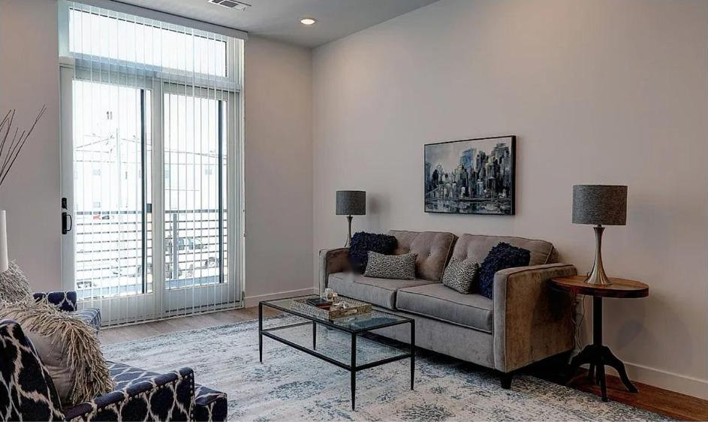 | 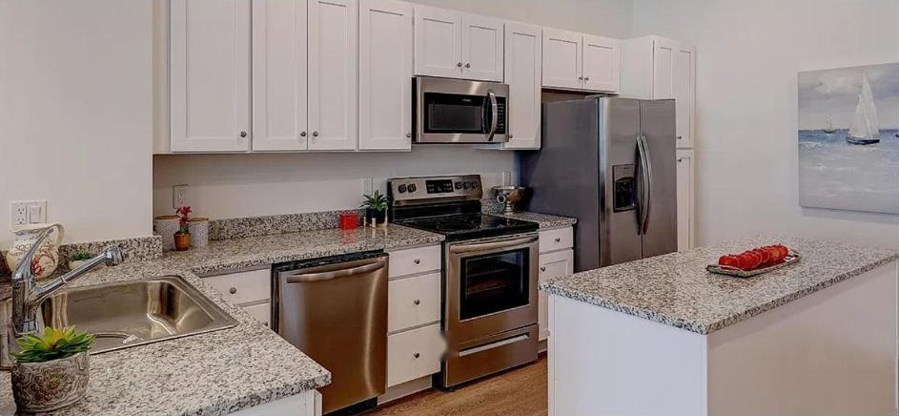 | 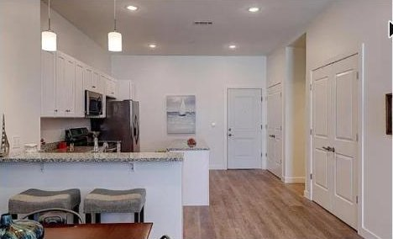

Built  2021 | Units / stories  34 / 3 | Bed / bath  1 / 1 | Sq ft (available units)  753–896 | Current asking rent  $1,975–$2,200

Units currently available
Unit | Bed / bath | Sq ft | Available | Asking rent | $ / sq ft
A104 | 1 bd / 1 ba | 896 | Now | $1,975 | $2.20
A210 | 1 bd / 1 ba | 807 | Now | $2,100 | $2.60
A207 | 1 bd / 1 ba | 753 | Now | $2,200 | $2.92

Amenities  - In-unit washer/dryer  - Parking  - Balcony  - Pet-friendly  - Well-appointed kitchen  - Open layout  - Ample natural light | Where it is listed  - Zillow listing: https://www.zillow.com/apartments/east-providence-ri/30-veterans-memorial-parkway/CkBMzR/  - Apartments.com listing: https://www.apartments.com/the-residences-at-bold-point-east-providence-ri/khwhvf8/  - RI State-Wide MLS #: [MLS # / link if listed]

Our recommendation
$2,075 – $2,200 / month
Current asking rents are correctly positioned for the market; A104 is now testing the lower end at $1,975.
Nine comparable 1BR/1BA units within 5 miles support a market range of $1,788 to $2,333 a month, with a blended average of about $2,082 ($2.79 per square foot). The subject's current asking rents of $1,975 to $2,200 sit inside that range, with A210 and A207 tracking the average closely; A104, the largest unit at 896 sq ft, was reduced to $1,975 and is now the lowest-priced 1BR per square foot in the set. The three newest, amenity-rich communities (Newport Avenue, Kettle Point, The Christine) set the top of the range; the subject does not carry a pool, clubhouse or elevator, so we do not recommend pricing to that tier. Two signals argue against pushing higher: 1000 Providence Place #384 has sat at $2,300 for 145 days, and HelloData shows 1-bedroom listings across the comp set averaging 48 days on market over the trailing month.
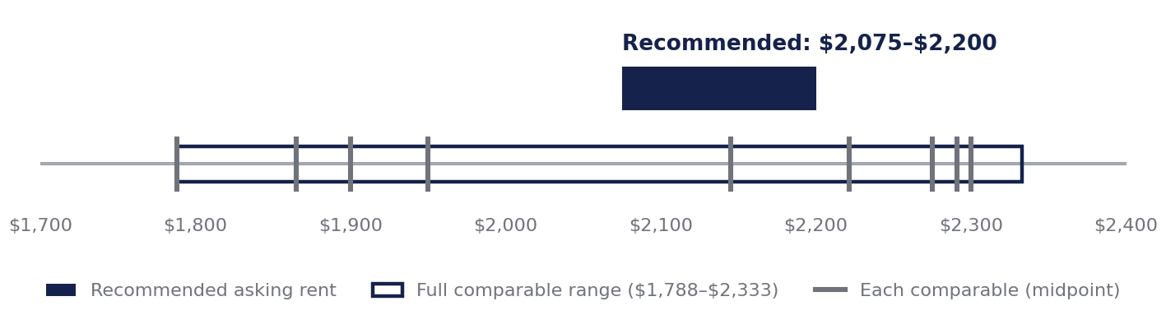
Blended average rent, 9 comps  $2,082 | Average rent per sq ft  $2.79 | Comparable rent range  $1,788–$2,333 | Subject’s current asking  $1,975–$2,200 | Avg 1BR days on market (HelloData)  48 days
The comparables side by side
Property | Built | Units / stories | Sq ft | Rent | $ / sq ft | DOM | Distance
135–153 Waterman Avenue | 2023 | 25 / 3 | 711 | $1,788 | $2.52 | 25 | 0.67 mi
446 Waterman Ave | 2025 | 34 / 3 | 710 | $1,900 | $2.68 | — | 1.5 mi
East Point Apartments | — | — | 710 | $2,291 | $3.23 | 56 | 1.72 mi
Kettle Point | 2018 | 228 / 4 | 656–741 | $2,171–$2,272 | $3.18 | 83 | 1.9 mi
Wayland Manor Apartments | 1925–1926 | 109 / 7 | 783 | $1,950 | $2.49 | — | 2.2 mi
Newport Avenue Apartments | 2024 | 142 / 4 | 689–899 | $2,007–$2,283 | $2.70 | 96 | 4.2 mi
1000 Providence Place #384 | — | Condo | 741 | $2,300 | $3.10 | 145 | ~3.0 mi
Landings on the Trail | 1968 | 71 / 3 | 750 | $1,805–$1,925 | $2.49 | — | 4.8 mi
The Christine Apartments | 2023 | 432 / 4 | 784–888 | $2,217–$2,333 | $2.72 | — | 4.9 mi
Days on market: HelloData property averages across all unit types (Kettle Point, 135–153 Waterman, Newport Avenue, East Point); MLS days on market for 1000 Providence Place. Not reported for the remaining comps.

How we chose comparables
We start with Rentometer and HelloData pulls for 1-bedroom units near the subject, then verify each candidate against its live listing on Zillow, Apartments.com and the regional MLS (RI State-Wide MLS; SmartMLS for Connecticut). Candidates are scored on distance, building size and age, unit size and amenity match, with extra weight on in-unit laundry and parking. Properties that fail on bed/bath mix, ownership type or scale appear under “Reviewed and excluded” so you can see what was considered.

Reviewed and excluded
- Ambassador Providence (77 Pitman St, Providence) — No 1BR/1BA units; only 2BR/1BA and 3BR/2BA floor plans.
- 54 Pitman St, Unit 5 (Providence) — Individually owned condo rented by its owner, not a professionally managed community.
- Winchester Park and Woods (125 Village Grn N, East Providence) — 478 units, built 1978, shared laundry; roughly 14× the subject's scale.
- MLS #1420890, 1424879, 1427444, 1426731 (Wesleyan Ave, Bentley St, California Ave, Grape St) — Small older-stock units of 430–675 sq ft, including a below-grade unit, priced $1,225–$1,650; not comparable in product type or finish.

Comparable properties
135–153 Waterman Avenue Strongest match
135–153 Waterman Ave, East Providence, RI 02914 • 0.67 mi from subject • HelloData
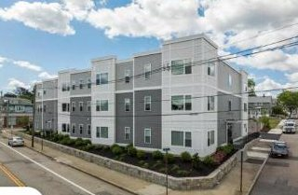 | 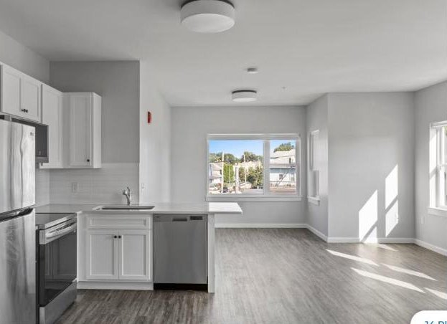 | 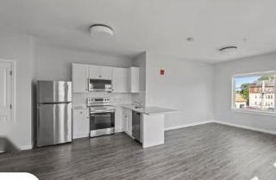

Built  2023 | Units / stories  25 / 3 | Bed / bath  1 / 1 | Sq ft  711 | Rent  $1,788 | $ / sq ft  $2.52 | Days on mkt  25

Community amenities  - Fitness center  - Pets allowed  - Madison Management | In-unit  - Central air  - Dishwasher  - Hardwood floors  - In-unit washer/dryer
Closest comp to the subject (under a mile) and the highest HelloData similarity score (79%); small new-construction building with in-unit laundry. Its $1,788 sets the floor of the range.
446 Waterman Ave Strongest match
446 Waterman Ave, East Providence, RI 02914 • 1.5 mi from subject • Apartments.com
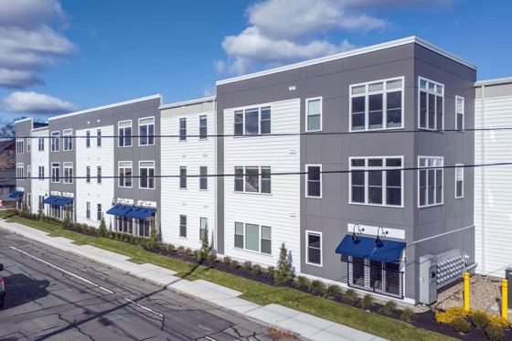 | 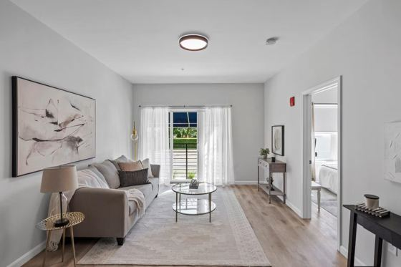 | 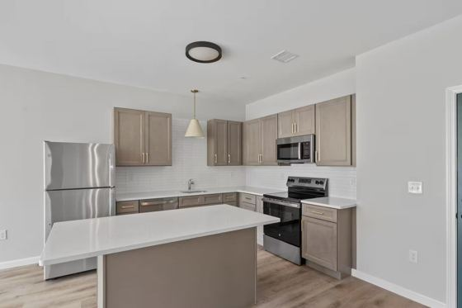

Built  2025 | Units / stories  34 / 3 | Bed / bath  1 / 1 | Sq ft  710 | Rent  $1,900 | $ / sq ft  $2.68

Community amenities  - Covered parking  - 24-hour maintenance  - Fitness center  - Online rent & maintenance portal | In-unit  - In-unit washer/dryer  - Central air  - Electric heat
Closest match to the subject in age, in-unit washer/dryer and scale (34 units, 3 stories).

East Point Apartments Moderate match
140–150 East Point Dr, Rumford, RI 02916 • 1.72 mi from subject • HelloData
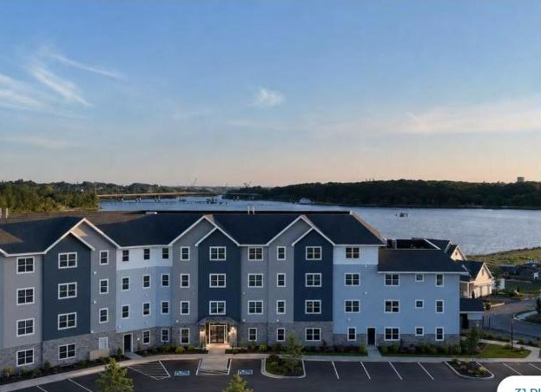 | 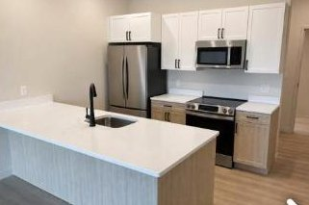 | 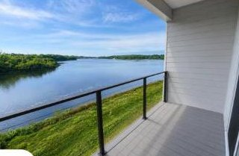

Built  — | Units / stories  — | Bed / bath  1 / 1 | Sq ft  710 | Rent  $2,291 | $ / sq ft  $3.23 | Days on mkt  56

Community amenities  - Elevator  - Fitness center  - Pets allowed  - Churchill & Banks Companies | In-unit  - Hardwood floors  - High ceilings  - Patio or balcony  - Stainless appliances  - In-unit washer/dryer
Large lease-up with 56 units advertised and 8 leases in the last 30 days; top of the 1BR set on a per-foot basis. Year built and unit count not yet published.
Kettle Point Moderate match
12 Captain John Jacobs Rd, East Providence, RI 02914 • 1.9 mi from subject • Apartments.com
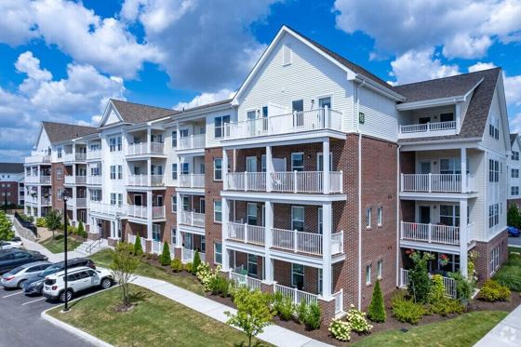 | 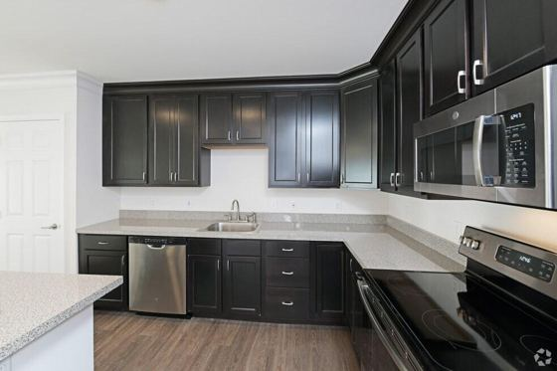 | 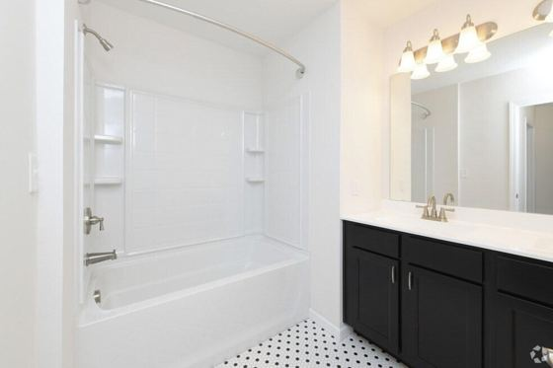

Built  2018 | Units / stories  228 / 4 | Bed / bath  1 / 1 | Sq ft  656–741 | Rent  $2,171–$2,272 | $ / sq ft  $3.18 | Days on mkt  83

Community amenities  - Fitness center  - Pool  - Clubhouse  - Elevator  - + 5 more | In-unit  - Washer/dryer  - Air conditioning  - Balcony/patio  - Walk-in closets
Newer waterfront community with a full amenity package (228 units); sets a premium ceiling above the subject.

Wayland Manor Apartments Context only match
500 Angell St, Providence, RI 02906 • 2.2 mi from subject • Apartments.com
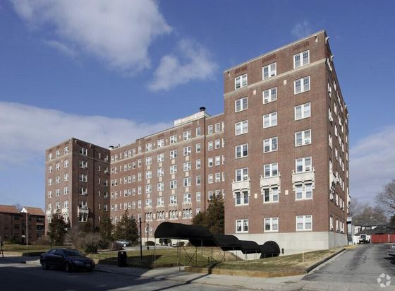 | 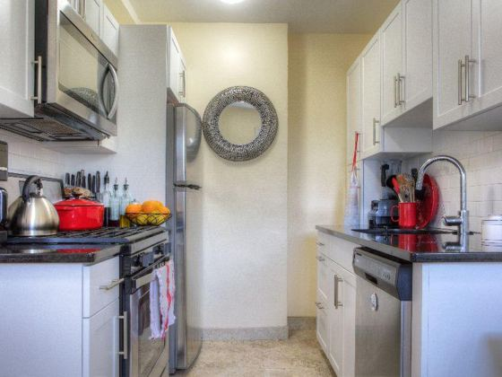 | 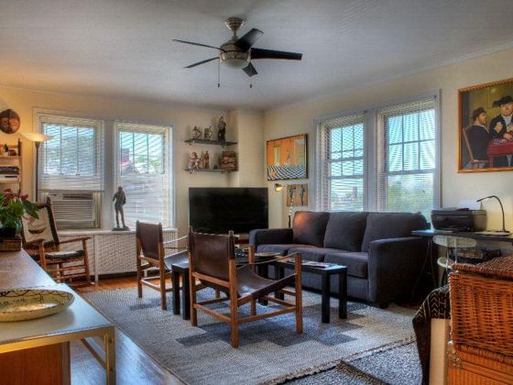

Built  1925–1926 | Units / stories  109 / 7 | Bed / bath  1 / 1 | Sq ft  783 | Rent  $1,950 | $ / sq ft  $2.49

Community amenities  - Fitness center  - Laundry facilities  - Elevator  - Bicycle storage  - + 2 more | In-unit  - Air conditioning  - High-speed internet
Included for rent-range context; differs materially in scale (109 units, 7 stories), age (1925–26) and lacks in-unit laundry.
Newport Avenue Apartments Moderate match
95 Newport Ave, Rumford, RI 02916 • 4.2 mi from subject • Apartments.com
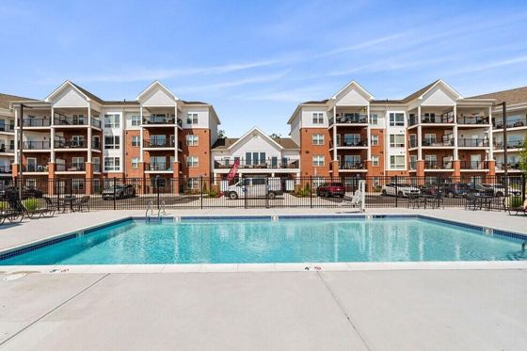 | 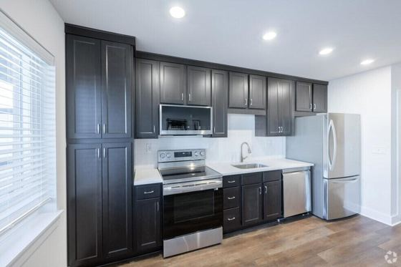 | 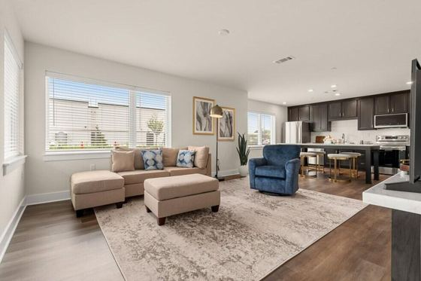

Built  2024 | Units / stories  142 / 4 | Bed / bath  1 / 1 | Sq ft  689–899 | Rent  $2,007–$2,283 | $ / sq ft  $2.70 | Days on mkt  96

Community amenities  - Fitness center & pool  - Gated  - Courtyard  - Elevator  - + 4 more | In-unit  - Washer/dryer  - Air conditioning  - Balcony/patio  - Floor-to-ceiling windows  - Walk-in closets
New construction with resort-style amenities and roughly four times the unit count.

1000 Providence Place #384 Moderate match
1000 Providence Place, Providence, RI 02903 • ~3.0 mi from subject • RI State-Wide MLS #1414833
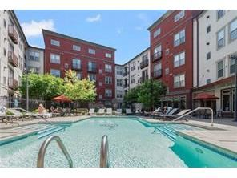 | 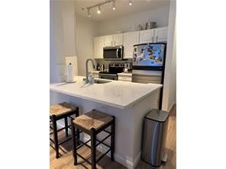 | 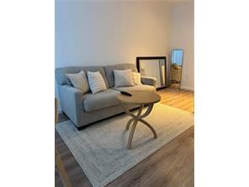

Built  — | Units / stories  Condo | Bed / bath  1 / 1 | Sq ft  741 | Rent  $2,300 | $ / sq ft  $3.10 | Days on mkt  145

Community amenities  - Pool  - Clubhouse & lounge  - Fitness center  - Theater room  - + 2 more | In-unit  - In-unit washer/dryer  - Open kitchen with island  - Hardwood-style floors
Only comparable unit in the MLS search. Listed 06/09/2026 and still active after 145 days at $2,300: evidence that the upper end of the range is slow to absorb.
Landings on the Trail Moderate match
1355–1357 Wampanoag Trl E, Riverside, RI 02915 • 4.8 mi from subject • Apartments.com
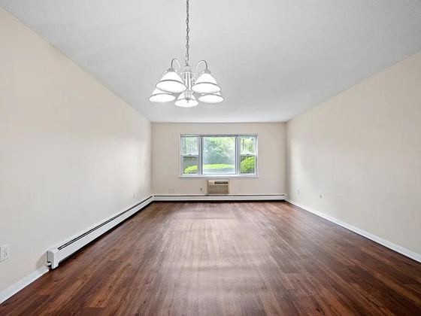 | 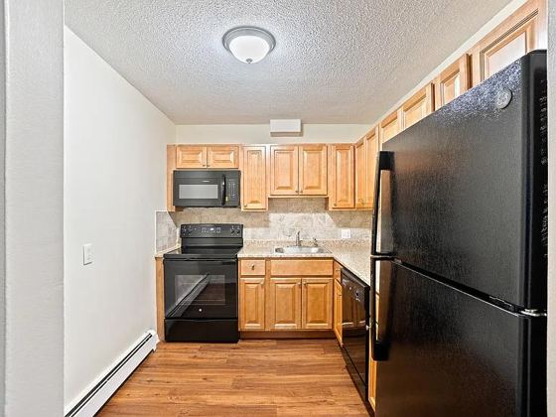 | 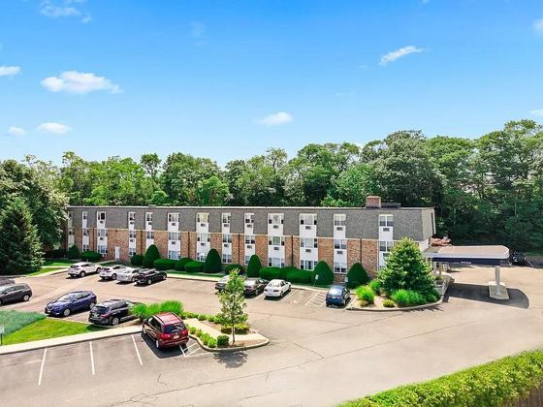

Built  1968 | Units / stories  71 / 3 | Bed / bath  1 / 1 | Sq ft  750 | Rent  $1,805–$1,925 | $ / sq ft  $2.49

Community amenities  - 24-hour fitness center  - Swimming pool  - Elevator  - On-site management | In-unit  - Walk-in closets  - Updated kitchens & baths (select units)  - Plank flooring (select units)
Same story height but double the unit count, built about 50 years earlier, and the farthest comp in the set.

The Christine Apartments Moderate match
1279 Wampanoag Trl, Riverside, RI 02915 • 4.9 mi from subject • Apartments.com
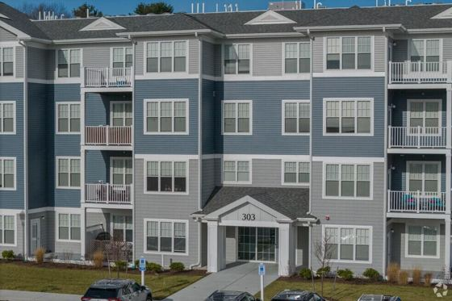 |  | 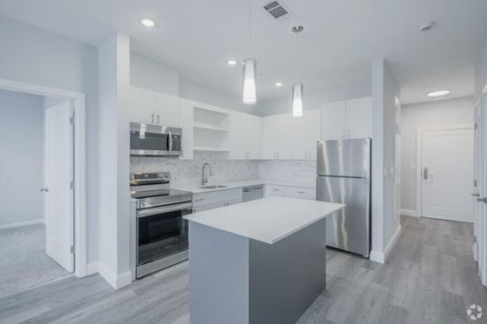

Built  2023 | Units / stories  432 / 4 | Bed / bath  1 / 1 | Sq ft  784–888 | Rent  $2,217–$2,333 | $ / sq ft  $2.72

Community amenities  - Fitness center & pool  - Clubhouse & lounge  - Business center  - Tennis & pickleball courts  - + 2 more | In-unit  - Washer/dryer  - Air conditioning  - Balcony/patio  - High ceilings  - Den (select units)
Largest and newest community in the set (432 units); represents the top of the market for the area.

Weekly listing update — October 15 – October 22, 2026
Nine leads this week across both platforms (4 Zillow, 5 Apartments.com), with all three available units still active. Zillow views converted to leads at 1.6% this week, down from the listing-to-date rate of 3.9%, which is typical as a listing ages. One Apartments.com prospect has requested a tour; we are scheduling for early next week.
Zillow Rental Manager (Premium listing) | Apartments.com leads  Call log  - 10/16 10:25 am — 2:06  - 10/20 1:12 pm — 0:17  - 10/21 2:43 pm — 2:15  Email inquiries  - 10/15 — tour request for late Monday morning or early afternoon; prospective move date 12/14/2026  - 10/16 — follow-up inquiry from the same prospect; 45 sec on listing page
  Metric | This week | Listing to date
  Impressions | 10,590 | 47,693
  Listing views | 252 | 1,268
  Web referrals | 4 | 39
  Total leads | 4 | 49
  Phone leads | 0 | 4
  Email leads | 4 | 45
  Ad impressions | 2,699 | 12,547
  Ad clicks | 63 | 398
  Phone calls  3 | Emails  2
  Tours booked  0 | Applications  0

Tours and prospect feedback
One tour was requested through Apartments.com this week and is being scheduled; no tours were completed in the period, so there is no prospect feedback to report yet. This section will carry tour counts and what prospects tell us about price, the unit and the building each week.
Tours scheduled  1 | Tours completed  0 | Applications received  0
What prospects told us
- [Prospect feedback on price — e.g. “felt fair for a new building with in-unit laundry”]
- [Feedback on the unit — layout, finishes, light, storage]
- [Feedback on the building or location — parking, noise, commute]
- [Reasons given for not applying, if any]
What we are doing this week
- Schedule the requested tour for the Apartments.com prospect.
- Watch A104 at the new $1,975: if it leases quickly, hold A210 and A207; if not, price is not the issue.
- Review A207 ($2,200, 753 sq ft) if no application by 11/15; it is the highest $/sq ft of the three.
Sources: Rentometer, HelloData, Zillow, Apartments.com, Rhode Island State-Wide MLS, SmartMLS (CT). Comparable data verified against live listings on the report date; rents and availability change frequently. Photos of comparable properties are from their public listings. Prepared for the owner of 30 Veterans Memorial Parkway by PKL Management LLC.

