Citation
Kato, A. (2006). Error analysis of high school student essays. Accents Asia [Online], 1 (2), 1-13. Available: http://www.accentsasia.org/1-2/kato.pdf
Error Analysis of High School Student Essays

Asako Kato
Fudooka Seiwa High School

Introduction
Ever since the introduction of oral communication into the school curriculum in 1989, speaking has drawn attention as an important skill for Japanese students to master. A variety of speaking and listening practices have been experimented within high school English classes. Writing has also been included as an extensive practice. The 2003 revision of the Course of Study emphasizes “writing” as a vehicle of communication to convey messages according to the purpose and the situation (MEXT, 2003). However, in many of the university entrance exam-oriented high schools, writing classes are modified into grammar-centered classes; in other words, the students are accustomed to writing short sentences based upon the structures or the grammar points they are taught, and chances of writing effective essays are limited (Minegishi, 2005). It is true that grammar processing is needed for accurate production, but it is a challenge to teach how to write essays or even paragraphs within the available classroom hours, with the exception perhaps of some foreign language elective courses in select high schools.
Under these circumstances, the English Composition Division of the Saitama Senior High School English Education and Research Association hosts writing contests, for the purpose of encouraging students to test their English knowledge and to enhance their production skills in the form of writing. The contest consists of two sections: a translation section and an essay writing section. In the essay section the participants are given topics and expected to write their opinions in about 200 words. They have 80 minutes to work on translation and essay writing. The translation sentences are assigned according to level, but the essay topic is the same for all. The translation part is marked and graded by Japanese teachers; the essays are evaluated by ALTs (Assistant Language Teachers) according to three criteria: creativity, organization and grammar. The winners are chosen depending on the total points of the two sections. In this paper, I will shed some light on the essays and analyze them with a view towards identifying problems students have, which will provide evidence of how English is learned and what strategies students are employing to construct their essays. The primary focus of this paper is on grammar in writing not creativity and organization, but some pedagogical suggestions for teaching and learning are also mentioned.

Methods
The data analyzed for this study are errors in students’ essays written in an essay competition held in Saitama Prefecture, Japan. In this contest, the participants were given the topic, “If you were to meet a celebrity, who would you like to meet? What would you like to ask him/her? What would you like to do with him/her?” The errors in the essays were categorized based on Ferris’ (2005) Analysis Model (Fig.1). Her “Common ESL writing errors” fall into four categories; morphological errors, lexical errors, syntactic errors, and mechanical errors. This model is based upon the “Description of the major error categories” (Fig. 2), which covers verb errors, noun ending errors, article errors, word wrong, and sentence structure (p.92). According to James (1998), an error analysis model must be “well-developed, highly elaborated, and self-explanatory” (p.95). Ferris’ model fulfills these needs. With this system it is easy to identify global and local errors (Burt and Kiparsky, 1972, cited in James, 1998) which I added to Ferris’ model of major errors in Figure 1. Global errors are major errors in sentence structure, which makes a sentence difficult or impossible to understand, whereas local errors are minor mistakes, which do not cause problems of comprehension. In Ferris’ classification, syntactic errors are considered global errors. Mechanical and lexical mistakes, on the other hand, are local errors. Morphological errors can be global errors, but when they do not hinder readers’ understanding of the content they are local errors.

Figure 1
Common ESL Writing Errors based on Ferris’(2005) Model
Morphological Errors → global / local errors
Verbs: Tense, From, Subject-verb agreement
Nouns: Articles/determiners, Noun endings (plural/possessive)
Lexical Errors → local errors
Word choice, Word form, Informal usage, Idiom error, Pronoun error
Syntactic Errors → global errors
Sentence structure, Run-ons, Fragments
Mechanical → local errors
Punctuation, Spelling, Capitalization*
* “Capitalization” is added in this study.

Figure 2
Description of major error categories (Ferris, 2005)
Verb errors | All errors in verb tense or form, including relevant subject-verb agreement  errors.
Noun ending errors | Plural or progressive ending incorrect, omitted, or unnecessary; includes relevant subject-verb agreement errors
Article errors | Article or other determiner incorrect, omitted, or unnecessary
Word  wrong | All specific lexical errors in word choice or word form, including preposition and pronoun errors. Spelling errors only included if the (apparent) misspelling resulted in an actual English word.
Sentence  structure | Errors in sentence/clause boundaries(run-ons, fragments, comma splices), word order, omitted words or phrases, unnecessary words or phrases; other unidiomatic sentence construction.

Participants
The essays analyzed for this study were written by 148 high school students: 46 first year students, 58 second year students, and 44 third year students; 48 males and 100 females. The participants’ high schools consisted of twenty public schools and two private schools. Most of these schools are considered “academic” high schools in that they prepare students for university exams, which means the students tend to be highly motivated and are expected to be able to utilize their English grammar, structure knowledge and vocabulary in writing.

Procedure
All errors were marked and classified. They were first classified into global errors or local errors. The verb-related errors were considered as “verb errors”, therefore, they were considered morphological errors. However, confusion in the use of transitive/intransitive verbs was considered a global syntactic error because it affects the whole sentence structure. Also, tense errors were anticipated because the essay topic “If you were to meet a celebrity…?” presumably requires the use of the conditional. As long as the errors did not interfere with the understanding of the sentence, they were put into tense errors, i.e., morphological errors.
It was sometimes difficult to draw the line between lexical errors and mechanical errors; that is, whether the word is a wrong choice or simply a spelling mistake. If the word had a separate meaning but exists as a word, then it was treated as lexical error; otherwise, it was marked as a mechanical error. However, if an inappropriate word choice disrupts the meaning in the whole sentence, it was considered a syntactic error. In short, the decision of error classification depends on each sentence. As for repeated mechanical errors in the same sentence, i.e., spelling mistakes, punctuation, and capitalization, the multiple mistakes were counted as one.

Findings and Discussion
First of all, not all errors were easily categorized: some went beyond and across the categories. In each case, errors were carefully identified and classified according to the seriousness of the problem. If one major error included other minor errors, then together they were considered to be a major error. For example, a sentence “*And, I want to *go to abroad such as the UK, the US, *French, *Australlia and so on” was categorized as one syntactic error because the misuse of verb and adverb (go to abroad) causes sentence diffusion, even though this sentence included one lexical error (French) and one mechanical error (Australlia).
Secondly, a danger with lists of “common” ESL/EFL errors, as Ferris (2005) herself points out, is that they may be over-generalized to all students. Of course, individual students have different language capabilities and learning traits; for example, one student constantly omitted articles and another student confused tense of verbs all through her essay. Although the statistics give a general picture of the problems, these do not apply to every student.
While keeping these considerations in mind, the statistics provide interesting information. The total number of errors was 1518 (596 in 46 first year essays, 491 in 58 second year essays, and 431 in 44 third year essay). The average number of errors per student was 13.5 for the first year students, 11.2 for the second year students, and 9.8 for the third year students. Considering the short length of the essay, these were not small numbers, although the average number of errors decreased according to the students’ year in school. As a total, syntactic errors dominated the rest at 29%, followed by lexical errors (21%), morphological errors in nouns and mechanical errors (18%), and morphological errors (14%). According to the school year, the most common errors observed in first year essays were lexical errors, which comprised 24% of the total, while syntactic errors comprised most errors in second and third year essays, which amounted to 35.2% and 31.1% respectively. Among the first years’ lexical errors, “word choice” was the most common mistake (93 in total). As for second year and third year samples, as many as 158 and 121 errors were made respectively in “sentence structure.” These findings indicate that first year students did not have sufficient vocabulary while the second and third year students did not use it adequately.

Table 1.
Common EFL Writing Errors in Japanese High School Students’ Essays
Error Type |  | Percentage of Total Errors Marked (%)
 |  | 1st year | 2nd year | 3rd year | Average
Morphological Errors  Lexical Errors  Syntactic Errors  Mechanical | (Verbs)  Tense  Form  Subject-verb agreement  Total Verb Errors  (Nouns)  Articles/determiners  Noun endings  Total Noun Errors  Word choice  Word form  Informal usage  Idiom error  Pronoun error  Total Lexical Errors  Sentence structure  Run-ons  Fragments  Total Syntactic Errors  Punctuation  Spelling  Capitalization  Total Mechanical Errors | 5.87  5.87  0.67  12.4  10.6  8.22  18.8  15.6  1.51  1.01  3.19  2.68  24.0  15.3  1.34  3.19  19.8  5.7  14.4  4.87  25.0 | 8.96  1.22  2.65  12.8  11.0  5.91  16.9  13.6  4.07  0.61  1.02  3.87  23.2  32.2  0.61  2.44  35.2  1.43  6.11  4.28  11.8 | 11.1  2.09  4.64  17.9  9.98  8.12  18.1  9.51  3.25  0.23  1.16  2.55  16.7  28.1  1.86  1.16  31.1  1.86  11.4  3.02  16.2 | 8.66  3.06  2.65  14.4  10.5  7.42  17.9  12.9  2.94  0.62  1.79  3.04  21.3  25.2  1.27  2.26  28.7  3.0  10.6  4.05  17.7
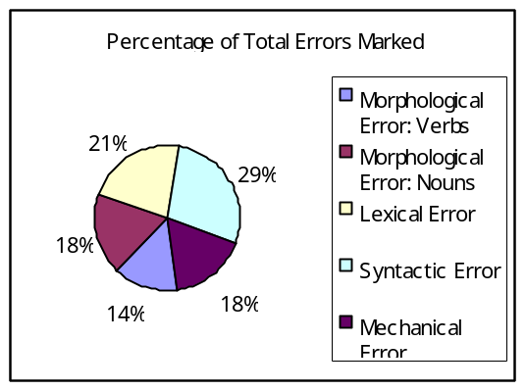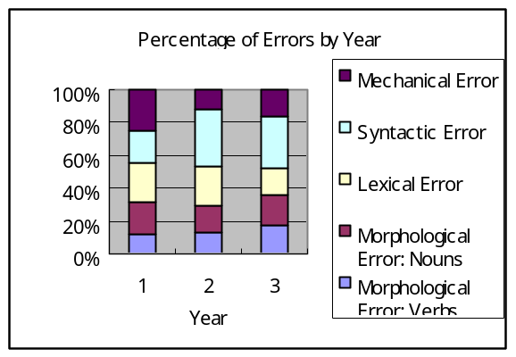

The syntactic errors, the most prevalent errors, were mainly related to verbs, for example, the misuse of be-verbs, transitive and intransitive verbs, auxiliary verbs, no verb use, the word order in indirect questions, and tense confusion in relation to the conditional. From an English educator’s point of view, it was rather disappointing that many students made errors in the use of basic verbs such as “go”, “want” and “listen”, such as in “*I want to go my future”, “*I want become a doctor”, and “*I want to listen the story”. In the case of errors in conditional sentences, on the other hand, the structure was usually grammatically correct, but the meaning was irrational. For example, if a writer mentioned a celebrity such as a historical man/woman, movie actor, singer, athlete or an imaginary character, s/he had to make the sentence conditional. However, some used simple present tense. One of these examples is, “*If I ride Doraemon’s time machine, I can go everywhere”. This type of error was put into verb tense errors under morphological errors. As an explanation of Japanese students’ use of conditional, Thompson (2001) asserts that even when students have mastered the mechanics of forming unreal conditionals and wishes in all their complexity, the problem of concept remains. Additionally, it is difficult for Japanese students to use conditionals correctly, for there is a disparity in the use of conditionals in English and Japanese.
Another characteristic in the syntactic errors stemed from interference from Japanese, their mother tongue (L1 interference). L1 interference is considered a major obstacle to second and foreign language acquisition (Ellis, 2003; Ferris, 2005; Lightbrown & Spada, 2002; Littlewood, 2002. Some examples from students’ essays are as follows:
(a)* He challenged. (彼は挑戦した。)
(b)* They hit all over the world since 1984.
(彼らは1984年以来世界中でヒットした。)
In these sentences, the writers used English equivalents for the Japanese words, i.e., (a) 挑戦するchousen-suru=challenge, and (b) ヒットするhitto-suru=hit. Incidentally, the verbs “challenge” and “hit” are transitive verbs, which means these sentences are grammatically incorrect; therefore, they were classified as syntactic errors. Other syntactic errors from L1 interference are observed in relation to the choice of prepositions. The examples are:
(c) *I will join to children’s network of UNICEF.
(ユニセフの子どもネットワークに入るつもりだ。)
(d) *I want to marry with him. （彼と結婚したい。）
The writers translated the Japanese prepositional particle “に[ni]” into “to” in example (c) and “と[to]” into “with” in example (d). This type of error is common among Japanese students because transitive verbs include prepositions in their Japanese meanings; therefore it is hard to distinguish whether a verb is transitive or prepositional from the translated meanings.
The second dominant error category was that of lexical errors, especially in first year student essays. Here again L1 interference was observed in word choices.
(e) *I think his baseball soul is the biggest of all.
(彼の野球魂は他に比べるものが無いだろう。)
(f) *I want to hear Murasaki Shikibu three questions. (私は紫式部に３つ質問したい。)
In (e), “soul” and “big” do not match with each other in this context. The writer meant to say, “I think he has the strongest spirit in baseball.” In Japanese “soul” and “spirit” are given the same translation as “魂（たましい）tamashii.” Besides, neither soul nor spirit can be “big” but rather “strong”. In (f), the verb “hear” is derived from the Japanese word “聞く(きく) kiku”, which can also mean “listen” or “ask” in Japanese. These students seemed to have picked up words without thinking about content and collocation. Presumably, in English class, there is a tendency for students not to consult dictionaries for language usage but to look up word meaning only, then memorize the main translation of the word, and use this translation regardless of context.
The third and fourth prominent error categories were noun related morphological errors and mechanical errors, especially spelling mistakes. In noun errors, article errors outnumbered the rest, accounting for as much as 10% of the total. The problem with articles stems from the fact that the Japanese language has no concept of articles and the countable and uncountable distinction. It is natural that Japanese students have difficulty in using them correctly. In addition, articles are introduced near the end in many of grammar textbooks, which in a sense is parallel to the language acquisition order described by Littlewood (2002) of a study of children acquiring morphemes in their native language. Plurals and articles have always been, and will continue to be difficult to teach to Japanese students, which is why some teachers wait until the end of school year to introduce them in class.
Spelling mistakes, sorted as mechanical errors, comprised 10% of the total number of errors. This was partly because many students applied Japanese (katakana) pronunciation to English spellings. For example, writers who spelled *performence (performance), *calacter (character), and *confort (comfort) did not seem to spell according to his/her understanding of the pronunciation, but from how the words sound through the filter of katakana.
Lastly the problem of organization as well as the use of conjunctions needs to be mentioned. Sentences starting with “because” were categorized as fragments which belonged to syntactic errors, whereas sentences starting with “and” and “so” were not treated as errors. “And” and “so” are taught as conjunctions that connect two phrases that carry equal weight in the sentence, whereas “because” is taught as a conjunction followed by a subordinate clause. However, the fact is that as many as 75 “and”s and 89 “so”s were observed at the beginning of the students’ sentences. James (1998) states that learners tend to overuse connectors to support logical relationships between propositions that just do not exist. It is probable that few students have learned how to organize English writing; that is, they do not know they should start with an introduction, followed by a main body, and then a conclusion, paying attention to the consistency of their thoughts. Those who were not familiar with English writing ended up listing items in order: who they wanted to meet, what they would like to do, and where they would like to go. Without cohesive devices such as paraphrasing and rephrasing, or markers that direct the logical flow of sentences, the writers could not communicate their ideas effectively.

Conclusion
How, then, can teachers empower students to become better writers? Obviously the class time allotted for writing is limited, yet there are things teachers can do in order to improve students’ writing in other English classes.
Judging from the fact that sentence fragments outnumbered other errors in this study, teachers need to draw students’ attention to the whole sentence structure and sentence combining when discussing verbs and other grammar points in class. The confusion between transitive/intransitive verbs and prepositional verbs can be pointed out in reading class, bringing awareness to the differences between English and Japanese. When students come up with a new verb, or even a familiar one, they should be aware of the conceptual gap between English and Japanese. One good example of a split between Japanese and English is the word 見る (to see). There are many more English verbs for miru. In Japanaese miru is used when you perceive with your eyes, when you watch, look, view, overlook or investigate; when you take care of somebody like children or sick people, as in “kodomo wo miru”. You can even say miru when you try something, like ‘mitemiru’ or ‘yattemiru’, literally “try to see” and “try to do” respectively. Therefore, it is confusing for students to select the suitable equivalent of miru in English. They have to think about the context. Kowalski (2005) gives usages of 見る in Figure 4:

Figure 4 Different kinds of meanings associated with 見る
見る | see (something that falls within your field of vision)
見る | look (intentionally at a stationary object)
見る | watch (something moving)

Also, the gap between English and Japanese applies not only at sentential level but also to the lexical level. As I mentioned earlier, L1 interference affects both sentence structure and word choice. Underlying knowledge of usage and collocation enables students to choose the right words in right the places in their writing. Because of the avalanche of Japanese-English in the media, however, it has become even more difficult to eliminate these Japanglish words from students’ vocabulary. Teachers and learners should pay special attention not reinforce these words and phrases in the English language classroom.
Good writing, however, does not rely only on grammatical and lexical accuracy but also on the creativity in context and the logical flow of sentences. In order to write coherent, well-structured paragraphs and essays, the writers have to be creative and concentrate on the content as well. First, teachers can help students raise their awareness of how to organize English writing, and how units of sentences and paragraphs are connected with one another to form meaningful text. By recognizing the importance of coherency in their writing, the students can dedicate themselves to the ideas or message that they are trying to convey. I employ “process writing” for the improvement of this skill. In contrast to translation or guided composition, “process writing” emphasizes the processes such as planning, drafting, and reviewing (Johnson & Johnson, 1998 cited in Furneaux, 2000). In this contest, only a few participants seemed to employ this approach, possibly because of the time constraints of the competition. By reflecting on their writing process, students will internalize their grammatical and lexical knowledge and utilize it for production.
Another effective approach to improve writing skill is to work on other language skills. All four skills are interconnected. Even though writing classes are not consistently available in school curriculums, compared to reading and oral communication classes, students can cultivate their writing skills by consciously reading or listening. Krashen and Terrell (1983) claim that speech and writing production emerges by focusing on listening and reading. Extensive reading outside of the class, for instance, will become a rich source for extensive writing. Exposure to authentic writing will help students expand their vocabulary and write well-organized, reasonably cohesive essays.
In conclusion, I believe that Japanese students can become competent writers of English with the appropriate support from teachers. Quoting Kramsch (1993): “Teachers have to impart a body of knowledge, but learners have to discover that knowledge for themselves in order to internalize it” (p.6). I suggest that teachers integrate the grammar focus while encouraging creativity and teaching organizational form. Learners, on the other hand, can enrich their knowledge of language by taking every opportunity to use it, developing learning strategies outside of the class, and reflecting on the writing process before, during and after they write.

References
Ellis, R. (2003). Second language acquisition. (8th ed.). Oxford: Oxford University Press.
Ferris, D.R. (2005).Treatment of error in second language writing. Ann Arbor: The University of
Michigan Press.
Furneaux, C.(2000). Process writing. The University of Reading school of linguistics and applied
language studies. Retrieved September 29, 2005, from
http://www.rgd.ac.uk/AcaDeps/cl/slas/process.htm
James, C.(1998).Errors in language learning and use Exploring error analysis. Essex: Pearson
Education Limited.
Kowalski, C. (2005). Translation in the writing class: friend or foe? In K. Bradford-Watts, C.
Ikeguchi, & M. Swanson (Eds.). JALT2004 Conference Proceedings. Tokyo: JALT
Kramsch, C. (1993). Context and culture in language teaching. New York: Oxford University Press.
Krashen, S.D. & Terrell, T. (1983). The natural approach: Language acquisition in the classroom.
San Francisco:The Alemany Press.
Lightbrown, P.M. & Spada, N. (2002). How languages are learned. (2^{nd.} ed). Oxford: Oxford
University Press.
Littlewood, W. (2002). Foreign and second language learning. (17th ed.). Cambridge: Cambridge
University Press.
Minegishi, H. (2005, March). The questionnaire result. Saitama high school English education
bulletin, 41.49-59.
Ministry of Education, Culture, Sports, Science, and Technology. The course of study for foreign
languages. (2003, March). Retrieved November 20, 2005, from
http://www.mext.go.jp/english/shotou/030301.htm
Sonoda, N. (2005). A comparative study of two approaches to English writing: translation and
process writing. In K. Bradford-Watts, C. Ikeguchi, & M. Swanson (Eds.). JALT2004
Conference Proceedings. Tokyo: JALT
Thompson, I. (2001). Japanese speakers. In M. Swan & B. Smith (Eds), Learner English: A
teacher’s guide to interference and other problems. Cambridge: Cambridge University Press.

Citation
Leung, M. (2006). Attitudinal and motivational differences among Japanese junior high school students towards English education in Japan. Accents Asia [Online], 1 (2), 14-79. Available: http://www.accentsasia.org/1-2/leung.pdf
Attitudinal and Motivational Differences Among Japanese Junior High School Students Towards English Education in Japan

Michael K. Leung

Introduction
In Japan, English is studied as a foreign language throughout six years of compulsory education. In this EFL setting, not only are opportunities to speak to native speakers very limited, there is also a cultural detachment or distance between the social context in which the learner lives and the social context from which English comes, i.e., an English-speaking country. These two factors may produce feelings of doubt, for example, as to the value of the study of English, which occurs in a setting where there may be few immediate rewards for the language study being done. It was suggested by Lott (1978) that English in EFL countries such as Jordan does not play any significant role in internal communication, and a limited role in contact with the outside world. Until prospects for use open up, he continues, the learner may feel that within his/her country, the learning of English is of little significance. This is potentially a problem that learners of English in Japan currently face as well.
The current study examines attitudes and motivation and its role in the study of English in the Japanese junior high school EFL setting. The study of attitudes and motivation began as the socio-psychological theory of second- or foreign-language learning at McGill University and the University of Western Ontario in Canada. The theory proposed was that, "...a successful learner of a second language must be psychologically prepared to adopt various aspects of behaviour which characterize members of another linguistic-cultural group" (Gardner & Lambert, 1972, p.3).

Review of Literature
Gardner and Lambert (1972) have done extensive research on the roles of attitudes and motivation in the study of English in both ESL and EFL situations. In their words, motivation is
The combination of effort plus desire to achieve the goal of learning the language plus favourable attitudes toward learning the language. That is, motivation to learn a second language is seen as referring to the extent to which the individual works or strives to learn the language because of a desire to do so and the satisfaction experienced in this activity. (p.10)

Research in motivation dates back to 1949 where Jones (1949, 1950; cited in Gardner & Lambert, 1972) did research in Wales, England, using an index of interest in learning a language. Since then, research on attitudes and motivation has been done extensively by Gardner and Lambert, starting as early as 1959 in Montreal, Canada. They wrote that the learner's degree of ethnocentricity, his/her attitudes towards the members of the group whose language is being studied, attitudes towards foreign people in general, and his/her orientation toward the learning task, are believed to be influential on how successful he/she will be in learning the language.
Gardner and Lambert (1972) have studied attitudes and motivation in a range of ESL and EFL situations and have developed a simple classification of motivation as either (1) instrumental, where "the purposes of language study reflect the more utilitarian value of linguistic achievement, such as getting ahead in one's occupation" (p.3), or (2) integrative, "if the student wishes to learn more about the other cultural community because he is interested in it in an open-minded way, to the point of eventually being accepted as a member of that other group" (p.3).
Gardner and Lambert (1972) conducted a study in Louisiana, U.S.A., in a community where English-speaking Americans and French-Americans were socially close, to the point that stable attitudes toward one another could be formed, but not so fixed that individual attitudes of favourableness and unfavourableness would not be apparent. A similar study was conducted, but in a different setting, in Hartford, Connecticut. This community was chosen for study because, unlike the bicultural community found in Louisiana, the community in Harford consisted of a wider mix of linguistic and cultural backgrounds, including French-Americans, such that exposure to French-Americans was not exclusive, but rather a part of the cultural mix. This was noted as being more representative of most large East Coast cities.
The results for both of these studies indicated that the students' grades in French derived from a strong motivation and desire to learn the language. However, in Connecticut, this motivation appeared to be integrative, whereas in Louisiana, it appeared to be instrumental (Gardner & Lambert, 1972, p.52). In the Japanese EFL setting, because there are relatively few native English speakers, there can be very little cultural mixing, much less than that found in Louisiana, so one might expect instrumental motivation to play a larger role than integrative motivation.
Some researchers have studied the role of attitudes and motivation in different cultural settings and with different age groups. Benson (1991) conducted a study on 311 freshmen in a private Japanese university. It was in this study that Benson introduced the concept of personal motivation, which is in addition to instrumental and integrative motivation, an addition he introduced to satisfy the analysis of the EFL situation in Japan. He states that this addition is necessary because,
a good number of students have been observed to be interested in English for reasons which could not realistically be termed either instrumental or integrative. These include, for example, pleasure at being able to read English, and enjoyment of entertainment in English...They appear to relate to individual development and satisfaction. (p. 36).

In his study, Benson found a clear rejection of instrumental motivation, and little support for integrative and personal motivation. He concludes that the "rejection of instrumental reasons reinforces the idea that the students do not see English as playing a vital part in their lives, either currently or in the future" (p.36). These results would appear to contradict those of Gardner and Lambert’s (1972) Louisiana study, although it should be noted that the setting in Benson’s (1991) study was EFL, whereas Gardner and Lambert’s was ESL.
Teweles (1996) studied motivational differences between Chinese and Japanese EFL learners of English at the university level, each group studying in their respective countries. The Chinese group showed an inclination toward instrumental motivation, while the Japanese learners showed a slight preference for integrative motivation. The results for the Japanese students are similar to what Benson (1991) found. However, in extrapolating the findings of these two studies of Japanese students to the present study, the differences in the age groups involved must be kept in mind, i.e., that motivation may vary according to the stage in a learner’s life at which s/he is studying English.
A study done in 1977 by Oller, Hudson and Liu produced results suggestive of a general positive correlation between attitudes toward the target language group and attained proficiency in ESL. In this study of Chinese-speaking foreign students studying at the graduate level in the United States, however, a significant negative correlation between desire to stay in the U.S. and attained ESL proficiency was also observed, which was contrary to their predictions. They interpreted the results as suggesting that it is not always the case that students who score high on proficiency tests necessarily have positive feelings towards the culture from which the language comes.
In a study by Gardner, Smythe and Clement (1979) of American and Canadian adult students studying in an intensive French program, an integrative motive factor was found for both groups, but while there was an observed relationship between the integrative motive and French oral proficiency for the Canadian students, this was not observed for the Americans. Interestingly, the American group demonstrated a decreased appreciation of the French Canadian community, and yet an increased desire to learn French.
Belmechri and Hummel (1998) reported in a study of francophone high school students in Quebec, Canada, that students' orientations towards learning English as a second language were found to be: school (instrumental), career (instrumental), travel, friendship, and understanding, with an absence of an integrative orientation. They defined "travel", "friendship", and "understanding" as neither integrative nor instrumental, but rather as motivations in their own right because their students had expressed friendly feelings towards Anglophones, and they wanted to think and behave like them, but they had no intention of integrating into that community. It must be kept in mind that some items cannot be neatly categorized as integrative, instrumental, or personal. Gardner and Lambert's (1972) definition of "travel" as an instrumental motivator was adopted in the present study, i.e., the use of English to facilitate traveling.
In a study of grade nine Francophone students living in a bicultural setting in Canada, it was found by Labrie and Clement (1986) that contact with Anglophones and self-confidence with English as a second language were related to motivation.
The effects of the demands of working society on students' motivation to study a language has been suggested by Bausenhart (1984). In this study of Anglophone and Francophone students of German in a Canadian university, it was found that a majority of students indicated integrative reasons for the study of German, rather than utilitarian (instrumental) reasons. They offered a possible explanation as being that perhaps the Canadian business community had not yet succeeded in entering the world market to a degree as to offer job opportunities for linguistically competent people. A corollary of this in the current study could be that as English is apparently becoming required for more and more jobs in Japan, instrumental motivation would be expected to be high.
Research has been done on attitudes and motivation in relation to a number of factors: proficiency (Gardner & Lambert, 1972; Teweles, 1996; Chihara & Oller, 1978), ethno-linguistic vitality (Labrie & Clement, 1986) and language learning background factors (Gradman & Hanania, 1991). The results of the research reviewed here appear to be varied and dependent upon various factors: exposure to native-English speakers may increase integrative motivation; the potential for employment opportunities may increase instrumental motivation, and conversely, the lack of such opportunities may increase integrative motivation.
The sample populations in these studies have included elementary and high school students, post-secondary and graduate students, but not junior high school students in an EFL setting. The study presented here examined attitudes and motivation in a group of junior high school-level learners in Japan who study EFL English in a setting where there is little direct exposure to English and native-English speakers, in a country where entrance examinations and tests are very prominent, and where English ability is becoming an important asset for employment.

Purpose of the Study
The purpose of this study was to investigate what the primary sources of motivation are for Japanese junior high school students studying EFL English, and whether there are changes in the attitudes and motivations of Japanese junior high school students towards English education in Japan as they progress from first-year to third-year of study. It was hypothesized that third-year students would be more instrumentally motivated than both the first- and second-year students, particularly by entrance examinations for high school.

Methods
Subjects
The subjects were students in a public junior high school in Sayama City, in southeast Japan. Mandatory, public English education in Japan presently begins from the first year of junior high school (i.e., grade 7, or approximately age 13) and continues to the end of junior high school (i.e., grade 9, or approximately age 15), a total of three years, and for another three years in high school (i.e., grades 10 to 12, or approximately ages 16 to 18).
A questionnaire, described in the following section, was administered to the student population of 389 students at this school. However, as it was voluntary, some students did not respond, while others misunderstood one or more of the instructions, rendering their data invalid. In total, then, complete data was gathered from 276 students (71%).
There were 93 students from the first grade (male=40, female=53; mean age=13 years); 117 students from the second grade (male=65, female=52; mean age=14 years); and 66 students from the third grade (male=29, female=37; mean age=15 years).
At the time of the study, all students were being taught by a Japanese teacher of English, who was occasionally assisted by an Assistant English Teacher, a native speaker of English and the author of this study. The school is a public junior high school where the students have English lessons three times per week, for 37 weeks per academic year, for a total of approximately 111 lessons. Since each lesson is usually 50 minutes in length, total instruction time per year is approximately 93 hours.
The questionnaire was administered at the end of March, the end of the academic year in Japan. The timing was such that the first-year students (grade 7) had just completed one year of junior high school EFL English study, the second-year students two years, and the third-year students, three years. At the time of administration of the questionnaire, first-year students would have had approximately 93 hours of lessons, second-year students approximately 186 hours, and third-year students approximately 279 hours.

Questionnaire
A questionnaire was produced to assess the opinions of junior high school students on English education in Japan (Appendix D). The questionnaire was given in Japanese, the students' first language. In Appendix D, an English translation is provided.
The questionnaire consisted of five questions. The first question ("A") asked the students to evaluate 19 reasons for Japanese people to study English. The students were asked to identify three reasons they thought were the most important reasons, and to mark them in order of importance (i.e., 1, 2, 3), labeled “Important”, and another three reasons they thought were the least important reasons for studying Japanese, from most to least unimportant (i.e., X1, X2, X3). For simplicity in the analysis, these items will be referred to as "Not Important." The remaining 13 items were to be left unmarked. Items included, for example, "Passing of English proficiency tests", "Traveling abroad", "Studying about foreign countries", etc. The results of question "A" were analyzed using homogeneity analysis and principal component analysis.
The second question ("B") listed 16 classroom activities that were commonly used in the junior high school English classes that these students are exposed to, which are also representative of the array of activities used in EFL teaching. They included: "Reading to oneself", "Listening to stories", "Translating English into Japanese", etc. Each student was asked to mark three activities that they liked the most, and three activities that they disliked the most, in a manner similar to that of question "A". The activity marked as the most-liked was assigned a value of '3', the second most-liked activity a value of '2', and the third most-liked activity a value of '1'. Unmarked activities were not assigned any value.
Similarly, when looking at the disliked activities, the most-disliked activity received a value of ‘3’, the second most-disliked activity a value of ‘2’, and the third most-disliked activity a value of ‘1’. Again, unmarked activities were not assigned any value. The “disliked activities” were analyzed separately from the “liked activities.” The results of question “B” were analyzed by ranking the activities according to the sum of their assigned values.
The third question (“C”) was worded in a way that was more personal than that of question “A”, but essentially the same information was gathered. Question “A” was worded, “The following items are some reasons why Japanese people study English…” The items of question “C” reflected specific scenarios that all students could directly relate to, i.e., the question started, “I study English…”, and a possible completion was, “…because my parents make me.” The students were asked to answer with either a “Yes”, “No”, or “Not applicable.” The purpose of the subtle contrast in wording between these two questions was to show possible similarities and/or parallels between students’ opinions regarding English education in general, and their opinions regarding their personal situations.
The fourth question (“D”) assessed whether they study English outside of day school, which in Japan usually occurs in the form of private evening “cram” school lessons, and whether they had traveled or lived abroad.
The final question (“E”) was an open-ended question, giving the students a chance to express whether their way of thinking towards English had changed from the time they entered junior high school to the present.
The focus of the analysis is on question “A”. The 19 items were categorized as either “integrative”, “instrumental”, or “personal” (Appendix A, Questionnaire Question A—Types of Motivators), based on classifications previously determined by Gardner and Lambert (1972), Benson (1991), and Teweles (1996). As noted above, the use of computers for learning is so diverse that different uses of computers would determine which of the three categories Item 2, “Using computers or the Internet”, would fall under. For simplicity of understanding for the student, this item was not stated in more specific terms on the questionnaire. As such, however, this has been categorized as “instrumental/integrative.” It should be noted that this item could also be considered a personal motivator.
The analysis of the data for question “A” was done using the Statistical Package for the Social Sciences for Windows, Version 9.0.0. (1998).
The questionnaire was first administered to two second-year students as a pilot to assess the clarity of wording of the questionnaire. Based on the students’ comments, the questionnaire was adjusted accordingly before being administered to the full student population. The questionnaire was done during the homeroom periods, taking approximately ten minutes for completion.

Results
Opinions on English Education—Question “A”
The first question on the survey was designed to establish the students’ opinions on the relative importance of 19 items related to English education and learning in Japan (see Appendix A, Questionnaire Question A—Types of Motivators). The data consisted of responses from 276 junior high school students.
The raw data was collapsed to form the following variables: (1) Grade (this refers to the grade of the student: 1=first grade; 2=second grade; 3=third grade); this was analyzed as ordinal data; (2) Item (this refers to items one to 19 from the questionnaire), analyzed as multiple nominal data; and (3) Importance (this is the relative importance assigned to a given item by the student, where 3=important, 2=neutral/unmarked, and 1=not important), analyzed as ordinal data. ‘Grade’ and ‘Importance’ are analyzed as ordinal data based on the assumption that the three grades and the three levels of importance are ordered sequences.
Using principal component analysis (optimal scaling), the output for the first analysis was as follows (See Fig.1):

Figure 1.
Principal component analysis 1 of “Grade”, “Item”, and “Importance”.
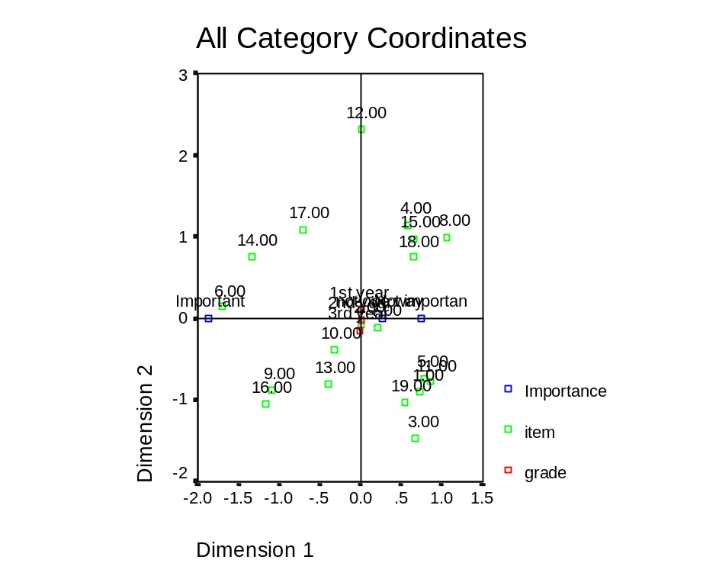

The variation between the grades (“1st year”, “2nd year”, and “3rd year”) along Dimension 2 is 0.009 (Appendix B, Principle Component Analysis 1, Summary of Analysis). This would suggest that there is very little difference between the ways that each grade scored the 19 items. In contrast, the variation between the levels of importance is 0.682, suggesting that there is, as would be expected, a difference between what is construed as “Important” versus “Not important”. “Important” falls on the negative side of Dimension 1, at –1.87, while “Not Important” is at +0.74. Because this type of analysis is primarily graphic, the interpretation follows as such. Items 6, 14, 16, 9, and 17, fall close to “Important”. These items would be interpreted as being important reasons for English study for this sample; they represent “Entrance exams”, “Broaden one’s point of view”, “Self-confidence in speaking”, “Traveling”, and “Study about foreign countries,” respectively. Only Item 14, “Broaden one’s point of view” would be considered an integrative motivator. The others that fall close to “Important” are instrumental motivators. The full output appears in Appendix B, Principle Component Analysis 1.
A similar analysis was done, this time with the variable “Grade” analyzed as multiple nominal data. This was done based on the assumption that attitudes in different grades is not an ordered sequence, in contrast to the first principle component analysis. The output appears below (See Fig.2), with a full output in Appendix B, Principle Component Analysis 2.

Figure 2.
Principal component analysis 2, analyzed with “grade” as a multiple nominal.
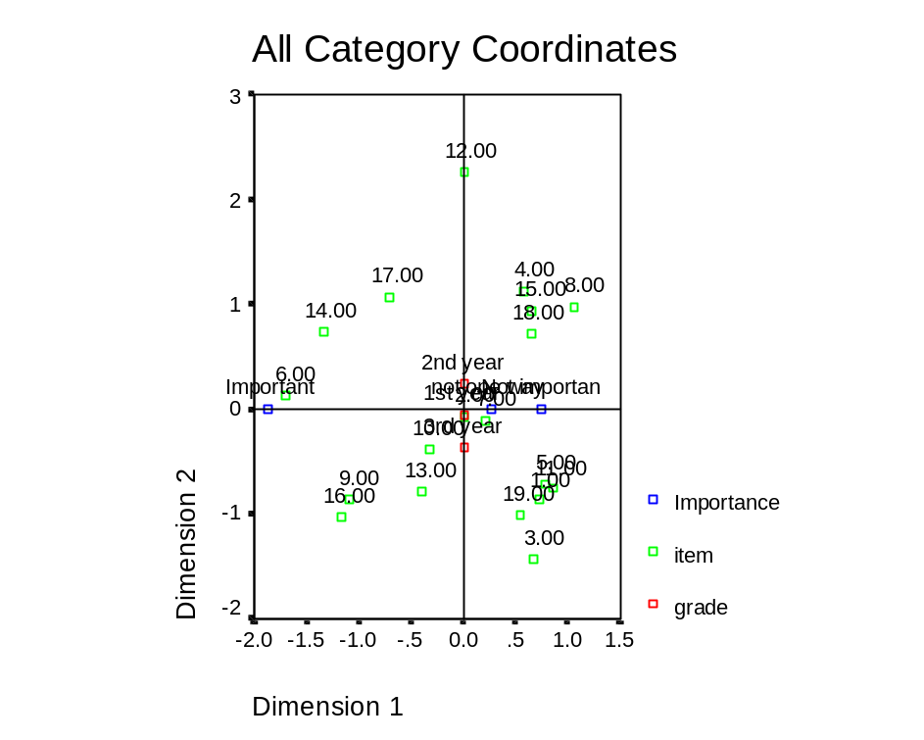

The variance for Grade was 0.058 (Appendix B, Principle Component Analysis 2, Summary of Analysis); this was slightly stronger than that obtained when “Grade” defined as an ordinal (0.009) as in the first principal component analysis (above, Fig. 1), but still very weak. Again, the interpretation would be that there is very little difference between how the three grades of students scored the 19 items. As there were no other changes in the analysis, the values for “Importance” (Appendix B, Principle Component Analysis 2, “Importance”) were unchanged from those of the first principle component analysis (above, Fig. 1), while those of “Item” varied marginally from those of the first analysis (Appendix B, Principle Component Analysis 1, “Importance”). Graphically interpreted, the same items were chosen as “Important” in both analyses: Items 6, 14, 16, 9, and 17.
A third analysis of the data used homogeneity analysis. The three variables, “Grade”, “Item”, and “Importance” were analyzed as multiple nominal data, in contrast to the second principle component analysis, where only the first two variables were analyzed as such. This is based on the assumption that there is no previous ordering of the values of the variables. The output is shown in Figure 3.

Fig.3.
Homogeneity analysis of Grade, Item and Importance.
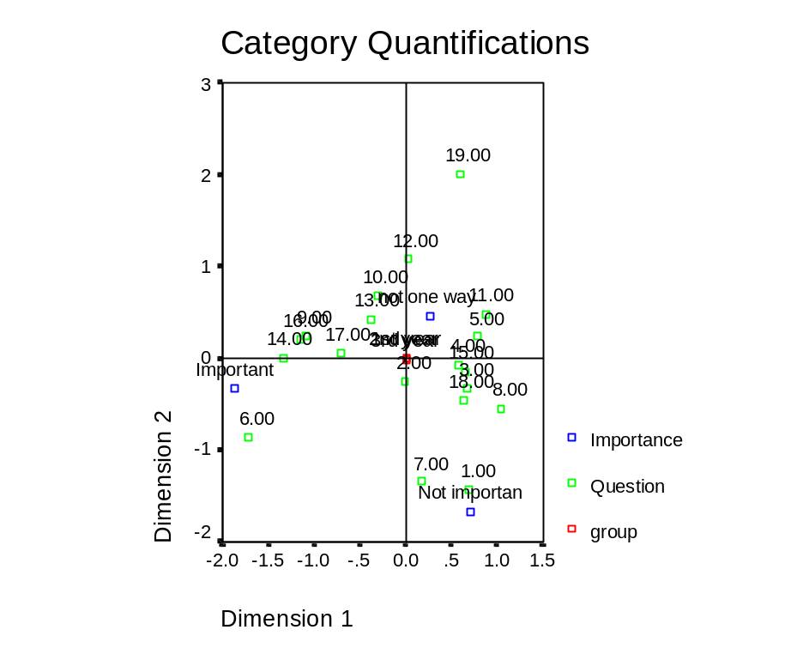
The output shows an almost perfect overlap between the three grades, suggesting little or no variation between how the grades scored the 19 items. From the numerical output, there is only minimal variation (-0.01 along Dimension 2) for “3rd year” (Appendix B, Homogeneity Analysis, “Marginal Frequencies and Category Quantifications”, “Group”). There is a clustering of items around “Important”, consistent with both previous principal component analyses, of Items 6, 14, 16, 9, and 17. Again, with the exception of Item 14, “Broaden one’s point of view”, all items are instrumental motivators.
In this analysis, Items 7 and 1, “Getting a good job” and “Passing English proficiency exams”, respectively, are clearly situated near “Not important.” This result would suggest that employment and proficiency exams are not considered important reasons for studying English for these students. English proficiency exams in Japan (commonly known by the abbreviated term, eiken) are voluntary, can be taken at any age, and can be an asset in finding employment. In contrast, entrance examinations are required of all students, by all high schools, both private and public. The contrast between the occurrence of Item 6, “Entrance examinations”, close to “Important”, and Item 1, “Passing English proficiency exams”, close to “Not important”, would suggest the relatively higher motivation for examinations of English that are required to enter high schools versus those done voluntarily, which would be beneficial for employment.

Likes and Dislikes in Classroom Activities—Question “B”
The second question (“B”) presented a number of common EFL classroom activities, and asked the student to choose and rank three which they liked the most, in order of preference, and three that they liked the least, in order of non-preference. The results for this were obtained by ranking the items according to the sum of their assigned values (please see above, Methods—Questionnaire for a detailed explanation on how this was scored). For this question, random equal samples of 58 students (29 females and 29 males) were taken from each of the three grades, for a total of 174 students.
When a comparison was done between grades (n=58 for each grade), first-grade students preferred: (1) “Watching videos and movies” (Item 14—62 points); (2) “Playing speaking games” (Item 11—61 points); and (3) “Talking with the Assistant English Teacher” (Item 15—36 points). The second-grade students chose: (1) “Watching videos and movies” (96 points); (2) “Playing speaking games” (49 points); and (3) “Conversation practice” (Item 7—28 points). Third-grade students favoured: (1) “Watching videos and movies” (102 points); (2) “Singing” (Item 12—57 points); and (3) “Playing speaking games” (34 points) (Appendix C, Table 2. Likes—Between Grades). “Playing speaking games” referred in general to information gap games and activities that are regularly used in classroom lessons at this school.
When analyzed between sexes (n=87 for each sex), females chose the following types of activities (in order of preference): (1) “Watching videos and movies” (135 points); (2) “Singing” (Item 12—76 points); and (3) “Playing speaking games” (51 points). The males chose two similar activities: (1) “Watching videos and movies” (125 points); (2) “Playing speaking games” (Item 11—93 points); and (3) “Translating English into Japanese” (Item 5—39 points) (Appendix C, Table 3. Likes--Between Sexes).
Among all students, “Watching videos and movies” was chosen by a large margin as the most highly-liked item (Item 14—260 points). This was followed by “Playing speaking games” (Item 11—144 points), and “Singing” (Item 3—96 points). (Appendix C, Table 1. Likes—All Students). This was reflective of the results obtained when analyses were done between sexes and grades.
For contrast, students were also asked to mark those items in Question B that they did not like. For all students, the results were as follows: (1) “Writing essays” (Item 4—292 points); (2) “Writing sentences” (Item 3—156 points); and (3) “Translating Japanese into English” (Item 6—110 points) (Appendix C, Table 4. Dislikes—All).
Between the grades, the results were as follows: first-grade, (1) “Writing essays” (Item 4—90 points); (2) “Writing sentences” (Item 3—51 points); (3) “Studying grammar” (Item 13—41 points). The second-grade results were: (1) “Writing essays” (103 points); (2) “Writing sentences” (58 points); and (3) “Translating Japanese into English” (Item 6—45 points); and for the third-grade students, it was: (1) “Writing essays” (99 points); (2) “Writing sentences” (47 points); and (3) “Translating Japanese into English” (36 points) (Appendix C, Table 5. Dislikes—Between Grades).
When compared between sexes, the females chose the following: (1) “Writing essays” (Item 4—152 points); (2) “Writing sentences” (Item 3—76 points); and (3) “Translating Japanese into English” (Item 6—70 points). The males had a slightly different selection: (1) “Writing essays” (140 points); (2) “Writing sentences” (80 points); and (3) “Singing” (53 points) (Appendix C, Table 6. Dislikes—Between Sexes).
The results appear to be fairly consistent for the different analyses, suggesting that writing is not an activity that is considered highly liked for this sample of students.

Personal Response—Question “C”
The third question “(C”) asked, “Why do you study English?” Students were asked to answer “Yes”, “No”, or “Not applicable” to each item. In contrast to question “A”, this question was posed in a more personal manner, with the intent of eliciting a more personal response from the students. There is a possibility of discrepancies between what the students feel are important for themselves versus what they feel is good for Japanese people in general. Further to this, the method of analysis for this question was chosen for the purpose of ease of understanding by and drawing of pedagogical implications for the classroom teacher.
The samples consisted of the same respondents as in Question B, 58 students (29 females and 29 males) from each of the three grades, for a total of 174 students. The results are ranked according to percentage of 174 students who answered “Yes” to each item (See Table 1).

Table 1.
Personal reasons for studying English—all students (n=174).
Rank | Item | %
1 | Entrance exams | 68
2 | Tests | 68
3 | I like it. | 49
4 | Movies | 37
5 | Teachers make me. | 16
6 | Study abroad | 14
7 | Friends | 7
8 | Parents make me. | 6
The items, “Entrance examinations” and “tests” received the highest “Yes” response rates, each at 68 percent. “Tests” referred to classroom tests (midterm, final tests, etc.) The next highest item, “I like it”, received almost 25 percent less “Yes” responses.
The results of this question were analyzed between grades, using the same samples of 58 students (29 males and 29 females) from each grade. The results are presented in the Table 2. Again, the percentages represent percent of “Yes” responses to the question, “Why do you study English?”, “Because (of)…”

Table 2.
Personal reasons for studying English—differences between grades.
Rank | 1st Grade  (n=58) | 2nd Grade  (n=58) | 3rd Grade  (n=58)
1 | Tests (67%) | Tests (69%) | Entrance exams (84%)
2 | I like it. (64%) | Entrance Exams (66%) | Tests (67%)
3 | Entrance exams (55%) | I like it. (47%) | I like it. (36%)
4 | Movies (36%) | Movies (45%) | Movies (31%)
5 | Teachers make me (16%) | Teachers make me (12%) | Study abroad (21%)
6 | Study abroad (16%) | Friends (5%) | Teachers make me (19%)
7 | Friends (12%) | Study abroad (5%) | Parents make me (7%)
8 | Parents make me (9%) | Parents make me (2%) | Friends (3%)

For all three grades, “tests” received similar “Yes” response rates. The importance of “Entrance exams” shows a trend of increasing “Yes” responses from the first-grade through to the third-grade. A decreasing trend is evident in “Yes” responses to the item, “I like it”, a trend clearly defined throughout the grades.
When analyzed between sexes, the results as in Table 3 (below) were obtained.

Table 3.
Personal reasons for studying English—differences between sexes.
Rank | Females  (n=87) | Males  (n=87)
1 | Entrance exams (68%) | Tests (71%)
2 | Tests (64%) | Entrance exams (69%)
3 | I like it. (60%) | I like it. (38%)
4 | Movies (43%) | Movies (32%)
5 | Study abroad (22%) | Teachers make me (15%)
6 | Teachers make me (16%) | Friends (6%)
7 | Parents make me (9%) | Study abroad (6%)
8 | Friends (8%) | Parents make me (2%)

The items, “Entrance exams” and “tests” were chosen by both sexes to be strong reasons for studying English, with males having slightly more “Yes” responses. There is a noticeable difference between the third-ranked item, “I like it”, with females responding at 60 percent, and males with only 38 percent. The results of this analysis, when taken with those of question “A”, suggest that entrance examinations play a large part as a motivator for this sample of junior high school students. As classroom tests were not included as one of the 19 items in question “A”, such a comparison could not be made.

Other Questions—Questions “D” and “E”
The fourth question (“D”) was used to assess the percentage of students who had answered “Yes” to having attended “cram” schools, which are evening and weekend lessons conducted by private companies to supplement daytime, public education. Also assessed was the percentage of students who had traveled and/or lived abroad. The sample of respondents was the same as that of questions “B” and “C”. The results are presented in Table 4.

Table 4.
Percentage of students who responded “Yes” to having done these things (n=174).
Item | %
Cram school | 60
Travelled abroad | 14
Lived abroad | 2

Almost two-thirds of respondents (60 percent) had answered “Yes” to having attended cram school. Small percentages reported having travelled or lived abroad. Between different grades (See Table 5), there is a slight increase in cram school attendance from first- to second-grade, but essentially no difference from the second- to third-grade. A very small percentage of students had either lived and/or studied abroad.

Table 5.
Percentage of students who responded “Yes” to having done these things—differences between grades.
Item | 1st Grade  (n=58) (%) | 2nd Grade  (n=58) (%) | 3rd Grade  (n=58) (%)
Cram school | 53 | 66 | 62
Travelled abroad | 17 | 9 | 16
Lived abroad | 5 | 0 | 2

When analyzed between sexes (See Table 6), there is an apparent difference between females and males in cram school attendance, but similar values for traveling and living abroad.

Table 6.
Percentage of students who responded “Yes” to having done these things—differences between sexes.
Item | Females  (n=87) (%) | Males  (n=87) (%)
Cram school | 51 | 69
Travelled abroad | 13 | 15
Lived abroad | 3 | 1

Attendance at cram schools appears to be much higher among males than females. Even from the first grade of junior high school, over one-half of respondents were attending cram schools, and this number increases slightly to the next grade. One of the purposes of cram school is to help students to prepare for high school entrance examinations. The attendance rate at cram school observed in this sample appears to be in accordance with the importance of entrance examinations observed in the analysis of question “A” (above).
The fifth and last question (“E”) asked students to comment on any changes they experienced in their feelings toward studying English, from the time they began junior high school (and formal English education), to the present. Selected responses will be examined in the Discussion.

Discussion
The purpose of this study was to investigate the primary sources of motivation for Japanese junior high school students studying EFL English, and whether there would be changes in these attitudes and motivations towards English education as they progressed from first-year to third-year of study. It was hypothesized that third-year students would be more instrumentally motivated than both the first- and second-year students, particularly by entrance examinations for high school.
Through the three analyses done on Question “A” of the questionnaire (Types of Motivators), the results suggest that there is little or no variation in the attitudes that this sample of junior high school students of different grades hold towards English education.
In all three analyses, items 6, 14, 16, 9, and, to a lesser extent, 17, fall close to “Important”. They represent “Entrance exams”, “Broaden one’s point of view”, “Self-confidence in speaking”, “Traveling”, and “Study about foreign countries,” respectively. Item 6, “Entrance exams”, appeared closer to “Important” than other items, suggesting a higher relative importance. These results suggest that these items are perceived by these students as being relatively important reasons for Japanese people to study English. Except for Item 14, “Broaden one’s point of view”, all items of these items are categorized as instrumental motivators, suggesting a strong instrumental influence. This is in contrast with the findings of Benson (1991), where integrative and personal motivation were supported in his study of Japanese university freshmen, and with Teweles (1996), where Japanese EFL learners at the university level showed a slight preference for integrative motivation. This is perhaps due to the fact that junior high school students face entrance examinations for both high school and post-secondary school, whereas university students do not.
In Japan, entrance examinations for junior high school students entering high school require much preparation and studying. In question “D”, from a sample of 174 students, 60% had responded that they were attending cram school at the time of the questionnaire. There was a slight difference between grades, with only 53% of first-year students attending, compared to 62%~66% for the second and third-year students. Over two-thirds of boys were attending cram school, versus 51% for girls. The overall rate of 60% of students who attend cram school is therefore also suggestive of the importance of entrance examinations for junior high school students.
Despite attempts at the wording of question “A” to elicit objective opinions (“The following items are reasons for why Japanese people study English.”), it is conceivable that some students may interpret this from a personal point of view, and thus answer as such. The third question (“C”) on the questionnaire was included to compensate for this. This specifically asked the student to answer from their own situations and experiences, i.e., “I study English because…”, followed by sentence completions. From all student responses, 68% had answered “Yes” to “Entrance exams” as being a reason for English study. A similar 68% affirmative response rate to “Tests” was found as being a reason. These two reasons represented the two highest “Yes” responses among the eight options given. The next highest response rate was for the reason, “I like it”, with a rate of 49%. These findings correspond with those in the first question, the suggestion that entrance examinations are perceived as being of relatively high importance. It could be interpreted that this importance is both what students feel personally and what they feel is important for Japanese learners of English in general. Because “tests” as an item was not included in question “C”, a similar conclusion cannot be drawn for this item.
When the third question was analyzed comparing grade and sex differences, “Entrance exams” and “Tests” consistently appeared within the top three reasons. It is interesting to note that the next highest reason in all analyses was, “I like it.” This would suggest that there appears to be a rudimentary attraction to English, but that this attraction is offset as the choice of being the strongest reason for studying English by tests and examinations.
Among the classroom activities presented in question “B”, “Watching videos and movies” was chosen as the most-liked activity in all comparisons: all students, by grade, and by sex. “Playing speaking games” was also highly favoured by all groups. These as well as the following activities that were chosen as favourable were common in all analyses: “Singing” and “Conversation practice.” These activities do not, however, directly benefit the students in preparation for entrance examinations, which from the analysis of question “A”, is suggested as being a primary motivator. Only one item that could be directly beneficial in preparation for entrance examinations was chosen as being favourable by the males: “Translating English into Japanese.” A related activity, “Translating Japanese into English” was found to be disliked when looking at the results for all students. Other activities identified as such were: “Writing essays”, “Writing sentences”, “Studying grammar”, and “Singing.” Except for the last item, these activities can be considered as supportive of the preparation for entrance examinations, and yet they were chosen as being disliked. The results of question “A” would suggest that entrance examinations are strong motivators for this sample, while those of question “B” would suggest that translating, and writing essays and sentences are disliked. It thus appears that there is a discrepancy between the primary motivator observed here and classroom activities that students actually like.
The last question (“E”) on the questionnaire asked the students about whether their thinking towards English had changed from the time they entered junior high school to the present (i.e., the time of the questionnaire). A number of first-year males expressed that English was more difficult than they had imagined it, based on their exposure to it during elementary school. One student mentioned that he felt indifferent to English education, but that it was nevertheless necessary to learn.
The feeling among first-year girls was that English turned out to be easier than the impression they had when they were in elementary school. A number of them had stated that their interest in foreign countries in general had increased through having to learn English. Some second-year females mentioned that because they were able to express themselves in English, they liked it more than when they were in first-year. Others mentioned that English had been difficult throughout junior high school.
A number of second-year boys felt that English was difficult; for some, this was a change from the first year, while for others, it had always been difficult. Among third-year boys, the opinions were mixed: some felt that English had been difficult all along, others felt happy that they could understand English more and more, and others grew to dislike English (one of the reasons given being the emphasis on grammar). One student asked rhetorically why he had to study a language of such a “faraway place”, yet not one of a neighbour such as China or South Korea. The opinions of third-year girls ranged from dislike of English since first-grade, while others mentioned the importance of English in international communication. One student pointed out the enjoyment of being exposed to English in elementary school, where the emphasis was on speaking and listening, contrasted with the difficulty and emphasis on writing and reading in junior high school.

Conclusion
The results obtained in this study suggest that the attitudes and motivations of this sample of junior high school students in Japan towards English education is fairly consistent between the three grades studied, and that the sources for this motivation do not, for the most part, change throughout their three years of EFL study at this level. Instead, it appears that entrance examinations, an instrumental motivator, play a large part in determining their primary motivation for studying English throughout their junior high school years. This, along with a number of other instrumental motivators, suggest an overall instrumental effect. The data is also suggestive of the influence of an integrative reason for studying English, “Broaden one’s point of view.”
It appears that the classroom activities that students chose as favourable are not those which would be considered as directly helpful in preparation for entrance examinations, despite entrance examinations appearing to be their primary motivator in studying English.
The junior high school level is possibly the first difficult stage of a student’s school life in Japan because of the entrance examinations required to enter high school, both public and private. This is their first exposure to entrance examinations, which will then be followed (if the student chooses this route) by entrance examinations for everything from university and junior college, to vocational schools, employment, and professional certification. High school entrance examinations have the reputation of being very difficult exams; this is evidenced by the attendance rate in cram schools. If the primary motivation for this sample of junior high school students studying English as a foreign language is entrance examinations, perhaps the question that needs to be asked is whether this is desirable as being the primary purpose of devoting so many hours and so much effort to studying and learning the English language.

References
Bausenhart, W.A. (1984). Attitudes and motivation of Anglophone and Francophone
university students of German. Canadian Modern Language Review, 40 (2),
208-217.
Belmechri, F., & Hummel, K. (1998). Orientations and motivation in the acquisition of
English as a second language among high school students in Quebec City.
Language Learning, 48 (2), 219-244.
Benson, M.J. (1991). Attitudes and motivation towards English: a survey of Japanese
freshmen. RELC Journal, 22 (1), 34-48.
Chihara, T., & Oller, Jr., J.W. (1978). Attitudes and attained proficiency in EFL: A
sociolinguistic study of adult Japanese speakers. Language Learning. 28 (1),
55-68.
Gardner, R.C. (1985). Social psychology and second language learning—The role of
attitudes and motivation. London: Edward Arnold.
Gardner, R.C. (1989). Attitudes and motivation. Annual Review of Applied Linguistics,
9, 135-148.
Gardner, R.C., & Lambert, W.E. (1972). Attitudes and motivation in second-language
learning. Massachusetts: Newbury.
Gardner, R.C., Smythe, P.C., & Clement, R. (1979). Intensive second language study in
a bicultural milieu: An investigation of attitudes, motivation and language
proficiency. Language Learning, 29 (2), 305-320.
Gradman, H.L., & Hanania, E. (1991). Language learning background factors and ESL
proficiency. The Modern Language Journal, 75 (1), 39-51.
Kondo, K. (1999). Motivating bilingual and semibilingual university students of
Japanese: An analysis of language learning persistence and intensity among
students from immigrant backgrounds. Foreign Language Annals, 32 (1), 77-88.
Labrie, N., & Clement, R. (1986). Ethnolinguistic vitality, self-confidence and second
language proficiency: An investigation. Journal of Multilingual and
Multicultural Development, 7 (4), 269-282.
Lott, B. (1978). Motivation for the learning of English: Some regional considerations.
ELT Journal, 32 (2), 87-92.
Oller, Jr., J.W., Hudson, A.J., & Liu, P.F. (1977). Attitudes and attained proficiency in
ESL: A sociolinguistic study of native speakers of Chinese in the United States.
Language Learning, 27 (1), 1-27.
Oxford, R., Park-Oh, Y., & Ito, S. (1993). Japanese by satellite: Effects of motivation,
language learning styles and strategies, gender, course level, and previous
language learning experience on Japanese language achievement. Foreign
Language Annals, 26 (3), 359-371.
Statistical package for the social sciences for Windows, version 9.0.0 [Computer
software]. (1998). Redmond, Washington: Microsoft Corp.
Sung, H., & Padilla, A.M. (1998). Student motivation, parental attitudes, and
involvement in the learning of Asian languages in elementary and secondary schools. The Modern Language Journal, 82 (2), 205-216.
Teweles, B. (1996). Motivational differences between Chinese and Japanese learners of
English as a foreign language. JALT Journal, 18 (2), 211-228.

Appendix A—Questionnaire Question “A”—Types of Motivators

The student were asked: “The following items are reasons for why Japanese people study English. From these, please mark those that you feel are the most important reasons, using [1], [2] and [3]. Also, please mark the three least important reasons, using [X1], [X2] and [X3].“
Each item is categorized as one of the following types of motivation: instrumental, integrative, or personal.

Item Number | Description | Type of Motivation
1 | Passing English proficiency examinations (“ei-ken”) | instrumental
2 | Using computers or the Internet | instrumental/integrative
3 | Watching English movies or television | personal
4 | Listening to English radio or music | personal
5 | Reading English books or magazines | personal
6 | For entrance examinations (high school, junior college,  college/university, vocational school) | instrumental
7 | Getting a good job | instrumental
8 | Writing letters to penpals | integrative
9 | When travelling to foreign countries | instrumental
10 | Personal interest in English | personal
11 | Speaking with friends (or friends of family)  who speak English | integrative
12 | Talking to foreign friends | integrative
13 | Understanding the ways of thinking of  foreign people | integrative
14 | Broaden one’s point of view | integrative
15 | Talking with foreign tourists | integrative
16 | To have self-confidence when speaking to  English speakers | instrumental
17 | To study about foreign countries | instrumental
18 | To study abroad | instrumental
19 | Other | -

Appendix B—Principal Component Analysis (1).

P R I N C A L S - VERSION 0.6
BY
DEPARTMENT OF DATA THEORY
UNIVERSITY OF LEIDEN, THE NETHERLANDS

The number of observations used in the analysis = 5244

List of Variables
=================

Number of Measurement
Variable Variable Label Categories Level
-------- -------------- ---------- -----------
GRADE grade 3 Ordinal
ITEM item 19 Multiple Nominal
IMPRTNCE Importance 3 Ordinal

Marginal Frequencies
====================

Variable Missing Categories
1 2 3 4 5 6 7 8 9

GRADE 0 1767 2223 1254
ITEM 0 276 276 276 276 276 276 276 276 276
IMPRTNCE 1 827 3589 827

Marginal Frequencies (cont'd)
=============================

Variable Categories
10 11 12 13 14 15 16 17 18 19

GRADE
ITEM 276 276 276 276 276 276 276 276 276 276
IMPRTNCE

The iterative process stops because the convergence test value is reached.

Dimension Eigenvalue
--------- ----------
1 .4547
2 .3334

Variable: GRADE grade
---------
Type: Ordinal Missing: 0

Category: Marginal Frequency Quantification
--------- ------------------ --------------
1 1st year 1767 -1.18
2 2nd year 2223 .09
3 3rd year 1254 1.49

Single Category Coordinates
---------------------------

Category Dimension

1 2

1 .00 .11
2 .00 -.01
3 .00 -.14

Multiple Category Coordinates
-----------------------------

Category Dimension

1 2

1 .00 .11
2 .00 -.01
3 .00 -.14
=============================================================================

Variable: ITEM item
---------
Type: Multiple Nominal Missing: 0

Category: Marginal Frequency
--------- ------------------
1 276
2 276
3 276
4 276
5 276
6 276
7 276
8 276
9 276
10 276
11 276
12 276
13 276
14 276
15 276
16 276
17 276
18 276
19 276

Category Quantifications
------------------------

Category Dimension

1 2

1 .72 -.89
2 .00 -.08
3 .67 -1.46
4 .57 1.14
5 .78 -.73
6 -1.70 .14
7 .20 -.11
8 1.06 1.01
9 -1.10 -.88
10 -.32 -.38
11 .86 -.78
12 .00 2.33
13 -.39 -.81
14 -1.34 .76
15 .65 .98
16 -1.17 -1.05
17 -.71 1.09
18 .65 .75
19 .55 -1.03
=============================================================================

Variable: IMPRTNCE Importance
---------
Type: Ordinal Missing: 1

Category: Marginal Frequency Quantification
--------- ------------------ --------------
1 Not important 827 -.90
2 not one way or the o 3589 -.31
3 Important 827 2.26

Single Category Coordinates
---------------------------

Category Dimension

1 2

1 .74 .00
2 .26 .00
3 -1.87 .00

Multiple Category Coordinates
-----------------------------

Category Dimension

1 2

1 .74 .02
2 .26 -.01
3 -1.87 .00
=============================================================================

-------------------
Summary of Analysis
-------------------

Multiple Fit
------------

Variable Row Sums Dimension
-------- 1 2

GRADE .009 .000 .009
ITEM 1.674 .682 .991
IMPRTNCE .682 .682 .000

Mean: .788 .455 .333

Single Fit
----------

Variable Row Sums Dimension
-------- 1 2

GRADE .009 .000 .009
ITEM - - -
IMPRTNCE .682 .682 .000

Mean: .345 .341 .004

Component Loadings
------------------

Variable Dimension
-------- 1 2

GRADE -.001 -.093
ITEM - -
IMPRTNCE -.826 .000

Iteration Total Total Multiple Single
Number Fit Loss Loss Loss
--------- ----- ----- -------- ------
25 .7881 1.2119 1.2119 3.277912E-05
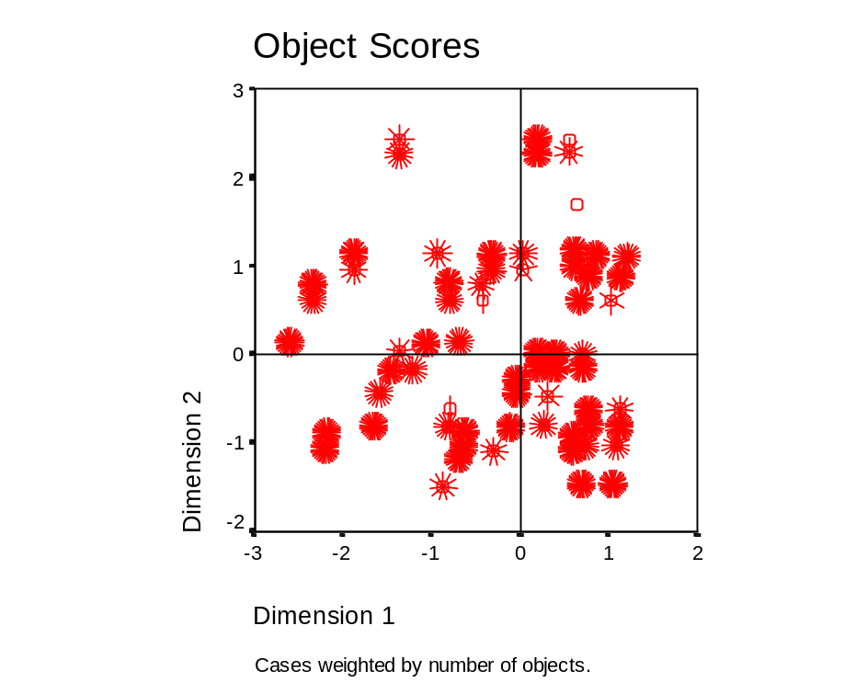
Appendix B (cont’d)—Principal Component Analysis (2).

P R I N C A L S - VERSION 0.6
BY
DEPARTMENT OF DATA THEORY
UNIVERSITY OF LEIDEN, THE NETHERLANDS

The number of observations used in the analysis = 5244

List of Variables
=================

Number of Measurement
Variable Variable Label Categories Level
-------- -------------- ---------- -----------
GRADE grade 3 Multiple Nominal
ITEM item 19 Multiple Nominal
IMPRTNCE Importance 3 Ordinal

Marginal Frequencies
====================

Variable Missing Categories
1 2 3 4 5 6 7 8 9

GRADE 0 1767 2223 1254
ITEM 0 276 276 276 276 276 276 276 276 276
IMPRTNCE 1 827 3589 827

Marginal Frequencies (cont'd)
=============================

Variable Categories
10 11 12 13 14 15 16 17 18 19

GRADE
ITEM 276 276 276 276 276 276 276 276 276 276
IMPRTNCE

The iterative process stops because the convergence test value is reached.

Dimension Eigenvalue
--------- ----------
1 .4547
2 .3334

Variable: GRADE grade
---------
Type: Multiple Nominal Missing: 0

Category: Marginal Frequency
--------- ------------------
1 1st year 1767
2 2nd year 2223
3 3rd year 1254

Category Quantifications
------------------------

Category Dimension

1 2

1 .00 -.05
2 .00 .25
3 .00 -.36
=============================================================================

Variable: ITEM item
---------
Type: Multiple Nominal Missing: 0

Category: Marginal Frequency
--------- ------------------
1 276
2 276
3 276
4 276
5 276
6 276
7 276
8 276
9 276
10 276
11 276
12 276
13 276
14 276
15 276
16 276
17 276
18 276
19 276

Category Quantifications
------------------------

Category Dimension

1 2

1 .72 -.87
2 .00 -.07
3 .67 -1.43
4 .57 1.13
5 .78 -.71
6 -1.70 .14
7 .20 -.10
8 1.06 .98
9 -1.10 -.86
10 -.32 -.37
11 .86 -.76
12 .00 2.26
13 -.39 -.79
14 -1.34 .74
15 .65 .95
16 -1.17 -1.02
17 -.71 1.06
18 .65 .73
19 .55 -1.00
=============================================================================

Variable: IMPRTNCE Importance
---------
Type: Ordinal Missing: 1

Category: Marginal Frequency Quantification
--------- ------------------ --------------
1 Not important 827 -.90
2 not one way or the o 3589 -.31
3 Important 827 2.26

Single Category Coordinates
---------------------------

Category Dimension

1 2

1 .74 .00
2 .26 .00
3 -1.87 .00

Multiple Category Coordinates
-----------------------------

Category Dimension

1 2

1 .74 .02
2 .26 -.01
3 -1.87 .00
=============================================================================

-------------------
Summary of Analysis
-------------------

Multiple Fit
------------

Variable Row Sums Dimension
-------- 1 2

GRADE .058 .000 .058
ITEM 1.624 .682 .942
IMPRTNCE .682 .682 .000

Mean: .788 .455 .333

Single Fit
----------

Variable Row Sums Dimension
-------- 1 2

GRADE - - -
ITEM - - -
IMPRTNCE .682 .682 .000

Mean: .682 .682 .000

Component Loadings
------------------

Variable Dimension
-------- 1 2

GRADE - -
ITEM - -
IMPRTNCE -.826 .000

Iteration Total Total Multiple Single
Number Fit Loss Loss Loss
--------- ----- ----- -------- ------
25 .7881 1.2119 1.2119 3.207540E-05
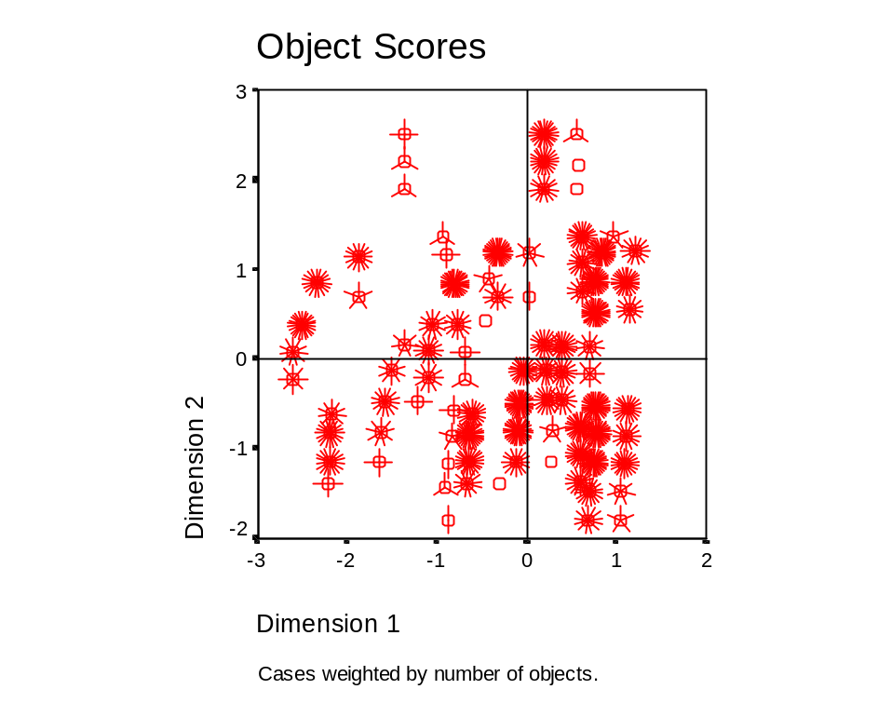

Appendix B (cont’d)—Homogeneity Analysis.

H O M A L S - VERSION 0.6
BY
DEPARTMENT OF DATA THEORY
UNIVERSITY OF LEIDEN, THE NETHERLANDS

The number of observations used in the analysis = 5244

List of Variables
=================

Variable Variable label Number of
Categories
GROUP group 3
ITEM Question 19
IMP Importance 3

Marginal Frequencies
====================

Variable Missing Categories
1 2 3 4 5 6 7 8 9

GROUP 0 1767 2223 1254
ITEM 0 276 276 276 276 276 276 276 276 276
IMP 1 827 3589 827

Marginal Frequencies (cont'd)
==============================

Variable Categories
10 11 12 13 14 15 16 17 18 19

GROUP
ITEM 276 276 276 276 276 276 276 276 276 276
IMP

The iterative process stops because the convergence has been reached in 50 iteration(s).

Dimension Eigenvalue
--------- ----------
1 .4547
2 .4049

Discrimination measures per variable per dimension
==================================================

Variable Dimension

1 2

GROUP .000 .000
ITEM .682 .608
IMP .682 .607

Marginal Frequencies and Category Quantifications
=================================================

Variable: GROUP group
---------
Category Marginal Frequency
-------- ------------------
1 1st year 1767
2 2nd year 2223
3 3rd year 1254

Missing: 0

Category Quantifications
------------------------

Category Dimensions
-------- ----------
1 2

1 .00 .00
2 .00 .00
3 .00 -.01
=============================================================================

Variable: ITEM Question
---------
Category Marginal Frequency
-------- ------------------
1 276
2 276
3 276
4 276
5 276
6 276
7 276
8 276
9 276
10 276
11 276
12 276
13 276
14 276
15 276
16 276
17 276
18 276
19 276

Missing: 0

Category Quantifications
------------------------

Category Dimensions
-------- ----------
1 2

1 .68 -1.42
2 .00 -.25
3 .67 -.32
4 .57 -.08
5 .79 .23
6 -1.72 -.87
7 .17 -1.35
8 1.04 -.55
9 -1.10 .25
10 -.30 .68
11 .87 .48
12 .03 1.08
13 -.38 .43
14 -1.34 .00
15 .65 -.14
16 -1.16 .20
17 -.70 .06
18 .64 -.46
19 .60 2.01
=============================================================================

Variable: IMP Importance
---------
Category Marginal Frequency
-------- ------------------
1 Not important 827
2 not one way or the o 3589
3 Important 827

Missing: 1

Category Quantifications
------------------------

Category Dimensions
-------- ----------
1 2

1 .70 -1.68
2 .27 .46
3 -1.88 -.33
================================================================================

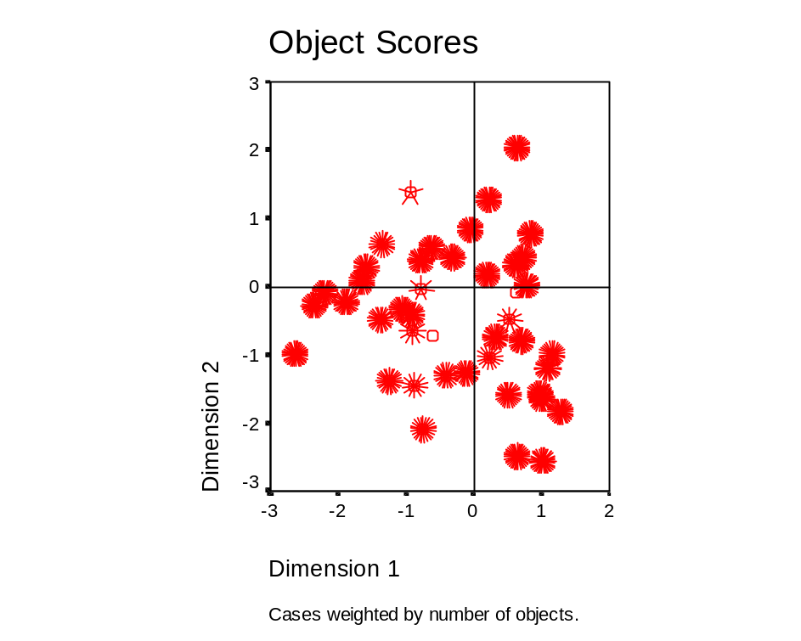
Appendix C—Tables: Question “B”—“Likes and Dislikes”

Table 1. Likes—All Students (brackets indicate rank).

Item | Description | Value
1 | Reading to oneself | 64
2 | Reading & repeating after the teacher | 30
3 | Writing sentences | 42
4 | Writing essays | 7
5 | Translating English into Japanese | 73
6 | Translating Japanese into English | 39
7 | Conversation practice | 70
8 | Greetings | 32
9 | Learning new Words | 35
10 | Listening to stories | 73
11 | Playing speaking games | 144 (2)
12 | Singing | 96 (3)
13 | Studying grammar | 11
14 | Watching videos & movies | 260 (1)
15 | Talking with the Assistant English Teacher | 61
16 | Other | 7

Table 2. Likes—Between Grades (brackets indicate rank).

Item | Description | 1st  Grade | 2nd  Grade | 3rd  Grade
1 | Reading to oneself | 13 | 25 | 26
2 | Reading & repeating after the teacher | 10 | 13 | 7
3 | Writing sentences | 16 | 21 | 5
4 | Writing essays | 2 | 0 | 5
5 | Translating English into Japanese | 28 | 27 | 18
6 | Translating Japanese into English | 19 | 7 | 13
7 | Conversation practice | 18 | 28 (3) | 24
8 | Greetings | 16 | 8 | 8
9 | Learning new Words | 20 | 9 | 6
10 | Listening to stories | 24 | 22 | 27
11 | Playing speaking games | 61 (2) | 49 (2) | 34 (3)
12 | Singing | 16 | 23 | 57 (2)
13 | Studying grammar | 0 | 5 | 6
14 | Watching videos & movies | 62 (1) | 96 (1) | 102 (1)
15 | Talking with the Assistant English Teacher | 36 (3) | 15 | 10
16 | Other | 7 | 0 | 0
Appendix C (cont’d)

Table 3. Likes—Between Sexes (brackets indicate rank).

Item | Description | Female | Male
1 | Reading to oneself | 36 | 28
2 | Reading & repeating after the teacher | 13 | 17
3 | Writing sentences | 18 | 24
4 | Writing essays | 0 | 7
5 | Translating English into Japanese | 34 | 39 (3)
6 | Translating Japanese into English | 11 | 28
7 | Conversation practice | 41 | 29
8 | Greetings | 18 | 14
9 | Learning new Words | 11 | 24
10 | Listening to stories | 40 | 33
11 | Playing speaking games | 51 (3) | 93 (2)
12 | Singing | 76 (2) | 20
13 | Studying grammar | 7 | 4
14 | Watching videos & movies | 135 (1) | 125 (1)
15 | Talking with the Assistant English Teacher | 24 | 37
16 | Other | 7 | 0

Table 4. Dislikes—All Students (brackets indicate rank).

Item | Description | Value
1 | Reading to oneself | 64
2 | Reading & repeating after the teacher | 75
3 | Writing sentences | 156 (2)
4 | Writing essays | 292 (1)
5 | Translating English into Japanese | 44
6 | Translating Japanese into English | 110 (3)
7 | Conversation practice | 32
8 | Greetings | 2
9 | Learning new Words | 28
10 | Listening to stories | 9
11 | Playing speaking games | 54
12 | Singing | 69
13 | Studying grammar | 100
14 | Watching videos & movies | 4
15 | Talking with the Assistant English Teacher | 5
16 | Other | 0

Appendix C (cont’d)

Table 5. Dislikes—Between Grades (brackets indicate rank).

Item | Description | 1st  Grade | 2nd  Grade | 3rd  Grade
1 | Reading to oneself | 23 | 23 | 18
2 | Reading & repeating after the teacher | 33 | 9 | 33
3 | Writing sentences | 51 (2) | 58 (2) | 47 (2)
4 | Writing essays | 90 (1) | 103 (1) | 99 (1)
5 | Translating English into Japanese | 6 | 26 | 12
6 | Translating Japanese into English | 29 | 45 (3) | 36 (3)
7 | Conversation practice | 11 | 8 | 13
8 | Greetings | 0 | 0 | 2
9 | Learning new Words | 15 | 8 | 5
10 | Listening to stories | 1 | 3 | 5
11 | Playing speaking games | 17 | 9 | 28
12 | Singing | 27 | 25 | 17
13 | Studying grammar | 41 (3) | 30 | 29
14 | Watching videos & movies | 4 | 0 | 0
15 | Talking with the Assistant English Teacher | 0 | 1 | 4
16 | Other | 0 | 0 | 0

Table 6. Dislikes—Between Sexes (brackets indicate rank).

Item | Description | Female | Male
1 | Reading to oneself | 25 | 39
2 | Reading & repeating after the teacher | 29 | 46
3 | Writing sentences | 76 (2) | 80 (2)
4 | Writing essays | 152 (1) | 140 (1)
5 | Translating English into Japanese | 28 | 16
6 | Translating Japanese into English | 70 (3) | 40
7 | Conversation practice | 18 | 14
8 | Greetings | 1 | 1
9 | Learning new Words | 17 | 11
10 | Listening to stories | 5 | 4
11 | Playing speaking games | 28 | 26
12 | Singing | 16 | 53 (3)
13 | Studying grammar | 56 | 44
14 | Watching videos & movies | 0 | 4
15 | Talking with the Assistant English Teacher | 1 | 4
16 | Other | 0 | 0
Appendix D—Questionnaire: Japanese (original) (English translation follows).

みなさんこんにちは。このアンケートはマイク先生の大学院の論文の研修に使うものです。私はみなさんがどうして英語を勉強しているのかを知りたいと思います。個人のデータは、統計的に処理され、研究以外に使用されることはありません。テストではないので、どの回答が正しいということはありません。あまり深く考えこまず、楽しい気持ちで答えてください。

Ｏ印をつけてください。 男 女 １ ２ ３ 年生

Ａ．次に挙げた日本人が英語を勉強する理由の中で、１番目、２番目、３番目 に
「大切だ」と思う順番に、「１」「２」「３」を ＿＿に書いてください。
さらに、１番目、２番目、３番目に 「大切ではない」と思う順番に 「Ｘ１」「Ｘ２」「Ｘ３」を＿＿に書いてください。

＿＿ 英検に合格するため
＿＿ コンピュータやインターネットを使うため
＿＿ 英語の映画やテレビを見るため
＿＿ 英語のラジオや音楽を聞くため
＿＿ 英語の本や雑誌を読むため
＿＿ 学校（高校・短大・大学・専門学校）の入学試験のため
＿＿ いい仕事に就くため
＿＿ ペンパルに手紙を書くため
＿＿ 外国へ旅行するときのため
＿＿ 自分が英語に興味があるため
＿＿ 家族や友達に英語を話す人がいて一緒に話すため
＿＿ 外国人の友達と話すため
＿＿ 外国人の考え方を分かるようにするため
＿＿ 視野を広くさせるため
＿＿ 外国の観光客と話すため
＿＿ 英語を話す人と自信をもって会話をするため
＿＿ 外国について学習するため
＿＿ 外国で留学するため
＿＿ 他に ＿＿＿＿＿＿＿＿＿＿＿＿

Ｂ．次に挙げた英語の授業の活動の中で、１番目、２番目、３番目に 「好きだ」と思う順番に、「１」「２」「３」を ＿＿ に書いてください。
さらに、１番目、２番目、３番目に 「好きではない」と思う順番に、「Ｘ１」「Ｘ２」「Ｘ３」を ＿＿ に書いてください。

＿＿ 自分で読むこと
＿＿ 先生の後に繰り返して読むこと
＿＿ 文を書くこと
＿＿ 作文を書くこと
＿＿ 英語を日本語にすること
＿＿ 日本語を英語にすること
＿＿ 会話をすること
＿＿ あいさつをすること
＿＿ 新しい単語を習うこと
＿＿ 物語を聞くこと
＿＿ 会話ゲームをすること
＿＿ 歌うこと
＿＿ 文法を習うこと
＿＿ ビデオや映画を見ること
＿＿ ＡＥＴと会話をすること
＿＿ 他に ＿＿＿＿＿＿＿＿＿＿

Ｃ．次の文を読んで「はい」か「いいえ」か「関係ない」を選んで Ｏで囲んでください。
私は英語を勉強しています。なぜならば・・・
英語の勉強が好きだから。 はい いいえ 関係ない
両親が私にさせるから。 はい いいえ 関係ない
友達が英語を勉強しているから。 はい いいえ 関係ない
先生達が私にさせているから。 はい いいえ 関係ない
テストでいい点をとりたいから。 はい いいえ 関係ない
入学試験に合格するため。 はい いいえ 関係ない
将来外国で留学をしたいから。 はい いいえ 関係ない
外国の映画が好きだから。 はい いいえ 関係ない
他に＿＿＿＿＿＿＿＿＿＿ はい いいえ 関係ない

Ｄ．私は・・・
中学校以外の英語を勉強しています。（熟など） はい いいえ
外国へ行ったことがあります。 はい いいえ
外国に住んだことがあります。 はい いいえ

Ｅ．中学校に入って英語の学習を始めてから今まで、英語に対してのあなたの考え方は変わりましたか、それとも変わっていませんか。あなたの今までの英語に対する考えを書いてください。
＿＿＿＿＿＿＿＿＿＿＿＿＿＿＿＿＿＿＿＿＿＿＿＿＿＿＿＿＿＿＿＿＿＿＿＿＿＿＿＿＿＿＿＿＿＿＿＿＿＿＿＿＿＿＿＿＿＿＿＿＿＿＿＿＿＿＿＿＿＿＿＿＿＿＿＿＿＿＿＿＿＿＿＿＿＿＿＿＿＿＿＿＿＿＿＿＿＿＿＿＿＿＿＿＿＿＿＿＿＿＿＿＿＿

御協力ありがとうございました。Ｔｈａｎｋ ｙｏｕ ｖｅｒｙ ｍｕｃｈ！
Appendix D (cont’d)—Questionnaire—English Translation.

Hello, everyone. The purpose of this questionnaire is for my graduate school thesis. I would like to investigate the reasons why you study English. The data is will not be used for purposes other research. This is not a test. There are no correct answers. Please don’t think too deeply about the answers, and just answer the questions according to your feelings.

Please mark as appropriate: male female 1 2 3 grade

A. The following items are reasons for why Japanese people study English. From these, please mark those that you feel are the most important reasons, using [1], [2] and [3]. Also, please mark the three least important reasons, using [X1], [X2] and [X3].

_____ Passing English proficiency examinations (“ei-ken”)
_____ Using computers or the Internet
_____ Watching English movies or television
_____ Listening to English radio or music
_____ Reading English books or magazines
_____ For entrance examinations (high school, junior college,
college/university, vocational school)
_____ Getting a good job
_____ Writing letters to penpals
_____ When travelling to foreign countries
_____ Personal interest in English
_____ Speaking with friends (or friends of family) who speak English
_____ Talking to foreign friends
_____ Understanding the ways of thinking of foreign people
_____ Broaden one’s point of view
_____ Talking with foreign tourists
_____ To have self-confidence when speaking to English speakers
_____ To study about foreign countries
_____ To study abroad
_____ Other

B. The following items are activities done in English lessons. Please mark three (3) that you like the most, using [1], [2] and [3]. Also, please mark three (3) that you like the least, using [X1], [X2] and [X3].

_____ | Reading to oneself
_____ | Reading & repeating after the teacher
_____ | Writing sentences
_____ | Writing essays
_____ | Translating English into Japanese
_____ | Translating Japanese into English
_____ | Conversation practice
_____ | Greetings
_____ | Learning new Words
_____ | Listening to stories
_____ | Playing speaking games
_____ | Singing
_____ | Studying grammar
_____ | Watching videos & movies
_____ | Talking with the Assistant English Teacher
_____ | Other

C. Please read the following statements and for each one, circle either, “Yes”, “No”, or “Not applicable”.

I study English…

…because I like it. Yes No Not applicable
…because my parents make me. Yes No Not applicable
…because my friends study English. Yes No Not applicable
…because my teacher makes me. Yes No Not applicable
…to get good test scores. Yes No Not applicable
…to pass entrance exams. Yes No Not applicable
…to study abroad in the future. Yes No Not applicable
…because I like foreign movies. Yes No Not applicable

D. As for me, I…

…study English outside of junior high school (cram school, etc.). Yes No
…have travelled abroad. Yes No
…have lived abroad. Yes No

E. Since you entered junior high school and began to study English, until now, has your way of thinking towards English changed or not? Please write your thoughts about this below.
__________________________________________________________________________________________________________________________________________________________
_____________________________________________________________________________

Thank you very much for your efforts.

Acknowledgments

I would like to express deep appreciation to the students who participated in this study. Without them, there is no reason for pedagogical research.

During all stages of this project, I have received support, advice, and guidance from many people. I would thus like to thank all of those who are my teachers, in every sense of the word.

