

AssessmentItem
ChangePlan
Submitted by: Assessment Work Group
Version: 1.0
Target SIF Version: 2.4
Date Submitted: 8/15/2008
New Object: None
New Element: ItemScoreMinimum, ItemScoreMaximum, ItemCutScore

Draft Specification Document Version Control
Version | Date: | Author/Organization: | Comments
1.0 | 8/15/2008 | Jill Abbott/SIF Association  Kris Herakovich/Pearson  John Lovell/ESD 189  Doug Martinson/NWEA  Vince Paredes/SIF Association | First draft

Table of Contents

Introduction 2
Business and End User Use Cases 2
Timeline 2
Object Dependencies 2
Changes to Other Objects 2
Infrastructure Changes 3
Object Definition 3
Issues 3
XML Example 3

Introduction
The AssessmentItem allows software systems to provide item detail information such as the stem of the item, the distractors, the stimuli, etc. There is a need to capture the score range and performance level and cut scores for each assessment item.

Business and End User Use Cases
A school district provides information to teachers about students’ scores on assessments. In order to provide a comprehensive picture about each AssessmentItem, it is needed to reflect the specific information about scoring for the items. This information is helpful in analysis of assessment items and an understanding of the scores associated with each.

Use Case # 1 | Title: Provide Item score parameters  SIFObject: AssessmentItem  Use Case Number: 2.4Activity - 1  History: new  Date: August 17, 2008
Use Case Type (Mandatory or Optional) | Optional
SIF Versions and References | SIF Implementation Specification 2.4
Summary | A teacher wants to understand the student performance on individual items.
Actors | Primary: Learning Management System Agent (Teacher)  Secondary:
Preconditions | - Assessment has been scored.
Outcomes | The teacher understands the context of a student response
Action Steps
Variations
Exceptions
SIF System Services
Open Issues

Timeline
This additional element is anticipated to be released with Implementation Specification 2.4.

Object Dependencies
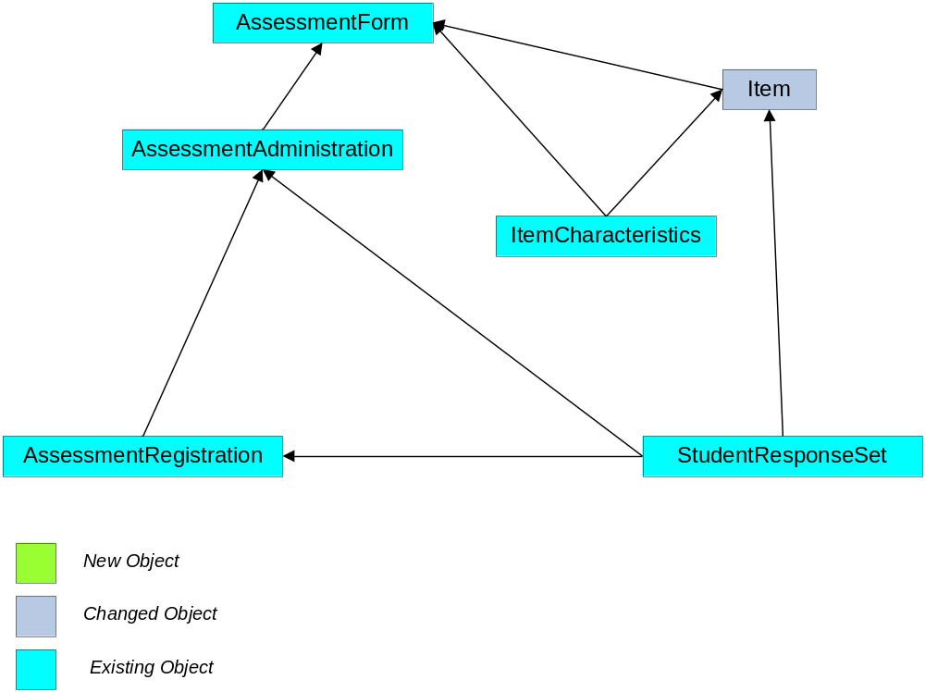

Changes to Other Objects
There are no anticipated changes to other objects.

Infrastructure Changes
There are no infrastructure changes necessary with this proposal.

Object Definition
These new elements should be added after ResponseChoices.

Object | Elements | Attribute | Description | Type
AssessmentItem |  |  | This object is designed to allow software systems to provide item detail information such as the stem of the item, the distractors, the stimuli, etc. This initial version of the object does not deal with presentation aspects of the item. Instead it focuses on the item content and characteristics needed to enable interoperability and the usage of item-level information in the improvement of learning and instruction.
 | ItemScoreMaximum | O | The maximum item score possible for this item. | Token
 | ItemScoreMinimum | O | The minimum item score possible for this item. | Token
 | PerformanceLevels | O | List | --
 | PerformanceLevels/PerformanceLevel | OR | Defines cut scores for placing student sin appropriate performance levels. | --
@ | LevelName | M | The name of the performance level. | Normalized String
 | PerformanceLevels/PerformanceLevel/CutScores | O | Score bounds for the performance level | --
@ | ScoreMetric | M | The metric or scale used to report the scores. This should use the NCES0056 AssessmentReportingMethodType. | Token
 | PerformanceLevels/PerformanceLevel/CutScores/LowerCut | O | Lower Bound for the performance level. | Token
 | PeformanceLevels/PerformanceLevel/CustScores/UpperCut | O | Upper bound for the performance level. | Token

Issues
There are no known issues.

XML Example
<AssessmentItem RefId="C294F3E190F019AD8E1DFC8367537EC8" AssessmentFormRefId="9372CB8EA910FF87D5672CAEF01387AA" ResponseType="multiple-choice">
<ItemLabel>5</ItemLabel>
<ItemName>Geometry diagnostic</ItemName>
<LearningStandardItems>
<LearningStandardItemRefId>DE072A87EFAD4B778AF9FAF83C94839E</LearningStandardItemRefId>
</LearningStandardItems>
<Stimulus>
<Reference MIMEType="image/jpeg" Description="triangle_1">
<URL>http://www.trianglezz.com/triangle.jpg</URL>
</Reference>
</Stimulus>
<Stem>
<TextData Description="Pythagorean Theorem">
Express the length of side C in terms of A and B.
</TextData>
</Stem>
<ResponseChoices>
<Choice>
<ChoiceLabel>A</ChoiceLabel>
<ChoiceContent>
<TextData>A + B</TextData>
</ChoiceContent>
<CreditValue>0.0</CreditValue>
</Choice>
<Choice>
<ChoiceLabel>B</ChoiceLabel>
<ChoiceContent>
<TextData>3PI*R</TextData>
</ChoiceContent>
<CreditValue>-0.1</CreditValue>
</Choice>
<Choice>
<ChoiceLabel>C</ChoiceLabel>
<ChoiceContent>
<TextData>SQRT(A2 + B2)</TextData>
</ChoiceContent>
<CreditValue>1.0</CreditValue>
</Choice>
<Choice>
<ChoiceLabel>D</ChoiceLabel>
<ChoiceContent>
<TextData>A2 + B2</TextData>
</ChoiceContent>
<CreditValue>0.5</CreditValue>
</Choice>
<ItemScoreMaximum>1.0</ItemScoreMaximum>
<ItemScoreMinimum>-.1</ItemScoreMinimum>
<PerformanceLevels>
<PerformanceLevel LevelName="Pass">
<CutScores ScoreMetric="0499">
<LowerCut>0</LowerCut>
<UpperCut>0.5</UpperCut>
</CutScores>
</PerformanceLevel>
</PerformanceLevels>
</ResponseChoices>
</AssessmentItem>

