

LearningStandardItem
ChangePlan
Submitted by: Instructional Services Task Force
Version: 1.1
Target SIF Version: 2.4
Date Submitted: 5/27/2009
New Object: None
New Element: Level4 and Level5

Draft Specification Document Version Control
Version | Date: | Author/Organization: | Comments
1.0 | 8/25/2008 | Jill Abbott/SIF Association | Initial
1.1 | 5/27/2009 | Jill Abbott, Richard Hughes, Alex Jackl, David Longdon, John Lovell | Highlighted changes, added new elements in XML example and added data types based on tech board review

Table of Contents

Introduction 2
Business and Use Cases 2
Timeline 2
Object Dependencies 2
Changes to Other Objects 2
Infrastructure Changes 2
Object Definition 2
Issues 2
XML Example 2

Introduction
We are currently proposing to change one element within the LearningStandardItem. Introduced in the 2.2 Implementation Specification was the StandardIdentifier element. There is a need to add two additional hierarchical pieces to this element to better meet the needs of all state departments of education and other learning and performance standards setting bodies.

Business and Use Cases
State Departments of Education and other learning and performance standards setting bodies create and disseminate learning and performance standards. These standards are represented in a hierarchal way by the SIF Association using the LearningStandardItem. In order to align content and instruction to the learning and performance standards, it is important to define this content from a searchable perspective. A piece of this is including a description to describe the standard in a granular, unique way. In order to accomplish this, the LearningStandardItem must contain a way to present the learning and performance standard. A content provider receives a request for learning resources (which could be represented by dozens of SIF objects) of a particular type. They need to respond to the request tagging the content by which filters the content represents.

Use Case # 1 | Title: Discover content resources related to other content areas  SIFObject: LearningStandardItem  Use Case Number: 2.4LSI – 01  History: new  Date: July 10, 2008
Use Case Type (Mandatory or Optional) | Optional
SIF Versions and References | SIF Implementation Specification 2.4
Summary | A physics teacher wants to find calculus related content in order to support her instruction of a physics lesson.
Actors | Primary: Learning Management System Agent (Teacher)  Secondary: Content Repository Agent
Preconditions | - Physics and math learning standards are loaded in the LMS and content repository.  - Content in the repository is aligned to learning standards using the LearningStandardItemRefID.  - Math and Physics standards have relationships defined using the RelatedLearningStandardItems elements of the LearningStandardItem object.
Outcomes | The teacher is presented with a list of content related to the math learning standards associated with the physics learning standards she is interested in.
Action Steps | - A teacher teaches a physics concept and wants math resources to support it. Using a content discovery tool in her LMS, the teacher identifies the physics concept she is teaching and tells the system to look for additional resources. (Should the LMS present the teacher with a list of related standards for her to choose from, or should we retrieve all of the related content?)  - The LMS agent selects the RelatedLearningStandardItems that are associated with content standards based on the LearningStandardItem associated with the teacher chose.  - The LMS agent issues a request to the content repository agent (via the ZIS) to look for content resources associated with the related math standard(s).  - The content repository agent receives the query and passes it to the content repository application.  - The content repository application returns a list of content resources to the to the content repository agent.  - The content repository agent formats the list of content resources into LearningResource objects  - The content repository agent returns the list of LearningResource objects to the LMS via the ZIS.  - The LMS agent receives the LearningResources objects, parses them, and passes the data to the LMS.  - The LMS displays the data to the teacher.
Variations | In step 3, the LMS agent could issue a request to the content repository agent with the teacher’s selected physics standard and a command to look for related-standards content.
Exceptions
SIF System Services
Open Issues

Timeline
This additional element is anticipated to be released with Implementation Specification 2.4.

Object Dependencies
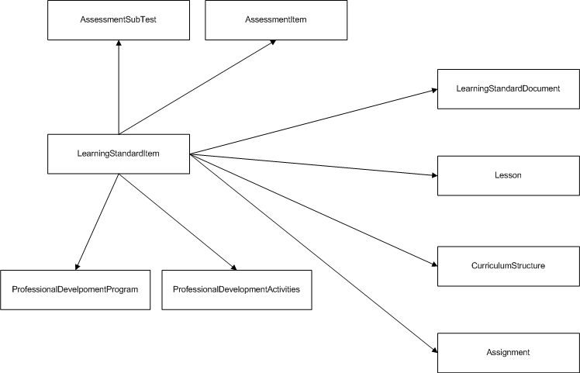

Changes to Other Objects
There are no anticipated changes to other objects.

Infrastructure Changes
There are no infrastructure changes necessary with this proposal.

Object Definition
This object contains information related to curriculum standards statements "standards" or "benchmarks" or the like within the document. This object primarily focuses upon state department curriculum standards, published curriculum standards and local education agency learning standards. Each LearningStandardItem reflects an individual standard statement and may occur at several levels within a hierarchically structured document.

Please note that only level 4 and 5 are being added to the object. The rest of the object is included to provide the entire context.

*Highlighted changes in yellow

Object | Elements | Attributes | Object Description | New New Types
LearningStandardItem | This object contains information related to curriculum standards statements "standards" or "benchmarks" or the like within the document. This object primarily focuses upon state department curriculum standards, published curriculum standards and local education agency learning standards. Each LearningStandardItem reflects an individual standard statement and may occur at several levels within a hierarchially structured document.
 | RefId | M
 | xml:lang | M
 | StandardSettingBody | O | The name of the state or organization that authored and manages updates to the standards document, (i.e., NCTM, Ohio Department of Education)
 | Country | M | This should be a common element.
 | StateProvince | O | This should be a common element.
 | NCESId | O | This should be a common element.
 | SettingBodyName | O | This is the text version of the organization’s name.
 | StandardHierarchyLevel | M | Description of hierarchical level within standards tree.
 | StandardHierarchyLevel/Number | M | Integer assigned to each hierarchical level within standards tree. The top level is “1”.
 | StandardHierarchyLevel/Description | M | Used to describe what role this item is serving in the structure. Some standards describe their levels in terms of standard, strand and topics. Others use standards, benchmarks and indicators. This attribute names the level of the item.
 | PredecessorItems | O
 | PredecessorItems/LearningStandardItemRefId | OR | GUID assigned to the LearningStandardItem directly above it in the hierarchy tree. This is a repeatable element because a single granular item may relate to multiple parent levels of the hierarchy. If the object has no parent, the ParentRefId should be the same as the object’s RefId. The RefId in LearningStandardDocumentRefId will always point to the parent’s LearningStandardDocument object.
 | StatementCodes | O
 | StatementCodes/StatementCode | OR | An alphanumeric ID code as defined by the organization to identify the statement.
 | Statements | O
 | Statements/Statement | MR | The text of the “standard” or “benchmark”.
 | GradeLevels | CM | This element currently exists. This will be conditional based upon whether or not the application supports the StandardIdentifier. If the object supports StandardIdentifier, then this element is not to be used.
 | SubjectArea | CO | This element currently exists. This will be conditional based upon whether or not the application supports the StandardIdentifier. If the object supports StandardIdentifier, then this element is not to be used. This should be the common element.
 | StandardIdentifier | O | This element describes the unique identifier for each LearningStandard.
 | YearCreated | M | This represents the year that this specific learning standard was created. This is important to indicate as standards are updated to reflect the appropriate year it was created. This would be assigned and unique to the standard setting body.
 | SubjectArea | M | This represents the subject or content area this learning standard addresses. This would be assigned and unique to the standard setting body. This should be the common element.
 | StandardNumber | M | This is the specific number of the standard. For example, if the subject is mathematics and this standard is Patterns, Functions and Algebra, this would be StandardNumber 1. This would be assigned and unique to the standard setting body.
 | GradeLevels | M | This represents the grade level(s) this specific learning standard will address. This may be addressed in different ways. Some states have a grade level that covers several grades and others have just one grade. This would be assigned and unique to the standard setting body.
 | Benchmark | O | This is the next level within the hierarchy of the learning standard. For example, if the subject is mathematics and the standard is algebra, this would be the next delineation - Represent an unknown quantity as a variable using a symbol, including letters. This would be assigned and unique to the standard setting body.
 | GradeLevel | O | This is the specific grade level. This is to be utilized if the GradeLevel covers several grades. This would be assigned and unique to the standard setting body.
 | IndicatorNumber | O | This would be the next granular level of the learning standard associated with the grade level. Following the same example, an indicator for Algebra GradeLevel 5-7, the indicator for the benchmark above at 6 grade would be to Evaluate simple expressions by replacing variables with given values, and use formulas in problem-solving situations. This would be assigned and unique to the standard setting body.
 | Level4 | O | This is the second to most granular level of the learning or performance standard associated with the grade level. | xs:normalizedString
 | Level5 | O | This is the most granular level of the learning or performance standard associated with the grade level. | xs:normalizedString
 | AlternateIdentificationCodes | O | This element is for an organization to utilize for an internal code. This may be used for an alignment schema or other purposes that are only internal for the organization.
 | AlternateIdentificationCodes/AlternateIdentificationCode | MR | An alphanumeric ID code as defined by the organization to identify the statement.
 | Organization | M | Name of organization represented by the document, i.e., "National Council of Teachers of Mathematics (NCTM)," "Washington," "Seattle School District." This is the name of the organization that has this AlternateIdentificationCode. This should be a text field.
 | LearningStandardDocumentRefId | M | The RefId of the item’s parent LearningStandardDocument.
 | SIF_Metadata | O
 | SIF_ExtendedElements

Issues
There are no known issues.

XML Example
<LearningStandardItem RefId="A5D75F789175101B8C7E08EA123A8234" xml:lang="en">
<StandardSettingBody>
<Country>US</Country>
<StateProvince>OH</StateProvince>
<SettingBodyName>Ohio Department of Education</SettingBodyName>
</StandardSettingBody>
<StandardHierarchyLevel>
<Number>3</Number>
<Description>Indicator</Description>
</StandardHierarchyLevel>
<PredecessorItems>
<LearningStandardItemRefId>DE072A87EFAD4B778AF9FAF83C94839E</LearningStandardItemRefId>
</PredecessorItems>
<StatementCodes>
<StatementCode>Mathematics.4.C.06</StatementCode>
</StatementCodes>
<Statements>
<Statement> Evaluate simple expressions by replacing variables with given values, and use formulas in problem-solving situations. </Statement>
</Statements> <LearningStandardDocumentRefId>8454189F6BBC26C6B97DDB4B6D0E3AC8</LearningStandardDocumentRefId>
<StandardIdentifier>
<YearCreated>Y2003</YearCreated>
<Subject>Mathematics</Subject>
<StandardNumber>04</StandardNumber>
<GradeLevels>
<GradeLevel>
<Code>05</Code>
</GradeLevel>
<GradeLevel>
<Code>06</Code>
</GradeLevel>
<GradeLevel>
<Code>07</Code>
</GradeLevel>
</GradeLevels>
<Benchmark>C</Benchmark>
<GradeLevel>
<Code>06</Code>
</GradeLevel>
<IndicatorNumber>06</IndicatorNumber>
<Level4>b</Level4>
<Level5>1</Level5>
</LearningStandardItem>

