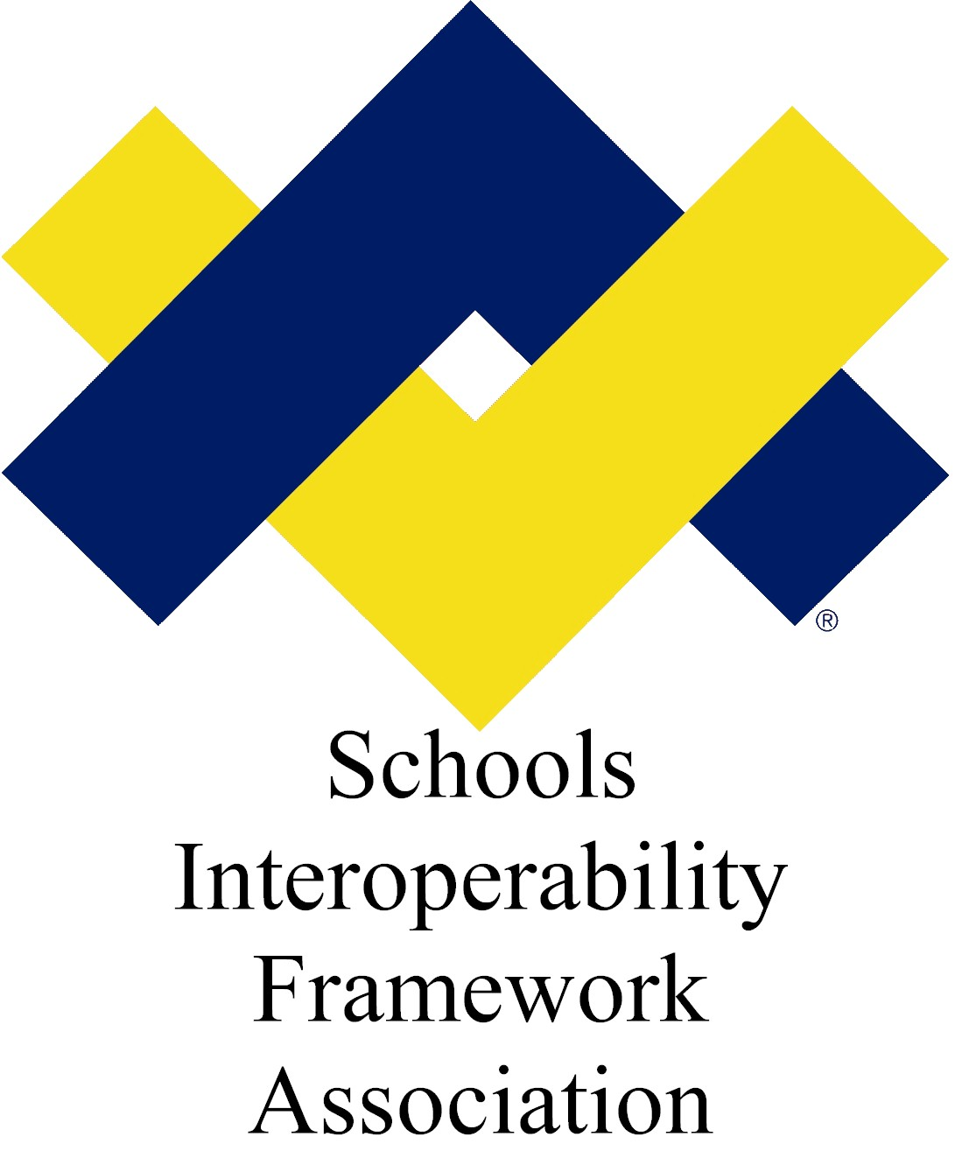

SIF Object Plan:
Scheduling Information

Submitted by: Special Programs Working Group
Target SIF Version: 2.4
Version: 1.5
Date Submitted: 9/1/2009

Table of Contents

Business Case 2
Time Line 2
Object Dependencies and Relation Map (possible) 2
New Object – StudentSpecialEducationSummary - Description and Definitions 2
XML Example for StudentSpecialEducationSummary 13
Changes to Other Objects 14
Infrastructure Changes 14
Questions and Comments: 15
Appendices 16

Draft Specification Document Version Control
Version | Date: | Author/Organization: | Comments
V1.0 | 8/26/2009 | Elycia Hansen, WSIPC | Initial Draft
V1.1 | 8/30/2009 | Elycia Hansen, WSIPC  Jill Abbott, SIFA | Revisions based on Work Group feedback.
V1.2 | 8/31/2009 | Elycia Hansen, WSIPC  Barbara Andrepont, ESP Solutions Group | Revisions based on Work Group feedback.
V1.3 | 9/1/2009 | Elycia Hansen, WSIPC  Barbara Andrepont, ESP Solutions Group  Ron Kleinman, SIF Association | Revisions based on feedback.
V1.4 | 10/30/2009 | Elycia Hansen, WSIPC  Barbara Andrepont, ESP Solutions Group  Jill Abbott, SIFA | Updates based on Tech Board feedback.
V1.5 | 11/5/2009 | Elycia Hansen, WSIPC | Updates based on Tech Board feedback.

Business Case
There is a standalone reporting object managed by the Student Records Exchange Task Force which conveys a student's special education program information for student record exchange. However, there is no corresponding summary object among existing Special Programs objects. This disparity makes it difficult to adapt to growing business needs relating to Special Programs objects. Special Programs is proposing that a new object, StudentSpecialEducationSummary, be included in SIF Specification 2.4 to shore up this gap.

Currently, several state initiatives have requested changes that could easily be accommodated with this new StudentSpecialEducationSummary object which can then be referenced by the StudentSpecialEducationRecord.

Time Line
The plan will be developed according to the SIF 2.4 timeline.

Object Dependencies and Relation Map (possible)

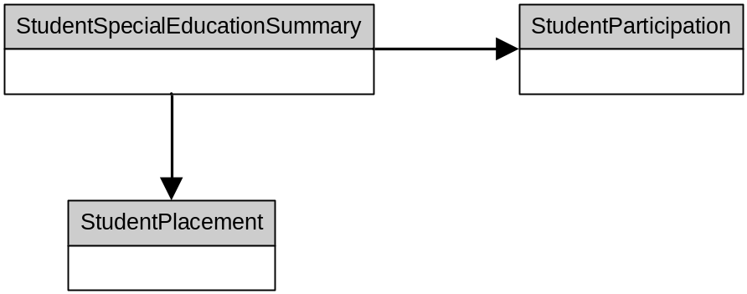

New Object – StudentSpecialEducationSummary - Description and Definitions
This object provides a summary of a student's participation and placement in special education programs for a given school during the time period between the StartDate and EndDate, inclusive. As such, there may be multiple instances of this object for a student in a school over the course of a school year. SIF_Events are not supported by this object.

 | Element/@Attribute | Char | Description | Type
 | StudentSpecialEducationSummary |  | This object provides a summary of a student's participation and placement in special education programs for a given school during the time period between the StartDate and EndDate, inclusive. As such, there may be multiple instances of this object for a student in an LEA over the course of a school year.
@ | StudentPersonalRefId | M | The ID (GUID) of the student for whom this special education information is being reported. | IdRefType
@ | SchoolYear | M | School year for which the information is applicable. | SchoolYear
 | StudentSpecialEducationFTE | O | Calculated ratio of time the student is in a special ed setting. Values range from 0.00 to 1.00. If the student is in a special ed setting 25% of the time, the value is .25; if 100% of the time, the value is 1.00. | xs:decimal
  xs:minInclusive | 0
  xs:maxInclusive | 1
  xs:fractionDigits | 2
 | PrimaryDisabilityCode | O | A code that identifies the primary disability type for a student who is eligible for services under the Individuals with Disabilities Education Act (IDEA) and who has an Individualized Education Program (IEP). Since primary disability is time-dependent a student’s primary disability can change through a school year or reporting period | NCES0768PrimaryDisabilityType
 | NeglectedOrDelinquentParticipationList | O |  | NeglectedOrDelinquentParticipation
 | NeglectedOrDelinquentParticipation | MR | The type and number of days a student participated in a Neglected or Delinquent program during the reporting period.
 | NeglectedOrDelinquentParticipation/Type | M | The specific classification for the neglected or delinquent program. | Values:  S001 Neglected programs  S002 Juvenile detention facility  S003 Juvenile correctional institution  S004 Adult correctional institution  S005 At risk program  S006 Other program
 | NeglectedOrDelinquentParticipation/TotalDayCount | O | The total number of instructional days the student was enrolled in this neglected or delinquent program during this reporting period.
 | NeglectedOrDelinquentParticipation/ConsecutiveDayCount | O | The highest number of consecutive instructional days the student was enrolled in this neglected or delinquent program. This may or may not match the TotalDayCount for the reporting period.
 | StudentParticipationList | O |  | List
 | StudentParticipationList /StudentParticipationData | MR | Collects elements of interest for each StudentParticipation.
 | StudentParticipationList /StudentParticipationData/ProgramType | M |  | ProgramType
 | StudentParticipationList /StudentParticipationData/ProgramFundingSources | O |  | List
 | StudentParticipationList /StudentParticipationData/ProgramFundingSources/ProgramFundingSource | MR
 | StudentParticipationList /StudentParticipationData/ProgramFundingSources/ProgramFundingSource/  Code | M | Funding source for the program, may be more than one. | union of:  NCES0222ProgramFundingSourceType  subset:  0797  0617  0622  0654  9999  additional values:  S001  Education for the Disadvantaged, ESEA I-A  S002  English Language Acquisition, Language Enhancement and Academic Achievement, ESEA III-A  S003  Foreign Language Assistance, ESEA V-D  S004  Gifted and Talented, Javits, ESEA V-D  S005  Homeless Children and Youths, ESEA X-C (MVHAA VII-B)  S006  Impact Aid, ESEA, Title VIII  S007  Indian Education, ESEA Title VII  S008  Migrant, ESEA I-C  S009  Migrant, HEA IV-A  S010  Neglected and Delinquent, ESEA I-D  S011  Other ESEA reading programs  S012  Public School Choice, ESEA I-A  S013  Reading First, ESEA I-B  S014  Rural Education, ESEA VI-B  S015  Safe Schools and Citizenship Education, ESEA IV-A and V-D  S016  School Choice, ESEA, Title V-B,-C,-D  S017  Special Education Early Intervening Services, IDEA, Part B  S018  Special Education Grants for Infants and Families Ages 0-2, IDEA, Part C  S019  Special Education Preschool Grants Ages 3-5, IDEA, Part B  S020  Special Education State Grants, IDEA, Part B  S021  State Scholars Capacity Building, ESEA V-D  S022  Supplemental Education Services, ESEA I-A  S023  Vocational Education (Carl D Perkins VTEA)  S024  Reading Proficiency  S025  Reading Sufficiency  S026  Alternative Education
 | StudentParticipationList /StudentParticipationData/ProgramFundingSources/ProgramFundingSource/  OtherCodeList | O |  | OtherCodeList
 | StudentParticipationList /StudentParticipationData/ManagingPublicAgency | O | The GUID of the public agency (a district / LEA) to which the "ManagingSchool" reports / belongs. | IdRefType
@ | SIF_RefObject | M |  | values:  LEAInfo
 | StudentParticipationList /StudentParticipationData/ManagingSchool | O | The GUID of the school responsible for coordinating the student's program participation. | IdRefType
@ | SIF_RefObject | M |  | values:  SchoolInfo
 | StudentParticipationList /StudentParticipationData/ReferralDate | O |  | xs:Date
 | StudentParticipationList /StudentParticipationData/ProgramStatus | O |  | ProgramStatus
 | StudentParticipationList /StudentParticipationData/GiftedEligibilityCriteria | O | State / local code used to determine eligibility for Gifted / Talented program. | xs:token  Additional values:  S001 General Intellectual Aptitude only  S002 Specific Academic Aptitude only  S003 Visual/Performing Arts only  S004 Tech/Practical Arts only  S005 General Intellectual Aptitude & Specific Academic Aptitude  S006 General Intellectual Aptitude & Visual/Performing Arts  S007 General Intellectual Aptitude & Technical/Practical Arts  S008 Specific Academic Aptitude & Visual/Performing Arts  S009 Specific Academic Aptitude & Technical/Practical Arts  S0010 Visual/Performing Arts & Technical/Practical Arts  S0011 General Intellectual Aptitude, Specific Academic Aptitude, and Visual Performing Arts  S0012 General Intellectual Aptitude, Specific Academic Aptitude, & Technical/Practical Arts  S0013 Specific Academic Aptitude, Visual/Performing Arts, & Technical/Practical Arts  S0014 General Intellectual Aptitude, Specific Academic Aptitude, Visual/Performing Arts & Technical/Practical Arts  S0015 Other  S0016 Not specified
 | StudentParticipationList /StudentParticipationData/EvaluationDate | O |  | xs:Date
 | StudentParticipationList /StudentParticipationData/ReevaluationDate | O |  | xs:Date
 | StudentParticipationList /StudentParticipationData/ExceptionalityCategories | O |  | ExceptionalityCategories
 | StudentParticipationList /StudentParticipationData/ProgramPlanDate | O |  | xs:Date
 | StudentParticipationList /StudentParticipationData/ProgamPlanEffectiveDate | O |  | xs:Date
 | StudentParticipationList /StudentParticipationData/PlannedAssessmentParticipation | O |  | PlannedAssessmentParticipation
 | StudentParticipationList /StudentParticipationData/DaysInParticipation | O |  | xs:integer
 | StudentPlacementList | OR | This list contains information that describes each specific instructional, related or transitional service that has been prescribed or recommended in the program plan developed for a student who has been placed in an individualized special program. | List
 | StudentPlacementList /StudentPlacementData | MR | Collects elements of interest for each StudentPlacement. | Service
 | StudentPlacementList /StudentPlacementData/Service | M
 | StudentPlacementList /StudentPlacementData/Service/Code | M | Specialized instruction or related / transitional service provided to this student. | union of:  NCES0273StudentSupportServiceTypeType  subset:  0290  0291  0292  0293  0295  0334  0297  0298  0299  0333  0302  0303  0304  0332  0305  0306  0308  0335  0336  0309  0310  0311  0312  0313  0331  0314  0315  0318  0319  0320  0294  0337  0321  0322  0323  0324  0325  0327  0329  0330  9999  NCES0289TransitionalSupportServiceTypeType  EDENHomelessEducationalSupportServicesAndActivitiesTypeOfServicesReceivedType  subset:  TUT  EE  PD  MEDREF  TRANS  ECPGM  ASST  BASSUM  RECS  PARENT  COORD  COUNS  DOMV  CLOTH  SUPPLY  OTHREF  EMER  OTHER  EDENMigrantStudentsServedMigrantServiceTypeType  subset:  COS  AIS  RI  MI  HSCA  ANYSS  CS  ARS  EDENLEPProgramTypeOfServicesReceivedType  subset:  BILING  DUALLANG  TWOIMM  TRANSBIL  DEVBIL  HERITAGE  SHELENGL  STRUCIMM  SDAIE  CONTENTESL  PULLESL  OTHER  EDENStudentsInNeglectedOrDelinquentProgramsNeglectedOrDelinquentServicesReceivedType  subset:  TS  AS  DP  ASC  JT  StudentPlacementTitleIServicesType  StudentPlacementOtherServicesType  StudentPlacementOtherTypesOfTransportationType
 | StudentPlacementList /StudentPlacementData/Service/OtherCodeList | O |  | OtherCodeList
 | StudentPlacementList /StudentPlacementData/ServiceCategory | O | Collects elements of interest for each StudentPlacement. Category of service (for example, whether it is instruction or a related / transitional service or a supplemental service). Typically designated by a state. | values:  S001  Service is instructional  S002  Service is a related service (e.g. speech / language, vision)  S003  Service is transitional  S004  Service is itinerant  S999  Service is of another category
 | StudentPlacementList /StudentPlacementData/ServiceFundingSources | O | Collects elements of interest for each StudentPlacement. | List
 | StudentPlacementList /StudentPlacementData/ServiceFundingSources/ServiceFundingSource/  Code | MR | Funding source for the program, may be more than one. | union of:  NCES0222ProgramFundingSourceType  subset:  0797  0617  0622  0654  9999  additional values:  S001  Education for the Disadvantaged, ESEA I-A  S002  English Language Acquisition, Language Enhancement and Academic Achievement, ESEA III-A  S003  Foreign Language Assistance, ESEA V-D  S004  Gifted and Talented, Javits, ESEA V-D  S005  Homeless Children and Youths, ESEA X-C (MVHAA VII-B)  S006  Impact Aid, ESEA, Title VIII  S007  Indian Education, ESEA Title VII  S008  Migrant, ESEA I-C  S009  Migrant, HEA IV-A  S010  Neglected and Delinquent, ESEA I-D  S011  Other ESEA reading programs  S012  Public School Choice, ESEA I-A  S013  Reading First, ESEA I-B  S014  Rural Education, ESEA VI-B  S015  Safe Schools and Citizenship Education, ESEA IV-A and V-D  S016  School Choice, ESEA, Title V-B,-C,-D  S017  Special Education Early Intervening Services, IDEA, Part B  S018  Special Education Grants for Infants and Families Ages 0-2, IDEA, Part C  S019  Special Education Preschool Grants Ages 3-5, IDEA, Part B  S020  Special Education State Grants, IDEA, Part B  S021  State Scholars Capacity Building, ESEA V-D  S022  Supplemental Education Services, ESEA I-A  S023  Vocational Education (Carl D Perkins VTEA)  S024  Reading Proficiency  S025  Reading Sufficiency  S026  Alternative Education
 | StudentPlacementList /StudentPlacementData/ServiceFundingSources/ServiceFundingSource/OtherCodeList | O |  | OtherCodeList
 | StudentPlacementList /StudentPlacementData/ServicingPublicAgency | O | The GUID of the public agency (a district / LEA) to which the "ServicingSchool" reports / belongs. | IdRefType
@ | SIF_RefObject | M |  | values:  LEAInfo
 | StudentPlacementList /StudentPlacementData/ServicingSchool | O | The GUID of the school responsible for providing and coordinating this service (but physical location where service delivered could be different and is identified in SchoolWhereServiceDelivered). | IdRefType
@ | SIF_RefObject | M |  | values:  SchoolInfo
 | StudentPlacementList /StudentPlacementData/SchoolWhereServiceDelivered | O | The GUID of the school where the service is delivered. | IdRefType
@ | SIF_RefObject | M |  | values:  SchoolInfo
 | StudentPlacementList /StudentPlacementData/ServiceProviderType | O
 | StudentPlacementList /StudentPlacementData/ServiceProviderType/Code | M | Used for an individual providing the service. Review by state / program, may be required. Service provider title (such as Physical Therapist or Psychologist). | NCES0557JobClassificationType  subset:  0100  0200  0201  0202  0203  0204  0205  0206  0207  0208  0209  0210  0211  0212  0213  0300  0309  0313  0322  0328  0329  0333  0334  0335  0336  0338  0339  0340  0342  0343  0345  0346  0347  0349  0351  0352  0353  0356  0359  0361  0363  0400  0500  0501  0507  0512  0600  0700  0800  0801  0802  0900  1000  1001  1002  1009  1011  1012  9999
 | StudentPlacementList /StudentPlacementData/ServiceProviderType/OtherCodeList | O |  | ServiceProviderType/OtherCodeList
 | StudentPlacementList /StudentPlacementData/AgencyType | O | Identifies an agency or clinic that will provide the specified service. | xs:normalizedString
 | StudentPlacementList /StudentPlacementData/FrequencyTime | O
 | StudentPlacementList /StudentPlacementData/Frequency Time/Code | M |  | Code for the frequency that the service is provided.  Values:  S001  Weekly  S002  Bi-weekly  S003  Semi-monthly  S004  Monthly  S005  quarterly  S006  Semi-annually  S007  Annually  S008  Daily  S999  Other
 | StudentPlacementList /StudentPlacementData/FrequencyTime/OtherCodeList | O |  | OtherCodeList
 | SIF_Metadata | O |  | SIF_Metadata
 | SIF_ExtendedElements | O |  | SIF_ExtendedElements

XML Example for StudentSpecialEducationSummary

<StudentSpecialEducationSummary RefId="D3E34B359D75101A8C3D00AA001A1652" StudentPersonalRefId="A2E34F59A742C1A4B3D11CC002B163A2">
<SchoolYear>2008</SchoolYear>
<StudentSpecialEducationFTE>0.45</StudentSpecialEducationFTE>
<PrimaryDisabilityCode>2134</PrimaryDisabilityCode>
<NeglectedOrDelinquentParticipationList>
<NeglectedOrDelinquentParticipation>
<Type>S002</Type>
<TotalDayCount>45</TotalDayCount>
<ConsecutiveDayCount>45</ConsecutiveDayCount>
</NeglectedOrDelinquentParticipation>
<NeglectedOrDelinquentParticipation>
<Type>S005</Type>
<TotalDayCount>90</TotalDayCount>
<ConsecutiveDayCount>68</ConsecutiveDayCount>
</NeglectedOrDelinquentParticipation>
</NeglectedOrDelinquentParticipationList>
<StudentParticipationList>
<StudentParticipationData>
<ProgramType>
<Code>0270</Code>
<OtherCodeList>
<OtherCode Codeset="StateProvince">0839</OtherCode>
</OtherCodeList>
</ProgramType>
<ProgramFundingSources>
<ProgramFundingSource>
<Code>0797</Code>
</ProgramFundingSource>
</ProgramFundingSources>
<ManagingPublicAgency SIF_RefObject="LEAInfo">F3434F59A742C1A4B3D11CC002B163A2</ManagingPublicAgency>
<ManagingSchool SIF_RefObject="SchoolInfo">D93F4D183A42C1A4B3D11CC002B163A2</ManagingSchool>
<ReferralDate>2005-09-04</ReferralDate>
<ProgramStatus>
<Code>S004</Code>
</ProgramStatus>
<GiftedEligibilityCriteria>G938</GiftedEligibilityCriteria>
<EvaluationDate>2005-11-25</EvaluationDate>
<ReevaluationDate>2008-11-25</ReevaluationDate>
<ExceptionalityCategories>
<ExceptionalityCategory>
<Code>2121</Code>
<ExceptionalityPriority>Primary</ExceptionalityPriority>
</ExceptionalityCategory>
<ExceptionalityCategory>
<Code>2134</Code>
<ExceptionalityPriority>Secondary</ExceptionalityPriority>
</ExceptionalityCategory>
<ExceptionalityCategory>
<Code>2127</Code>
<ExceptionalityPriority>Tertiary</ExceptionalityPriority>
</ExceptionalityCategory>
</ExceptionalityCategories>
<ProgramPlanDate>2007-01-02</ProgramPlanDate>
<ProgramPlanEffectiveDate>2007-09-14</ProgramPlanEffectiveDate>
<DaysInParticipation>34</<DaysInParticipation>
</StudentParticipationData>
</StudentPartipcationList>
<StudentPlacementList>
<StudentPlacementData>
<Service>
<Code>0290</Code>
<OtherCodeList>
<OtherCode Codeset="StateProvince">8829</OtherCode>
</OtherCodeList>
</Service>
<ServiceCategory>S999</ServiceCategory>
<ServiceFundingSources>
<ServiceFundingSource>
<Code>0797</Code>
</ServiceFundingSource>
</ServiceFundingSources>
<ServicingPublicAgency SIF_RefObject="LEAInfo">F3434F59A742C1A4B3D11CC002B163A2</ServicingPublicAgency>
<ServicingSchool SIF_RefObject="SchoolInfo">D93F4D183A42C1A4B3D11CC002B163A2</ServicingSchool>
<SchoolWhereServiceDelivered SIF_RefObject="SchoolInfo">D93F4D183A42C1A4B3D11CC002B163A2</SchoolWhereServiceDelivered>
<ServiceProviderType>
<Code>0203</Code>
</ServiceProviderType>
<AgencyType>Public School</AgencyType>
<FrequencyTime>
<Code>S008</Code>
</FrequencyTime>
</StudentPlacementData>
</StudentPlacementList>

Changes to Other Objects
This object does not require any changes to other objects.

Infrastructure Changes
A new code set is needed to support the PrimaryDisabilityCode in this object.

0768 Primary Disability Type

2121 - Autistic/autism
2122 - Deaf-blindness
2133 - Deafness
2134 - Developmental delay
2127 - Emotional disturbance
2123 - Hearing impairment
2135 - Infants and Toddlers with Disabilities
2124 - Mental retardation
2125 - Multiple disabilities
2126 - Orthopedic impairment
2132 - Other health impairment
2128 - Specific learning disability
2129 - Speech or language impairment
2130 - Traumatic brain injury
2131 - Visual impairment

Questions and Comments:
The following were the codes provided for use with the new NeglectedOrDelinquentParticipation object. These match those found in EdFacts data.

Code | Description
1 | Neglected programs - An institution for neglected children and youth is a public or private residential facility, other than a foster home, that is operated primarily for the care of children who have been committed to the institution or voluntarily placed under applicable State law due to abandonment, neglect, or death of their parents or guardians.
2 | Juvenile detention facilities - Detention facilities are shorter term institutions that provide care to children who require secure custody pending court adjudication, court disposition, or execution of a court order, or care to children after commitment.
3 | Juvenile correction - An institution for delinquent children and youth is a public or private residential facility other than a foster home that is operated for the care of children and youth who have been adjudicated delinquent or in need of supervision. Include any programs serving adjudicated youth (including non–secure facilities and group homes) in this category.
4 | Adult corrections - An adult correctional institution is a facility in which persons, including persons 21 and under, are confined as a result of conviction for a criminal offense.
5 | At Risk: Programs operated (through LEAs) that target students who are at risk of academic failure, have a drug or alcohol problem, are pregnant or parenting, have been in contact with the juvenile justice system in the past, are at least 1 year behind the expected age/grade level, have limited English proficiency, are gang members, have dropped out of school in the past, or have a high absenteeism rate at school.
6 | Other Programs - Any other programs, not defined above, which receive Title I, Part D funds and serve non–adjudicated children and youth.

The following list was provided as a potential list of GiftedEligibilityCriteria codes. There is no known external code set that references these. SIF-specific codes will be created based on other business use cases. In addition the list below, there will be a code for “Other” and one for “Not Specified”. In the next major release of the SIF Implementation Specification, the GiftedEligibilityCriteria in this object, as well as that in StudentPlacement, will change to match the Code/OtherCode design found elsewhere in the Spec.

Gifted Code | Description
1 | General Intellectual Aptitude only
2 | Specific Academic Aptitude only
3 | Visual/Performing Arts only
4 | Tech/Practical Arts only
12 | General Intellectual Aptitude & Specific Academic Aptitude
13 | General Intellectual Aptitude & Visual/Performing Arts
14 | General Intellectual Aptitude & Technical/Practical Arts
23 | Specific Academic Aptitude & Visual/Performing Arts
24 | Specific Academic Aptitude & Technical/Practical Arts
34 | Visual/Performing Arts & Technical/Practical Arts
123 | General Intellectual Aptitude, Specific Academic Aptitude, and Visual Performing Arts
124 | General Intellectual Aptitude, Specific Academic Aptitude, & Technical/Practical Arts
234 | Specific Academic Aptitude, Visual/Performing Arts, & Technical/Practical Arts
1234 | General Intellectual Aptitude, Specific Academic Aptitude, Visual/Performing Arts & Technical/Practical Arts

Appendices

