

SIF Change Proposal: Assessment
Object Name: ItemCharacteristics

Submitted by: Assessment Working Group
Version: v0.1
Date Submitted: 2/3/2010

Table of Contents

Original Business Case 2
Rational for Change 2
Time Line 2
Object Dependencies and Relation Map 2
Changes to Other Objects 3
Impact of Change 3
Object Description and Definitions 3
Issues 5
XML Example 6
Infrastructure Changes 7

Draft Specification Document Version Control
Version | Date: | Author/Organization: | Comments
v.0.1 | 2/3/2010 | Doug Martinson NWEA.org | Initial Proposal Draft
v.0.2 | 2/11/2010 | Doug Martinson | Added comments and changes based on AWG meeting
v.1.0 | 3/1/2010 | Doug Martinson, Vince Parades, John Lovell, Jill Abbott | Changes based on ATF review

Original Business Case
Item characteristics information is needed in SIF for software systems to provide item detail information such as the psychometric properties of each item and item-level information needed for the improvement of learning and instruction.

An assessment vendor develops assessment items for a SEA to use on their statewide assessment in mathematics. As part of the report, the SEA desires detailed item information about each item in order to determine validity and reliability of items.

Rational for Change
Research conducted on this object, based on vendor/partner enhancement requests, identified the need for more psychometric measures, both exiting as well as the need to accommodate new, innovative performance measures of Assessment Items. This object change proposes a more flexible and accommodating object using structured code lists rather that attempting to specifically name every possible measurement.

The goals for this proposal are two:
- The proposal for the 2.5 release adds an optional repeating structure that allows selection of measurement type from a code list of measurements. All measurements, including those already called out in the Descriptive branch of the object, will be available within this list. With this design, new measurements may be added at any time without waiting for a software release.
- The proposal for the 3.0 release will deprecate the current Descriptive branch. Since this branch was subsumed by the Measurement structure, applications built using the 2.5 best practices for the Measurement branch will not be affected.

Time Line
The plan will be developed according to the SIF 2.5 timeline. The second part of the proposal will be developed according to the SIF 3.0 timeline.

Object Dependencies and Relation Map

Object dependencies are illustrated in the diagram below.

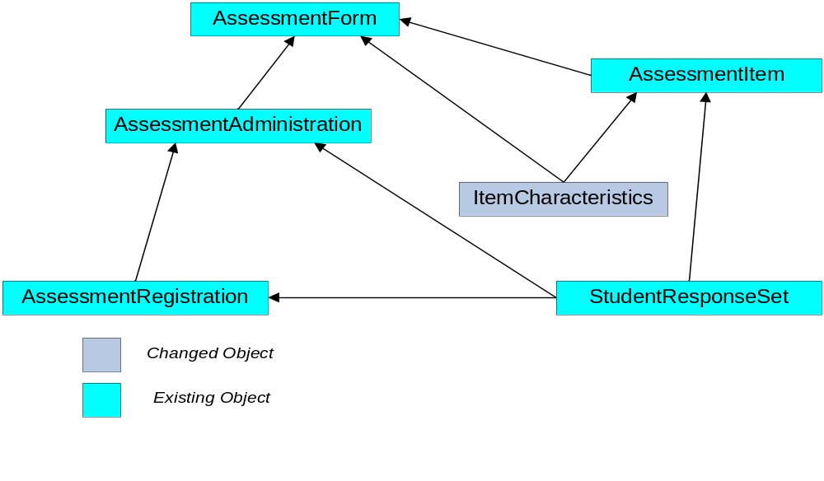

Changes to Other Objects
There are no anticipated changes to other objects.

Impact of Change
This proposal redesigns this object to be more in tune with the environment it must represent. The use case included in this proposal demonstrates the need for a much more robust structure for psychometric measures of Items that accommodates all existing measurements, innovative measurements and different test designs.

The Branch defined by the attribute MEASUREMENT subsumes the full functionality of the existing attribute DISCRIPTIVE including the individual metrics within that branch. Since the 2.5 is a minor release, insuring backward compatibility requires this legacy structure remain available until the next major release (3.0). However, the best practices document that will accompany this change will recommend that the new structure be used exclusively, thus assuring full compatibility at the time of a major release when the legacy DISCRIPTIVE attribute will be removed.

Object Description and Definitions
The ItemCharacteristics object provides specific information about each assessment Item within the context of an AssessmentForm or other logical grouping of Item exposures. This information includes an analysis, psychometric measures, reliability and validity information. This item level information assists in interpreting assessment scores as well as aide in improving teaching and learning.

Object/Element/Attribute | Char | Object Description | Type
ItemCharacteristics
@RefId | M |  | GUID
@AssessmentIemRefId | M | This RefId points to the assessment item of which the characteristics are a part. | GUID
@AssessmentFormRefId | O |  | GUID
PercentCorrect | O | Number of correct answers in sample | xs:decimal
SampleSize | O | Number of total Item exposures | Integer
SampleDescription | O | The description of the Sample the statistics are based on. May be District name, State or National sample | xs:NormalizedString

Measurements | OR | A Repeating group of psychometric measures
Measurements/Measurement |  | Container for series of item statistics
Measurements/ Measurement/MeasurementCode | O | Code List:  MSF  WMSF  RMSE  Rpbim  RIT  RC  RCS  zChiSq  PVal  PBi  BiS  DI  RC  CoA  ITC  IV  Scale | List
Measurements/  Measurement/MeasurementDescription | O | Mean Square Fit  Weighted Mean Square Fit  Revised Mean Square Fit  Revised Point Biserial measure  Rasch Item ??  Response Correlation  Response Correlation Squared  Z CHI Square  PValue  PointBiserial  Biserial  DiscriminationIndex  Reliability Coefficient  Coefficient Alpha  ItemTestCorrelation  ItemVariance  ScaleValue | List
Measurements/  Measurement/ScaleValue | O | The value of the Item based on this analysis | xs:decimal
Measurements/  Measurement/Min | O | The minimum value possible for the measurement and test design | xs:decimal
Measurements/  Measurement/Max | O | The maximum value possible for the measurement and test design | xs:decimal
Measurements/  Measurement/Optimal | O | The optimal value for this measurement and test design | xs:decimal

Descriptive |  | This group will be deprecated in 3.0
Descriptive/PValue | O | The percent of respondents who answered correctly. This number represents the probability of the correct response to a question. | Float
Descriptive/SampleSize | O | The size of the student group that saw the item. | Integer
Descriptive/PointBiserial | O | The correlation between correct answers (dichotomous variable) on this item and total correct answers on the test. | -1.00 to 1.00
Descriptive/Biserial | O | Similar to the Point Biserial Correlation except that answers to the item are assumed to come from an underlying continuous variable. | -1.00 to 1.00
Descriptive/DiscriminationIndex | O | The Index of Discrimination is the difference between the proportion of an upper group who got an item right and the proportion of a lower group who got the item right. | 0 to 1.00
DifferentialItemAnalysis | O
DifferentialItemAnalysis/CMH | O | Cochran-Mantel-Haenszel statistic. | -1.00 to 1.00
DifferentialItemAnalysis/MH | O | Mantel-Haenszel statistic. | -1.00 to 1.00
ResponseChoicePattern | O | The distribution of responses to each choice. This element only applies to multiple choice items.
ResponseChoicePattern/Choice | MR
ResponseChoicePattern/Choice/ChoiceLabel | M | Identifier for the choice. | Token
ResponseChoicePattern/Choice/Responses | M | The number of responses | Integer
SIF_Metadata

Issues
- The masks for these are harder because the correlations are open ended, how to display this. Our Researchers like the ability to include some guidance in the exchange because as they say:”It depends”
- Does the order the measurements construct appear in the spec matter?
- Should I include values for the deprecated structure in the XML?
- There needs to be the ability to send a pdf of the graph showing the item results. LearningResourcePackage comes the closest but can I use it? Is there somthign in SIF metadata or Extended Elements that can be used?

XML Example
(This example includes SIF_Metadata because metadata can be very important in the interpretation of the statistics transmitted by this object).

<ItemCharacteristics RefId="64B0CC6CFB314A328E520A102229CBC8" AssessmentItemRefId="A328E520A102229CBC864B0CC6CFB314" AssessmentFormRefId="229CBC864A328E520A102B0CC6CFB314">
<PercentCorrect>66.6</PercentCorrect>
<SampleSize>1777</SampleSize>
<SampleDescription>District tests only</SampleDescription>
<Measurements>
<Measurement MeasurementCode="MSF">
<MeasurementDescription>Mean Square Fit</MeasurementDescription>
<ScaleValue>.0066</ScaleValue>
<Min>0.0</Min>
<Max>>0.0</Max>
<Optimal>0.6</Optimal>
</Measurement>
<Measurement MeasurementCode="WMSF">
<MeasurementDescription>Weighted Mean Square Fit</MeasurementDescription>
<ScaleValue>.0066</ScaleValue>
<Min>0.0</Min>
<Max>>0.0</Max>
<Optimal>.2</Optimal>
</Measurement>
<Measurement MeasurementCode="ZChiSq">
<MeasurementDescription>Z Chi Square</MeasurementDescription>
<ScaleValue>3.3625</ScaleValue>
<Min><0.0</Min>
<Max><=0.0</Max>
<Optimal><0.0</Optimal>
</Measurement>
</Measurements>
<Descriptive>
<PValue/>
<SampleSize/>
<PointBiserial/>
<Biserial/>
<DiscriminationIndex/>
</Descriptive>
<DifferentialItemAnalysis>
<CMH>-.30</CMH>
<MH>-.15</MH>
</DifferentialItemAnalysis>
<ResponseChoicePattern>
<Choice>
<ChoiceLabel>1</ChoiceLabel>
<Responses>183</Responses>
</Choice>
<Choice>
<ChoiceLabel>2</ChoiceLabel>
<Responses>182</Responses>
</Choice>
<Choice>
<ChoiceLabel>3</ChoiceLabel>
<Responses>1184</Responses>
</Choice>
<Choice>
<ChoiceLabel>4</ChoiceLabel>
<Responses>228</Responses>
</Choice>
</ResponseChoicePattern>
<SIF_Metadata>
<TimeElements>
<TimeElement>
<Type>Full school year</Type>
<Code>01</Code>
<Name>2004/2005 School Year</Name>
<Value>2004-2005</Value>
<StartDateTime>2004-09-01T08:00:00-05:00</StartDateTime>
<EndDateTime>2005-06-30T15:00:00-05:00</EndDateTime>
<IsCurrent>true</IsCurrent>
</TimeElement>
</TimeElements>
<LifeCycle>
<Created>
<DateTime>2006-08-13T09:00:00-05:00</DateTime>
<Creators>
<Creator>
<Name>My Testing Service</Name>
<ID>http://www.myTestingService.com</ID>
</Creator>
</Creators>
</Created>
<ModificationHistory>
<Modified>
<By>http://www.myTestingService.com</By>
<DateTime>2006-08-17T09:30:00-05:00</DateTime>
</Modified>
</ModificationHistory>
</LifeCycle>
</SIF_Metadata>
</ItemCharacteristics>

Infrastructure Changes
There are no anticipated changes to the infrastructure.

