Instruction:

Complete all questions in 2:30 hrs

Let’s get started with some helpful Batch scripts:

1. What is Windows Start-up? How can all the start-up programs be viewed?

Ans:

Window start-up is the process of booting up computer and loading all the necessary programs and drivers. When computer is turned on some programs automatically start-up and run in the background.

All the start-up program can be viewed via Task manager, then by clicking on more options and then in Start-up tab. After that all the programs that begin at start-up are seen.

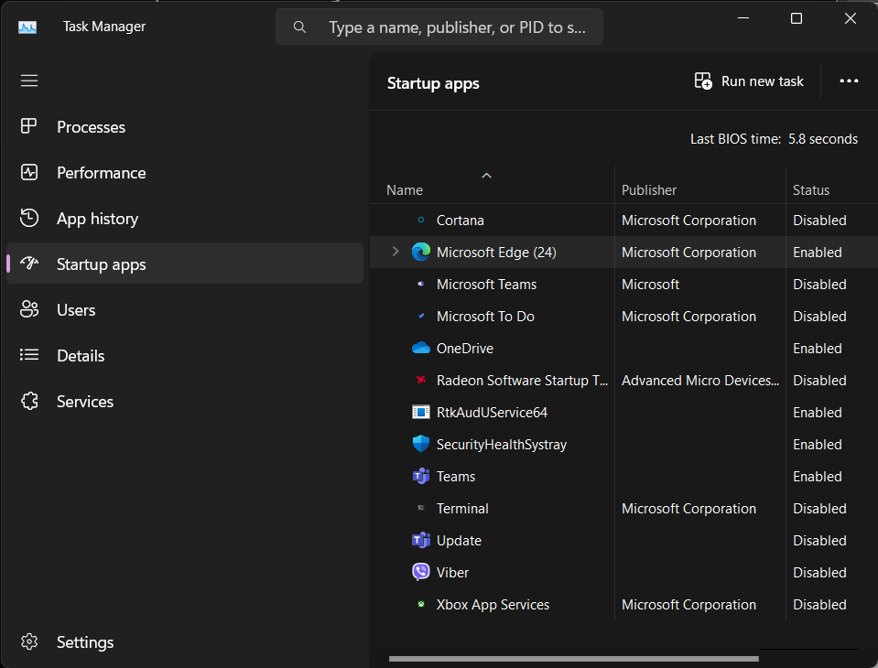

1. Write a batch script to display a simple “Hello YourName” message during the startup.

**Note: Copy the file to the Startup folder**

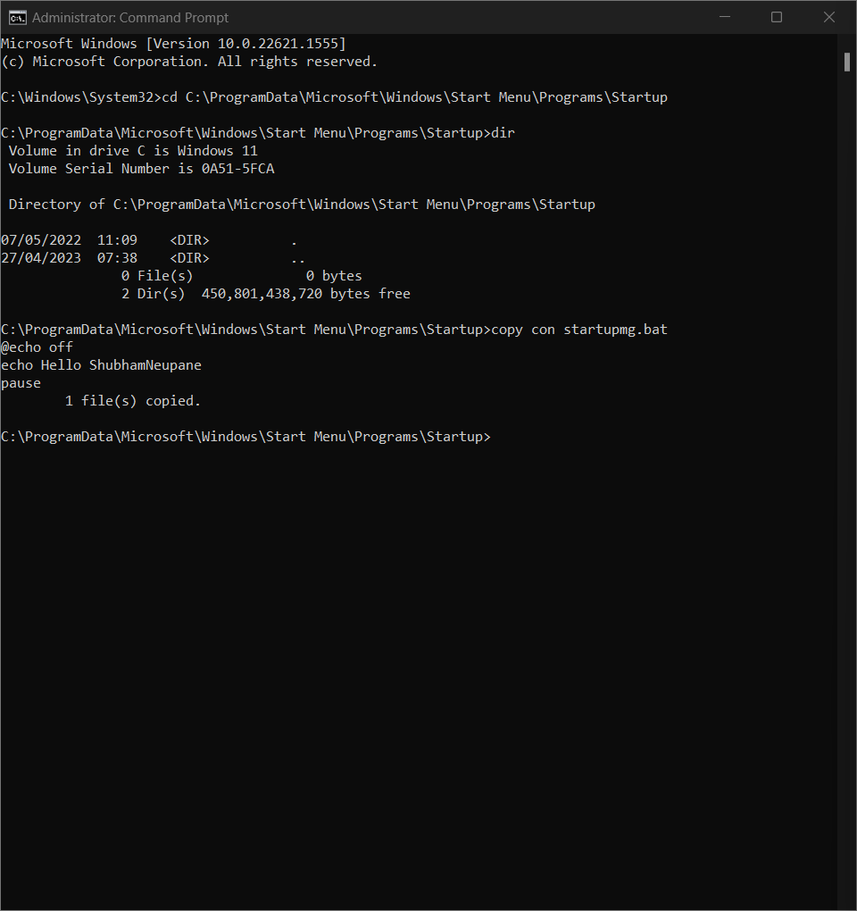

1. Write a batch script to schedule to automatically back up important files and folders to a different location at a scheduled time.

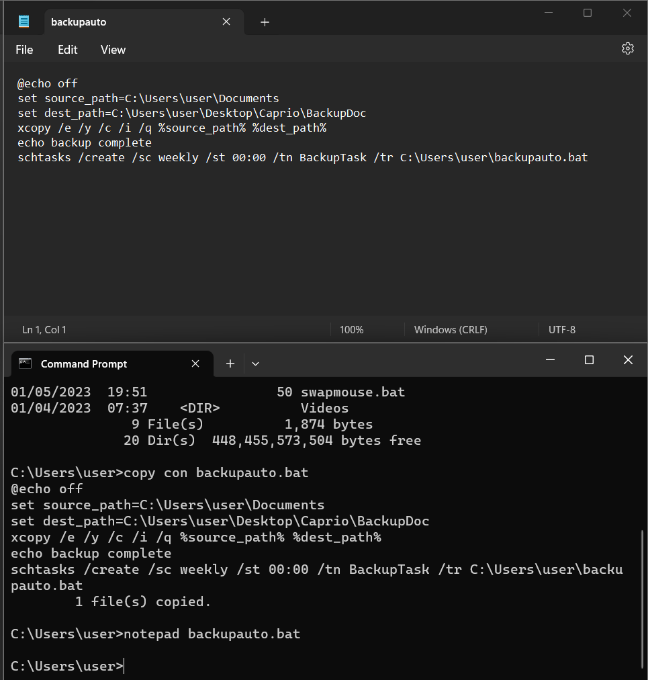

1. Write a Windows batch script that automatically deletes temporary files and clears out the recycle bin to free up space on the hard drive.

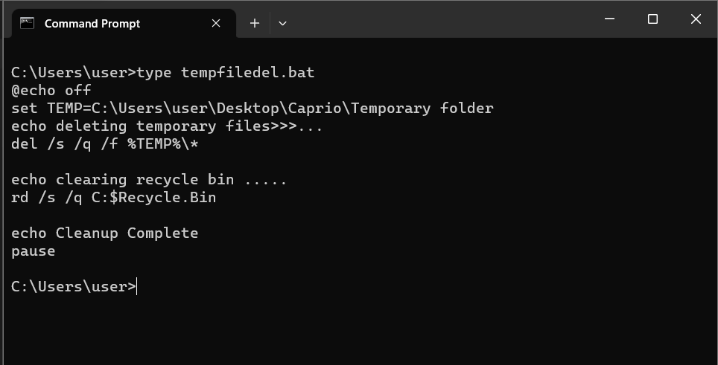

1. Write a windows batch script that can be run to diagnose and troubleshoot common network issues

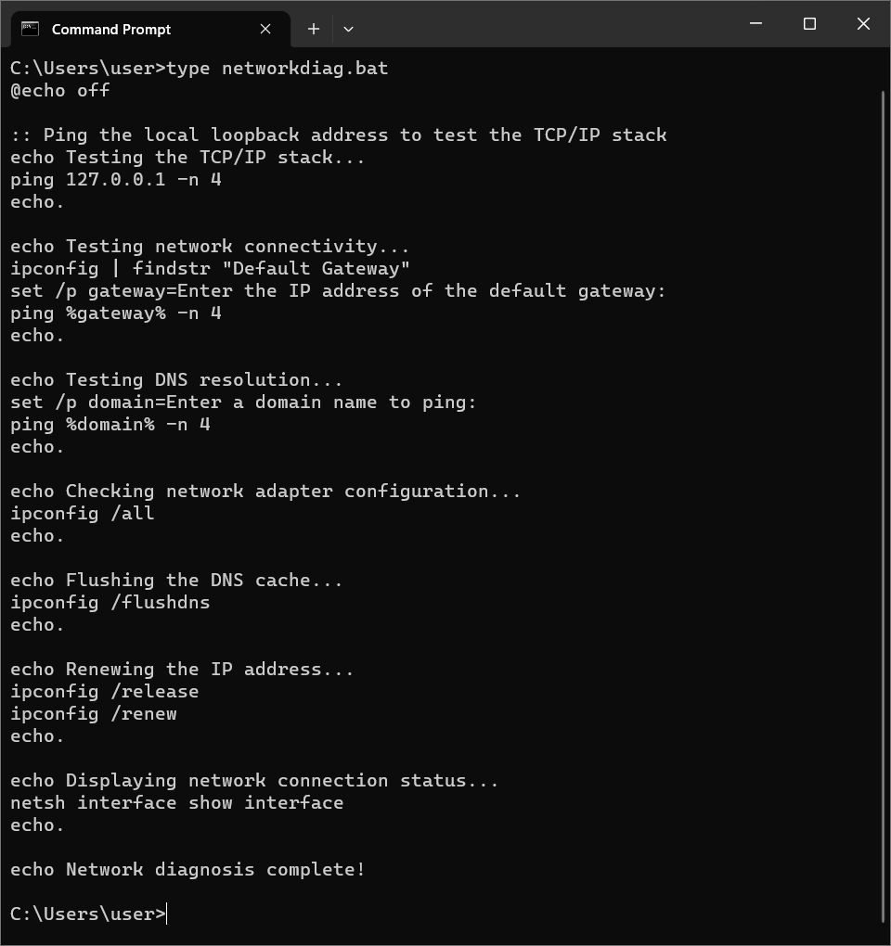

1. Write a batch script that can be scheduled to shut down the computer at a specific time (**using** **WINDOWS TASK SCHEDULER**).

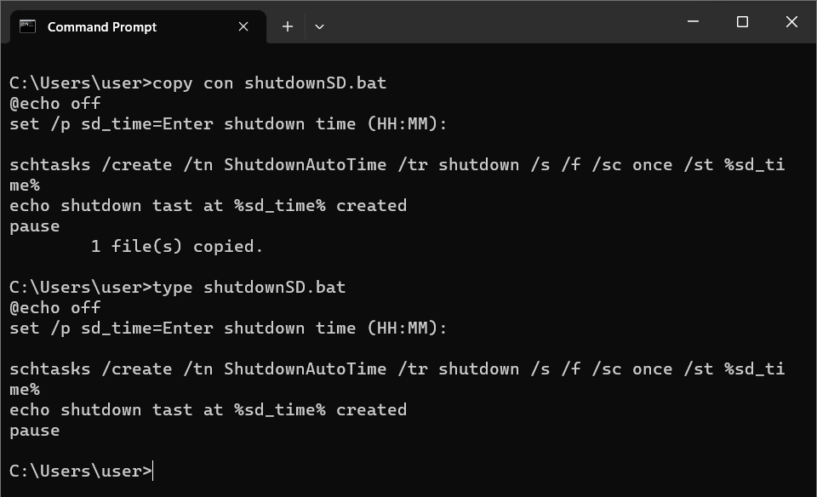

1. Copy the following script Save this and run this in the **Downloads** directory or any directory you want.

*@echo off*

*for %%a in (".\*") do (*

*if "%%~xa" NEQ "" if "%%~dpxa" NEQ "%~dpx0" (*

*if not exist "%%~xa" mkdir "%%~xa" (*

*move "%%a" "%%~dpa%%~xa\"*

*)*

*)*

*)*

What does the above script do? Elaborate on your answer.

Ans:

The above script goes through every single file in the current directory and segretes the similar files to a new folder with similar file types and extensions.

This batch file iterates through every file in the directory and places the same files into a folder then moves the files in the directory while are not in folder to their specific folders.

The programs only works for files that are not in any sub directory. It makes directory like .docx, .gif, .exe and moves the same type of file to the sub-directory.

