**Setup AccessData Products**

1. Install MSSQL 2012, 2014, or 2016
2. Obtain an Enterprise license with the “beta” flag and "Quin-C API" feature
3. Download and install PostgreSQL 9.6 from the “Product Management/Beta” folder on the tams FTP
4. Download and install Enterprise 7.1 Beta from the “Product Management/Beta” folder on the tams FTP
   * Install the EP, Enterprise Examiner, and Quin-C Server, but not PostgreSQL
   * The Service Account used to run Quin-C Server must have full access to any desired case folder and evidence shares
5. Download and install SiteServer from the “Product Management/Beta” folder on the tams FTP
   * The Service Account used to run Site Server must have read access to any shares you wish to collect from
   * Configure SiteServer as a Root Site Server
   * Connect SiteServer to PostgreSQL
6. Navigate to the Enterprise installation’s bin folder (typically "C:\Program Files\AccessData\Forensic Tools\7.1\bin)
7. Modify “ADG.WeblabSelfHost.exe.config” in a text editor as follow:
   * Change the value of “CertificatePath” to point to your Agent private certificate  
     
   * Change the value of “TrustedCertificatePath” to point to your agent.p7b in the Site Server installation folder  
     
   * Change the value of “SiteServerHost” and “SiteServerPort” to point to your Site Server  
     
8. Launch Enterprise to connect it to MSSQL, lay down the database, create the first user, and configure Agent certificates and port
9. Restart the “AccessData Quin-C Self Host Service”
10. To access the API documentation, navigate to <http://localhost:4443/swagger/ui/index> in a browser

**Setup Your IDE**

1. Download and install Visual studio Code (<https://aka.ms/win32-x64-user-stable>)
2. Download and install Python 3.7 (<https://www.python.org/downloads/>)
   * Perform an Advanced install
   * Check the option to install for all users
   * Check the option to add it to the PATH Variable
   * Check the option to install PIP
3. Open Visual Studio Code
4. Click the lower-left corner  
   
5. In the lower pane the opens, select the “TERMINAL” tab
6. Type and run the command “pip install requests”  
   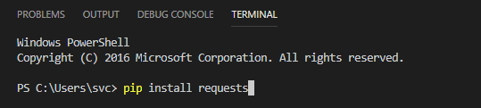  
   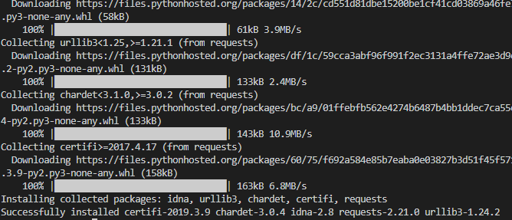
7. Type and run the command “pip install pyodbc”
8. Download any of the sample Python scripts from <https://github.com/AccessDataOps/QuinCAPI/tree/master/APIV2> and open it in Visual Code
9. If prompted, allow Visual Code to install the Python Extension  
   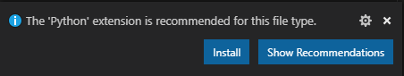
10. Confirm the lower-left corner says “Python 3.7.3”. If it doesn’t, click the corner and select “Python 3.7.3” from the available options.  
    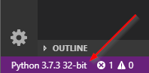  
      
    CreateCase_AddEvidencepy - Visual Studio Code 
    current: 
    Python 3.3.5 64-bit 
    Python 3.7.3 32-bit 
    — exe 

**Get Your API Key**

1. Open Enterprise and log in
2. Go to Tools > Access API Key
3. Highlight your user and click “Generate Key”  
   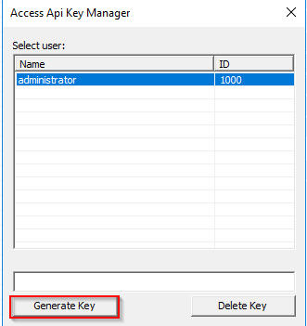
4. Copy the key out and save it. You will need it in every script.

**Test the API**

1. Open the test script AD\_APIV2\_CreatCase.py in Visual Code
2. Update the casename, casepath, responsivepath, API key, and resp values as needed (remember that backslashes “\” in strings must be escaped with another backslash) and save the changes
3. Execute the script by going to Terminal > Run Active File (you can also run scripts by double-clicking them)
4. Confirm the case folder was created and you can see the case in Enterprise

Documentation and Scripts

* <https://github.com/AccessDataOps/QuinCAPI/wiki/Enterprise-Quin-C-API-Documentation>