**Install and Configure the AccessData Software**

1. Obtain an Enterprise license with “ADAPI” feature.
2. Install .NET 4.7.2.
3. Download and install Enterprise 7.1 release from https://accessdata.com/product-download/ad-enterprise-version-7.1.0
   * Run the autorun.exe from the root of the disc/ISO
   * From the disc’s autorun menu, click “Other Products”
   * Click “Install License Manager” and follow the prompts to complete the installation
   * Click “Install CodeMeter 64 bit” and follow the prompts to complete the installation
   * If you have a physical Codemeter dongle:
     + Connect the dongle to the PC
     + Use License Manager to ensure it has your current licenses, and update the dongle if necessary
   * If you received an activation code for a virtual Codemeter dongle, follow the proper steps here to activate it
   * Click “Back to Main Menu”
   * Select “Examiner 64 Bit Install” on the autorun menu
   * At the “Setup Type” screen, check “Install Quin-C as a Windows Service” and click “Advanced”
   * At the “Custom Setup” screen, check at least Enterprise and Quin-C  
     Note: If you uncheck PostgreSQL, you will need to install MSSQL 2012, 2014, or 2016. If you uncheck Processing Engine, you’ll need to install a Distributed Processing Manager and configure distributed processing
   * If the installer prompts you to reboot, you may need to repeat the above steps after rebooting
   * Install the EP as a local engine
   * The Service Account used to run Quin-C Server must have full access to any desired case folder and evidence shares
4. Download and install PostgreSQL 9.6 and SiteServer from the eDiscovery 6.3.0 release
   * If you installed PostgreSQL 11.2 in the previous step, you’ll need to specify a different port and pgdata folder for PostgreSQL 9.6
   * The Service Account used to run Site Server must have read access to any shares you wish to collect from
   * Configure SiteServer as a Root Site Server
   * Connect SiteServer to PostgreSQL
5. Navigate to the Enterprise installation’s bin folder (typically "C:\Program Files\AccessData\Forensic Tools\7.1\bin)
6. Modify “ADG.WeblabSelfHost.exe.config” in a text editor as follow:
   * Change the value of “CertificatePath” to point to your Agent private certificate  
     
   * Change the value of “TrustedCertificatePath” to point to your agent.p7b in the Site Server installation folder  
     
   * Change the value of “SiteServerHost” and “SiteServerPort” to point to your Site Server  
     
7. Launch Enterprise to initialize the database and create the first Application Administrator user.
8. In Tools > Preferences, configure Agent certificates and port
9. Go to Tools > Access API Key
10. Highlight your user and click “Generate Key”
11. Copy the key out and save it as it won’t be shown again
12. Close Enterprise
13. Restart the “AccessData Quin-C Self Host Service”

**Setup Your IDE**

1. Download and install Visual studio Code (<https://aka.ms/win32-x64-user-stable>)
2. Download and install Python 3.7 (<https://www.python.org/downloads/>)
   * Perform an Customized install
   * Check the option to install PIP
   * Check the option to install for all users
   * Check the option to add it to the environment variables
3. Open Visual Studio Code
4. Click the lower-left corner  
   
5. In the lower pane the opens, select the “TERMINAL” tab
6. Type and run the command “pip install requests”  
   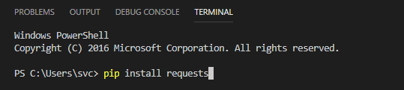  
   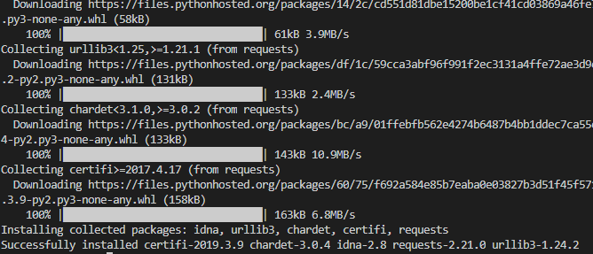

**Confirm the API is Functional**

1. In a browser, confirm you can navigate to <http://localhost:4443/swagger/ui/index>
2. Open the Basic\_Create\_Case.py script from <https://github.com/AccessDataOps/QuinCAPI/tree/master/APIV2/Services/release> in Visual Code
3. If prompted, allow Visual Code to install the Python Extension  
   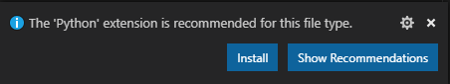
4. Confirm the lower-left corner says “Python 3.7.3”. If it doesn’t, click the corner and select “Python 3.7.3” from the available options.  
   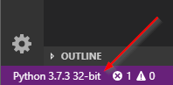  
     
   CreateCase_AddEvidencepy - Visual Studio Code 
   current: 
   Python 3.3.5 64-bit 
   Python 3.7.3 32-bit 
   — exe 
5. Update the apihost, apikey, casename, and casepath values as needed (remember that backslashes “\” in strings must be escaped with another backslash in Python) and save the changes
6. Execute the script by going to Terminal > Run Active File (you can also run scripts by double-clicking them)
7. Confirm the case folder was created and you can see the case in Enterprise

Documentation and Scripts

* <https://github.com/AccessDataOps/QuinCAPI/wiki/Enterprise-Quin-C-API-Documentation>