AEPL
ACCOLADE ELECTRONICS PVT. LTD.

CONTINUOUS FOTA AUTOMATION UTILITY
OPERATING PROCEDURE
Standard Operating Procedure (SOP)
Target Unit: Accolade 4G TCU (AIS-140)

SOP No. | AEPL/SOP/QA/FOTA-001
Revision No. | 2.1.0
Effective Date | 24-08-2026
Review Date | 24-08-2027
Department | Verification And Validation

Confidential @ Accolade Electronics Pvt. Ltd.

1.0 OBJECTIVE & PURPOSE
1.1 The objective of this Standard Operating Procedure (SOP) is to establish a standardized, repeatable, and automated protocol for performing continuous Firmware Over-The-Air (FOTA) upgrade testing, boot log telemetry abstraction, 10-stage progression validation, and server state matrix verification on Accolade 4G Telematics / TCU Hardware Units.
1.2 This document defines step-by-step operating guidelines for QA Engineers, Hardware Technicians, and Firmware Developers to ensure zero-defect FOTA deployment, prevent task collisions on state servers, and log verified compliance audit trails.
1.3 In addition to the operating steps, this SOP is intended to serve as a self-contained reference manual for the Continuous FOTA Automation Utility — describing its internal architecture, configuration files, data outputs, and quality checkpoints — so that any trained reader can understand what the utility does internally, and independently operate, verify, and troubleshoot it without relying on tribal knowledge.

2.0 SCOPE
2.1 This procedure applies to all validation testing, endurance cycle testing, production staging audits, and quality assurance testing of Accolade 4G TCU hardware units across all target server states (Maharashtra, Bihar, Assam, Default, etc.).
2.2 It covers software execution, hardware serial connection, Bluetooth port safety guards, 10-stage progression monitoring, Console OTA command verification, and audit CSV report generation.
2.3 This SOP is applicable at the QA & Embedded Hardware Testing lab and at production staging locations where the Continuous FOTA Automation Utility is deployed on an approved Windows workstation. It is not applicable to over-the-air rollout to fielded/live vehicles, which is governed by a separate Production OTA Release SOP.

3.0 DEFINITIONS, ABBREVIATIONS & ACRONYMS
Term | Definition
FOTA | Firmware Over-The-Air — a mechanism to remotely deliver and install firmware updates on a device without physical reflashing.
TCU | Telematics Control Unit — the onboard hardware unit responsible for vehicle data reporting.
DUT | Device Under Test — the specific TCU hardware unit connected for validation during a test session.
AIS-140 | Automotive Industry Standard 140 — the Government of India mandated standard for GNSS-based vehicle tracking and alert devices.
UART | Universal Asynchronous Receiver-Transmitter — the serial hardware interface used for direct communication with the DUT.
IMEI | International Mobile Equipment Identity — the unique identifier of the cellular modem embedded in the TCU.
VIN | Vehicle Identification Number — the unique code used to identify the vehicle associated with the DUT.
UIN | Unique Identification Number — a device-specific identifier string (prefixed ACON...) parsed from the boot log.
ESD | Electrostatic Discharge — a sudden flow of static electricity that can damage unprotected electronic components.
COM Port | The operating-system serial communication port abstraction (physical UART or virtual Bluetooth SPP) enumerated by Windows.
Bluetooth SPP | Serial Port Profile — a virtual serial link carried over Bluetooth; disallowed by this utility due to latency and drop-out risk during FOTA.
REST API | Representational State Transfer Application Programming Interface — the HTTP-based interface used to sync the server state matrix and trigger/poll FOTA jobs.
servers. Json | The local configuration file holding the state-to-server IP/Port matrix used to validate and route FOTA targets.
55AA Login Packet | A proprietary handshake packet transmitted by the TCU after reboot, used to confirm the post-upgrade firmware version.
State Server Matrix | The mapping of Indian state codes to their designated OTA server IP addresses and ports.
QThread | The Qt/PyQt6 threading class used to run background operations (serial I/O, API calls) without blocking the GUI.
StageProgressionWidget | The GUI component that renders and tracks the real-time status of the 10 sequential FOTA validation stages.

4.0 REFERENCE DOCUMENTS & APPLICABLE STANDARDS
This SOP is to be read in conjunction with the following documents and standards:
Reference No. | Document / Standard Title
AIS-140 | GNSS Vehicle Tracking Device Standard — Government of India (ARAI / ICAT type-approval requirement).
ISO 9001:2015 | Quality Management Systems — Requirements.
IATF 16949:2016 | Automotive Quality Management System requirements, as applicable to embedded hardware validation.
IEC 61340-5-1 | Protection of electronic devices from electrostatic phenomena (ESD control program).
QM/AEPL/01 | AEPL Quality Manual.
AEPL/SOP/QA/RFID-001 | SOP for RFID Tag Reader & Writer Utility (companion QA test-utility SOP).
— | Accolade 4G TCU Firmware Release Notes (version-specific, issued per release by Embedded Firmware team).

5.0 RESPONSIBILITY & ACCOUNTABILITY
Role / Designation | Operational Responsibilities
QA Test Operator | Connects hardware, configures target state, selects physical serial port, executes utility, monitors 10-stage progression bar, and exports audit CSV reports.
QA Lead / Manager | Reviews audit logs (fota_results.csv, login_packets.csv), verifies state server matrices in servers. Json, approves release certification reports, and performs periodic QC sampling per Section 14.0.
Embedded Firmware Engineer | Investigates failed runs, analyses millisecond session logs (logs/*.log), addresses firmware stage verification failures, and owns root-cause analysis for non-conformances per Section 16.0.
Document Controller | Maintains the master copy of this SOP, controls distribution per Section 19.0, and archives superseded revisions.

6.0 PREREQUISITES & TRAINING REQUIREMENTS
Before operating the Continuous FOTA Automation Utility unsupervised, personnel must satisfy the following prerequisites:
1. Minimum qualification: Diploma / Degree in Electronics, Electrical, or Computer Engineering, or equivalent hands-on experience under supervision.
2. Completion of ESD Awareness & Handling training, with a valid training record on file.
3. Read and acknowledged this SOP (signature recorded in the training log), including the safety mandates in Section 8.0.
4. Successful completion of a minimum of three (3) supervised FOTA test sessions before independent sign-off authority is granted.
5. Basic familiarity with AT serial command syntax (Section 12.0) and the ability to interpret pass/fail status on the progression bar.

7.0 EQUIPMENT, INFRASTRUCTURE & SOFTWARE TOOLS REQUIRED

7.1 Hardware Infrastructure
Item | Minimum Specification
Workstation | Windows 10 / 11, 64-bit, minimum 8 GB RAM, 1 free USB port.
DUT (Device Under Test) | Accolade 4G Telematics / TCU Unit (AIS-140 Compliant).
Power Supply | Regulated DC Power Supply, 12V / 24V DC, minimum 2A.
Serial Cable / Interface | USB-to-UART / RS232 Serial Cable (FTDI / Prolific / CH340 chipset).

7.2 Software Infrastructure
1. FOTA Automation Utility: Standalone executable (Continuos_Fota.exe) or source distribution (python main.py).
2. Configuration Files: .env (API endpoints and credentials) and input/servers.json (server state matrix).
3. Python Environment (if running from source): Python 3.10+ with PyQt6, pyserial, requests, python-dotenv.

7.3 Utility Directory & File Structure
The utility reads from and writes to the following folders relative to its installation directory. Operators should never manually edit files inside results/ or logs/ while a session is active.
Path | Purpose
.env | Stores API endpoint URLs and authentication credentials used by ApiSyncWorker and FotaApiPollerWorker.
input/servers.json | State server matrix — maps target states to OTA server IP/Port and target firmware version.
results/fota_results.csv | Row-per-run audit trail of execution outcome, timestamps, and final status.
results/fota_results.json | Machine-readable equivalent of the audit trail, used for downstream analytics.
results/fota_analytics_report.csv | Aggregated pass/fail/stage-failure statistics, refreshed periodically for QA trend review.
results/login_packets.csv | Log of all 55AA login packets received, used to cross-verify post-upgrade firmware versions.
logs/terminal_session.log | Master, continuously appended log of all terminal/serial output across sessions.
logs/{IMEI}_{PREV_VER}_TO_{TARGET_VER}.log | Dedicated, millisecond-resolution log generated per individual FOTA upgrade cycle for deep-dive failure analysis.

8.0 SAFETY PRECAUTIONS & HANDLING GUIDELINES
CRITICAL SAFETY & OPERATIONAL MANDATES:
1. ESD Protection: Wear an Anti-Static Electrostatic Discharge (ESD) wrist strap when handling un-housed TCU PCBs.
2. Power Supply Polarity: Ensure positive (+12V/24V) and ground (GND) power leads are correctly wired before powering ON.
3. Physical Serial Port Enforcement: ALWAYS connect via a physical USB/UART Serial adapter. DO NOT use Bluetooth serial ports.
4. Single Application Access: Ensure no other serial software (Tera Term, PuTTY, Real Term) is holding the COM port open.

8.1 Personal Protective Equipment (PPE)
• ESD wrist strap, connected to a verified ground point, at all times when handling un-housed PCBs.
• Anti-static mat on the workbench surface where the DUT is placed during testing.

8.2 Environmental Operating Conditions
Parameter | Recommended Range
Ambient Temperature | 18°C – 30°C
Relative Humidity | 30% – 70% RH, non-condensing
ESD Control | Grounded workstation, anti-static flooring/matting where available

9.0 SYSTEM ARCHITECTURE & THREADING MODEL
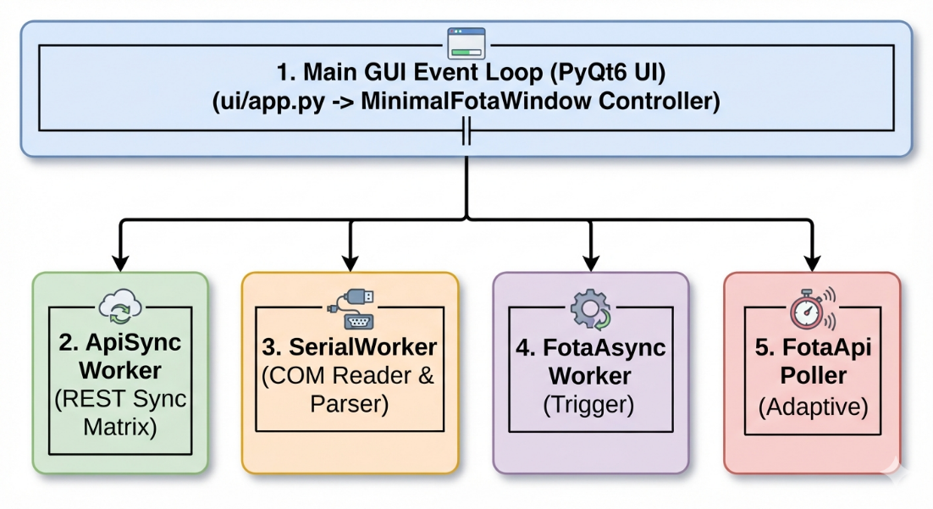
The utility features a multi-threaded architecture utilizing PyQt6 and PySerial to ensure the User Interface (UI) remains 100% responsive and never freezes during high-rate serial log reads or network REST API requests. Separating I/O-bound work onto background threads prevents a slow serial read or a stalled HTTP request from blocking stage-progression updates on screen.

Core Architecture Components
• Main GUI Thread (MinimalFotaWindow): Renders 4 main tabs, 10-stage progression bar, live terminal, and header controls.
• ApiSyncWorker: Background thread syncing the state server matrix from backend API into input/servers.json.
• SerialWorker: Asynchronous QThread reading live serial stream and feeding MessageParser for real-time telemetry abstraction.
• FotaAsyncTriggerWorker: Evaluates active device state/version history, resolves next sequential target, and posts FOTA trigger requests.
• FotaApiPollerWorker: Adaptive polling worker monitoring server-side download percentage (60s interval when < 95%, 2s interval when ≥ 95%).

9.1 Why This Architecture Matters to the Operator
An operator does not need to modify code, but understanding the separation of concerns above explains observed GUI behaviour: the port dropdown and Start button remain clickable even while a download is in progress (handled by background workers), a temporarily unresponsive serial link only stalls stage progress rather than the whole application, and the adaptive poller is what allows the utility to recover a session automatically even if the serial log stream is briefly interrupted (see Section 15.0, "Device Stuck at 99% Download").

10.0 PRE-OPERATIONAL CHECKLIST
Complete the following checklist before starting any FOTA test session. This checklist may be reproduced as a standalone log sheet for shift records.
# | Checklist Item | Expected Condition
1 | DC power supply polarity checked | +12V/24V and GND correctly wired
2 | USB-Serial cable connected | Physical UART/RS232 adapter, not Bluetooth
3 | No conflicting serial software running | Tera Term / PuTTY / Real Term closed
4 | .env and servers.json present and current | Synced within current shift via ApiSyncWorker
5 | Target server state identified | Confirmed against work order / test plan

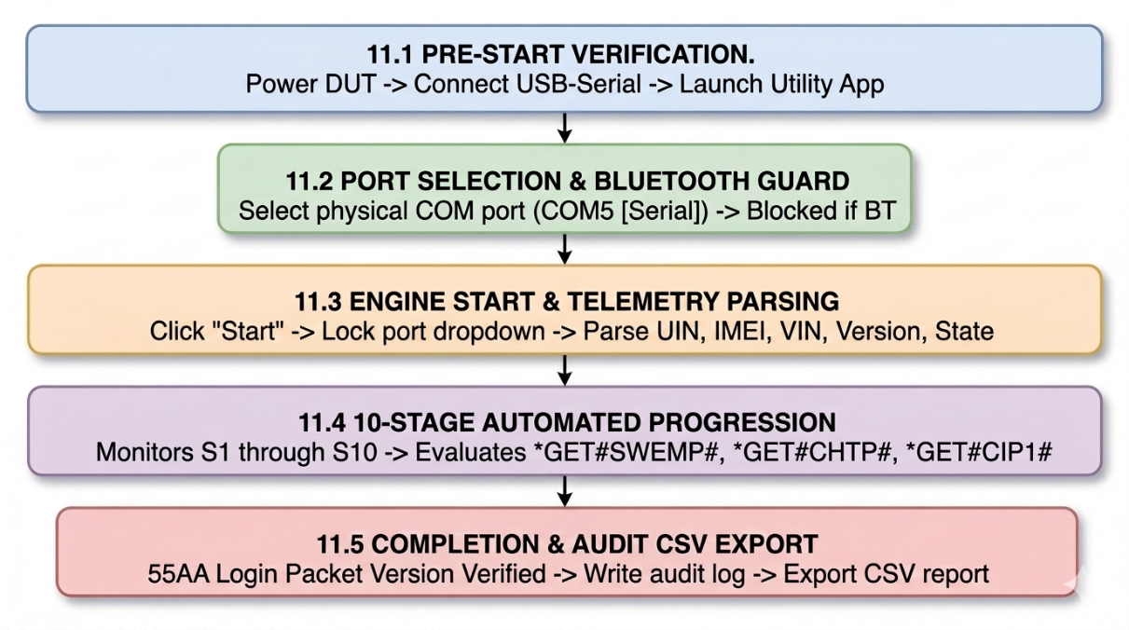
11.0 OPERATING PROCEDURE & WORKFLOW

11.1 Pre-Start Hardware Verification
1. Connect DUT to DC power supply (12V/24V) and plug USB-Serial cable into workstation PC.
2. Launch Continuous FOTA Utility via executable (Continuos_Fota.exe) or terminal (python main.py).
3. Confirm the application window loads all 4 main tabs and the header control bar without error dialogs.

11.2 Port Selection & Bluetooth Safety Enforcement
1. Locate the Port Dropdown in the top header control bar.
2. Inspect the scanned COM ports list. Ports are automatically formatted with hardware classification.
• COM5 [Serial] - USB Serial Port (COM5) — VALID PHYSICAL SERIAL
• COM4 [Bluetooth] - Standard Serial over Bluetooth link (COM4) — DISALLOWED BLUETOOTH

3. Select a physical USB/UART Serial port.
BLUETOOTH SELECTION GUARD
If a Bluetooth port is selected, the application displays a warning toast and blocks starting the engine. If the Refresh button is clicked, hardware ports are scanned quietly without triggering warning popups.

11.3 Target State Matrix Selection & Engine Start
1. Select the target server state from the Target State Dropdown (e.g. Maharashtra, Bihar, Assam, Default).
2. Click Start. The port selection dropdown and refresh button will automatically lock during active logging.
3. Confirm the live terminal pane begins streaming serial output and that the UIN, IMEI, VIN, firmware version, and state are correctly parsed on screen.
11.4 10-Stage Progression Bar Validation Matrix
The 10-Stage Progression Bar (StageProgressionWidget) automatically tracks and evaluates all 10 sequential FOTA stages:
Stage | Title | Verification Logic & Response Criteria | Status Outcomes
S1 | S1: Telemetry | Parses UIN (ACON...), IMEI, VIN, Firmware Version, and State from serial boot logs. Saves pre-upgrade snapshot. | PASSED / WAITING
S2 | S2: Servers Matrix | Validates target state and version against input/servers.json matrix metadata. | PASSED / FAILED
S3 | S3: Progress Sync | Queries server history. Attaches tracking to Pending/In-Progress runs; advances past completed/aborted runs. | PASSED / RUNNING
S4 | S4: Audit Report | Logs execution record into results/fota_results.csv, results/fota_results.json, and session logs. | PASSED
S5 | S5: 100% Download | Verifies download reaches 100.00% via serial log line ([FOT] downloading 100.00%) or REST API poller. | PASSED / RUNNING
S6 | S6: Device Reboot | Monitors post-download reset log line (GSM soft shutdown pass, MQTT disconnect, synchronized suspend ok). | PASSED / RUNNING
S7 | S7: State OTA Fired | Queries *GET#SWEMP#. If device state matches servers.json, logs ALREADY SET and passes immediately. If state missing, displays NOT PRESENT. | PASSED / ALREADY SET / NOT PRESENT
S8 | S8: IP1 & Port Set | Queries *GET#CHTP#. If unconfigured default (255.255.255.255:65535), waits for set response line. If matching target IP, logs ALREADY SET and passes immediately. | PASSED / ALREADY SET / NOT PRESENT
S9 | S9: IP2 & Port Set | Queries *GET#CIP1#. If unconfigured default (255.255.255.255:65535), waits for set response line. If matching target IP, logs ALREADY SET and passes immediately. | PASSED / ALREADY SET / NOT PRESENT
S10 | S10: Config Verified | Validates post-upgrade version from 55AA Login Packet vs target release version and verifies telemetry snapshot integrity. | PASSED / FAILED

STAGES 7, 8, 9 SERIAL QUERY EVALUATION RULES

Serial Query Sequence: Queries *GET#SWEMP# (S7) → *GET#CHTP# (S8) → *GET#CIP1# (S9) are issued sequentially.

Already Set Match: If the serial response matches target state/IP/Port in servers.json, the stage card displays ALREADY SET and passes immediately without waiting for set commands.

Unconfigured Factory Default: If *GET#CHTP# or *GET#CIP1# returns STATUS#255.255.255.255:65535#OK#, the orchestrator waits for the set command response (STATUS#SET#...#OK#).

Missing State Parameter: If a state parameter is absent in servers.json, the stage displays NOT PRESENT and passes the stage cleanly.

11.5 Completion & Audit Export
1. Upon Stage S10 passing, the utility writes the final execution record to results/fota_results.csv with status COMPLETED.
2. Click Export CSV (or equivalent report action) at the end of the shift to archive audit reports per Section 17.0.
3. Disconnect the DUT only after confirming the engine has fully stopped, and no active session is in progress.

12.0 SERIAL COMMAND QUICK REFERENCE TABLE
Command String | Purpose & Function | Expected Response Pattern
*SET#CRST#1# | Soft reboot / reset TCU hardware unit. | STATUS#SET#CRST#1#OK# / GSM soft shutdown pass
*GET#SWEMP# | Query active state OTA configuration. | STATUS#SWEMP#<state>#OK#
*GET#CHTP# | Query primary server IP1 & Port1. | STATUS#CHTP#<ip>:<port>#OK#
*GET#CIP1# | Query secondary server IP2 & Port2. | STATUS#CIP1#<ip>:<port>#OK#
*CLR#FOTA# | Clear active FOTA update state. | STATUS#CLR#FOTA#OK#

COMMAND TIMING NOTE

Each *GET#...# query is issued with an internal response timeout; if no response is received the orchestrator retries automatically before flagging the stage as NOT PRESENT or FAILED per the rules in Section 11.4.Missing State Parameter: If a state parameter is absent in servers.json, the stage displays NOT PRESENT and passes the stage cleanly.

13.0 ACCEPTANCE & REJECTION CRITERIA

13.1 Acceptance Criteria (PASS)
1. 10-Stage Progression Completion: All 10 stages (S1 through S10) evaluate to PASSED, ALREADY SET, or NOT PRESENT.
2. Version Match: Post-upgrade firmware version parsed from incoming 55AA Login Packet matches the target version in servers.json.
3. Audit Log Generation: Execution record saved in results/fota_results.csv with status COMPLETED.

13.2 Rejection Criteria (FAIL)
1. Stage Validation Failure: Any stage evaluates to FAILED or ABORTED.
2. Timeout Error: Reboot verification (S6) or FOTA download (S5) exceeds timeout window without progress.
3. Version Mismatch: Post-upgrade version does not match target release version.

14.0 QUALITY CONTROL & IN-PROCESS VERIFICATION
1. Every DUT undergoes 100% verification across all 10 stages (S1–S10); no stage may be skipped or manually overridden by the operator.
2. The QA Lead / Manager performs a daily review of fota_results.csv to confirm completeness and flag any anomalous patterns.
3. A minimum 10% sample of PASSED units, selected at random each week, is cross verified by the QA Lead against raw session logs in logs/ for traceability.
4. A weekly trend analysis of results/fota_analytics_report.csv is conducted to identify recurring stage-level failure patterns (e.g., repeated S5 timeouts on a specific state).
5. Calibration/health check of the DC power supply and serial adapter set is performed monthly, or per the equipment calibration schedule, whichever is more frequent.

15.0 TROUBLESHOOTING & DO'S AND DON'TS MATRIX
Fault Condition | Root Cause | Corrective Action
Cannot Start (Bluetooth Warning) | Selected COM port is a Bluetooth link (COM4). | Select a physical USB/UART Serial port (e.g. COM5 [Serial]) and click Start.
COM Port Access Denied | Port occupied by Tera Term / PuTTY. | Close external terminal apps, click Refresh (CTRL+R), and retry.
BLOCKED_VERSION_NOT_FOUND | Version missing in servers.json. | Select correct Target State or update input/servers.json matrix.
API HTTP 401 Unauthorized | Token expired or invalid credentials. | Verify .env credentials and restart application.
Device Stuck at 99% Download | Serial log stream interrupted. | Engine adaptive poller will automatically verify completion via server REST API.
servers.json Sync Failure | Backend API unreachable or network interruption during ApiSyncWorker sync. | Check network connectivity, retry sync from the header control bar, and confirm the file timestamp updates.
Firmware Version Parse Error | Corrupted or partial 55AA login packet received. | Trigger *SET#CRST#1# to reboot the DUT and allow a fresh login packet to be captured.

Operational Do's and Don'ts
• DO ensure DC power supply is stable (12V / 24V DC) throughout the upgrade cycle.
• DO export CSV audit reports at the end of every testing shift.
• DO raise a non-conformance record for any recurring FAILED/ABORTED run per Section 16.0.
• DON'T disconnect serial cable or power off DUT during active FOTA download (Stage S5).
• DON'T attempt to run logging on Bluetooth serial ports.
• DON'T manually edit files inside results/ or logs/ while a session is active.

16.0 NON-CONFORMANCE, DEVIATION & CAPA HANDLING
1. Any run that evaluates to FAILED or ABORTED after the corrective actions in Section 15.0 have been attempted is logged as a Non-Conformance Record (NCR) in the QA non-conformance register.
2. The Embedded Firmware Engineer performs root-cause analysis using the dedicated session log (logs/{IMEI}_{PREV_VER}_TO_{TARGET_VER}.log) within 24 hours of the NCR being raised.
3. Corrective and Preventive Actions (CAPA) are documented against the NCR and tracked to closure by the QA Lead / Manager.
4. Any fault condition recurring more than three (3) times within a calendar week, across any DUT, is escalated to the Engineering Lead for firmware-level investigation.
5. Deviations from this SOP (e.g., a one-off manual override) must be documented and approved in writing by the QA Lead / Manager before the affected DUT can be released.

17.0 RECORD KEEPING & DATA RETENTION
1. Master Log File (logs/terminal_session.log): Continuously records all terminal session output.
2. Dedicated Session Logs (logs/{IMEI}_{PREV_VER}_TO_{TARGET_VER}.log): Individual log files generated per FOTA upgrade cycle.
3. CSV Audit Reports (results/fota_results.csv, results/fota_analytics_report.csv, results/login_packets.csv): Archived on QA server for 3 years for ISO/IATF compliance audits.
4. All records are backed up nightly to the QA fileserver; the operator's local copies are for working reference only and are not the controlled record of truth.
5. Records may be requested for internal audit, customer audit, or regulatory (AIS-140) inspection at any time within the retention period.

18.0 DOCUMENT REVISION LOG
Revision | Date | Section Changed | Description of Changes | Approved By
1.0.0 | 15-01-2026 | All | Initial SOP creation for FOTA utility testing. | QA Lead
1.5.0 | 10-05-2026 | Sec 6, 7 | Added 3-status logic engine and automated REST poller. | QA Manager
2.0.0 | 24-08-2026 | Sec 3, 7, 8 | Added 10-Stage Progression Bar, Bluetooth port guard, ALREADY SET / NOT PRESENT stage logic, and AEPL corporate PDF header. | Engineering Lead
2.1.0 | 24-08-2026 | All | Expanded to full industry-standard SOP format: added Definitions, References, Prerequisites & Training, File Structure, Pre-Operational Checklist, Quality Control, and Non-Conformance/CAPA sections. | QA Manager

19.0 DISTRIBUTION LIST
This document is issued as a Controlled Copy to the following functions. Uncontrolled copies (printed or emailed) are not subject to revision update notifications.
Copy No. | Function / Department | Format
01 | Quality Assurance & Embedded Hardware Testing | Controlled — Electronic (Master)
02 | Embedded Firmware / R&D | Controlled — Electronic
03 | Production Staging | Controlled — Electronic
04 | Document Control Cell | Master Record

20.0 PREPARATION, REVIEW & APPROVAL SIGN-OFF
Action / Designation | Name | Signature | Date
PREPARED BY:  QA Automation Engineer | Suraj Bhalerao | ____________________ | 24 / 08 / 2026
CHECKED BY:  Verification and Validation Manager | Prathmesh Desai | ____________________ | 24 / 08 / 2026
APPROVED BY:  Verification and Validation Manager | Prathmesh Desai | ____________________ | 24 / 08 / 2026

