**Assignment:**

#### Ans 1. Since there are more than one independent attribute with multiple values in the same table. With “CustID” being the Primary Key therefore, there is Multivalued Functional Dependency which is as follows: -

#### CustID -> CustName

#### CustID -> AccountManager

#### CustID -> AccountManagerRoom

#### CustID -> ContactName1

#### CustID -> ContactName2

#### 

#### BCNF Normalization of the given Table is as follows: -

|  |  |  |  |  |
| --- | --- | --- | --- | --- |
| CustID | CustName | AccountManager | ContactName1 | ContactName2 |
| 171 | ABNAmro | Hans | Piet | Koos |
| 190 | RaboBank | Guus | Mona | Mieke |

|  |  |
| --- | --- |
| AccountManager | AccountManagerRoom |
| Hans | 12 |
| Guus | 15 |

Ans 2. The ERD for Hospital Management is as follows: -

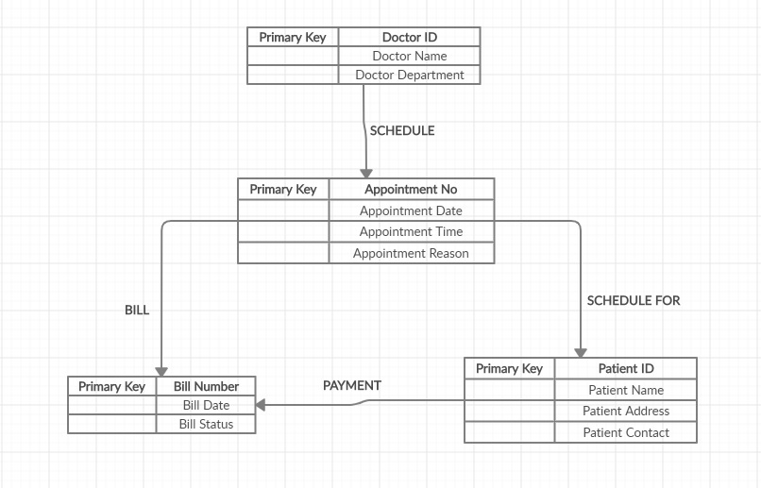

Ans 3. Basic Relational Table of Given Student Relation can be as follows: -

|  |  |  |  |  |  |  |
| --- | --- | --- | --- | --- | --- | --- |
| StudentID | ModuleID | ModuleName | StudentName | StudentAddress | TutorId | TutorName |
| S1 | M1 | Module 1 | Aryan | Bangalore | T1 | Prof X |
| S1 | M2 | Module 2 | Aryan | Bangalore | T1 | Prof X |
| S2 | M1 | Module 1 | Praveen | Bangalore | T2 | Hari |
| S2 | M2 | Module 2 | Praveen | Bangalore | T2 | Hari |
| S3 | M1 | Module 1 | Aryan | Pune | T1 | Prof X |

#### 3NF Normalization of the given Table is as follows: -

|  |  |  |  |
| --- | --- | --- | --- |
| StudentID | StudentName | ModuleID | ModuleName |
| S1 | Aryan | M1 | Module 1 |
| S1 | Aryan | M2 | Module 2 |
| S2 | Praveen | M1 | Module 1 |
| S2 | Praveen | M2 | Module 2 |
| S3 | Aryan | M1 | Module 1 |

|  |  |  |
| --- | --- | --- |
| StudentID | StudentName | StudentAddress |
| S1 | Aryan | Bangalore |
| S2 | Praveen | Bangalore |
| S3 | Aryan | Pune |

|  |  |  |  |
| --- | --- | --- | --- |
| TutorId | TutorName | StudentID | StudentName |
| T1 | Prof X | S1 | Aryan |
| T1 | Prof X | S3 | Aryan |
| T2 | Hari | S2 | Praveen |

Functional Dependency is as follows: -

StudentID -> StudentName

StudentID -> ModuleID

StudentID -> ModuleName

StudentID -> StudentAddress

TutorID -> TutorName

TutorID -> StudentID

TutorID -> StudentName