Task 1. DDL and DML queries are as follows: -

CREATE TABLE DOCTOR (

doctorId int,

doctorName varchar (255),

doctorDept varchar (255),

PRIMARY KEY (doctorId)

);

CREATE TABLE APPOINTMENT (

appntNo int,

appntDate DATE,

appntTime TEXT,

appntReason TEXT,

PRIMARY KEY (appntNo)

);

CREATE TABLE PATIENT (

ptntId int,

ptntName varchar(255),

ptntAdd TEXT,

ptntContact int,

PRIMARY KEY (ptntId)

);

CREATE TABLE BILL (

billNo int,

billDate DATE,

billStatus TEXT,

PRIMARY KEY (billNo)

);

CREATE TABLE DOC_APPNT (

doctorId int,

appntNo int,

PRIMARY KEY (doctorId, appntNoi),

FOREIGN KEY (doctorId) REFERENCES DOCTOR(doctorId),

FOREIGN KEY (appntNo) REFERENCES APPOINTMENT(appntNo)

);

CREATE TABLE PTNT_APPNT (

appntNo int,

ptntId int,

PRIMARY KEY (appntNo,ptntId),

FOREIGN KEY (appntNo) REFERENCES APPOINTMENT(appntNo),

FOREIGN KEY (ptntId) REFERENCES PATIENT(ptntId)

);

CREATE TABLE PTNT_BILL (

ptntId int,

billNo int,

PRIMARY KEY (ptntId,billNo),

FOREIGN KEY (ptntId) REFERENCES PATIENT(ptntId),

FOREIGN KEY (billNo) REFERENCES BILL(billNo)

);

INSERT INTO DOCTOR

( doctorId, doctorName, doctorDept )

VALUES

(10001, 'Raj', 'Neuro'),

(10002, 'Aman', 'Chemo'),

(10003, 'Prakash', 'Ortho'),

(10004, 'Hari', 'Opthamologist'),

(10005, 'Shiva', 'Surgery');

INSERT INTO APPOINTMENT

( appntNo, appntDate, appntTime, appntReason)

VALUES

(1, '2020-07-02', '2 PM', 'Paralysis'),

(2, '2020-07-02', '2 PM', 'Lung Cancer'),

(3, '2020-07-02', '2 PM', 'Knee Fracture'),

(4, '2020-07-02', '2 PM', 'Glaucoma'),

(5, '2020-07-02', '2 PM', 'Bypass Surgery'),

(6, '2020-07-03', '2 PM', 'Numbness'),

(7, '2020-07-03', '2 PM', 'Skin Cancer'),

(8, '2020-07-03', '2 PM', 'Dislocation'),

(9, '2020-07-03', '2 PM', 'Loss of Sight'),

(10, '2020-07-03', '2 PM', 'Bone Twist');

INSERT INTO PATIENT

( ptntId, ptntName, ptntAdd, ptntContact)

VALUES

(1090, 'Andrew', 'Ohio', 31902190)

(1091, 'George', 'Delaware', 31902191),

(1092, 'Steve', 'California', 31902192),

(1093, 'Tony', 'Chicago', 31902193),

(1094, 'Bruce', 'Spain', 31902194),

(1095, 'Clint', 'Vatican', 31902195),

(1096, 'Robert', 'California', 31902196),

(1097, 'Chris', 'New York', 31902197),

(1098, 'Mark', 'London', 31902198),

(1099, 'Angela', 'Portugal', 31902199);

INSERT INTO BILL

( billNo, billDate, billStatus)

VALUES

(9900, '2020-07-13', 'Paid'),

(9901, '2020-07-14', 'Paid'),

(9902, '2020-07-14', 'Paid'),

(9903, '2020-07-15', 'Paid'),

(9904, '2020-07-15', 'Paid'),

(9905, '2020-07-16', 'Paid'),

(9906, '2020-07-17', 'Paid'),

(9907, '2020-07-17', 'Paid'),

(9908, '2020-07-18', 'Paid'),

(9909, '2020-07-19', 'Paid');

INSERT INTO DOC_APPNT

( doctorId, appntNo)

VALUES

(10001, 1),

(10001, 6),

(10002, 2),

(10002, 7),

(10003, 3),

(10003, 8),

(10004, 4),

(10004, 9),

(10005, 5),

(10005, 10);

INSERT INTO PTNT_APPNT

( appntNo, ptntId)

VALUES

(1, 1090),

(2, 1091),

(3, 1092),

(4, 1093),

(5, 1094),

(6, 1095),

(7, 1096),

(8, 1097),

(9, 1098),

(10, 1099);

INSERT INTO PTNT_BILL

( ptntId, billNo)

VALUES

(1090, 9900),

(1091, 9901),

(1092, 9902),

(1093, 9903),

(1094, 9904),

(1095, 9905),

(1096, 9906),

(1097, 9907),

(1098, 9908),

(1099, 9909);

Task 2.

Query –

SELECT doctorName, doctorDept, ptntName FROM

DOCTOR, PATIENT, DOC_APPNT, PTNT_APPNT WHERE

DOCTOR.doctorId = DOC_APPNT.doctorId

AND DOC_APPNT.appntNo = PTNT_APPNT.appntNO

AND PTNT_APPNT.ptntId = PATIENT.ptntId;

OUTPUT –

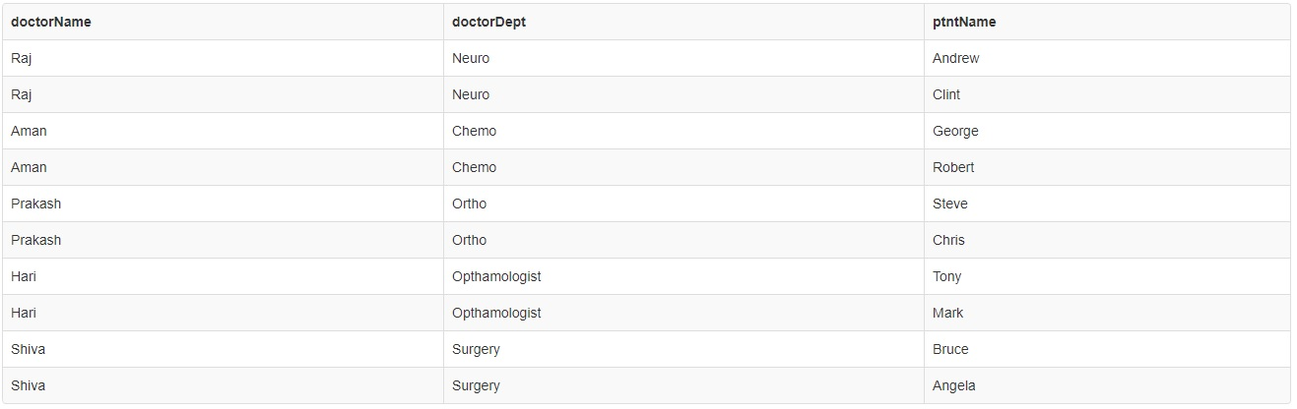

Task 3.

Query –

SELECT billDate, COUNT(billDate) FROM PATIENT, BILL, PTNT_BILL

WHERE PATIENT.ptntId = PTNT_BILL.ptntId AND PTNT_BILL.billNo =

BILL.billNo AND billDate >= '2020-07-13' AND billDate <= '2020-07-19'

GROUP BY billDate;

OUTPUT –

