1. Change name to : Good Deed
2. Chart of account on the menu when a top level account is clicked, a sub menu should appear
3. Add and edit accounts

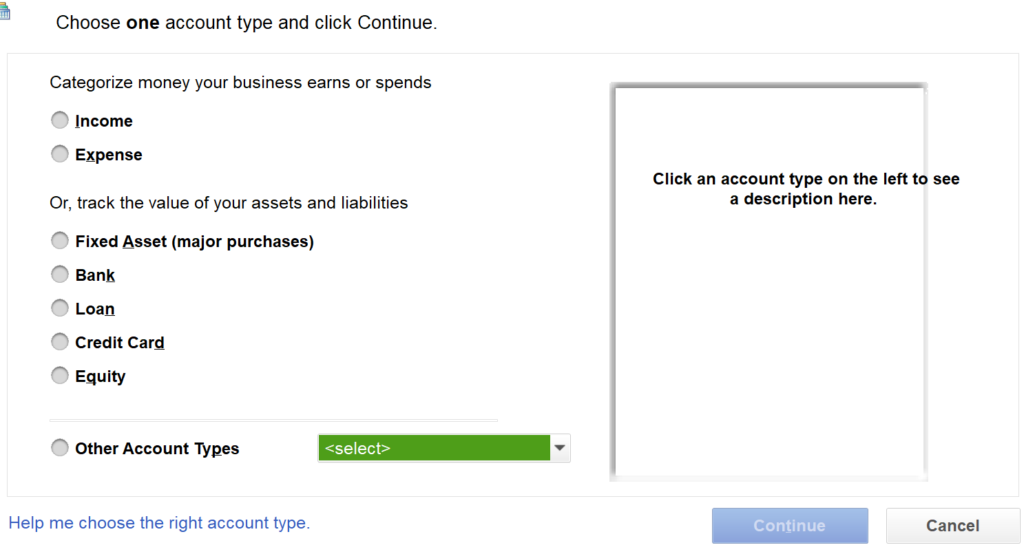

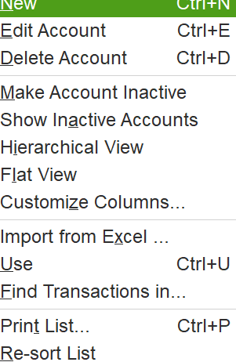

This is the list for changing the account in a chart of account

On chart of acc, name is alias

Remove cash & desc columns in chart of account

Change AC >> Sales Quotation to Sales Proposal

Customer

Description

Quantities

Discounts % or $

Delivery Date

Price per unit

Amount excluding taxes

Delete Sales Orders & Sales Receipt under AR

Accounts Receivable >> Add Sales Invoice crashes on save invoice

New Customer

* Delete Fax
* AR dropdown should include all account numbers except account 10120 (account receivable) because it is a control account
* Beside AR dropdown, display code in brackets
* Add a new item in chart of accounts named “Advances” under code 10114. Thereafter, it is the only option beside prepayment
* Discount field is simply a percentage numeric field
* There must be a lookup table for payment terms

Financials >> Taxes

* There must be ability to add/delete/edit taxes

Reda TODO

* Design the donation form