Sales Updation
We need to record the sales date wise in xero and daily reporting sheet. We need to record the Sales through Shopify and we prepare the Shopify sales sheet through Chat GPT

Required Documents
- Net payment by Order
- Total Sales by Order
Source
- Shopify
- Chatgpt

Downloading the Reports from Shopify
We need to download the following two reports from Shopify. To login Shopify Credentials files are saved in Slack Channel.
Go to Analytics > Reports > Net Payments by Order
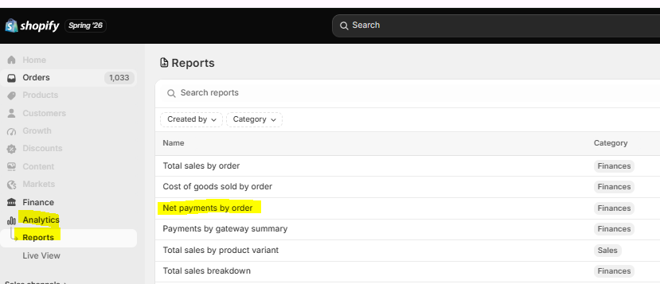

Now Select the date range and click on Apply
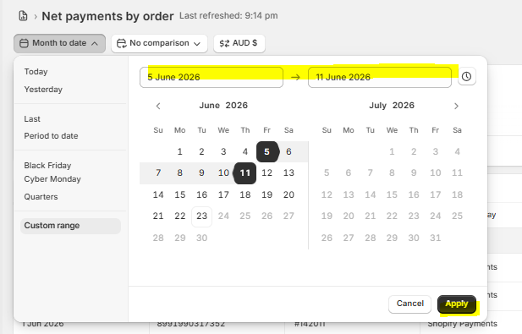
Click on three dots and then Export
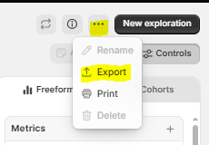

Click on Export
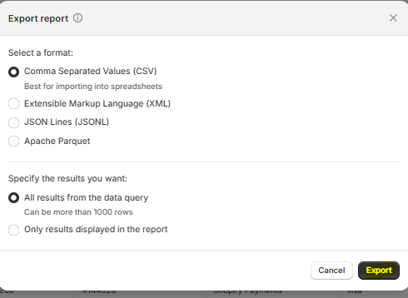

Go to Analytics > Reports > Total Sales by order
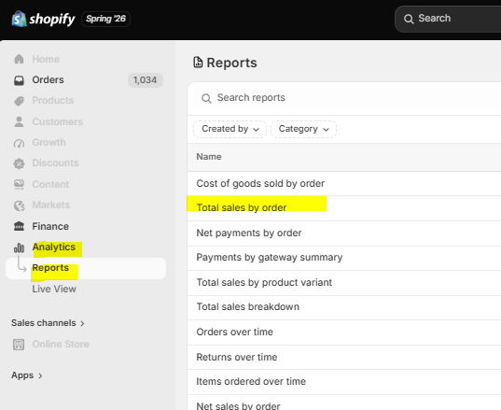

Now Select the date range and click on Apply and Export the same
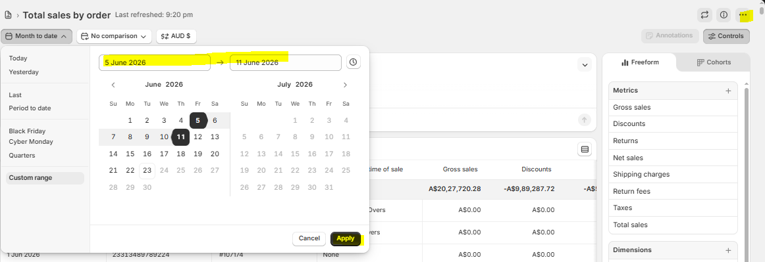

Process to Prepare Sales Sheet
Sales Sheet are prepared using Chatgpt in Agent mode — https://chatgpt.com/
- Click + > More > Agent mode.
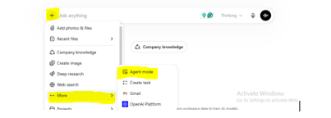
Give Chatgpt the prompt below along with all the files you downloaded. Also make sure to specify the following:
- Mention Each country Sales, Refunds Shipping information separately
You are an accounting assistant.
You are provided with two CSV files for a given date range:
- “Net payments by order” (authoritative for Payment Gateway, Billing Country, and Net Payments)
- “Total sales by order” (authoritative for Net Sales, Shipping Charges, and Taxes)
Your task is to fully reconcile these two reports and produce an Excel workbook with:
- JournalEntriesDaily (one row per day)
- Summary (export totals by country for the entire period)
Accuracy is critical. All figures must tie back to the Net payments by order report.
1. Base Dataset & Join Logic (CRITICAL)
• Use Net payments by order as the base dataset.
• Aggregate Net payments by order + Day.
• Capture Payment gateway and Billing country from the Net payments report.
• Aggregate the Total sales by order report by Order name + Day, summing:
Net sales
Shipping charges
Taxes
• Join the two datasets on BOTH:
Order name
Day
Never join on Order name alone.
Billing country and gateway must always come from the Net payments report.
Any missing sales values after the join should be treated as zero.
2. Normalize Payment Gateways
Normalize gateway names using the Net payments report:
Any value containing “afterpay” → Afterpay
Any value containing “paypal” → PayPal
- Any value containing “shopify” → Shopify Payments
This ensures gateways such as “Afterpay (New)” are not dropped or misclassified.
3. Country Classification
• Use Billing country from Net payments by order as the single source of truth.
• Classify orders as:
Domestic → Billing country = Australia
Export → All other countries
Export countries to report separately:
- United States
- New Zealand
- Canada
- United Kingdom
- Singapore
- Bulgaria
- Hong Kong
- Taiwan
Any other country goes into an “Other” bucket.
4. Domestic (Australia) Calculations (GST-Inclusive Source Data)
For positive net sales:
- Sales Revenue (Australia, excl. GST) = Net sales ÷ 1.1
- GST on Sales = Net sales ÷ 11
For positive shipping charges:
- Shipping (Australia, excl. GST) = Shipping ÷ 1.1
- GST on Shipping = Shipping ÷ 11
For refunds (Net sales + Shipping < 0):
• Refunds (Australia, excl. GST) = (Net sales + Shipping) ÷ 1.1
• GST on Refund = (Net sales + Shipping) ÷ 11
• Total GST Payable (Australia) =
GST on Sales
GST on Shipping
GST on Refund (negative)
5. Export Calculations (No GST Adjustments)
For each export country per day:
- Sales Revenue (Country) = sum of positive Net sales
- Shipping (Country) = sum of positive Shipping charges
- Other Tax (Country) = sum of Taxes
- Refunds (Country) = sum of negative Net sales + negative Shipping
No GST calculations apply to exports.
6. Payment Gateway Totals (Daily)
For each day, calculate:
- Shopify Payments total
- PayPal total
- Afterpay total
These totals must match exactly the Net payments by order report when grouped by day and gateway.
7. Rounding / Reconciliation Check (MANDATORY)
For each day:
- Expected Total = Net sales + Shipping charges + Taxes (from joined dataset)
- Payments Total = Sum of Net payments (from Net payments report)
Calculate:

Rounding = Payments Total − Expected Total
- Rounding should be only minor cents-level differences
- Large differences indicate a reconciliation failure
8. Output: JournalEntriesDaily Sheet
One row per day with columns in this exact order:
- Date
- Shopify Payments
- PayPal
- Afterpay
- Sales Revenue (Australia)
- Shipping (Australia, excl. GST)
- GST on Shipping
- GST on Sales
- Refunds (Australia, excl. GST)
- GST on Refund
- Total GST Payable
Then for each export country (plus Other):
- Sales Revenue (Country)
- Shipping (Country)
- Other Tax (Country)
- Refunds (Country)
Final column:
- Rounding
Ensure:
- All Australia figures are GST-exclusive
- Export figures tie back to Net payments by order
- Total debits equal total credits per day (after rounding)
9. Summary Sheet
For the entire period, list for each export country (and Other):
- Total Sales Revenue
- Total Shipping
- Total Other Tax
- Total Refunds
10. Audit Expectations
Before finalizing:
- Verify each country per day ties back to Net payments by order
- Verify gateway totals per day match Net payments by order
- Confirm no country leakage between days
- Confirm rounding is immaterial
Only provide the Excel file after all checks pass.

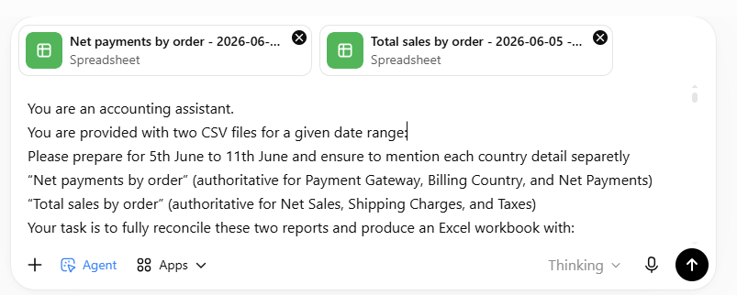
Chatgpt will provide below file you need to download the same
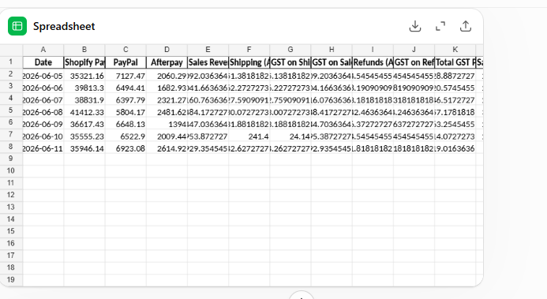

Now, we need to match Output report with Net Payment by Order report
- First we will match Payout amount of each platform (PayPal, Shopify and after pay). See here the total of both files are match i.e. $323,979.91
Output Sheet
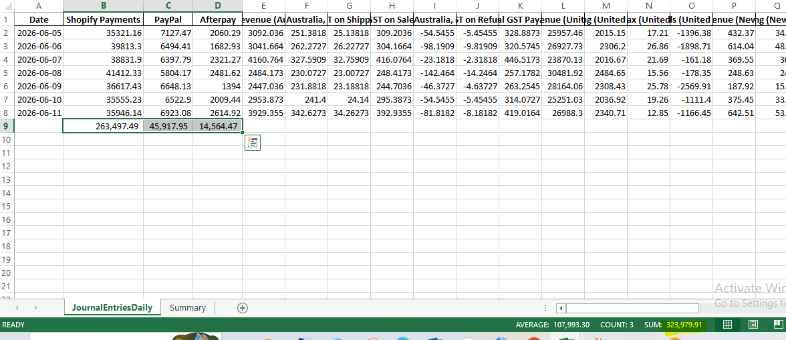
Net Payment by Order
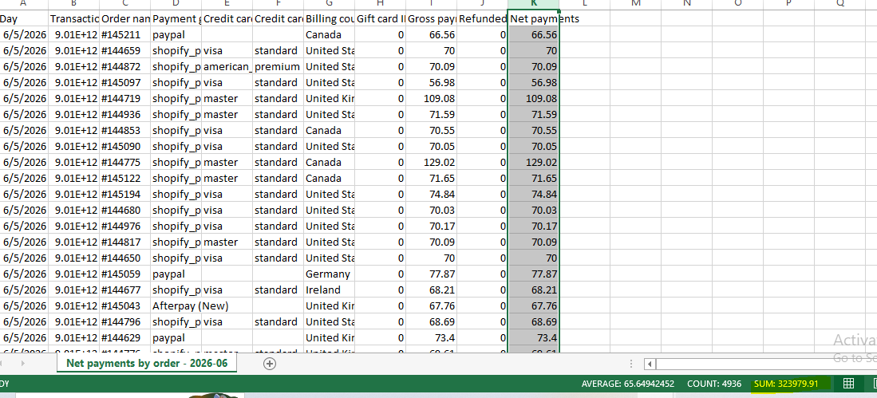
- Country wise Matching of Sales and refunds with Net payment by order
We need to match Sales and refunds with Net Payment by order separately

For Instance we will start with Australia for this we need to match Sum of sales revenue + Shipping +GST on Shipping +GST on Sales
Output Sheet
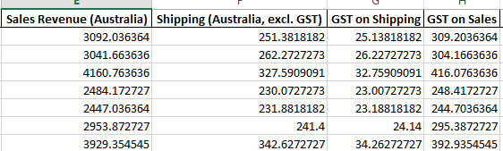

With Gross Payment in Net Payment by order Apply filter on Billing country and select Australia
Net Payment by Order
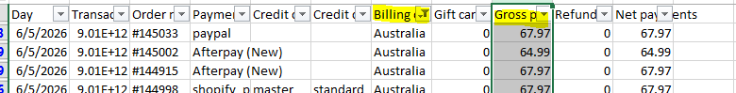

Here the sum of both files are matched i.e. $26,395.74
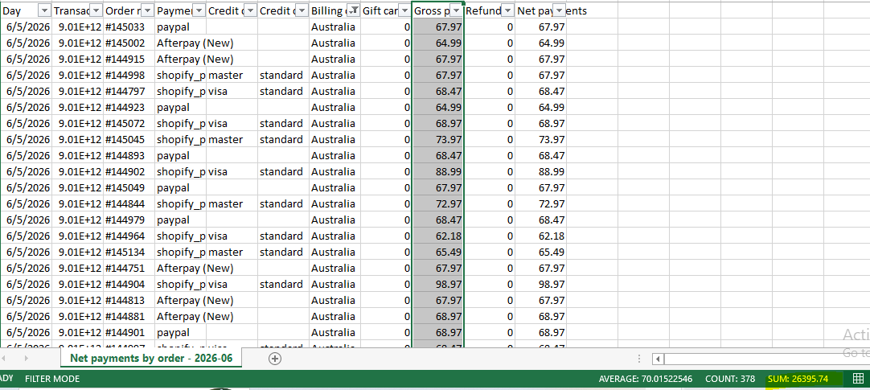

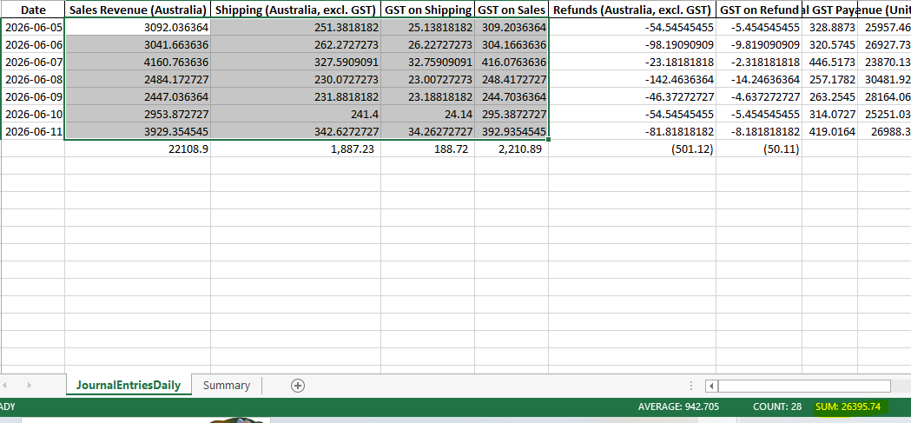
Now we need to match Refunds with Net Payment by order $551.23(refer below screenshot)
Output Sheet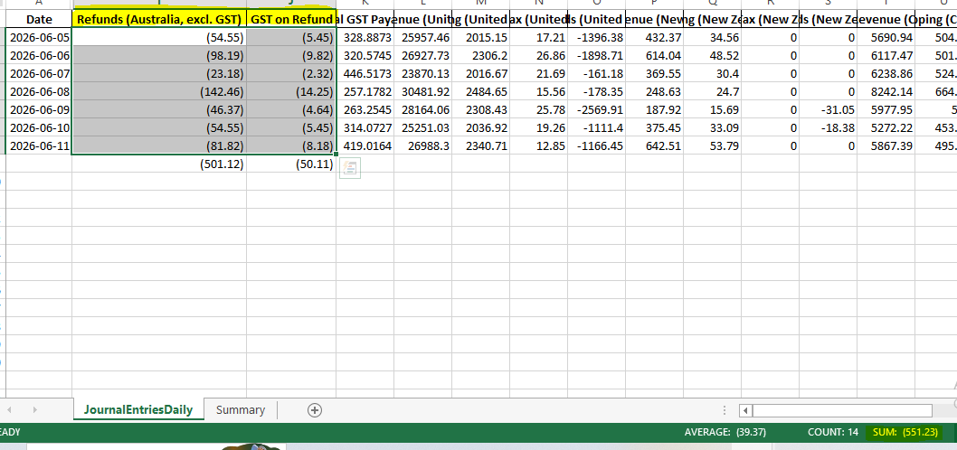

Net Payment by order
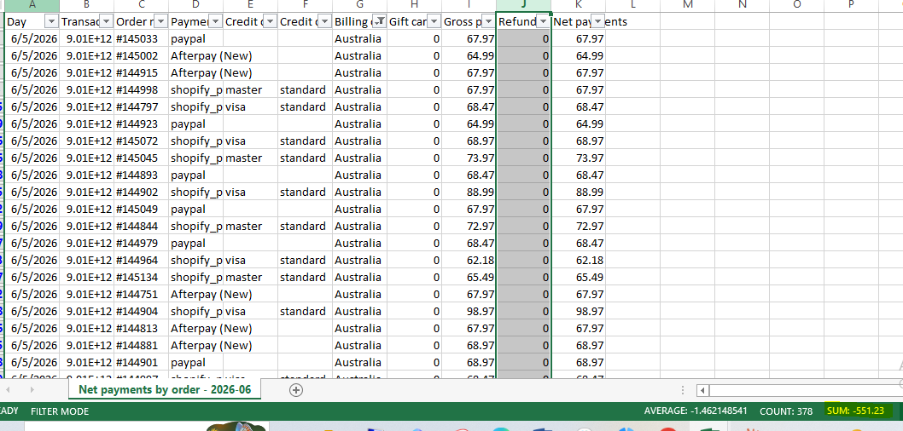

Similar way we need to match the sales and refunds of each country. If you found any variance between Output file and Source file(Net Payment by order) you can make changes manually in Output file if you face difference between the sum of Sales + Shipping in Output file with Gross Sales of Net payment by order you can make changes in only Sales amount keep shipping amount as it is.
If you face variance in refund you can make changes in refunds amount.
After matching the Sales of each country make sure to make following changes in Sheet
GST Payable is sum of GST on Shipping, GST on sales and GST on refunds but we need to edit this as we need to show GST on refunds separately in JE 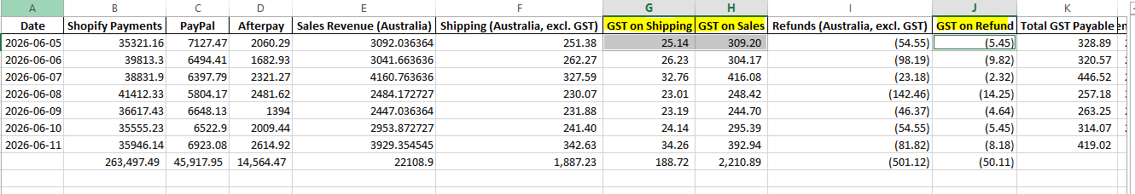
We will take sum of GST of Shipping and GST on Sales in GST payable and remove the tab GST on Shipping and GST on Sales from sheet.(Make sure to Copy paste the data as we need GST on Shipping and GST on Sales separately as well to record in Daily reporting sheet)
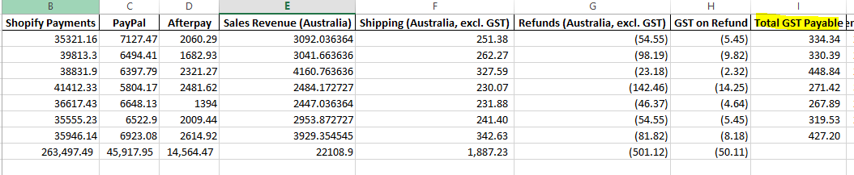

After matching the output sheet we need to give this to Chatgpt again with new prompt to prepare Journal entry which we need to record in Xero with following instructions as well
Refunds should be separately mention for each country
Rounded off amount should be small.
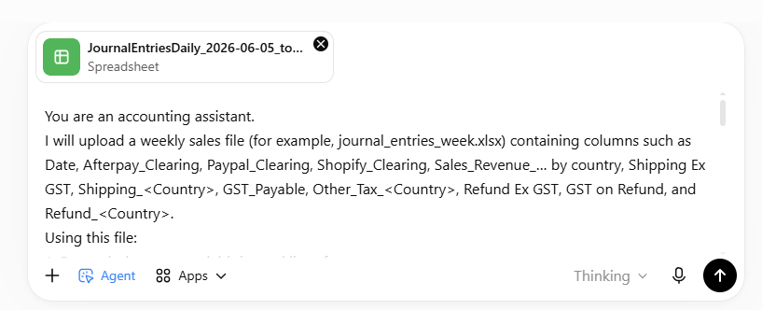
You are an accounting assistant. I will upload a weekly sales file (for example, journal_entries_week.xlsx) containing columns such as Date, Afterpay_Clearing, Paypal_Clearing, Shopify_Clearing, Sales_Revenue_… by country, Shipping Ex GST, Shipping_<Country>, GST_Payable, Other_Tax_<Country>, Refund Ex GST, GST on Refund, and Refund_<Country>. Using this file: 1. For each date, create debit journal lines for: Shopify Clearing (Account 251), Afterpay Clearing (Account 253), and PayPal Clearing (Account 252) using the corresponding columns. A single “Refunds” line (Account 204) equal to the sum of Refund Ex GST plus all Refund_<Country> columns. If GST on Refund is non-zero, add a “GST on Refund” line (Account 820) for that amount. 2. Create credit journal lines for: “Shipping Income – AU” (Account 254) using Shipping Ex GST. “Product Revenue – AU” (Account 257) using Sales_Revenue_AUS plus Refund Ex GST (add the refund amount back to sales). “GST” (Account 820) equal to Total_GST_Payable plus the sum of all Other_Tax_<Country> columns. “Product Revenue – <Country>” lines for each known country (Accounts 258, 259, 261, 262, 265, etc.) using Sales_Revenue_<Country> plus Refund_<Country> (add refunds back to sales). A single “Shipping Income – Other” (Account 250) equal to the sum of all Shipping_<Country> columns. 3. New country handling (important): If sales appear for a country that does not have a predefined country-specific GL account, record the entire sales amount plus any related refund amount to: GL: “Product Revenue – Others” Do not create a new country GL automatically; always use Product Revenue – Others for new/unmapped countries. 4. Rounding: Calculate the difference between total debits and total credits excluding refunds. Add a “Rounding” line (Account 860) on the side necessary (debit or credit) only to balance minor differences. 5. Output: Produce an Excel file with columns: Date, Account Code, Description, Debit, Credit List day-wise journal entries for the entire week. Ensure each day balances exactly. Please generate this Excel workbook for the entire week and provide it as a downloadable file.
Download the Output file from Chatgpt
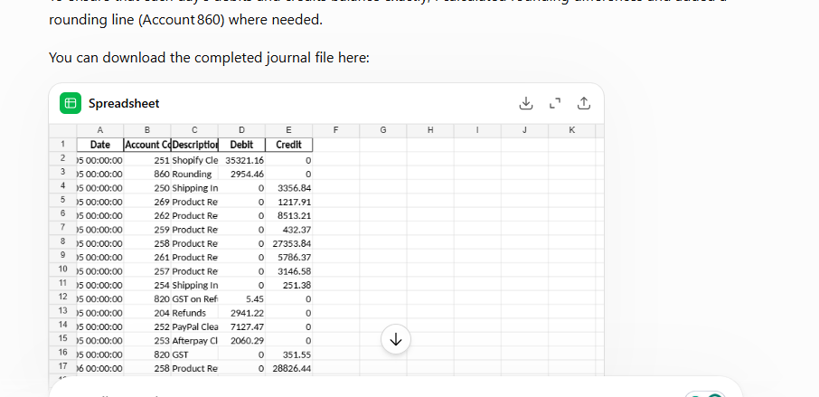

Here is the Output file of Journal Entry match this with Source File. Once everything match with source file (first Output file) you are good to record the same in xero.
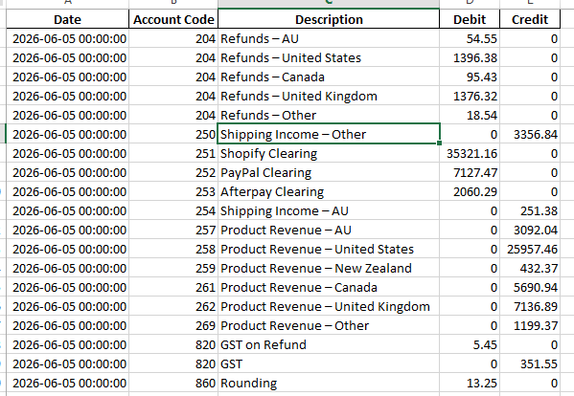

Sales Updation in Xero
After Preparing the Sales Journal entry we need to record the same in Xero. Refer the below Screenshot for Sales JE
