**Project** **–** Web based Accounting Application

**Document Type:** High Level Solution Design Document

# Introduction

The Accounting Application is a comprehensive web-based financial management system designed to streamline accounting processes, enhance data accuracy, and provide insightful financial analysis for organizations of all sizes. This High-Level-Design (HLD) document serves as a detailed blueprint for the implementation of various modules and components within the Accounting Application.

**1.1. Purpose:**

The purpose of this HLD document is to provide developers with detailed specifications and guidelines for designing and implementing specific modules and components of the Accounting Application. It aims to ensure consistency, maintainability, and scalability in the development process by outlining the technical details and implementation strategies for each module.

**1.2. Objectives:**

The objectives of accounting software are to streamline and enhance various financial processes within an organization, offering efficiency, accuracy, and better management of financial information. Here are the key objectives of accounting software:

* Automation of financial processes
* Accurate financial reporting
* Efficient bookkeeping
* Invoice and receivables management
* Expense banking
* Bank reconciliation
* Payroll processing
* Security and data integrity
* Compliance with regulatory requirements
* Integration with other systems
* User-Friendly interface

**1.3. Intended Audience:**

* Development team members.
* Project stakeholders.
* Quality assurance (QA) engineers.
* System administrators.

# System Overview

**2.1. System Architecture:**

The system architecture of accounting software is a critical component that defines how the software is designed, organized, and functions. It encompasses various layers and modules that work together to provide a comprehensive accounting solution. Here is a general overview of the typical system architecture for accounting software:

* **User Interface Layer:** This is the front end of the software that users interact with. It includes the graphical user interface (GUI) and user experience elements. Provide users with a visual representation of key financial data, reports, and analytics.
* **Application Logic Layer:** The core functionalities and rules governing financial transactions, calculations, and processes. It ensures accuracy, consistency, and compliance with accounting standards. Handles tasks such as data validation, calculations, and workflow management.
* **Data Access Layer:** Manages the storage, retrieval, and manipulation of data. Common database systems include MySQL, PostgreSQL, Oracle, or Microsoft SQL Server. Define the structure and relationships of the data within the database.
* **Security Layer:** Ensures that only authorized users can access the system and defines their level of access. Protects sensitive data during transmission and storage to safeguard against unauthorized access.
* **Workflow and Process Automation:** Manages and automates accounting processes, such as invoicing, approvals, and reconciliation. Custom scripts or rules that automate repetitive tasks, reducing manual intervention.
* **Audit Trail and Compliance Layer:** Records all changes and transactions made within the system, providing a trail for accountability and compliance. Ensures adherence to accounting standards, tax regulations, and industry-specific requirements.
* **Scalability and Performance Optimization:** Distributes processing load across multiple servers to optimize performance. Allows the system to handle increased data volumes and user loads.

**2.2. Key Features:**

* Financial reports generation.
* Chart of accounts management.
* Transaction recording and tracking.
* Invoice processing and management.
* Ad-hoc analysis and reporting.

# Architectural Overview

**3.1. Microservices Architecture:**

* Each user story represented as a separate microservice.
* Ensures modularity, scalability, and maintainability.

**3.2. Components:**

* Frontend components development using Node.js and AngularJS.
* Backend services implementation with Spring Boot.
* Databases: MySQL for structured data, MongoDB for semi-structured data.
* Containerization with Docker for easy deployment and scalability.
* Continuous Integration with Jenkins.
* Deployment and hosting on AWS.

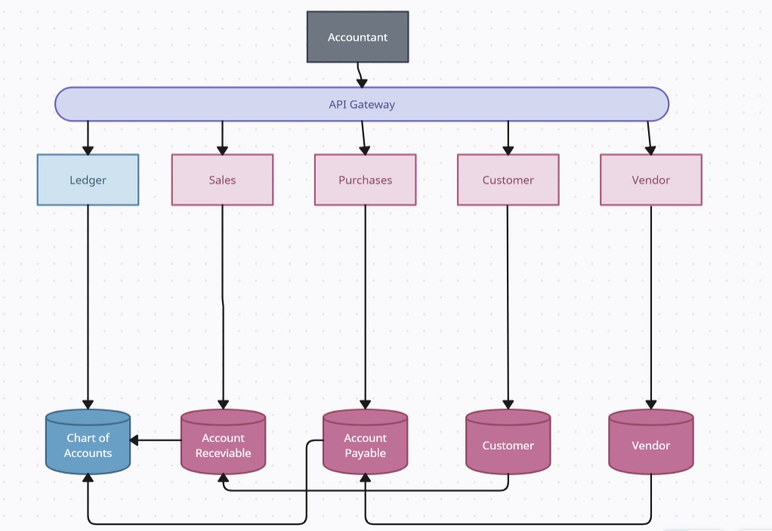

**3.3. Interactions:**

* Communication between frontend and backend components via APIs.
* Integration points with external systems for data exchange.

# Functional Overview

**4.1. User Roles and Functionalities:**

* Finance Managers: Financial reports analysis.
* Accountants: Chart of accounts management.
* Bookkeepers: Transaction recording and tracking.
* Accounts Payable Clerks: Invoice processing and payment tracking.
* Accounts Receivable Clerks: Invoice generation and payment tracking.
* Financial Analysts: Ad-hoc analysis and reporting.

**4.2. High-Level-Design**

**4.2.1. General Ledger**

**I. Chart of Accounts**

**Component:** Chart of Accounts Management Module

**Functionality:**

* Ability to define and customize the chart of accounts.
* Support for multiple currencies.

**Sub-components:**

* Chart of Accounts Editor: Interface for adding, editing, and deleting account categories and subcategories.
* Currency Management: Module to manage currencies and exchange rates.

**II. Transaction Processing**

**Component:** Transaction Processing Module

**Functionality:**

* Real-time posting of financial transactions.
* Automated journal entry generation based on predefined rules.

**III. Periodic Closing**

**Component:** Periodic Closing Module

**Functionality:**

* Year-end closing procedures.
* Ability to close accounting periods.

**4.2.2. Accounts Payable**

**I. Vendor Management**

**Component:** Vendor Management Module

**Functionality:**

* Maintain a centralized vendor database.
* Track vendor performance and history.

**II. Invoice Processing**

**Component:** Invoice Processing Module

**Functionality:**

* Automated invoice capture and approval workflows.
* Integration with procurement systems.

**III. Payment Processing**

**Component:** Payment Processing Module

**Functionality:**

* Electronic fund transfer capabilities.
* Payment scheduling and optimization.

**4.2.3. Accounts Receivable**

**I. Customer Management**

**Component**: Customer Management Module

**Functionality**:

* Maintain a centralized customer database.
* Monitor and manage credit limits.

**II. Invoicing and Billing**

**Component**: Invoicing and Billing Module

**Functionality**:

* Automated invoicing based on sales orders or project milestones.
* Flexible billing options.

**III. Collections**

**Component**: Collections Module

**Functionality**:

* Aging reports for tracking overdue payments.
* Automated dunning and collection letters.

**4.2.4. Financial Reporting**

**I. Standard Reports**

**Component**: Standard Reports Module

**Functionality**:

* Generate standard financial statements with drill-down capabilities.
* Comparative analysis of financial performance.

**II. Custom Reports**

**Component**: Custom Reports Module

**Functionality**:

* Ad-hoc reporting with drag-and-drop functionality.
* Save and share custom report templates.

**III. Dashboards**

**Component**: Dashboard Module

**Functionality**:

* Real-time financial dashboards with key performance indicators.
* Customizable dashboard views.

**4.2.5. Budgeting and Forecasting**

**I. Budget Creation**

**Component**: Budget Creation Module

**Functionality**:

* User-friendly budget creation interface.
* Version control for budget iterations.

**II. Forecasting**

**Component**: Forecasting Module

**Functionality**:

* Historical data analysis for accurate forecasting.
* Scenario modelling for 'what-if' analysis.

**4.2.6. Compliance and Security**

**I. Regulatory Compliance**

**Component**: Compliance Module

**Functionality**:

* Automatic updates for compliance with accounting standards.
* Audit trails for compliance reporting.

**II. Access Control**

**Component**: Access Control Module

**Functionality**:

* Role-based access control with granular permissions.
* Two-factor authentication.

**III. Data Encryption**

**Component**: Data Encryption Module

**Functionality**:

* Encryption of data at rest and during transmission.
* Regular security audits and vulnerability assessments.

**4.2.7. Custom Reporting**

**I. Custom Reporting**

**Component**: Custom Reporting Module

**Functionality**:

* Ability to generate custom reports based on user-defined criteria.
* Advanced reporting features such as data visualization and filtering.

# Data Design

**5.1. Data Entities:**

* Company Details
* Ledger
* Account Receivable
* Account Payable
* Customer
* Vendor

**5.2. Attributes and Relationships:**

* Define attributes for each entity (e.g., account name, transaction amount).
* Establish relationships between entities (e.g., invoice associated with a customer).

* 1. **Entity Relationship Diagram:**

Illustrate how data moves through the system.

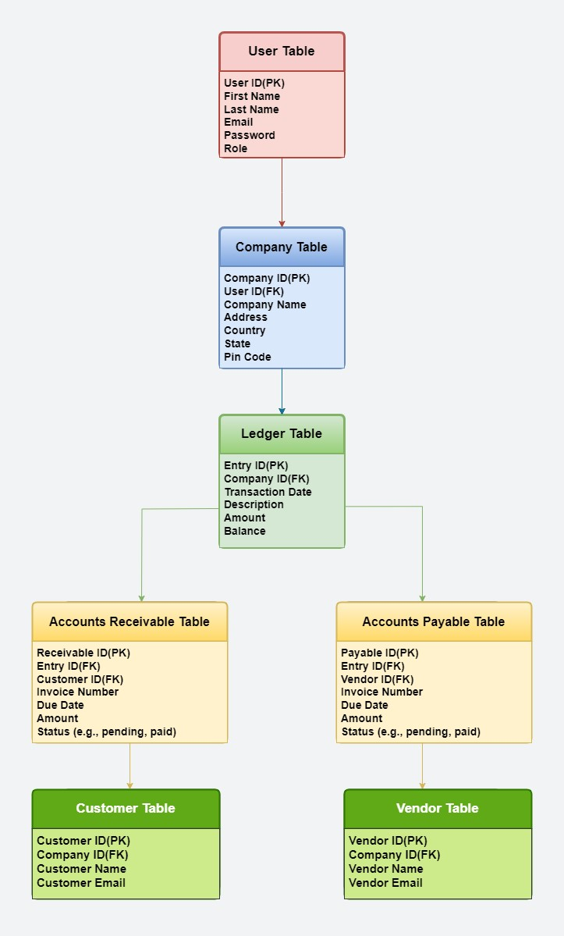

* 1. **Required Tables**

**I. User Details:**

* This table stores information about the User.
* Columns may include:
  + 1. User ID (Foreign Key)
    2. First Name
    3. Last Name
    4. Email
    5. Password
    6. Role

**II. Company Details:**

* This table stores information about the company.
* Columns may include:
  + 1. Company ID (Primary Key)
    2. User ID
    3. Company Name
    4. Address
    5. Country
    6. State
    7. Pin code

**III. Ledger Table:**

* This table stores the ledger entries for the company.
* Columns may include:
  + - 1. Entry ID (Primary Key)
      2. Company ID (Foreign Key referencing Company Table)
      3. Transaction Date
      4. Description
      5. Amount
      6. Balance

**IV. Accounts Receivable Table:**

* This table stores accounts receivable information, tracking money owed to the company by its customers.
* Columns may include:
  + 1. Receivable ID (Primary Key)
    2. Entry ID (Foreign Key referencing Ledger table)
    3. Customer ID (Foreign Key referencing Customer table)
    4. Invoice Number
    5. Due Date
    6. Amount
    7. Status (e.g., pending, paid)

**V. Accounts Payable Table:**

* + This table stores accounts payable information, tracking money owed by the company to its suppliers or vendors.
  + Columns may include:
    1. Payable ID (Primary Key)
    2. Entry ID (Foreign Key referencing Ledger table)
    3. Vendor ID (Foreign Key referencing Vendor table)
    4. Invoice Number
    5. Due Date
    6. Amount
    7. Status (e.g., pending, paid)

**VI. Customer Table:**

* + This table stores information about customers.
  + Columns may include:
    1. Customer ID (Primary Key)
    2. Company ID (Foreign Key referencing Company Table)
    3. Customer Name
    4. Contact Info

**VII. Vendor Table:**

* + - This table stores information about vendors/suppliers.
    - Columns may include:
      1. Vendor ID (Primary Key)
      2. Company ID (Foreign Key referencing Company Table)
      3. Vendor Name
      4. Contact Info

# Interface Design

**6.1. User Interfaces:**

* Intuitive navigation and user experience.
* Wireframes to visualize UI design.



**6.2. Application Programming Interfaces (APIs):**

* Define APIs for communication between frontend and backend components.
* Ensure consistency and security in API design.

**6.3. Integration Points:**

* Integration with external systems for data exchange.
* Maintain data integrity and security during integration.

# Security Design

**7.1. Authentication and Authorization:**

* Implement secure authentication mechanisms (e.g., OAuth, JWT).
* Role-based access control (RBAC) to restrict user access to authorized functionalities.

* 1. **Encryption:**

Encrypt sensitive data at rest and in transit (e.g., SSL/TLS for communication, encryption for data storage).

* 1. **Data Protection:**

* Implement data protection measures to ensure confidentiality and integrity.
* Regular security audits and vulnerability assessments.

# Performance Design

**8.1. Scalability:**

* Horizontal scaling to handle increasing loads.
* Load balancing strategies for distributing traffic across multiple instances.

**8.2. Responsiveness:**

* Optimizing frontend and backend code for faster response times.
* Asynchronous processing for time-consuming tasks.

**8.3. Resource Utilization:**

* Efficient use of hardware resources to minimize costs.
* Monitoring and optimization of resource usage.

# Deployment Design

**9.1. Hardware and Software Requirements:**

* Specify hardware specifications for servers.
* Software dependencies and versions required for deployment.

**9.2. Deployment Environments:**

* Development, testing, staging, and production environments.
* Configuration management for consistency across environments.

**9.3. Deployment Processes:**

* Automated deployment pipelines with Jenkins.
* Rollback strategies for handling deployment failures.

# Maintenance and Support

**10.1. System Monitoring:**

* Implement monitoring tools for tracking system health and performance.
* Alerts and notifications for critical events.

**10.2. Error Handling:**

* Comprehensive error handling mechanisms.
* Logging and error reporting for debugging purposes.

**10.3. Troubleshooting:**

* Procedures for diagnosing and resolving issues.
* Knowledge base for common troubleshooting scenarios.

**10.4. Ongoing Support:**

* User support channels (e.g., help desk, ticketing system).
* Regular updates and patches for bug fixes and security enhancements.