All Departments
STUDENT PLACEMENTS REPORT
Academic Year: 2025-2026
Introduction
The pursuit of academic and professional excellence remains a cornerstone of the institutional mission, reflecting a commitment to fostering student success beyond the traditional classroom environment. This report serves as a formal documentation of student achievements, highlighting the tangible outcomes of rigorous academic preparation and the strategic alignment of institutional resources with industry demands.
This specific report focuses exclusively on the domain of placement, providing a comprehensive overview of the professional milestones attained by students during the 2025-2026 academic year. By analyzing these records, the institution evaluates the efficacy of its career readiness initiatives and the successful transition of students into the professional workforce across all departments.
The primary purpose of this document is to provide stakeholders with a transparent and data-driven assessment of placement outcomes. By cataloging these seven approved records, the institution ensures accountability and maintains a robust evidence base for accreditation purposes, demonstrating the sustained impact of institutional support systems on student career trajectories.
Placement
Student | Company | Role | Package | Joining Date
Vishwajeet Patil | MICROLISE | — | — | —
Anjali Urunkar | Tata Consultancy Services | — | — | —
Sayali Pundapal | Infosys | Placement | — | —
Aakash Mohole | Volkswagen | Placement | — | —
Sana Mujawar | Movate | Awards | 9 LPA | —
Rohan Patil | Tata Consultancy Services (TCS) | — | — | 14 Aug 2026
Rohan Patil | Tata Consultancy Services (TCS) | — | — | 14 Aug 2026
Conclusion
The data presented in this report underscores the successful integration of professional development strategies within the institutional framework. The seven documented placement achievements serve as a testament to the students' dedication and the effectiveness of the institution's career guidance programs in preparing graduates for competitive professional environments.
These outcomes reflect a holistic approach to student development, where the acquisition of specialized skills and professional competencies is prioritized. By facilitating these placement opportunities, the institution continues to bridge the gap between academic theory and industrial application, ensuring that students are well-equipped to meet the evolving challenges of their respective fields.
In conclusion, the institution remains steadfast in its commitment to encouraging and documenting student achievements as a vital component of academic quality assurance. Moving forward, the insights derived from these placement records will inform future strategic planning, ensuring that the institution continues to provide the necessary environment for students to excel in their professional endeavors.
Achievement / Activity Photographs
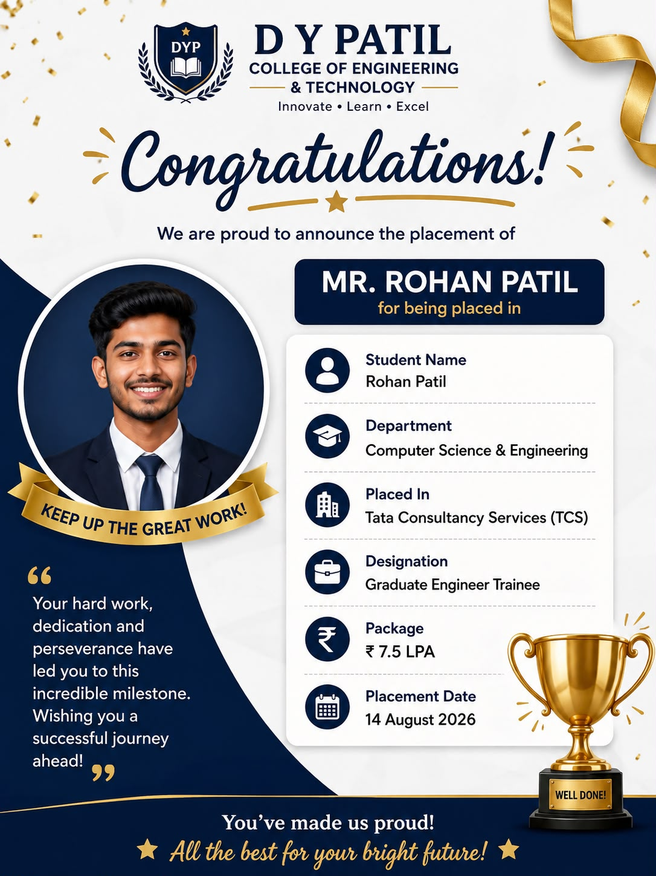
Placement – Tata Consultancy Services (TCS)
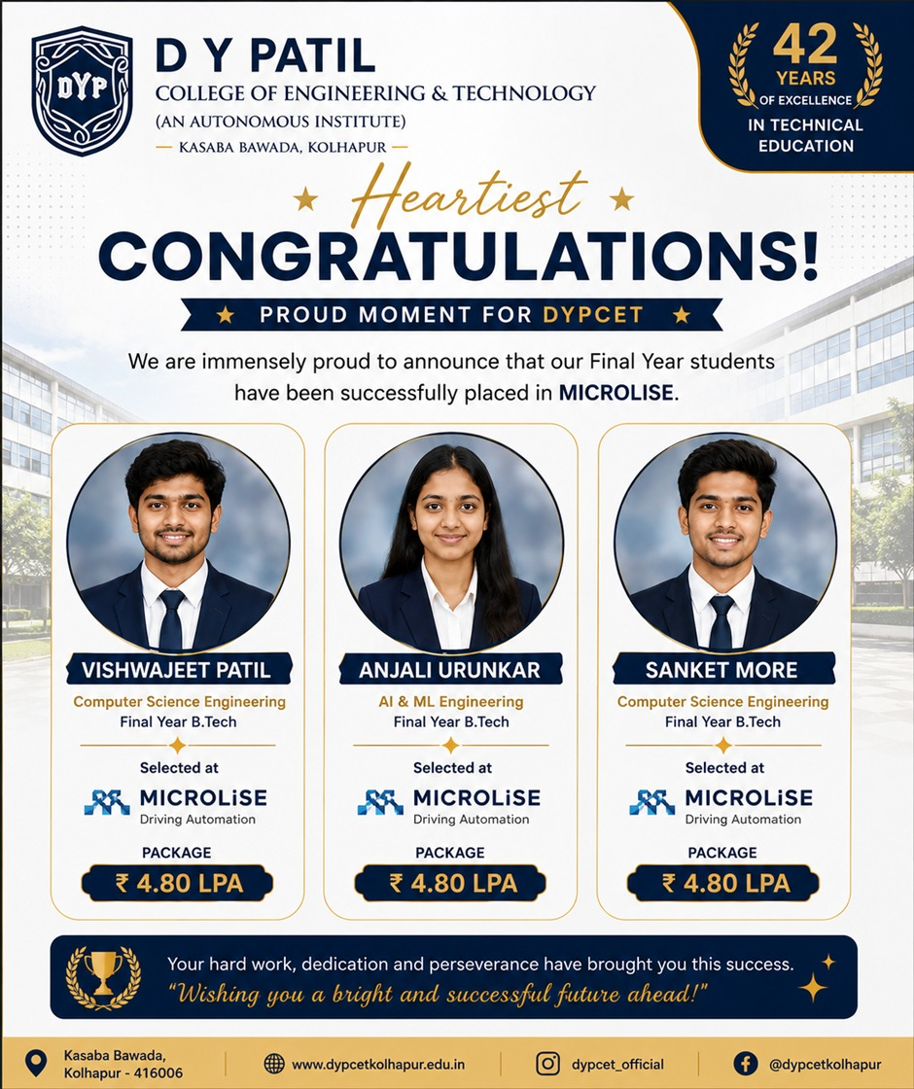
Placement – MICROLISE
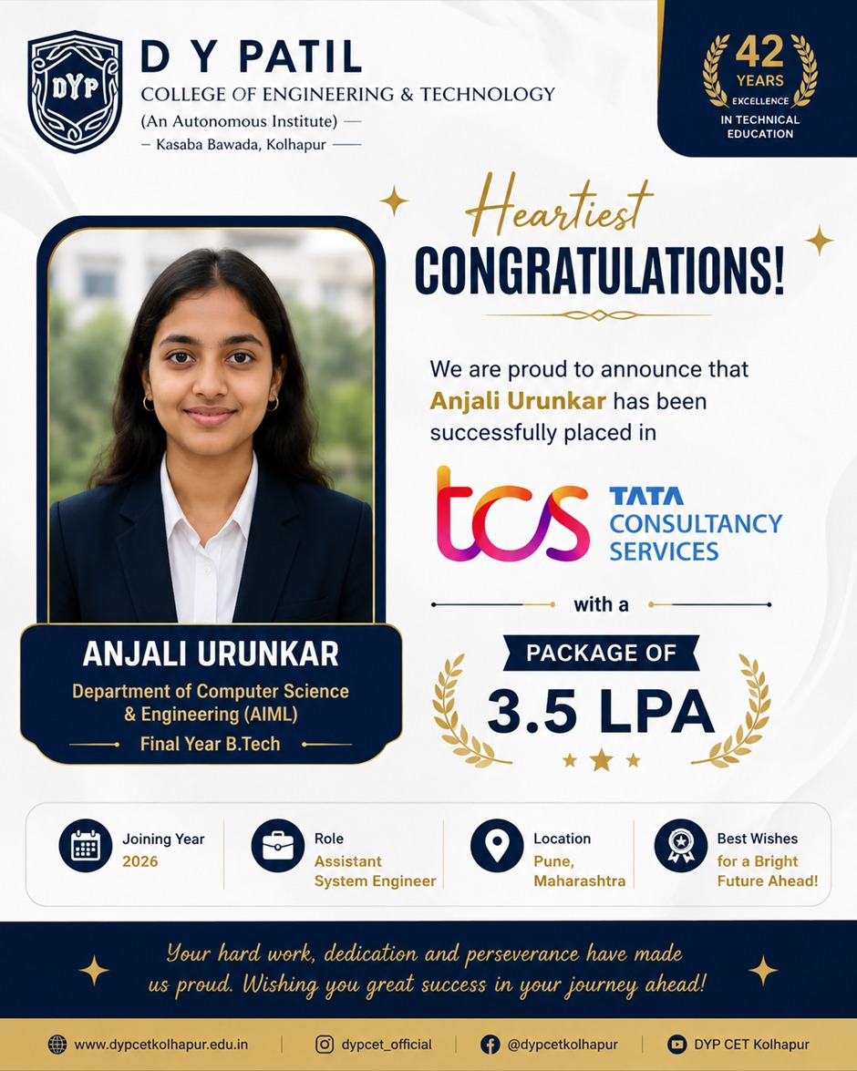
Placement – Tata Consultancy Services
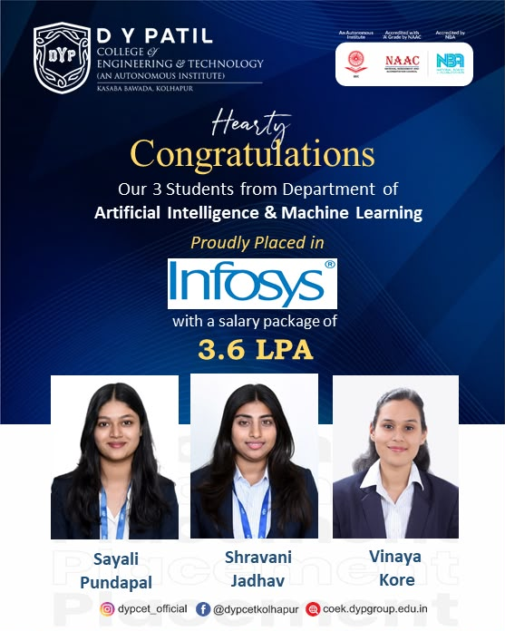
Placement – Placement at Infosys
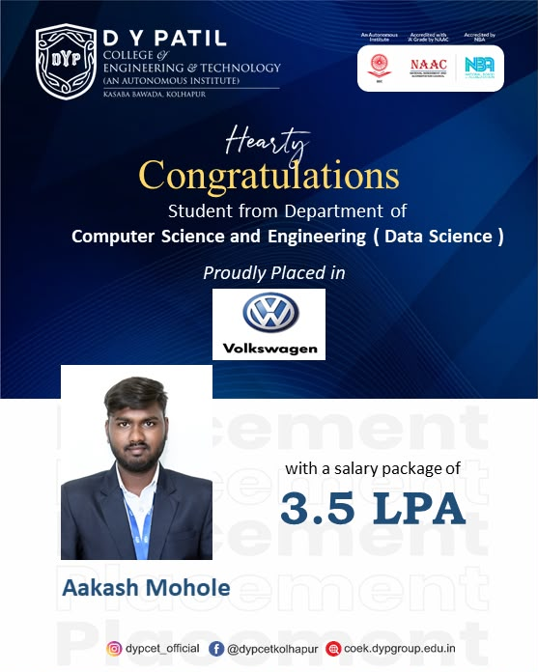
Placement – Placement at Volkswagen
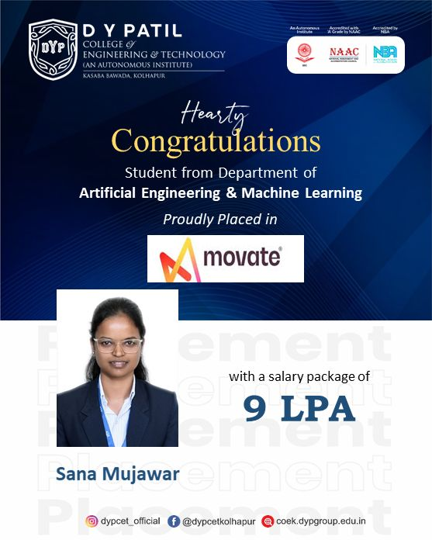
Placement – Awards at Movate

