Department of Artificial Intelligence & Machine Learning (AIML)
Industrial Visit Report on Industry Exposure at Pimpri-Chinchwad

Event Details :
Title of the Event: Industrial Visit
Organized By: Department of AIML
Resource Person: Information was not available in the provided WhatsApp conversation or uploaded documents.
Head of Department: Prof. Siddheshwar Patil
Venue: 64, Block F-2, MIDC, Pimpri Colony, Pimpri-Chinchwad, Maharashtra 411018
Date: 2022-07-02
Time: 10:06 AM
Participants: 45

Introduction
The Department of Artificial Intelligence & Machine Learning (AIML) organized an industrial visit to provide students with practical exposure to real-world industrial practices and emerging technologies.
The visit aimed to connect classroom knowledge with practical industry applications, focusing on AI, Machine Learning, and software development processes.
Objectives
The objectives of the industrial visit were:
1. To provide students with practical exposure to real-world industrial practices.
2. To bridge the gap between classroom theoretical knowledge and industrial applications.
3. To gain insights into Artificial Intelligence, Machine Learning, and Cloud Computing implementations.
4. To understand professional workplace culture and software development lifecycles.
Visit Proceedings
The visit commenced with an arrival at the industrial facility in Pimpri-Chinchwad. Students were welcomed by the facility staff and provided with an overview of the organization's operations. The session flowed through a guided tour of the technical departments, followed by an interactive session where students engaged with industry professionals regarding software development and AI integration.
Information was not available in the provided WhatsApp conversation or uploaded documents.
The visit saw active participation from the AIML department students. They engaged professionally with the host organization, asked insightful questions, and demonstrated a high level of interest in the technical demonstrations provided.
Topics Covered
1. Artificial Intelligence
2. Machine Learning
3. Cloud Computing
4. Data Analytics
5. Software Development Processes
Schedule Summary
1. Information was not available in the provided WhatsApp conversation or uploaded documents.
Learning Outcomes
After the industrial visit, students were able to:
1. Enhanced understanding of industry-standard software development practices.
2. Exposure to real-world applications of AI and Machine Learning.
3. Improved awareness of professional workplace expectations.
Key Highlights
1. Successful site visit to the MIDC industrial area.
2. Direct observation of industrial infrastructure and workflows.
Benefits
1. Increased awareness of internship and placement opportunities.
2. Better alignment of academic skills with industry requirements.
Conclusion
The industrial visit was a successful endeavor that provided students with a clear perspective on the professional landscape of the AI and ML industry.
The experience has reinforced the importance of practical learning and has motivated students to pursue excellence in their technical studies.
AI Executive Summary
This report details the industrial visit conducted by the AIML department on July 2, 2022, in Pimpri-Chinchwad. The visit provided 45 students with critical exposure to industrial AI and software development practices. Through site tours and professional interactions, students gained insights into the practical application of their curriculum, enhancing their readiness for future internships and careers. The event successfully bridged the gap between theoretical learning and industrial reality.
Acknowledgement
The department expresses its gratitude to the host organization for facilitating the visit. We also thank the Head of Department, Prof. Siddheshwar Patil, for his leadership, and the faculty members and students for their active participation in making this event a success.
Industrial Visit Photographs
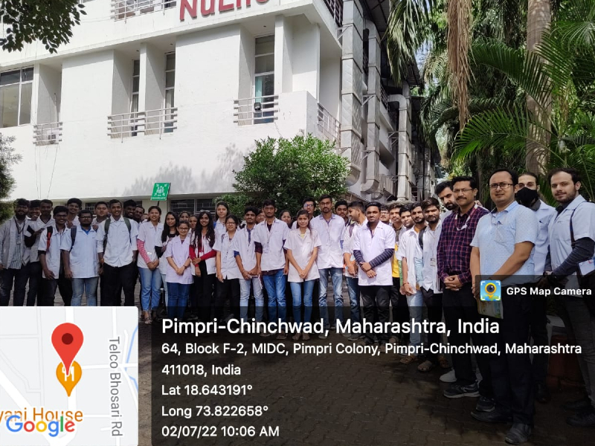
Group photograph of AIML students and faculty during the industrial visit at Pimpri-Chinchwad on July 2, 2022.

